

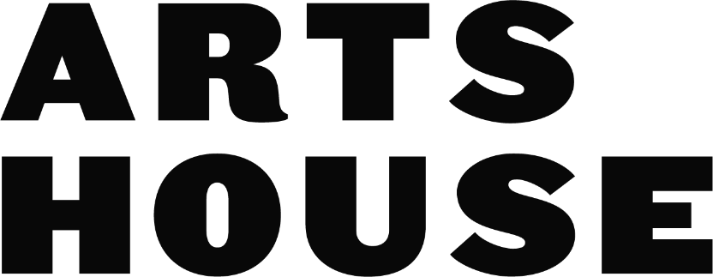
Access Key
September 2026
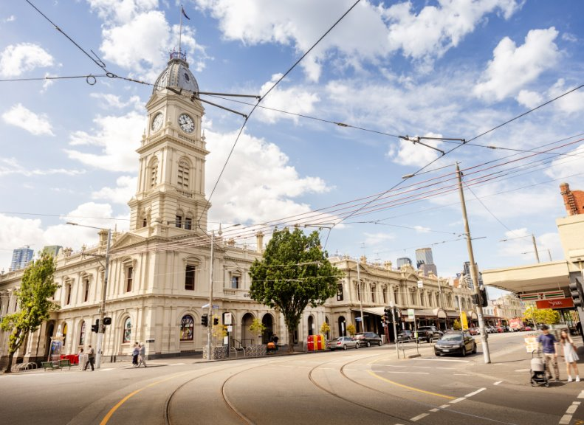

Contents
Acknowledgement of Country 3
Introduction 3
Getting to Arts House 4
Entry and Exit 5
COVID-19 and Viral Safety 7
Staff 8
Gathering Spaces and Amenities 9
The Foyer 9
Quiet Space 10
Toilets 11
Lift 12
Event Presentation Spaces 12
​Main Hall 13
Studios 13
Supper Room 13
The Warehouse 14
Ticketing and Events 15
Accessible Events 15
How to Buy Tickets 16
Ticketing Types 17
Contact Us 17
Was this Access Key helpful? 18

Acknowledgement of Country

Arts House acknowledges the Traditional Owners of the land, the Bunurong Boon Wurrung and Wurundjeri Woi Wurrung peoples of the Eastern Kulin Nation, and pay our respect to Elders both past and present and, through them, to all Aboriginal and Torres Strait Islander people.

Introduction
- This Access Key will help you prepare for your visit to Arts House.​
- Arts House is the City of Melbourne’s space for theatre, art, and performance. ​
- It is located in the North Melbourne Town Hall at 521 Queensberry Street, North Melbourne.​
- Everyone is welcome to visit Arts House during opening hours and event times.
- It is a priority for us to be an inclusive and accessible venue for all. ​
- Arts House is open between 11am and 4pm between Monday and Friday each week. ​
- Arts House is often open for performances and events during the evening. Events have scheduled start times and often require tickets. ​
- For upcoming events and more information on Arts House, look at our website.​
- You can also view an interactive walk through of Arts House.​
- Arts House is closed on public holidays and closes for maintenance for a month over summer.​​

Getting to Arts House
Arts House is located in the North Melbourne Town Hall, at the corner of Queensberry Street and Errol Street in North Melbourne. ​​
We have some resources that can help you with navigation throughout the building, including a video guide and a verbal map.​
Tram
From the CBD (Elizabeth St), Take the Route 57 tram and get off at Stop 12, North Melbourne Town Hall.
Please note, this is not a level access tram stop and is only occasionally serviced by low floor trams.

Train
Arts House is 1.1 kilometers from North Melbourne Train Station (16 minute walk), 1.3 kilometers from Flagstaff Station (18 minute walk) or 1.2 kilometers from Arden Station (20 minute walk)

Car
There is street parking around Arts House. There are two accessible on-street parking spaces on Queensberry Street and two on Errol Street for holders of a Disability Parking Permit. On Queensberry St and Levenson St – standard parking is time restricted from 7am – 7pm. Parks are metered on Mon – Fri. On Errol St, Parking is metered and time restricted 7:30am-6:30pm Mon – Fri. Parks are time restricted 7:30am – 12:30pm but not metered on Saturdays.

Walk
Arts House is 2.5 kilometers from Flinders Street Station, (35 minute walk), and 850 meters from Queen Victoria Markets (11 minute walk).

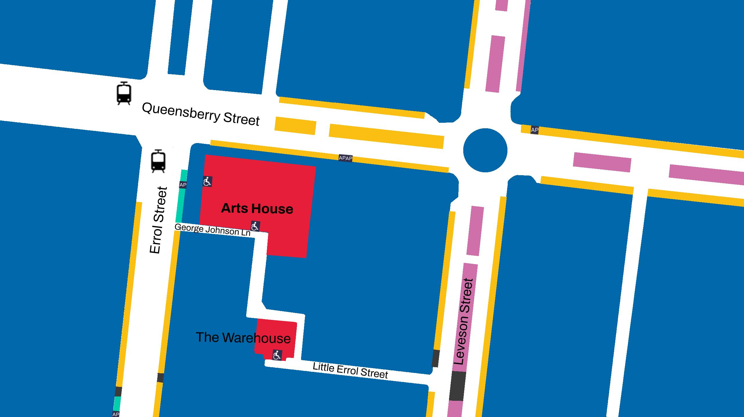

Step-free entrance
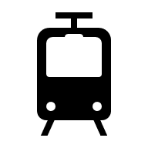Tram stop ​
2P (Metered sometimes)
4P (Metered sometimes)

1P or shorter (Metered sometimes)
Permit or Loading Zone
Accessible Parking Permit Spaces
AP
Buildings

Entry and Exit
​Main Entrance ​
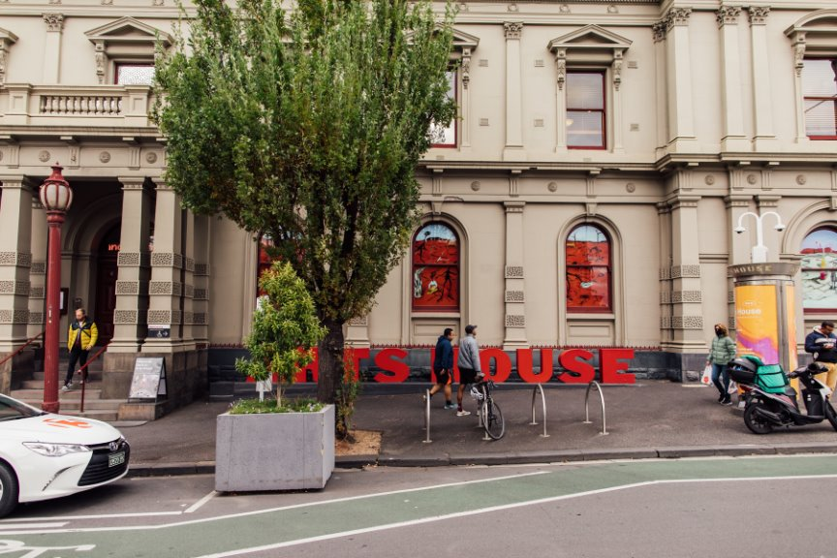
The main entrance to Arts House is at 521 Queensberry Street. This entrance has stairs with handrails, and the doorway opening is 112 centimeters wide. ​

Arts House has two wheelchair accessible entrances to the building: ​
Errol Street ​
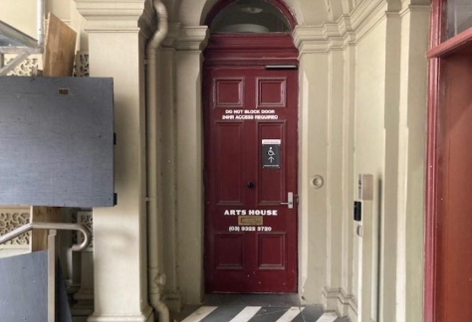
84 centimeter wide doorway, next to the post office. This can be accessed via stairs or a ramp. Push the silver button to the right of the door to enter, or ring the doorbell if you need assistance. ​
​
George Johnson Lane​
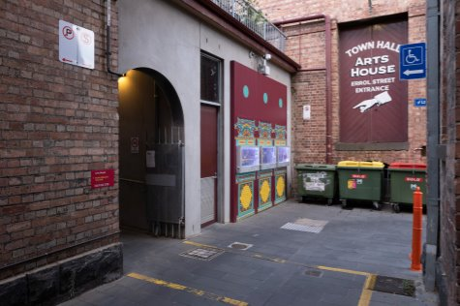
110 centimeter wide doorway. Watch out for traffic in the laneway. Push the silver button to the right of the door to enter. ​
All entrances are paved. ​

COVID-19 and Viral Safety
You must not attend our venue or programs in person if you have any signs of transmissible illness such as:
- a cough
- sore throat
- fever
- shortness of breath
- flu-like symptoms
We will provide a refund if you need to cancel your attendance due to illness.
Please contact us by 9am on the day of the event. This helps our staff by letting them process your refund during off-peak times.
We cannot provide refunds to events that have already passed.
To minimise the risk of viral transmission, we encourage you to wear a well fitted respirator of P2 or comparable standards.
Outside of masked events/hours. this is not something Arts House enforces. Because of this, it is reasonable to expect that most others in the building will not be masking.
Stay up to date with vaccines (as recommended by your healthcare professional)
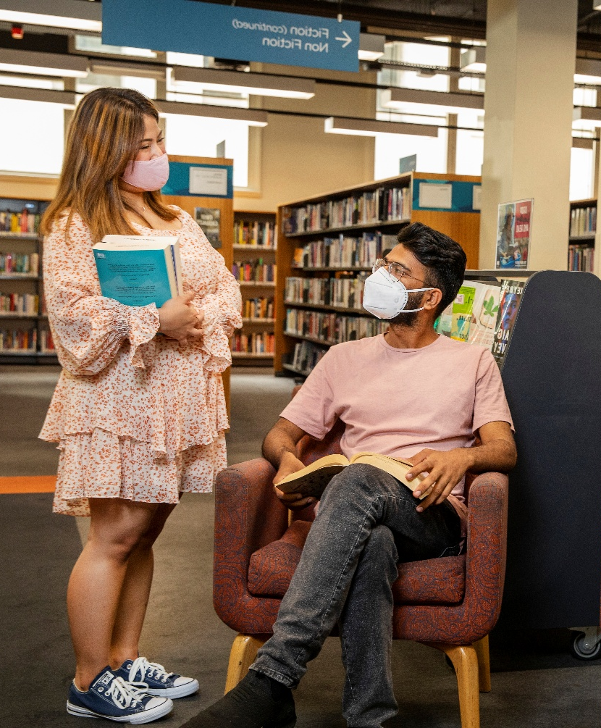
Around Arts House:

Hand sanitiser available

Masks available

Two Levoit Core 600s Smart HEPA Air FIlters

Staff
During the day, staff can always be found at the reception desk in the foyer at Arts House. ​​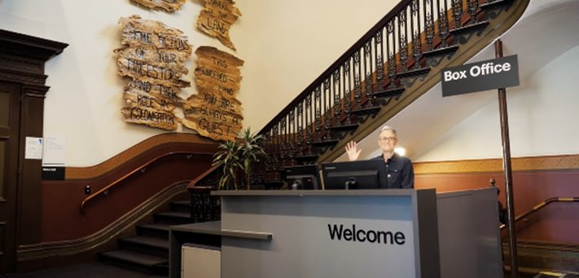
During events, staff at Arts House will be throughout the foyer. They wear black t-shirts or black jackets with the Arts House logo on them.
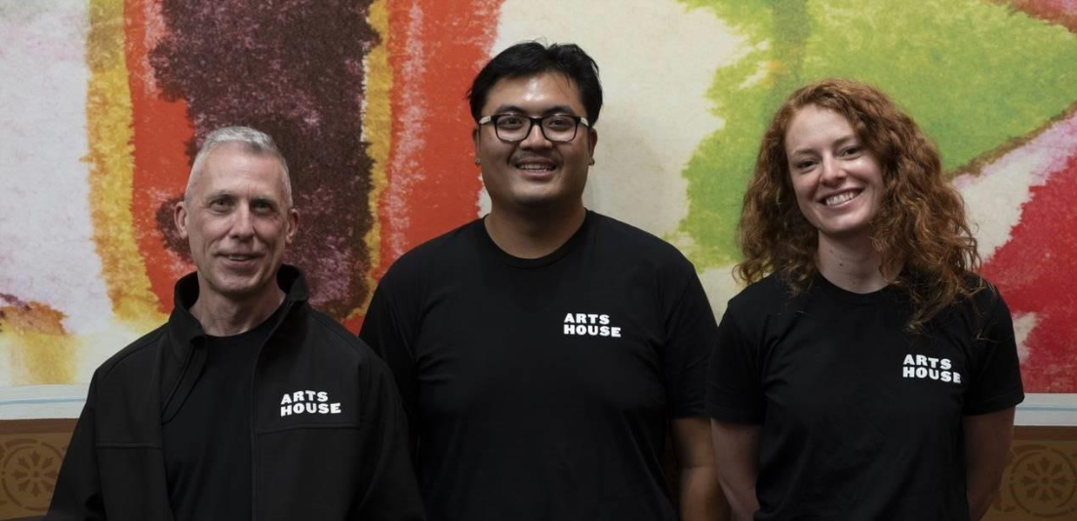
​Our staff are there to assist you, please ask for help if you need it.​

Gathering Spaces and Amenities

The Foyer
When you enter Arts House, you will find yourself in the foyer. ​
- The foyer is the main gathering space for events and the access point for exhibitions.
- Information about upcoming events and performances is available on posters on the walls and on a tablet computer at the reception desk.
- There is limited seating available against the walls of the foyer and the hallway. More seating is available in the quiet space.
- A communication board and pen and paper are available at reception.
- Free Wi-Fi is available for visitors. ​
- The foyer contains a lift.
- A water cooler is located nearby the reception desk. ​
- During events in the evening, a bar serving alcohol is run out of the foyer. ​
- Arts House frequently has exhibitions on in the building. There is always something to see.

Sensory Notes

Low Lighting

Crowds


Limited Seating

_{full}
Noise
- People Talking
- Appliance Buzzing


Quiet Space

There’s a dedicated Quiet Space located on the ground level opposite the Accessible Bathroom. ​
It is suitable as a chill out space, prayer or parenting space and features a range of seating options, dimmable lights, sensory and stimming objects and ear plugs. Anyone is welcome to access the Quiet Space during venue operating hours and events. ​

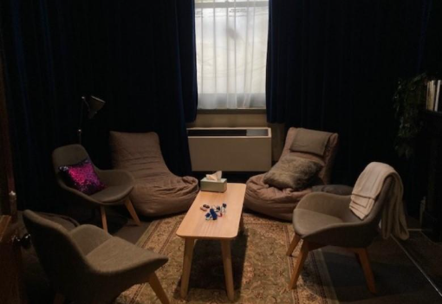
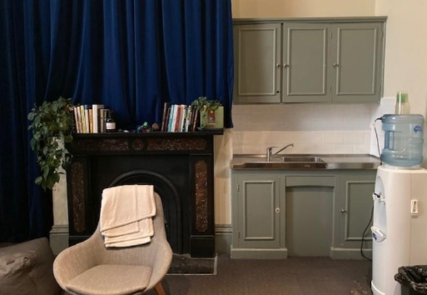

Sensory Notes

Adjustable Lighting


Noise
- Foyer sound bleed sometimes
- Appliance buzzing

Hard and Soft Textures


Smells
- Travelling smells from bathroom
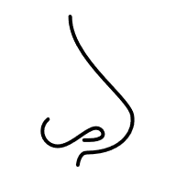

Toilets
All toilets at Arts House are gender neutral.
There are toilets on all floors, and wheelchair accessible toilets on the Ground and Upper floors.
There is a toilet on the Basement level with rails and ample room, but the entrance has a very tight turn so may not be accessible for most wheelchair users.
There are two bathrooms with showers and one with a baby change table on the upper level.

Sensory Notes

Human Waste and
Cleaning Product Smells


Wet Textures


Hand Dryer Sounds

Echoey Room
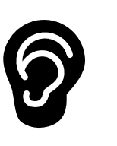

Lift
Arts House has a single lift which travels between the Ground Floor, the Basement and the Upper Floor. ​
You can find the lift on the Ground Floor behind the reception desk. The closest entry to the lift is via George Johnson Lane.
The lift has buttons with braille. It also has audio cues inside.
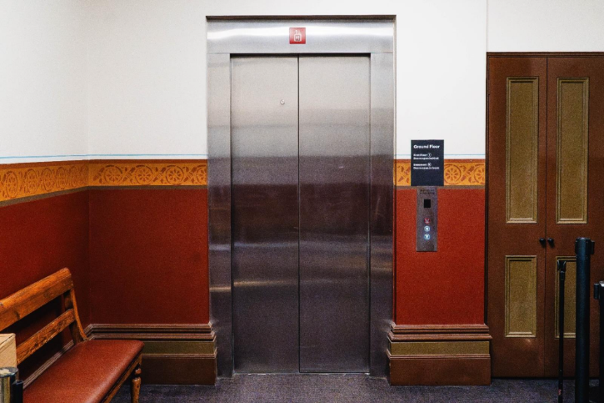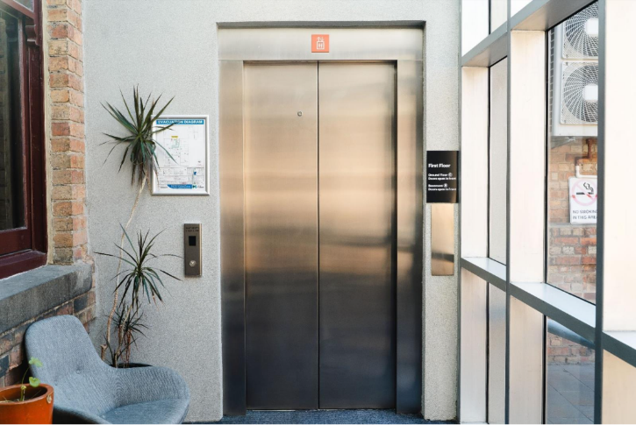
Sensory Notes

Confined Space
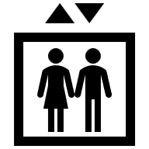
Changes in Altitude


Event Presentation Spaces
Sensory Notes
These will change with each event. Please see each event’s access guide for specifics.
Some basics to expect include:

Static artworks​

People moving around​

Voices recording and instruments​

Shared space and air

Dynamic sound and lighting​
​Note: This might include intense moments.
Please see each event’s access guide for more information.​

Main Hall
Our major presentation space. ​
​Often there will be a large seating bank which overlooks the stage.
This space can transform a lot depending on which event is inside it. Pleases see the event’s access guide for more information.
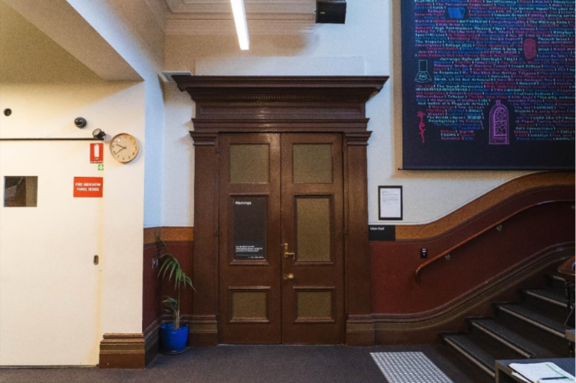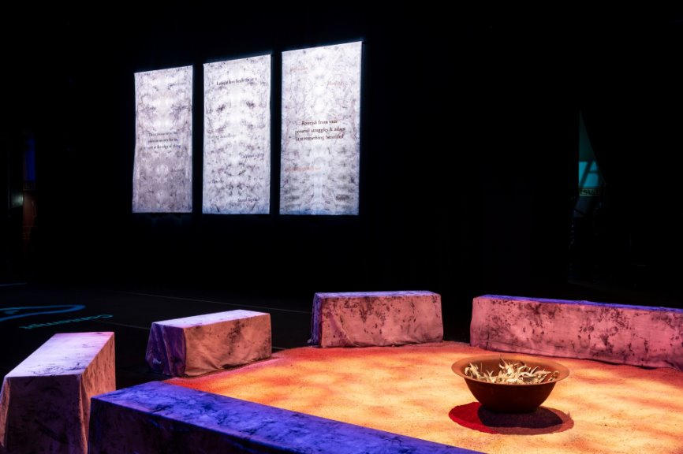

Studios
Located upstairs, our two studio spaces are largely used for artist development but sometimes are host to exhibitions and presentations.
For events, please see the access guide for more information.
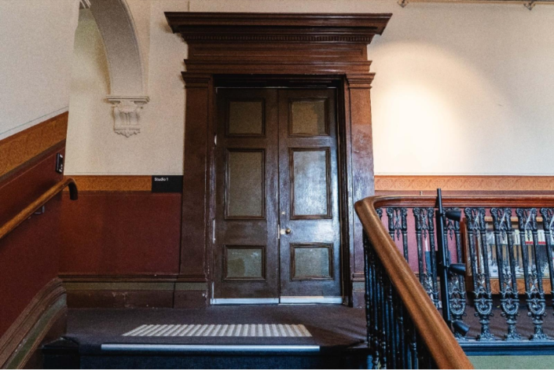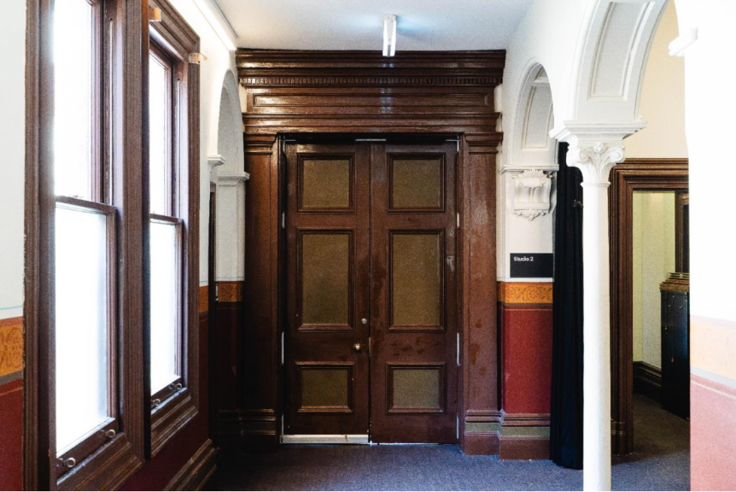

Supper Room
In the basement of Arts House.
The Supper Room is sometimes a performance space or gallery space.
For information about events in the Supper Room, please see their access guide.
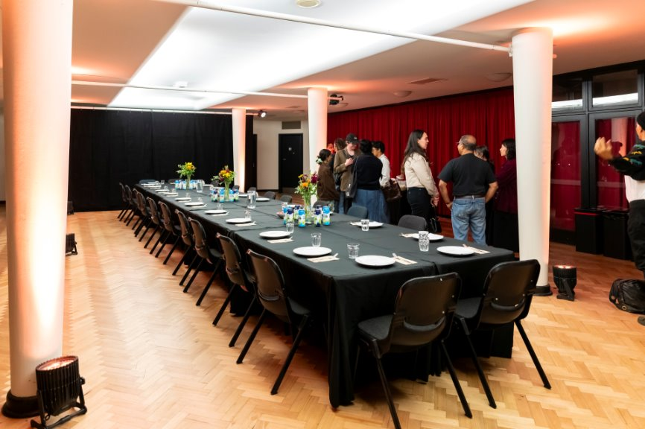

The Warehouse
The Warehouse is Arts House’s rehearsal and performance venue, with a dedicated program for Deaf and Disabled artists. It is a flexible space which also often hosts residencies, meetings, workshops, and roundtables. ​
​
The Warehouse is located in a separate building on the corner of George Johnson Lane and Little Errol Street. Please see the map below for more information.
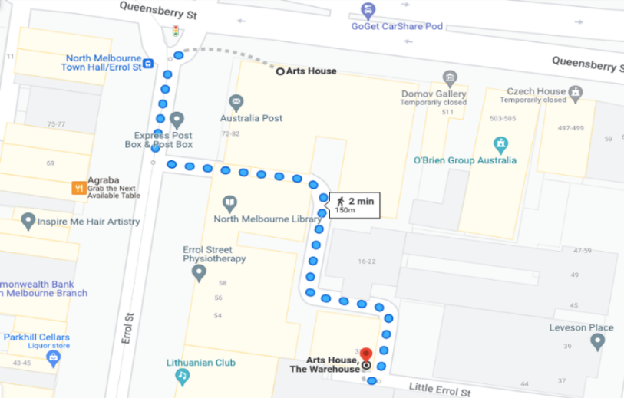 ​
A ramp entrance to The Warehouse is located on Little Errol Street. This ramp has a steep incline. Handrails begin a short distance up and run on either side until the door. Staff at the Arts House reception desk can help direct you to The Warehouse.​
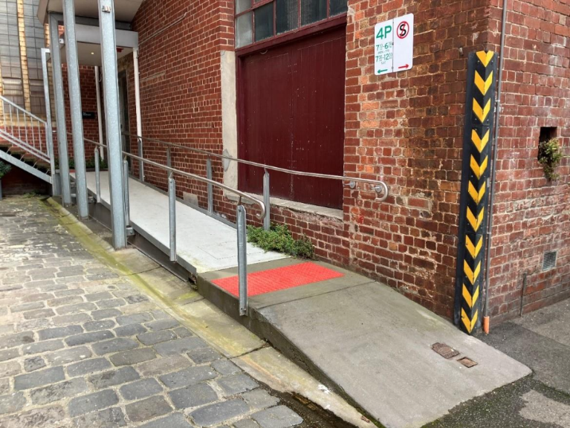

Ticketing and Events
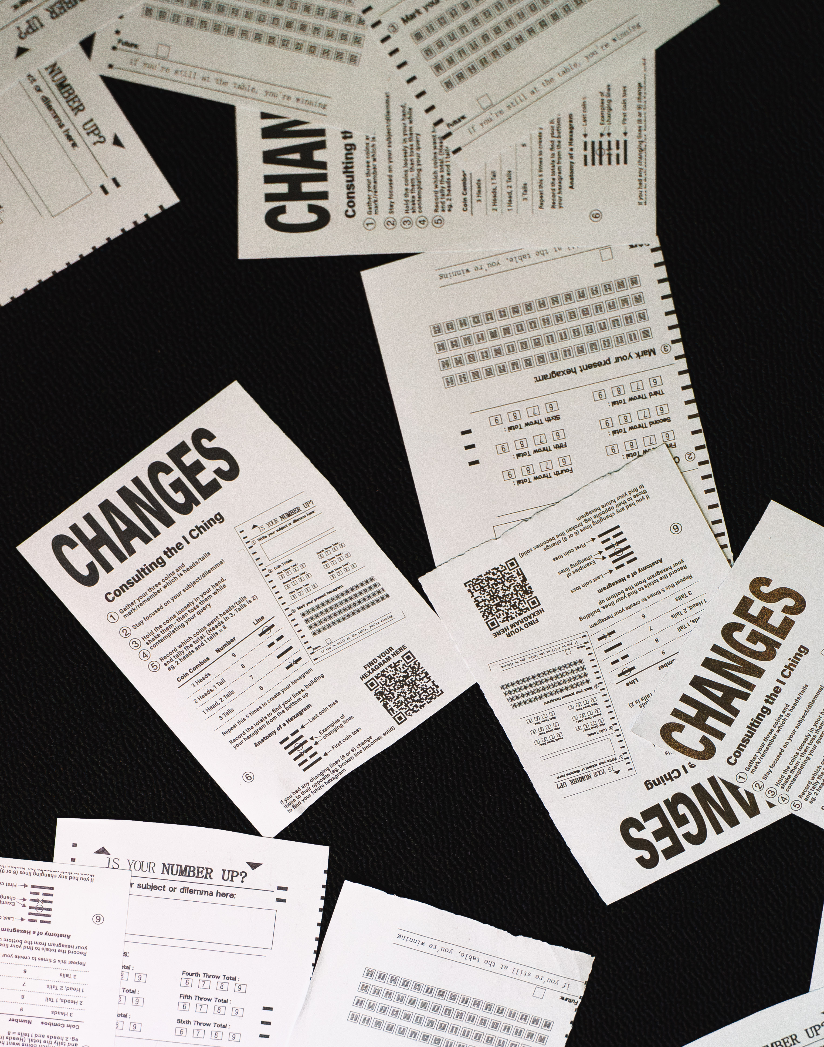
Most events are ticketed at Arts House.
To attend one, you will need to book a ticket to reserve a seat.
Everyone is welcome to visit Arts House, but some events we present may not be a good fit for your tastes and needs.
If an event requires content warnings, they will be present on the Arts House web page, posted by the entrance to the event space and in the event’s Access Guide document.

Accessible Events
Arts House is committed to making our events more accessible.
We have multiple Auslan Interpreted and Audio Described events per season. Less regularly, we host events with Open Captions, Relaxed Performances or other more event specific offerings.
Please view our website, read our access guides or contact our team to learn what access services specific events are offering.
If you have any specific questions about your visit that are not answered here, or if there is anything we can do to improve the access for your visit to Arts House, please don’t hesitate to contact us.
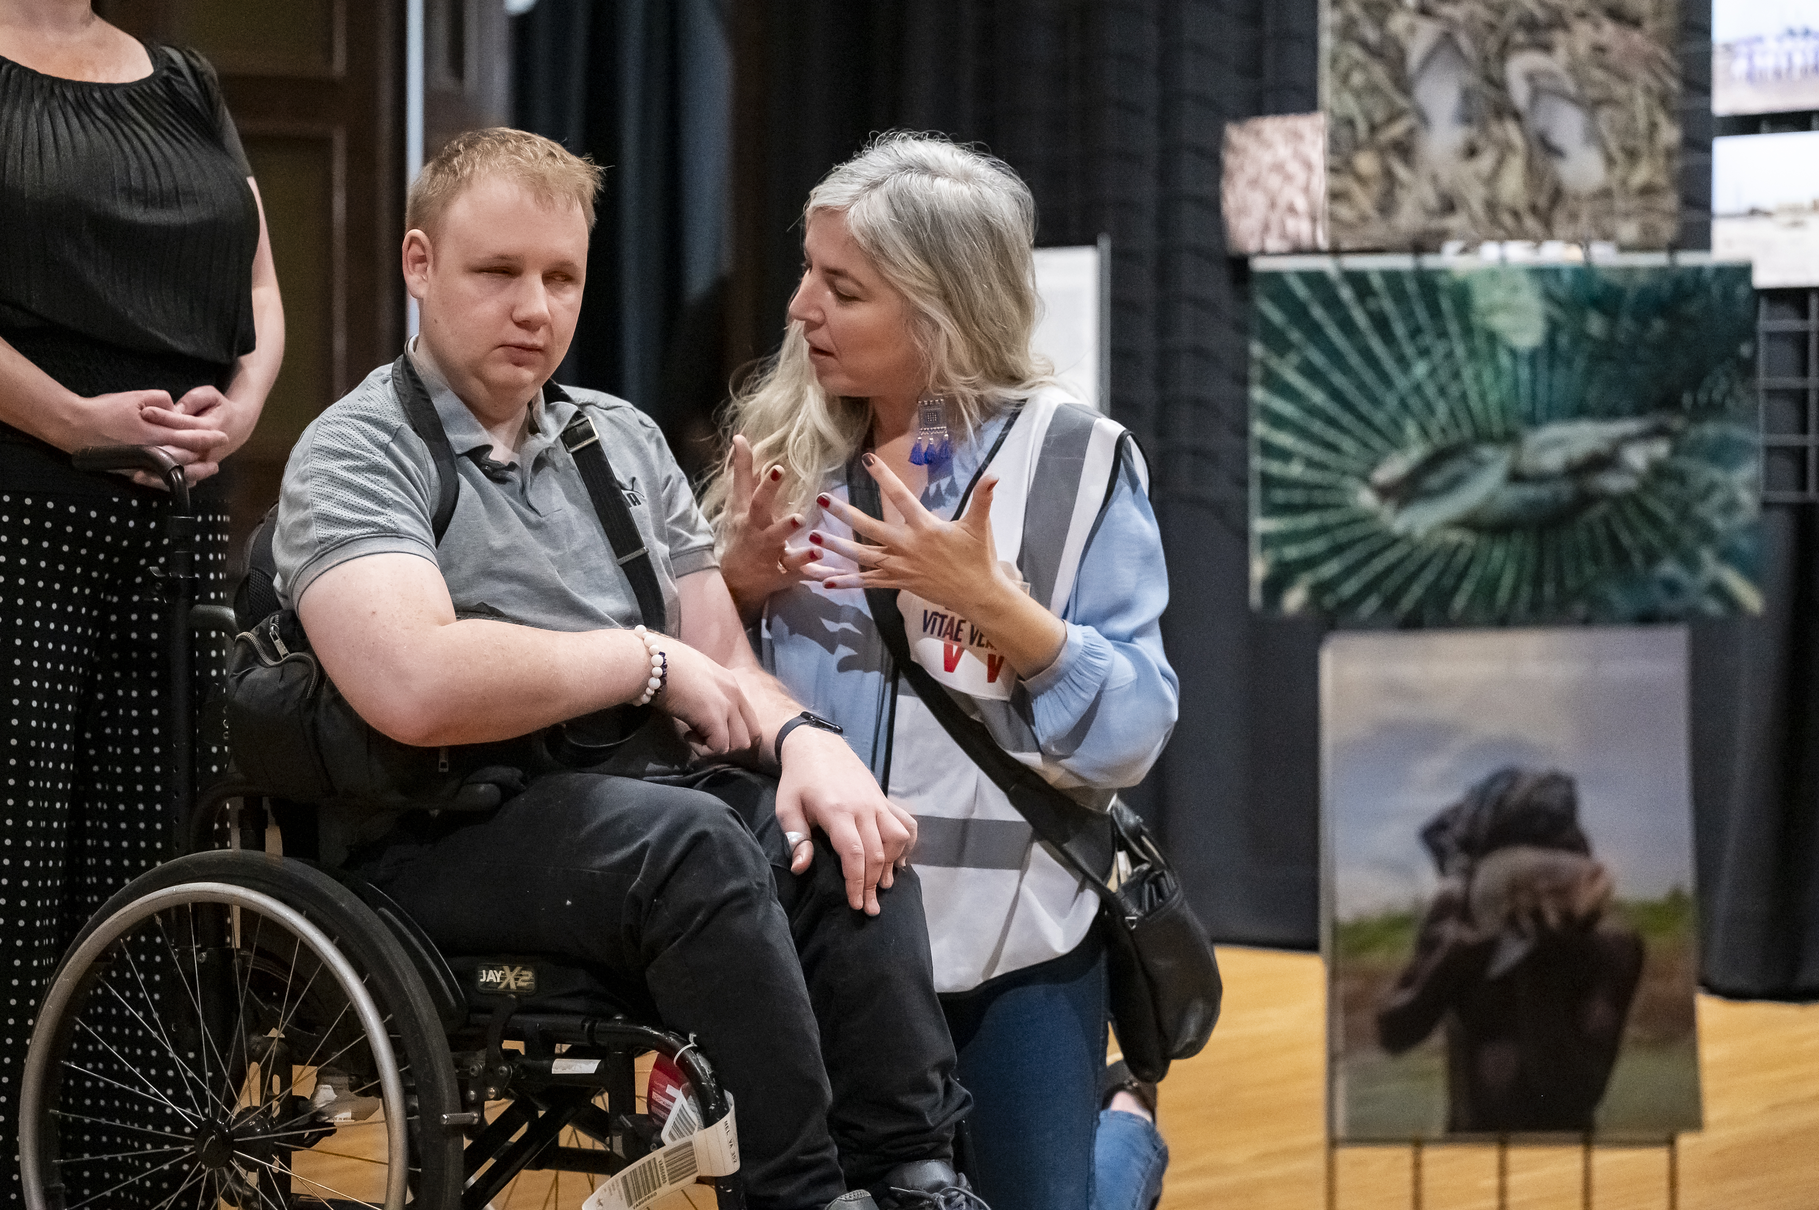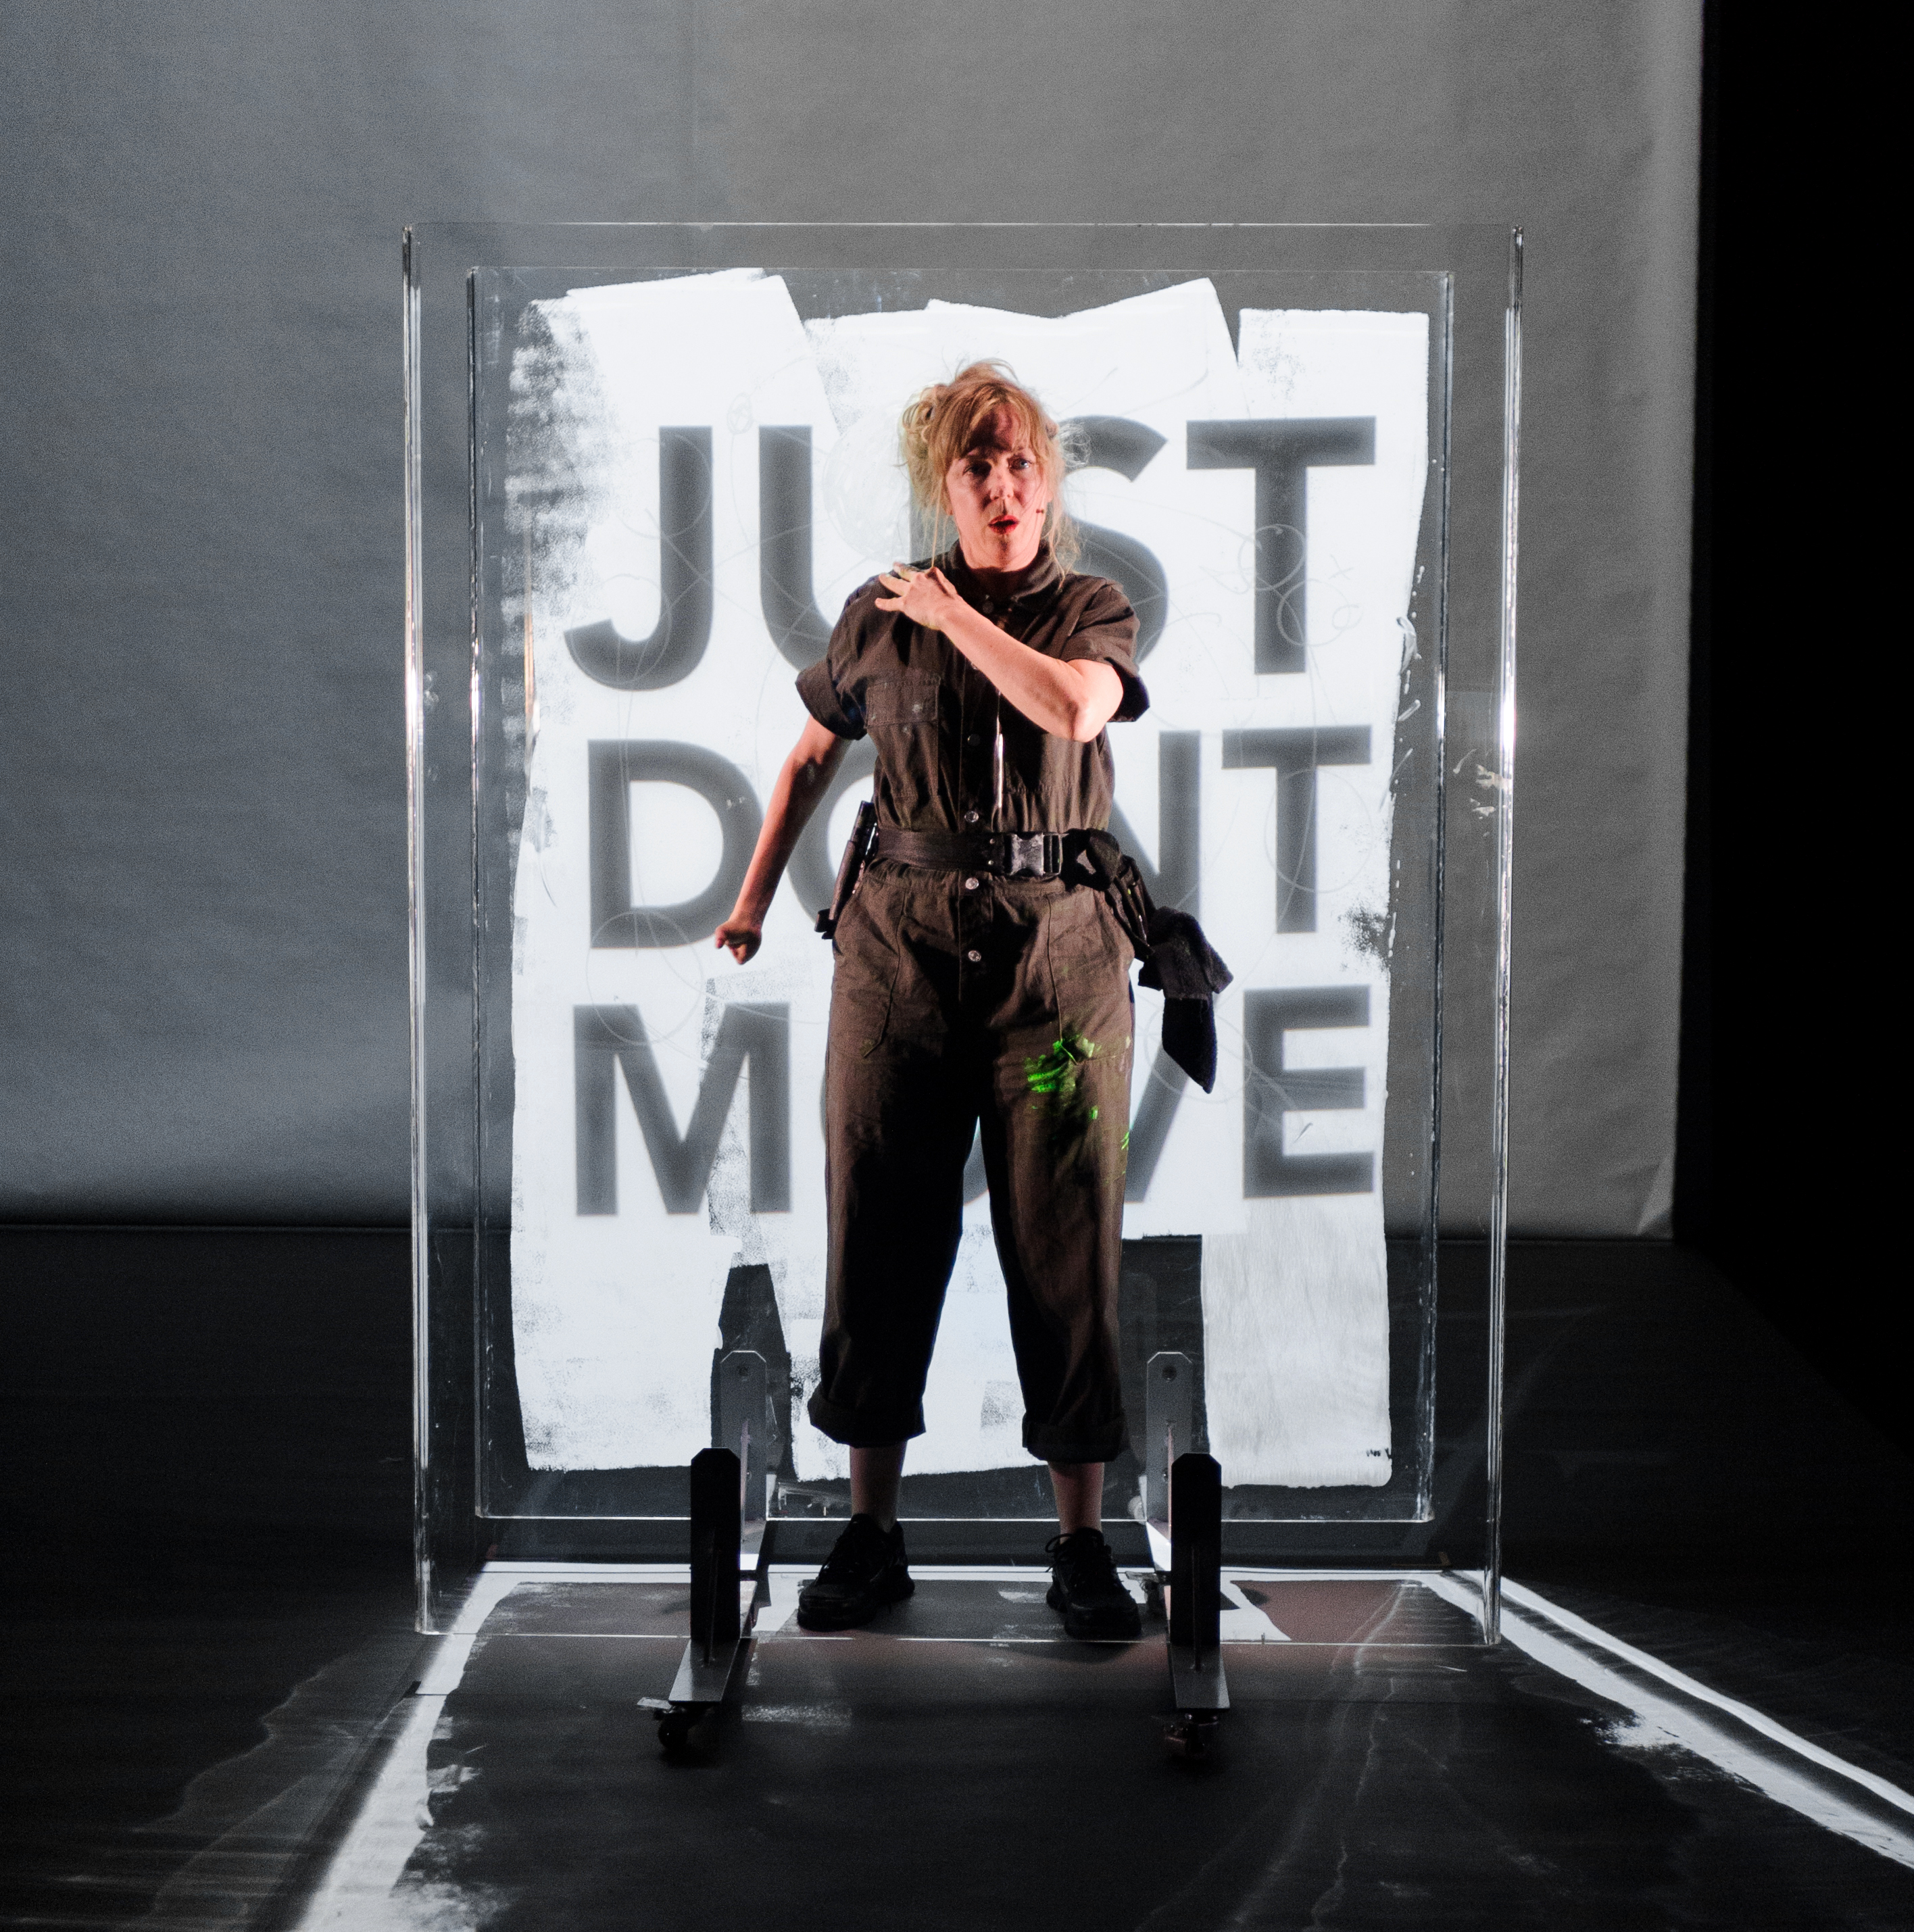

How to Buy Tickets

Tickets can be purchased online at any time.
Click “Buy Tickets” on our website and it will take you to our ticketing platform.
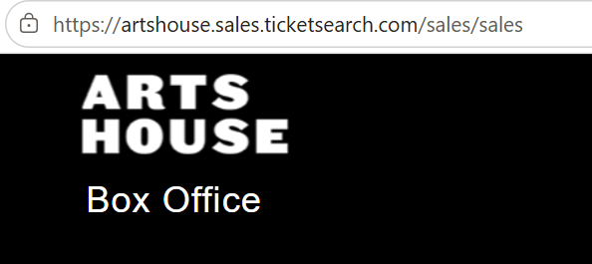


Tickets can be booked over the phone at (03) 9322 3720 between 10am and 4pm Monday to Friday
If you are deaf or find it hard to hear or speak on the phone, you can connect with us via:
- National Relay Service
- Video Relay Service
- TTY (phone 133 677)
- Speak and Listen (phone 1300 555 727)


Our Box Office desk at North Melbourne Town Hall also opens 60 minutes before performance start times for in person bookings.
Please check ticket availability ahead of time to avoid disappointment.

Ticketing Types
Access Services
We list certain access services as ticket types e.g. Auslan, Audio Description, Wheelchair seating.
These are full tickets to the show, NOT add-ons. We sell tickets this way as it helps our team and the service providers we work with anticipate numbers and offer a better service.

Reduced
Our Reduced ticket type is equivalent to Concession pricing. This ticket type is open to anyone who may be facing barriers to attend the arts. We do not ask for any proof or verification.
BLAKTIX
For every ticketed event, Arts House ensures discounted tickets are available for First Nations people. You can book BLAKTIX online when purchasing tickets to any event.

Companion Card
Arts House supports the Companion Card program. You can book your companion ticket online when purchasing tickets to any show. Only the person whose photograph and details appear on the Companion Card can use the card.

Contact Us
Arts House
521 Queensberry Street
North Melbourne
Victoria 3051
Phone: 9322 3720
Text Enquiries: 0447 570 178
Email: artshouse@melbourne.vic.gov.au
Website: https://www.artshouse.com.au
TTY users: phone 13 36 77 – then ask for – 03 9322 3720
Speak and Listen users:
phone 1300 555 727 – then ask for – 03 9322 3720
Internet relay users:
connect to the NRS (https://internet-relay.nrscall.gov.au) – then type in: 03 9322 3720

Was this Access Key helpful?
Your feedback can help us improve. Please call, text, or email us to provide feedback.



Thank-you for using this Access Key

