
Manifesto of Silences
Irene Holub
Access Guide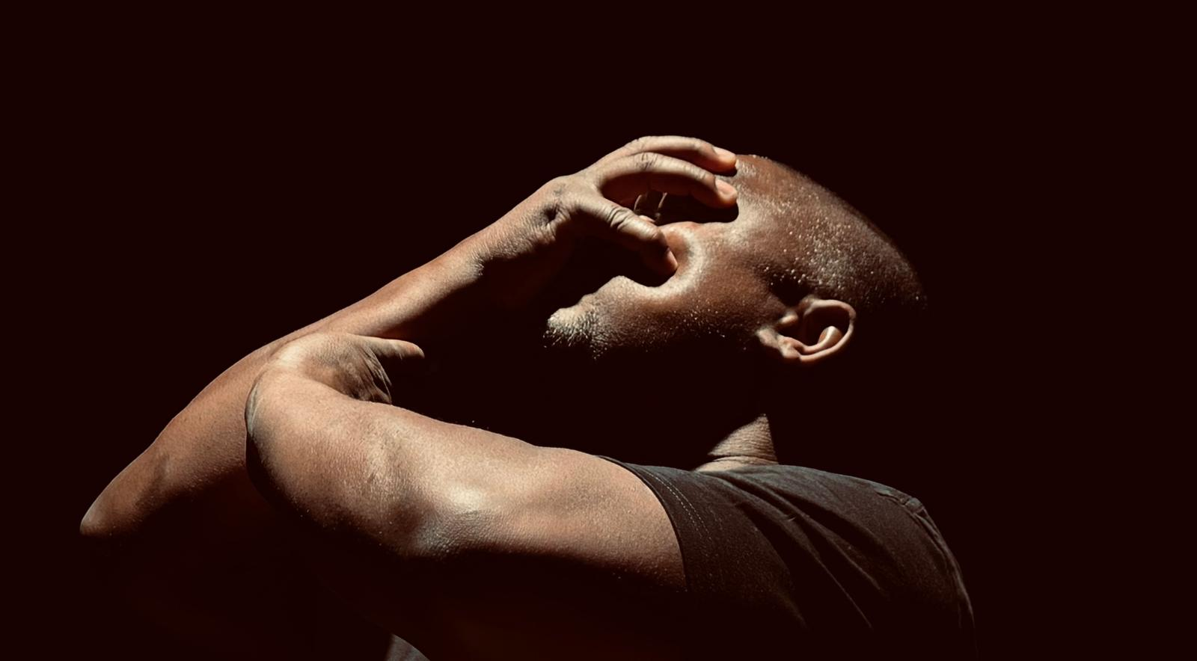
Image credit: Irene Holub
Image: A black man with short hair, wearing a black t-shirt, covers his face with his hand in claw shape, while tilting his head back. The background is dark, lighting highlights his profile and arm.
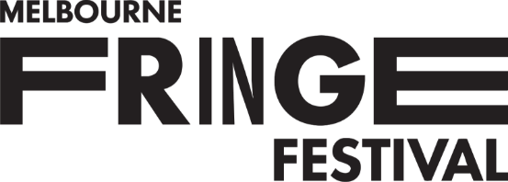

Updates to this document
Please note, this performance is a new work and changes are being made by artists until opening.
This guide will be updated as new information becomes available.
Arts House website will contain the most up to date version of this guide. If changes have been made, all ticket holders will be sent the latest version of this guide 3 days and 1 day prior to the event.
This document was created: 28 September 2026
Contents
Updates to this document 2
About This Guide 3
Show Overview 4
Important Notes 5
Access Services 6
How to Buy Tickets 9
Ticket Types 9
COVID-19 and Viral Safety 10
Getting to Arts House 11
The Venue 12
Arrival and Entrances 12
The Foyer 15
Staff 16
Bar 17
Quiet Space 18
Toilets 18
Main Hall 20
Manifesto of Silences 21
Sensory Notes 21
Audience Experience 22
Performers 23
Synopsis 26
Contact Us 29

About This Guide
This Access Guide is a document designed to help prepare you for the experience of attending an event at Arts House.
The first few pages should give you the most important information about the show.
The section after that will tell you how to get here and what to expect from the venue.
The last section goes into detail of the experience of the event you are here to see. This may include spoilers.
Please use the contents page to navigate to whichever part of the guide is most useful to you.

Show Overview
​Where
Arts House
521 Queensberry Street
North Melbourne VIC

When
Tuesday 6 – Sunday 11 October 2026
Preview: Tue, 7:30pm
Wed – Fri, 7:30pm
Sat, 2pm & 7:30pm
Sun, 5pm

Overview
Manifesto of Silences is a 60 minute, 6-person show performed on stage.
- It is a Deaf-led performance work created by Irene Holub
- It combines sign language opera, movement, projection and immersive sound
- The work explores Deaf history, identity, resilience and community
- The performance reflects on the impacts of historical decisions that suppressed Deaf language and culture, while celebrating the strength and creativity of Deaf communities

Note: This show has a Lockout

Important Notes
Content Notes
Suitable for ages 16+
Audience members may encounter:
- Themes of social exclusion and oppression
- Historical discrimination against Deaf people
- Discussion of language suppression and cultural erasure
- Emotional themes including grief, resilience and transformation
- Audism
- Oralism
- Strong emotional content
- Theatrical darkness
- Immersive sound
- Projection and changing lighting states
These warnings are intended to help audience members prepare and make informed choices about attendance. No graphic violence or explicit sexual content is described.

General Notes
There will be an Acknowledgement of Country and Deaf elders played on a video in the foyer prior to entering.
This performance is a lock-out. There is no entrance to the performance once it has started. If you need to leave during the performance, you can, however you will not be able to re-enter.
You can watch the performance on a small screen in the foyer if you are late and unable to enter.
This performance contains loud music, lights that black out, lights that change colours and intensity, abrupt lighting changes, and under seat vibration.

Access Services
Deaf and Hard of Hearing Access
This work has been created by Deaf artists and is performed in sign language. The show is designed to be accessible to both sign language users and non-signers.
The performance communicates through movement, visual storytelling, sign language, projection and sound. Prior knowledge of sign language is not required.

Interpreters
The show will not be interpreted into English.
Deaf Blind Auslan users may bring Auslan interpreters to support their experience.
The post-show Artist Talk facilitated by Darlene Thornton will be Auslan interpreted.

Visual Rating 100%
Entirely visual or all non-visual elements open captioned.

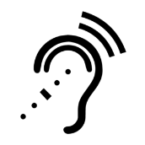
Assistive Listening is available free of charge. Ask staff for assistance on arrival.

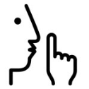
The quiet space will be available for you to use before and after the show.
More information about the quiet space can be found later in this guide.


Assistance Animals are welcome.


This performance is fully wheelchair accessible.
More information on wheelchair accessible entrances and bathrooms can be found later in this guide.


We offer a Meet and Assist service.
Please Contact Us so we can arrange this for you.


Patrons who need to can gain Early Access to the venue.
Please approach Ushers to let them know you would like to utilise this.


Companion cards are accepted for this event.


Pre-Show Access
There will be a person in the foyer who can assist you with any questions you have prior to the show, to support your experience. There is an interpreter also.
On Tue, Wed, Thu & Sun Dan Goronszy will be available, they use Auslan and English.
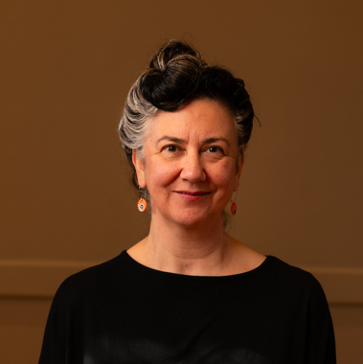
Image: Dan, a person with pale skin and dark-hair with grey streaks and large earrings smiles forward.

On Fri and Sat Irene Holub will be available, they use Auslan.
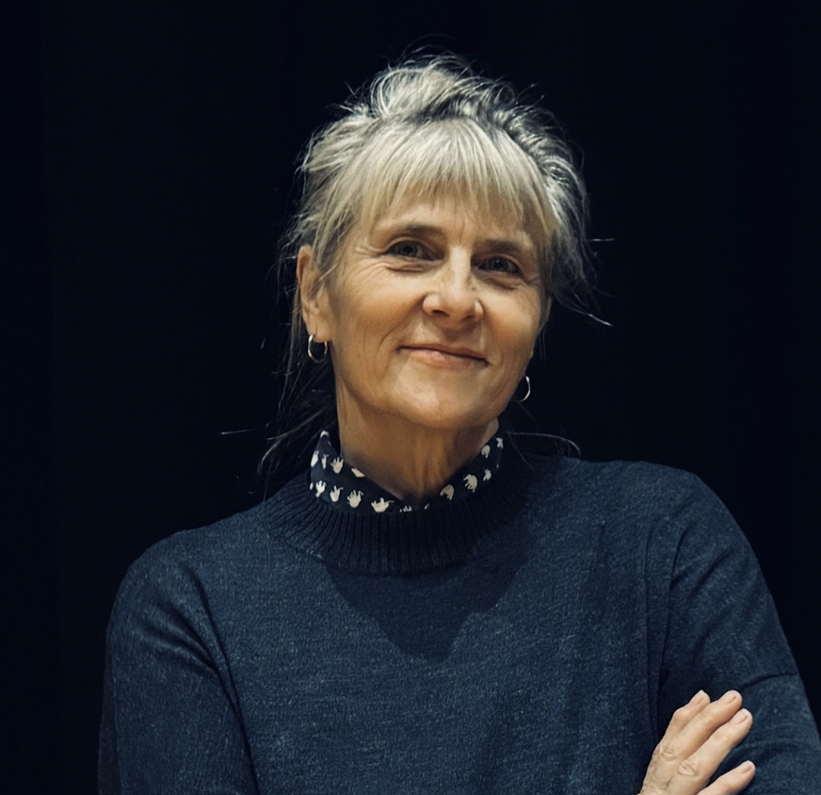
Image: Irene, a woman with pale skin and grey hair with a fringe smiles with her arms crossed.

How to Buy Tickets

Tickets can be purchased online at any time.
Click “Buy Tickets” on our website and it will take you to our ticketing platform.
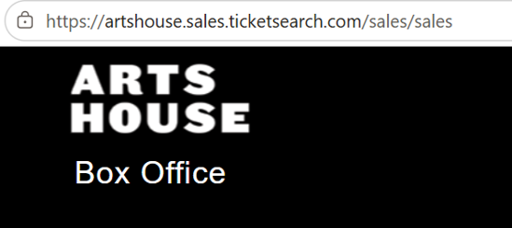


Tickets can be booked over the phone between 10am and 4pm Monday to Friday
If you are deaf or find it hard to hear or speak on the phone, you can connect with us via:
•National Relay Service
•Video Relay Service
•TTY (phone 133 677)
•Speak and Listen (phone 1300 555 727)

Our Box Office desk at North Melbourne Town Hall also opens 60 minutes before performance start times for in person bookings.
Please check ticket availability ahead of time to avoid disappointment.

Ticket Types
Access Services
We list certain access services as ticket types e.g. Auslan, Audio Description, Wheelchair seating. These are full tickets to the show, NOT add-ons. We sell tickets this way as it helps our team and the service providers we work with anticipate numbers and offer a better service.

Reduced
Our Reduced ticket type is equivalent to Concession pricing. This ticket type is open to anyone who may be facing barriers to attend the arts. We do not ask for any proof or verification.
BLAKTIX
For every ticketed event, Arts House ensures discounted tickets are available for First Nations people. You can book BLAKTIX online when purchasing tickets to any event.

Companion Card
Arts House supports the Companion Card program. You can book your companion ticket online when purchasing tickets to any show. Only the person whose photograph and details appear on the Companion Card can use the card.

COVID-19 and Viral Safety
You must not attend our venue or programs in person if you have any signs of transmissible illness such as:
- a cough
- sore throat
- fever
- shortness of breath
- flu-like symptoms
We will provide a refund if you need to cancel your attendance due to illness.
Please contact us by 9am on the day of the event. This helps our staff by letting them process your refund during off-peak times.
We cannot provide refunds to events that have already passed.
To minimise the risk of viral transmission, we encourage you to wear a well fitted respirator of P2 or comparable standards.
Outside of masked events/hours. this is not something Arts House enforces. Because of this, it is reasonable to expect that most others in the building will not be masking.

Hand sanitiser available

Masks available

Getting to Arts House
Arts House is located in the North Melbourne Town Hall, at the corner of Queensberry Street and Errol Street in North Melbourne.
We have some resources that can help you with navigation throughout the building, including a video guide and a verbal map.
Walk
Arts House is 2.5 kilometers from Flinders Street Station, (a 35 minute walk), and 850 meters from Queen Victoria Markets (an 11 minute walk).
Train
Arts House is 1.1 kilometers from North Melbourne Train Station (a 16 minute walk), or 1.2 kilometers from Flagstaff Station, (a 15 minute walk).
Tram
From the City of Melbourne, Take the Route 57 tram and get off at Stop 12, North Melbourne Town Hall.
Please note, this is not a level access tram stop and is not serviced by low floor trams.
Car
There is paid street parking around Arts House. There are two accessible on-street car parking spaces on Queensberry Street and two more on Errol Street for holders of a Disability Parking Permit.

The Venue

Arrival and Entrances
View From Street
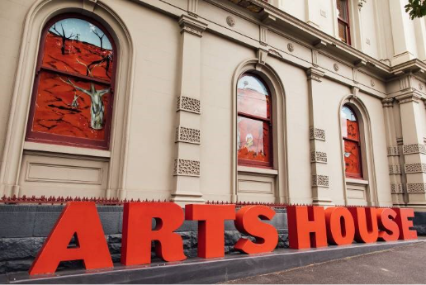
Image: North Melbourne Town Hall view from Queensberry Street which features giant red letters that say ARTS HOUSE out the front of it.
Map
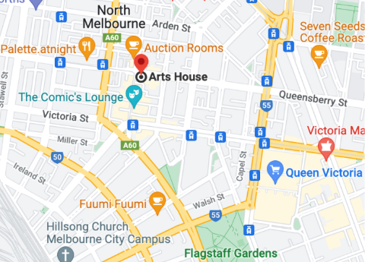
Image: A map of Arts House and its surrounding area. LINK TO MAP
Queensberry Street Entrance
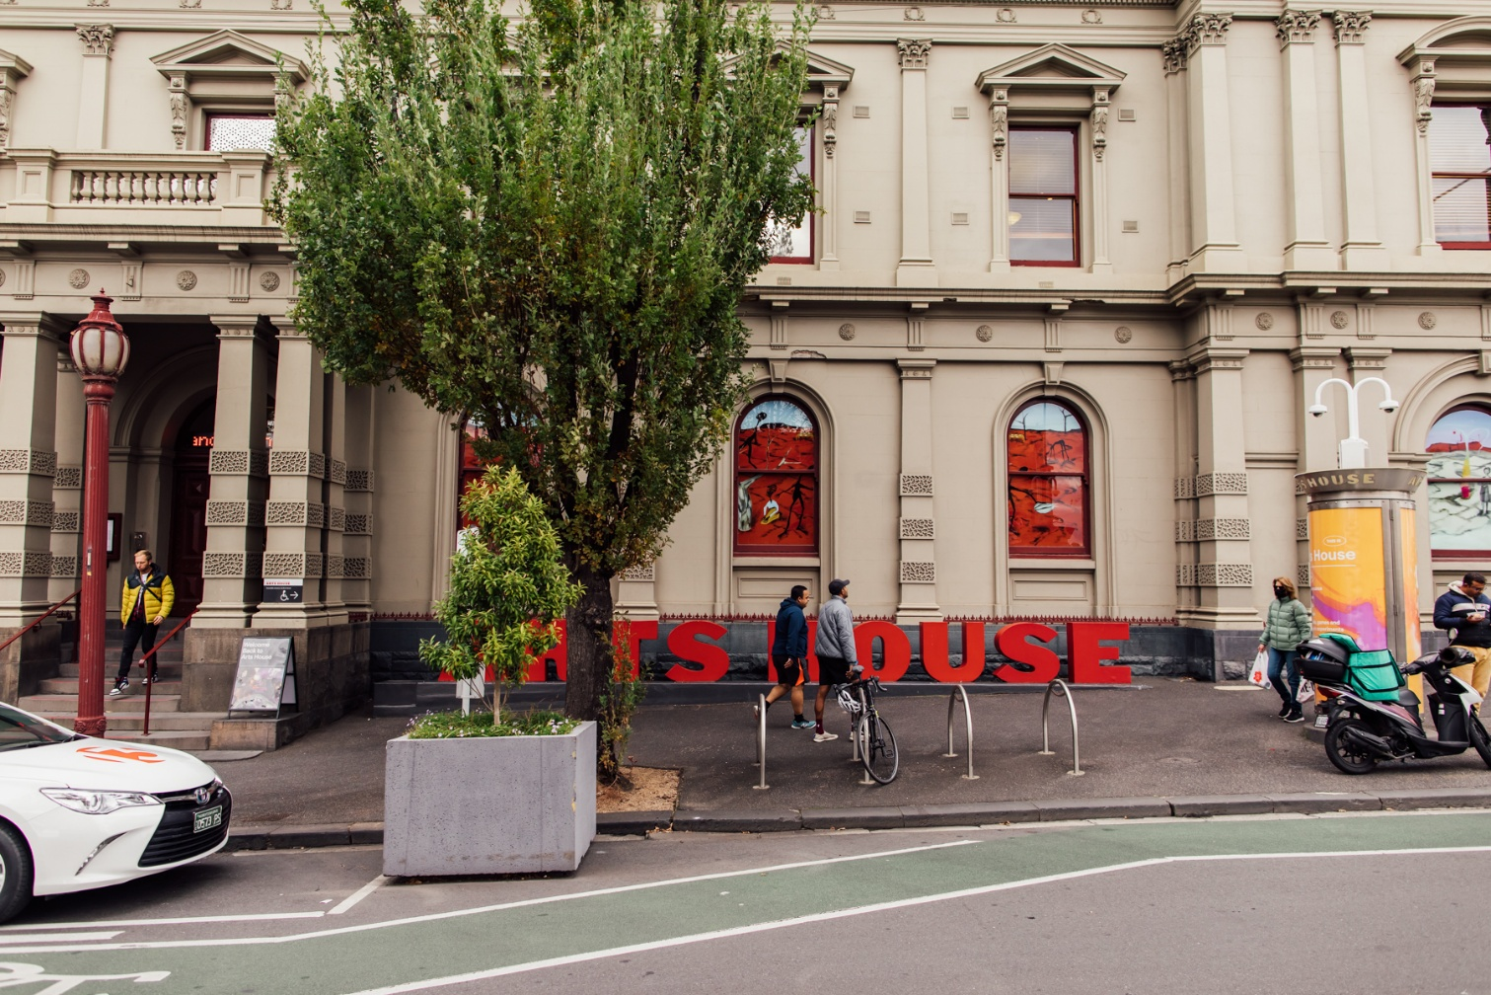
Image: North Melbourne Town Hall entrance on Queensberry Street. The entrance is to the left of the giant red letters that say ARTS HOUSE and features a staircase of eight steps with grab rails in parts.
Errol Street Entrance
There are two Wheelchair Accessible Entrances. The first is on Errol St next to the Post Office.

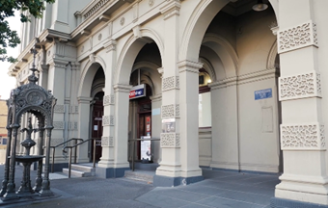
Image: Errol Street entrance next to the Post office with wheelchair accessible ramp or two steps with grab rails.
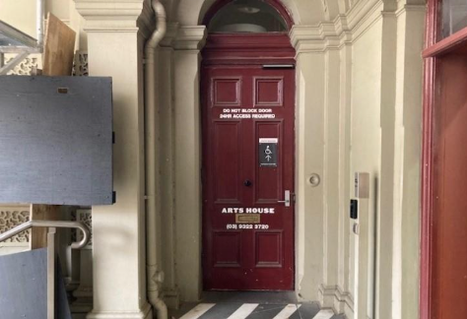
Image: View of door at Post office entrance.
The button to open automated door is on the right.

George Johnson Lane Entrance
The second Wheelchair Accessible Entrance is towards the end of George Johnson Lane.

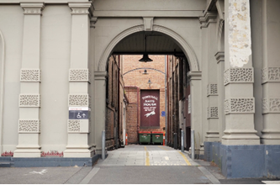
Image: View of George Johnson Lane from Errol St. The laneway passes through an archway with a brick wall at the end.
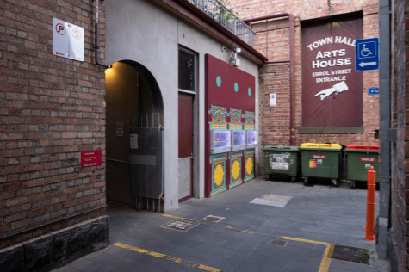
Image: View of the left turn from George Johnson Lane to the accessible entrance ramp. A large painted sign points the way and reads 'Town Hall Arts House Errol Street Entrance’
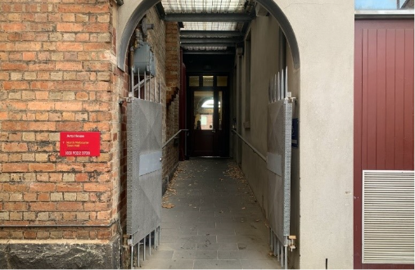
Image: View of the ramp with grab rail leading from George Johnson Lane to the automated door which opens into the Arts House foyer.

The Foyer
When you enter Arts House, you will find yourself in the foyer.
- Please gather and wait in the foyer if your show is in the Studios, Supper Room or the Main Hall.
- Information about upcoming events and performances is available on posters and a tablet computer.
- Tickets for events can be reserved or purchased at the reception.
- There is limited seating available. Mostly, cushioned grey chairs.
- A communication board and pen and paper are available at reception.
- Free Wi-Fi is available for visitors.
- The foyer contains a lift.
- A water cooler is located nearby the reception desk.
- Arts House frequently commissions artists to present works in the foyer. There is always something to see.
Sensory Notes

Low Lighting

Crowds

Limited Seating

_{full}
Noise
- People Talking
- Appliance Buzzing
- Music


Staff
Staff at Arts House wear black t-shirts or black jackets with the Arts House logo on them.
When you arrive you will be greeted by a Front of House person who may be Deaf, Hard of Hearing or hearing. There may be an Auslan interpreter available.
This person will have an iPad with all ticket holder names. They will ask for your name and will mark you off the list to indicate you have arrived.
You don’t need to bring your ticket printed out.
Our staff are there to assist you, please ask for help if you need it.
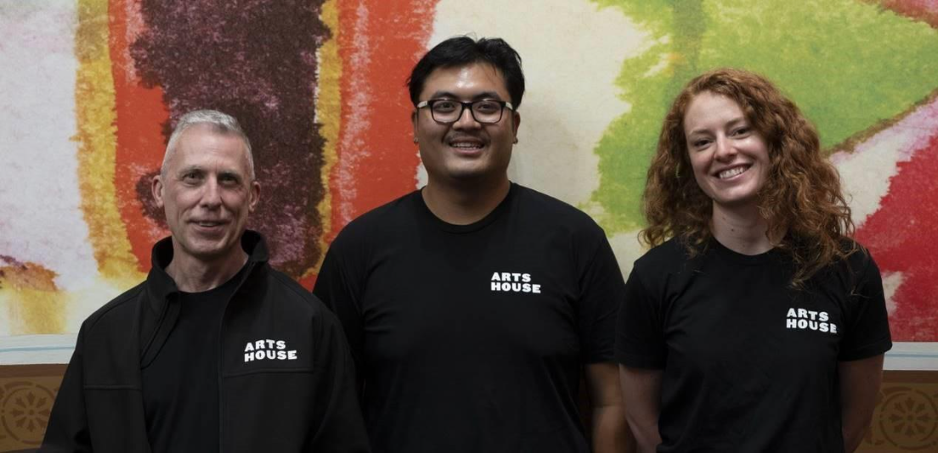
Image: Three Arts House Ushers. They wear black t-shirts and jackets with the Arts House logo on the left shoulder.

Bar
The Arts House Bar is in the foyer.
Bar staff will be wearing black with an Arts House Logo.
They may be Deaf, Hard of Hearing or hearing
We have a range of alcoholic and non-alcoholic beverages for sale. There is free water.
We are a cashless venue and accept EFTPOS, Visa and Mastercard payments.
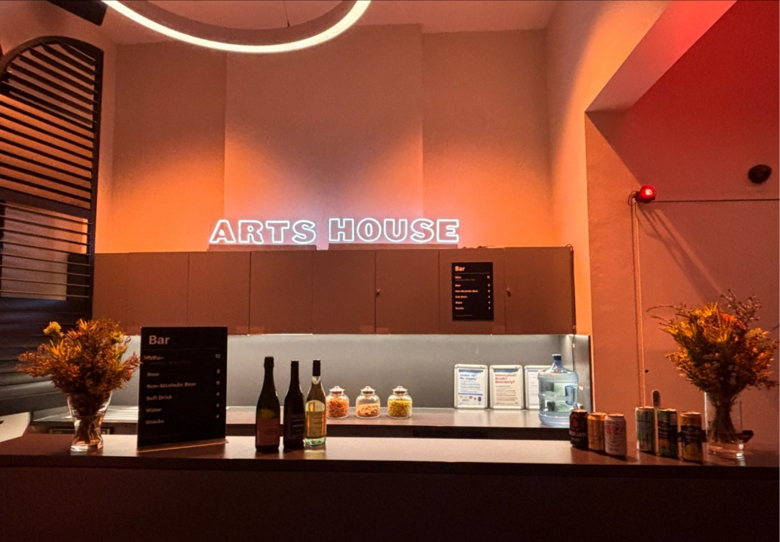
Image: Arts House bar in warm lighting. Vases of flowers sit on each side. A menu and drinks display sit atop it. On the back wall, a small Arts House sign is lit up.

Quiet Space

The Quiet Space is located on the ground level opposite the Accessible Bathroom. It is suitable as a chill out space, prayer or parenting space and features a range of seating options, dimmable lights, sensory and stimming objects and ear plugs.
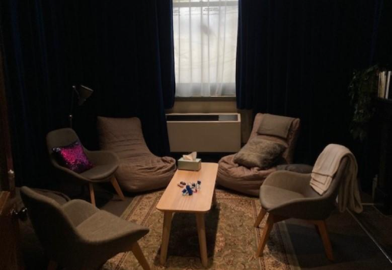
Image: Quiet Space with lights dimmed.
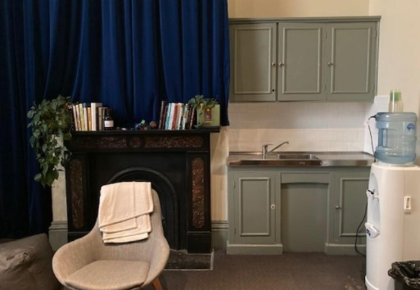
Image: Quiet Space kitchenette and bookshelf.

Sensory Notes
Adjustable Lighting

Hard and Soft Textures


Noise
- Foyer sound bleed sometimes
- Appliance buzzing

Smells
- Travelling smells from bathroom
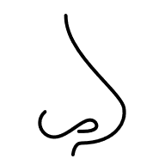

Toilets
All toilets at Arts House are gender neutral.
There are toilets on all floors, and wheelchair accessible toilets on the Ground and Upper floors.
There are two bathrooms with showers and one with a baby change table on the upper level.
The nearest Changing Places facility is a 17 minute walk away at Narrm Ngarrgu Library and Family Services.
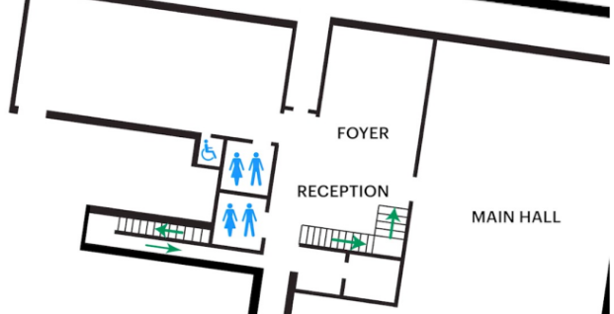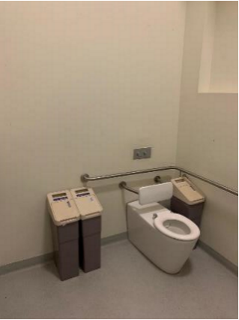
Images:
(Left)
Map of downstairs Arts House with bathrooms marked. There is one accessed from near reception. One accessible bathroom and gender neutral bathroom can be accessed from the hall near the foyer.
(Right): Ground Floor Accessible Bathroom. There is a grabrail behind the toilet basin and to the left of the basin.
Sensory Notes
Toilet Smells

Wet Textures


Hand Dryer Sounds

Echoey Room
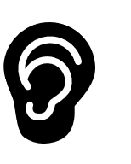

Main Hall

The Performance is in the Main Hall. It is on the ground floor. It is to the left of the box office desk and right of the bar. An artist statement is available on signage and warnings on the door.
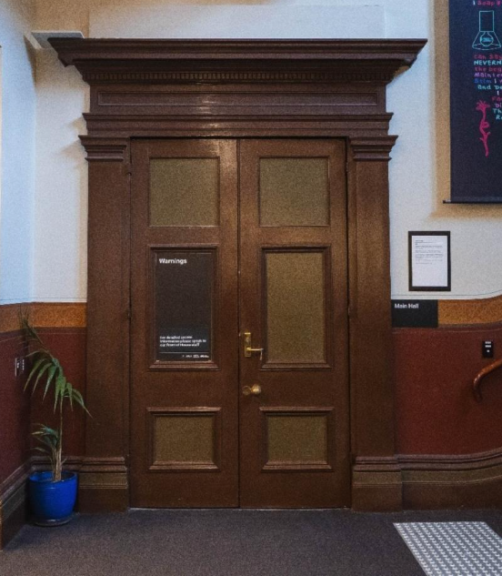

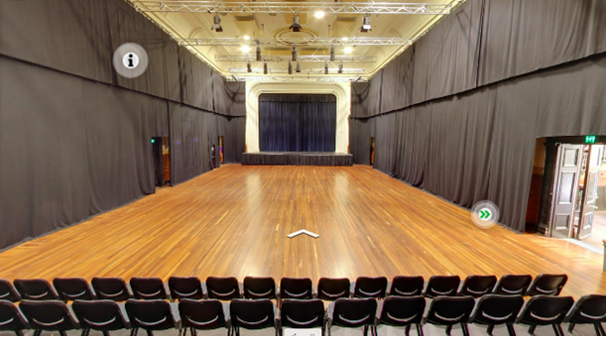
Images:
(Top) The closed doors to the Main Hall. They are heavy brown double doors. A large black sign on the left door lists show warnings.
(Bottom) Tiered seating looks out to large hall with wooden floor and raised stage along back wall.

Manifesto of Silences

Sensory Notes

Visual
- Busy visuals (projection and movement)
- Movement
- Signing
- Wooden chair
- Plain black boxes
- Bowl and books
- Stage raised on sides
- White curtain at front of stage
Sound
- Immersive
- Varied intensity
- Loud
- Immersive
- Loud
- Pre-recorded
- Loop based
- Instruments and synths
- Musical soundscapes
- Repetitive sounds
- Resonant sounds
- Overlapping sounds


Lighting
- Extensive projection
  - Water
  - Historical footage
  - People and faces
  - Stars
  - Maps and pages
  - Text
- Moving Lights
- Coloured Lights
- Performer spotlights
- Blackouts
- Shadows and silhouettes


Physical
- Vibration in seating bank (from sound)

Audience Experience

Entering the Space
- Enter via main doors
- Sit in seating bank


Shocks or Surprises
- Fast cuts/shifts in projection
- Potentially upsetting imagery


Social Expectations
- Stay seated
- Lockout. You cannot return if you leave.


Performance Expectations
- Auslan Opera
- Visual vernacular
- Movement
- Projection
- Heightened communication

Performers
Walter Kadiki
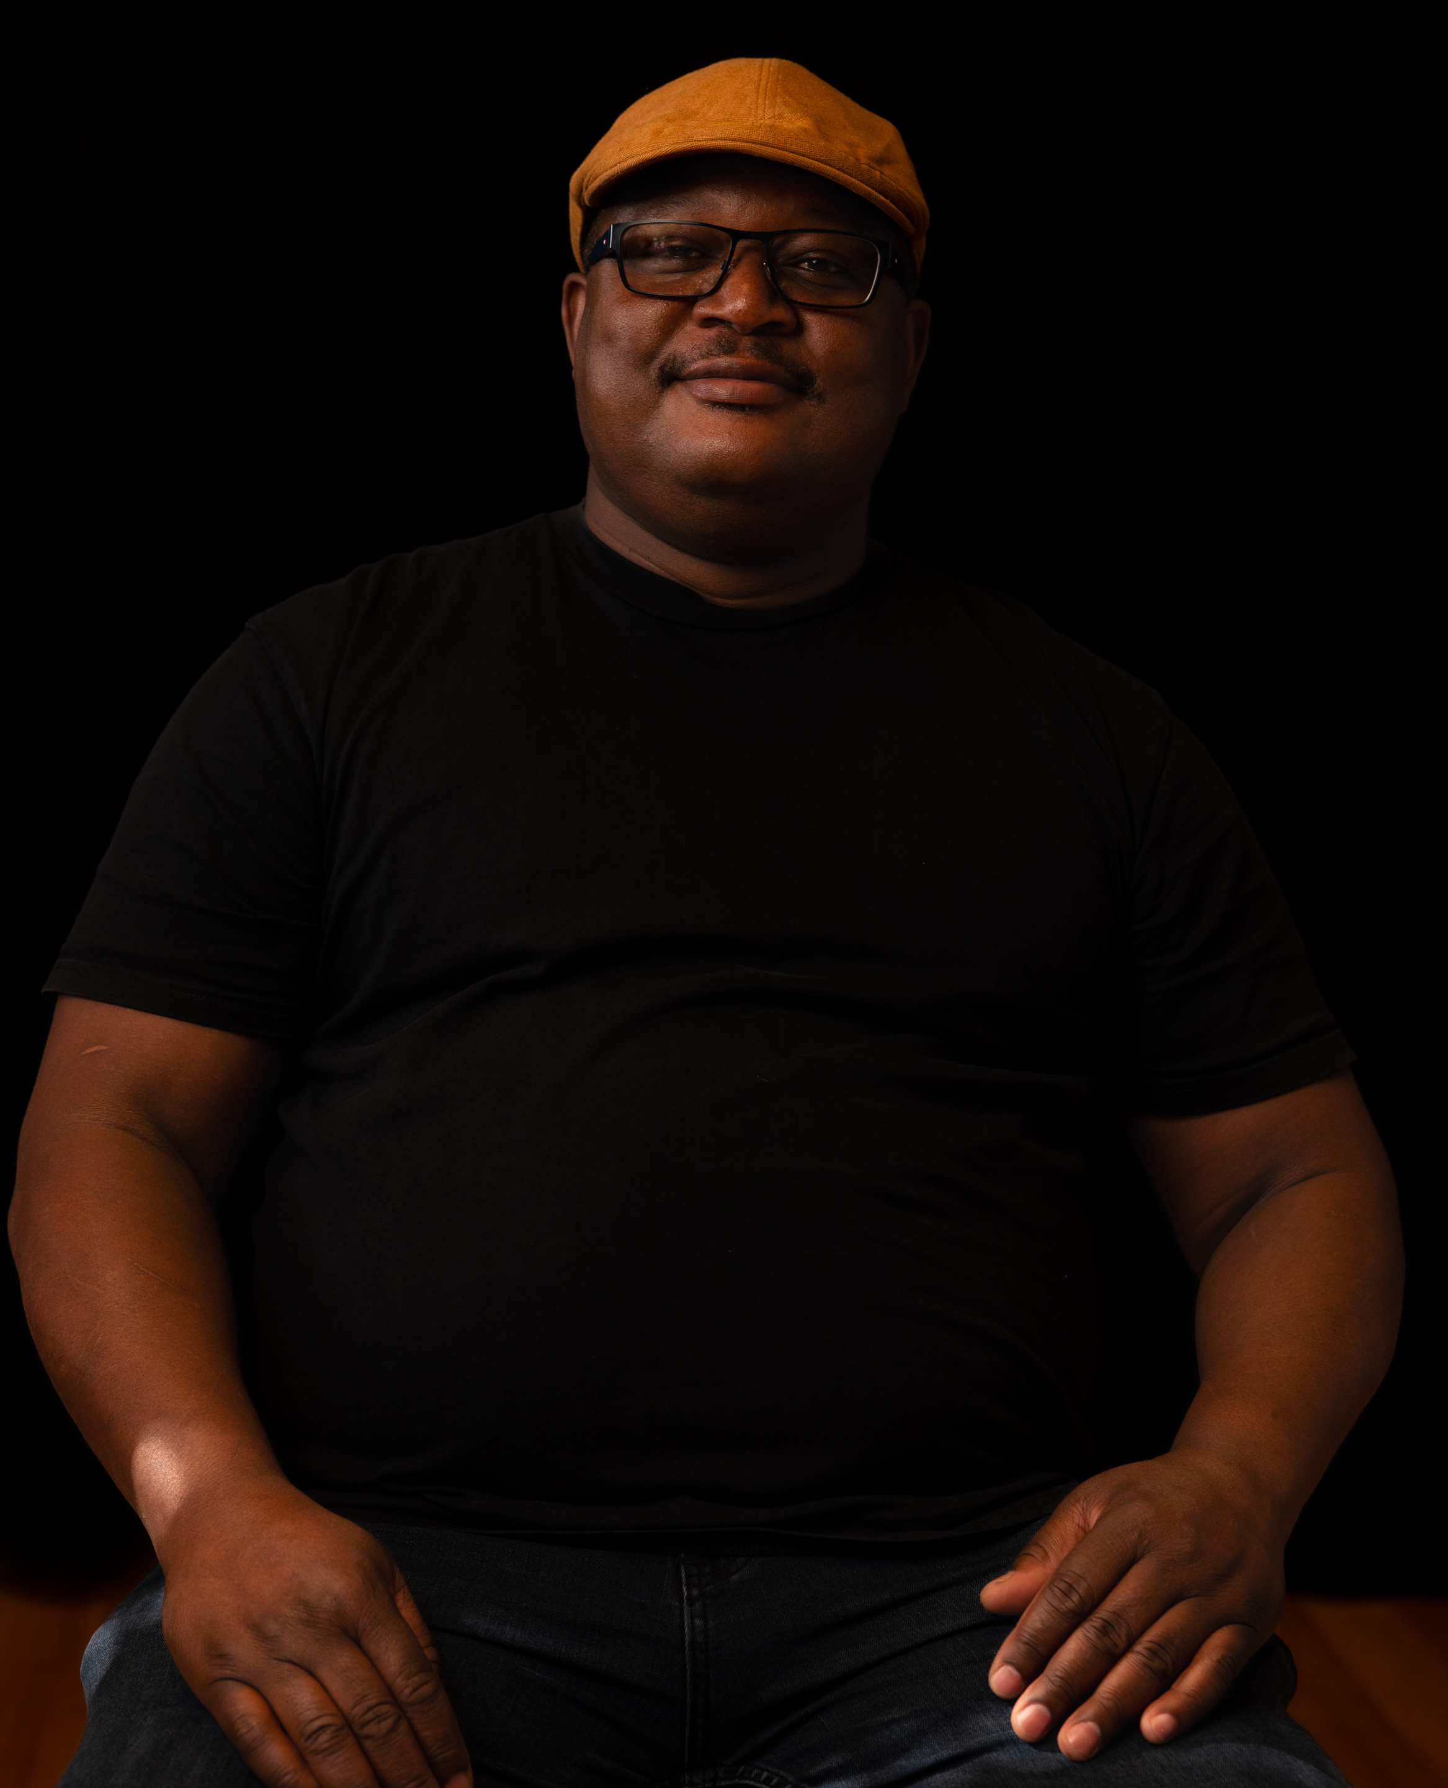
Image: Headshot of Walter, a black man wearing a black t-shirt, glasses and a yellow hat. He looks forward gently.
Anna Seymour
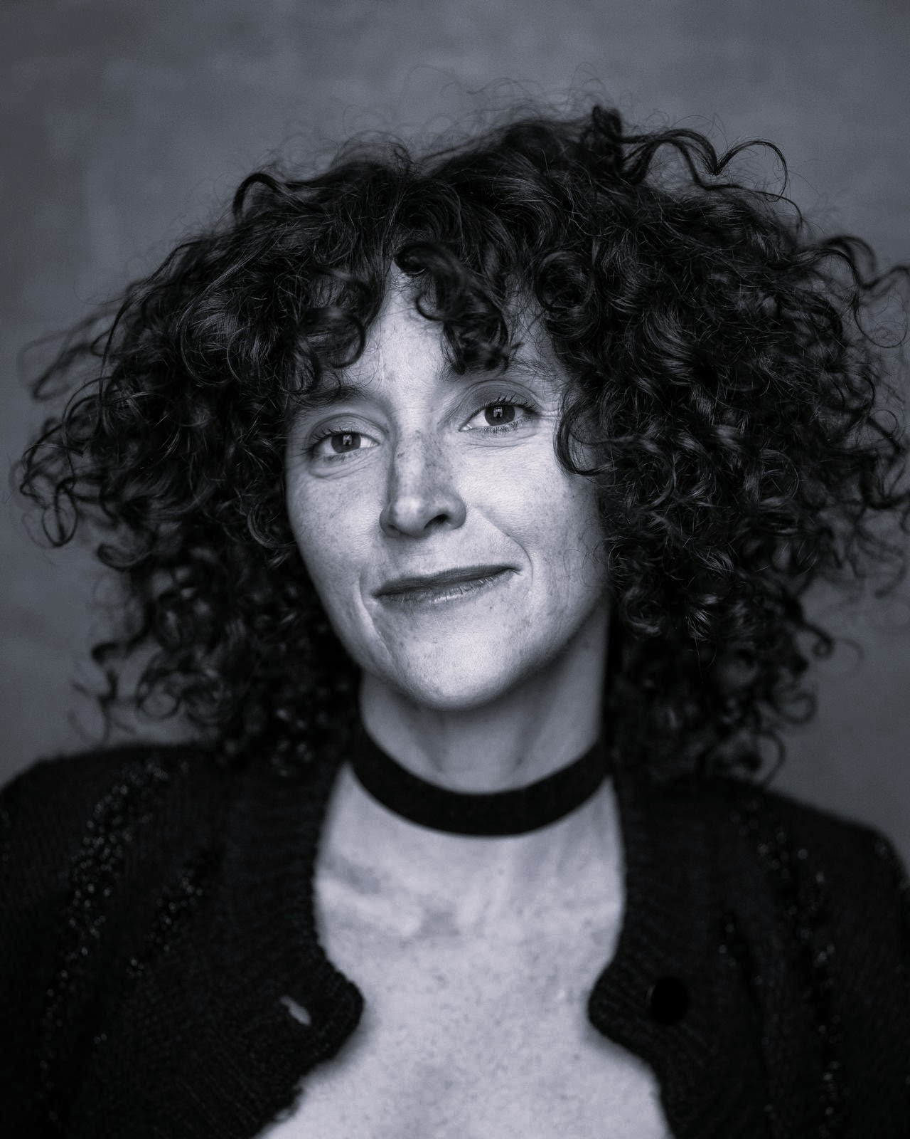
Image: Black and white headshot of Anna, a white woman with dark curly hair. She smiles forward wearing a black cardigan and a black chocker necklace.
Luke King

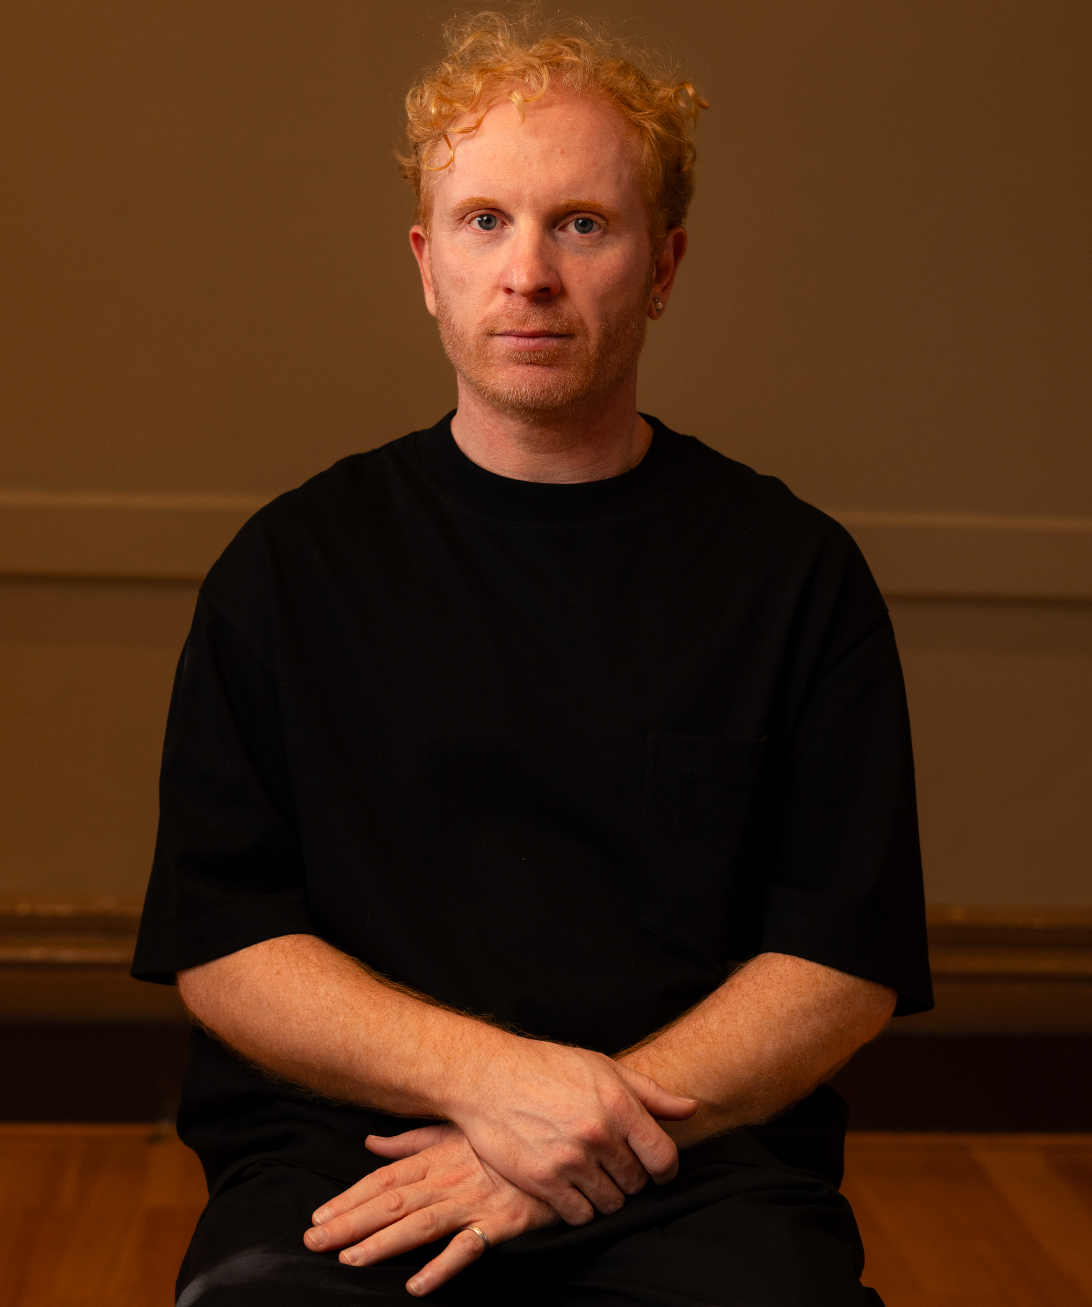

Image: Headshot of Luke, a white man with short, red, curly hair. He wears a black t-shirt and gazes forward with a serious expression.
Ramas McRae
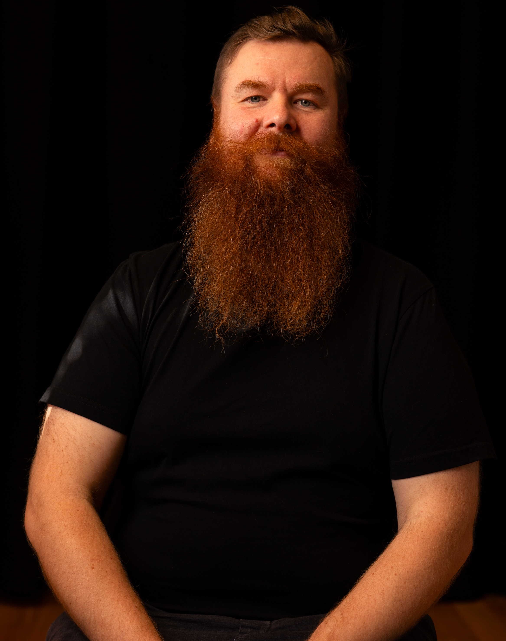
Image: Headshot of Ramas, a person with pale skin, and a long red beard. Ramas wears a black t-shirt and gazes forward softly.

Maya Sandon
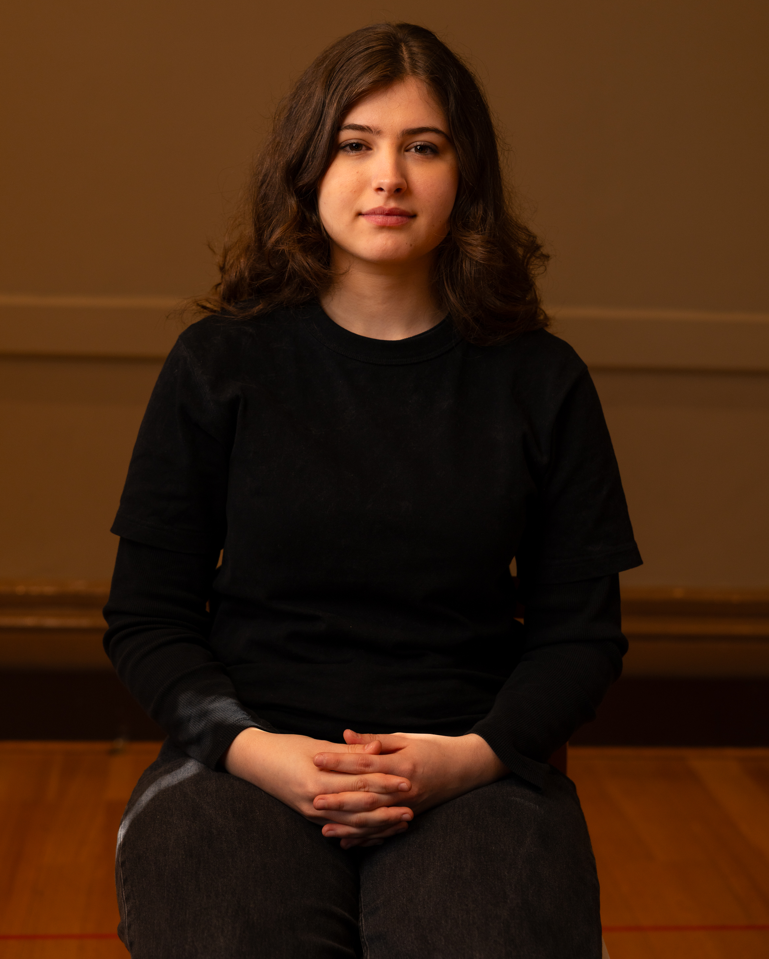
Image: Headshot of Maya, a person with pale skin and long wavy brown hair. Maya wears all black and sits with hands folded on their knees and a soft expression.
Franco Spadea
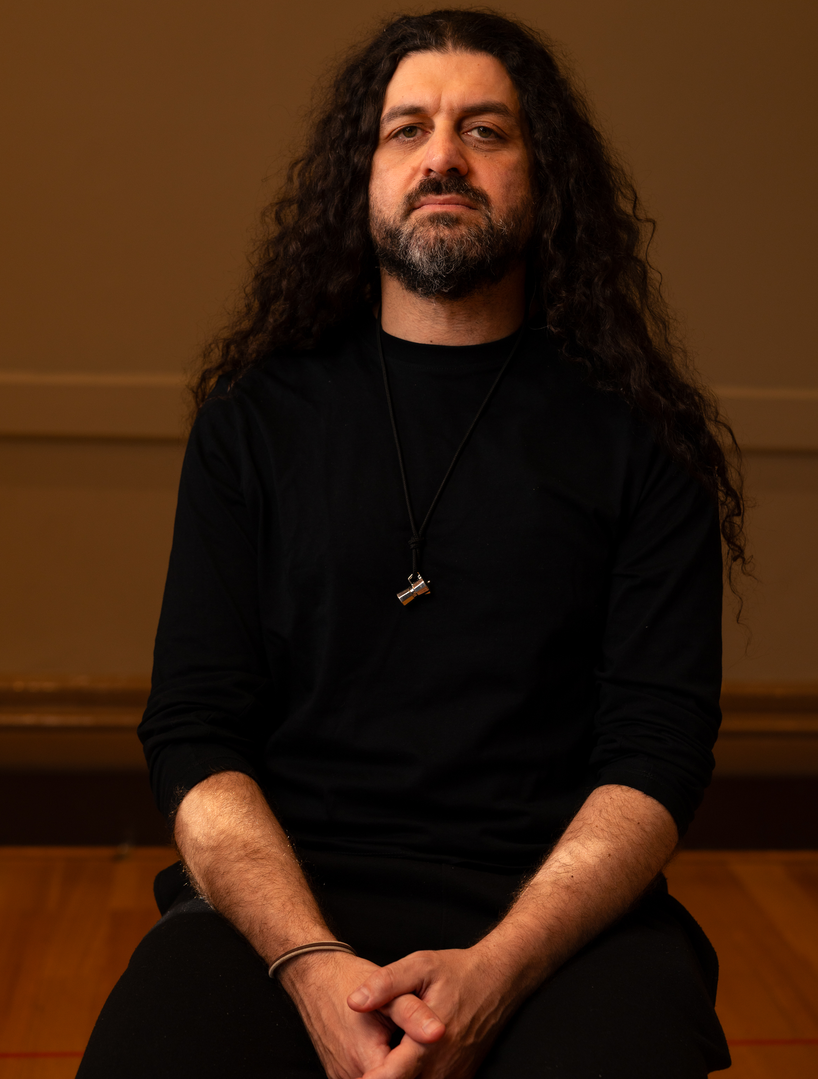
Image: Headshot of Franco, a person with pale skin, long, dark, curly hair and a short beard. Franco’s hands rest on their knees. Wearing all black, Franco looks forward with a serious expression.

Synopsis
***SPOILER WARNING***
The show does not follow a conventional narrative. Instead, it combines sign language opera, movement, imagery, video projection and sound to create an emotional journey through aspects of Deaf history and lived experience. The show explores Deaf history, language, identity and resistance through movement, Auslan, projection, visual poetry and sound.
Transitions between the scenes may either be blackout, fade in/out of sounds or continuous sounds/ transitional projections linking scenes.
Before the Show
- Audience members enter a semi-darkened theatre space.
- Projected imagery may already be visible when entering.
- Sound begins before the first visual image appears.
Scene 1: Manifesto of Silences
The performance begins with projected images of a performer, movement and water. A heartbeat gradually increases in intensity while images appear across transparent curtains. The projected face of a performer slowly enlarges until the image disappears into darkness. A performer appears in shadow behind the curtains as water imagery continues. The scene introduces the themes of silence, power, identity and the right to self-expression.
Scene 2: Language Invisible – Winds of Change
A single performer uses movement and Auslan poetry to narrate the meaning of Manifesto of Silences. Water imagery continues in the background while words appear as projections around the performer. Themes include fear, silence, freedom and the question of who has the power to decide how people communicate. The scene ends slowly in darkness.
Scene 3: Strange History
Projected images inspired by stars, maps and history create a transition into the historical section of the work. Performers appear in historical costume. This scene introduces early Deaf history and changing attitudes towards Deaf people prior to the nineteenth century. There is no text and the focus is on projection and movement.
Scene 4: Light in Me
Two Deaf sisters and Abbé de l'Épée appear in a theatrical retelling of a key moment in Deaf history. Projected pages gradually fill with writing and signs as the performers move, sign and interact. The scene explores how Deaf people contributed to the development and preservation of language and knowledge. It includes movement, signing, and engagement between the performers.
Scene 5: Language is Power
A performer reflects on the importance of language, culture and identity. They start on one side of the stage. Projected imagery shifts from peaceful water to historical images associated with industrialisation, social change and discrimination. The performer moves to the other side of the stage during this shift. The scene becomes darker and more intense as it explores attempts to control Deaf language and culture. Repeated references to language being precious form the emotional centre of the scene.
Scene 6: The Silencer
This scene focuses on the 1880 Milan Convention and its impact on Deaf communities around the world. Two performers sit on either side of the stage, and represent opposing viewpoints about Deaf education and communication.
They take turns explaining their perspective, like a debate. When it is their turn they are lit and the other person is mostly in darkness. The light changes to the other person when it is their turn. The performers alternately and simultaneously present conflicting ideas about sign language and speech. It gets a bit faster as they argue until both are lit because they are simultaneously signing.
When the debate becomes most energetic, historical photographs and text are projected in quick succession on the screen behind them.

Scene 7: Am I Crazy?
The emotional climax of the performance. A solo performer moves through a physical and emotional journey that begins slowly and builds in intensity. Historical video of teaching oralism repeats, slowing down and zooming in. The performer becomes increasingly distressed, interacting with the stage objects before collapsing. Sound and lighting grow more intense throughout the sequence.
Audience Warning:
- Distressing themes relating to oppression and discrimination.
- Intense movement and emotion.
- Sudden increases in sound and visual intensity.

Scene 8: Picking Up the Pieces
Following the intensity of the previous scene, the pace becomes quieter and more reflective. One performer remains on the floor while another enters and helps them rise. The performers pause together and silently look towards the audience. The scene reflects ongoing resilience and the continuing fight for recognition and equality.
Scene 9: We Are Still Here
A large-scale visual sequence featuring images of Deaf community members displayed in multiple panels. Black-and-white portraits gradually multiply and layer over one another while a heartbeat sound continues throughout. The scene explores identity, solidarity, visibility and resistance across generations.
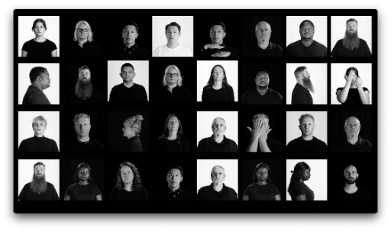
Audience Warning:
- Multiple rapidly changing projected images.
- Extended visual projection sequence.

Scene 10: Winds of Change (Final Scene)
The full cast returns for a final movement sequence. The performers initially appear as shadows before water imagery slowly returns. The cast move together before turning towards the projected water and remaining still. The work concludes quietly and deliberately, leaving audiences with an ongoing question about Deaf identity, rights and collective resilience. The ending is intentionally unresolved and reflective.
After the Show
- Performers will move to the front of the stage and bow.
- House lights return gradually.
- Audience members leave through venue exits.
- Post-show discussions or foyer interactions may occur if scheduled.

Contact Us
Arts House
521 Queensberry Street
North Melbourne
Victoria 3051
Phone: 9322 3720
Text Enquiries: 0447 570 178
Email: artshouse@melbourne.vic.gov.au
Website: https://www.artshouse.com.au
TTY users:
phone 13 36 77 – then ask for – 03 9322 3720
Speak and Listen users:
phone 1300 555 727 – then ask for – 03 9322 3720
Internet relay users:
connect to the NRS – then type in: 03 9322 3720
Video relay users:
connect to the VRS – then type in: 03 9322 3720

Was this Access Guide helpful?
Your feedback can help us improve. Please call, text, or email us to provide feedback.

Thank you for using this Access Guide

