

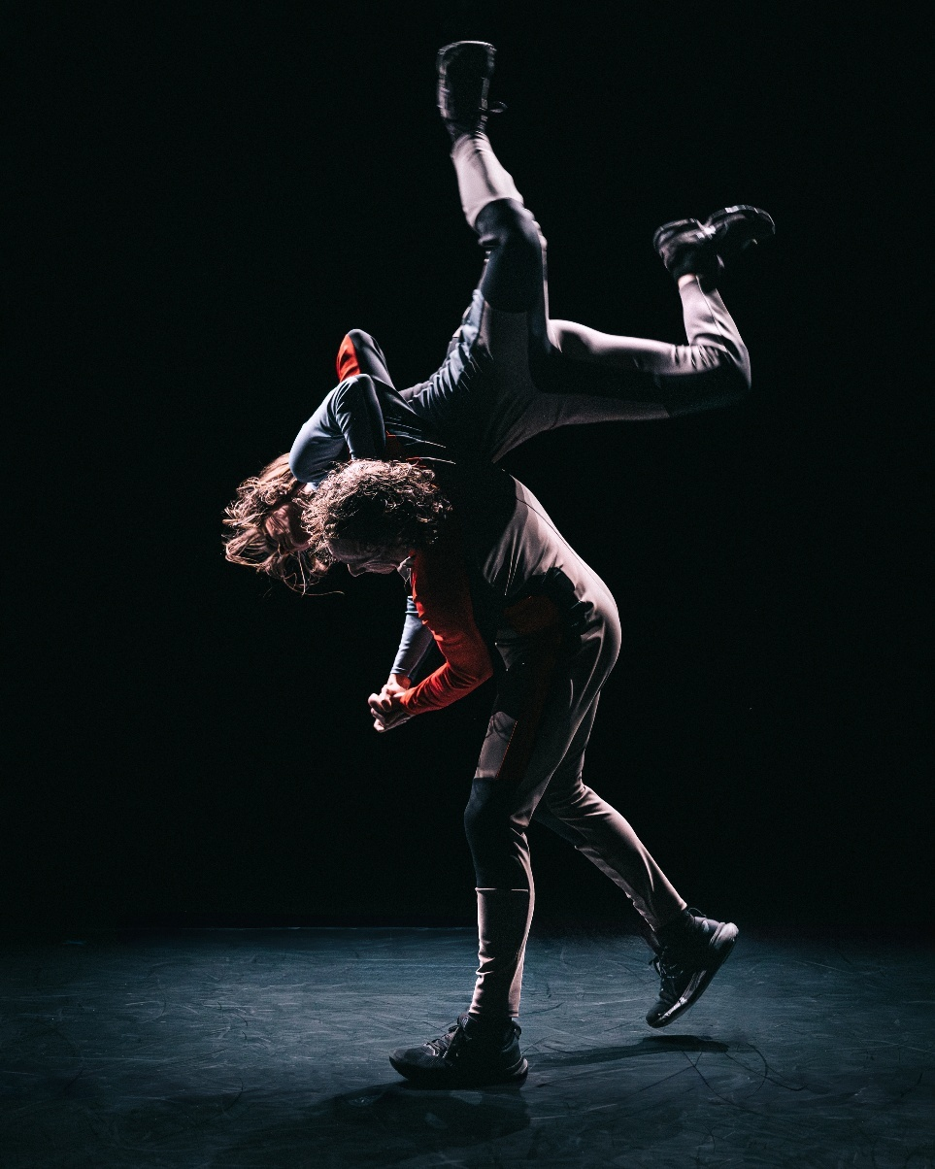
R.A.I.N
Harrison Ritchie-Jones
Access Guide
Image Credit: Darren Gill
Image Description: Two dancers mid action – one being flown/flipped mid air by the other dancer. Both dancers are wearing space-like wet suits in a dark stark environment.

Updates to this document
Please note, this performance is a new work and changes are being made by artists until opening.
This guide will be updated as new information becomes available.
Arts House website will contain the most up to date version of this guide. If changes have been made, all ticket holders will be sent the latest version of this guide 3 days and 1 day prior to the event.
This document was created: 7 September 2026
Contents
Updates to this document 2
About This Guide 2
Show Overview 4
Important Notes 4
Access Services 5
How to Buy Tickets 7
Ticket Types 7
Getting to Arts House 8
The Venue 9
Arrival and Entrances 9
The Foyer 12
Staff 13
Bar 14
Quiet Space 15
Toilets 16
Main Hall 17
R.A.I.N 18
Sensory Notes 18
Audience Experience 19
Performers 20
Contact Us 21

About This Guide
This Access Guide is a document designed to help prepare you for the experience of attending an event at Arts House.
The first few pages should give you the most important information about the show.
The section after that will tell you how to get here and what to expect from the venue.
The last section goes into detail of the experience of the event you are here to see. This may include spoilers.
Please use the contents page to navigate to whichever part of the guide is most useful to you.

Show Overview
​Where
Arts House
521 Queensberry Street
North Melbourne VIC

When
Wednesday 16 – Sunday 20 September 2026
Wed – Fri, 7:30pm
Sat, 2pm & 7:30pm
Sun, 5pm
Duration: 50 mins, no interval

Overview
R.A.I.N is a 50-minute, two (2) person contemporary dance performance show performed on a stage.

Important Notes
Content Notes
Suitable for ages 15+
The work contains adult themes, coarse language, haze, loud music, sudden loud noises, loud sub noises with under seat vibration, flashing lights, lighting changes, low lighting, lights black out and lights that colour and intensity.

Access Services

The quiet space will be available for you to use before and after the show.
More information about the quiet space can be found later in this guide.


Visual Rating 50%
A mixture of visual and auditory components including dialogue, music, other sounds.


Aural Rating 50%
A mixture of both sound and visual components like lighting, movement and physical design.


Assistance Animals are welcome.

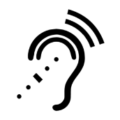
Assistive Listening is available free of charge. Ask staff for assistance on arrival.


This performance is fully wheelchair accessible.
More information on wheelchair accessible entrances and bathrooms can be found later in this guide.

We offer a Meet and Assist service.
Please Contact Us so we can arrange this for you.
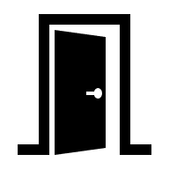
Patrons who need to can gain Early Access to the venue.
Please approach Ushers to let them know you would like to utilise this.

Companion cards are accepted for this event.

How to Buy Tickets


Tickets can be purchased online at any time.
Click “Buy Tickets” on our website and it will take you to our ticketing platform.
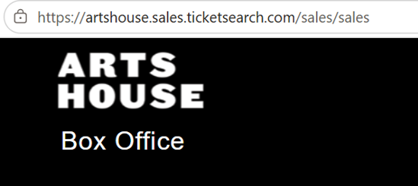


Tickets can be booked over the phone between 10am and 4pm Monday to Friday
If you are deaf or find it hard to hear or speak on the phone, you can connect with us via:
•National Relay Service
•Video Relay Service
•TTY (phone 133 677)
•Speak and Listen (phone 1300 555 727)

Our Box Office desk at North Melbourne Town Hall also opens 60 minutes before performance start times for in person bookings.
Please check ticket availability ahead of time to avoid disappointment.

Ticket Types
Access Services
We list certain access services as ticket types e.g. Auslan, Audio Description, Wheelchair seating. These are full tickets to the show, NOT add-ons. We sell tickets this way as it helps our team and the service providers we work with anticipate numbers and offer a better service.

Reduced
Our Reduced ticket type is equivalent to Concession pricing. This ticket type is open to anyone who may be facing barriers to attend the arts. We do not ask for any proof or verification.
BLAKTIX
For every ticketed event, Arts House ensures discounted tickets are available for First Nations people. You can book BLAKTIX online when purchasing tickets to any event.

Companion Card
Arts House supports the Companion Card program. You can book your companion ticket online when purchasing tickets to any show. Only the person whose photograph and details appear on the Companion Card can use the card.

Getting to Arts House
Arts House is located in the North Melbourne Town Hall, at the corner of Queensberry Street and Errol Street in North Melbourne.
We have some resources that can help you with navigation throughout the building, including a video guide and a verbal map.
Walk
Arts House is 2.5 kilometers from Flinders Street Station, (a 35 minute walk), and 850 meters from Queen Victoria Markets (an 11 minute walk).
Train
Arts House is 1.1 kilometers from North Melbourne Train Station (a 16 minute walk), or 1.2 kilometers from Flagstaff Station, (a 15 minute walk).
Tram
From the City of Melbourne, Take the Route 57 tram and get off at Stop 12, North Melbourne Town Hall.
Please note, this is not a level access tram stop and is not serviced by low floor trams.
Car
There is paid street parking around Arts House. There are two accessible on-street car parking spaces on Queensberry Street and two more on Errol Street for holders of a Disability Parking Permit.

The Venue

Arrival and Entrances
View From Street
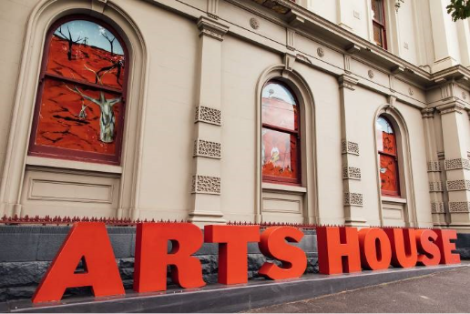
Image: North Melbourne Town Hall view from Queensberry Street which features giant red letters that say ARTS HOUSE out the front of it.
Map
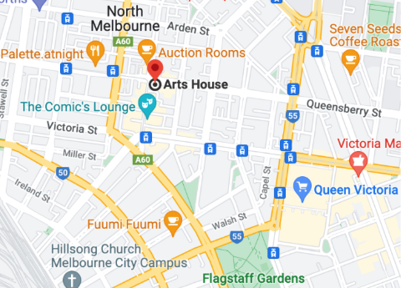
Image: A map of Arts House and its surrounding area. LINK TO MAP
Queensberry Street Entrance
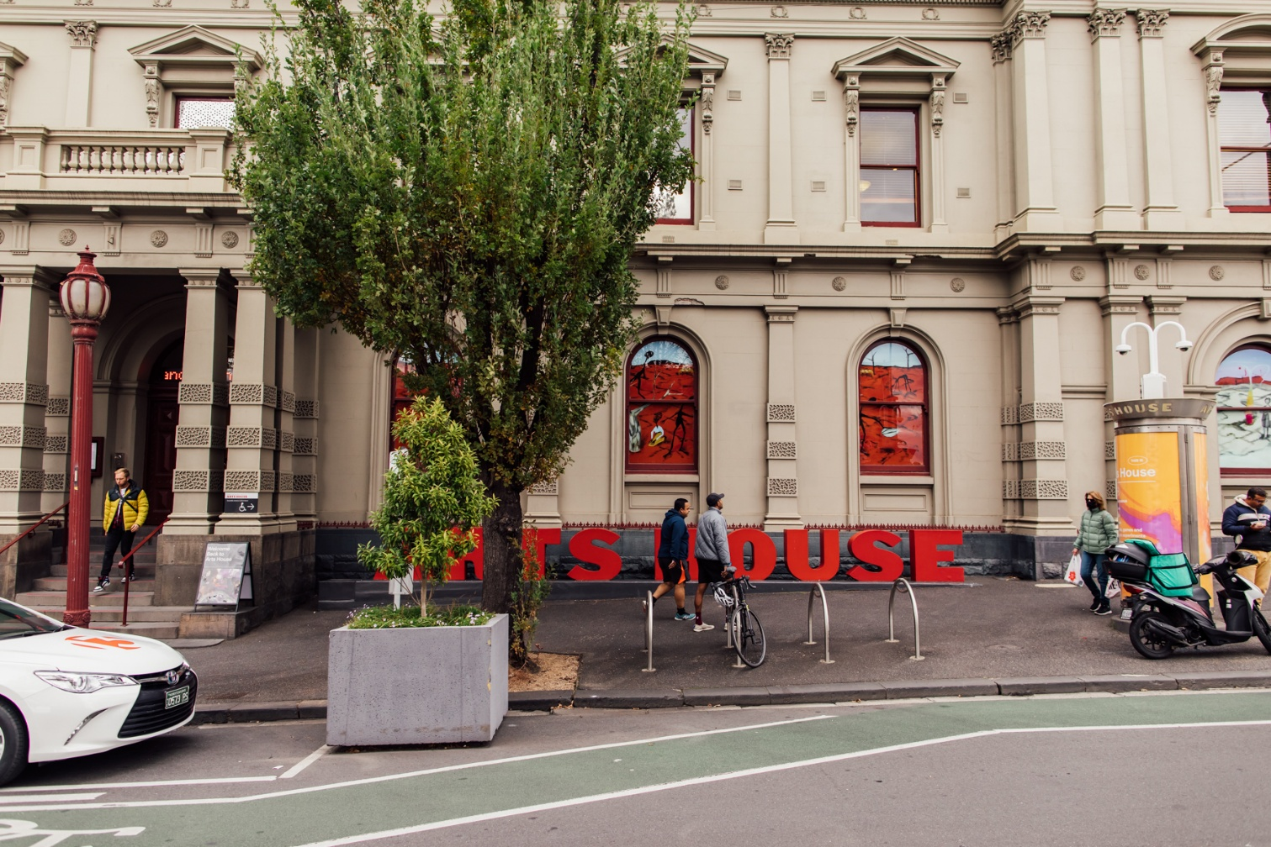
Image: North Melbourne Town Hall entrance on Queensberry Street. The entrance is to the left of the giant red letters that say ARTS HOUSE and features a staircase of eight steps with grab rails in parts.
Errol Street Entrance
There are two Wheelchair Accessible Entrances. The first is on Errol St next to the Post Office.

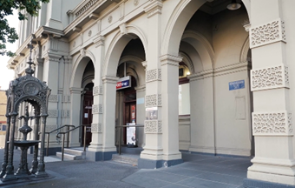
Image: Errol Street entrance next to the Post office with wheelchair accessible ramp or two steps with grab rails.
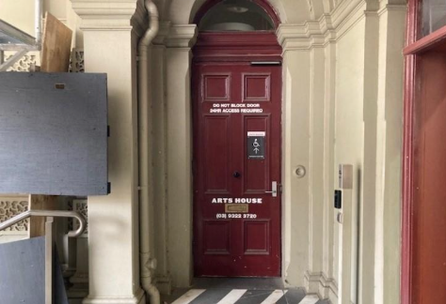
Image: View of door at Post office entrance.
The button to open automated door is on the right.

George Johnson Lane Entrance
The second Wheelchair Accessible Entrance is towards the end of George Johnson Lane.

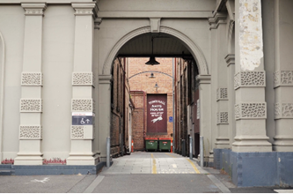
Image: View of George Johnson Lane from Errol St. The laneway passes through an archway with a brick wall at the end.
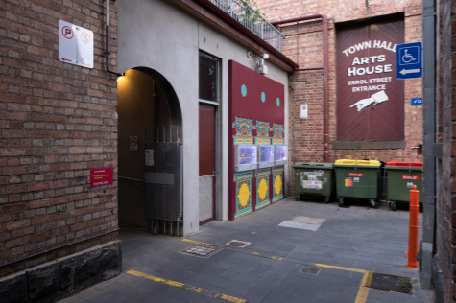
Image: View of the left turn from George Johnson Lane to the accessible entrance ramp. A large painted sign points the way and reads 'Town Hall Arts House Errol Street Entrance’
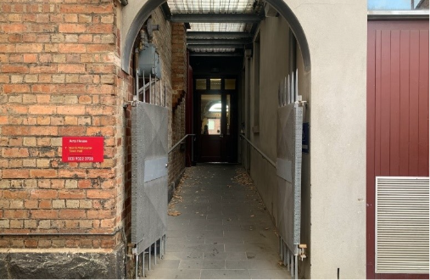
Image: View of the ramp with grab rail leading from George Johnson Lane to the automated door which opens into the Arts House foyer.

The Foyer
When you enter Arts House, you will find yourself in the foyer.
- Please gather and wait in the foyer if your show is in the Studios, Supper Room or the Main Hall.
- Information about upcoming events and performances is available on posters and a tablet computer.
- Tickets for events can be reserved or purchased at the reception.
- There is limited seating available. Mostly, cushioned grey chairs.
- A communication board and pen and paper are available at reception.
- Free Wi-Fi is available for visitors.
- The foyer contains a lift.
- A water cooler is located nearby the reception desk.
- Arts House frequently commissions artists to present works in the foyer. There is always something to see.

Sensory Notes

Low Lighting


Crowds


Limited Seating

_{full}
Noise
- People Talking
- Appliance Buzzing
- Music


Staff
Staff at Arts House wear black t-shirts or black jackets with the Arts House logo on them.
Our staff are there to assist you, please ask for help if you need it.
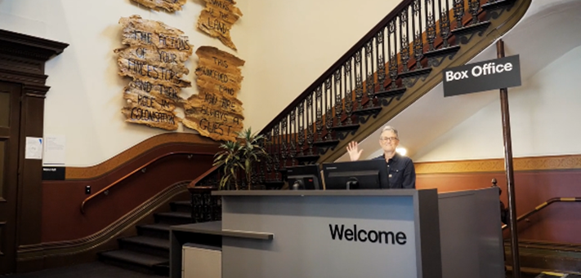
Image: A person in black smiling from behind the reception desk. To the left is a staircase with artwork on the walls on the way up.
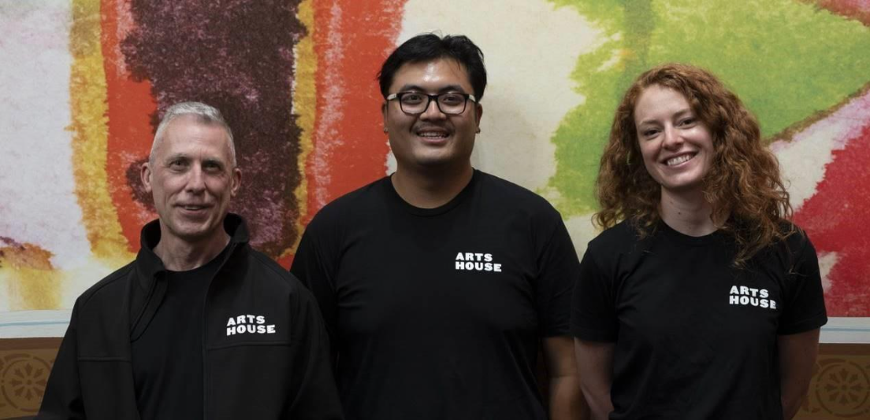
Image: Three Arts House Ushers. They wear black t-shirts and jackets with the Arts House logo on the left shoulder.

Bar
The Arts House Bar is in the foyer.
Bar staff will be wearing black with an Arts House Logo.
We have a range of alcoholic and non-alcoholic beverages for sale.
We are a cashless venue and accept EFTPOS, Visa and Mastercard payments.
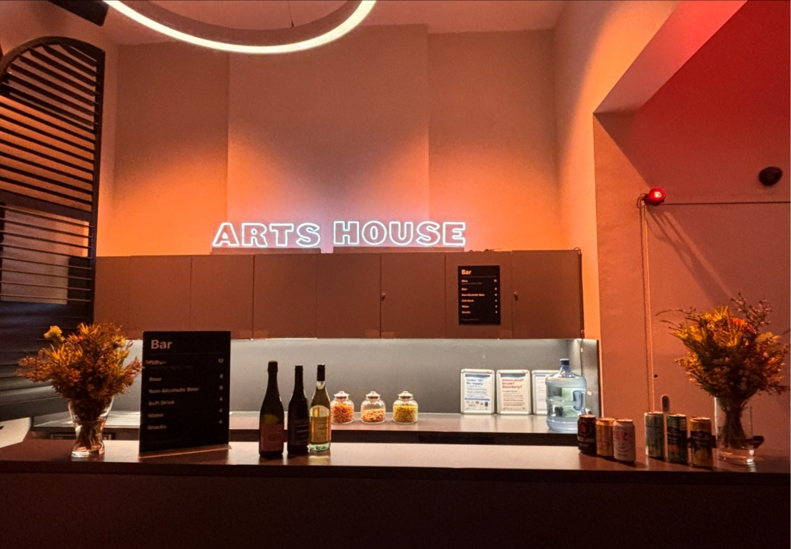
Image: Arts House bar in warm lighting. Vases of flowers sit on each side. A menu and drinks display sit atop it. On the back wall, a small Arts House sign is lit up.

Quiet Space

The Quiet Space is located on the ground level opposite the Accessible Bathroom.
It is suitable as a chill out space, prayer or parenting space and features a range of seating options, dimmable lights, sensory and stimming objects and ear plugs. Anyone is welcome to access the Quiet Space during venue operating hours and events.

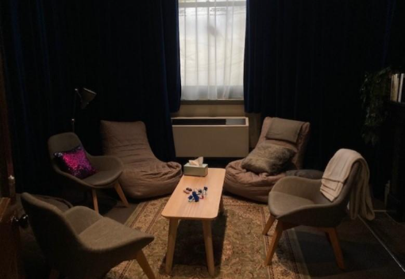
Image: Quiet Space with lights dimmed.
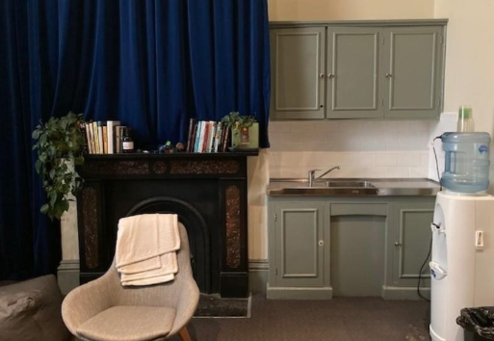
Image: Quiet Space kitchenette and bookshelf.

Sensory Notes

Adjustable Lighting


Noise
- Foyer sound bleed sometimes
- Appliance buzzing

Hard and Soft Textures


Smells
- Travelling smells from bathroom


Toilets
All toilets at Arts House are gender neutral.
There are toilets on all floors, and wheelchair accessible toilets on the Ground and Upper floors.
There are two bathrooms with showers and one with a baby change table on the upper level.
The nearest Changing Places facility is a 17 minute walk away at Narrm Ngarrgu Library and Family Services.
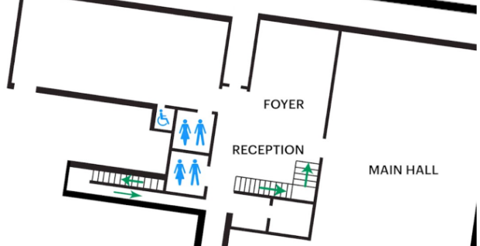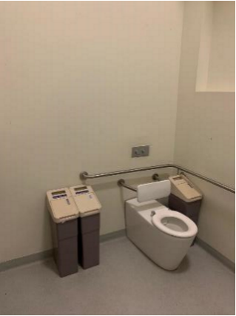
Images:
(Left)
Map of downstairs Arts House with bathrooms marked. There is one accessed from near reception. One accessible bathroom and gender neutral bathroom can be accessed from the hall near the foyer.
(Right): Ground Floor Accessible Bathroom. There is a grabrail behind the toilet basin and to the left of the basin.

Sensory Notes

Toilet Smells


Wet Textures


Hand Dryer Sounds

Echoey Room
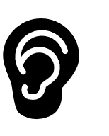

Main Hall
The Performance is in the Main Hall. It is on the ground floor. It is to the left of the box office desk and right of the bar.
An artist statement is available on signage and warnings on the door.
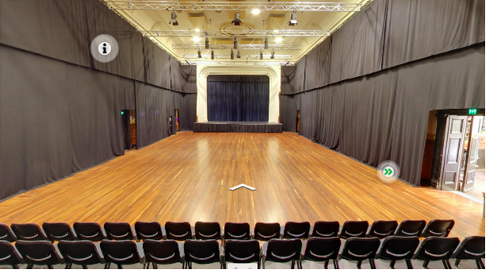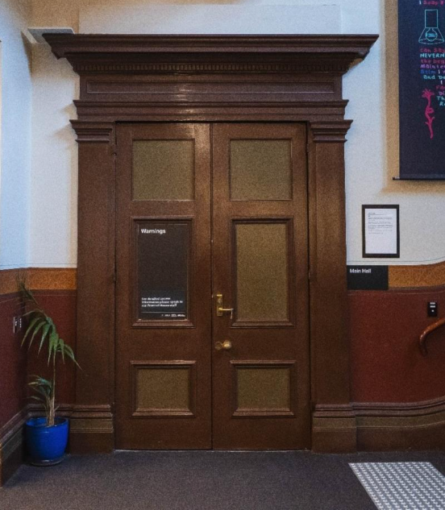
Images:
(Top) The closed doors to the Main Hall. They are heavy brown double doors. A large black sign on the left door lists show warnings.
(Bottom) Tiered seating looks out to large hall with wooden floor and raised stage along back wall.

R.A.I.N

Sensory Notes

Sound
- Different levels of talking, sometimes purposefully unclear
- Emotional changes in conversation, sometimes screaming
- Overlapping sounds
- Voice modulation and auto tune
- Sudden loud noises


Lighting
- Flashing lights
- Colour changes
- Intensity changes

Visual
- Sparce, empty set
- Distorted mirror
- Fast changing
- Highly physical
- Perfomers leave the stage momentarily but are still heard

Audience Experience

Entering the Space
- Main doors
- Seating bank
- Sit anywhere


Shocks or Surprises
- Screaming voices
- Operatic Gestures


Social Expectations
- Sit and watch dance performance
- Laugh if you find something funny


Performance Expectations
- Dance
- No clear narrative
- Cinematic style


Relaxed Elements
- Stimming

Performers
Michaela Tancheff – performer / dancer
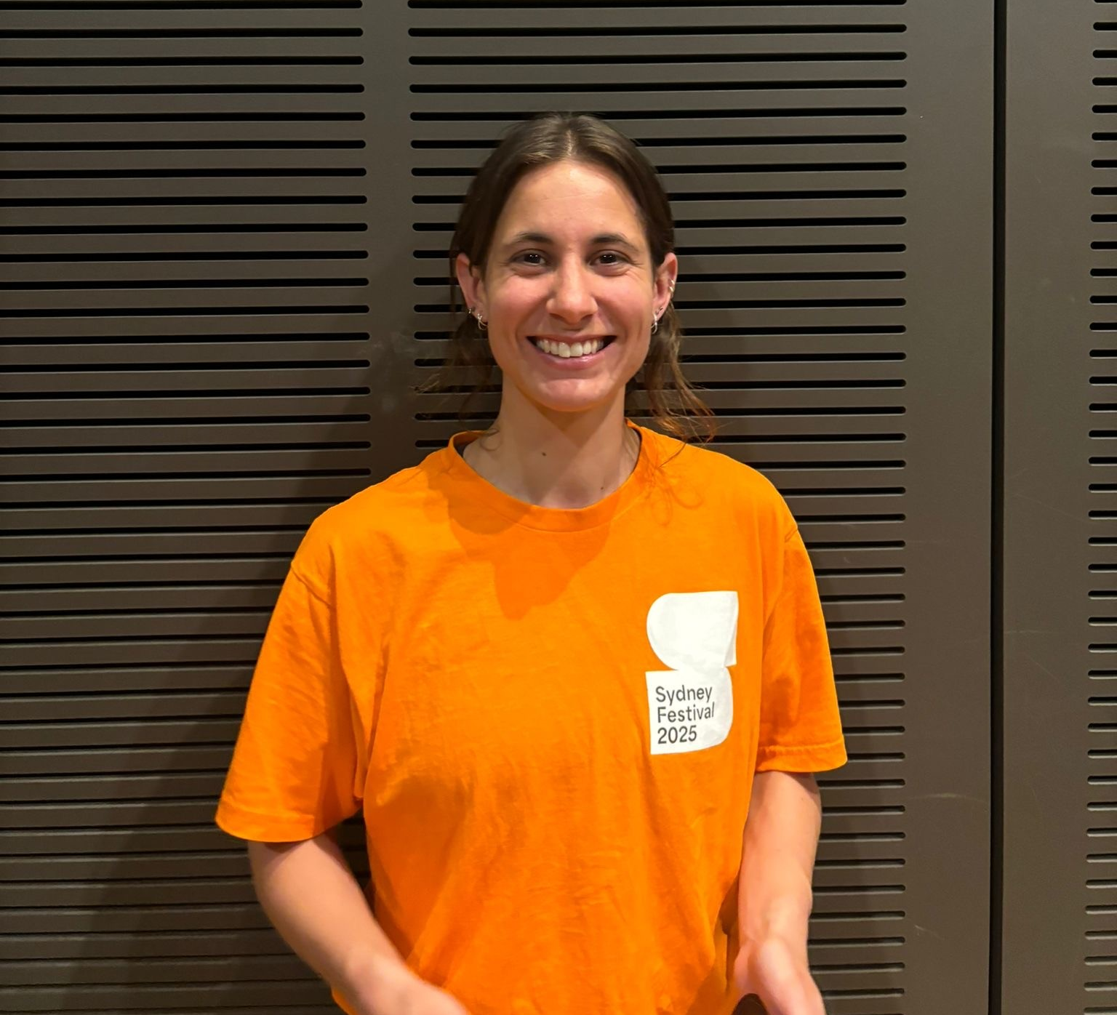

Harrison Ritchie-Jones – performer / dancer
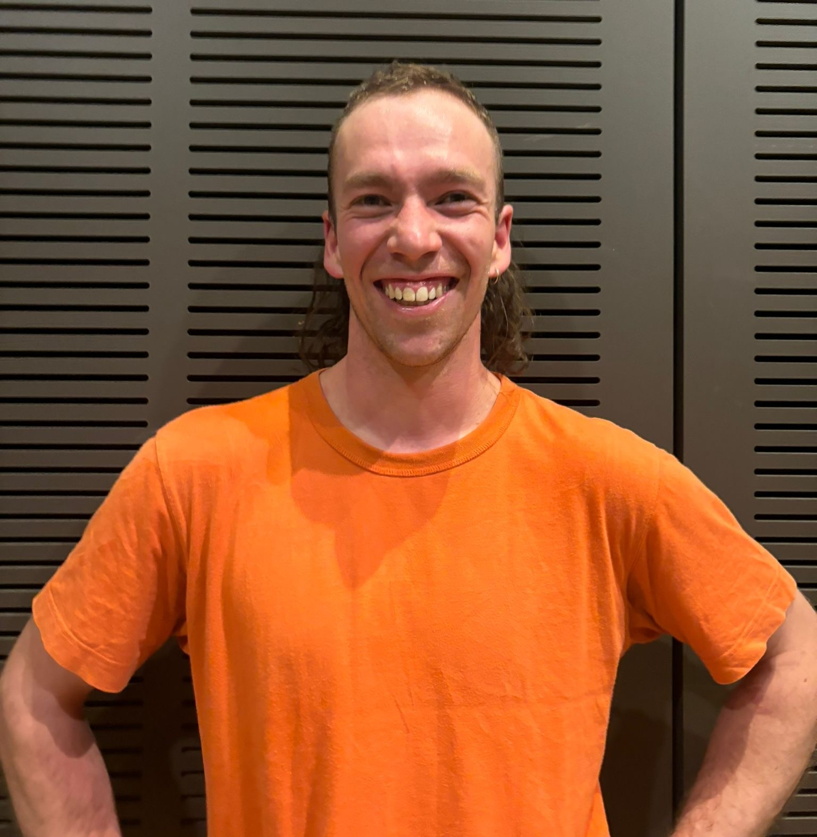

Contact Us
Arts House
521 Queensberry Street
North Melbourne
Victoria 3051
Phone: 9322 3720
Text Enquiries: 0447 570 178
Email: artshouse@melbourne.vic.gov.au
Website: https://www.artshouse.com.au
TTY users:
phone 13 36 77 – then ask for – 03 9322 3720
Speak and Listen users:
phone 1300 555 727 – then ask for – 03 9322 3720
Internet relay users:
connect to the NRS – then type in: 03 9322 3720
Video relay users:
connect to the VRS – then type in: 03 9322 3720

Was this Access Guide helpful?
Your feedback can help us improve. Please call, text, or email us to provide feedback.



Thank-you for using this Access Guide

