a bit thing

By Dr Paola Balla, Katen Balla & Rosie Kalina

Access Guide
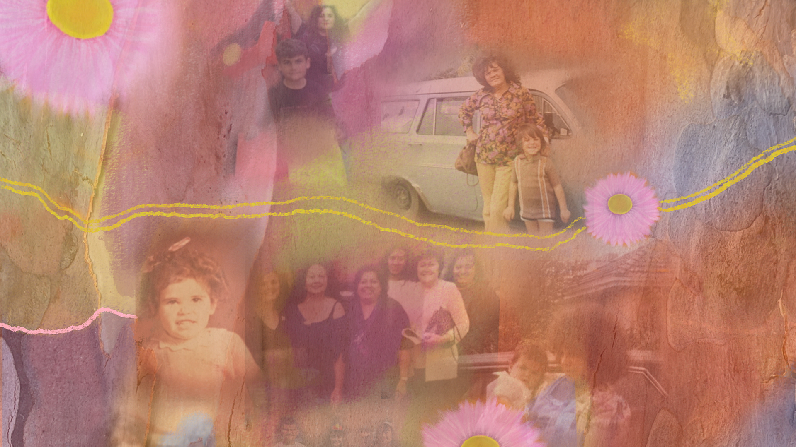

Image Credit: Rosie Kalina, with photographs supplied from a family collection.
Image Description: A collage style image in pastel tones, incorporating an archive of family photographs and flora overlays.

Updates to this document

Please note, this performance is a new work and changes are being made by artists until opening. This guide will be updated as new information becomes available.

Arts House website will contain the most up to date version of this guide and all ticket holders will be notified of any changes made 3 days and 1 day prior to the event.

This document was created: 9 June 2026

Revision 1: 24 June 2026

Contents
Where 3
When 3
Show Overview 4
Important Notes 4
Content Warnings 4
General Notes 4
Access Services 5
Sensory Elements 7
Audience Experience 8
Transport 9
The Venue 10
COVID Safet 20

Where

Arts House
521 Queensberry Street
North Melbourne VIC

When

Saturday 27 June – Saturday 18 July 2026
Monday – Friday, 10am – 4pm
Saturday, 11am – 3pm

Exhibition Overview

Explore a house built within the Arts House Main Hall in this bold new intergenerational exhibition curated by Dr Paola Balla and her children Rosie Kalina and Katen Balla.

Visitors are invited to step inside a fantastical Blak family home. There are rooms to wander, artworks to experience and a Blakyard to relax in.

a bit thing celebrates the family home as a site of gathering, culture, memories and personal identity. Grounded firmly in Blak perspectives and lived experiences, a bit thing creates spaces of communal respite for visitors to connect, make a cuppa and experience artworks within a home shaped by memory, joy and care.

Important Notes

Content Warnings

a bit thing is suitable for all ages, with a family friendly and culturally safe environment. The exhibition contains references to colonisation and trauma.

General Notes

Visitors are welcome to wander throughout and around the house. You can take a seat in the living room or in the Blakyard. You can make yourself a cup of tea, read a book and engage with the self-led activities on offer including card games, weaving and letter writing.

Please do not touch the artworks or remove any items from the space.

Access Services



Assistance Animals are welcome.

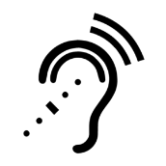

Assistive Listening is available free of charge. Ask staff for assistance on arrival.

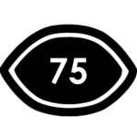

Visual Rating 75% - Mostly visual. Spoken dialogue is fully captioned, but no visual representation is given for other sounds/music.



Aural Rating 50% - A mixture of both sound and visual components like lighting, movement and physical design.

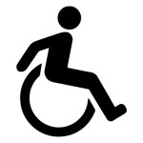

This exhibition is fully wheelchair accessible. More information on wheelchair accessible entrances and bathrooms can be found later in this guide.

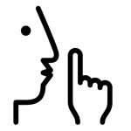

The quiet space will be available for you to use before, during and after viewing the show. More information about the quiet space can be found later in this guide.

Sensory Elements

Sound
There are no loud, sudden sounds in this exhibition. You may hear some music and sounds coming from different sources throughout the house.

In the first bedroom, contemporary music is playing softly through a speaker. In the living room, the radio will be tuned in to 3KND Kool N Deadly. In the Blakyard, there is a film work with some spoken dialogue, whispering voices and ambient sound.

Lighting
The lighting is designed to give the effect of it being night-time. Around the house, the lighting will be low and blue. Inside the house, the spaces will be lit with a mix of overhead lights and lamps to create ambient light through the rooms and highlight the artwork. The only source of flashing light is from the film work in the Blakyard space.
Physical
Visitors can wander throughout and around the house. The house has two entrance / exit points. There is a hallway leading to 2 large bedrooms and a kitchen / living area opening to a backyard - known as the 'Blakyard'. The house has a wooden floor and the blakyard has a deck and an astroturf lawn.

Visitors can take a seat in the living room or in the Blakyard. You can make yourself a cup of tea, read a book and engage with the self-led activities on offer including card games, weaving and letter writing. There are fidget toys and sensory items available in the living area space.

Smell
There are no smells in this work.

Visual
The main structure in the space is a full-scale wooden house frame. There are two large bedrooms, a hallway, a kitchen / living space and a backyard. There are some sheer bush-dyed fabrics stretched across the inside walls of the house frame. Five bush-dyed fabric banners are draped above the house, creating the outline of a triangle roof.

The first bedroom is a darker space, with a black and white colour scheme. The second bedroom is a brighter space with a pink colour scheme. Both bedrooms include furniture as well as mix of 2D and 3D artworks. The hallway leads from the bedrooms to the kitchen / living room. This space includes seating, a table, a fridge and kitchen bench with a tea station. Artworks are installed on the walls and house frame. In the Blakyard, there is an astroturf lawn with a table and chairs, and a clothesline with a film work projected.

Audience Experience

Entry to space
Visitors enter the exhibition through the doors to the Main Hall space. The exhibition is an immersive experience with visitors encouraged to wander through the house.

Social expectations
This exhibition is a relaxed space. Visitors are allowed to come and go and move around the space. There is seating available in the living room and Blakyard.

There are fidget toys and sensory items available in the living area space. Visitors are welcome to make noise and stim.

Transport

Tram

Route 57 (High Floor trams only)
Stop 12, North Melbourne Town Hall.
Please note, this is not a wheelchair accessible tram
GETTING TO ARTS HOUSE VIDEO LINK

Train

Arts House is 1.1km from
North Melbourne Train Station,
approximately 16 minute walk
North Melbourne Station Information
1.2km from Flagstaff Station,
approximately 15 minute walk
Flagstaff Station Information

Bus

Bus number: 216

Parking

There is limited paid on-street parking on Queensberry Street and Errol Street.

There are two accessible on street car parking spaces on Queensberry Street (150m to our accessible Errol Street entrance) for holders of a Parking Permit for Disabled people.

The Venue

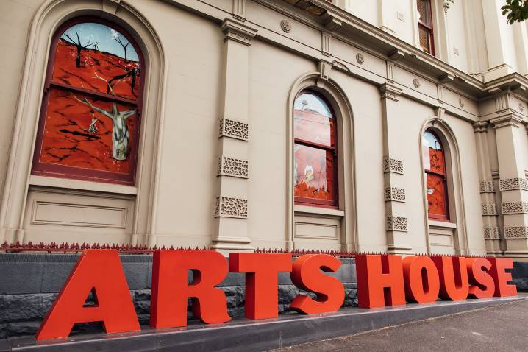
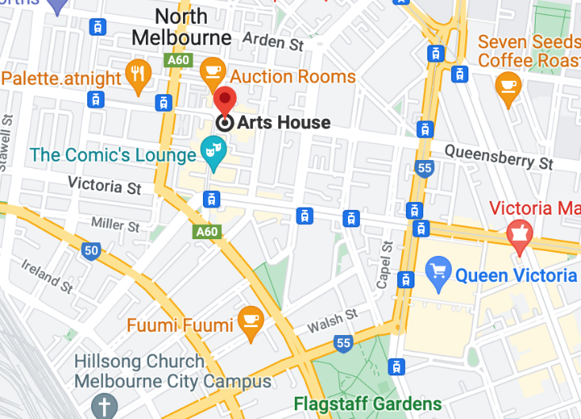

Image: North Melbourne Town Hall view from Queensberry Street which features giant red letters that say ARTS HOUSE out the front of it.

Image: a map of Arts House and its surrounding area. LINK TO MAP
Front Entrance

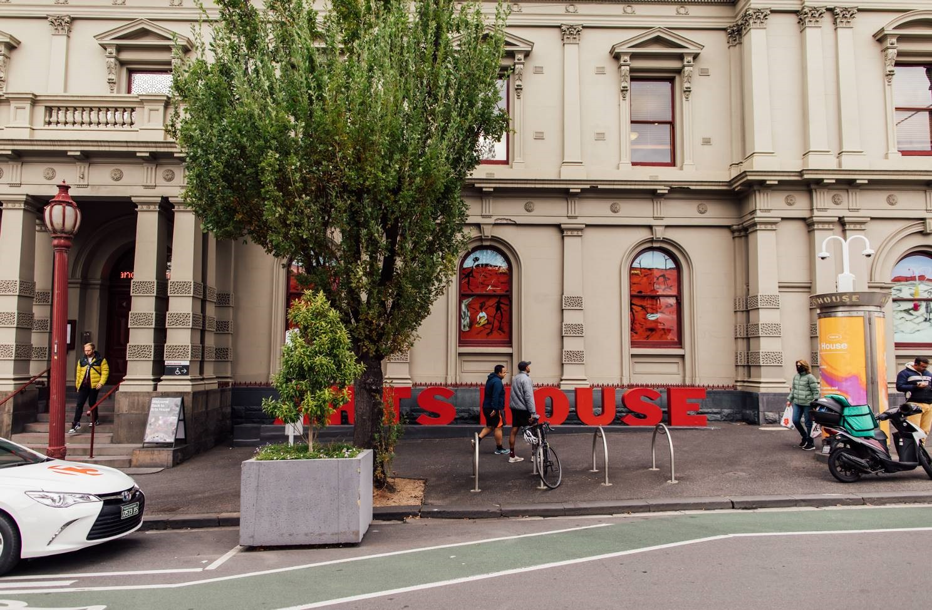

Image: North Melbourne Town Hall entrance on Queensberry Street. The entrance is to the left of the giant red letters that say ARTS HOUSE and features a staircase of eight steps with grab rails in parts.

Wheelchair Accessible Entrances

There are two Wheelchair Accessible Entrances. The first is on Errol St next to the Post Office.

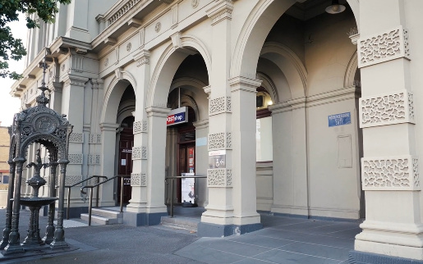

Image: Errol Street entrance next to the Post office with wheelchair accessible ramp or two steps with grab rails.
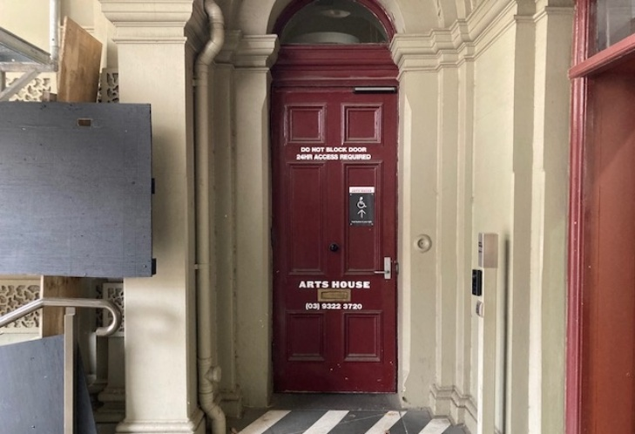
Image: View of door at Post office entrance.
Button to open automated door is on the right.

The second Accessible Entrance is towards the end of George Johnson Lane.

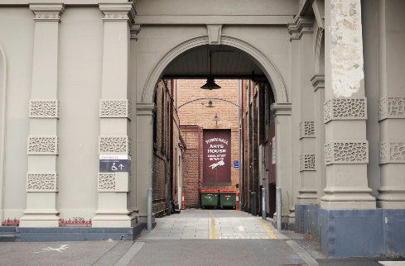

Image: View of George Johnson Lane from Errol St. The laneway passes through an archway with a brick wall at the end.
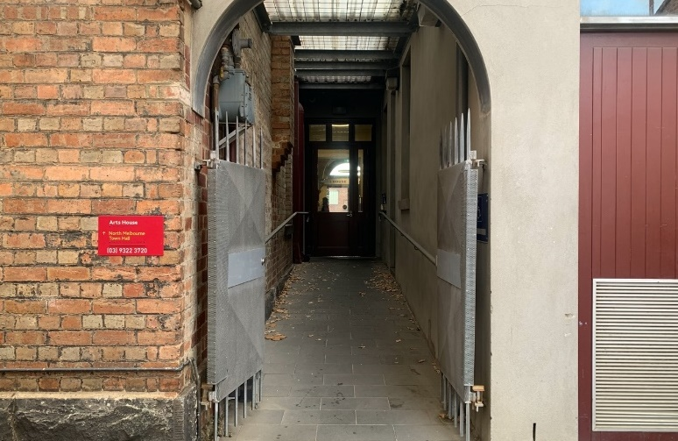

Image: view of the ramp with grab rail leading from George Johnson Lane to the automated door which opens into the Arts House foyer.

Box Office

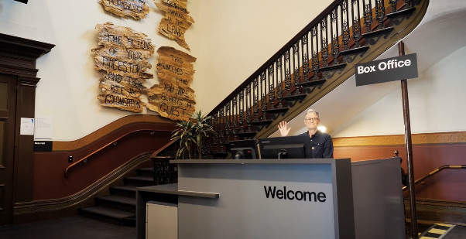
The Box Office is located in the foyer under the stairwell. If you enter from the Main Entrance it should be straight ahead of you. If entering from the Post Office or George Johnson lane your should approach on its right hand side.

Ushers

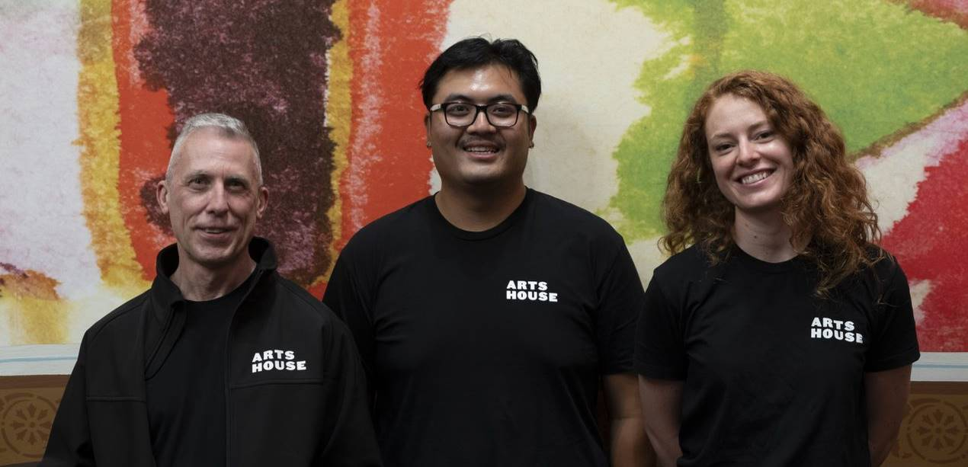

Ushers will be wearing black with an Arts House Logo on the left hand shoulder.

Bar

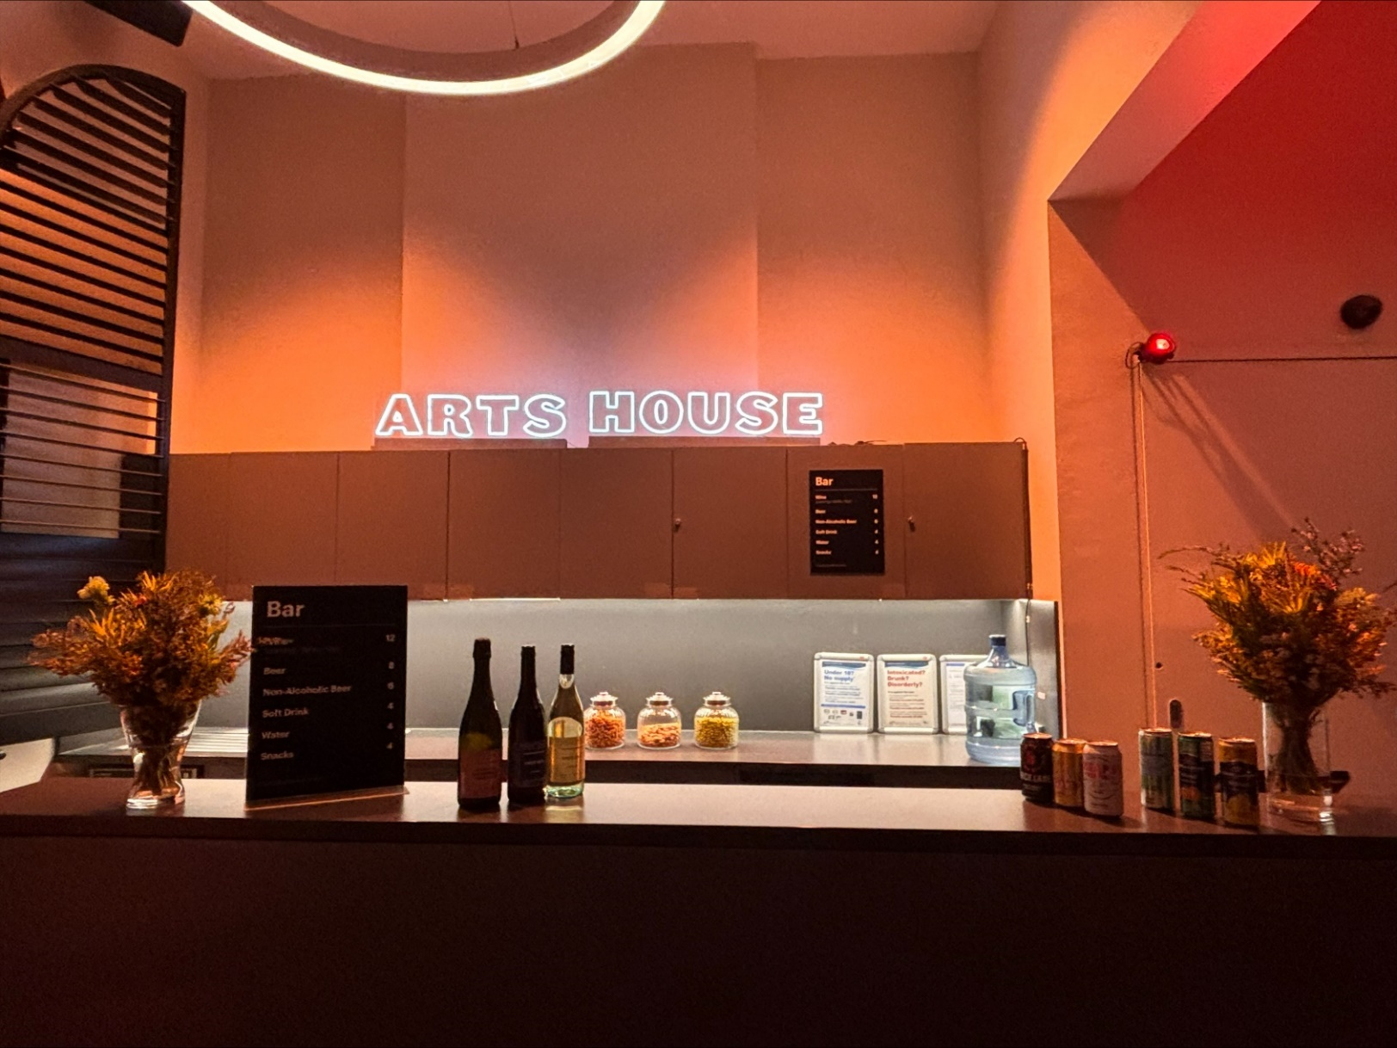
Image Description: The Arts House Bar with vases on each side of the bar filled with native flowers. In the centre there is a bar menu displayed with drinks set up on the top level on the bar. Towards the back wall there is a Arts House sign that is lit up. The lighting of the space is lit up orange.
The bar is to the Bar staff will be wearing black with an Arts House Logo.

We have a range of alcoholic and non-alcoholic beverages for sale.

We are a cashless venue and accept EFTPOS, Visa and Mastercard payments.

Quiet Space

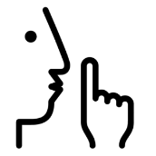

Arts House Quiet Space is located on Ground Level and is nearby reception and opposite the accessible bathrooms. It includes a range of seating options including soft furnishings, dimmable lights, sensory and stim objects. It is open during venue opening hours and events as a quiet space, prayer or parenting space.

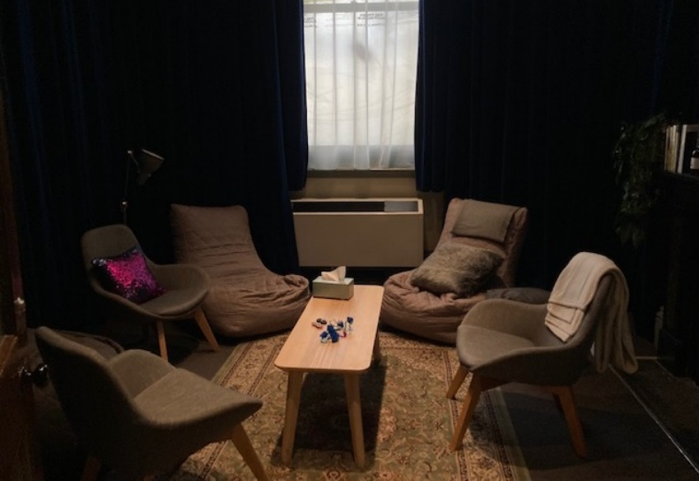Image: Quiet space with lights dimmed
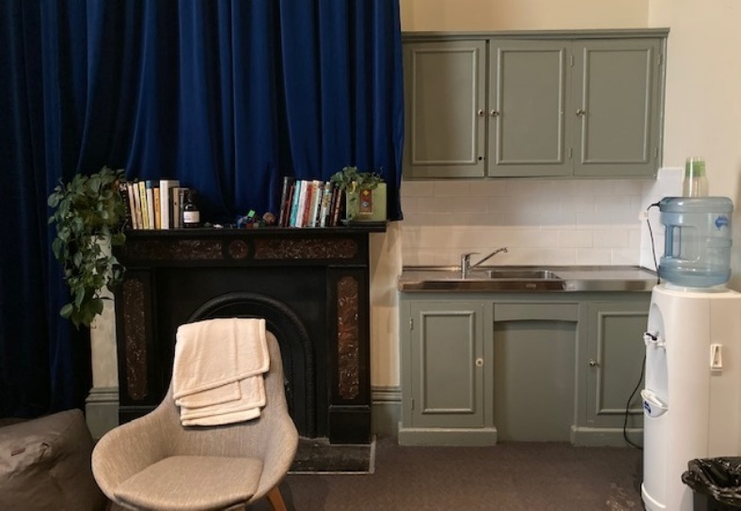
Image: Quiet space kitchenette and book shelf

Bathrooms

All bathrooms have Dyson hand dryers with sensor activation. There is an accessible bathroom that is single use on ground level opposite the Quiet Space. There is another accessible bathroom upstairs – this is accessible via lift or stairs.

Door to Main Hall

The exhibition is in the Main Hall.
It is on the ground floor.
It is to the left of the box office desk and right of the bar.
An artist statement is available on signage and warnings on the door.

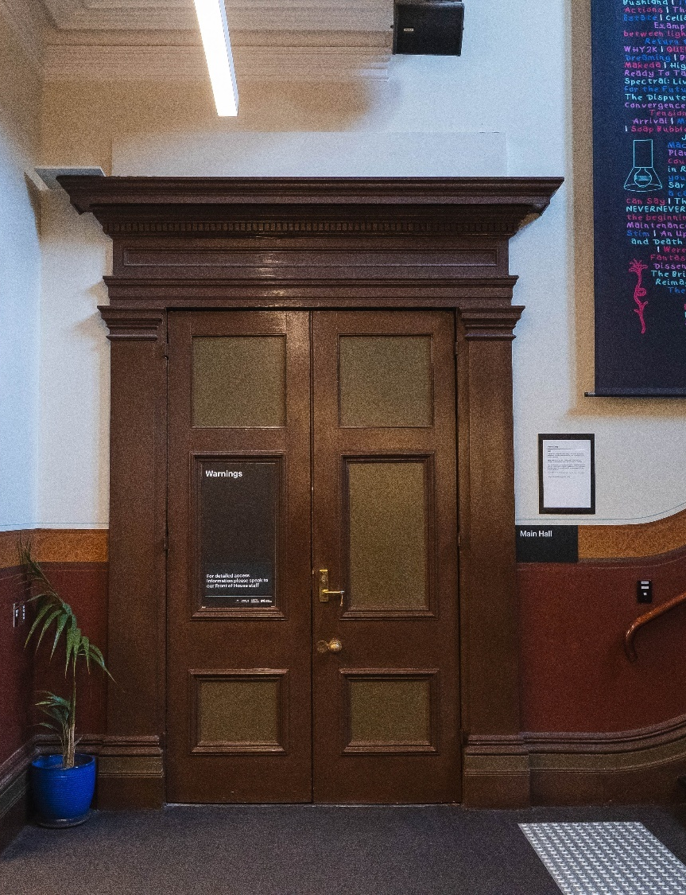

COVID Safet

Please note: If you have a cough, sore throat, fever, shortness of breath or flu-like symptoms, you must not attend our venue or programs in person.
We will provide a refund if you need to cancel your attendance due to illness. Please contact us by 9am on the day of the event.
To minimise the risk of COVID-19 transmission, we advise all patrons, artists and staff to:
- Wear a well fitted mask of P2 or comparable standards
- Practise physical distancing where possible
- Practise good hygiene by washing and or sanitising your hands often
- Test often (PCR or PlusLife testing recommended where possible)
- Stay up to date with vaccines (as recommended by your healthcare professional)
Throughout the venue you will find:
- hand sanitiser stations available
- masks available (ask one of our staff for assistance)​
- increased signage to direct patron movement and avoid crowd congestion
- two air filters, which move between different parts of the venue as needed.
We also ensure that spaces are well ventilated.
Staying COVID-safe remains important. We must all follow these steps:
- Follow the Victorian Government’s measures on how to stay safe.
- When you cannot safely socially distance it is recommended to wear a well fitted mask.
- Practise COVID-safe hygiene protocols.

