The Shepherds

By Carly Sheppard and Alisdair Macindoe
Access Guide

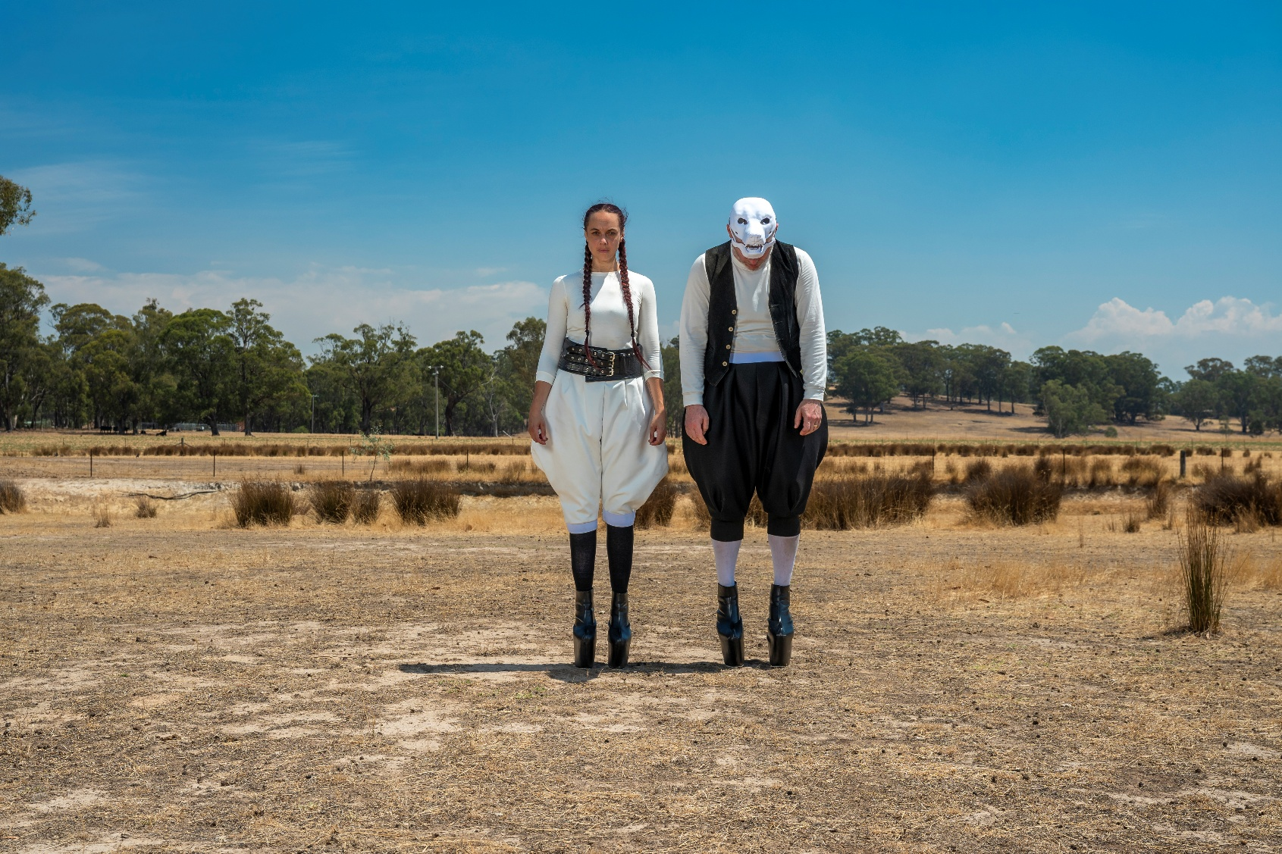Image Credit: Tiffany Garvie

Image Description: A wide landscape photograph shows two people standing side by side in the centre of a dry, open paddock. Both figures are directly facing the camera, standing upright on tall black hoofs (platform high heels). The person on the left wears a white long-sleeve top and loose white pants gathered at the calves, with black leggings and a wide dark belt around her waist. The person on the right wears a white long-sleeve shirt with a black vest and loose black pants, along with white socks. His face is covered by a white mask that looks like a dog’s skull.

Updates to this document

Please note, this performance is a new work and changes are being made by artists until opening. This guide will be updated as new information becomes available.

Arts House website will contain the most up to date version of this guide and all ticket holders will be notified of any changes made 3 days and 1 day prior to the event.

This document was created: 8 May 2026

Revision 1: 2 June 2026
Revision 2: 4 June 2026

Contents
Where 3
When 3
Show Overview 4
Important Notes 4
Content Warnings 4
General Notes 4
Access Services 5
Sensory Elements 7
Audience Experience 8
Transport 9
The Venue 10
COVID Safety 18

Where

Arts House
521 Queensberry Street
North Melbourne VIC

When

Friday 5 – Sunday 7 June 2026
Friday, 8pm
Saturday, 2pm & 8pm
Sunday, 2pm & 6pm

Duration: 70 mins, no interval

Show Overview

This show is a 60-minute show with four performers on stage.

The audience will be seated facing the stage, which has a white dance floor and a white back wall.
The show begins with two dark ‘beasts’ (Karlia and Tyrel) and two Shepherds (Carly and Alisdair) dancing on stage. Over the course of the show, the four performers participate in an act of mythmaking, becoming human, sheep and shepherds at various points. The work is set in an alternate universe, but also in our world.

Important Notes

Content Advice

Suitable for audiences 15+.
This performance of The Shepherds explores themes of colonial violence against Australia’s First Nations people. It contains adult themes, violence, triggering content, coarse language, smoke effects and haze, high pitched frequencies, loud music, very loud sound effects, sudden loud noises, flashing lights, abrupt lighting changes including colours, intensity and black out.
There is one moment where a performer has her arm cut off. This may be upsetting for some audience members.

Access Services

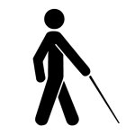
Audio Description and Tactile Tours are available on Sunday 7 June, 2pm
This is service is available on request by booking before Thursday 28 May.


Assistance Animals are welcome.

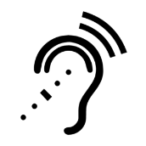

Assistive Listening is available free of charge. Ask staff for assistance on arrival.



Visual Rating 50% - A mixture of visual and auditory components including dialogue, music, other sounds.



Aural Rating 50% - A mixture of both sound and visual components like lighting, movement and physical design.



This performance is fully wheelchair accessible. More information on wheelchair accessible entrances and bathrooms can be found later in this guide.

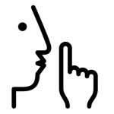
The quiet space will be available for you to use before and after the show. More information about the quiet space can be found later in this guide.

Companion card holders are welcome.

Performers

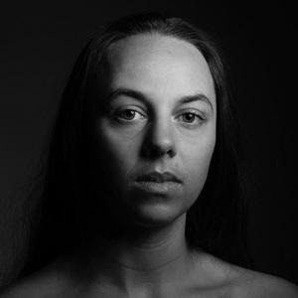

Carly Sheppard
Image Description: A black and white studio portrait of a woman with a composed, confident expression. She has long, dark hair that falls behind her back. One side of her face is well-lit, whereas the other side is partly in shadow. Her gaze is directed straight at the camera, creating a strong sense of presence.

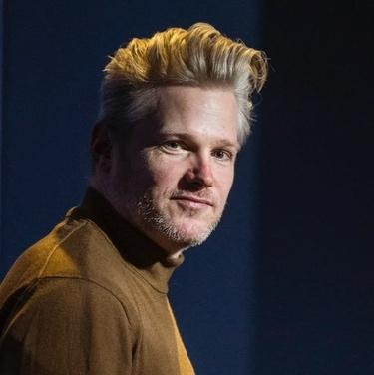

Alisdair Macindoe

Image Description: A colour headshot of a man with a short grey beard and hair. His hair is cut short on the sides with a longer, swept-back look on top. His body is positioned to the side/in profile, while his face looks front on at the camera with a confident expression. He is wearing a brown turtleneck against a navy-blue background.

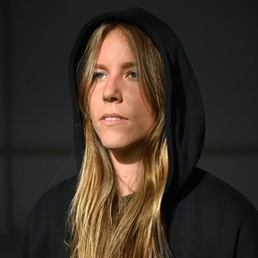

Karlia Cook

Image Description: A portrait of a woman diagonally facing the camera and looking off to the middle distance. She has long blond hair that frames her face and is wearing a dark coloured hoodie with the hood over her hair. Her face is brightly lit, while the background is in shadow. She wears a serious expression with her lips slightly parted.

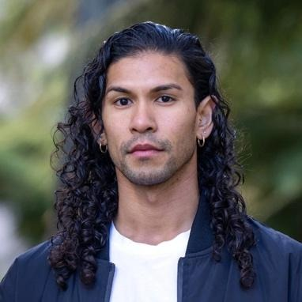

Tyrel Dulvarie

Image Description: An image of a man with long dark curly hair and light stubble. One side of his hair is tucked behind his ear, which is adorned with small silver earrings. He looks directly at the camera with a confident, composed expression. He is standing outside against a blurred green backdrop, wearing a white t-shirt and a navy-blue jacket.

Sensory Elements

Sound
There are overlapping sounds, with music containing low and high-pitched frequencies. There are moments when the music is quite loud it will vibrate the seating bank. Parts of the performance feature a disembodied, calm voice that sounds like a person describing a folk tale. Other parts of the performance include spoken text from two of the performers, Carly and Alisdair.
During the show, the performers play two different instruments. The first instrument is a shepherd's crook that has been modified to sound like a flute, producing a soft, eerie sound. The second instrument is a mechanical trombone-style contraption which is quite an abrasive sound.

Lighting
The lighting throughout the show moves between unexpected states, sometimes to the extreme.
At the beginning there is a blue frosted light coming from the rear of the stage, and a large sun-like light that beams onto the back wall. The performers on stage are backlit, and their bodies are silhouettes.
Throughout the show, the lighting will have about three moments of unexpected ‘glitching’ flashing and a red wash. To the audience, this will have a strobe effect which lasts for a few seconds each time it happens.
There is a sharp transition from dark, moody lighting into a full bright green wash. There is a complete blackout at one point and another moment where there is darkness except for a spotlight on the stage. There are no projections onto the audience.

Physical
There are moments when the sound will cause the seating bank to vibrate slightly. Towards the end of the show, there is a moment where it becomes windy in the theatre & fans blow on the performers. This should not affect the audience who are sitting on the seating bank, but they might notice a shift in the air.

Smell
There are no smells or scents in this performance. You may smell the theatrical haze used to fill the space from time to time.

Visual
The visuals in this work are designed to be unexpected. Some of them are smooth and satisfying transitions and transformations of props, beautiful, soft dance and choreography. Other times the images are harsh with stark colour contrast and strong movement. The floor and back wall of the theatre are white, and there is a large carcass hanging above the stage, and a grassy knoll on the ground to the front right.

Audience Experience

Entry to space
Audiences will gather in the foyer before entering the space, where an acknowledgement to country is played. Entry to the space is via the Main Hall doors to the theatre, and the audience is asked to sit in the seating bank in front of the stage. Ushers will be there to guide audiences into the space.

Shocks or surprises
Just before the show starts there is a sudden loud sound at the back of the seating bank to draw the audiences' attention. During this interruption, two performers will sit in the front row of the audience.

Throughout the show, the lighting will have about three moments of unexpected red flashing of a light. To the audience, this will have a strobe effect which lasts for a few seconds each time it happens. There is a sharp transition from dark and moody lighting into a full bright green wash.

Social expectations
The audience will not be expected to participate in the show, and we ask that movement in the seating bank is kept to a minimum where possible. There will be an usher seated by the door for anyone who would like to leave the theatre during the show. There is no lockout, however patrons will be asked to enter at certain points in the show which will be managed by the ushers in the foyer for those late or re-entering the space.

Performance expectations
The dancers may make eye contact with the audience at times during the performance, but there is no physical touch or close proximity with the audience at any time. There are moments when the performers will speak directly to the audience and there will be text played over the sound system. It is important that audience members can understand what is being said in these moments.

Transport

Tram

Route 57 (High Floor trams only)
Stop 12, North Melbourne Town Hall.
Please note, this is not a wheelchair accessible tram
GETTING TO ARTS HOUSE VIDEO LINK

Train

Arts House is 1.1km from
North Melbourne Train Station,
approximately 16 minute walk
North Melbourne Station Information
1.2km from Flagstaff Station,
approximately 15 minute walk
Flagstaff Station Information

Bus

Bus number: 216

Parking

There is limited paid on-street parking on Queensberry Street and Errol Street.

There are two accessible on street car parking spaces on Queensberry Street (150m to our accessible Errol Street entrance) for holders of a Parking Permit for Disabled people.

The Venue

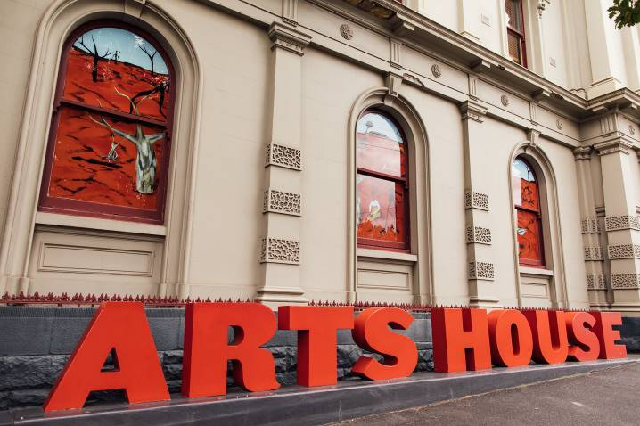
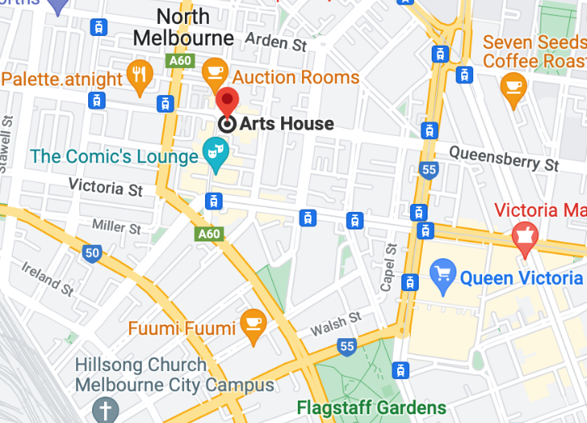

Image: North Melbourne Town Hall view from Queensberry Street which features giant red letters that say ARTS HOUSE out the front of it.

Image: a map of Arts House and its surrounding area. LINK TO MAP

Front Entrance

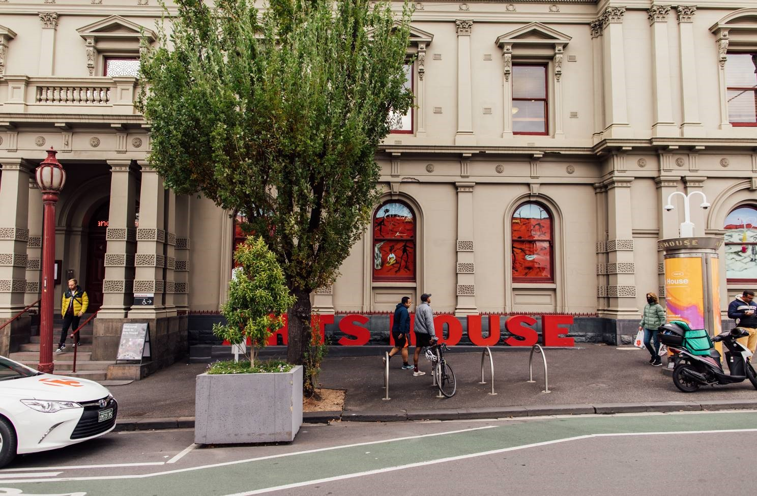

Image: North Melbourne Town Hall entrance on Queensberry Street. The entrance is to the left of the giant red letters that say ARTS HOUSE and features a staircase of eight steps with grab rails in parts.
Wheelchair Accessible Entrances

There are two Wheelchair Accessible Entrances. The first is on Errol St next to the Post Office.

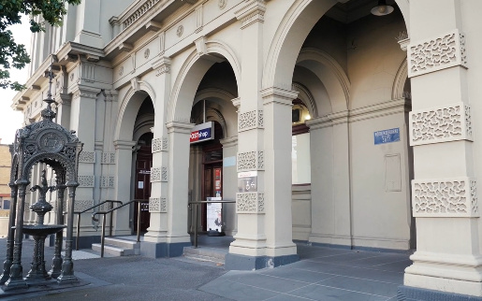

Image: Errol Street entrance next to the Post office with wheelchair accessible ramp or two steps with grab rails.
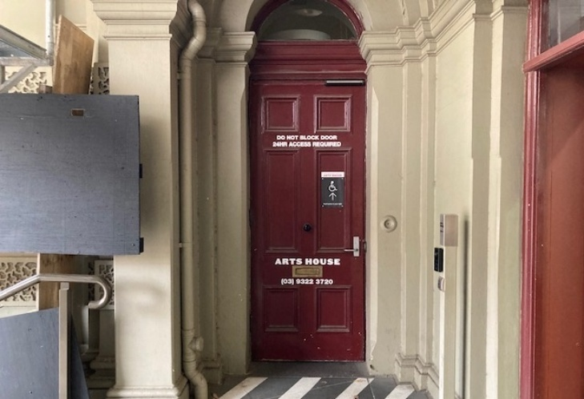
Image: View of door at Post office entrance.
Button to open automated door is on the right.

The second Accessible Entrance is towards the end of George Johnson Lane.

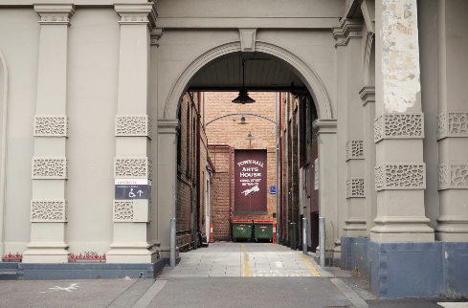

Image: View of George Johnson Lane from Errol St. The laneway passes through an archway with a brick wall at the end.
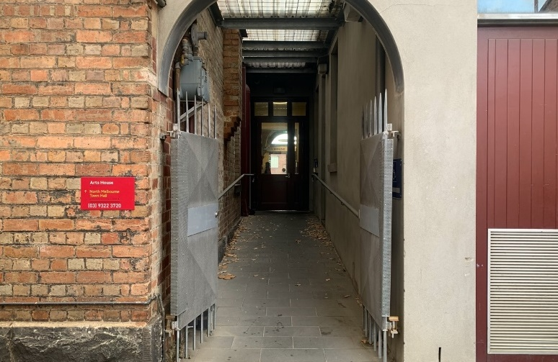

Image: view of the ramp with grab rail leading from George Johnson Lane to the automated door which opens into the Arts House foyer.

Box Office

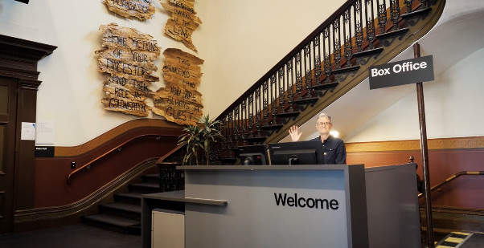

The Box Office is located in the foyer under the stairwell. If you enter from the Main Entrance it should be straight ahead of you. If entering from the Post Office or George Johnson lane your should approach on its right hand side.
Ushers

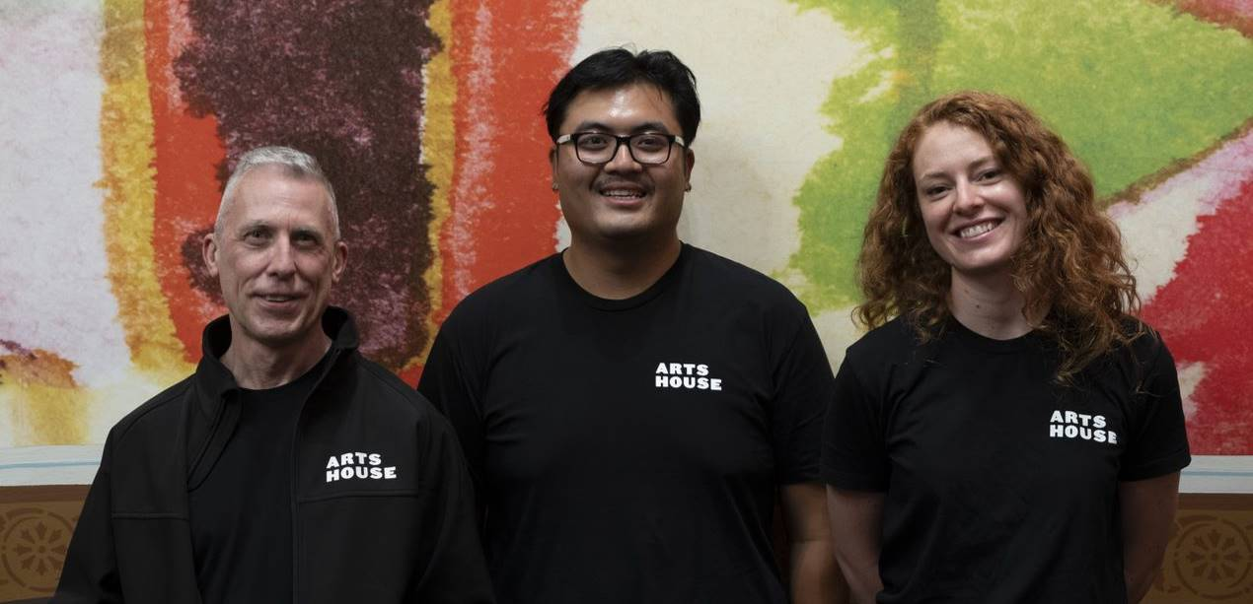
Ushers will be wearing black with an Arts House Logo on the left hand shoulder.
Bar

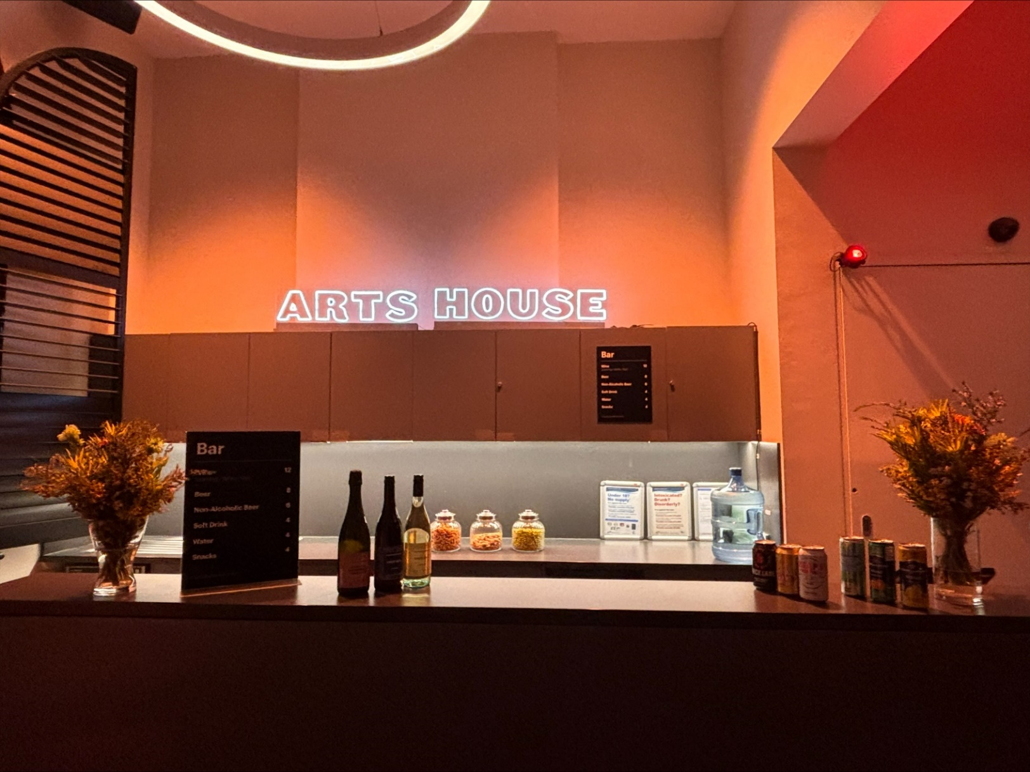
The bar is to the Bar staff will be wearing black with an Arts House Logo.

We have a range of alcoholic and non-alcoholic beverages for sale.

We are a cashless venue and accept EFTPOS, Visa and Mastercard payments.

Quiet Space

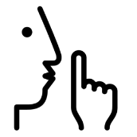
Arts House Quiet Space is located on Ground Level and is nearby reception and opposite the accessible bathrooms. It includes a range of seating options including soft furnishings, dimmable lights, sensory and stim objects. It is open during venue opening hours and events as a quiet space, prayer or parenting space.

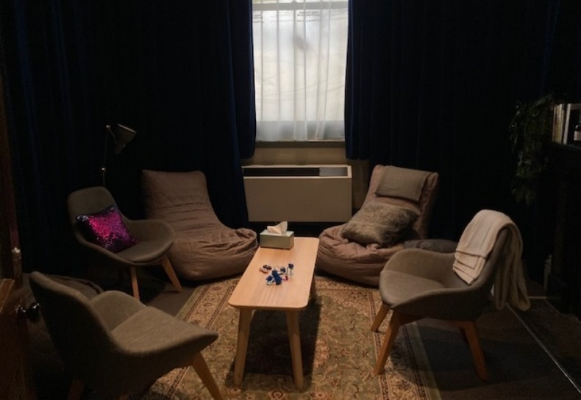Image: Quiet space with lights dimmed
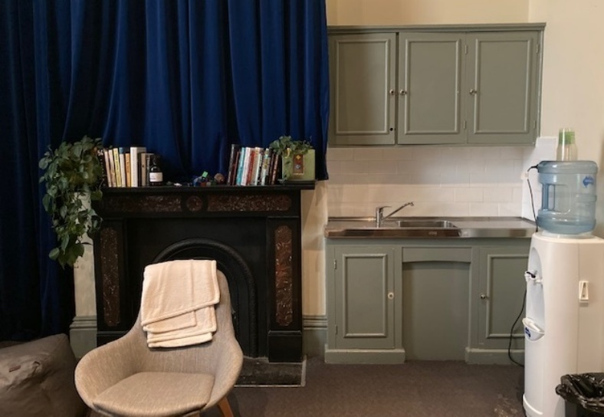
Image: Quiet space kitchenette and book shelf

Bathrooms

All bathrooms have Dyson hand dryers with sensor activation. There is an accessible bathroom that is single use on ground level opposite the Quiet Space. There is another accessible bathroom upstairs – this is accessible via lift or stairs.

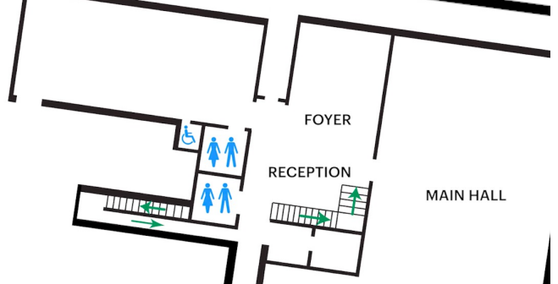

Image description: Floor plan of where bathrooms are located on the ground floor.

Door to Main Hall

The Performance is in the Main Hall.
It is on the ground floor.
It is to the left of the box office desk and right of the bar.
An artist statement is available on signage and warnings on the door.

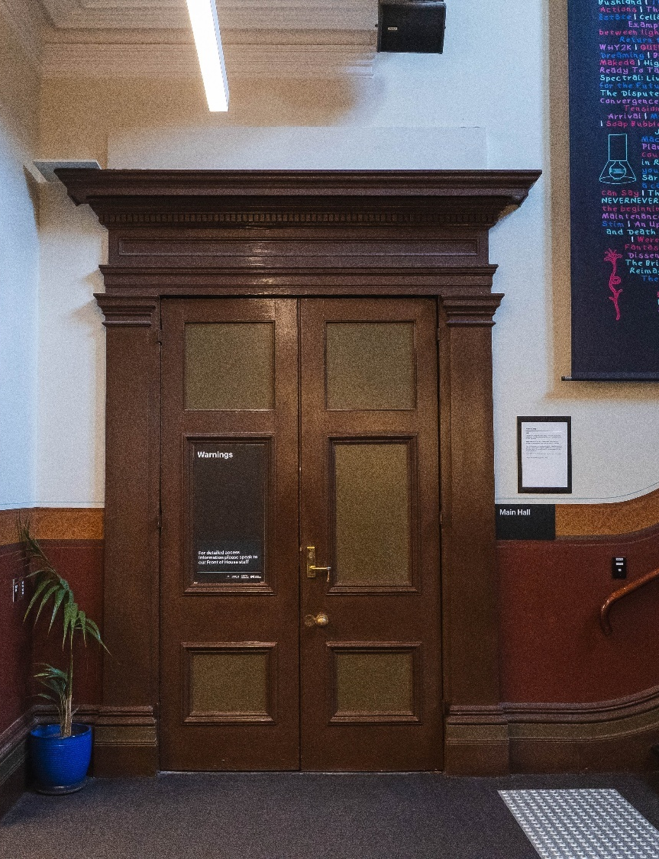

Image description: The Main Hall closed door.

COVID Safety

Please note: If you have a cough, sore throat, fever, shortness of breath or flu-like symptoms, you must not attend our venue or programs in person.
We will provide a refund if you need to cancel your attendance due to illness. Please contact us by 9am on the day of the event.
To minimise the risk of COVID-19 transmission, we advise all patrons, artists and staff to:
- Wear a well fitted mask of P2 or comparable standards
- Practise physical distancing where possible
- Practise good hygiene by washing and or sanitising your hands often
- Test often (PCR or PlusLife testing recommended where possible)
- Stay up to date with vaccines (as recommended by your healthcare professional)
Throughout the venue you will find:
- hand sanitiser stations available
- masks available (ask one of our staff for assistance)​
- increased signage to direct patron movement and avoid crowd congestion
- two air filters, which move between different parts of the venue as needed.
We also ensure that spaces are well ventilated.
Staying COVID-safe remains important. We must all follow these steps:
- Follow the Victorian Government’s measures on how to stay safe.
- When you cannot safely socially distance it is recommended to wear a well fitted mask.
- Practise COVID-safe hygiene protocols.

