1154 Days

By Cheng Lei, Emma Valente and Clyde White

Access Guide

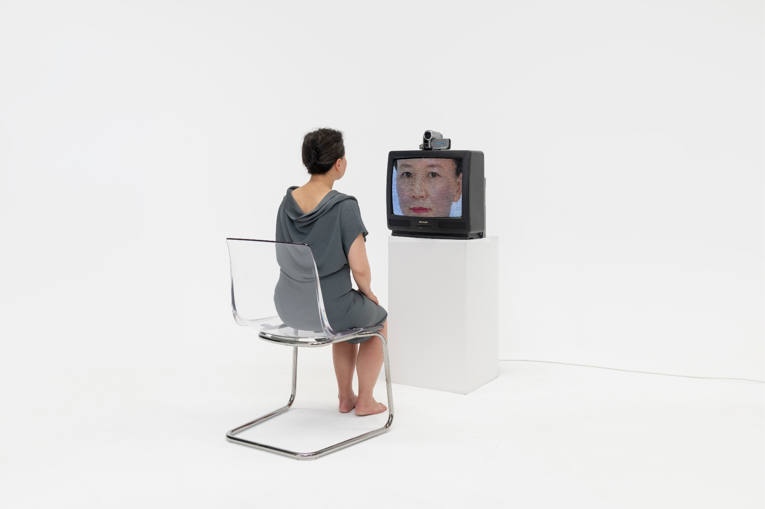

Image Credit: Sarah Walker

Image Description: In a stark white room, a woman sits barefoot on a chair facing an old CRT television. A small camera perched on the TV feeds her likeness back to her, filling the screen with an intimate, pixelated portrait. The simplicity of the scene heightens the tension between observer and observed, evoking themes of surveillance, self-reflection, and the quiet vulnerability of being seen.

Updates to this document

Please note, this performance is a new work and changes are being made by artists until opening. This guide will be updated as new information becomes available.

Arts House website will contain the most up to date version of this guide and all ticket holders will be notified of any changes made 3 days and 1 day prior to the event.

This document was created: 8 May 2026

Revision 1: 25 May 2026

Contents
Where 2
When 2
Show Overview 3
Important Notes 3
Content Warnings 3
General Notes 3
Access Services 4
Digital 7
Performers 8
Sensory Elements 8
Audience Experience 9
Transport 10
The Venue 11
COVID Safety 23

Where

Arts House
521 Queensberry Street
North Melbourne VIC

When

Thursday 28 – Sunday 31 May 2026

Thursday – Friday, 7.30pm
Saturday, 2pm & 7.30pm
Sunday, 5pm

Duration: 75 mins, no interval

Show Overview

This show is a 75-minute show performed on stage by Lei Cheng. For most of the show she will only be one performer on stage. Lei will be reenacting a time in her life where she was working as a journalist in China and was lured to work and detained for 1154 days.

Important Notes

Content Warnings

Suitable for audiences 16+

This performance of 1154 Days contains adult themes, violence, triggering content, coarse language, haze, high pitched frequencies, sudden loud noises, flashing lights, abrupt lighting changes including colours and intensity, and black out.

Access Services



Assistance Animals are welcome.

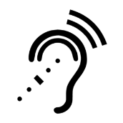

Assistive Listening is available free of charge. Ask staff for assistance on arrival.

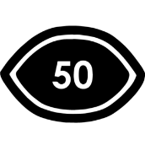

Visual Rating 50% - A mixture of visual and auditory components including dialogue, music, other sounds.



Aural Rating 50% - A mixture of both sound and visual components like lighting, movement and physical design.

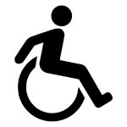

This performance is fully wheelchair accessible. More information on wheelchair accessible entrances and bathrooms can be found later in this guide.

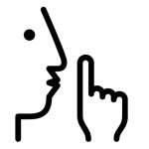
The quiet space will be available for you to use before and after the show. More information about the quiet space can be found later in this guide.

Companion card holders are welcome.

Performers

Performer: Cheng Lei
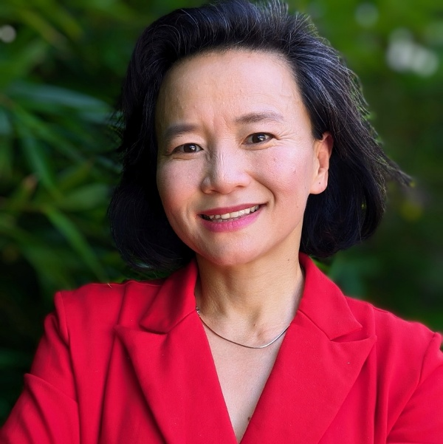

Image description: A photo of Lei, a woman with a black shoulder length bob. She is standing in front of a blurred green background wearing a bright red shirt and a silver necklace and is smiling.

Note: There will also two other performers in the show that are children. Their names and photos have not been included into the access guide.

Sensory Elements

Sound
The performance includes both sound effects and music coming from speakers dispersed across the theatre, some on stage and some above the audience. The show includes both loud and subtle sounds, which sometimes change rapidly.

Lighting
There are various lighting changes throughout the show and a full blackout at the end. The lighting will change slowly and sometimes abruptly, for example when transitioning quickly from darkness to a brightly lit stage.

Visual
The show includes multiple large screens on stands that move across the performance space throughout the show. The screens depict both prerecorded and live-streamed video from two cameras which also move on stage. In some scenes there are also large projections of the performer’s face and subtitles onto the back wall of the stage.

Audience Experience

Entry to space
Arts House ushers will guide audiences into the performance space located in the Main Hall. The Main Hall is located on the ground floor of Arts House.

Shocks or surprises
The performance includes loud sound effects of buzzers played at multiple points throughout the show which may feel shocking. Smoke and haze is also used briefly during the show.

Social expectations
The audience will be able to see the entire performance area from their seats. There is no audience participation in the show. Please feel free to do whatever you need to feel comfortable during the show. There will also be a Quiet Space on the ground floor of Arts House and toilets on both levels.

Performance expectations
For most of the show there will be only one performer on stage, but in some scenes, there will be two additional performers playing smaller roles. The performer will speak both aloud and through projected words on the back wall of the performance space. The performer will stay on the stage for the entire performance. There is no audience interaction.

Transport

Tram

Route 57 (High Floor trams only)
Stop 12, North Melbourne Town Hall.
Please note, this is not a wheelchair accessible tram
GETTING TO ARTS HOUSE VIDEO LINK

Train

Arts House is 1.1km from
North Melbourne Train Station,
approximately 16 minute walk
North Melbourne Station Information
1.2km from Flagstaff Station,
approximately 15 minute walk
Flagstaff Station Information

Bus

Bus number: 216

Parking

There is limited paid on-street parking on Queensberry Street and Errol Street.

There are two accessible on street car parking spaces on Queensberry Street (150m to our accessible Errol Street entrance) for holders of a Parking Permit for Disabled people.

The Venue

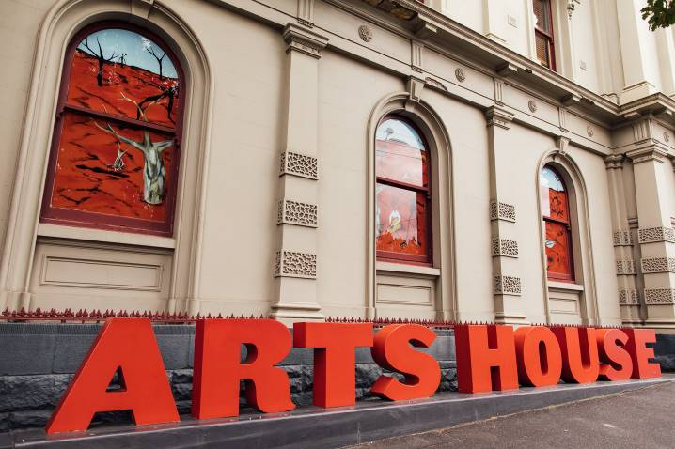
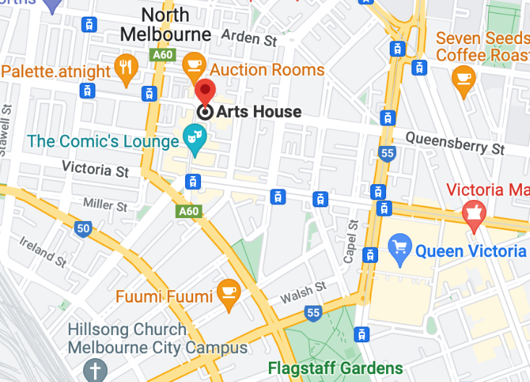

Image: North Melbourne Town Hall view from Queensberry Street which features giant red letters that say ARTS HOUSE out the front of it.

Image: a map of Arts House and its surrounding area. LINK TO MAP

Front Entrance

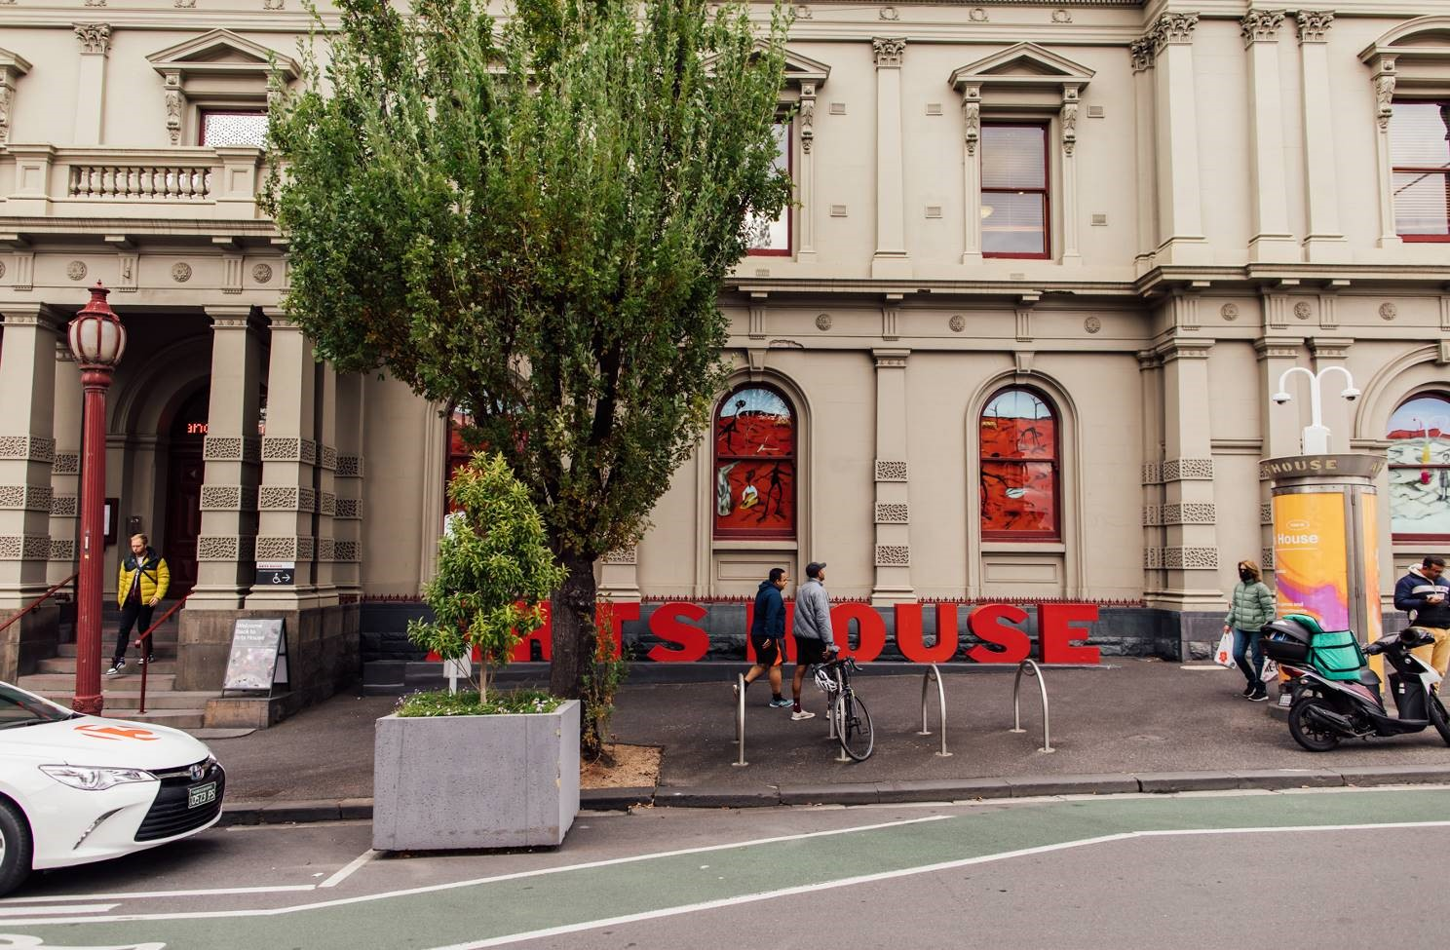

Image: North Melbourne Town Hall entrance on Queensberry Street. The entrance is to the left of the giant red letters that say ARTS HOUSE and features a staircase of eight steps with grab rails in parts.
Wheelchair Accessible Entrances

There are two Wheelchair Accessible Entrances. The first is on Errol St next to the Post Office.

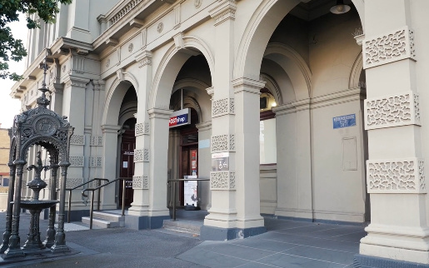

Image: Errol Street entrance next to the Post office with wheelchair accessible ramp or two steps with grab rails.
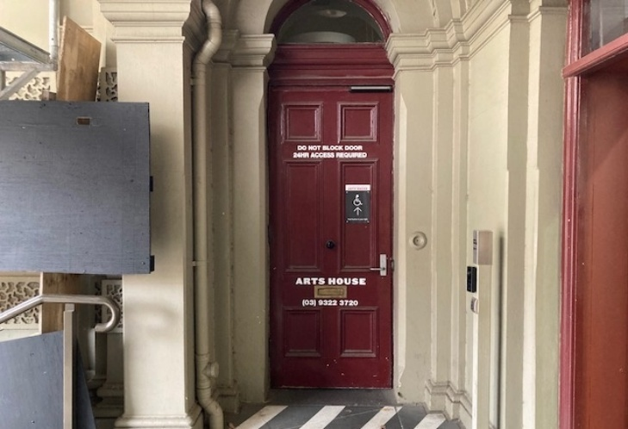
Image: View of door at Post office entrance.
Button to open automated door is on the right.

The second Accessible Entrance is towards the end of George Johnson Lane.

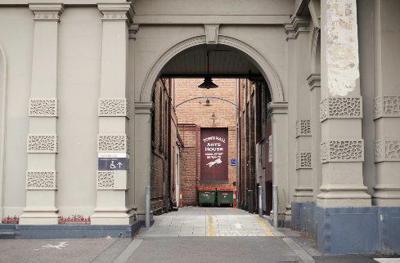

Image: View of George Johnson Lane from Errol St. The laneway passes through an archway with a brick wall at the end.
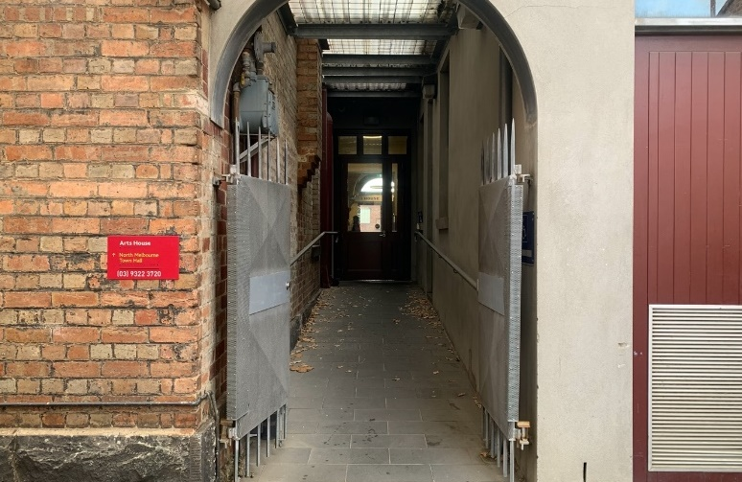

Image: view of the ramp with grab rail leading from George Johnson Lane to the automated door which opens into the Arts House foyer.

Box Office

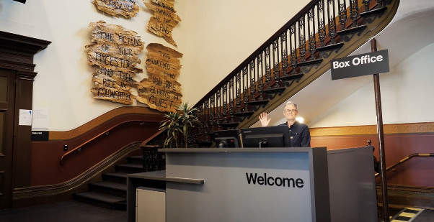

The Box Office is located in the foyer under the stairwell. If you enter from the Main Entrance it should be straight ahead of you. If entering from the Post Office or George Johnson lane your should approach on its right hand side.
Ushers

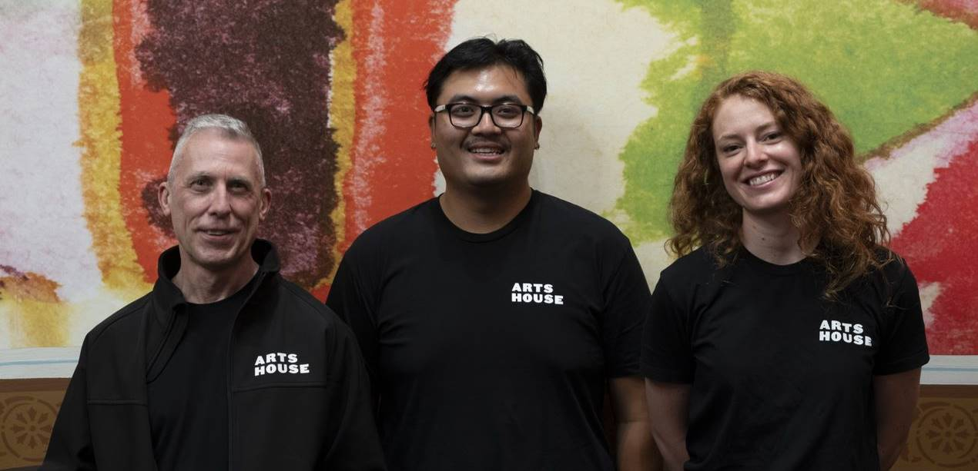
Ushers will be wearing black with an Arts House Logo on the left hand shoulder.
Bar

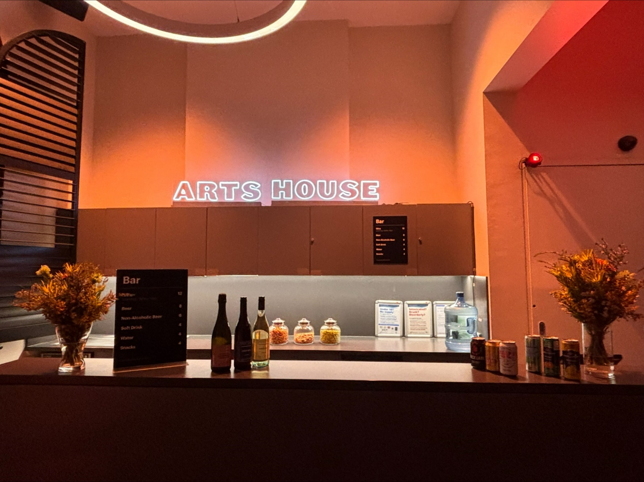
The bar is to the Bar staff will be wearing black with an Arts House Logo.

We have a range of alcoholic and non-alcoholic beverages for sale.

We are a cashless venue and accept EFTPOS, Visa and Mastercard payments.

Quiet Space

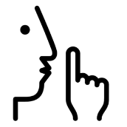
Arts House Quiet Space is located on Ground Level and is nearby reception and opposite the accessible bathrooms. It includes a range of seating options including soft furnishings, dimmable lights, sensory and stim objects. It is open during venue opening hours and events as a quiet space, prayer or parenting space.

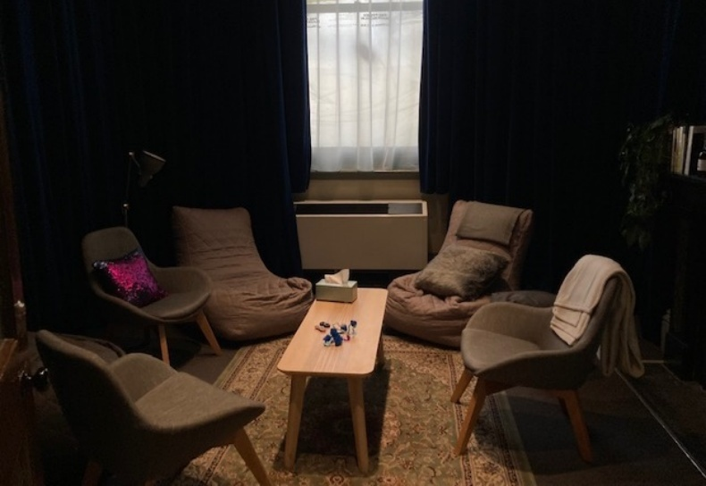Image: Quiet space with lights dimmed
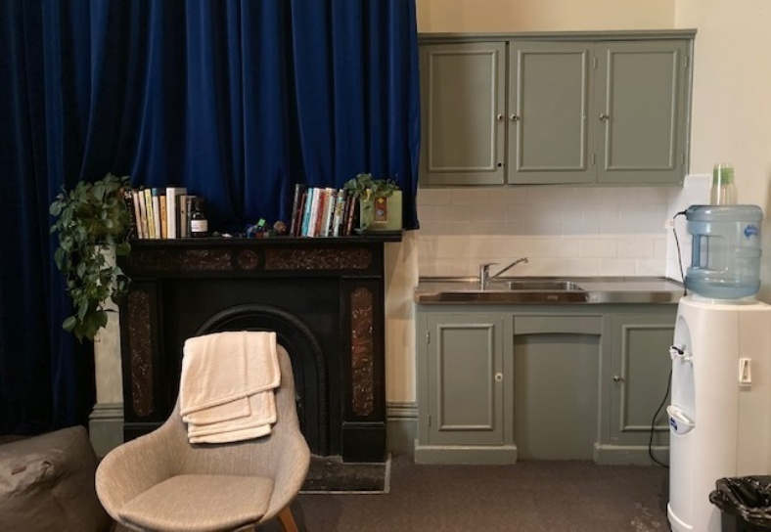
Image: Quiet space kitchenette and book shelf

Bathrooms

All bathrooms have Dyson hand dryers with sensor activation. There is an accessible bathroom that is single use on ground level opposite the Quiet Space. There is another accessible bathroom upstairs – this is accessible via lift or stairs.

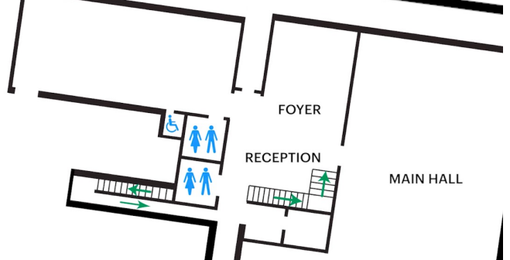

Door to Main Hall

The Performance is in the Main Hall.
It is on the ground floor.
It is to the left of the box office desk and right of the bar.
An artist statement is available on signage and warnings on the door.

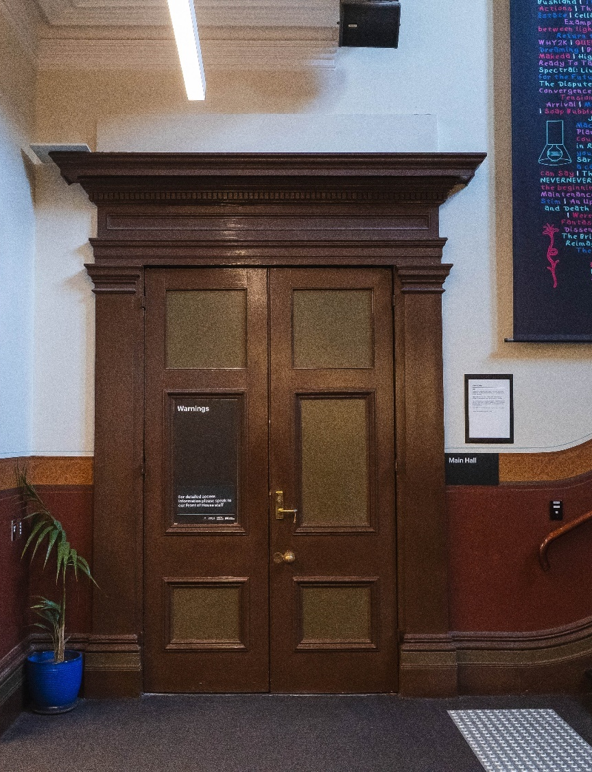

COVID Safety

Please note: If you have a cough, sore throat, fever, shortness of breath or flu-like symptoms, you must not attend our venue or programs in person.
We will provide a refund if you need to cancel your attendance due to illness. Please contact us by 9am on the day of the event.
To minimise the risk of COVID-19 transmission, we advise all patrons, artists and staff to:
- Wear a well fitted mask of P2 or comparable standards
- Practise physical distancing where possible
- Practise good hygiene by washing and or sanitising your hands often
- Test often (PCR or PlusLife testing recommended where possible)
- Stay up to date with vaccines (as recommended by your healthcare professional)
Throughout the venue you will find:
- hand sanitiser stations available
- masks available (ask one of our staff for assistance)​
- increased signage to direct patron movement and avoid crowd congestion
- two air filters, which move between different parts of the venue as needed.
We also ensure that spaces are well ventilated.
Staying COVID-safe remains important. We must all follow these steps:
- Follow the Victorian Government’s measures on how to stay safe.
- When you cannot safely socially distance it is recommended to wear a well fitted mask.
- Practise COVID-safe hygiene protocols.

