VIGIL

By Outer Urban Projects

Access Guide
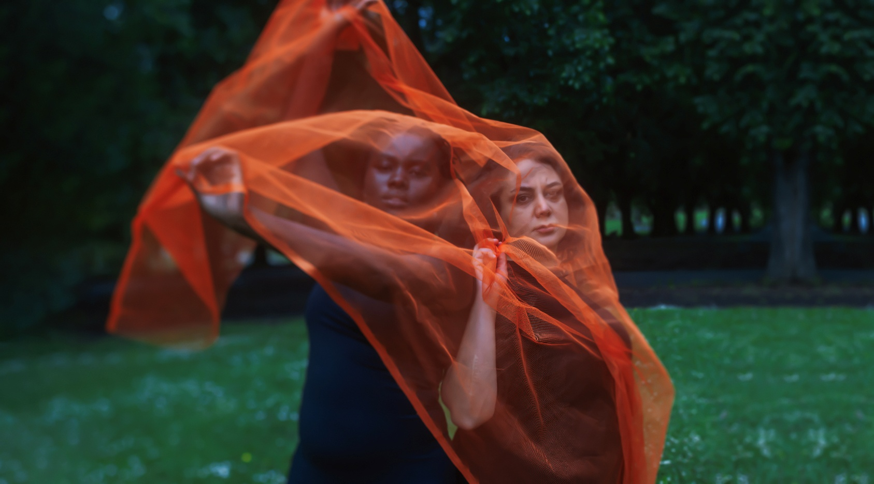

Image: Promotional image for the show
Image credit: Meredith O’Shea

Updates to this document

Please note, this performance is a new work and changes are being made by artists until opening. We will endeavour to provide the latest access information on performances to ticket holders across key stages of rehearsal and presentation.

Arts House website will contain the most up to date version of this document and all ticket holders will be notified of any revisions made 3 days and 1 day prior to the event.

This document was created: 20 March 2026
Contents
Updates to this document 1
Where 3
When 3
Access Services 3
Digital 6
Performers 7
Sensory Elements 7
Sound 7
Lighting 7
Physical 7
Smell 7
Visual 7
Entry to space 8
Shocks or surprises 8
Audience experience 8
Social expectations 8
Performance expectations 8
Other 8
Content Warnings 8
General Notes 9
The Venue 10
Front Entrance 10
Accessible Entrances 11
Box Office 12
Ushers 12
Bar 13
Quiet Space 16
Bathrooms 16
Door to Studio 1 17
Door to Studio 2 18
Door to Main Hall 19
Lift 20
The Warehouse 20
Transport 23
Tram 23
Train 23
Bus 23
Parking 23
COVID Safety 24

Where

Arts House
521 Queensberry Street
North Melbourne VIC

When

Wednesday 22 April – Sunday 3 May 2026
Preview: Wednesday 22 April, 7:30pm
Wednesday to Saturday, 7:30pm
Sunday, 5:00pm

Duration: 100 minutes, no interval.

Access Services

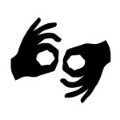
Auslan Interpreted Performance – Thursday 30 April



Assistance Animals are welcome.


Assistive Listening is available free of charge. Ask staff for assistance on arrival.

Visual Rating 50% – this performance has music and sounds in the background.


Aural Rating 50% – contains both sound and visual components, but sight is not essential to be able to engage with the event.


This performance is fully wheelchair accessible. More information is provided further below in this guide about the accessible entrances at Arts House and bathrooms.


Quite Space Available - The quiet space will be available for you to use before/during/after the show. More information about the quiet space can be found later in this guide.

Companion Card - Arts House supports the Companion Card program.

Show Overview

This is a 100-minute show performed on a ‘rostras’ - varying levels of platforms make the stage.

VIGIL is a polyvocal theatre work with interwoven stories made by visionary communities and creatives examining the intersections of public and private safety, race, gender, and terror in the streets of our city. VIGIL has something to ask Australia:

What lives matter?
Do our lives matter?

Important Notes

Content Advice:
This performance explores themes of trauma and violence. This includes gender, intimate and family-based violence, femicide, genocide, religious and cultural persecution, terror and war. It contains adult themes, coarse language, and triggering content. The work may include haze, low lighting, flashing lights and sudden loud sounds.

Suitable for ages 15+ (parental guidance is advised for -18)

If you or someone you know requires support:
outerurbanprojects.org/support-for-you-and-our-community/

While the work explores these strong themes there are no actual acts of violence portrayed on stage nor are any real-world events depicted within the work. The world in which VIGIL inhabits is our contemporary world with each character having experienced, faced, or facing through dialogue with other characters the themes in the work.

Some of the language in VIGIL used to describe the events and stories reflects past and contemporary expressions that can be harmful to people and communities. Specific behaviours expressed by some characters include racially discriminatory or racially prejudiced comments, sexist or gender-biased attitudes, homophobic or ableist remarks, culturally unsafe behaviour, and behaviours that target someone’s identity or background.

The work also contains strong coarse language (e.g. fuck, shit, bastards, bullshit, ass, idiots, kos kesh, old fart), religious-related profanity (fuck God, muzzie fucker, towel head), and references to violence, bombing, death and displacement. There are references to gendered oppression and political persecution, sexual references, references to sexual abuse in childcare centres (pedo’s), and scenes involving conflict, harassment and discrimination.

SYNOPSIS

The following summary of scenes in current order. It is intended to give audiences a deeper understanding of what to expect and the themes explored.

Note the order is subject to change and there is likely to be additional dance and or dramatic scenes sequences.

PROLOGUE: ACKNOWLEDGEMENT OF COUNTRY - Unc, a First Nations old man spirit rejects the notion of welcoming colonisers to this country.

SCENE 1: HENNA NIGHT - El Amal Arabic speaking women’s ensemble celebrate a bride and an upcoming wedding.

SCENE 2: VIGIL (THE SMILE FADES/ EL AMAL) BRIDE - El Amal Women’s Ensemble recall bloodshed and terror at the hands of their persecutors. They sing a lament to remember their murdered loved ones and their homeland.

DANCE 1

SCENE 3: DELILAH - MY MOTHER SAYS - A mother wants to keep her daughter, Delilah, safe and home at night. Her daughter doesn’t want to trade her freedom for so called ‘safety’. The young woman leaves the house against her mother’s wishes.

SCENE 4: DONYA AND KEREM - Donya, an Iranian woman and her partner Kerem, a Turkish man, are worried about the safety of her mother back in Iran. They discuss a piece of protest art they have just seen where an artist burns a hijab. A commuter wearing hijab takes offence. An argument about the Islamic Republic of Iran and freedom of speech in Iran and Australia ensues.

SCENE 5: UNC - An old First Nations man spirit conjures up life and country his mother and family before Naarm and Australia was colonised by the English Empire.

SCENE 6: GOODNIGHT - A poet recalls Naarm in the 1990’s and early 2000’s, woman's safety and violence back then compared to now, as she walks the night.
DANCE

SCENE 7: DELILAH - WAITING FOR THE TRAM - The young woman, Delilah, who left the house against her mother's wishes meets up with her old friend Naya. After initial excitement of reconnecting, they argue. Delilah blames Naya for not protecting her from an act of violence. Naya accuses Delilah of taking too many risks for her ‘so called’ freedom. Later, we see the threat had come from closer to her world.

SCENE 8: SURVIVING THE PEACE- Amna, a woman who has experienced war is trying to survive the peace. Her life is hard in Australia. She faces racism, culture clash and has had her children removed. Jacki, a support worker, does her best to support Amna while trying to contain Liz, a troubled young woman who provokes Amna’s temper with racist taunts. But when the danger surrounding Liz comes into focus, it is Amna and Jacki who move to shield her. And we learn that Jacki, as a First Nations woman, carries a past that asks to be grappled with.

SCENE 9: AUNT – Aunt is a spirit character. She tells a story of genocide in so called Victoria, including her own violent death at the hands of white men and her spirit returning to country.

DANCE 2

SCENE 10: A GOOD NIGHT OUT - Women commuters, coming straight from a comedy gig, laugh and purge themselves of sexist jokes about wives, and mothers. But when a man tells his own jokes and espouses freedom of speech to one remaining woman on her own, the laughter dies, and safety is not certain.

SCENE 11: DELILAH - A LADY WALKS INTO A BAR - Delilah, the young woman seeking her freedom, discusses her experience of sexual assault from someone in her community with a barman, challenging the barmen on his own lack of challenge to predatory men in his own community. At the end of the scene Delilah leaves the bar late, fearless, wanting to pursue her own personal freedom.

DANCE 3

SCENE 12: DORT – A First Nations woman recounts her love and connection to her cheeky, irreverent Blak mother, now deceased, and her mother's abuse and displacement within her white foster family and the broader community.

SCENE 14: VIGIL – All performers return to the stage and join a vigil.

Performers

ACTORS

Ali Ammouchi plays Kerem and Man Kamarra Bell-Wykes plays Jackie and Aunt
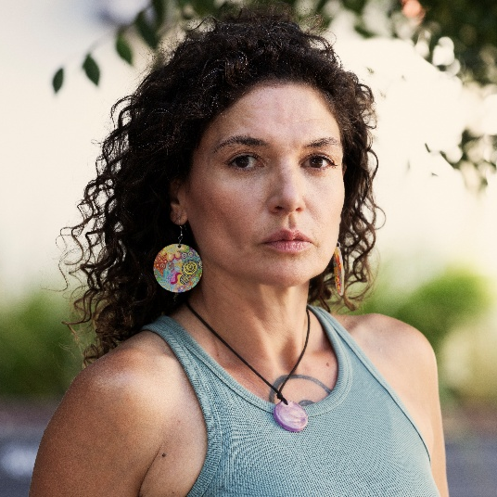
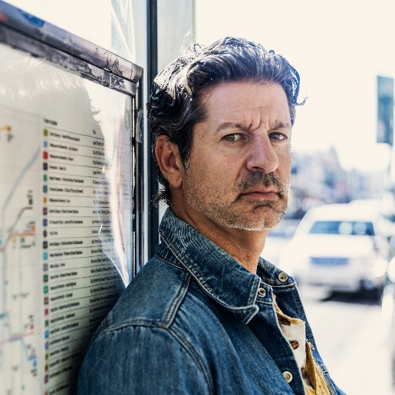

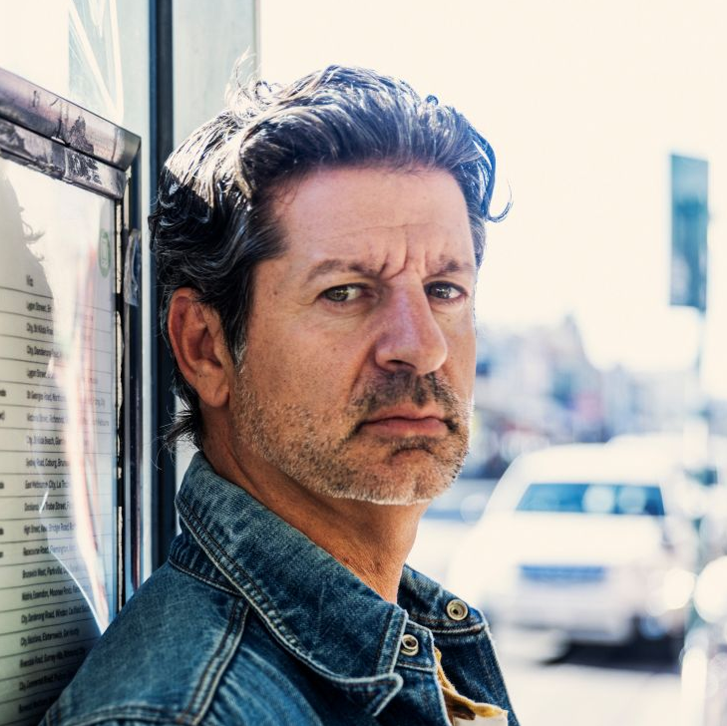
Navera Ari plays Delilah Rebecca Robinson plays Liz and Woman in Hijab
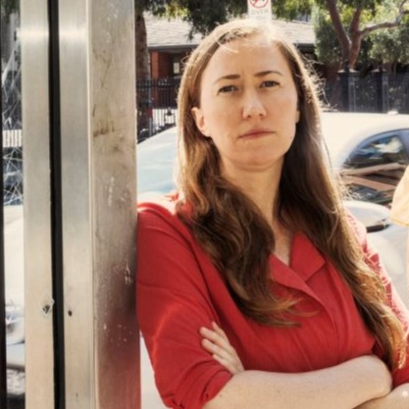
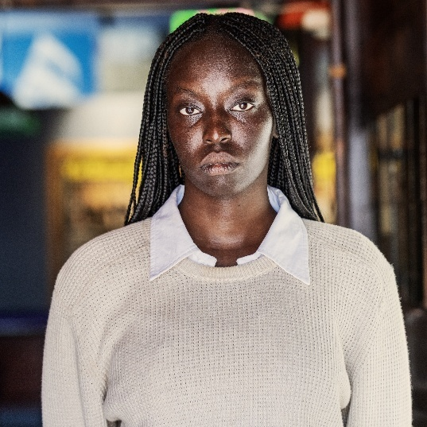

Nyawuda Chuol plays Fatima and Amna Sermsah Bin Saad Plays Unc and Bartender
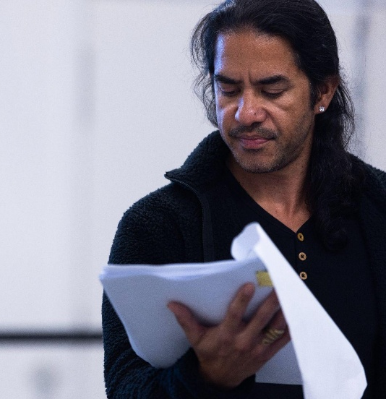
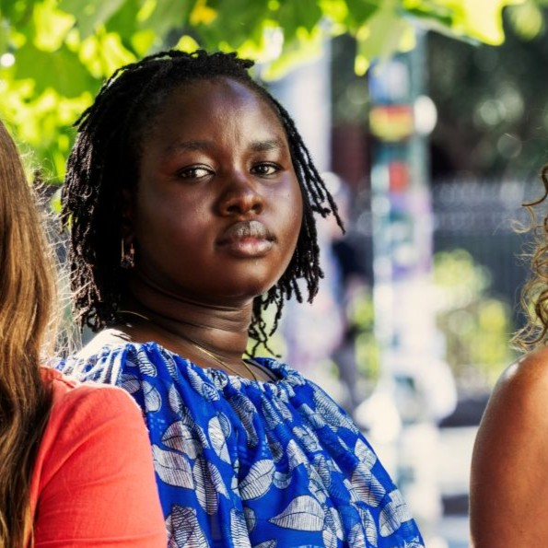

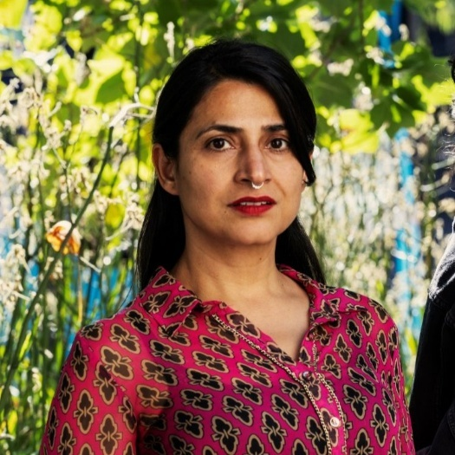
Carly Sheppard Plays Dort Joshinder Chaggar Plays Ana
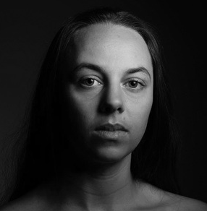

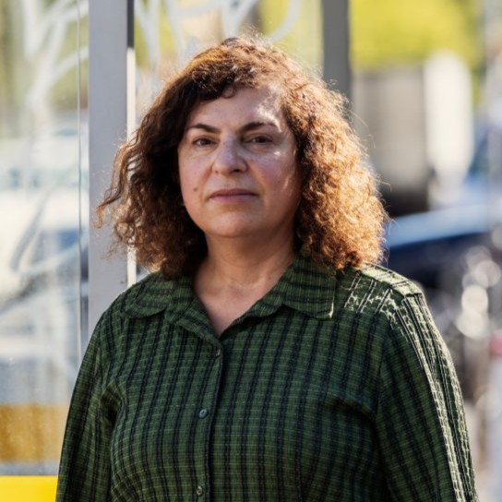
Taj Aldeeb Plays Bela and Bride Angela Costi Plays Angela
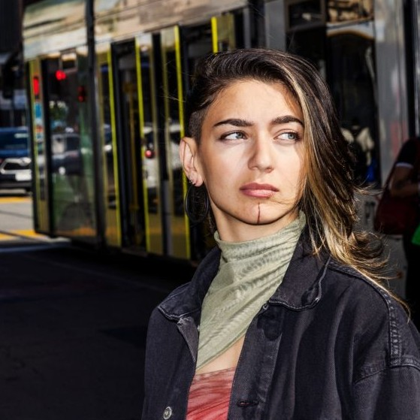

Sahra Davoudi plays Donya and Naya
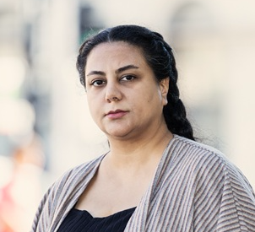

El Amal Women’s Ensemble
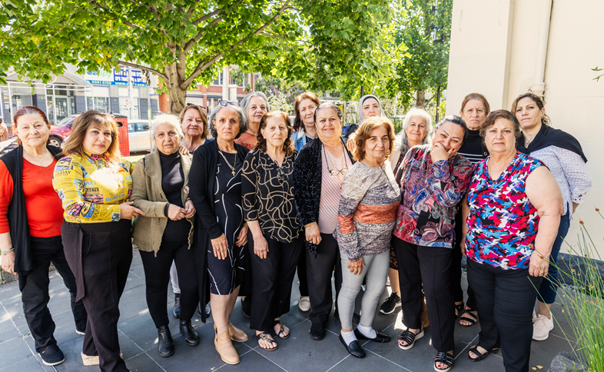

DANCERS

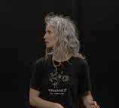
Georgia Rudd Michelle Heaven
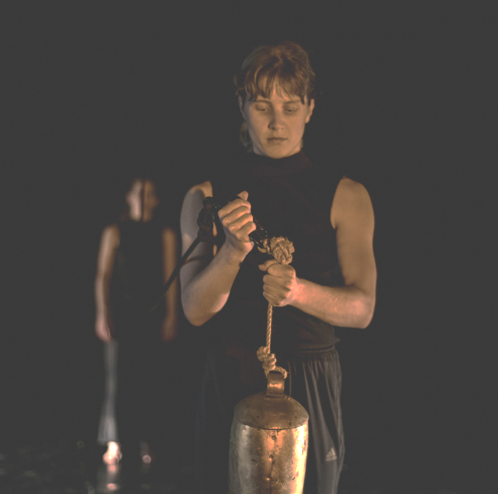

Michaela Tancheff Tara Jade Samaya (Understudy/Choreographer)
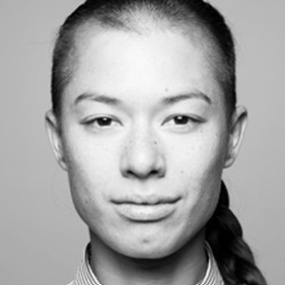
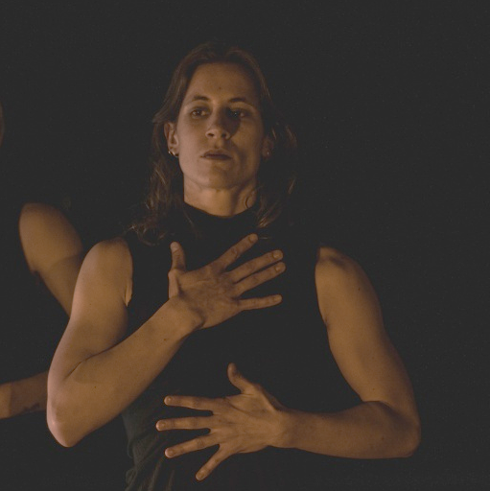

MUSICIANS

Paddy Montgomery Nic Synot
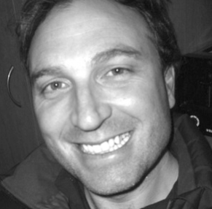
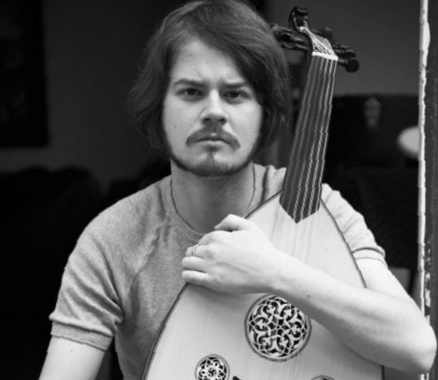

Sensory Elements

Sound

The sound can be loud at times, including the performers voices. Occasionally there are overlapping voices within the show.

There is live music overlapping with a soundscape which can include low frequencies, and high pitch vibrations. In one scene at the beginning of the performance there is vocal chanting followed by a sudden thumping sound inferring an explosion.

There are infrequently repetitive sounds or background noise at times: these include street scape sounds including trams and tram doors opening and closing, birds chirping and phone text message alerts occurring.

Lighting

Lighting does change in colour and intensity throughout the show and frequently. There are a few moments where the room has low light to darkness with a spotlight. There may be low level flashing lights.

There is no lighting or projection directly onto the audience. There are no mirrors or surfaces that reflect light on the audiences. There is a spark effect followed with small amount of smoke.

Physical

Audiences may feel vibrations of the live music and performers.

There is no interaction with the performers and the audience there is an approximately 1.2 metres distance between performers or audience.

Smell

There is a spark effect followed with small amount of smoke.

No other smells/scents are used in the performance, we cannot guarantee that audience members may not use perfumes or other scented products.

Visual
Frequent sounds of trams and street sounds are peppered throughout the performance. The set is designed to resemble a tram and a park at the same time. There are many performers on the stage at once. And at times there are not many at all.

There is nothing on stage which could fall or move unexpectedly.

Audience Experience

Entry to space

On arrival, audience members enter through the main Arts House building. They will see the back of the seating bank – the seating configuration resembles half a hexagon. Once the performance space is ready, the Main Hall doors will open for audiences to enter and take their seats.

Shocks or surprises

There is a loud bang and sparks at the beginning of the performance after the El Amal Women’s Ensemble begin chanting – this bang infers an explosion (a gun or a bomb).

Audience experience

The performers at times come close to the audience however they do not interact. Performers may make eye contact – however it will not be direct, they will not touch or ask audiences to participate. Audiences are expected to watch, listen and experience the work and not interact.

Social expectations

The audience will sit in five rows of seats, including accessible on the floor level. The seats are not able to be moved. There is ample space for multiple wheelchair users. The audience is seated throughout the performance and will not be moving around. However, if audiences members are required to leave the space due to the content of the work – they are welcome to.

No food is permitted to be eaten during the performance, unless it is an access requirement. Stim toys are welcome.

Performance expectations

There is dialogue, dance, live music and poetry throughout the performance. The performance features monologues, songs, music dance and chanting.

There are 11 actors, 3 dancers and 3 musicians all of whom perform on stage, some leave the stage and return, some depart or move around the stage. Many of the actors play various characters across 5 plays within the one play.

All the performers are distinguishable from staff by their costumes. Staff will be wearing black.

Relaxed Space

These are not relaxed performances in the usual sense, but audiences are welcome to come and go as they please if they have a strong response to the work. Audiences are welcome be themselves, make appropriate noise, stim, and respond to the work for the duration.

Other

Outer Urban Projects and Arts House have mental health first aid responders available if needed. See an Arts House usher to direct you to a mental health first aid officer.

If you or someone you know requires support:
outerurbanprojects.org/support-for-you-and-our-community/

The Venue

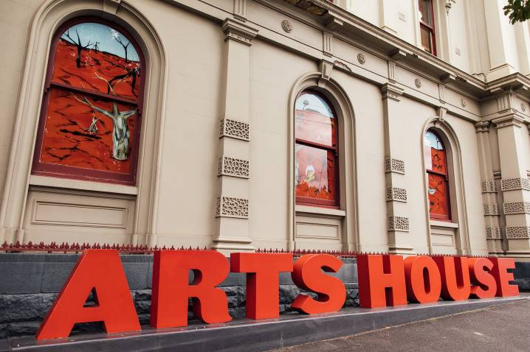
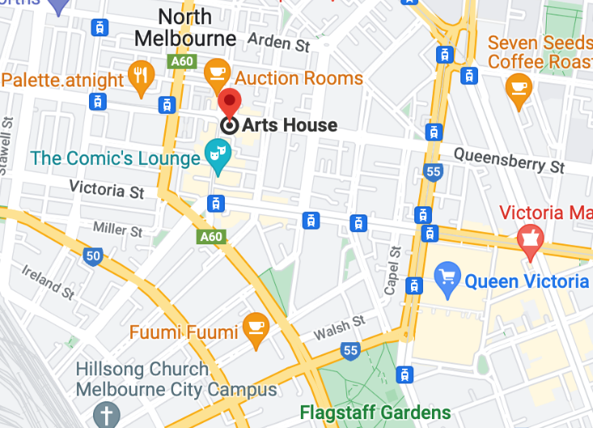

Image: North Melbourne Town Hall features giant red letters that say ARTS HOUSE out the front of it.

Image: a map of Arts House and its surrounding area. LINK TO MAP

Front Entrance

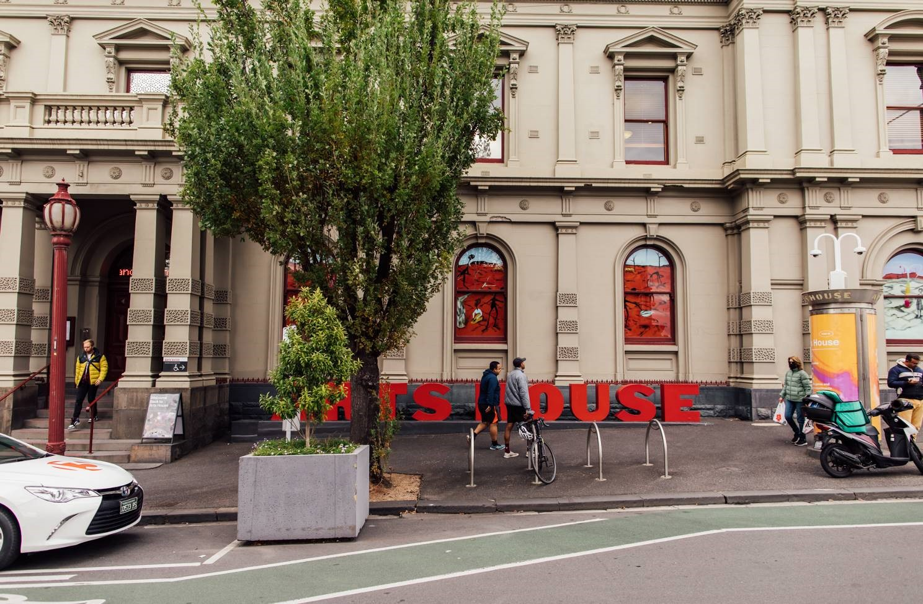

Accessible Entrances

There are two Accessible Entrances. The first is on Errol St next to the Post Office.

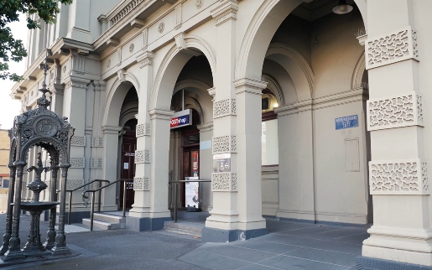

Image: Errol Street entrance next to the Post office with wheelchair accessible ramp or two steps with grab rails.
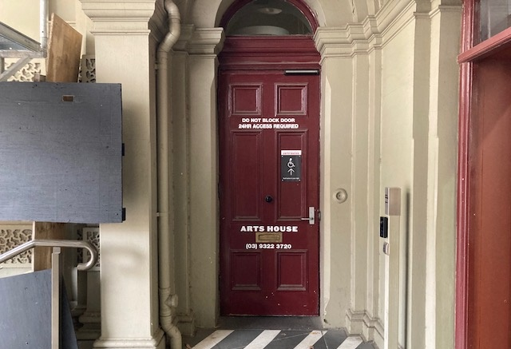
Image: View of door entrance.

The second Accessible Entrance is towards the end of George Johnson Lane.

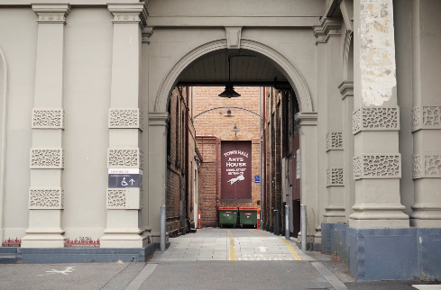

Image: View of George Johnson Lane from Errol St. The laneway passes through an archway with a brick wall at the end.
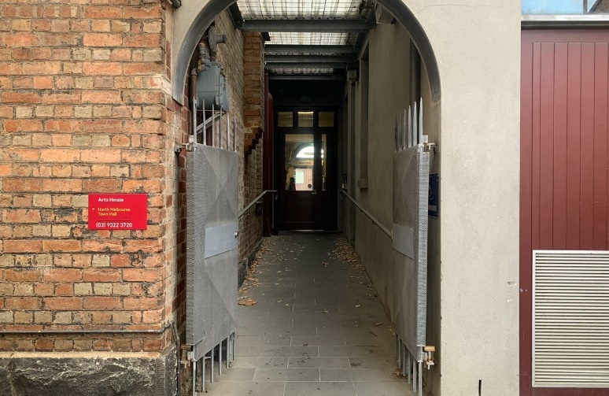

Image: view of the ramp leading from George Johnson Lane to the automated door which opens into the Arts House foyer.

Box Office

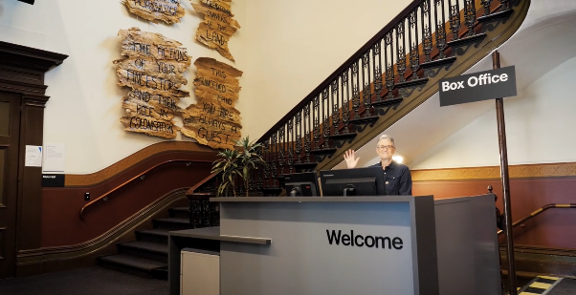

Image description: The Box office at Arts House, located in the ground floor foyer.

The Box Office is located in the foyer under the stairwell. If you enter from the Main Entrance it should be straight ahead of you. If entering from the Post Office or George Johnson lane your should approach on its right hand side.

Ushers

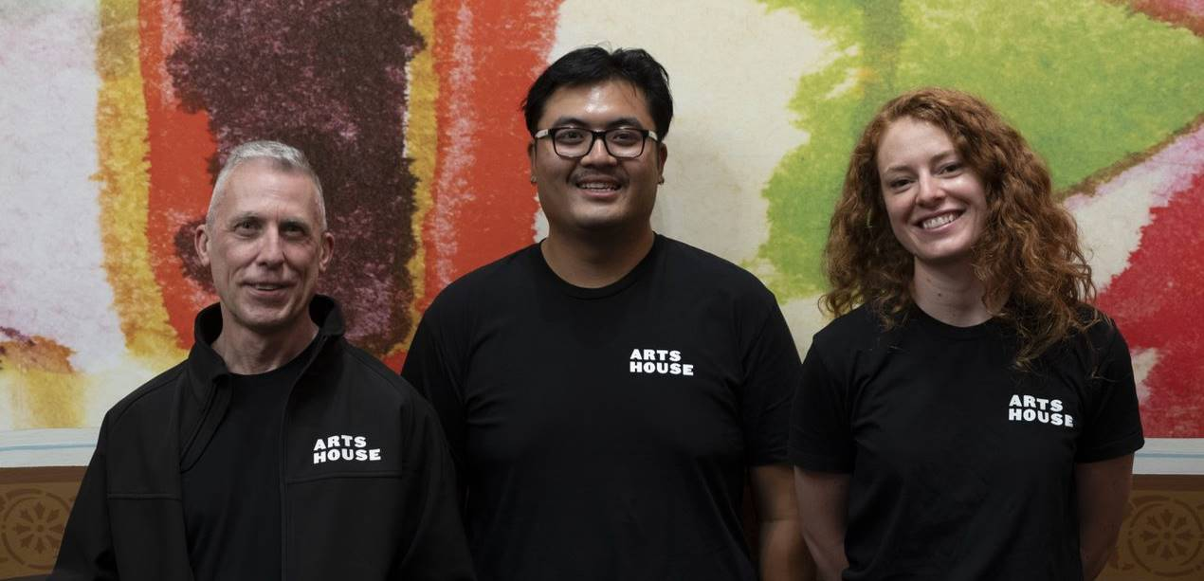

Image description: Three Arts House ushers wearing black shirts with ARTS HOUSE written on the left shoulder.

Bar

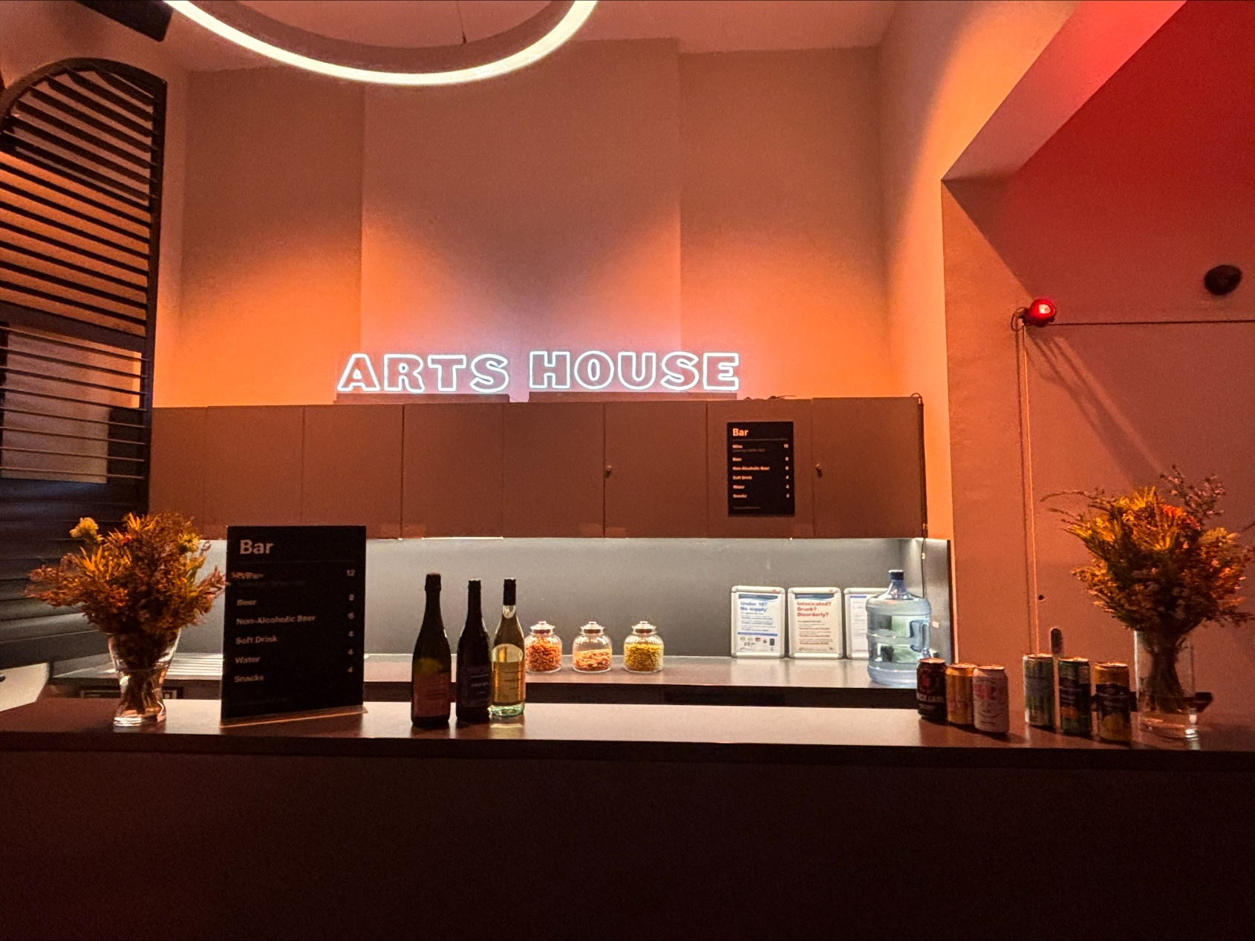

Image Description: The Arts House Bar with vases on each side of the bar filled with native flowers. In the centre there is a bar menu displayed with drinks set up on the top level on the bar. Towards the back wall there is a Arts House sign that is lit up. The lighting of the space is lit up orange.
Bar staff will be wearing black with an Arts House Logo.

We have a range of alcoholic and non-alcoholic beverages for sale.

We are a cashless venue and accept EFTPOS, Visa and Mastercard payments.

Quiet Space



Arts House Quiet Space is located on Ground Level and is nearby reception and opposite the accessible bathrooms. It includes a range of seating options including soft furnishings, dimmable lights, sensory and stim objects. It is open during venue opening hours and events as a quiet space, prayer or parenting space.

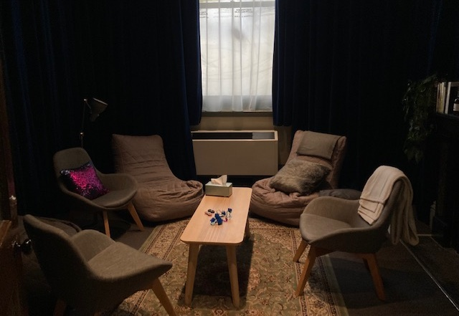

Image: Quiet space with lights dimmed
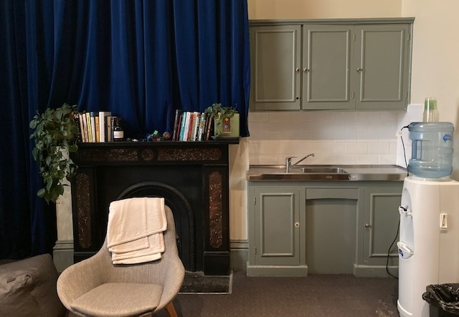

Image: Quiet space kitchenette and book shelf

Bathrooms

All bathrooms have Dyson hand dryers with sensor activation. There is an accessible bathroom that is single use on ground level opposite the Quiet Space. There is another accessible bathroom upstairs – this is accessible via lift or stairs.
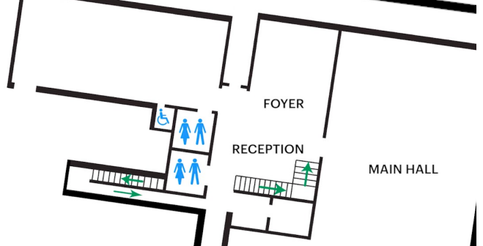

Door to Main Hall

The Performance is in the Main Hall.
It is on the ground floor.
It is to the left of the box office desk and right of the bar.
An artist statement is available on signage and warnings on the door.

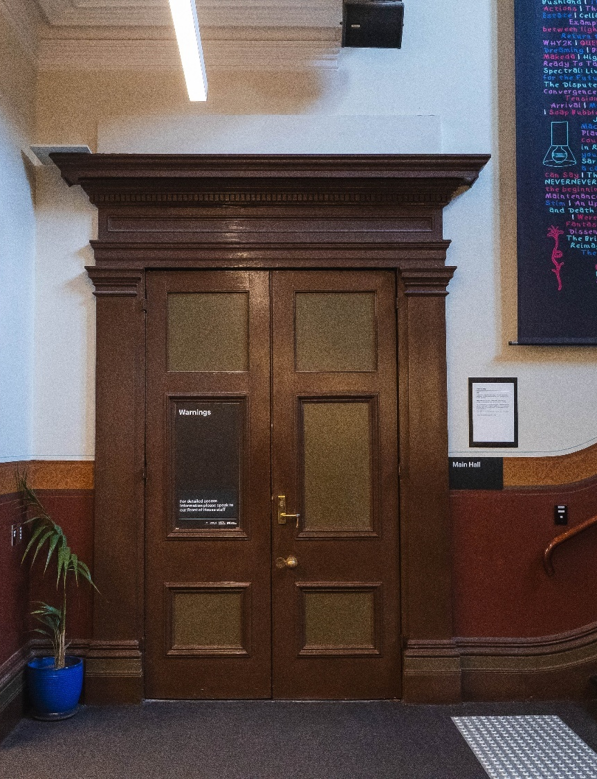

Image description: Closed brown wooden doors with a sign on the right hand side that states this entry is for the Main Hall.

Lift

The Ground Floor Lift is located behind reception desk in the foyer.
The closest entry to the lift is via George Johnson Lane.
The lift has buttons with braille. It also has audio cues inside.

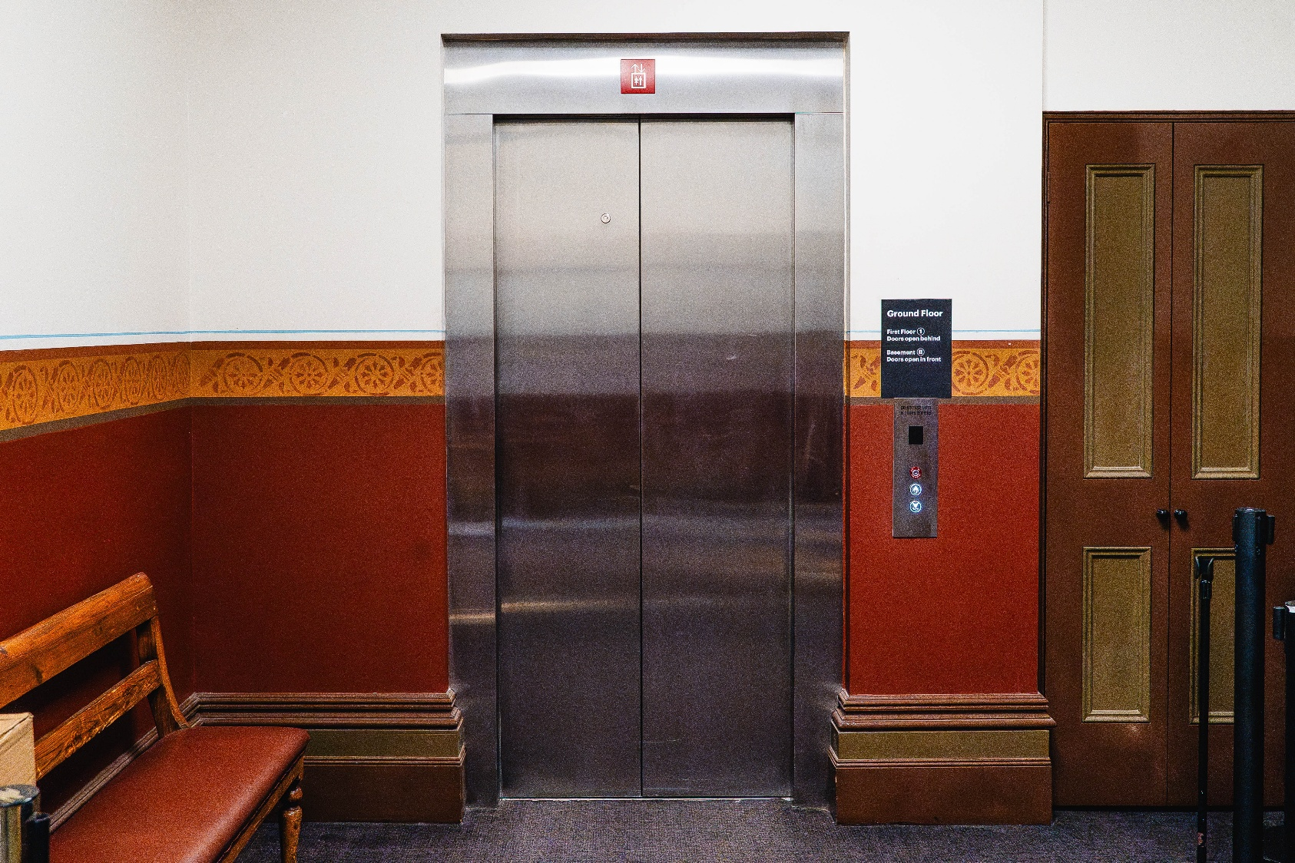
Image description: External entrance to the elevator.

Transport

Tram

Route 57 (High Floor trams only)
Stop 12, North Melbourne Town Hall.
Please note, this is not a wheelchair accessible tram
GETTING TO ARTS HOUSE VIDEO LINK

Train

Arts House is 1.1km from
North Melbourne Train Station,
approximately 16 minute walk
North Melbourne Station Information
1.2km from Flagstaff Station,
approximately 15 minute walk
Flagstaff Station Information

Bus

Bus number: 216

Parking

There is limited paid on-street parking on Queensberry Street and Errol Street.

There are two accessible on street car parking spaces on Queensberry Street (150m to our accessible Errol Street entrance) for holders of a Parking Permit for Disabled people.

COVID Safety

Please note: If you have a cough, sore throat, fever, shortness of breath or flu-like symptoms, you must not attend our venue or programs in person.
We will provide a refund if you need to cancel your attendance due to illness. Please contact us by 9am on the day of the event.
To minimise the risk of COVID-19 transmission, we advise all patrons, artists and staff to:
- Wear a well fitted mask of P2 or comparable standards
- Practise physical distancing where possible
- Practise good hygiene by washing and or sanitising your hands often
- Test often (PCR or PlusLife testing recommended where possible)
- Stay up to date with vaccines (as recommended by your healthcare professional)
Throughout the venue you will find:
- hand sanitiser stations available
- masks available (ask one of our staff for assistance)​
- increased signage to direct patron movement and avoid crowd congestion
- two air filters, which move between different parts of the venue as needed.
We also ensure that spaces are well ventilated.
Staying COVID-safe remains important. We must all follow these steps:
- Follow the Victorian Government’s measures on how to stay safe.
- When you cannot safely socially distance it is recommended to wear a well fitted mask.
- Practise COVID-safe hygiene protocols.

