VIGIL – Film Installation

By Outer Urban Projects

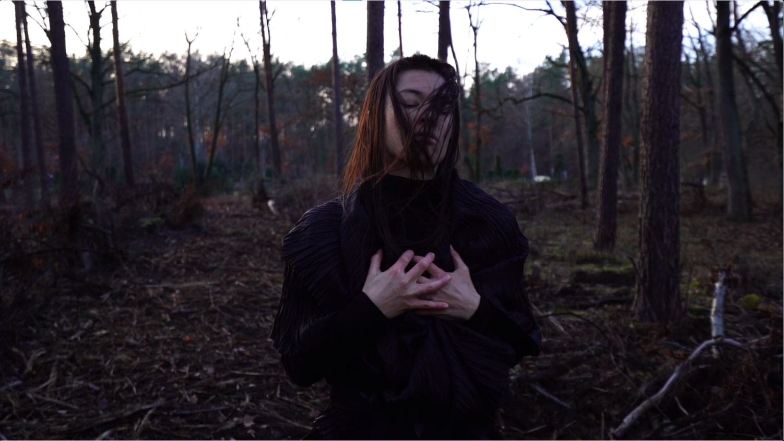
Image: Courtesy of Outer Urban Projects
Image description: Still from VIGIL showing a person surrounded by trees, hands clasped to their chest, eyes closed, hair over their face.

Access Guide

Updates to this document

Arts House website will contain the most up to date version of this guide and all ticket holders will be notified of any changes made 3 days and 1 day prior to the event.

This document was created: 09 April 2026

Contents
Where 2
When 2
Show Overview 3
Important Notes 3
Content Warnings 3
General Notes 3
Access Services 4
Performers 5
Sensory Elements 5
Audience Experience 6
Transport 7
The Venue 8
COVID Safety 17

Where

Arts House
521 Queensberry Street
North Melbourne VIC

When

Friday 10 April – Friday 1 May 2026
Open Monday to Saturday, 10am – 4pm

Duration: Approx. 20-30 minutes viewing time

Show Overview

This film is about the layers of trauma of an abusive relationship or event. It is an intimate reflection on the ripple effects of gender-based violence. The work is an embodied devotion about the power of the collective, a congregation, a vigil.

Set in a forest in Germany in winter, it explores the key themes of processing trauma and gender-based violence

The installation expands on the process of making the film using text and photographs to sit alongside the film.

Important Notes

Content Warnings

Suitable for ages 15+
This video work contains themes of violence, trauma and gender-based harm. It includes projected imagery and sound composition exploring personal and collective grief.

General Notes
The video is 14 min 17 seconds and plays on loop.
The installation space is a dark room with black carpeted floors and black walls. Please allow a moment for your eyes to adjust in the space. There are bench seats located in the centre of the space.

Access Services


Pre-recorded Audio Description is available. Please see reception for devices.

Assistance Animals are welcome.

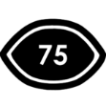
Visual Rating
75% - Mostly visual. Spoken dialogue is fully captioned but no visual representation is given for other sounds/music.

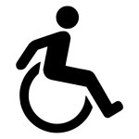
This performance is fully wheelchair accessible. More information on wheelchair accessible entrances and bathrooms can be found later in this guide.

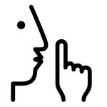
The quiet space will be available for you to use before, during and after the exhibition. More information about the quiet space can be found later in this guide.

Performers

There are three performers in the film.

Pippa Samaya
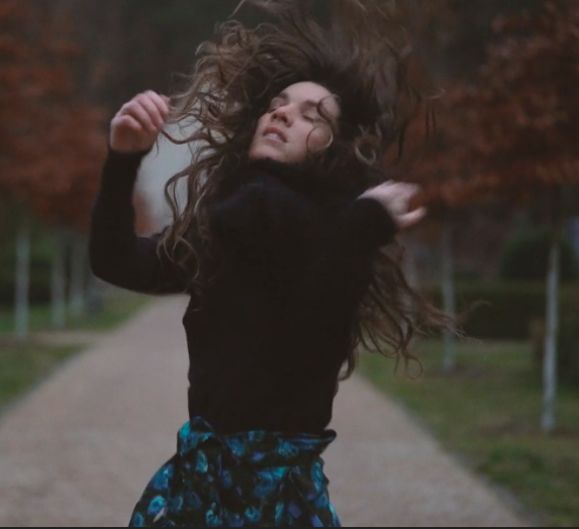
Tara Jade Samaya
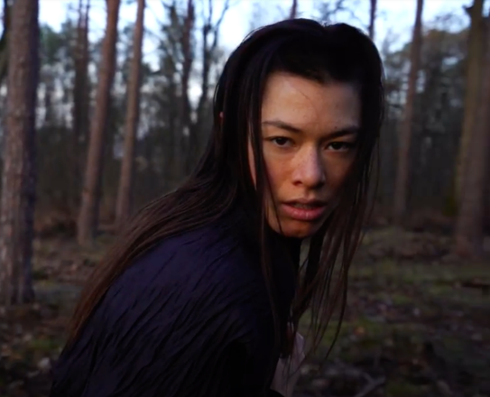

Ivy-Victoria Otradovec
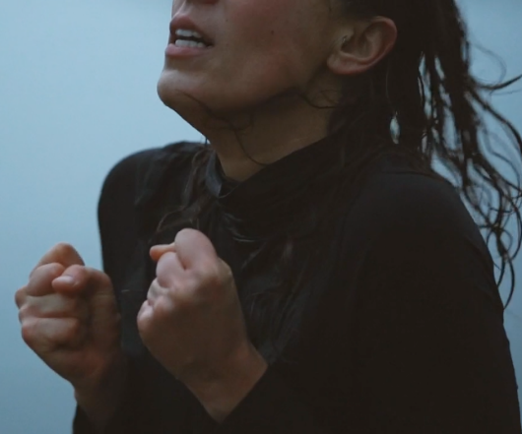

Sensory Elements

Sound
The sound score of the film will be playing on loop. It is a rolling slow melody of instruments.

Lighting
There is low lighting in the room, and it may take a moment for your eyes to adjust in the space.
There are candles in the room and small spotlights on photographs and text.
Smell
There may be the faint smell of pine leaves on the ground.

Audience Experience

Entry to space
Audiences enter the space through the main door of the Supper Room. The Supper Room is located on the Basement floor and can be accessed via stairs or the lift.

The installation will be on all day, with the video playing on a loop (14 min 17 seconds).
Social expectations
People can stand, sit or move about the space to view the work. There are bench seats in the middle of the space.

No drinks or food are permitted in the installation space. Please consume these in the foyer or leave them in your bags.
Relaxed space
Audience members are welcome to come and go as they please, be themselves, make noise, stim, and respond to the work.

Transport

Tram

Route 57 (High Floor trams only)
Stop 12, North Melbourne Town Hall.
Please note, this is not a wheelchair accessible tram
GETTING TO ARTS HOUSE VIDEO LINK

Train

Arts House is 1.1km from
North Melbourne Train Station,
approximately 16 minute walk
North Melbourne Station Information
1.2km from Flagstaff Station,
approximately 15 minute walk
Flagstaff Station Information

Bus

Bus number: 216

Parking

There is limited paid on-street parking on Queensberry Street and Errol Street.

There are two accessible on street car parking spaces on Queensberry Street (150m to our accessible Errol Street entrance) for holders of a Parking Permit for Disabled people.

The Venue

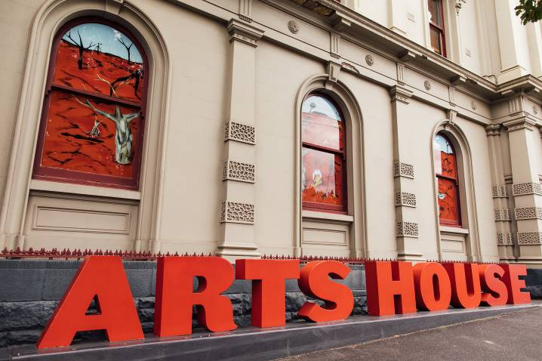
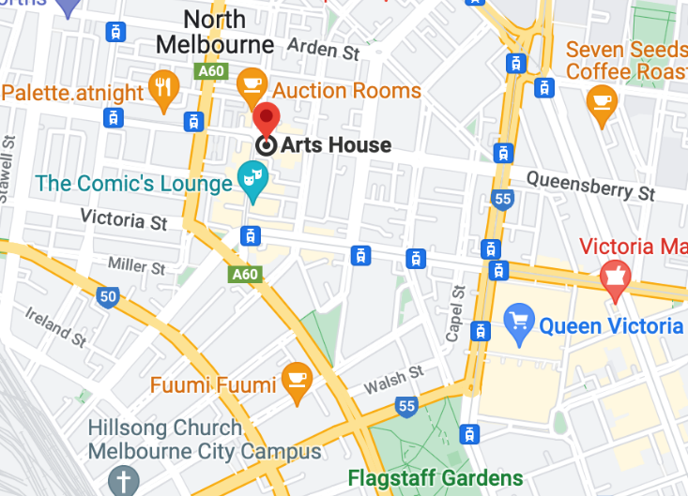

Image: North Melbourne Town Hall view from Queensberry Street which features giant red letters that say ARTS HOUSE out the front of it.

Image: a map of Arts House and its surrounding area. LINK TO MAP

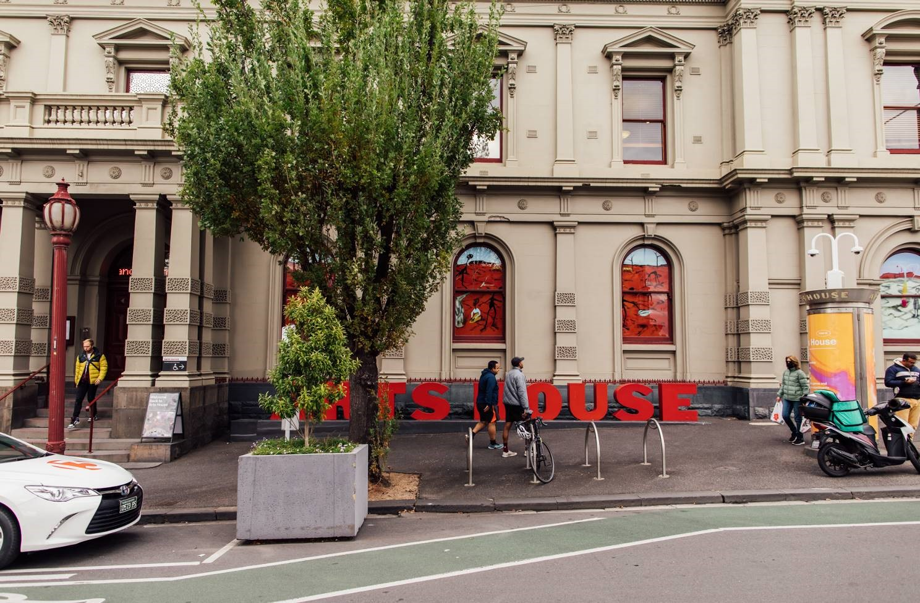

Image: North Melbourne Town Hall entrance on Queensberry Street. The entrance is to the left of the giant red letters that say ARTS HOUSE and features a staircase of eight steps with grab rails in parts.

Wheelchair Accessible Entrances

There are two Wheelchair Accessible Entrances. The first is on Errol St next to the Post Office.

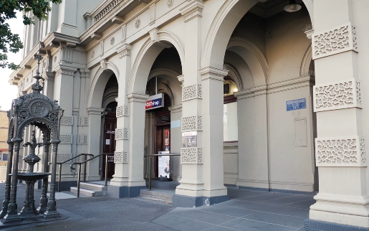

Image: Errol Street entrance next to the Post office with wheelchair accessible ramp or two steps with grab rails.
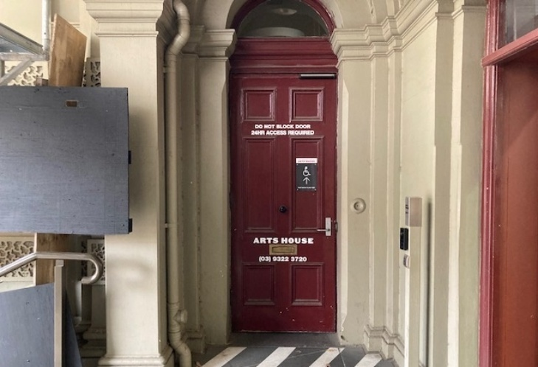
Image: View of door at Post office entrance.
Button to open automated door is on the right.

The second Accessible Entrance is towards the end of George Johnson Lane.

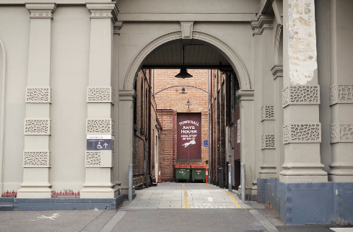

Image: View of George Johnson Lane from Errol St. The laneway passes through an archway with a brick wall at the end.
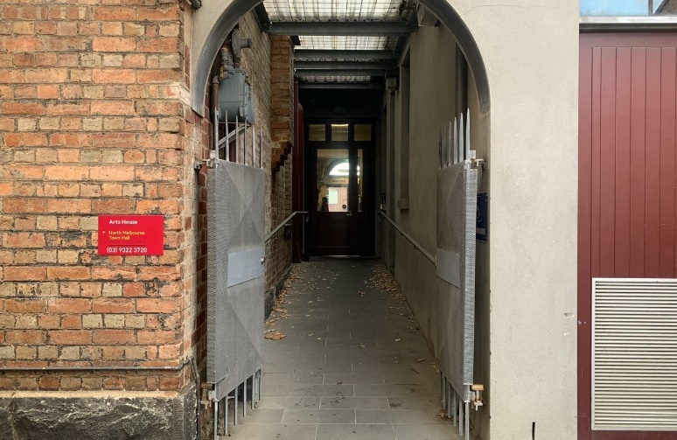

Image: view of the ramp with grab rail leading from George Johnson Lane to the automated door which opens into the Arts House foyer.

Box Office

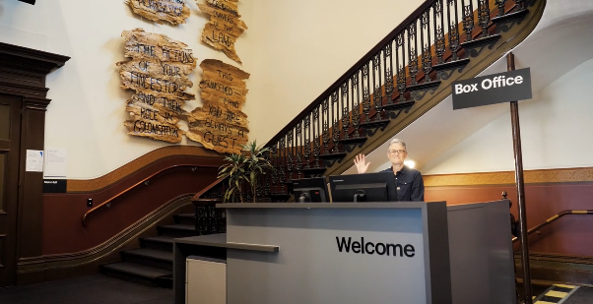

The Box Office is located in the foyer under the stairwell. If you enter from the Main Entrance it should be straight ahead of you. If entering from the Post Office or George Johnson lane your should approach on its right hand side.

Ushers

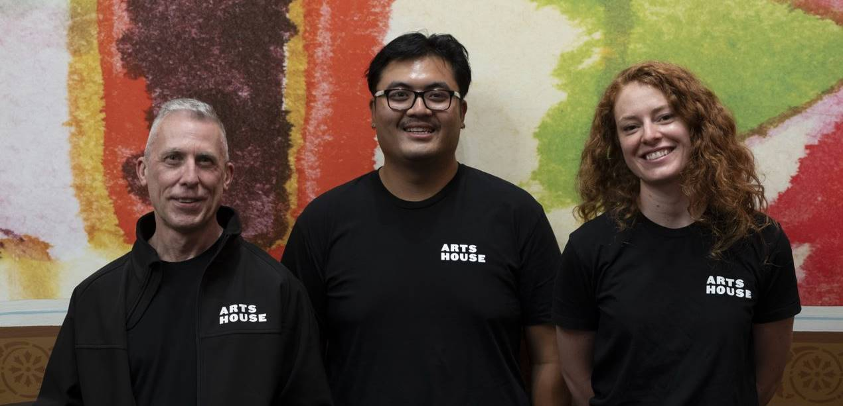

Ushers will be wearing black with an Arts House Logo on the left hand shoulder.

Bar

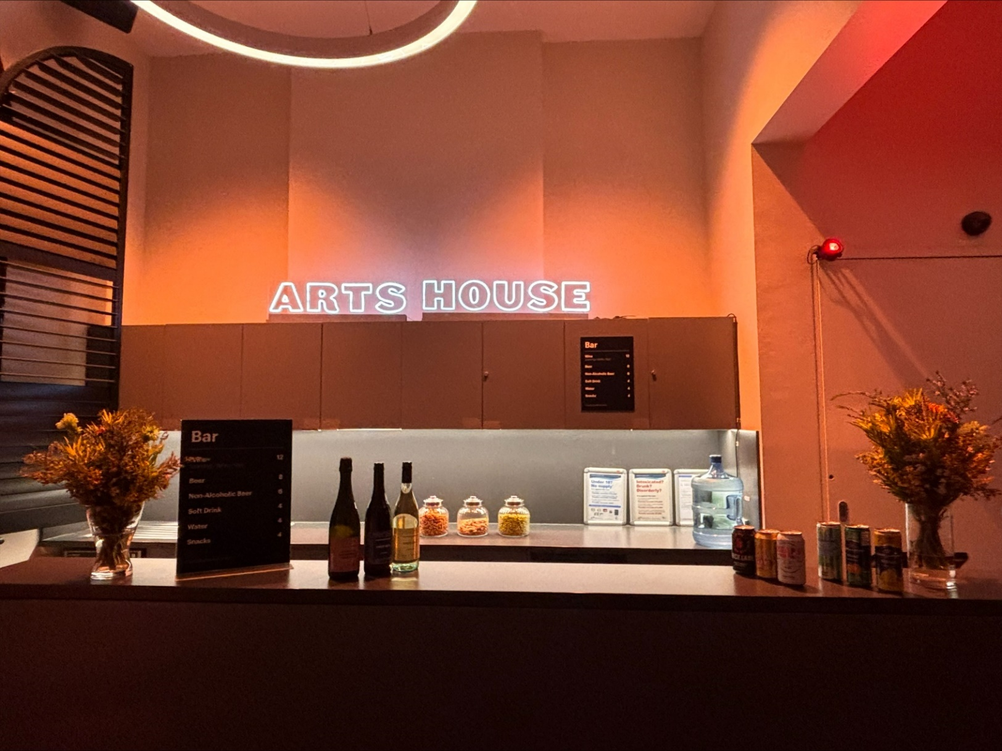
Image Description: The Arts House Bar with vases on each side of the bar filled with native flowers. In the centre there is a bar menu displayed with drinks set up on the top level on the bar. Towards the back wall there is a Arts House sign that is lit up. The lighting of the space is lit up orange.
The bar is to the Bar staff will be wearing black with an Arts House Logo.

We have a range of alcoholic and non-alcoholic beverages for sale.

We are a cashless venue and accept EFTPOS, Visa and Mastercard payments.

Quiet Space

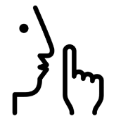

Arts House Quiet Space is located on Ground Level and is nearby reception and opposite the accessible bathrooms. It includes a range of seating options including soft furnishings, dimmable lights, sensory and stim objects. It is open during venue opening hours and events as a quiet space, prayer or parenting space.

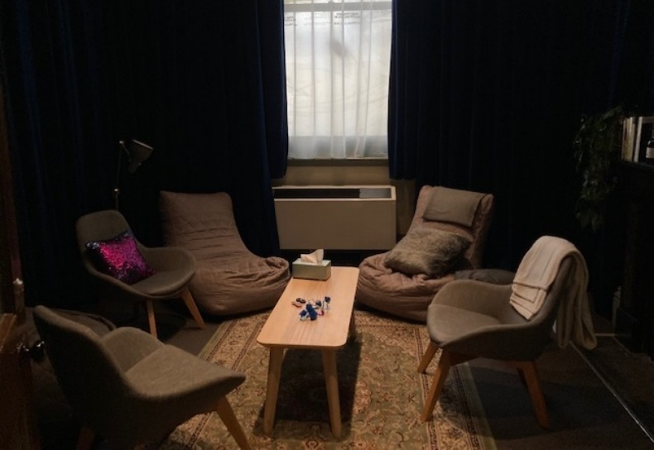Image: Quiet space with lights dimmed
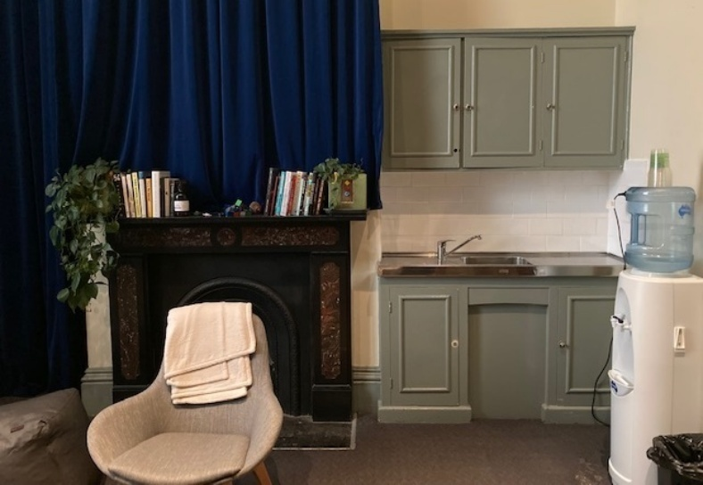
Image: Quiet space kitchenette and book shelf

Bathrooms

All bathrooms have Dyson hand dryers with sensor activation. There is an accessible bathroom that is single use on ground level opposite the Quiet Space. There is another accessible bathroom upstairs – this is accessible via lift or stairs.

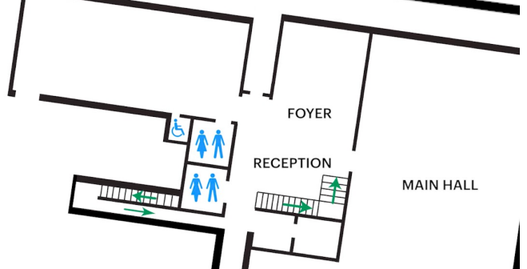

Lift

The Ground Floor Lift is located behind reception desk in the foyer.
The closest entry to the lift is via George Johnson Lane.
The lift has buttons with braille. It also has audio cues inside.

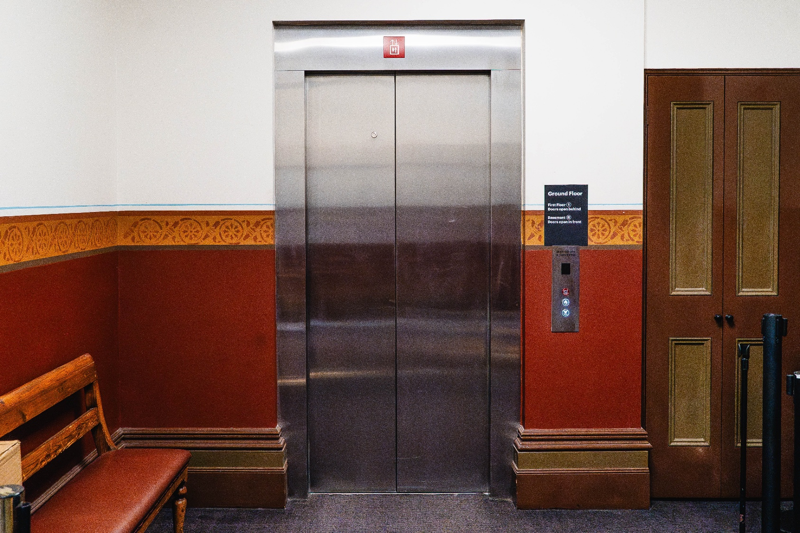

Supper Room
The Exhibition is in the Supper Room.
It is on the lower floor.
You can access these spaces via stairs with hand-railing or the lift.
An artist statement is available on signage and warnings on the door.

COVID Safety

Please note: If you have a cough, sore throat, fever, shortness of breath or flu-like symptoms, you must not attend our venue or programs in person.
We will provide a refund if you need to cancel your attendance due to illness. Please contact us by 9am on the day of the event.
To minimise the risk of COVID-19 transmission, we advise all patrons, artists and staff to:
- Wear a well fitted mask of P2 or comparable standards
- Practise physical distancing where possible
- Practise good hygiene by washing and or sanitising your hands often
- Test often (PCR or PlusLife testing recommended where possible)
- Stay up to date with vaccines (as recommended by your healthcare professional)
Throughout the venue you will find:
- hand sanitiser stations available
- masks available (ask one of our staff for assistance)​
- increased signage to direct patron movement and avoid crowd congestion
- two air filters, which move between different parts of the venue as needed.
We also ensure that spaces are well ventilated.
Staying COVID-safe remains important. We must all follow these steps:
- Follow the Victorian Government’s measures on how to stay safe.
- When you cannot safely socially distance it is recommended to wear a well fitted mask.
- Practise COVID-safe hygiene protocols.

