Specials

By Kath Duncan

Access Guide

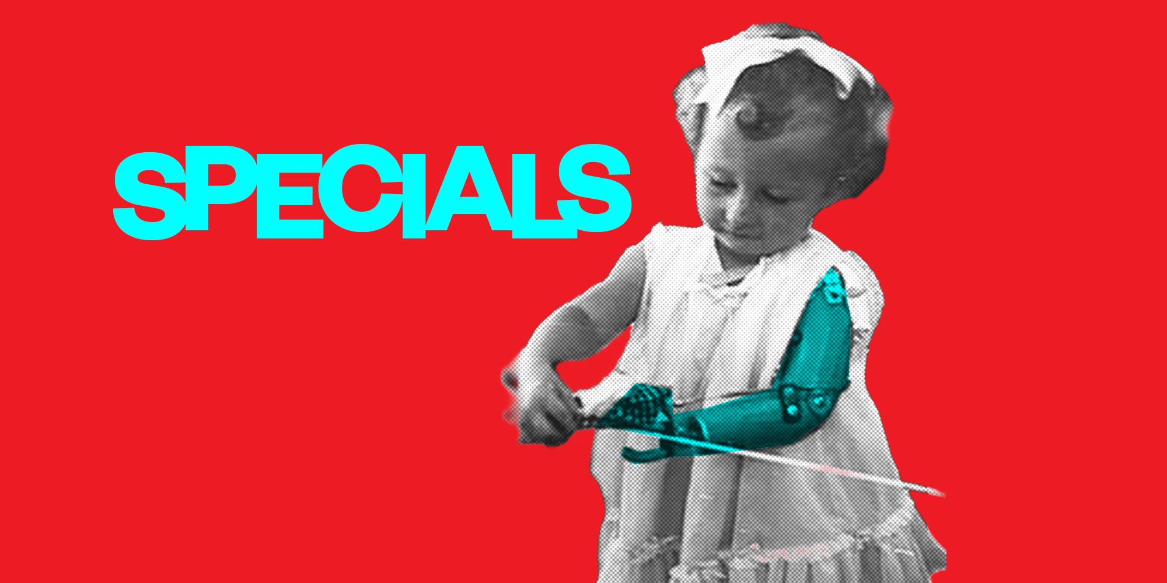

Image credit: Supplied by the artist / Actual Size

Image description: A young child with a prosthetic arm on a bright red background. The word ‘Specials’ appears in blue text beside her.

Updates to this document

Please note this performance is a new work and changes are being made by artists until opening. This guide will be updated as new information becomes available.

Arts House website will contain the most up to date version of this guide and all ticket holders will be notified of any changes made 3 days and 1 day prior to the event.

This document was created: 10 March 2026
Revision 1: 24 March 2026
Contents
Where 2
When 2
Show Overview 3
Important Notes 3
Content Warnings 3
General Notes 4
Access Services 5
Performers 7
Sensory Elements 8
Audience Experience 9
Transport 11
The Venue 12
COVID Safety 18

Where

Arts House
521 Queensberry Street
North Melbourne VIC

When

Tuesday 24 – Sunday 29 March 2026
Tuesday – Friday, 7.30pm
Saturday, 2pm & 7.30pm
Sunday, 5pm
Duration: 1 hour 30 minutes, no interval

Show Overview

This is a 90-minute show performed on stage.

The performance follows two characters, Simon and Cheryl, as they travel back in time to their days as students at Special School.

Featuring disabled performers and based on real life experiences of Special School in Australia, Specials is a comedic and confronting depiction of the different routes Special Education takes children on.

Important Notes

Content Advice
Suitable for ages 16+
This performance contains adult themes, violence, coarse language and content including ableism, bullying, and mistreatment of disabled people. It contains haze effects, loud music, high pitched frequencies, sudden loud noises, flashing lights, and lights that black out.

The work also contains the sounds of sirens and explosions.

Specials is based on real locations and events. The language draws from official reports, letters, tests and conference papers that include outdated and offensive terminology around impairment, disability, queerness and culture.

The language used to describe disabilities reflects the historical period of the work, which is the 1950-60, such as:

- Retard
- Idiot
- Spastic
- Cripple
- Deformed
- the handicapped
- the normal
- the congenital cripple
- Hopelessly incurable
- Psycho
- Slavery
- Freak
- Stupid
- Physically handicapped
- Remove or eradicate the handicapped
- Imbeciles
- Torture
- Hellhole
- Deficient
- Jabbering
- Ugly
- Witless
- Rejects
- Misshapen
- Damaged
- Mercy killing
- Disability is shameful and hideous

General Notes

A recorded Acknowledgment of Country plays at the beginning of each performance.

Access Services

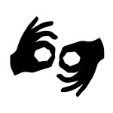
This show is Auslan Interpreted on Saturday 28 March, 2pm.

This show is Audio Described on Friday 27 March, 7:30pm.
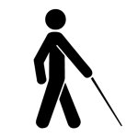
A Tactile Tour takes place on Friday 27 March, 6:30pm (1 hour prior to the show).

Assistance Animals are welcome.
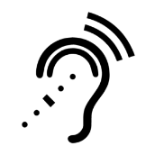
Assistive Listening is available free of charge. Ask staff for assistance on arrival.
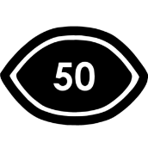
Visual Rating 50% - A mixture of visual and auditory components including dialogue, music, other sounds.
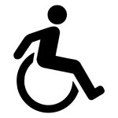
This performance is fully wheelchair accessible. More information on wheelchair accessible entrances and bathrooms can be found later in this guide.


This show has a performance with relaxed elements on Saturday 28 March, 2pm.
During this performance, overall sound levels will be lowered. Audiences are welcome to come and go, tic, stim, pace, change positions, disengage from the work, self-regulate, or self-soothe.

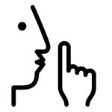
The quiet space will be available for you to use before and after the show. More information about the quiet space can be found later in this guide.

Companion card holders are welcome.

Performers

Sarah-Jayde Tracey – Actor (Cheryl)
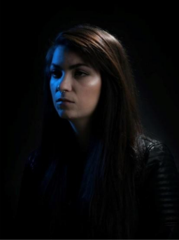

Oliver Ayres – Actor (Simon)
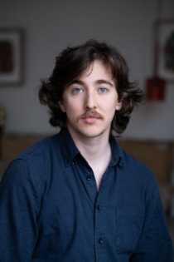

Felise Lyon – Actor (Mr Ginger)
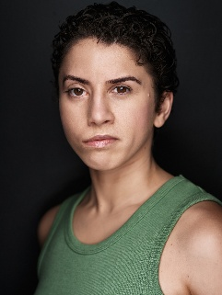

Sonia Marcon – Actor (Headmistress)
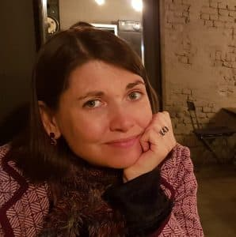

Emma J Hawkins – Actor (Nurse Grease)
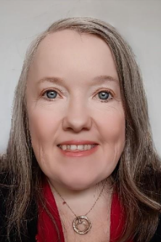

Trevor Dunn – Actor (Mr/s Toady)
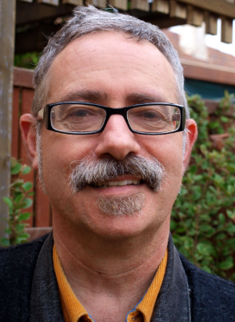

Kath Duncan – Writer
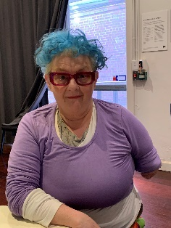
Tansy Gorman – Director
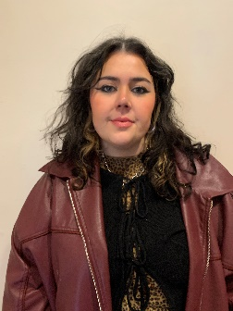

Sensory Elements

Sound
The sound is loud at times, including the performers’ voices. There are moments of overlapping voices and whispering.
Sound effects include a sharp whistle occurring multiple times throughout the show; rumbling, rhythmic noises; high pitched sounds; and repetitive sounds and a beat track building momentum towards the finale. There are two loud explosion sounds and sirens towards the end of the show.

Lighting
The overall lighting of the performance is dark. Lighting does change, but not abruptly or quickly. Projections are used throughout, but only onto screens on stage. There are two moments of blackout towards the end of the performance.
During a few moments, flashing lights are used for effects like a camera flash and explosion.
Physical
Audience members may be able to feel vibrations from speakers under the seating bank.
Floors are even. There is a seating bank of approximately 5 rows. The theatre is air conditioned. There is no air blowing on audiences.

During one scene, Mr Ginger and the Headmistress come into the audience space but do not touch the audience. The interaction involves making eye contact and offering no more than three audience members to tap or hit a balloon.

Smell
There will be no food in the theatre space. An herbal cigarette is lit at one point in the show. No other smells/scents are used in the performance, but we cannot guarantee that audience members may not use perfumes or other scented products.
Visual
The overall visual experience is gothic, surrealist horror. The work itself is loud and angry, with performers frequently in conflict. There is nothing on stage which could fall or move unexpectedly.

Images of children from the 1950-60s are present, however, these are de-identified.

Images and audio of ghosts appear in the work.

Images of special education settings appear throughout the work that reflect the conditions in which children were educated. This includes images of aids and equipment that are no longer deemed acceptable.

Images of institutions appear in the work.

Audience Experience

Entry to space
On arrival, audience members enter through the main Arts House building. Once the performance space is ready, the Main Hall doors will open for audiences to enter and take their seats.
Shocks or surprises
There are loud noises and vocalisations. Mr Ginger blows a whistle throughout the performance.
There are moments that are shocking as the treatment of disabled children is interrogated in this work. The language in general used to refer to the children can be shocking as it reflects institutional practices of the time.

Social expectations
The audience will sit in five rows of seats, including accessible on the floor level. The seats are not able to be moved. There is ample space for multiple wheelchair users. The audience is seated throughout the performance and will not be moving around.
There is a preference for no food in the space, unless it is an access requirement. Stim toys are welcome.

Performance expectations
There is dialogue throughout the performance. The performance also features monologue, poetry and song. Text is projected onto the stage at various points.

There are six performers, all of whom perform on stage, sometimes in front and sometimes behind a black scrim curtain. Their pictures are included above. They are distinguishable from staff by their costumes. Staff will be wearing black.
Relaxed space
These are not relaxed performances in the usual sense, but audience members are welcome to come and go as they please, be themselves, make noise, stim, and respond to the work for the duration.

Transport

Tram

Route 57 (High Floor trams only)
Stop 12, North Melbourne Town Hall.
Please note this is not a wheelchair accessible tram.
GETTING TO ARTS HOUSE VIDEO LINK

Train

Arts House is 1.1km from North Melbourne Train Station (approximately 16 minute walk) and 1.2km from Flagstaff Station (approximately 15 minute walk).

Bus

Bus number: 216

Parking

There is limited paid on-street parking on Queensberry Street and Errol Street.

There are two accessible on street car parking spaces on Queensberry Street (150m to our accessible Errol Street entrance) for holders of a Parking Permit for Disabled people.

The Venue

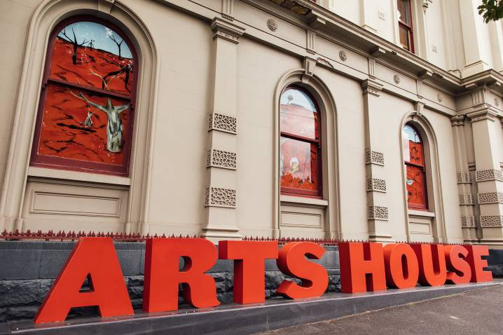
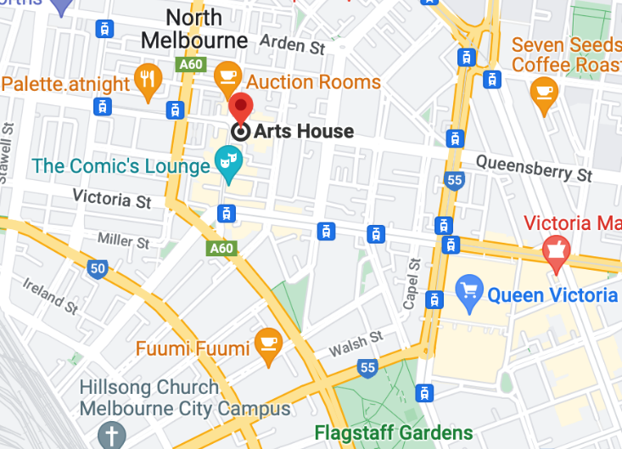

Image: North Melbourne Town Hall view from Queensberry Street which features giant red letters that say ARTS HOUSE out the front of it.

Image: a map of Arts House and its surrounding area. LINK TO MAP
Front Entrance

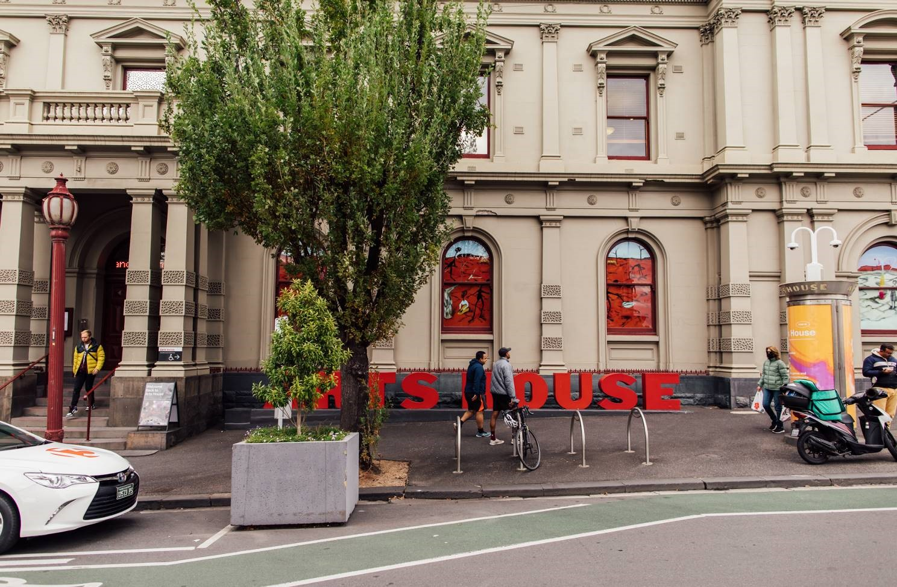
Image: North Melbourne Town Hall entrance on Queensberry Street. The entrance is to the left of the giant red letters that say ARTS HOUSE and features a staircase of eight steps with grab rails in parts.

Wheelchair Accessible Entrances

There are two Wheelchair Accessible Entrances. The first is on Errol St next to the Post Office.

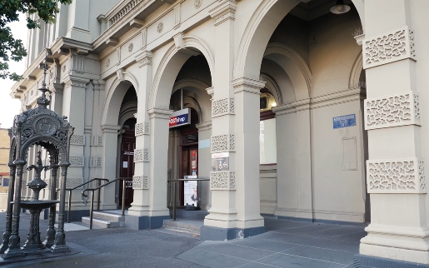

Image: Errol Street entrance next to the Post office with wheelchair accessible ramp or two steps with grab rails.
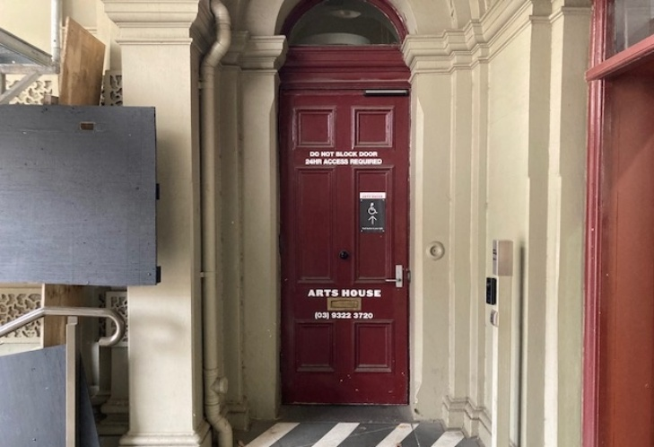
Image: View of door at Post office entrance.
Button to open automated door is on the right.

The second Accessible Entrance is towards the end of George Johnson Lane.

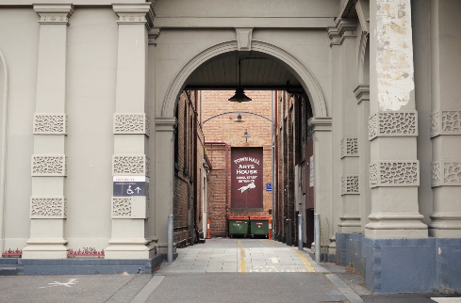
Image: View of George Johnson Lane from Errol St. The laneway passes through an archway with a brick wall at the end.
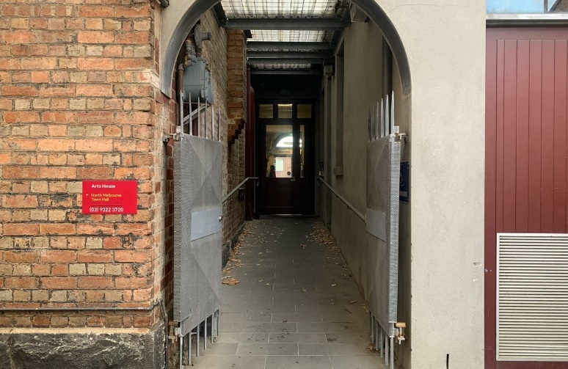Image: view of the ramp with grab rail leading from George Johnson Lane to the automated door which opens into the Arts House foyer.

Box Office

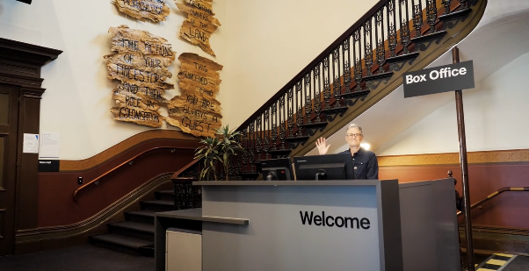
Image: The Box Office is located in the foyer under the stairwell. If you enter from the Main Entrance it should be straight ahead of you. If entering from the Post Office or George Johnson lane your should approach on its right hand side.

Ushers

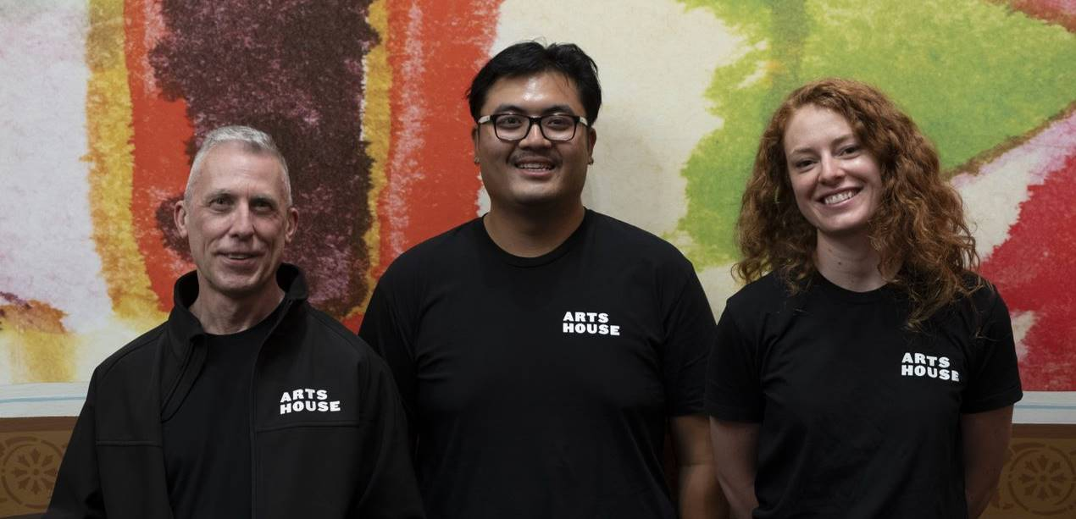
Image: Ushers wearing black tops with an Arts House Logo on the left hand shoulder.

Bar

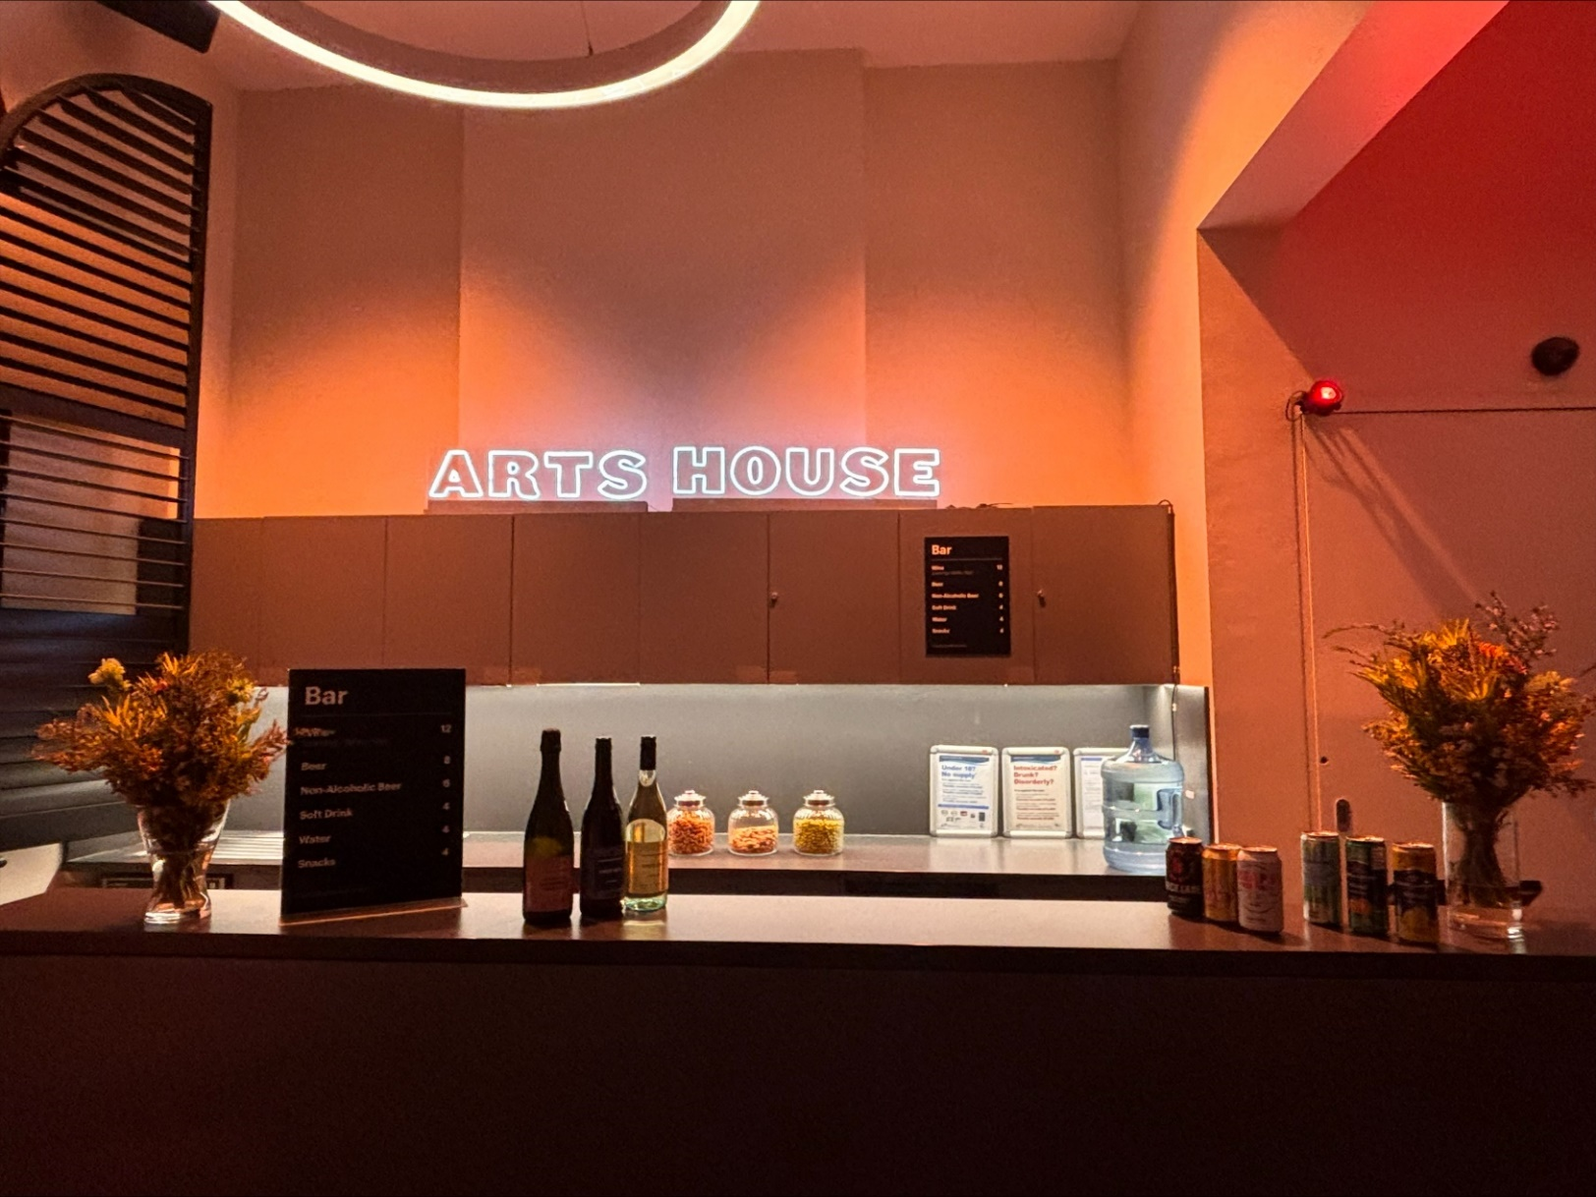

Image Description: The Arts House Bar with vases on each side of the bar filled with native flowers. In the centre there is a bar menu displayed with drinks set up on the top level on the bar. Towards the back wall there is a Arts House sign that is lit up. The lighting of the space is lit up orange.
Bar staff will be wearing black with an Arts House Logo.

We have a range of alcoholic and non-alcoholic beverages for sale.

We are a cashless venue and accept EFTPOS, Visa and Mastercard payments.

Quiet Space

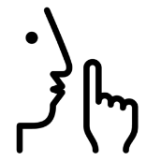
Arts House Quiet Space is located on Ground Level and is nearby reception and opposite the accessible bathrooms. It includes a range of seating options including soft furnishings, dimmable lights, sensory and stim objects. It is open during venue opening hours and events as a quiet space, prayer or parenting space.

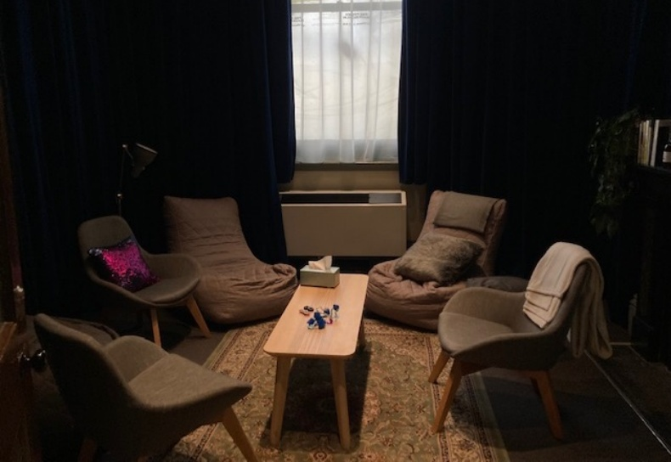Image: Quiet space with lights dimmed
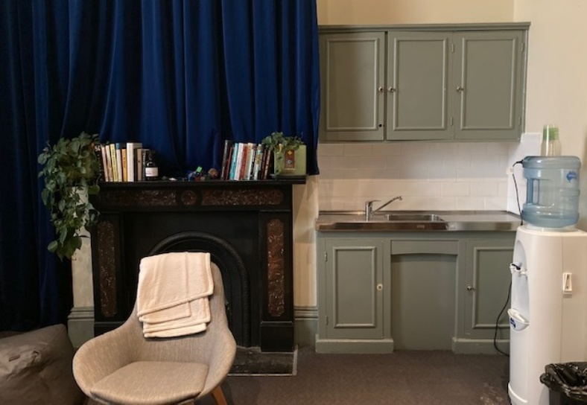
Image: Quiet space kitchenette and book shelf

Bathrooms

All bathrooms have Dyson hand dryers with sensor activation. There is an accessible bathroom that is single use on ground level opposite the Quiet Space. There is another accessible bathroom upstairs – this is accessible via lift or stairs.
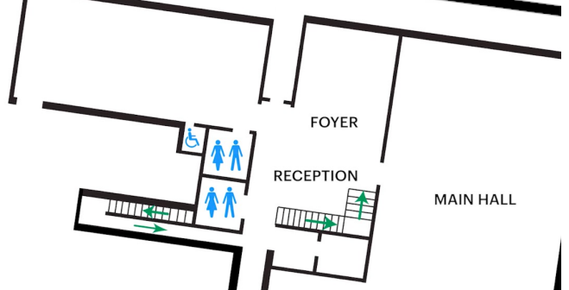

Door to Main Hall

The Performance is in the Main Hall.
It is on the ground floor.
It is to the left of the box office desk and right of the bar.
An artist statement is available on signage and warnings on the door.

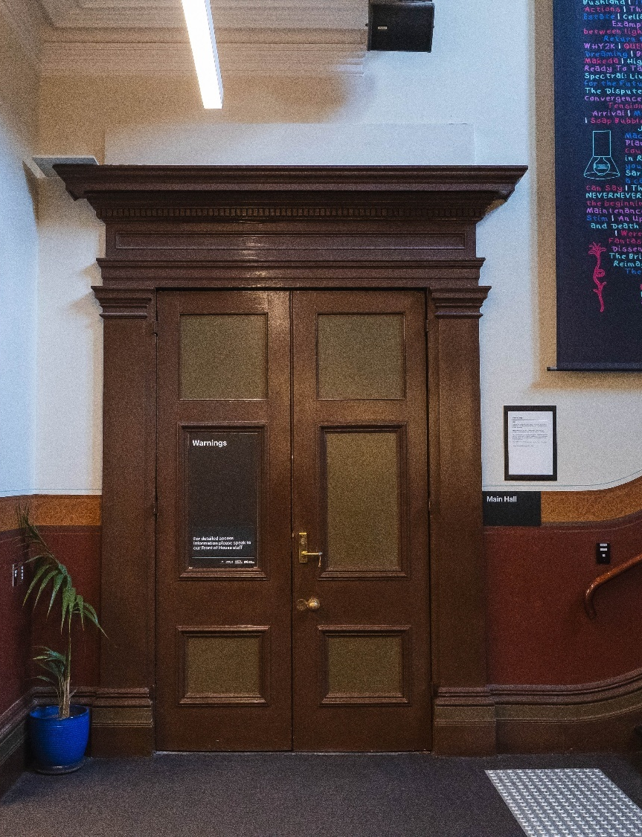

Image: Doors to the Main Hall.

COVID Safety

Please note: If you have a cough, sore throat, fever, shortness of breath or flu-like symptoms, you must not attend our venue or programs in person.
We will provide a refund if you need to cancel your attendance due to illness. Please contact us by 9am on the day of the event.
To minimise the risk of COVID-19 transmission, we advise all patrons, artists and staff to:
- Wear a well fitted mask of P2 or comparable standards
- Practise physical distancing where possible
- Practise good hygiene by washing and or sanitising your hands often
- Test often (PCR or PlusLife testing recommended where possible)
- Stay up to date with vaccines (as recommended by your healthcare professional)
Throughout the venue you will find:
- hand sanitiser stations available
- masks available (ask one of our staff for assistance)​
- increased signage to direct patron movement and avoid crowd congestion
- two air filters, which move between different parts of the venue as needed.
We also ensure that spaces are well ventilated.
Staying COVID-safe remains important. We must all follow these steps:
- Follow the Victorian Government’s measures on how to stay safe.
- When you cannot safely socially distance it is recommended to wear a well fitted mask.
- Practise COVID-safe hygiene protocols.

