COVID Safer Events Primer

Contents
Contents 1
Core Principles 1
Masking 3
Cleaner Air 5
Digital and Hybrid Events 6
Testing 6
Vaccinations 7
Hand Hygiene and Surface Cleaning 8
Advocacy 8
Other (Requires Reading) 8
References and Recommended Reading 8

Core Principles
COVID Safety vs General Viral Safety
This document has been prepared with SARS-CoV-2 and COVID-19 in mind. We chose this as our focus due to a few factors. Firstly, the virus has significant spread. Secondly, there are notable disabling traits and mortality rates associated with the disease.
Some of these suggestions may not apply to other viruses. Each virus will have different traits and thus different behaviour. That said, some of the suggestions in this document may also apply to non-SARS-CoV-2 viruses. We recommend further reading to understand other best approaches to other viruses.
Notably, the scientific understanding around SARS-CoV-2 continues to develop. Updates document may not be able to keep pace with new understanding. Please note the publication date and assess if further reading is required.

Swiss Cheese Model
The Swiss Cheese Model is a model aiming to direct our approach to risk and safety. Its connection to the SARS-CoV-2 pandemic was popularised by virologist Ian M Mackay. It suggests a multi-layered approach to be most effective for reducing spread.
Like individual slices of Swiss Cheese have holes, so too do our protective measures. We can address this by layering these measures and implementing a number at once. With enough measures, gaps will slowly be covered, just as if we stacked a number of Swiss Cheese slices.
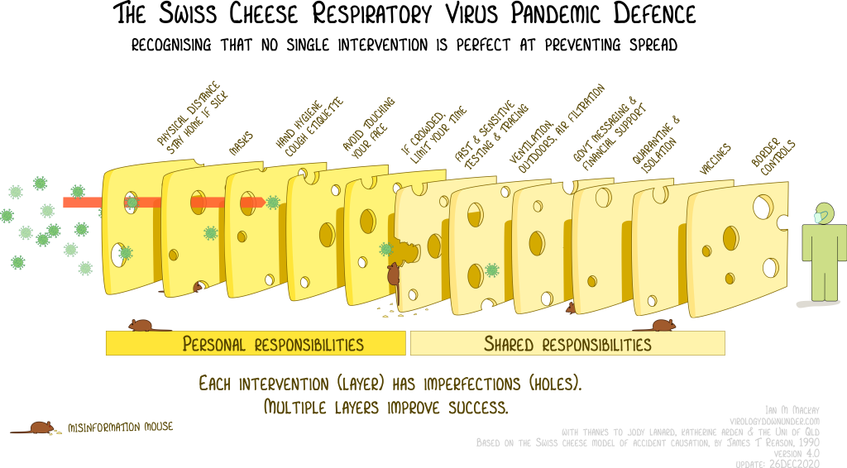
We recommend that you implement as many of the below recommendations at once as is feasible. This will provide the stronger protection and help break chains of transmission.

Breaking the Chain
Illness happens, even when precautions are taken. Still, every single infection that we prevent helps lessen further spread and outbreaks. This document is written with the goal of breaking as many chains of infection as possible.
Asymptomatic spread of SARS-CoV-2 is common, so a lack of symptoms is not a guarantee that you are virus free. We can help our communities by exercising caution, even if we have no active symptoms.
Those who have been contact with a case of COVID-19 or who are unwell should stay home and isolate from others. They should do this until they are very confident that they are unable to spread the virus to others.
Some signs that you might no longer be contagious include:
- having no symptoms of COVID-19
- testing negatively on RATs consistently over a 48 hour period
- returning a negative PCR or PlusLife test.
(Please see Testing for further information)
It is recommended that you continue to isolate until at least two of the above conditions have been met.

Masking
Respirator Filtration Quality
There are location based filtration standards that respirators can be approved for. For best protection, it is best to wear respirators rated at minimum 94% filtration.
Respirators that fit this standard include:
- P2 (Australia)
- N95 (US)
- Europe (FFP2)
- KN95 (China)
- DS FFR (Japan)
- KF94 or First Class (Korea)
Valved respirators may not filter the air being breathed out. This could present dangers to those around someone wearing a valved respirator. Some seem to have a higher chance of success, although this is a little inconsistent. Noting this, non-valved respirators may be a safer, more consistent choice.
Cloth and surgical masks provide less protection from COVID-19 than rated respirators do. Many consider wearing a less effective mask still better than wearing no mask. That said, these masks are not recommended for filtering out COVID-19.
Other respirators that you might want to consider include N99, FFP3 or P3 masks. These are less available or higher cost but offer higher levels of filtration. Some respirators like Elastomeric and PAPR masks are also re-usable.
Effective Mask Wearing
Mask wearing is most effective when most event attendees wear them as intended.
Most masks are designed to cover both the mouth and the nose. Negative pressure masks should be fitted tightly. This will form a seal so that all the air you are breathing needs to pass through the fibres of the mask first.
Most readily available masks are disposable but can still be worn a few times. For a re-used mask to be effective it needs to be kept clean and dry and a good seal needs to be maintained.
Increasing the number of people masking at an event helps reduce the risk of spread. Masks have a dual role. They can prevent outward spread in the event the wearer is ill. They also protect the wearer from viruses in the air around them.
You might want to set social rules about masking to ensure greater uptake of mask wearing. Encouragement is often not enough to get more than a small group of already engaged people to wear a mask. Wearing a mask even when not mandated by an event helps normalise mask wearing and is recommended.
Fit Tests
The best mask to wear is one that fits! Given the variance in human face shapes and head sizes, there is no ‘one size fits all’ mask that can be recommended. Facial hair and piercings likely will affect fit.
There are companies that can check the fit of various masks for you. You can also buy and self-administer various mask test kits. There are typically two types of fit testing, qualitative and quantitative testing.
Quantitative testing uses an instrument such as a particle counting fit tester. These determine a fit factor rating by comparing particles inside and outside of the mask.
Qualitative testing relies on a user’s senses. Test kits will aerosolise a challenge agent that can be tasted. When masked and breathing through your mouth you will need to note if you can taste the mist. If so, it means there are gaps in your mask and the seal might not be adequate.
It is not always easy to access these fit tests but if you can manage it is recommended to gather that information. When testing, check a few masks and respirators so you can select the best one for your needs.

Cleaner Air
Ventilation
Well-ventilated spaces can help minimise spread of airborne viruses. We can keep our event attendees safer by hosting events outside. Keeping doors and windows open will also help if hosting events inside.
CO2 monitors can be used to give a good indication of how well-ventilated a space is.
Filtration
Filters can be used to help cycle the air in less ventilated spaces. It is recommended that a space aims to achieve 6 air changes a minute. Filters HEPA Grade and above are typically considered the standard for this work.
Larger spaces may need a larger number of units in order to effectively cycle air in the way they are meant to.
Filter units require maintenance and must have their filters replaced following manufacturer guidelines.

Digital and Hybrid Events
Viruses spread through contact – either directly or through contact with the environment. Hosting digital and hybrid events can help reduce that contact.
The ability to pause and watch a digital event in a viewer's own time is useful for access. That said, 'on demand’ will limit interactivity in comparison to live events.
During hybrid events, ensure online attendees have an equal experience to those in-person.

Testing
Rapid Antigen Tests (RAT)
Many common brands of RATs have very low sensitivity to more recent strains of virus. In order for RAT use to be effective it is recommended to test on a consistent basis. You can get RATs that test for common viruses like COVID-19, Influenza and RSV.
If you are unwell and testing negative on a RAT this is not necessarily an indication that you are virus free. If you have symptoms of COVID or another viral illness, it is recommended to stay home and test every 48 hours. It is recommended you isolate until both you are asymptomatic and all tests come up negative.
Polymerase Chain Reaction Tests (PCR)
PCR tests are more sensitive than RATs but will require a referral to access. You can often get a referral from an online GP for $20 to $30 AUD.
Occasionally false negatives happen. A member of a local Covid Conscious group has recommended testing 3 - 5 days after your exposure. This is to lessen the chance of a false negative.

PlusLife Tests
PlusLife Tests have a similar sensitivity to PCR tests. To do a PlusLife test you will need access to a testing unit and the relevant test cassettes. These typically cost about $5 AUD per test.
PlusLife units and testing cassettes must be bought through a distributor. The main two that ship to the Australian continent are Ngaio Diagnostics and Altruan￼ Applying for a permit is pretty simple and involves paying a processing fee.
Like a PCR test, testing 3 – 5 days after exposure is recommended to avoid getting a false negative result. You can connect your machine to the virus.sucks/ website. This will give you detailed information about your test as it processes and tips for how to get the best result.

Vaccinations
Vaccines help teach your body how to recognise and fight a virus. Vaccines are not made from active viruses. It is highly unlikely that a recent vaccine will cause you to get a false positive result on a PCR or PlusLife test.
Vaccines lose their effectiveness over time (within 112 days). Getting booster doses can help boost that effectiveness.
Current eligibility as per Australian Government guidelines is as follows:
- Healthy adults under the age of 74 are eligible for one vaccine booster per year.
- Those with pre-existing conditions or over the age of 74 may be eligible for a vaccine booster every 6 months.
We strongly encourage people to get vaccinated as often as they are eligible.

Hand Hygiene and Surface Cleaning
COVID-19 is largely spread through the air. That said, it can also spread through contact with contaminated surfaces.
To help prevent infection, keep your hands clean and avoid contact with your mouth eyes and nose. It is also recommended to regularly clean surfaces with water and detergent.
Germicidal Ultraviolet Light
Germicidal Ultraviolet Light is effective at killing SARS-COV-2 and other viruses,,. Risks associated with UV (like to skin and eyes) are reduced to a safe range by utilising ∼200 nm far-UVC.,
Far UVC lighting can be installed into buildings either in the ceiling or on the walls. Some stand alone devices are also available. All of these options are likely to be costly.

Advocacy
One of the best things we can do to make our spaces COVID-Safer is to be an advocate. Make those around us aware of the impacts of the ongoing pandemic on our community and push them to act! Educating others is vital. We must continue to teach people about the nature of this virus and Long COVID. This does not have to be fearmonger-y but can be reassuring. We can teach people about all of the methods listed above that can help us control the spread.
Normalising COVID safety measures will help keep our communities safe and healthy. It will also reduce the risk of backlash when people do take protective measures.
Humans are social creatures. If something is normalised it is easier for people to want to take part. Pushing against the tide can be scary or confronting for people. We can help make it easier by lessening the degree of social resistance to precautions.

Further Reading
What you need to know about COVID-19 - Immunisation Coalition
Living next door to Alice - Virology Down Under

Global Prevalence of Post-Coronavirus Disease 2019 (COVID-19) Condition or Long COVID: A Meta-Analysis and Systematic Review - PubMed
Estimating excess mortality due to the COVID-19 pandemic: a systematic analysis of COVID-19-related mortality, 2020-21 - PubMed
The Swiss cheese infographic that went viral - Virology Down Under
Asymptomatic SARS-CoV-2 Carriers: A Systematic Review and Meta-Analysis - PubMed
COMMENTARY: What can masks do? Part 1: The science behind COVID-19 protection | CIDRAP
N95 vs FFP3 & FFP2 masks - what's the difference?
Performance of Valved Respirators to Reduce Emission of Respiratory Particles Generated by Speaking - PubMed
Efficacy of surgical masks or cloth masks in the prevention of viral transmission: Systematic review, meta-analysis, and proposal for future trial - PubMed
Effectiveness of cloth face masks to prevent viral spread: a meta-analysis - PubMed
Mask Ratings - N95 vs FFP2 vs KF94 vs KN95
Re Usable Respirators - Safety | Total Tools
Understanding Respiratory Protection: Negative vs Positive Pressure Respirators
DHHS (NIOSH) Publication No. 2018-128, Filtering out Confusion: Frequently Asked Questions about Respiratory Protection, Respirator Reuse and Extended Use
Association between COVID-19 outcomes and mask mandates, adherence, and attitudes - PMC
On Compliance - Themme Fatale’s Substack
Mask Fit Testing | Fit Test Australia
3M Respirator Fit Testing | 3M Australia
TSI Portacount | Portacount Plus - how it works | Fit Testing
Fit Testing | Worker Health & Safety | 3M Australia
Coronavirus disease (COVID-19): Ventilation and air conditioning
S1256_EMG_SPI-B_Application_of_CO2_monitoring_as_an_approach_to_managing_ventilation_to_mitigate_SARS-CoV-2_transmission.pdf
Copy of Version 4.0 pg.32
COVID-19 Ventilation Calculator download
Ways infectious diseases spread | SA Health
Live Streaming Vs VOD: Key Differences & Benefits
Rapid antigen testing for COVID-19: Decreasing diagnostic reliability, potential detrimental effects and a lack of evidence to support continued public funding of community-based testing - PMC
Novel coronavirus information for patients VIC - Australian Clinical Labs
Estimate false-negative RT-PCR rates for SARS-CoV-2. A systematic review and meta-analysis - PubMed
COVID Conscious Queers Naarm (@covidconsciousqueersnaarm) • Instagram photos and videos
JMIR Public Health and Surveillance - Trial of the Pluslife SARS-CoV-2 Nucleic Acid Rapid Test Kit: Prospective Cohort Study
Unofficial Aus Pluslife Info
Is it true? Get the facts on COVID-19 vaccines | Australian Government Department of Health, Disability and Ageing
Unofficial Pluslife FAQ (EN)
https://www.thelancet.com/journals/lanres/article/PIIS2213-2600(23)00015-2/fulltext
COVID-19 vaccine advice and recommendations | Australian Government Department of Health, Disability and Ageing
Standard and transmission-based precautions | health.vic.gov.au
UV Inactivation of SARS-CoV-2 across the UVC Spectrum: KrCl* Excimer, Mercury-Vapor, and Light-Emitting-Diode (LED) Sources | Applied and Environmental Microbiology
Frontiers | Genomic Modeling as an Approach to Identify Surrogates for Use in Experimental Validation of SARS-CoV-2 and HuNoV Inactivation by UV-C Treatment
Rapid and complete inactivation of SARS-CoV-2 by ultraviolet-C irradiation | Research Square
Far-UVC: Technology Update with an Untapped Potential to Mitigate Airborne Infections - PMC
Far-UVC light (222 nm) efficiently and safely inactivates airborne human coronaviruses - PMC

