When Your Number’s Up

By Rel Pham

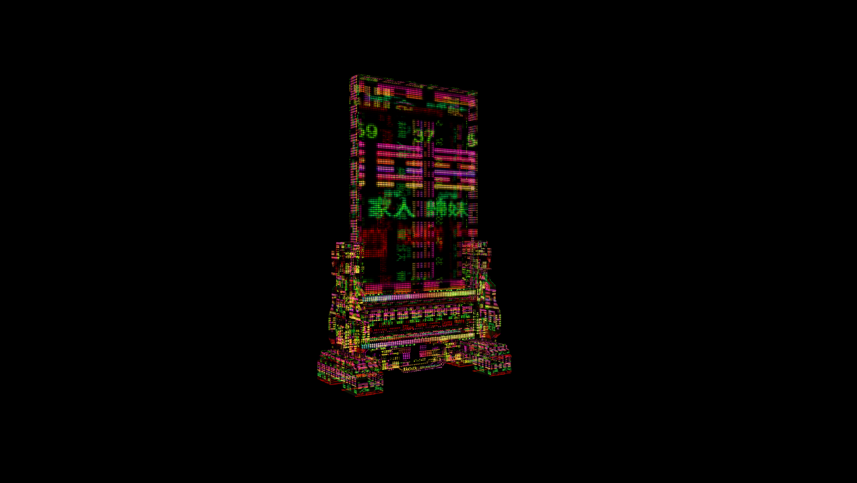
Access Guide

Image credit: Courtesy of the artist
Image description: Glowing I Ching hexagram that is semi-transparent with green Chinese characters on a black background, rising like a neon monolith made of shifting, pixelated blocks.

Updates to this document

Arts House website will contain the most up to date version of this guide and all ticket holders will be notified of any changes made 3 days and 1 day prior to the event.

This document was updated: 12 February 2026

Contents
Where 2
When 2
Show Overview 3
Important Notes 3
Content Warnings 3
General Notes 3
Access Services 4
Sensory Elements 6
Audience Experience 7
Transport 8
The Venue 9
COVID Safety 16

Where

Arts House
521 Queensberry Street
North Melbourne VIC

When

Thursday 12 February – Friday 6 March 2026
Open Monday – Friday, 10am – 4pm
Duration: Exhibition open daily (approx. 20 minutes viewing time)

Show Overview

When Your Number’s Up is an installation that explores how people try to find meaning in chaos. It probes people’s obsession with prediction — from fortune tellers and omens to data analytics and artificial intelligence.

The installation has 3 components including a large video work on the wall, 2 x LED light sculptures on the floor and paper ticket stubs scattered around the floor.

The video shows an abstract and shifting landscape with references to gambling, oracles, algorithms, superstitions, divinity and more. It reveals how both mysticism and technology promise certainty in an uncertain world.

Audiences are encouraged to ask themselves: when we seek answers from algorithms or the divine, are we chasing truth, or simply reassurance that the story ends in our favour?



Important Notes

Content Warnings

Suitable for ages 12+
Themes of technology, superstition, gambling, death and fate.
Contains flashing imagery and bright colour sequences.

General Notes

The video is 4 mins 59 seconds and plays on a loop.

The installation space is a dark room with black carpeted floors and black walls. Please allow a moment for your eyes to adjust in the space. There is a bench seat located in the centre of the space.

People may pick up and read the paper ticket stubs. Please don’t touch the LED sculptures.

Access Services

Audio Description is available. Please see reception for devices.

Assistance Animals are welcome.
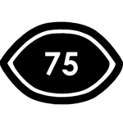
Visual Rating
75% - Mostly visual. Spoken dialogue is fully captioned but no visual representation is given for other sounds/music.

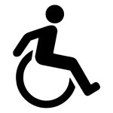
This performance is fully wheelchair accessible. More information on wheelchair accessible entrances and bathrooms can be found later in this guide.

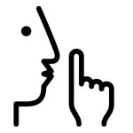
The quiet space will be available for you to use before and after your visit. More information about the quiet space can be found later in this guide.

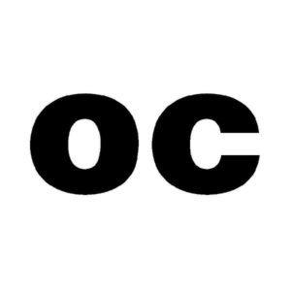
The video contains some poetic text which is captioned. Note, this captioned poetry does not correspond to any audible spoken text in the video.

Sensory Elements
Sound
The video work has sound, coming from speakers in the space. The soundtrack has overlapping sounds including Vietnamese instrumental music, a background voice speaking Vietnamese, sounds of the forest, digital elements and drumming. It starts softly and increases in volume and intensity toward the end of the video.

Lighting
The installation is in a blackened space with low lighting. There is a green light at the entrance to the space and there is a light on the wall signage. There is light flare from the video projection, which changes in colour and intensity as the video plays. Sometimes there are bright flashing images in the video. There are also 2 x LED light sculptures located on either side of the room.

Physical
There are three physical components to the installation, including the video projection, the LED light sculptures and the paper ticket stubs.
The space is enclosed by blackened walls. There is a bench seat in the middle of the space, between two white columns.
People may pick up and take the paper ticket stubs with instructions on consulting the I Ching oracle cards.

Smell
There are no elements of scent in this work.

Visual
The installation space has blackened walls and floor. At the entrance there is a rainbow-coloured title sign reading ‘When Your Number’s Up’ and an artist statement.
There is other signage in English text and braille, with details on the access guide, Audio Description, and a tactile QR code linking to the artwork details online.
The installation has 3 components including a large video work on the wall, 2 x LED light sculptures on the floor and paper ticket stubs scattered around the floor.

The video work shows a shifting digital landscape featuring imagery of dense green forest, a river, hexagrams, horse racing, gambling rooms, poker machines and fires.

Audience Experience

Entry to space
Audiences enter the space through the main door of the Supper Room. The Supper Room is located on the Basement floor and can be accessed via stairs or the lift.
The installation will be on all day, with the video playing on a loop (4 minutes 59 seconds).

Social expectations
People can stand, sit or move about the space to view the work. There is a bench seat in the middle of the space.
No drinks or food are permitted in the installation space. Please consume these in the foyer or leave them in your bags.

Performance expectations
N/A. There are no live performers in this installation.

Relaxed space
Audience members are welcome to come and go as they please, be themselves, make noise, stim, and respond to the work.

Transport

Tram

Route 57 (High Floor trams only)
Stop 12, North Melbourne Town Hall.
Please note, this is not a wheelchair accessible tram
GETTING TO ARTS HOUSE VIDEO LINK

Train

Arts House is 1.1km from
North Melbourne Train Station,
approximately 16 minute walk
North Melbourne Station Information
1.2km from Flagstaff Station,
approximately 15 minute walk
Flagstaff Station Information

Bus

Bus number: 216

Parking

There is limited paid on-street parking on Queensberry Street and Errol Street.

There are two accessible on street car parking spaces on Queensberry Street (150m to our accessible Errol Street entrance) for holders of a Parking Permit for Disabled people.

The Venue

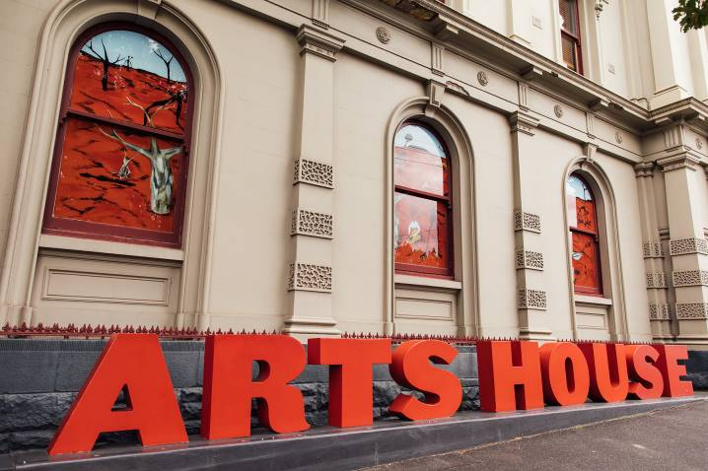
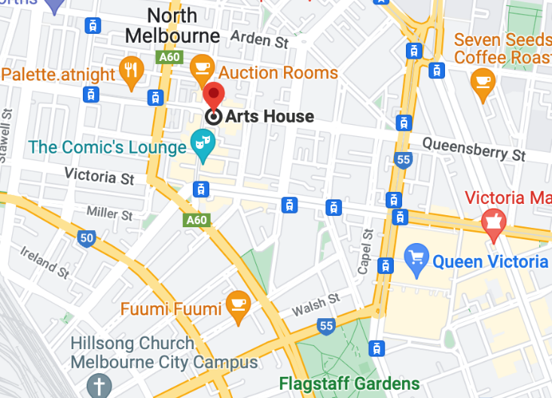

Image: North Melbourne Town Hall view from Queensberry Street which features giant red letters that say ARTS HOUSE out the front of it.

Image: a map of Arts House and its surrounding area. LINK TO MAP
Front Entrance

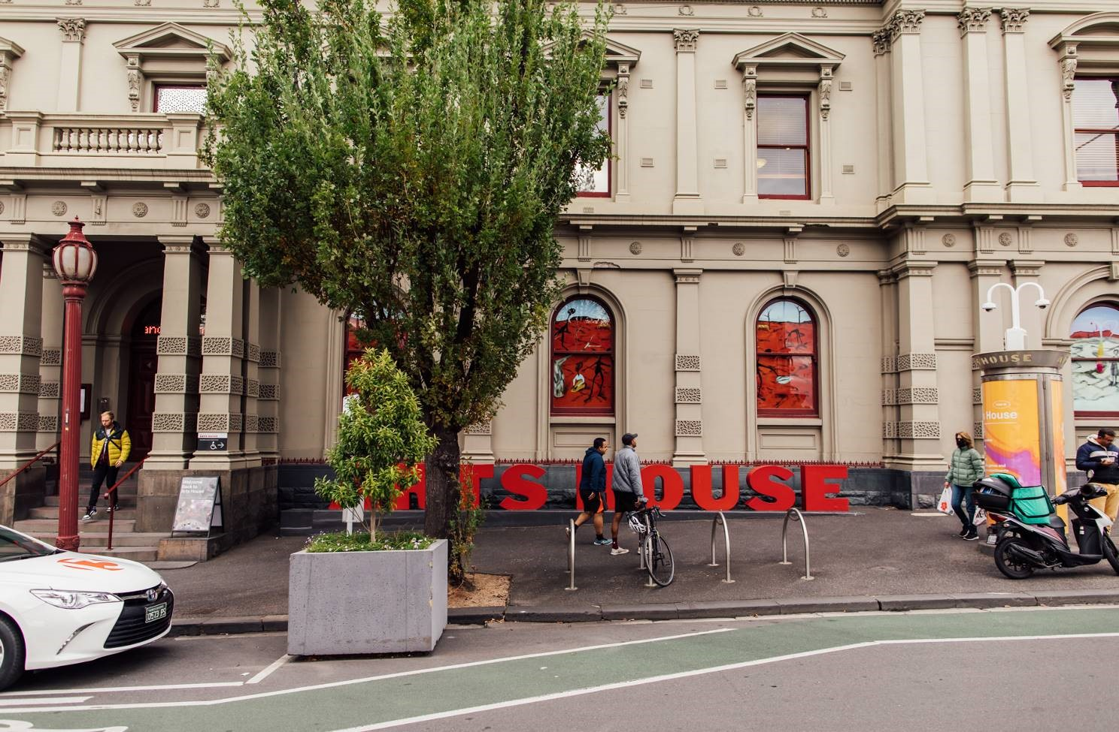

Image: North Melbourne Town Hall entrance on Queensberry Street. The entrance is to the left of the giant red letters that say ARTS HOUSE and features a staircase of eight steps with grab rails in parts.

Wheelchair Accessible Entrances

There are two Wheelchair Accessible Entrances. The first is on Errol St next to the Post Office.

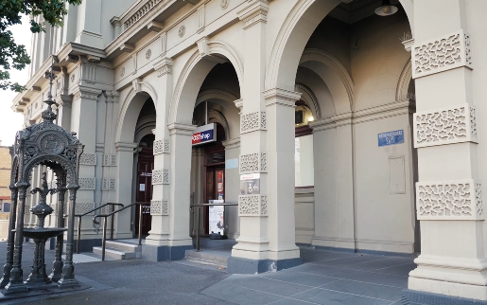

Image: Errol Street entrance next to the Post office with wheelchair accessible ramp or two steps with grab rails.
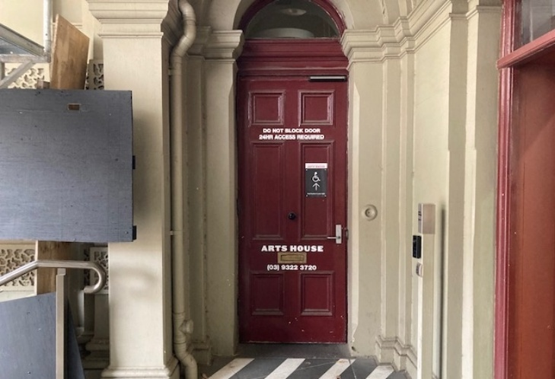
Image: View of door at Post office entrance.
Button to open automated door is on the right.

The second Accessible Entrance is towards the end of George Johnson Lane.

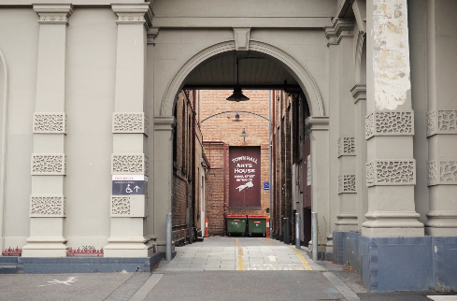

Image: View of George Johnson Lane from Errol St. The laneway passes through an archway with a brick wall at the end.
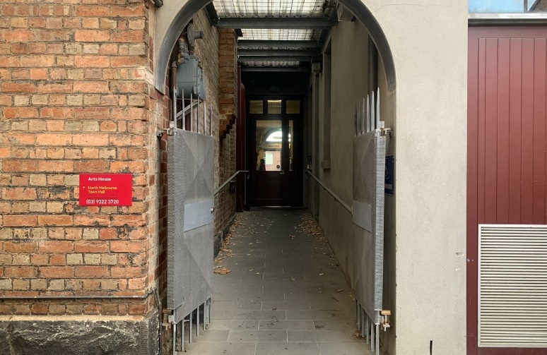

Image: view of the ramp with grab rail leading from George Johnson Lane to the automated door which opens into the Arts House foyer.

Box Office

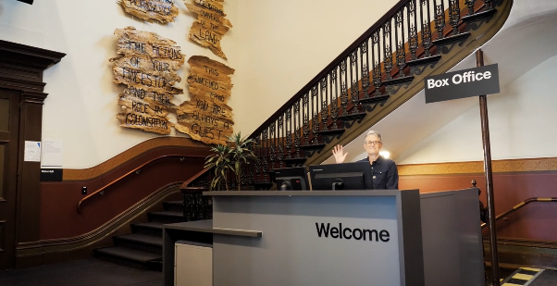
Image: The Box Office is located in the foyer under the stairwell. If you enter from the Main Entrance it should be straight ahead of you. If entering from the Post Office or George Johnson lane your should approach on its right hand side.

Ushers

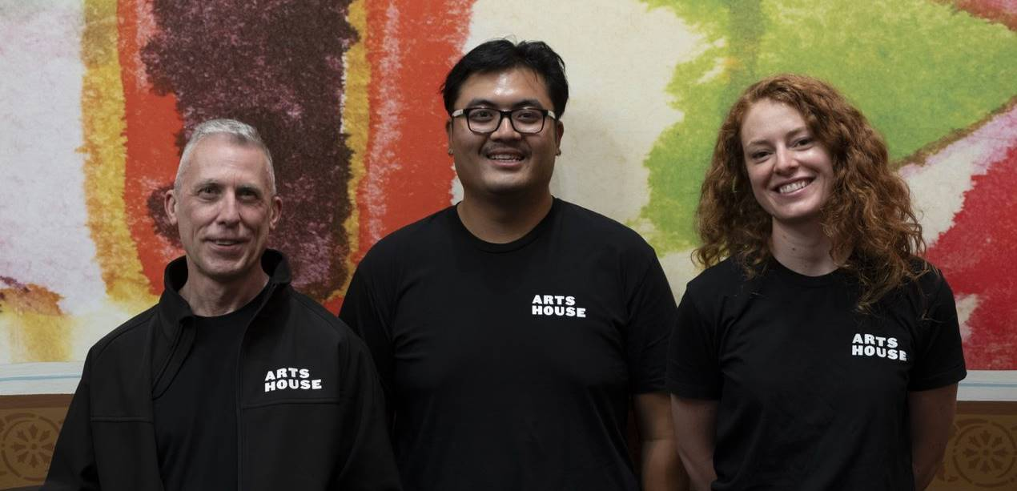
Image: Ushers will be wearing black with an Arts House Logo on the left hand shoulder.

Quiet Space

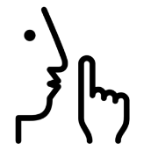
Arts House Quiet Space is located on Ground Level and is nearby reception and opposite the accessible bathrooms. It includes a range of seating options including soft furnishings, dimmable lights, sensory and stim objects. It is open during venue opening hours and events as a quiet space, prayer or parenting space.

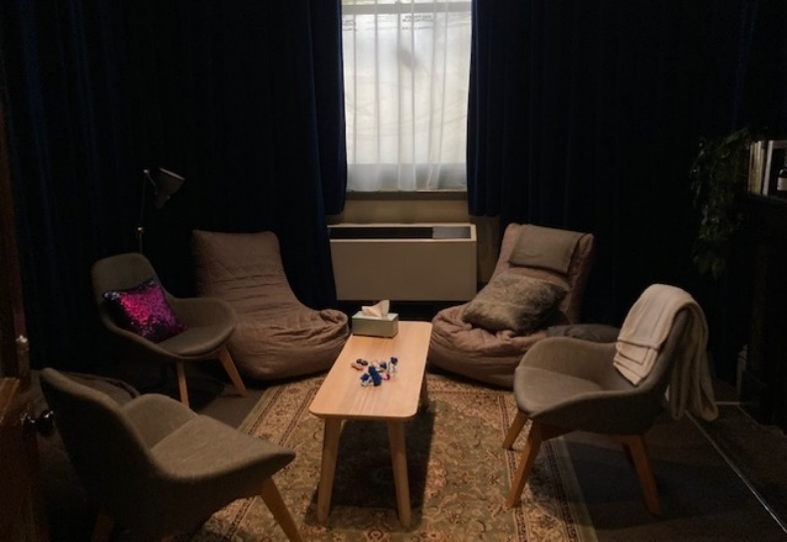
Image: Quiet space with lights dimmed
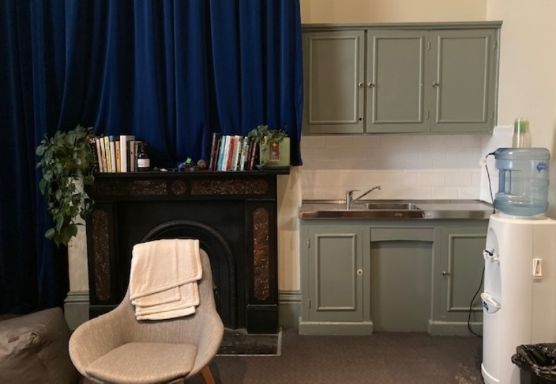
Image: Quiet space kitchenette and book shelf

Bathrooms

All bathrooms have Dyson hand dryers with sensor activation. There is an accessible bathroom that is single use on ground level opposite the Quiet Space. There is another accessible bathroom upstairs – this is accessible via lift or stairs.
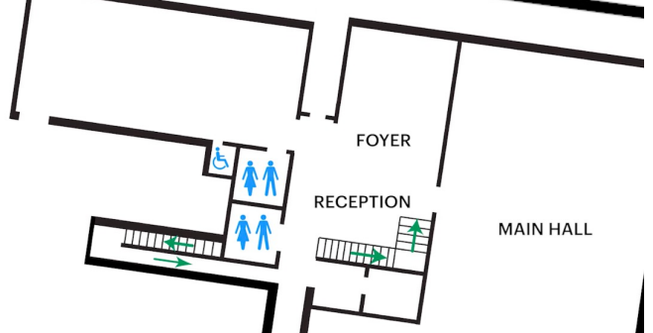

Lift

The lift is located behind reception desk in the foyer.
The closest entry to the lift is via George Johnson Lane.
The lift has buttons with braille. It also has audio cues inside.
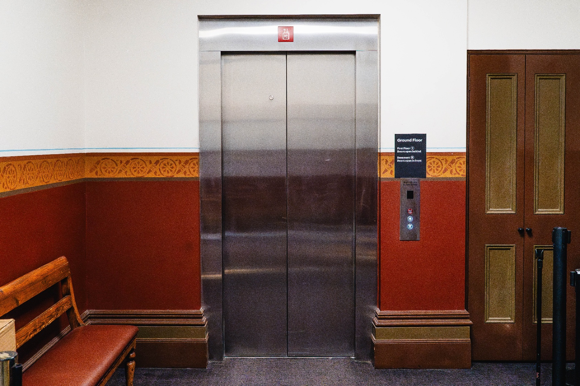

Image: The elevator entrance, located behind the reception desk.

Supper Room
The Supper Room is located at Basement level. You can access this space via the lift or down the stairs with hand-railing.

COVID Safety

Please note: If you have a cough, sore throat, fever, shortness of breath or flu-like symptoms, you must not attend our venue or programs in person.
We will provide a refund if you need to cancel your attendance due to illness. Please contact us by 9am on the day of the event.
To minimise the risk of COVID-19 transmission, we advise all patrons, artists and staff to:
- Wear a well fitted mask of P2 or comparable standards
- Practise physical distancing where possible
- Practise good hygiene by washing and or sanitising your hands often
- Test often (PCR or PlusLife testing recommended where possible)
- Stay up to date with vaccines (as recommended by your healthcare professional)
Throughout the venue you will find:
- hand sanitiser stations available
- masks available (ask one of our staff for assistance)​
- increased signage to direct patron movement and avoid crowd congestion
- two air filters, which move between different parts of the venue as needed.
We also ensure that spaces are well ventilated.
Staying COVID-safe remains important. We must all follow these steps:
- Follow the Victorian Government’s measures on how to stay safe.
- When you cannot safely socially distance it is recommended to wear a well fitted mask.
- Practise COVID-safe hygiene protocols.

