Neighbourhood Gathering, Season 1 2026

By Arts House

Access Guide
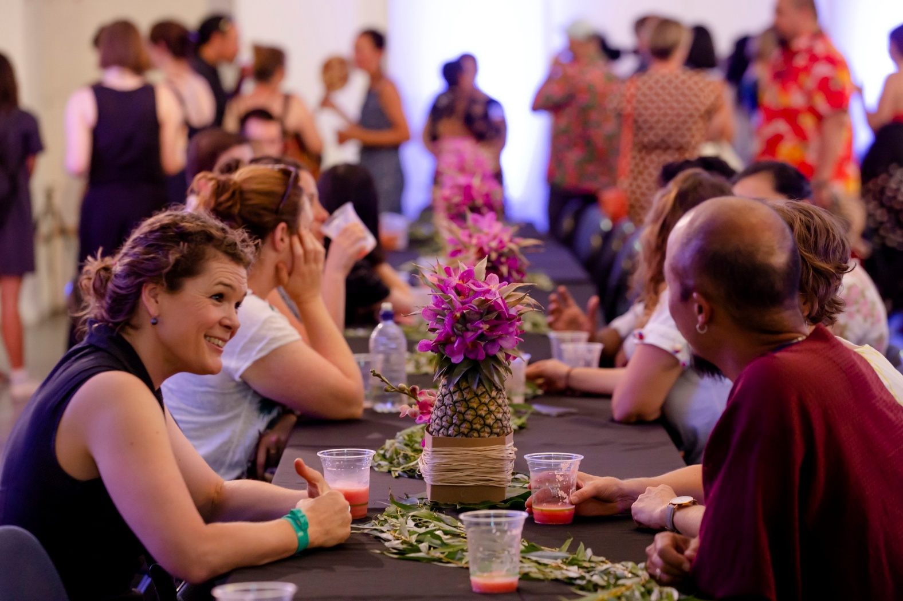
Image Credit: Bryony Jackson
Image Description: People are sitting on either side of a long table, smiling and in-conversation. There are drinks, pineapples, and greenery decorating the table.
Updates to this document

Please note, this performance is a new work and changes are being made by artists until opening. This guide will be updated as new information becomes available.

Arts House website will contain the most up to date version of this guide and all ticket holders will be notified of any changes made 3 days and 1 day prior to the event.

This document was created: 20 January 2026

Revision 1: 6 February 2026
Revision 2: 10 February 2026

Contents
Where 2
When 2
Important Notes 3
Content Warnings 3
General Notes 3
Access Services 4
Performers 6
Sensory Elements 6
Audience Experience 7
Transport 8
The Venue 9
COVID Safety 21

Where

Arts House
521 Queensberry Street
North Melbourne VIC

When

Thursday 12 February 2026
Doors 4:30pm
5pm–7pm
Duration: 2 hours

Important Notes

This event is family friendly – children and babies are welcome in our space.

The session will commence with an Acknowledgment of Country in the space.

Access Services


Assistance Animals are welcome.


Visual Rating - 50% - A mixture of visual and auditory components including dialogue, music, other sounds.


50% - A mixture of both sound and visual components like lighting, movement and physical design.


This performance is fully wheelchair accessible. More information on wheelchair accessible entrances and bathrooms can be found later in this guide.

Relaxed Elements

This show is relaxed with relaxed social rules, meaning you are encouraged to move around, make noise, pace and/or stim as much as you’d like. You are welcome to leave and return at any time you would like.


The quiet space will be available for you to use before and during the event. More information about the quiet space can be found later in this guide.

Companion card holders are welcome.

Performers and Presenters

Head of Programming - Naomi Velaphi
Artist - Rel Pham
Artist - Pey Chi
Artist - Jessica Wilson

Running order

4:30 – 5pm: Doors open, drinks and music
5 – 5:10pm: Noami Velaphi introduction
5:10 – 6:pm: Artist tour and talks walked throughout the building
6pm: Raffle drawn
6:05 – 7pm: Food served, mingling, music and drinks
7pm: Event concludes

Sensory Elements

Sound
The first part of this event is conversational involving audience mingling while listening to mildly amplified music playing in the main hall as people arrive. Sound is being played from main hall stage from a DJ being amplified throughout Main Hall and foyer space.
There will be a short verbal welcome presentation from some of the Arts House staff members.
Part way through event groups will be formed in 3 to take a tour of artworks throughout the event involving non-amplified speaking and conversation.
Lighting
The Neighbourhood Gathering conversation will be standard interior building lighting with no flashing or moving lights. The art tour section of the event will be standard interior building lighting.

Physical
The venue has heating and air conditioning. The rooms maintain an ambient temperature. When audiences move from Main Hall to throughout the rest of the building, they could be outside for a short period of time, and the weather may be inclement.

Smell
The Neighbourhood Gathering will have an assortment of catering both vegetarian and meat catering from Vietnamese, Mediterranean and Western local cuisines.

Visual
The DJ will be on an elevated stage in the Main Hall facing the entrance of the space. An exhibition of photographs is in the main floor of the space in the middle with a small bar at the edge of the space serving drinks. The space will have limited seating.

Audience Experience

Entry to space
Audiences mostly welcomed from front doors on Queensberry St by ushers giving out raffle tickets, as well as access through Erroll St and George Johnson Lane.

Shocks or surprises
There are no shocks or surprises.

Social expectations
This session involves optional light social interaction with other members of the public and Arts House staff. You are welcome to sit or stand anywhere you and come and go in the space and have a drink or snack whilst the session is happening.

Transport

Tram

Route 57 (High Floor trams only)
Stop 12, North Melbourne Town Hall.
Please note, this is not a wheelchair accessible tram
GETTING TO ARTS HOUSE VIDEO LINK

Train

Arts House is 1.1km from
North Melbourne Train Station,
approximately 16 minute walk
North Melbourne Station Information
1.2km from Flagstaff Station,
approximately 15 minute walk
Flagstaff Station Information

Bus

Bus number: 216

Parking

There is limited paid on-street parking on Queensberry Street and Errol Street.

There are two accessible on street car parking spaces on Queensberry Street (150m to our accessible Errol Street entrance) for holders of a Parking Permit for Disabled people.

The Venue

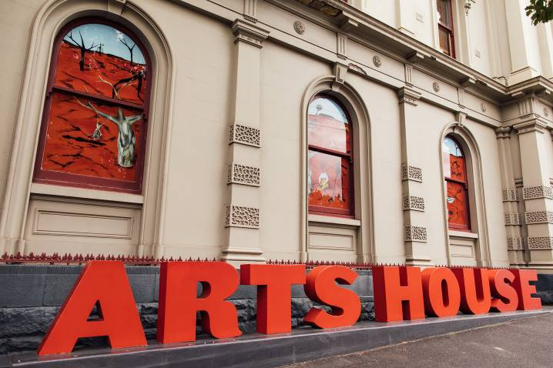
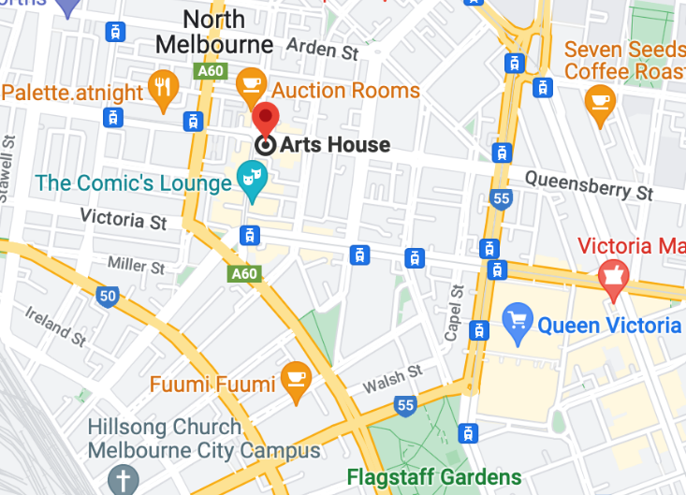

Image: North Melbourne Town Hall view from Queensberry Street which features giant red letters that say ARTS HOUSE out the front of it.

Image: a map of Arts House and its surrounding area. LINK TO MAP
Front Entrance

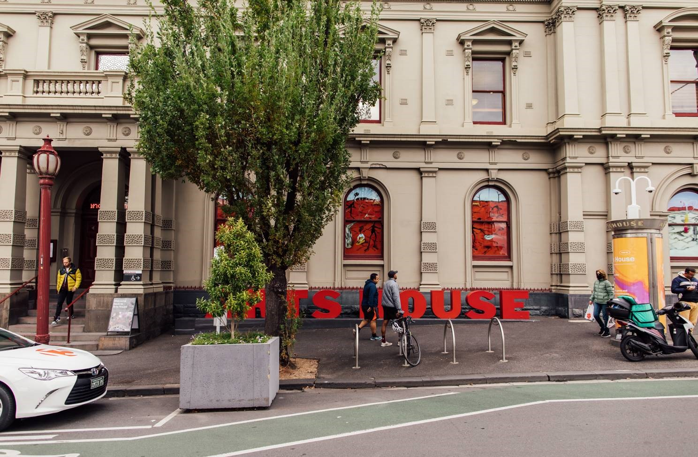
Image: North Melbourne Town Hall entrance on Queensberry Street. The entrance is to the left of the giant red letters that say ARTS HOUSE and features a staircase of eight steps with grab rails in parts.

Wheelchair Accessible Entrances

There are two Wheelchair Accessible Entrances. The first is on Errol St next to the Post Office.

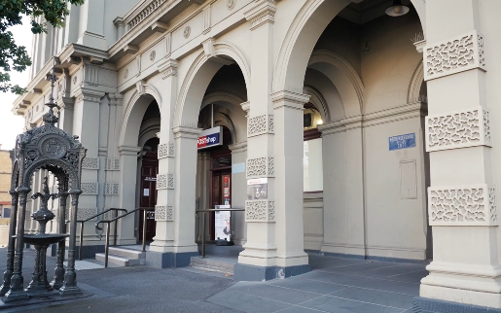

Image: Errol Street entrance next to the Post office with wheelchair accessible ramp or two steps with grab rails.
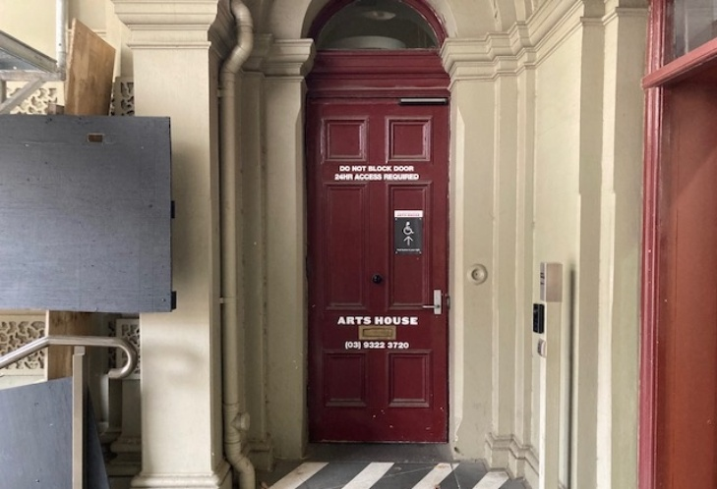

Image: View of door at Post office entrance.
Button to open automated door is on the right.

The second Accessible Entrance is towards the end of George Johnson Lane.

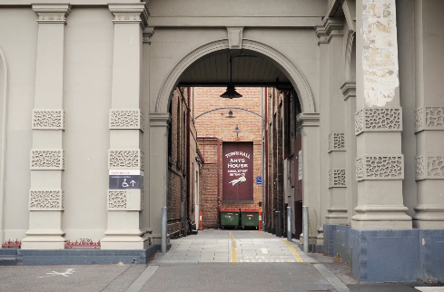
Image: View of George Johnson Lane from Errol St. The laneway passes through an archway with a brick wall at the end.
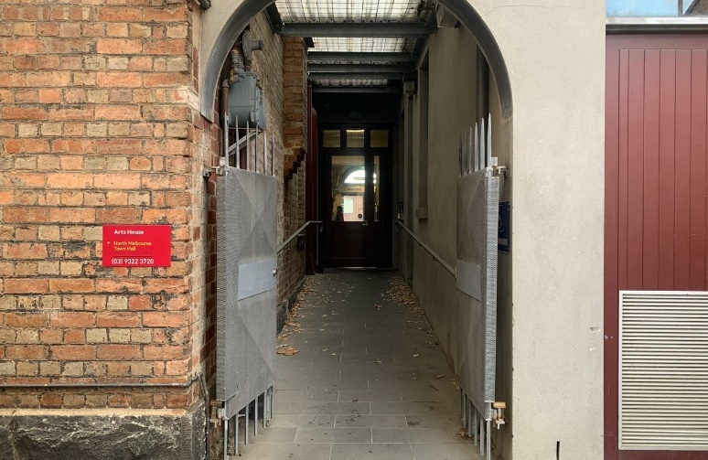
Image: view of the ramp with grab rail leading from George Johnson Lane to the automated door which opens into the Arts House foyer.

Box Office

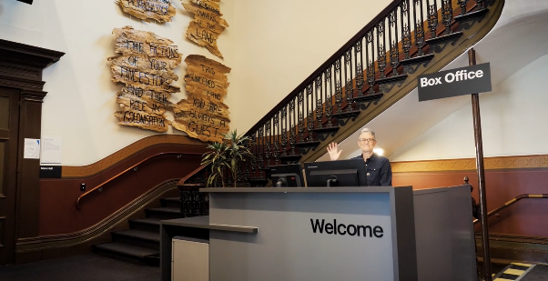

Image: The Box Office is located in the foyer under the stairwell. If you enter from the Main Entrance it should be straight ahead of you. If entering from the Post Office or George Johnson lane your should approach on its right hand side.

Ushers

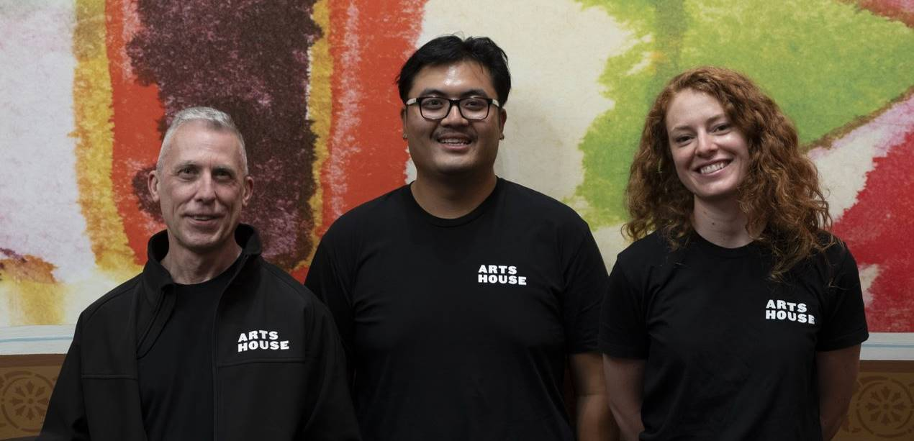

Image: Ushers will be wearing black with an Arts House Logo on the left hand shoulder.

Bar

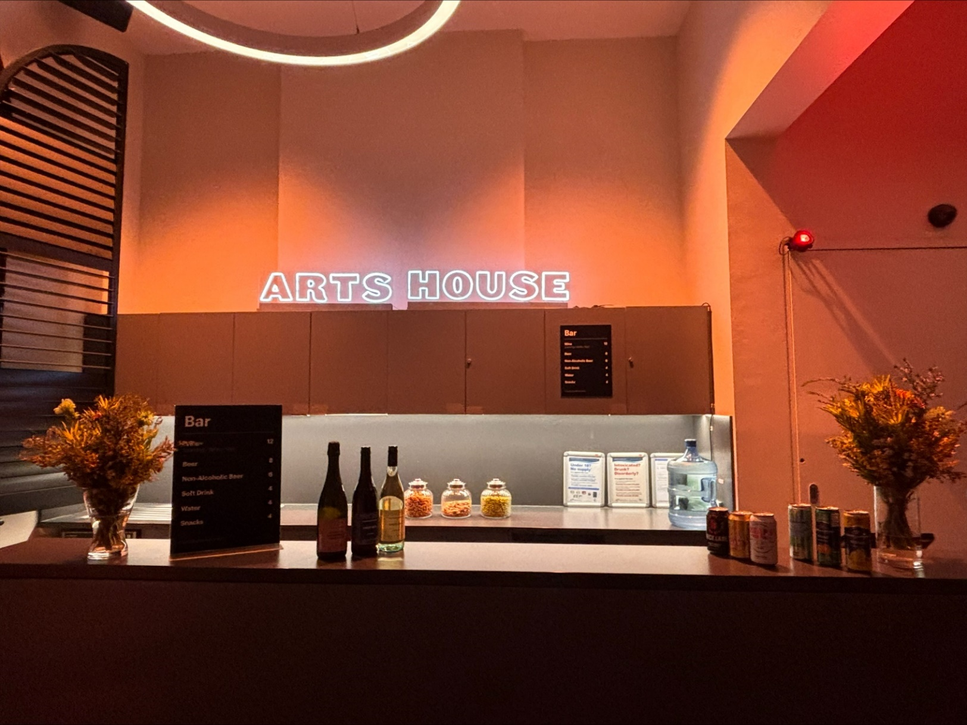
Image: The Arts House Bar with vases on each side of the bar filled with native flowers. In the centre there is a bar menu displayed with drinks set up on the top level on the bar. Towards the back wall there is a Arts House sign that is lit up. The lighting of the space is lit up orange.
The bar is to the Bar staff will be wearing black with an Arts House Logo.

We have a range of alcoholic and non-alcoholic beverages for sale.

We are a cashless venue and accept EFTPOS, Visa and Mastercard payments.

Quiet Space

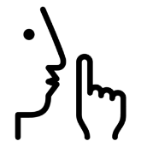
Arts House Quiet Space is located on Ground Level and is nearby reception and opposite the accessible bathrooms. It includes a range of seating options including soft furnishings, dimmable lights, sensory and stim objects. It is open during venue opening hours and events as a quiet space, prayer or parenting space.

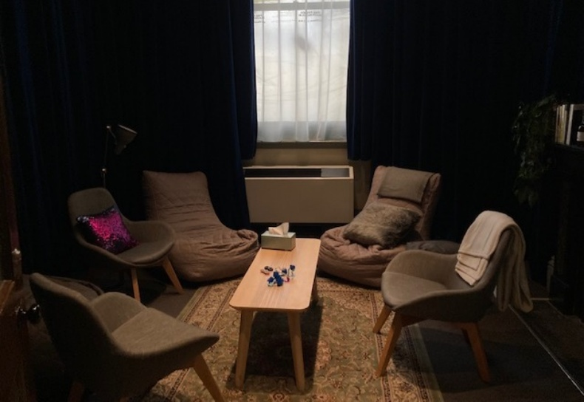
Image: Quiet space with lights dimmed
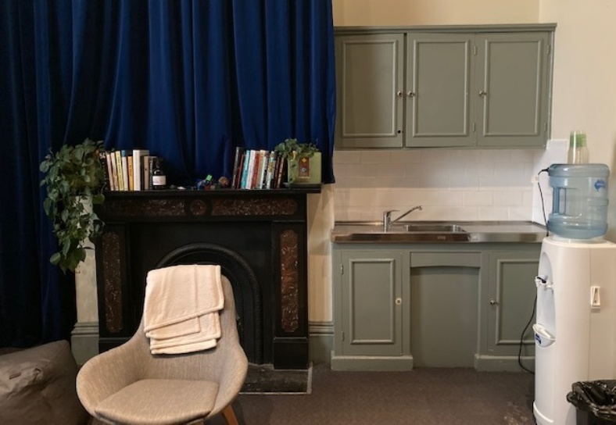

Image: Quiet space kitchenette and shelf

Bathrooms

All bathrooms have Dyson hand dryers with sensor activation. There is an accessible bathroom that is single use on ground level opposite the Quiet Space. There is another accessible bathroom upstairs – this is accessible via lift or stairs.

Door to Main Hall

The Performance is in the Main Hall.
It is on the ground floor.
It is to the left of the box office desk and right of the bar.
An artist statement is available on signage and warnings on the door.

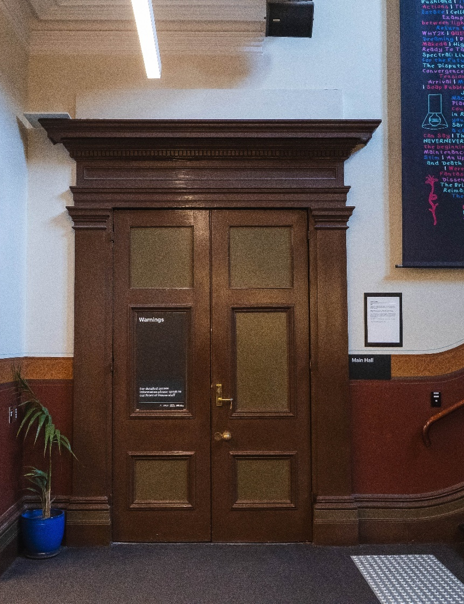

Lift

The lift is located behind reception desk in the foyer.
The closest entry to the lift is via George Johnson Lane.
The lift has buttons with braille. It also has audio cues inside.

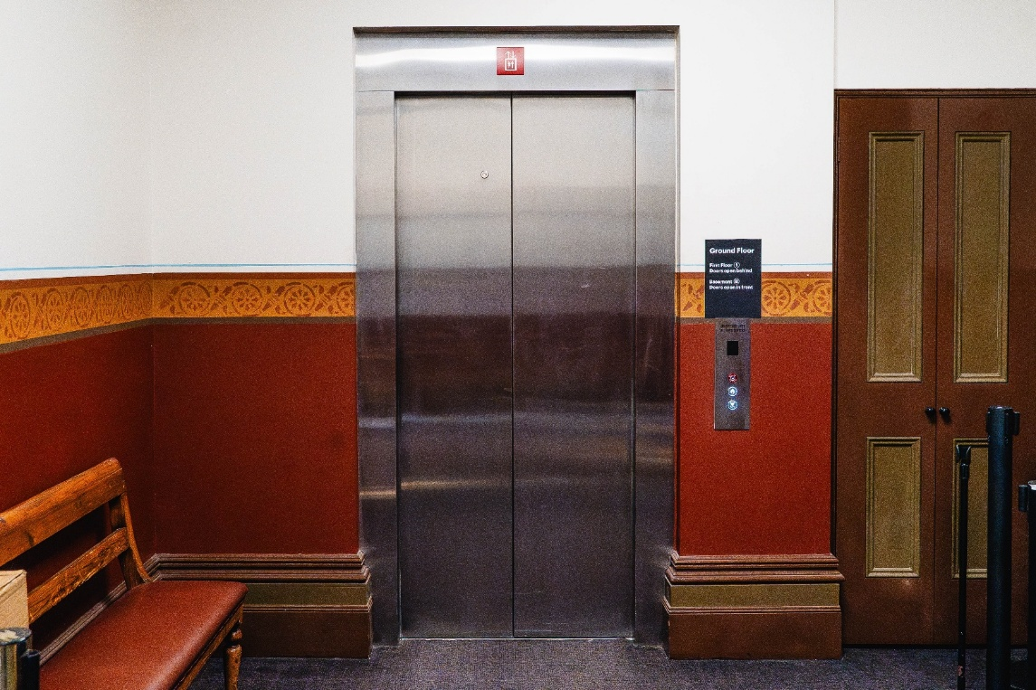

Image: Ground floor entrance to the lift, located behind the reception desk.
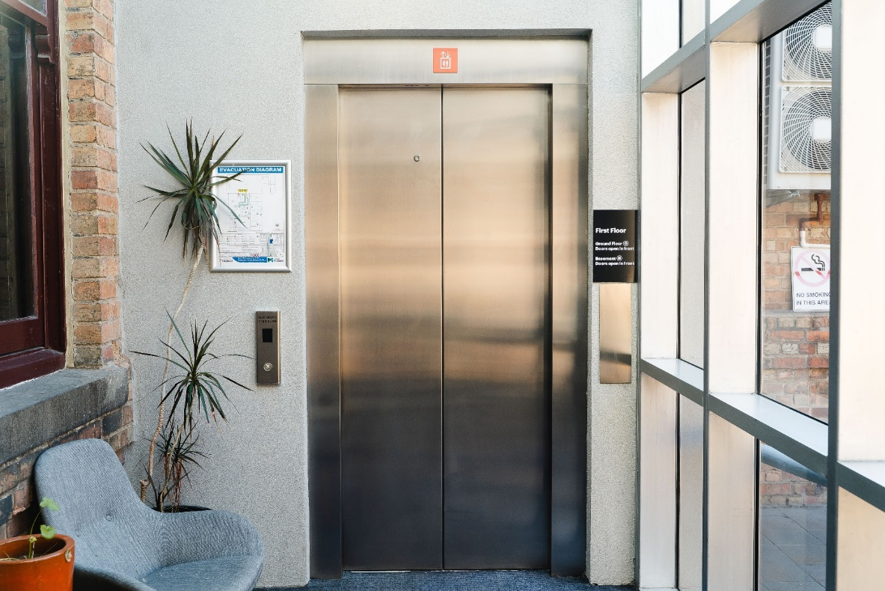

Image: Level 1 entrance to the lift.

Supper Room
The Performance is in the Supper Room.
It is on the first floor.
You can access these spaces via stairs with hand-railing or the lift.
An artist statement is available on signage and warnings on the door.

COVID Safety

Please note: If you have a cough, sore throat, fever, shortness of breath or flu-like symptoms, you must not attend our venue or programs in person.
We will provide a refund if you need to cancel your attendance due to illness. Please contact us by 9am on the day of the event.
To minimise the risk of COVID-19 transmission, we advise all patrons, artists and staff to:
- Wear a well fitted mask of P2 or comparable standards
- Practise physical distancing where possible
- Practise good hygiene by washing and or sanitising your hands often
- Test often (PCR or PlusLife testing recommended where possible)
- Stay up to date with vaccines (as recommended by your healthcare professional)
Throughout the venue you will find:
- hand sanitiser stations available
- masks available (ask one of our staff for assistance)​
- increased signage to direct patron movement and avoid crowd congestion
- two air filters, which move between different parts of the venue as needed.
We also ensure that spaces are well ventilated.
Staying COVID-safe remains important. We must all follow these steps:
- Follow the Victorian Government’s measures on how to stay safe.
- When you cannot safely socially distance it is recommended to wear a well fitted mask.
- Practise COVID-safe hygiene protocols.

