Is Anyone Even Watching

By Olivia Muscat

Access Guide

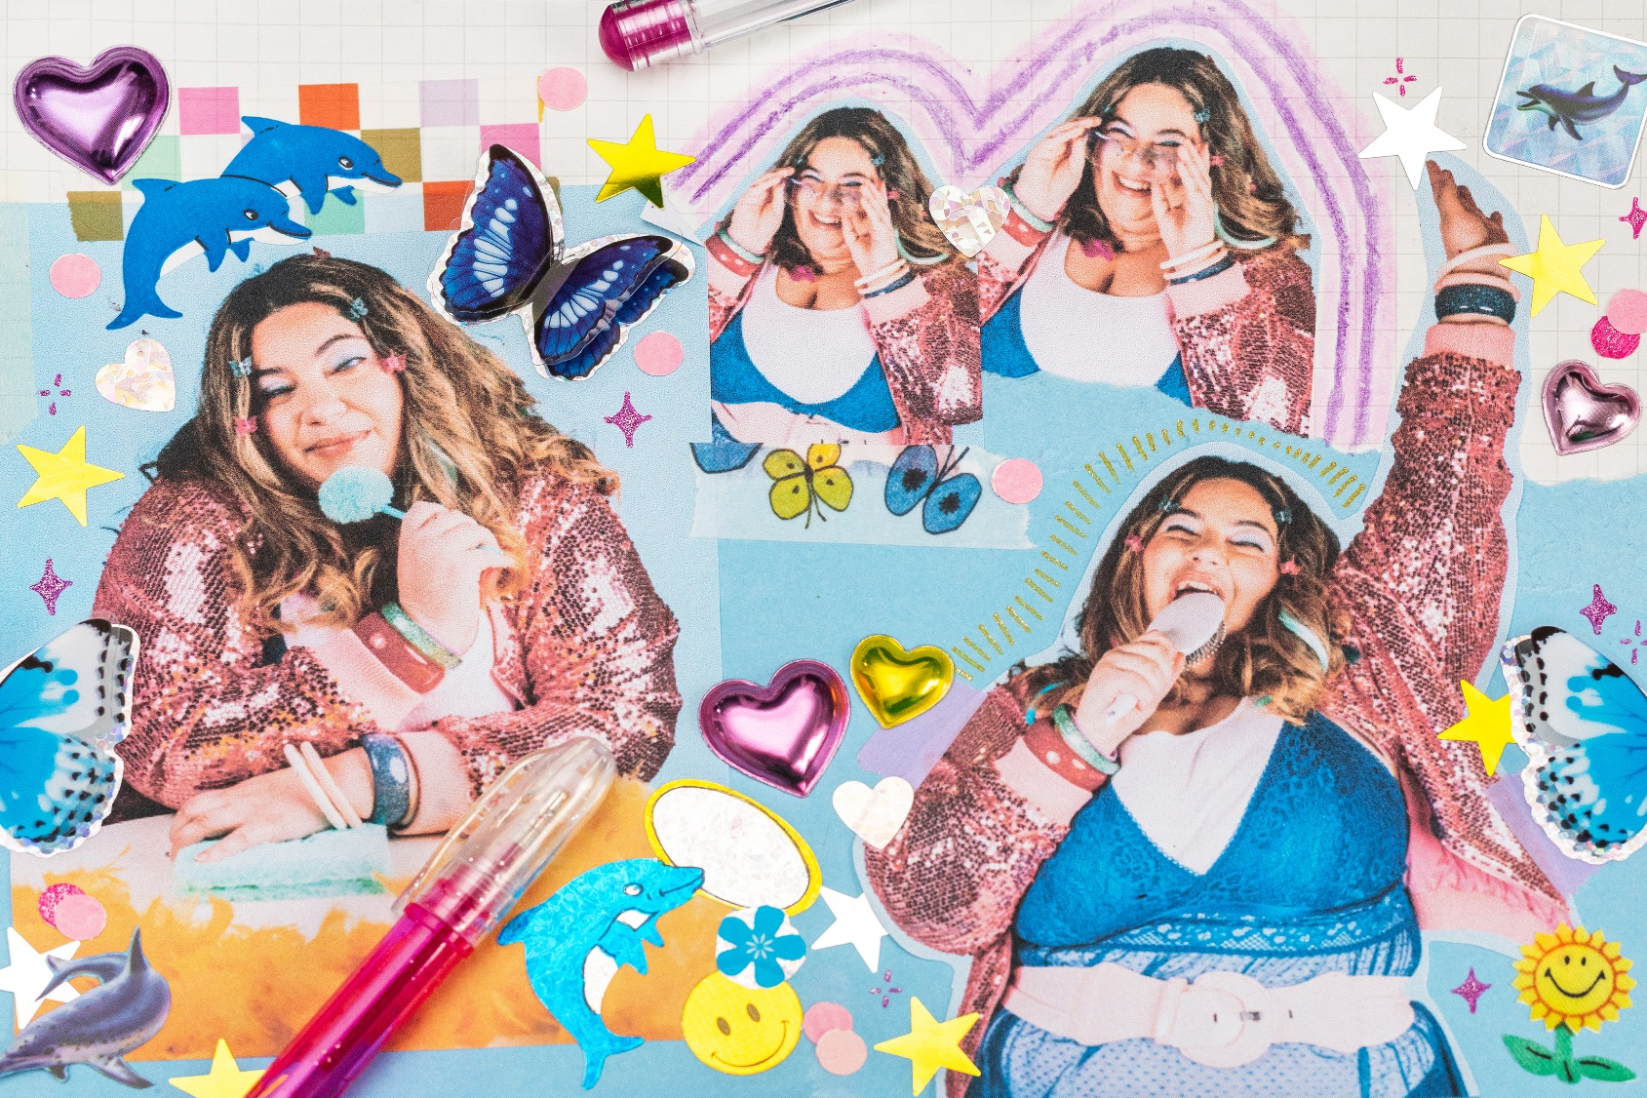
Image: Promotional image for the show.
Image Credit: Tatanja Ross.

Updates to this document

Please note, this performance is a new work and changes are being made by artists until opening. We will endeavour to provide the latest access information on performances to ticket holders across key stages of rehearsal and presentation.

Arts House website will contain the most up to date version of this document and all ticket holders will be notified of any revisions made 3 days and 1 day prior to the event.

This document was created: 09 September 2025

Revision 1: 1 October 2025
Revision 2: 6 October 2025

Contents
Updates to this document 2
Where 4
When 4
Access Services 4
Performers 6
Sensory Elements 6
Sound 7
Lighting 7
Physical 7
Smell 7
Visual 7
Entry to space 7
Shocks or surprises 8
Audience experience 8
Social expectations 8
Performance expectations 8
Other 8
Content Warnings 8
General Notes 8
The Venue 9
Front Entrance 9
Accessible Entrances 10
Box Office 11
Ushers 11
Bar 12
Quiet Space 13
Bathrooms 14
Door to Studio 1 15
Lift 16
Transport 17
Tram 17
Train 17
Bus 17
Parking 17
COVID Safety 18

Where

Arts House
521 Queensberry Street
North Melbourne VIC

When

Wednesday 8 – Sunday 12 October 2025
Wednesday – Friday, 8.30pm
Saturday, 2pm & 8.30pm
Sunday, 5pm

Duration: 60 Minutes, no interval.

Access Services

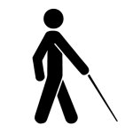
Tactile Tour – Available for all performances (45 minutes prior to performance).
The Tactile Tour (10 mins) run by the audio describer, followed by a context building and detailed descriptions (10 mins) of actions in a key moment that happens towards the end of the show. This second half of the tour will be run by the two performers in the performance space and is specifically for blind/ low vision audience members.

Sensory and Performance Space Tour (25 minutes prior to performance).
The Sensory and Performance Space Tour (5 minutes) is for any audience member who would like prior warning of lights, sounds and the performance space's sensory elements before the show begins. We'll demonstrate the brightest lighting state and the loudest point of the show, can reserve specific seats or spaces, or ask any general access questions.

Audio Described Performance – Available for all performances.


Assistance Animals are welcome.
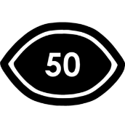
Visual Rating 50% – Includes dialogue and background music or sounds, so Deaf and hard of hearing audiences can have some engagement with the event.
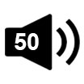
Aural Rating 50% - Contains both sound and visual components, but sight is not essential to be able to engage with the event.
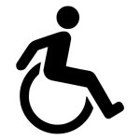
This performance is fully wheelchair accessible. More information is provided further below in this guide about the accessible entrances at Arts House and bathrooms.

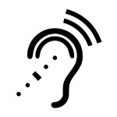
Assistive Listening - Is available free of charge to help amplify or enhance the sound quality of an event. Ask staff for assistance on arrival.
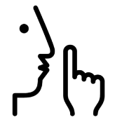
Quite Space Available - The quiet space will be available for you to use before, during and after the show. More information about the quiet space can be found later in this guide.


Companion Card - Arts House supports the Companion Card program.

For any other access information, you can contact the show’s producer, Hannah Reekie from Loom Arts and Management. Contact details are:

Email: hannah@loom.org.au
Phone: 0479 181 665

Performers

Writer and Lead Performer: Olivia Muscat

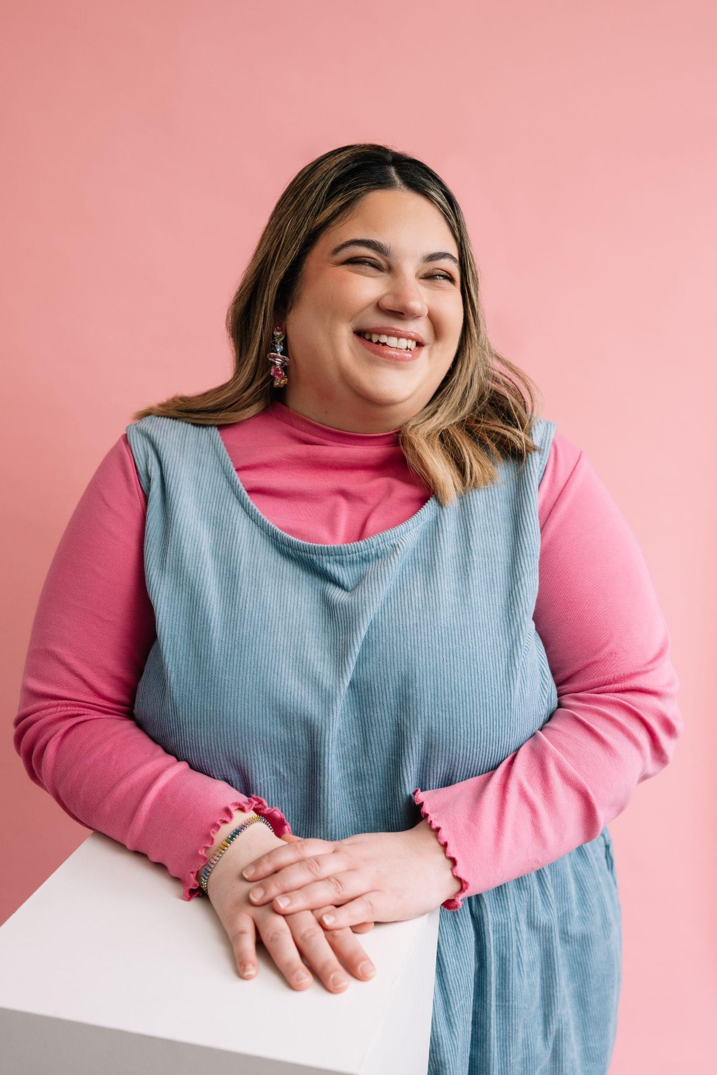

Image credit: Phoebe Powell

Image description: ​​A photo of Olivia, a woman pale with a pale complexion and shoulder length dark hair with blonde highlights. She is standing in front of a solid pale pink background wearing a long-sleeve hot pink top with ruffled edges under light blue corduroy overalls. She is smiling widely with her head tilted looking slightly to her left.

Collaborative Performer: Zoe Boesen

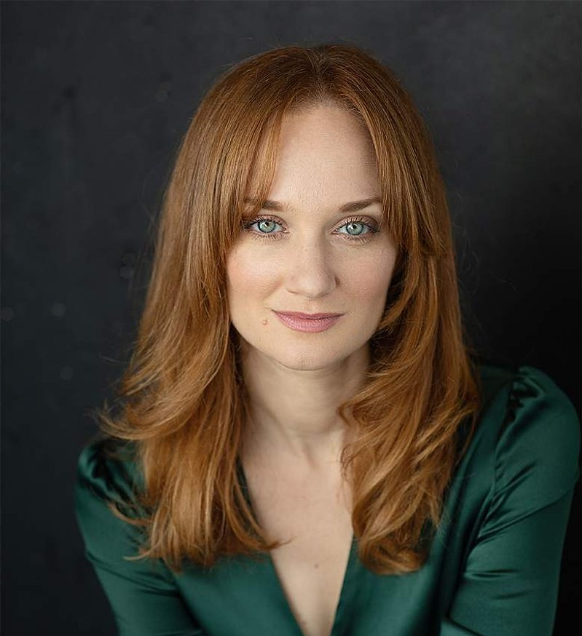

Image credit: Amelia J Dowd

Image description: A photo of Zoe, a woman with a light complexion, straight red/copper hair and green eyes, looking directly at the camera with a calm expression. She is in front of a black background and is wearing a dark green silk dress.

Sensory Elements

Sound

“Is Anyone Even Watching?” is set in the early 2000s and features pop music of that time. There are multiple scenes where music plays over chatter from the performers as they dance and sing around their ‘bedroom’ on stage. Audience members are encouraged to sing along or engage with the music in whatever way feels good to them.

There are sounds in the shows to aid the access for blind/ visually impaired audiences. They indicate when performers go on and off and when blackouts occur. These are introduced by the performers at the beginning of the show.

There is audio description (AD) voiceover throughout the show, but this sometimes acts as an unreliable narrator. It reflects both the good and bad of AD in the world of the show, this sometimes also becomes a cacophony of thoughts with overlapping voices which is designed to be overwhelming/ reflecting the main characters overwhelm.

Earplugs will be available in the foyer prior to the show if you would like the option to lessen these moments with busy soundscapes or loud music.

Lighting

The lighting in the show is warm and bright - there are glittery lamps and strings of fairy lights on the set.

There will be moments of blackout, these are also indicated with sound.

Towards the end of the show the lighting will get bright and flashy, mimicking a stadium concert.

There is no use of strobe lighting or fast paced changing lights.

Physical

The audience space is made up of three rows of chairs and a front row made up of low to the ground seating, soft rugs and cushions. Hidden amongst these cushions are hairbrushes, light up LED wands and rubbery bracelets which audience members are welcome to use during the show as props.

Those at the front are likely to feel more included in the action - you might be passed props from the performers, join in party games or spoken to directly by performers. You won’t have to leave your seat to join in, you also don’t have to join in - you can just pass things on to the person next to you or say “no thank you” if offered a prop.

There are bubbles used in the final part of the show, and a leaf blower used on stage.

Smell

The performers spray themselves with body spray, hair spray and perfume.

Food is eaten on stage, including a donut and popcorn, which may produce sweet smells.

Visual
Visually the show is very loud, vibrant and girly - it’s a vivid pink childhood fantasy bedroom. There are lots of soft cushions and textures. A large pink shag rug, soft sheer curtains and lots of shelving covered in trinkets, toys, makeup, posters, CDs, a white miniature piano, and lots of glittery, sparkly objects.

There are parts of the set that get moved into the centre, to be highlighted in a scene.

The two tall panels at the back of the stage are fixed firmly in place and do not move during the show.

There are parts of the set that move to transform into smaller areas, such as a pillow fort or wardrobe.

Audience Experience

Entry to space

The audience enters to an early 2000s pop soundtrack playing. They can sit on chairs or cushions and low seating on the floor.

You won’t be asked to do anything immediately but as the show starts the performers may ask you to join in with slumber party games, such as pass the parcel or singing along with a hairbrush. These are completely voluntary and you won’t be asked to go up onstage at any point.

You may be asked to read something out loud, but you can opt to hand the card to Sighted Girl (Zoe Boesen) to read instead.

Shocks or surprises

Inflatable beach balls are thrown at a performer at one point in the show. This is scripted and is not dangerous in any way, though the performer may seem in distress at times.

The music in the show can get loud in places, but not suddenly and not to an uncomfortable level.

Audience experience

The performers welcome and encourage the audience to feel a part of the action from the start, but there is no expectation to join in.

You may be passed props by the performers, or asked by the performers to pass props to them. Everyone will be asked to read out some things from cards at the same time/ in unison (this is also available in the AD for blind and low vision audience members to join).

Social expectations

You’re welcome to do whatever you need to feel comfortable during the show - stim, make noise, come and go as they need, take time out outside the room. There is a Quiet Space on the ground floor of Arts House and toilets on both levels.

When it comes to bringing food into the space, please be respectful of those around you - for example not bringing strong smells into the space, or things that can cause airborne allergies such as nuts.

Performance expectations

There are two performers on stage, Olivia who is blind and Sighted Girl (Zoe Boesen). The story is non-linear, meaning it doesn’t have a clear beginning, middle and end and jumps between a world that is close to reality and one that is representative of Olivia’s internal world.

“Is Anyone Even Watching” is set at a girls’ slumber party with all that entails - makeovers and watching films and playing games. It’s interspersed with stories relating to Olivia’s experience of growing up blind and also how she experiences the world now. She does this through personal monologues, voiceovers and also in scenes with Sighted Girl.

Relaxed space
Audience members are welcome to come and go as they please, be themselves, make noise, stim, and respond to the work for the duration.

Other

Content Warnings

Ableism
There is discussion of Olivia’s experience of othering and discrimination as a disabled person throughout the show.

Bullying

There are references to bullying, manipulative behaviour and unfair treatment of characters.

Sexual references

There is reference to sex scenes through suggestive audio description, but no graphic detail or direct representation of sexual activity.

General Notes

This performance contains some adult themes and content including ableism and bullying. This performance contains loud pop music played at multiple points throughout the show.

The Venue

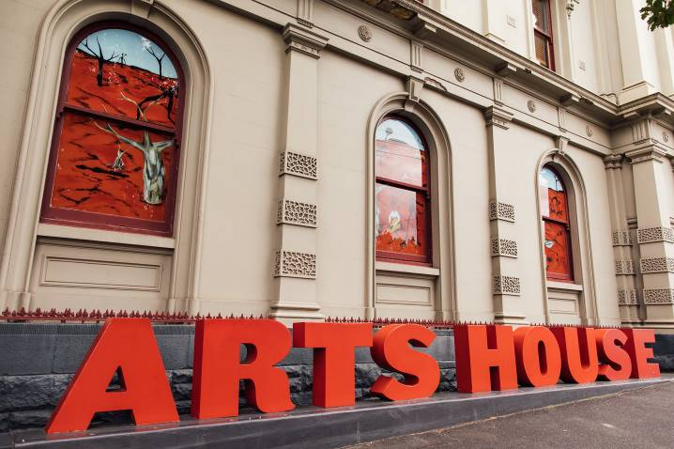
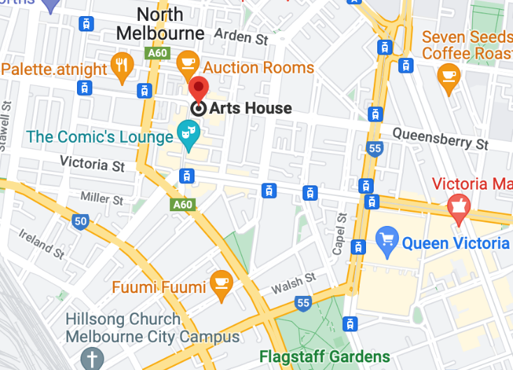

Image: North Melbourne Town Hall features giant red letters that say ARTS HOUSE out the front of it.

Image: a map of Arts House and its surrounding area. LINK TO MAP

Front Entrance

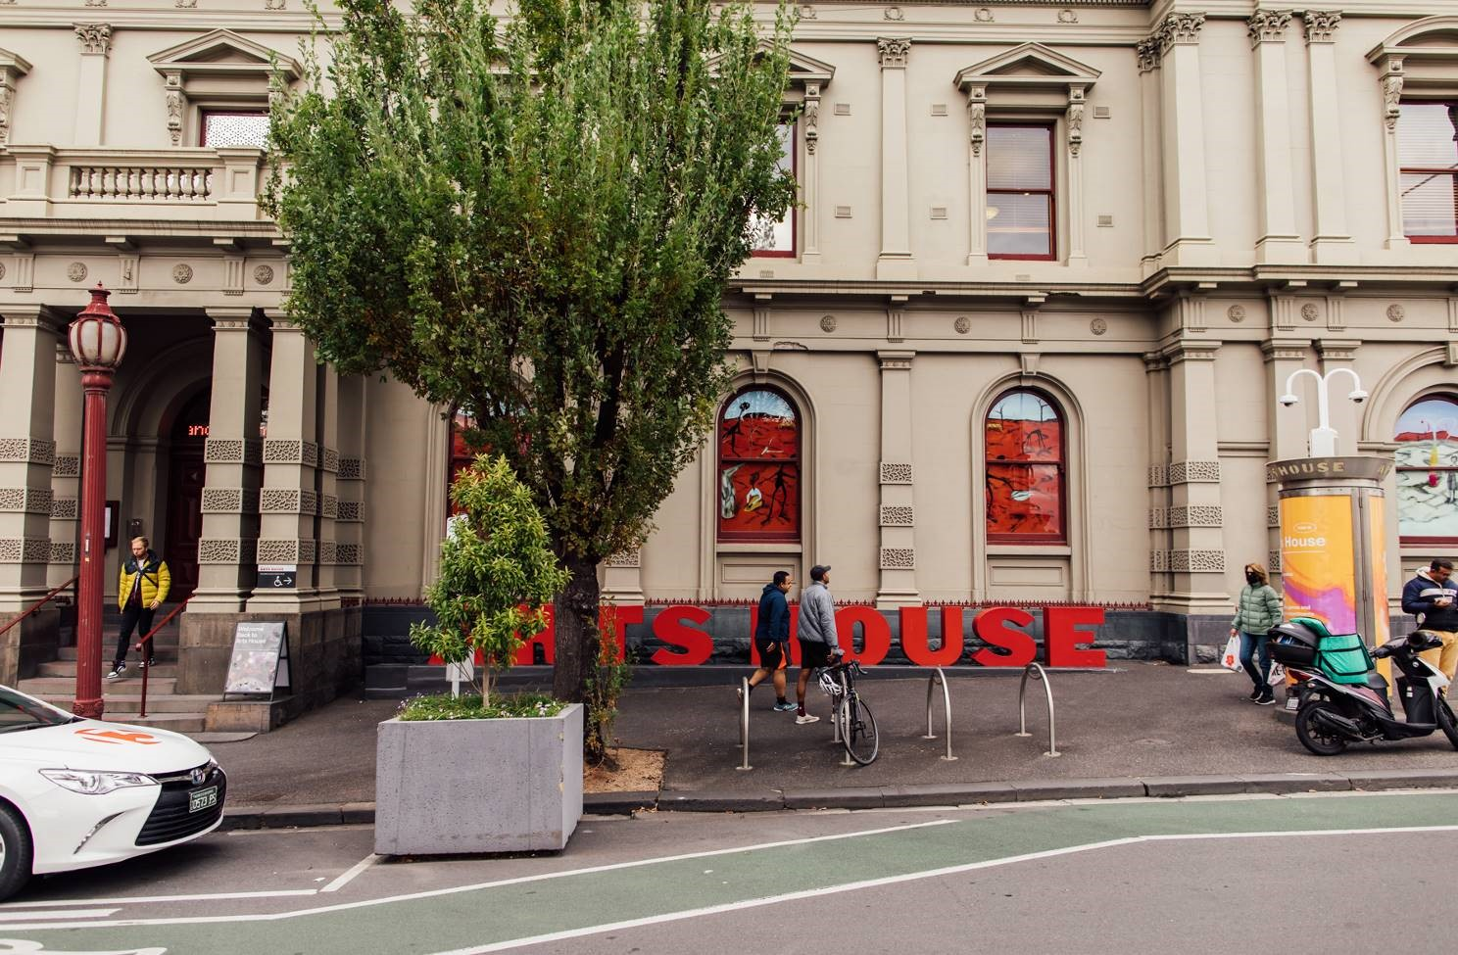

Accessible Entrances

There are two Accessible Entrances. The first is on Errol St next to the Post Office.

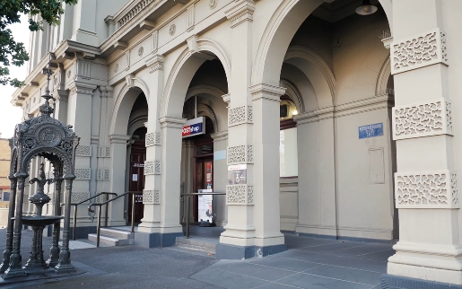

Image: Errol Street entrance next to the Post office with wheelchair accessible ramp or two steps with grab rails.
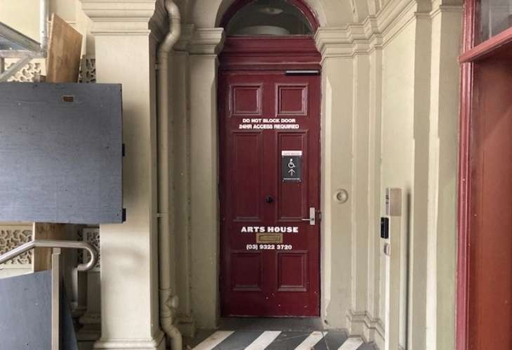
Image: View of door entrance.

The second Accessible Entrance is towards the end of George Johnson Lane.

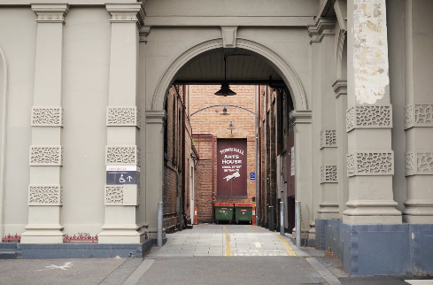

Image: View of George Johnson Lane from Errol St. The laneway passes through an archway with a brick wall at the end.
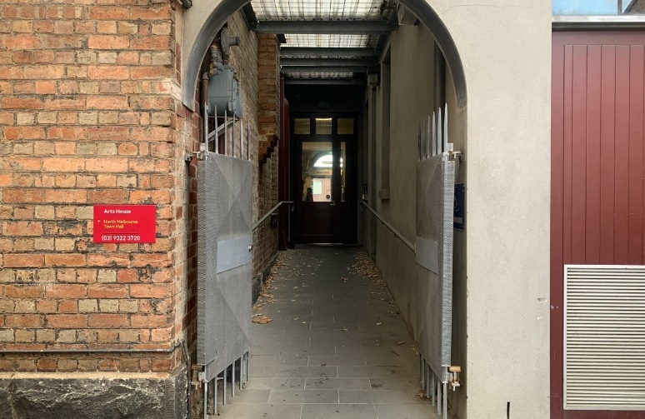

Image: view of the ramp leading from George Johnson Lane to the automated door which opens into the Arts House foyer.

Box Office

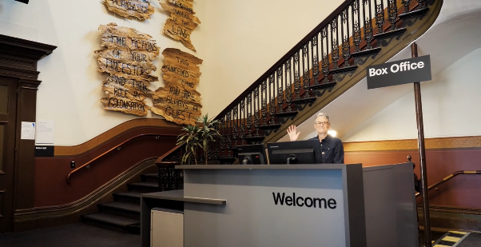

Image: Box Office is located in the foyer under the stairwell.

Ushers

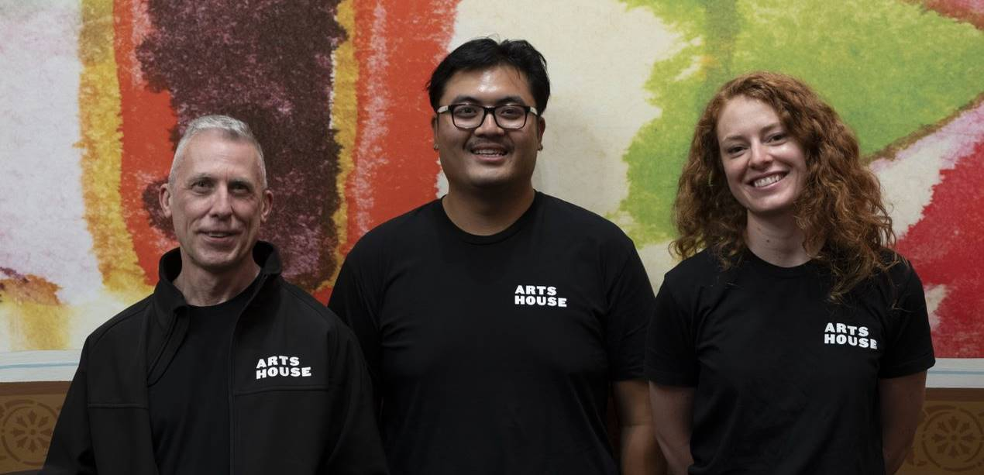

Image: Ushers will be wearing black with an Arts House Logo on the left hand shoulder.

Bar

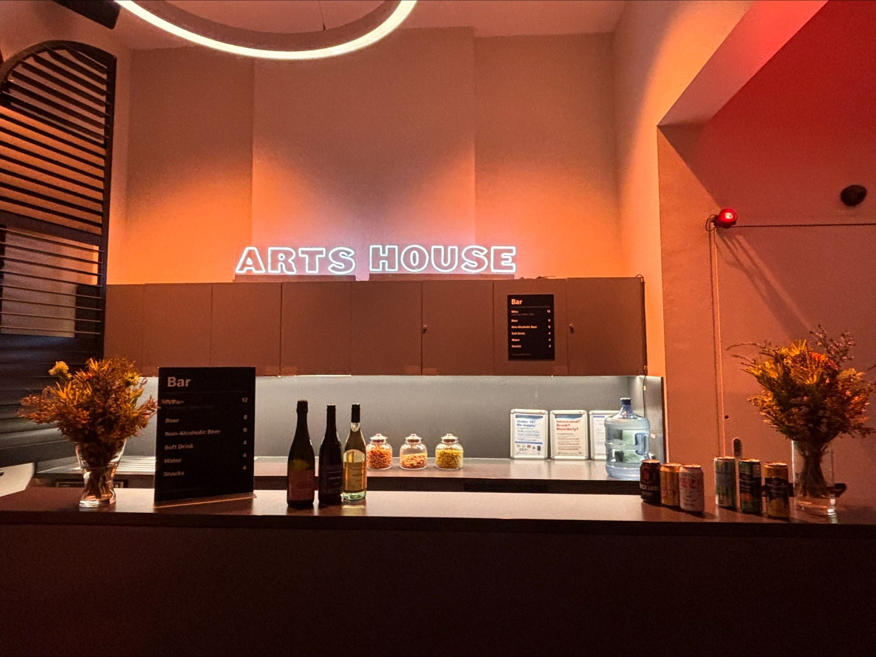

Image Description: The Arts House Bar located on the ground floor.
Bar staff will be wearing black with an Arts House Logo.
We have a range of alcoholic and non-alcoholic beverages for sale.
We are a cashless venue and accept EFTPOS, Visa and Mastercard payments.

Quiet Space

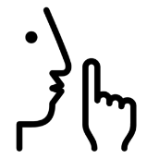

Arts House Quiet Space is located on Ground Level and is nearby reception and opposite the accessible bathrooms. It includes a range of seating options including soft furnishings, dimmable lights, sensory and stim objects. It is open during venue opening hours and events as a quiet space, prayer or parenting space.

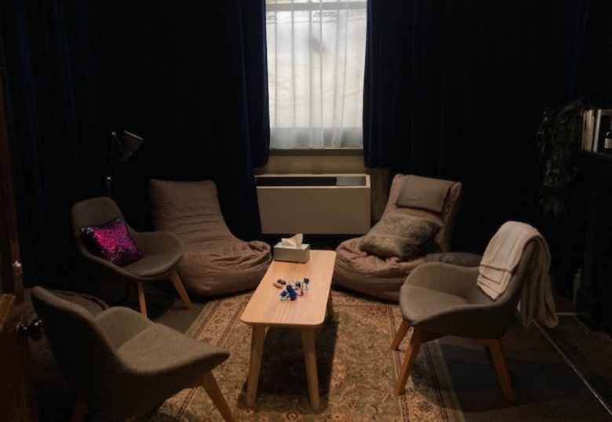

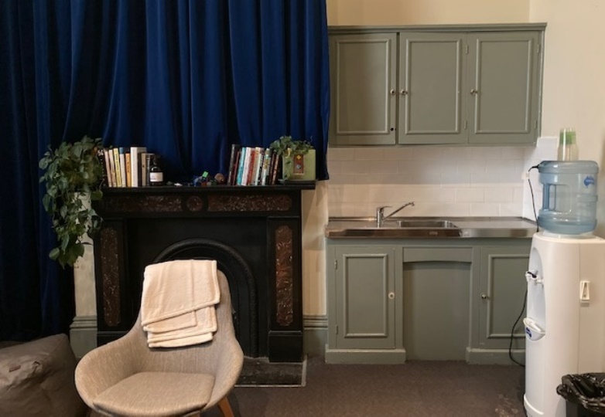
Image: Quiet space with lights dimmed

Image: Quiet space kitchenette and book shelf

Bathrooms

All bathrooms have Dyson hand dryers with sensor activation. There is an accessible bathroom that is single use on ground level opposite the Quiet Space. There is another accessible bathroom upstairs – this is accessible via lift or stairs.
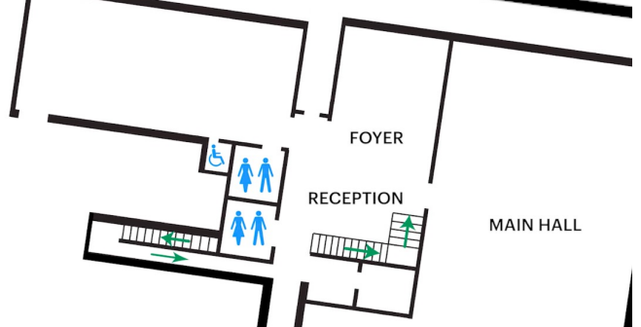

Image: Map of the bathrooms located on the ground floor. All of the bathrooms at Arts House are unisex.

Door to Studio 1

The Performance is in Studio 1.
It is on the first floor.
You can access these spaces via stairs with hand-railing or the lift.
An artist statement is available on signage and warnings on the door.

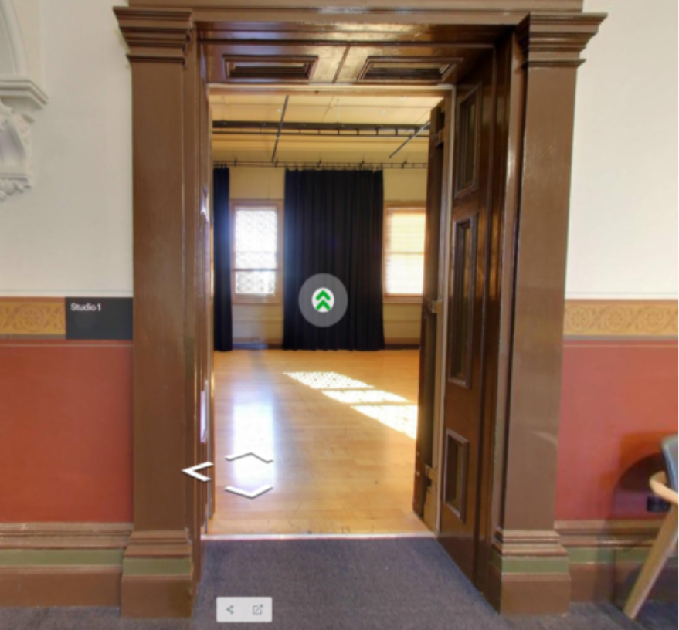

Image: Doors to Studio 1

Lift

The lift is located behind reception desk in the foyer.
The closest entry to the lift is via George Johnson Lane.

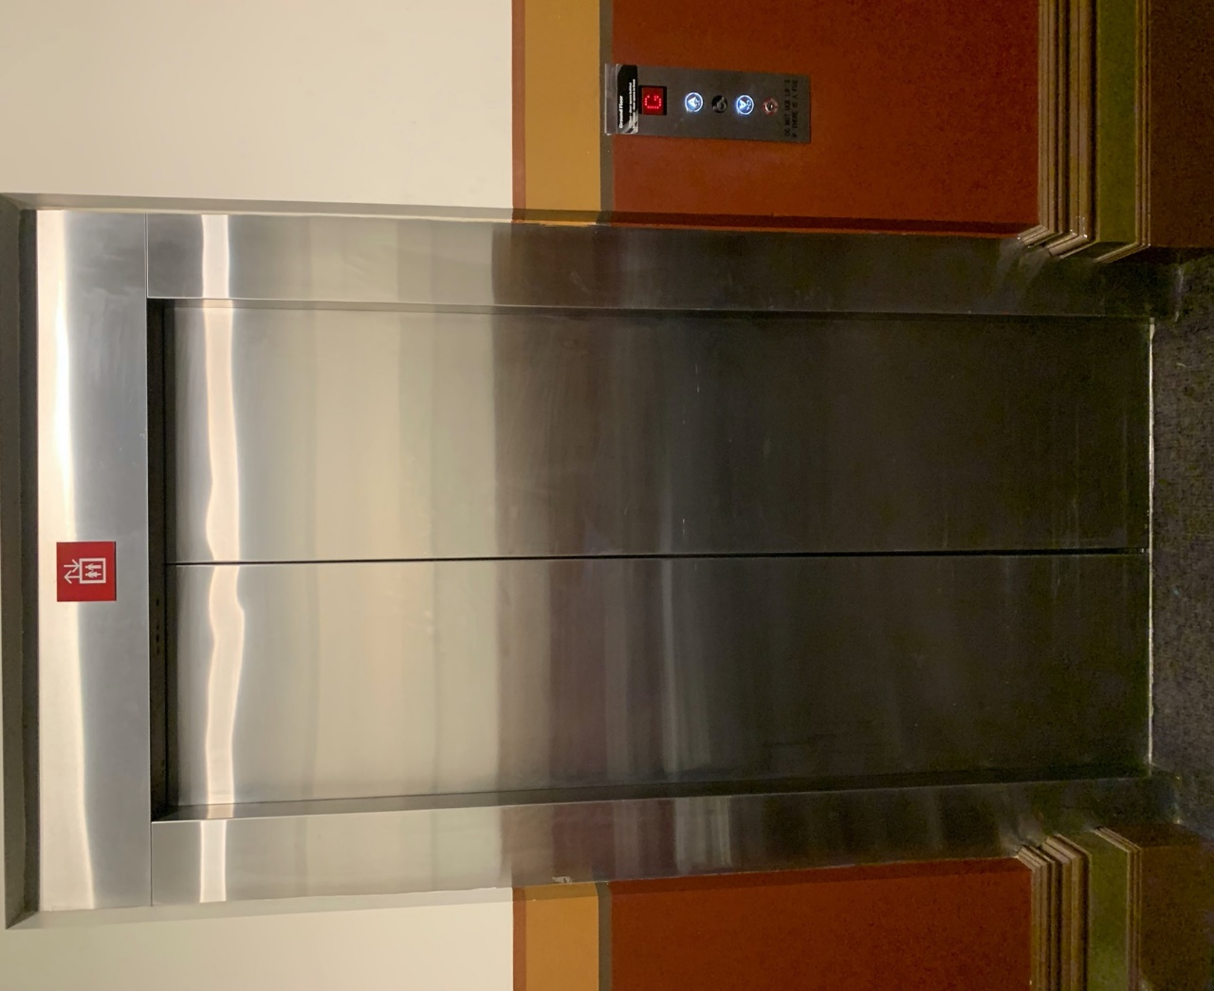
Image: The elevator. Located behind the Box Office desk on the ground floor foyer.

Transport

Tram

Route 57 (High Floor trams only)
Stop 12, North Melbourne Town Hall.
Please note, this is not a wheelchair accessible tram
GETTING TO ARTS HOUSE VIDEO LINK

Train

Arts House is 1.1km from
North Melbourne Train Station,
approximately 16 minute walk
North Melbourne Station Information
1.2km from Flagstaff Station,
approximately 15 minute walk
Flagstaff Station Information

Bus

Bus number: 216

Parking

There is limited paid on-street parking on Queensberry Street and Errol Street.

There are two accessible on street car parking spaces on Queensberry Street (150m to our accessible Errol Street entrance) for holders of a Parking Permit for Disabled people.

COVID Safety

Please note: If you have a cough, sore throat, fever, shortness of breath or flu-like symptoms, you must not attend our venue or programs in person.
We will provide a refund if you need to cancel your attendance due to illness. Please contact us by 9am on the day of the event.
To minimise the risk of COVID-19 transmission, we advise all patrons, artists and staff to:
- Practise physical distancing where possible
- Practise good hygiene by washing and or sanitising your hands often
- Wear a mask as directed by Victorian Government guidelines
Throughout the venue you will find:
- hand sanitiser stations available
- masks available (ask one of our staff for assistance)​
- increased signage to direct patron movement and avoid crowd congestion
We also ensure that spaces are well ventilated.
Staying COVID-safe remains important. We must all follow these steps:
- Follow the Victorian Government’s measures on how to stay safe.
- When you cannot safely socially distance it is recommended to wear a well fitted mask where required.
- Practise COVID-safe hygiene protocols.

