First Trimester

By Krishna Istha

Access Guide

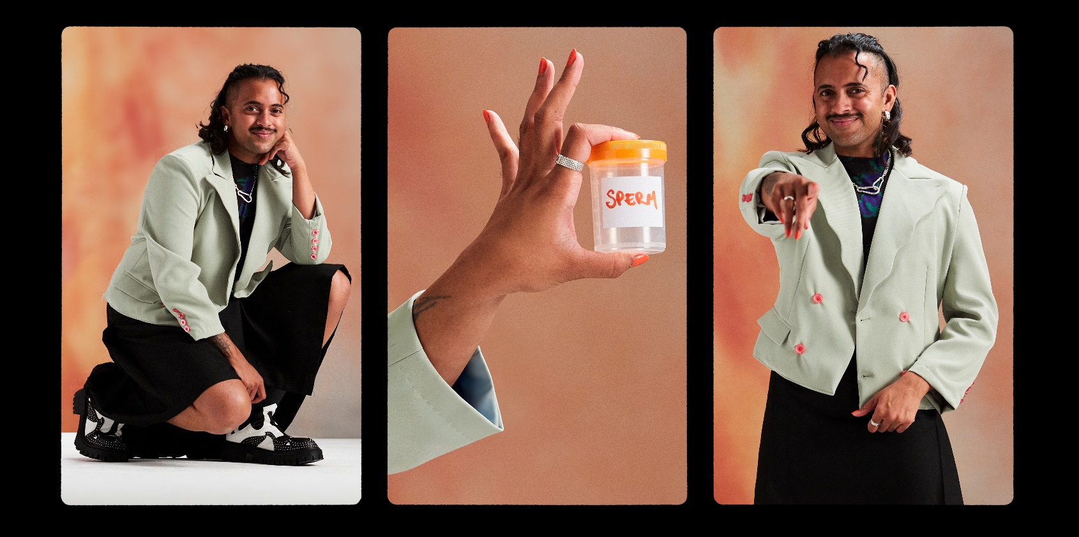
Image: Promotional image for the show.
Image Credit: Jordan Rossi and Emily Drake

Updates to this document

Please note, this performance is a new work and changes are being made by artists until opening. We will endeavour to provide the latest access information on performances to ticket holders across key stages of rehearsal and presentation.

Arts House website will contain the most up to date version of this document and all ticket holders will be notified of any revisions made 3 days and 1 day prior to the event.

This document was created: 18 September 2025

Revision 1: 3 October 2025
Contents
Updates to this document 1
Where 4
When 4
Access Services 4
Performers 7
Sensory Elements 8
Sound 8
Lighting 8
Physical 8
Smell 8
Visual 8
Entry to space 9
Shocks or surprises 9
Audience experience 9
Social expectations 9
Performance expectations 9
Other 9
Content Warnings 9
General Notes 10
The Venue 11
Front Entrance 11
Accessible Entrances 12
Box Office 13
Ushers 13
Bar 14
Quiet Space 15
Bathrooms 16
Door to Main Hall 17
Lift 18
Transport 19
Tram 19
Train 19
Bus 19
Parking 19
COVID Safety 20

Where

Arts House
521 Queensberry Street
North Melbourne VIC

When

Wednesday 16 – Saturday 18 October 2025
Thursday – Friday, 7pm for 3 hour sessions
Saturday, 1pm, 2-hour sessions beginning 1pm, 3pm, 6pm, 8pm OR
Durational 9-hour sessions running 1pm – 10pm with 1 hour interval 5pm – 6pm.

Please note: Due to the format of the show, there may be a small wait to enter the space if you arrive after the start time.

Access Services

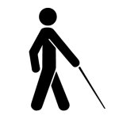
Tactile Tour – Saturday 18 October, 12pm (1 hour prior to 1pm – 3pm session)
Available on request – book by Fri 10 October

Audio Described Performance – Saturday 18 October, 1pm – 3pm
Describer guides available for meet and greet on arrival, tactile tour and one-on-one live descriptions of the performance.

Auslan Interpreting – Friday 17 October, 7pm


Assistance Animals are welcome.

Visual Rating 50% – This performance has music and sounds in the background.


Aural Rating 75% - Mainly sound-based with visuals only incidental to the work, so blind or low vision audiences can have close to the full experience of the event.



This performance is fully wheelchair accessible. More information is provided further below in this guide about the accessible entrances at Arts House and bathrooms.


Assistive Listening – Is available free of charge to help amplify or enhance the sound quality of an event. Ask staff for assistance on arrival.

Quite Space Available - The quiet space will be available for you to use before and after the show. More information about the quiet space can be found later in this guide.


Companion Card - Arts House supports the Companion Card program.

Performers

Image Description: A photo of Krishna Istha, a brown trans person in their 30’s, wearing green and black. Krishna is kneeling down and looking at the camera smiling.
Image Credit: Jordan Rossi and Emily Drake

Sensory Elements

Sound

This performance is mainly conversational between two people on stage. Each person is mic’d and their voices amplified through speakers. Between each interview, music will be playing.

Lighting

At the start of each interview, the lights on stage will turn from dim to bright suddenly. The house lights in the Main Hall will be low for the duration of the show. There is no strobe or flashing lights.

Physical

Audience members are welcome to move around and move seats only during the gaps between interviews on stage. There will be standard seating, as well as soft seating on the floor available in the front row.

Smell

No scents.

Visual
The visuals during the show will remain stable and constant throughout. There will be a set on stage where the interviews take place, with bright colours such as orange, pink, greens and yellows.

Audience Experience

Entry to space

The audience will enter into the Main Hall from the foyer. Audience members are only able to enter the space at the beginning or during the gaps between interviews. Front of House staff will assist you on when you are able to enter.

Pre-show access session
All shows include a 15-minute drop-in session 30 minutes prior to start time for anyone who would benefit from being in the performance space beforehand, to learn more about the work and meet the performer in a relaxed setting.

Shocks or surprises

There will be loud music at the end of every interview, as well as sudden change in lighting on the stage for the start of each interview.

Audience experience

This show does not require audience participation, and there is minimal interaction with the audience directly when Krisha is addressing them. Krishna’s partner who sits in the audience might contribute to the conversation on stage by calling out or interjecting.

Social expectations

You are welcome to bring in snacks and stim toys, with being mindful if they make loud noises to please sit further back to stop the noise getting picked up by the microphones and cameras on stage.
Babies and children are welcome.

Audience members will be able to enter the space during gaps in the interviews. The Front of House team will be there to assist when people are allowed to re-enter the space if they leave during.

Performance expectations

There is one performer on stage, Krishna Istha. They will be sitting in the same chair for the duration of the show. At the start and end of the show, Krishna will be standing out and addressing the audience directly.

Throughout the show, there will be three (3) production crew on stage who are identifiable by wearing tops that say ‘Sperm Donors Wanted’.

Other members of the First Trimester team will be either in the audience or other public spaces and can also be identified by wearing ‘Sperm Donors Wanted’ t-shirts.

Other

Content Warnings

Guests under the age of 16 are welcomed and must be accompanied by a parent or guardian.

This performance contains adult themes, triggering content, coarse language and loud music. There is no strobe or flashing lights. The participants taking part in the live conversation have not rehearsed and do not know the questions before taking part. We therefore cannot know what will be said in advance, however conversations will likely cover a multitude of topics relating to family, parenting, birth, abortion, queer and trans identity, and race.

General Notes

All performances have relaxed elements and are sensory adapted. Audience members are welcome to bring babies and children, come and go as they please, be themselves, make noise, stim, and respond to the work for the duration. Krishna will do a short introduction to the work before each show. There will be no strobe or flashing lights.

The Venue

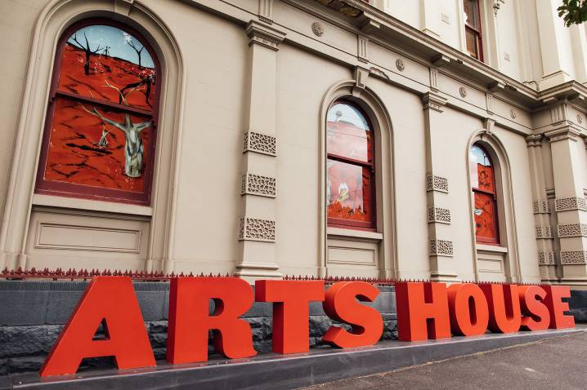
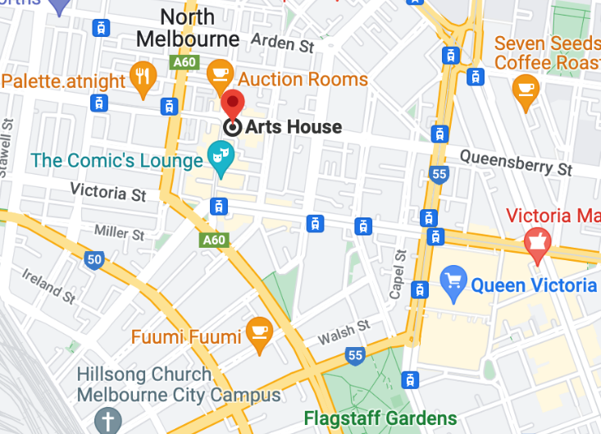

Image: North Melbourne Town Hall features giant red letters that say ARTS HOUSE out the front of it.

Image: a map of Arts House and its surrounding area. LINK TO MAP

Front Entrance

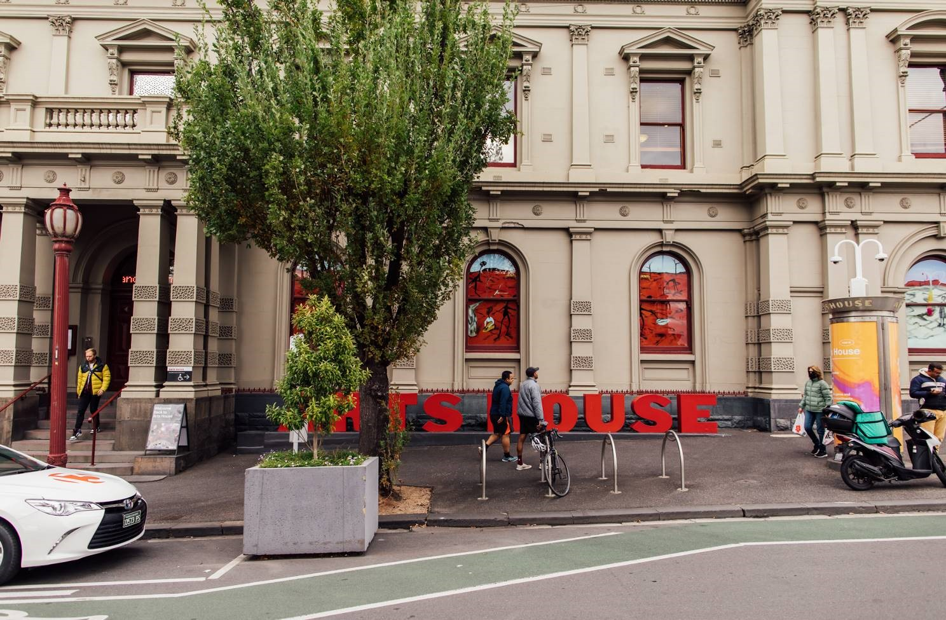

Accessible Entrances

There are two Accessible Entrances. The first is on Errol St next to the Post Office.

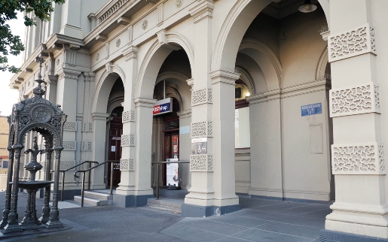

Image: Errol Street entrance next to the Post office with wheelchair accessible ramp or two steps with grab rails.
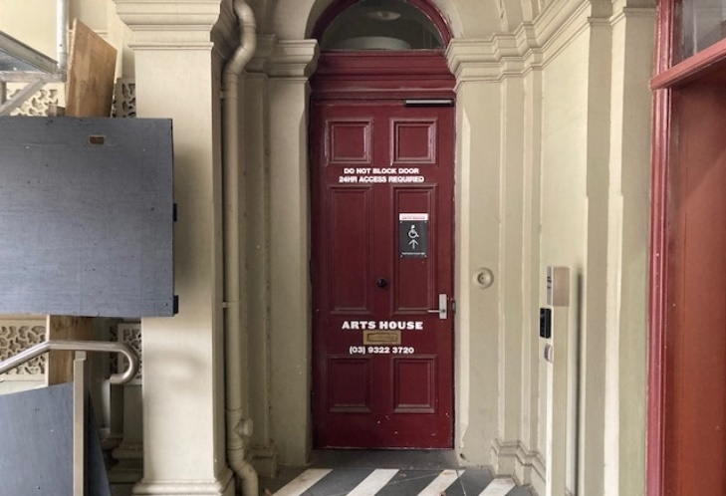
Image: View of door entrance.

The second Accessible Entrance is towards the end of George Johnson Lane.

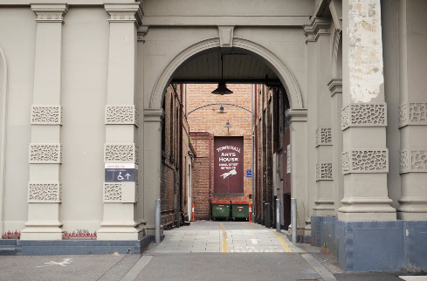

Image: View of George Johnson Lane from Errol St. The laneway passes through an archway with a brick wall at the end.
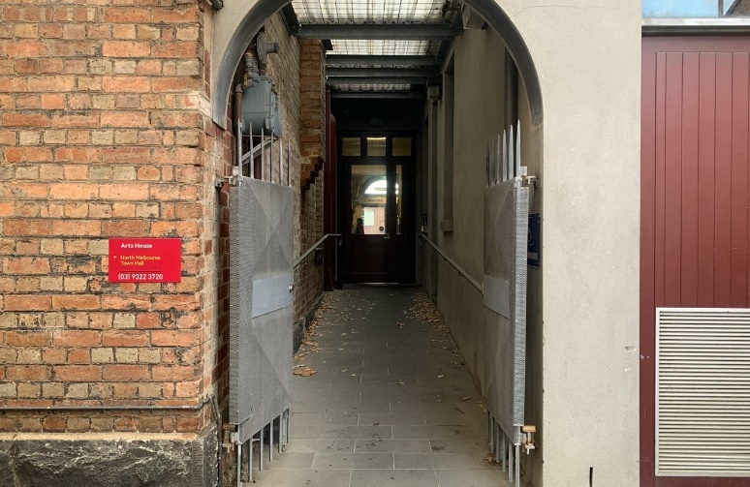

Image: view of the ramp leading from George Johnson Lane to the automated door which opens into the Arts House foyer.

Box Office

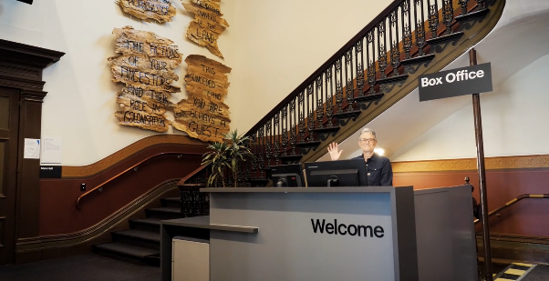

Image: Box Office is located in the foyer under the stairwell.

Ushers

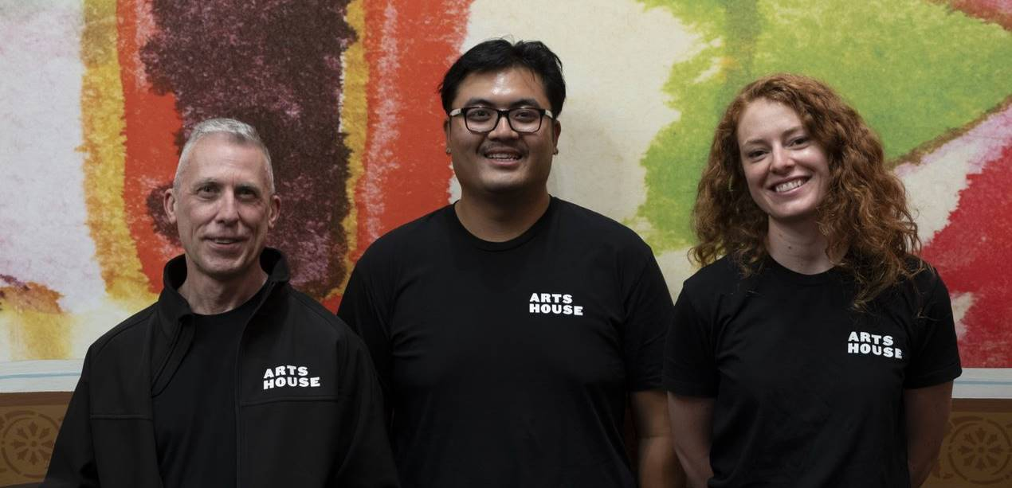

Image: Ushers will be wearing black with an Arts House Logo on the left hand shoulder.

Bar

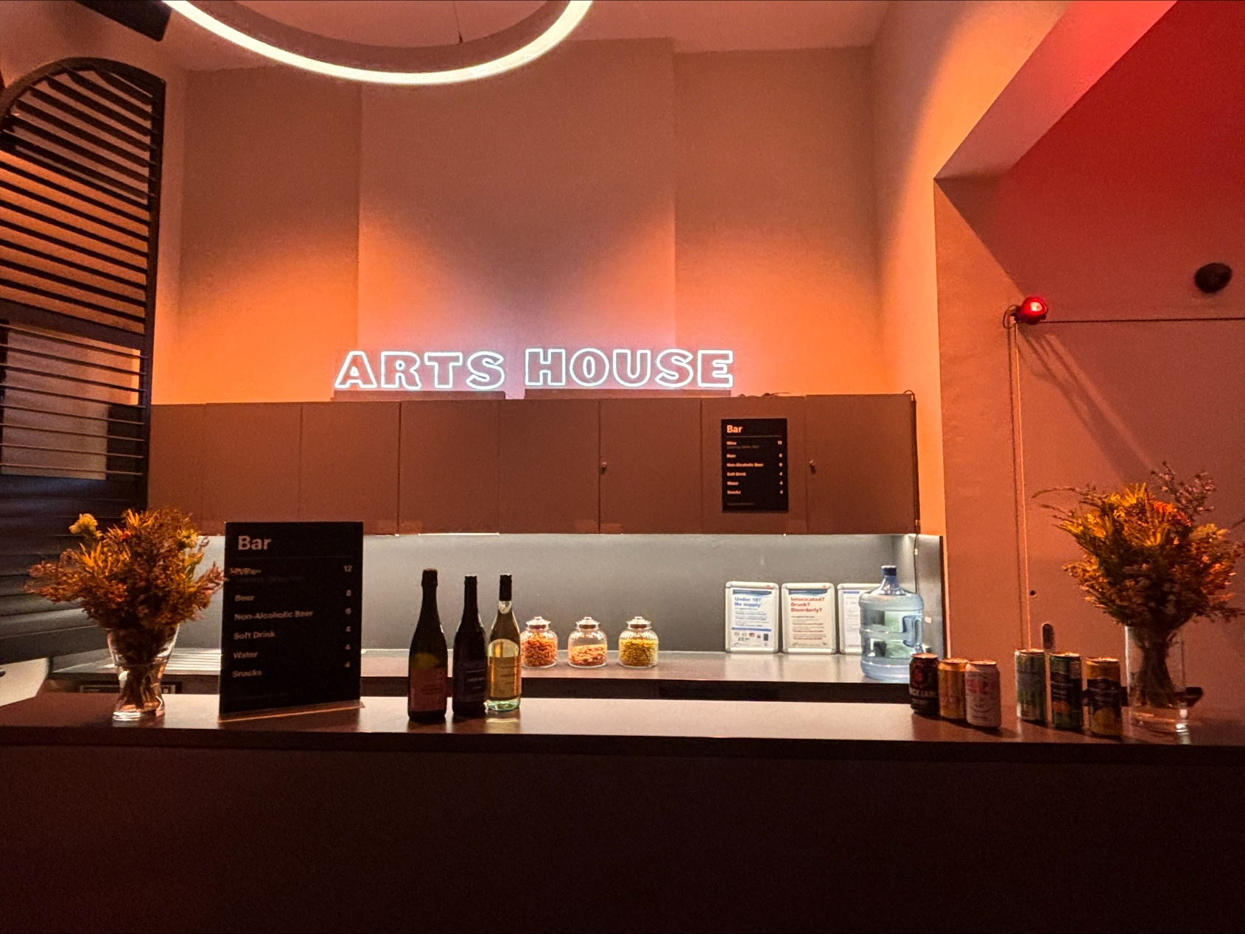

Image Description: The Arts House Bar located on the ground floor.
Bar staff will be wearing black with an Arts House Logo.
We have a range of alcoholic and non-alcoholic beverages for sale.
We are a cashless venue and accept EFTPOS, Visa and Mastercard payments.

Quiet Space



Arts House Quiet Space is located on Ground Level and is nearby reception and opposite the accessible bathrooms. It includes a range of seating options including soft furnishings, dimmable lights, sensory and stim objects. It is open during venue opening hours and events as a quiet space, prayer or parenting space.

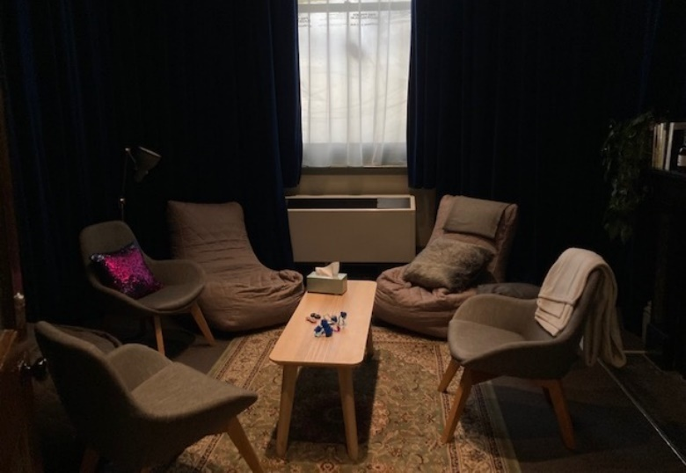

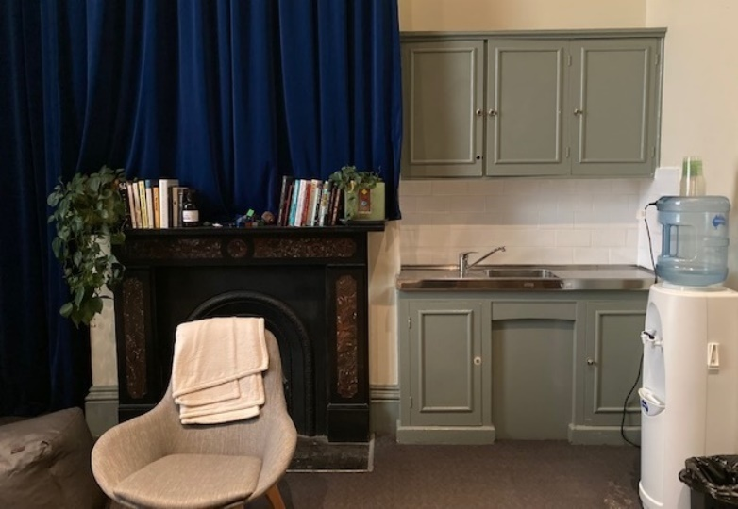
Image: Quiet space with lights dimmed

Image: Quiet space kitchenette and book shelf

Bathrooms

All bathrooms have Dyson hand dryers with sensor activation. There is an accessible bathroom that is single use on ground level opposite the Quiet Space. There is another accessible bathroom upstairs – this is accessible via lift or stairs.
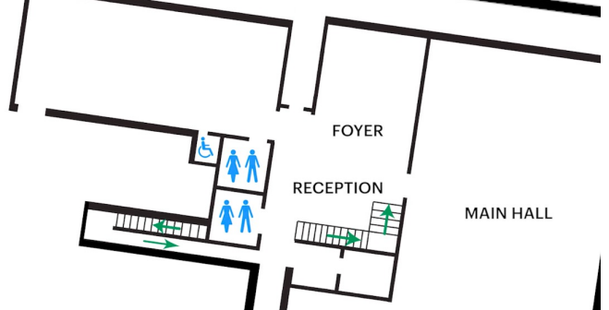

Image: Map of the bathrooms located on the ground floor. All of the bathrooms at Arts House are unisex.

Door to Main Hall

The Performance is in the Main Hall.
It is on the ground floor.
It is to the left of the box office desk and right of the bar.
An artist statement is available on signage and warnings on the door.

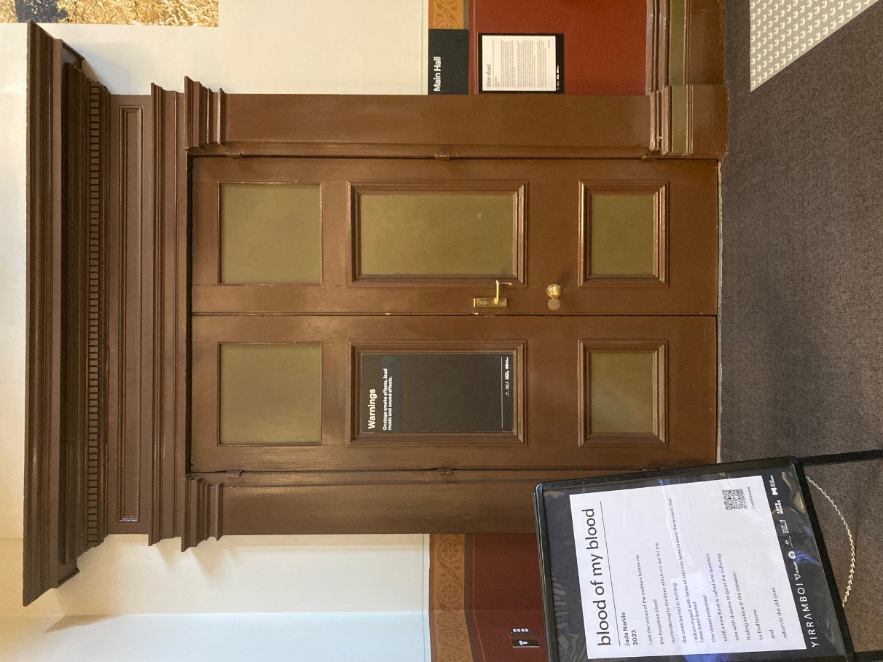

Image: Doors to The Main Hall.

Lift

The lift is located behind reception desk in the foyer.
The closest entry to the lift is via George Johnson Lane.

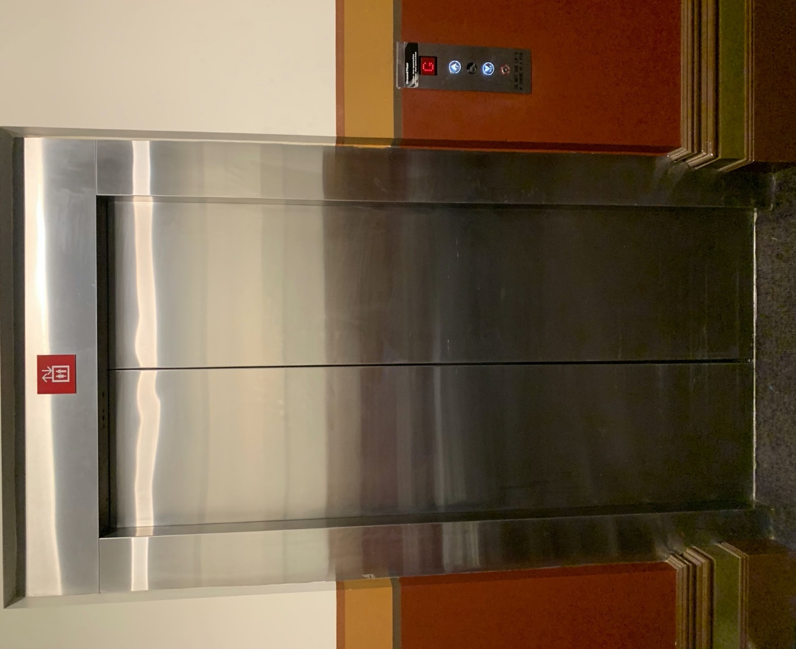
Image: The elevator. Located behind the Box Office desk on the ground floor foyer.

Transport

Tram

Route 57 (High Floor trams only)
Stop 12, North Melbourne Town Hall.
Please note, this is not a wheelchair accessible tram
GETTING TO ARTS HOUSE VIDEO LINK

Train

Arts House is 1.1km from
North Melbourne Train Station,
approximately 16 minute walk
North Melbourne Station Information
1.2km from Flagstaff Station,
approximately 15 minute walk
Flagstaff Station Information

Bus

Bus number: 216

Parking

There is limited paid on-street parking on Queensberry Street and Errol Street.

There are two accessible on street car parking spaces on Queensberry Street (150m to our accessible Errol Street entrance) for holders of a Parking Permit for Disabled people.

COVID Safety

Please note: If you have a cough, sore throat, fever, shortness of breath or flu-like symptoms, you must not attend our venue or programs in person.
We will provide a refund if you need to cancel your attendance due to illness. Please contact us by 9am on the day of the event.
To minimise the risk of COVID-19 transmission, we advise all patrons, artists and staff to:
- Practise physical distancing where possible
- Practise good hygiene by washing and or sanitising your hands often
- Wear a mask as directed by Victorian Government guidelines
Throughout the venue you will find:
- hand sanitiser stations available
- masks available (ask one of our staff for assistance)​
- increased signage to direct patron movement and avoid crowd congestion
We also ensure that spaces are well ventilated.
Staying COVID-safe remains important. We must all follow these steps:
- Follow the Victorian Government’s measures on how to stay safe.
- When you cannot safely socially distance it is recommended to wear a well fitted mask where required.
- Practise COVID-safe hygiene protocols.

