**Crisis Actor**

By Vidya Rajan, Sam Mcgilp, Andrew Sutherland

Access Guide

Hero Image for Crisis Actor


Image description: A desktop monitor on a desk, with a can of coke in front of it. Around the frame of the desktop screen are two superimposed graphics. One is a square video feed of a shocked face of an avatar with blonde hair. The other mimics a live chatstream. Both are surrounded by a flower and fire emoji borders. On the desktop screen is a photograph of two people. One is a person with brown hair, their right arm is raised, and their face is blurry. The other person is staring directly at the viewer, holding an upturned bouquet of flowers.

Image credit: Photograph by Jesse Vogelaar; Design by Sam Mcgilp and Quinn Franks

# **Updates to this document**

Please note, this performance is a new work and changes are being made by artists until opening. We will endeavour to provide the latest access information on performances to ticket holders across key stages of rehearsal and presentation.

Arts House website will contain the most up to date version of this document and all ticket holders will be notified of any revisions made 3 days and 1 day prior to the event.

This document was created: 20 August 2025

**Contents**

Updates to this document 2

Where 4

When 4

Access Services 5

Performers 7

Show Overview 8

Content Warnings 8

General Notes 8

Sensory Elements 9

Physical 9

Sound 9

Lighting 9

Visual 10

Entry to space 10

Shocks or surprises 11

Audience experience 11

Social expectations 11

Performance expectations 11

The Venue 13

Front Entrance 13

Accessible Entrances 14

Box Office 15

Ushers 15

Bar 16

Quiet Space 17

Bathrooms 18

Door to Main Hall 19

Lift 20

Transport 21

Tram 21

Train 21

Bus 21

Parking 21

COVID Safety 22

# **Where**

Arts House

521 Queensberry Street

North Melbourne VIC

# **When**

27 August – 31 August  
Wednesday to Saturday, 7:30pm  
Saturday, 1pm

Sunday, 5pm

Post-show Q&A   
Thursday 28 August, 8:45pm

Duration: 60 – 75 minutes

# **Access Services**



Assistance Animals are welcome



Assistive Listening is available free of charge. Ask staff for assistance on arrival.



Visual Rating 50% – this performance has music and sounds in the background. More information is provided further below in this guide.



This performance is fully wheelchair accessible. More information is provided further below in this guide about the accessible entrances at Arts House and bathrooms.  
  


Quiet Space Available - The quiet space will be available for you to use before and after the show. More information about the quiet space can be found later in this guide.

  
Companion Card - Arts House supports the Companion Card program.

# **Performers**

Performer: Jean Bachoura

A person with a beard



Image description: A headshot of a man looking directly into camera. He has short black hair and a trimmed beard.

Image credit: Daniel Grima

Performer: Jess Nyanda Moyle

A person sitting at a table



Image description: A photo of a non-binary man sitting outdoors at a picnic table, wearing a flower crown. They have platinum blonde hair and are smiling to the camera.

# **Show Overview**

## **Content Warnings**

*Crisis Actor*contains coarse language, adult themes and triggering content including fictionalised themes of crisis, catastrophe, and possible themes of death, gender and racial oppression, and systemic violence.

It contains possible stylised physical and verbal violence utilising digital avatars, gore and blood.

The work contains haze, and possible smoke effects, high pitched frequencies, loud music and effects, sudden loud noises, low, flashing and abrupt lighting changes, lights that black out and change in colour and intensity. 

Crisis Actor involves some elements of audience participation and moving around the space. This involves moving into other rooms as directed by the performers, ushers and digital communications.

## **General Notes**

There will be an Acknowledgment of Country read or played in the foyer prior to entry.

A strict lockout applies. No latecomers will be admitted. Please arrive early to avoid disappointment.

Throughout the show, the audience is encouraged to interact on a website via their phone. The website is screen-reader accessible and voiceover friendly.

**Website Instructions**

* There will be a briefing on how to access the website on your device at the start of the performance. If an audience member encounters difficulty using the website or prefers not to use their own phone, they are encouraged to share a phone with the audience member next to them, if possible.
* Charging stations will be available in the foyer.
* If the internet or the show website glitches or won’t load, try to reconnect or reload the website. There will be a link on display in each space of the show on the screens to rejoin the website.
* If the show website fully stops co-operating, feel free to scroll the internet, lean back and simply watch the show.

# **Sensory Elements**

## **Physical**

For the full duration of the performance, the audience is encouraged to interact on a website via their personal mobile device. The website is screen-reader accessible and voiceover friendly.

At the beginning of the performance, the audience will be standing in a separate performance area, with some seating options available.

Ushers will then assist all audience members to move into the main theatre seating, with chairs and floor cushions on opposite sides of the performance space.

For the final section of the performance, some audience members will be prompted to move back into the initial performance space. This is likely to happen in staggered groups with the assistance of ushers.

## **Sound**

Throughout the performance, there are overlapping sounds, music containing low and high pitched frequencies, and loud sounds.

Parts of the performance features a voice without a clear source, which is at times overlapping, repetitive, and hard to hear, but the words spoken will be displayed on screens.   
  
There is frequent text spoken by a ‘game show MC’-style voice with no clear source. This voice is distorted in pitch and at times may be loud and difficult to clearly understand.

At times the two on-stage performers practice and repeat sounds that are both loud and potentially distressing, such as screams, cries, and gasps.

## **Lighting**

Throughout the performance, audience members are encouraged to interact on their phones, and there will be lights from phone screens throughout the audience.

At the start of the show, the audience will be lit from above by projector light, and the movement of the projected images from above may be disorienting. There will be additional light from projector screens.

The main theatre space is lit by stage lights that illuminate the performers, as well as a projector screen in the centre of the performance space.

There will be sudden and flashing lights throughout the performance.

## **Visual**

In the centre of the first performance area is a circular truss suspended from the ceiling with several screens mounted on it and a sculpture on the floor. Text will be displayed on the mounted screens and on the audience members’ phone screens via the website.   
  
In the main performance space, the audience will be seated on either side of the set. The set will have grey flooring in a grid pattern, with mound-like structures that the performers may sit, lean, or balance their bodies on. The two live performers will be wearing motion-capture sensors on their bodies, which blink with coloured lights.

There will be one large projector screen in the centre of the set, and a smaller screen on either side of the set. Throughout the show, the screens will display simulated ‘avatars’ of the two live performers, which are intended to have an uncanny likeness to the live performers. There will be text prompts and a ‘chat’ on the website on the audience members’ phone screens.  
  
There will be intense and visually busy virtual environments and video displayed on the three screens. This may simulate cartoon-like digital violence and/or explosions. The website on the audience’s phone screens will display text and images that can be scrolled.

Audience Experience

## **Entry to space**

Audiences will gather in the foyer prior to the performance. Ushers will give instructions about using phones and the interactive website. Ushers will also offer options for phone holders, such as a ring holder and neck holder, to assist using the phone throughout the show.

The audience will then enter from the main doors of the foyer into the Main Hall.

## **Shocks or surprises**

Approximately 10 minutes into the show, as audiences move from the first space to their seats, the aural experience of the show shifts abruptly from a dramatic and overlapping soundscape to pop music.   
  
Approximately 40 minutes into the show, the two performers practice and repeat loud sounds such as screams, cries, and gasps. They will talk over one another in a loud, rapid tone and elevated emotional register.   
  
During the last part of the show, there will be intense and visually busy virtual environments and video displayed on the three screens.

## **Audience experience**

In the pre-show briefing, audience members will be told to turn their phones on silent for the duration of the show.

The audience will predominantly be standing in a separate performance space, with some seating options available. At the close of this section, the ushers will assist all audience members to move into the main theatre with seating on both sides of the set.

Towards the end of the performance some members of the audience will return to the first space. There may be some movement offered for those who wish to participate.  
  
Throughout the show, the audience is encouraged to interact on a website via their phone. The website is screen-reader accessible and voiceover friendly.

## **Social expectations**

Audience members are not encouraged to interact directly with the on-stage performers, but to do so via the ‘chat’ function on the phone website.

Audience members are free to stim or make noise in the performance space.

## **Performance expectations**

The audience is introduced to a fictional disaster which introduces the ‘world’ of the show. Text explaining the fictional disaster will be both heard and projected onto the screens. Audience members will be asked to select options relating to the story being told via the website on their phones.   
  
Audience members will be able to interact with the performers through a chat-function on the website and occasionally vote in polls. The voting system will be prompted both aurally and visually via spoken and projected text, and instructions will be made clear on how to vote.   
  
Results of the voting system will determine the outcome of the performance, and audience members are encouraged to participate. However, if an audience member does not wish to interact or vote, they do not have to.   
  
There will be dialogue performed by the two on-stage performers as well as a ‘game show MC’, who will not be visible and will speak through a microphone with a distorted pitch. The plot of the work relates to a competition element, in which the two on-stage performers compete in challenges and share parts of what they present as their real life stories. These stories may involve moments in their life around identity and trauma, or occasionally any kind of story that might make the actors seem more compelling and sympathetic.

# **The Venue**

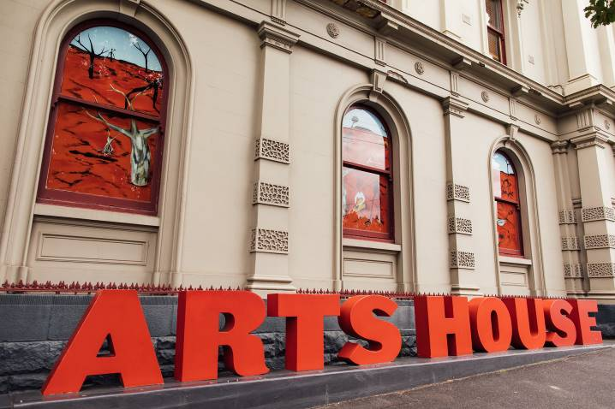

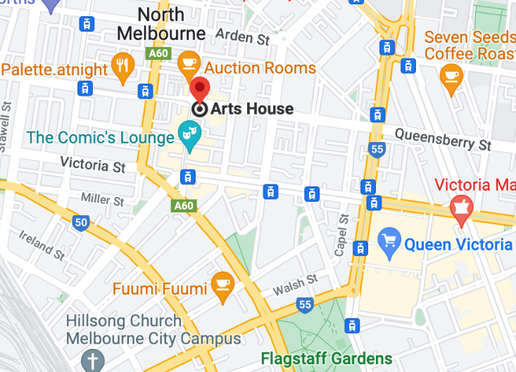

Image: North Melbourne Town Hall features giant red letters that say ARTS HOUSE out the front of it.

Image: a map of Arts House and its surrounding area. [LINK TO MAP](https://www.google.com/maps/place/Arts+House/@-37.802973,144.9486818,17z/data=!4m5!3m4!1s0x0:0x64c465ac7ef21cff!8m2!3d-37.803239!4d144.9498609?shorturl=1)

## **Front Entrance**

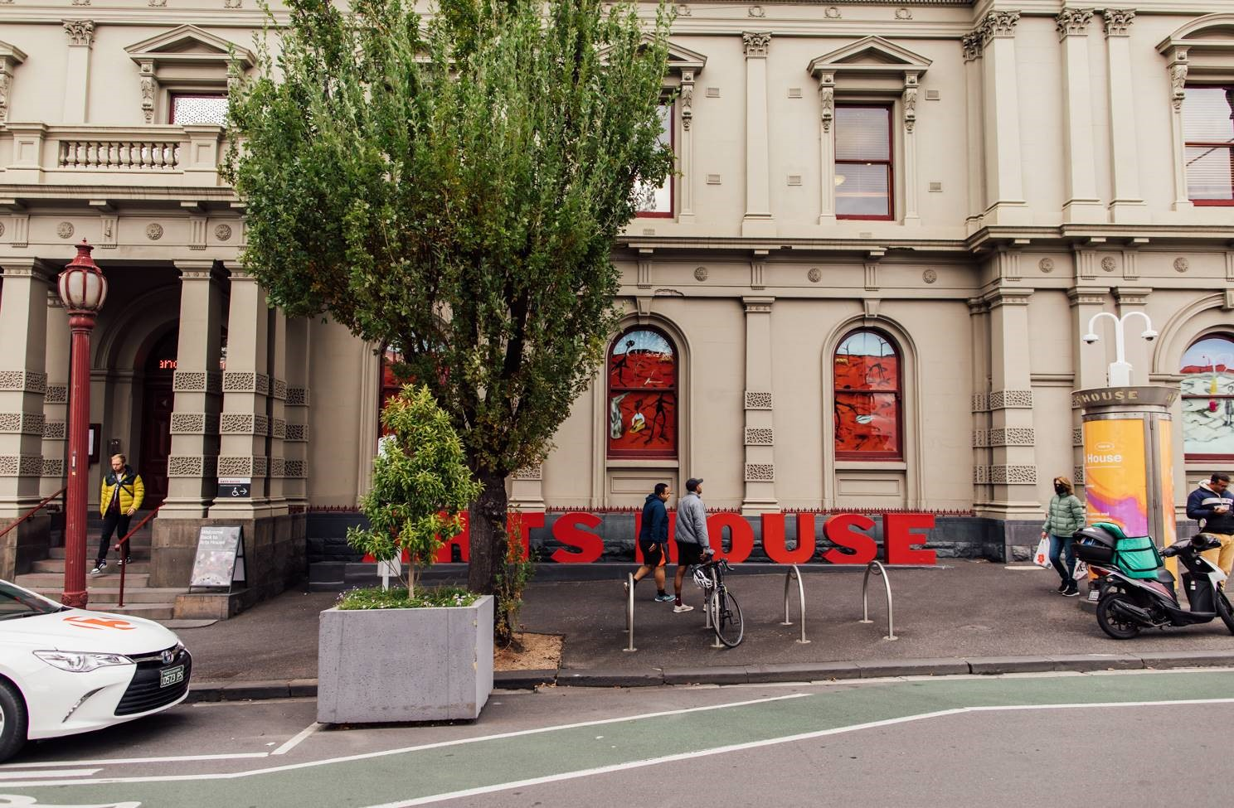

## **Accessible Entrances**



There are two Accessible Entrances. The first is on Errol St next to the Post Office.

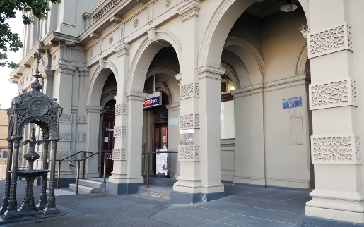

Image: Errol Street entrance next to the Post office with wheelchair accessible ramp or two steps with grab rails.

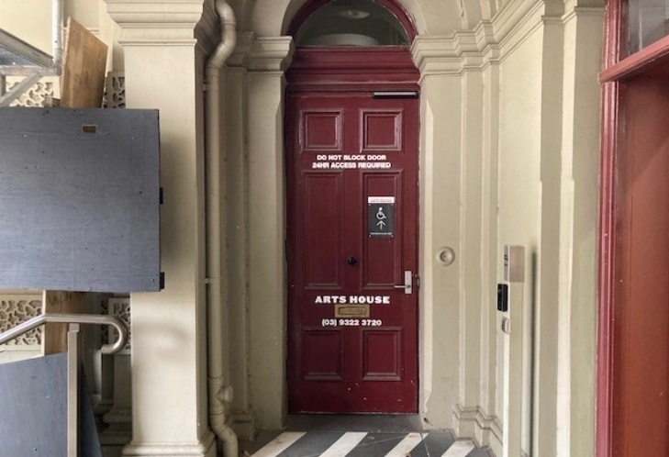

Image: View of door entrance.

The second Accessible Entrance is towards the end of George Johnson Lane.

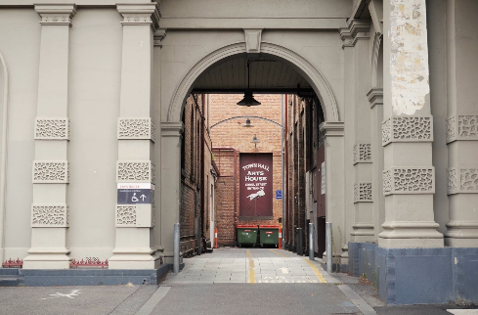

Image: View of George Johnson Lane from Errol St. The laneway passes through an archway with a brick wall at the end.

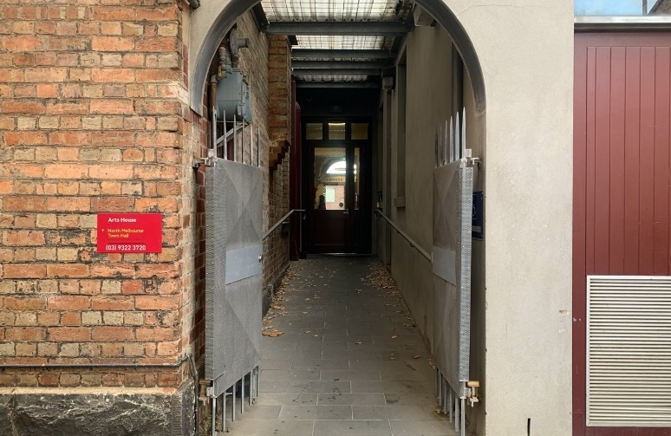

Image: view of the ramp leading from George Johnson Lane to the automated door which opens into the Arts House foyer.

## **Box Office**

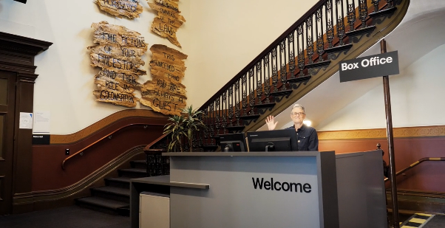

Image: Box Office is located in the foyer under the stairwell.

## **Ushers**

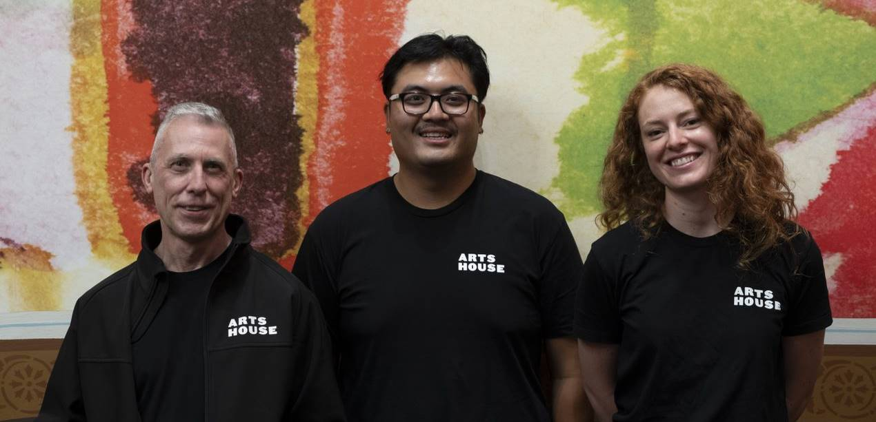

Image: Ushers will be wearing black with an Arts House Logo on the left hand shoulder.

## **Bar**

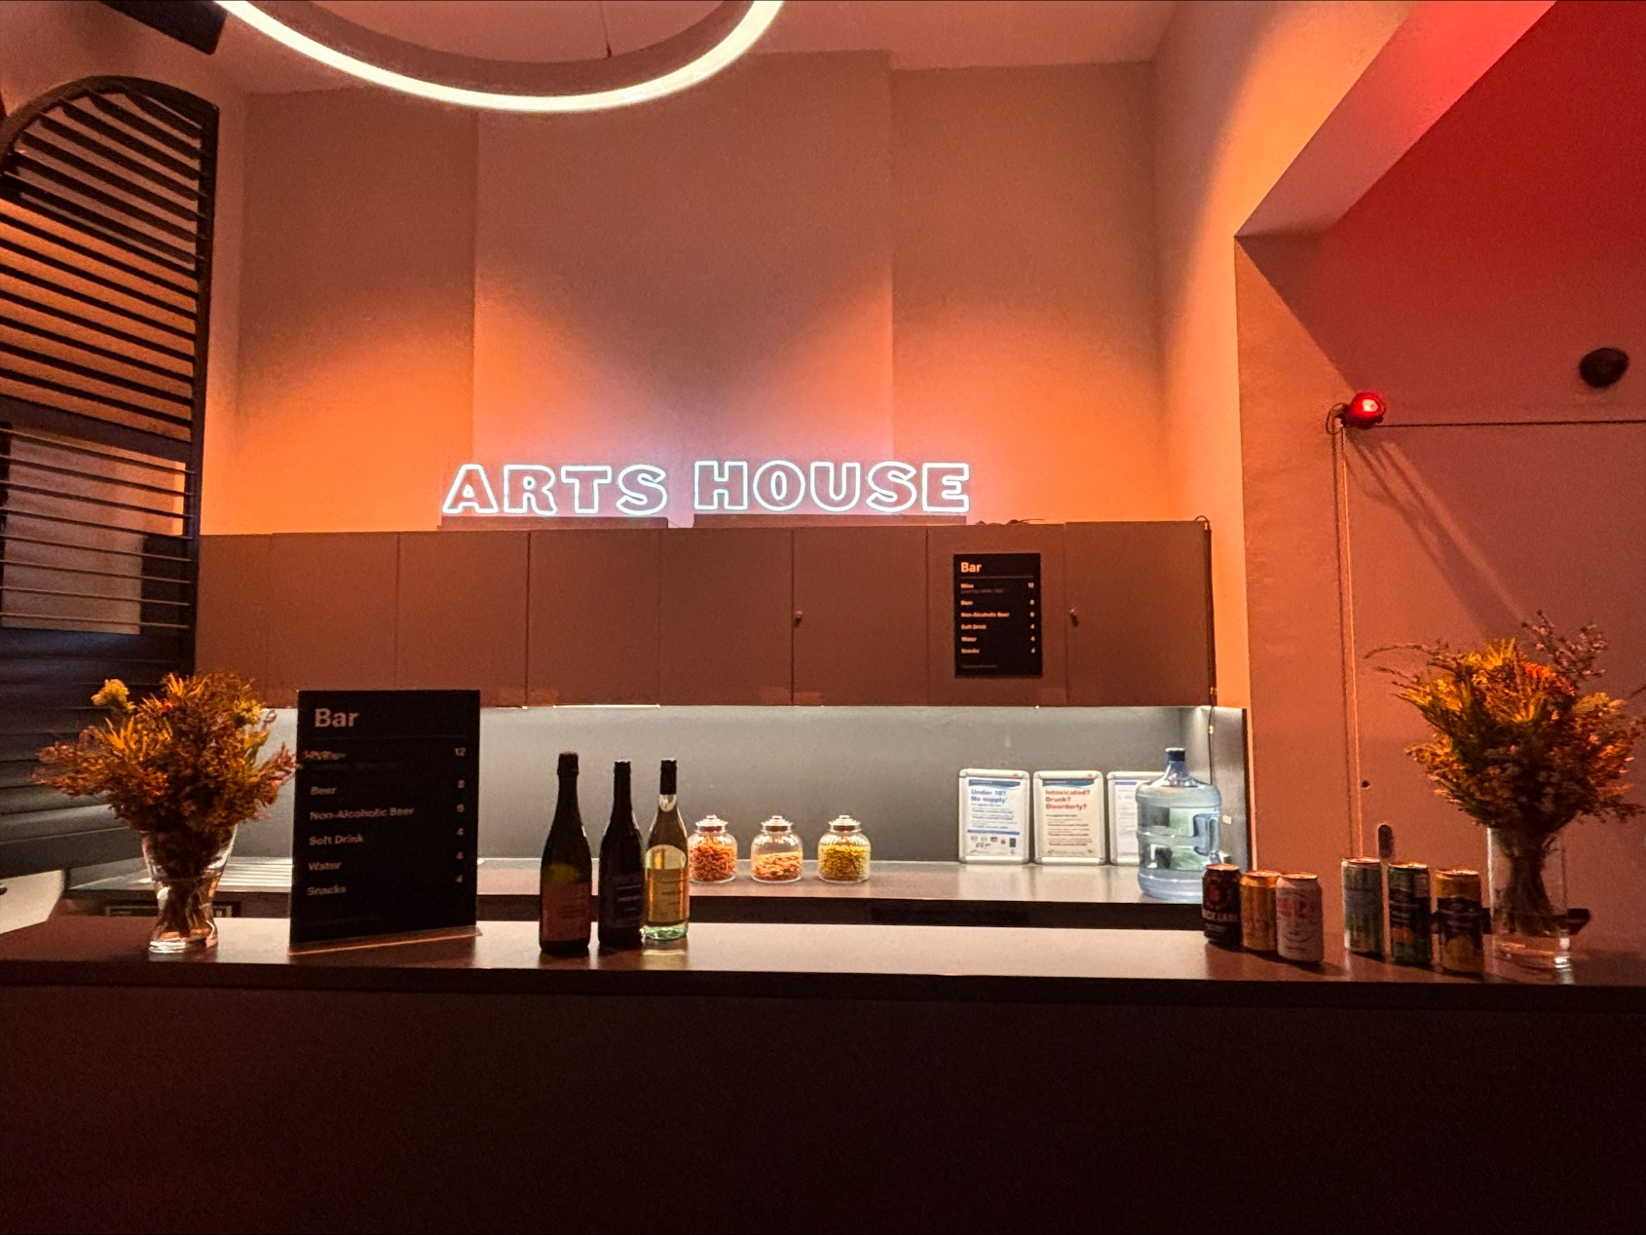

Image Description: The Arts House Bar located on the ground floor.   
   
Bar staff will be wearing black with an Arts House Logo.

We have a range of alcoholic and non-alcoholic beverages for sale.

We are a cashless venue and accept EFTPOS, Visa and Mastercard payments.

## **Quiet Space**



Arts House Quiet Space is located on Ground Level and is nearby reception and opposite the accessible bathrooms. It includes a range of seating options including soft furnishings, dimmable lights, sensory and stim objects. It is open during venue opening hours and events as a quiet space, prayer or parenting space.

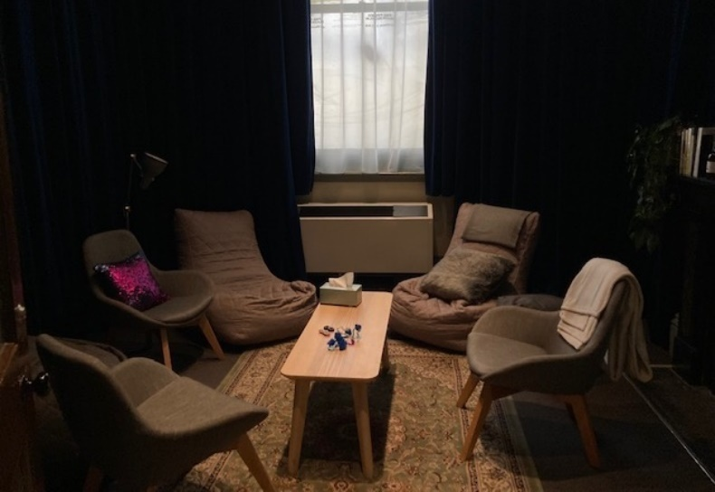

Image: Quiet space with lights dimmed

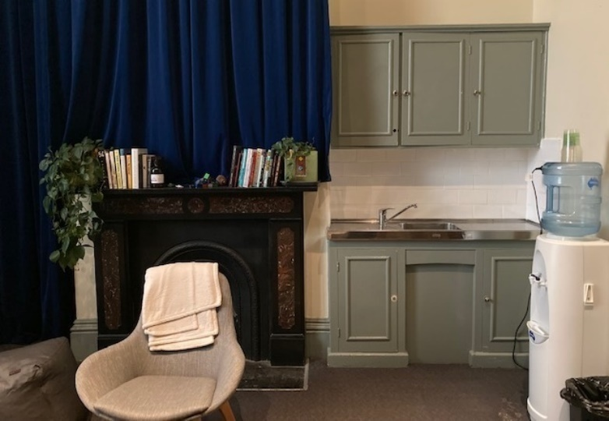

Image: Quiet space kitchenette and book shelf

## **Bathrooms**

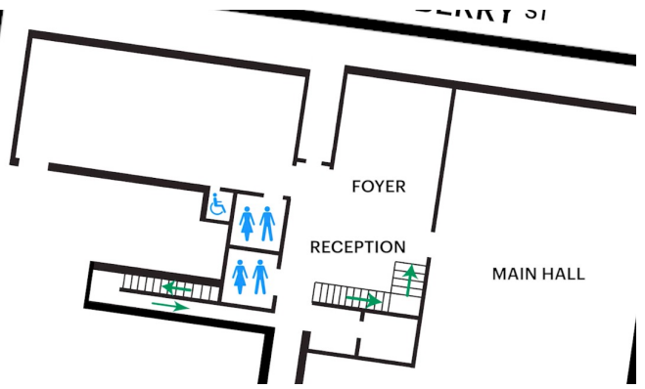All bathrooms have Dyson hand dryers with sensor activation. There is an accessible bathroom that is single use on ground level opposite the Quiet Space. There is another accessible bathroom upstairs – this is accessible via lift or stairs.

Image: Map of the bathrooms located on the ground floor. All of the bathrooms at Arts House are unisex.

## **Door to Main Hall**

The Performance is in the Main Hall.

It is on the ground floor.

It is to the left of the box office desk and right of the bar.

An artist statement is available on signage and warnings on the door.

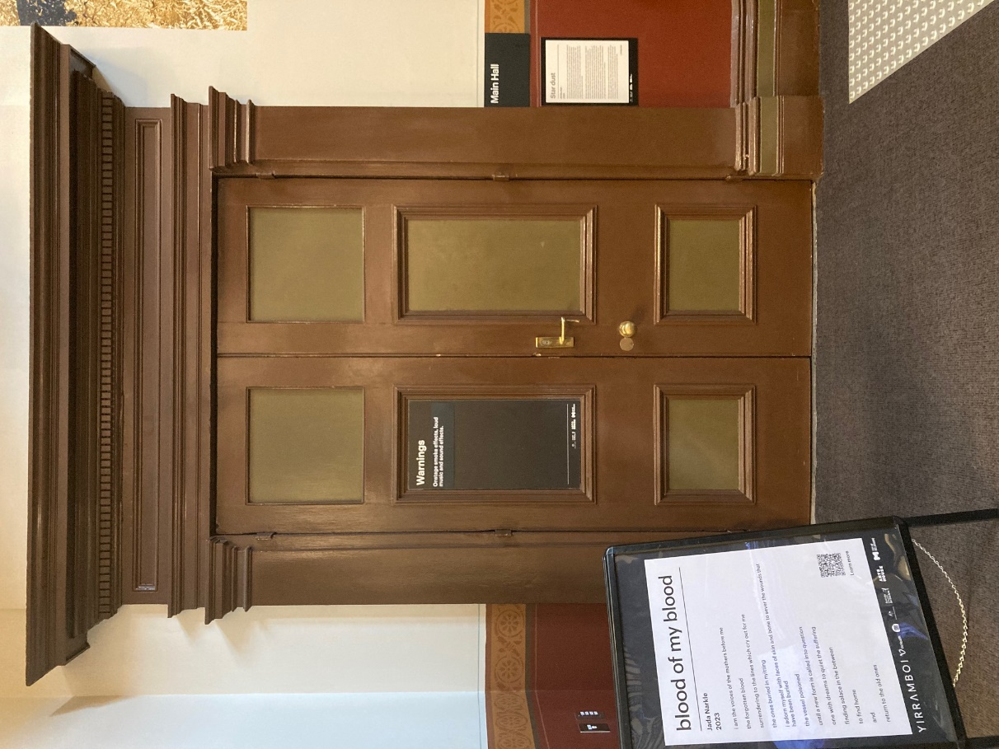

Image: Doors to The Main Hall.

## **Lift**

The lift is located behind reception desk in the foyer.

The closest entry to the lift is via George Johnson Lane.

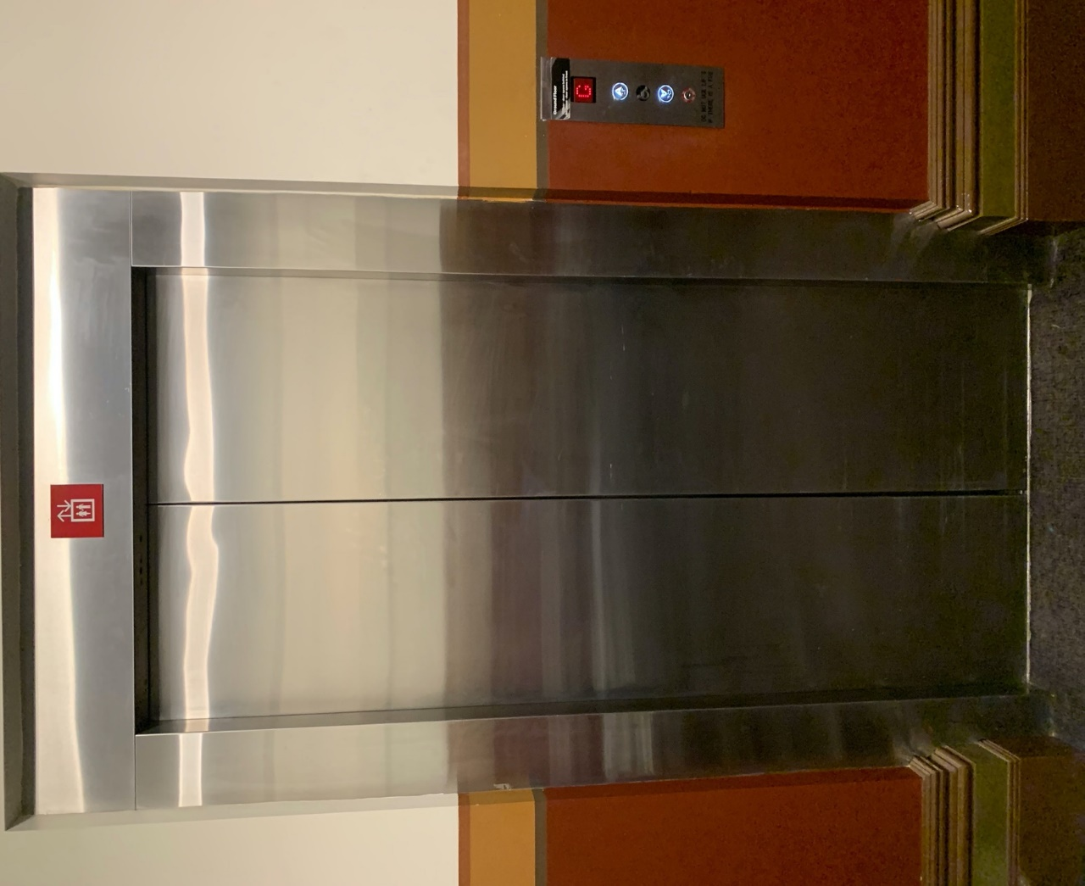

Image: The elevator. Located behind the Box Office desk on the ground floor foyer.

# **Transport**

## **Tram**

Route 57 (High Floor trams only)

Stop 12, North Melbourne Town Hall.

Please note, this is not a wheelchair accessible tram

[GETTING TO ARTS HOUSE VIDEO LINK](https://vimeo.com/544169506)

## **Train**

Arts House is 1.1km from   
North Melbourne Train Station,   
approximately 16 minute walk

[North Melbourne Station Information](https://www.ptv.vic.gov.au/stop/1144/north-melbourne-station/0/train/)

1.2km from Flagstaff Station,   
approximately 15 minute walk

[Flagstaff Station Information](https://www.ptv.vic.gov.au/stop/1068/flagstaff-station/0/train/#StopPage:::datetime=2023-04-06T04%3A41%3A27.669Z&directionId=-1&showAllDay=false&_auth=408ac3b1e97f4b0beb5bdf00c2f797057d10dd6e6cf2ad40a69334c4dfdf5e21)

## **Bus**

Bus number: 216

## **Parking**

There is limited paid on-street parking on Queensberry Street and Errol Street.

There are two accessible on street car parking spaces on Queensberry Street (150m to our accessible Errol Street entrance) for holders of a Parking Permit for Disabled people.

# **COVID Safety**

Please note: If you have a cough, sore throat, fever, shortness of breath or flu-like symptoms, you must not attend our venue or programs in person.

We will provide a refund if you need to cancel your attendance due to illness. Please [contact us](mailto:ArtsHouse.Ticketing@melbourne.vic.gov.au) by 9am on the day of the event.

To minimise the risk of COVID-19 transmission, we advise all patrons, artists and staff to:

* Practise physical distancing where possible
* Practise good hygiene by washing and or sanitising your hands often
* Wear a mask as directed by Victorian Government guidelines

Throughout the venue you will find:

* hand sanitiser stations available
* masks available (ask one of our staff for assistance)​
* increased signage to direct patron movement and avoid crowd congestion

We also ensure that spaces are well ventilated.

Staying COVID-safe remains important. We must all follow these steps:

* Follow the [Victorian Government’s measures on how to stay safe.](https://www.betterhealth.vic.gov.au/coronavirus-covid-19-victoria)
* When you cannot safely socially distance it is recommended to wear a well fitted mask where required.
* Practise [COVID-safe hygiene protocols.](https://www.health.gov.au/news/health-alerts/novel-coronavirus-2019-ncov-health-alert/how-to-protect-yourself-and-others-from-coronavirus-covid-19/good-hygiene-for-coronavirus-covid-19)