**THE BLOWOUT**

By Arts House

Access Guide



Image Design: Actual Size

Image Description: A checkered number 20 on a peach-coloured background.

# **Updates to this document**

Please note, this event contains new performances and changes are being made by artists until opening. We will endeavour to provide the latest access information on performances to ticket holders across key stages. The Arts House website will contain the most up to date version of this document and all ticket holders will be notified of any revisions made 3 days and 1 day prior to the event.

This document was created: 07 July 2025

**Contents**

Updates to this document 1

Where 3

When 3

Access Services 3

Event Overview 5

Warnings 5

Running Order & Performers 6

Sensory Elements 7

Audience Experience 8

Entry to space 8

Shocks or surprises 8

Audience experience 8

Social expectations 9

Performance expectations 9

Other 9

Content Warnings 9

General Notes 9

The Venue 10

Front Entrance 10

Accessible Entrances 11

Box Office 12

Ushers 12

Bar 13

Quiet Space 14

Bathrooms 14

Door to Main Hall 16

Door to Studio 1 17

Lift 18

Transport 19

Tram 19

Train 19

Bus 19

Parking 19

COVID Safety 20

# **Where**

Arts House

521 Queensberry Street

North Melbourne VIC

# **When**

# Saturday 26 July 2025

# 4pm – 10.30pm

# Running order for acts can be found below.

# **Access Services**

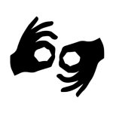  
Auslan Interpreting   
Interpreters will be on stage throughout the event.   
  
Social interpreting is available on request. This service must be pre-booked by Fri 18 July.  
  
  
Personal describer guides available for meet & greet on arrival and one-on-one live descriptions of the performance. This service must be pre-booked by Fri 18 July.



Assistance Animals are welcome.



Visual Rating 50% – this performance has music and sounds in the background.



This performance is fully wheelchair accessible. More information is provided further below in this guide about the accessible entrances at Arts House and bathrooms.  
  
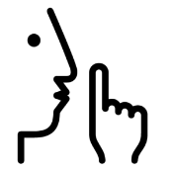

Quite Space Available - The quiet space will be available for you to use during the event. More information about the quiet space can be found later in this guide.

  
Companion Card - Arts House supports the Companion Card program.

# **Event Overview**

This event will take place across two levels of Arts House.

* **Main Hall, ground level** – Primary event space, performances and DJ
* **Studio 1, level 1** – Chill out space, Conversation Corner, ribbon lei making workshop and DJs

All spaces are accessible by lift and stairs.

Doors to all event spaces will open at 4:00pm. The event concludes at 10:00pm and doors close at 10:30pm.

# **Warnings**

This event contains sustained loud music, coarse language, crowds, and lights that change in colour and intensity.

# **Running Order & Performers**

**Main Hall**

|  |  |
| --- | --- |
| **4:00pm** | Doors open  Slow Art Collective installation |
| **4:15pm** | Welcome to Country |
| **4:30pm** | Dance Club with All The Queens Men |
| **4:50pm** | 180 Seconds in Heaven or Hell Featuring  Bella Waru and Fallon Te Paa, Emma Maye Gibson, Inkrewsive Krew, Nisha Madhan and Julia Croft, Raina Peterson, roya the destroya, Sam Martin and Nathan Borg, Taj Aldeeb and Meena Shamaly, Tamara Saulwick |
| **6:00pm** | DJ MzRizk |
| **6:30pm** | Performances by A Daylight Connection, Sammaneh Pourshafighi, Walter Kadiki, small sound, Bron Batten, Motherless Collective |
| **8:30 pm** | DJ MzRizk |
| **10:00pm** | Event concludes |
| **10:30pm** | Doors close |

**Studio 1**

|  |  |
| --- | --- |
| **4:00pm** | Conversation Corner hosted by Lorna Hannan and Robin Laurie  Ribbon Leis for Celebration with Veisinia Tonga |
| **6:30pm** | Lakatoi & Enter perform Great Ocean Volumes |
| **10:00pm** | Event concludes |
| **10:30pm** | Doors close |

# **Sensory Elements**

## **Main Hall**

* **Sound:** There will be consistent sound throughout the event. This includes performances, singing, MC dialogue and dance music. The music will occasionally fade in and out across the night and between performance acts. At times the music might be quite loud. At times the performers may be voicing over music or background noise. There will also be talking and noise from party guests.
* **Lighting:** Each act will have a different lighting state. Sometimes the stage may be bright spotlight or wash and coloured lighting may fade between warm and cool tones. Some performances may feature content on a projector screen. There will be no strobes or flashing lights.
* **Physical:** Vibration will be felt from the music. There may be potential for physical

interaction between the audiences as everyone can freely move around throughout the event. At times, performers may be roving in the party space during their acts. Some performers or MCs might interact with the audience but there is no pressure to respond. The floors are smooth and flat surface.

* **Smell:** There is no use of scent in any performance acts. There will be catering available in the space that will include the smell of fruit, cheese, spices and sauces.
* **Visual:** There will be an 8m x 6m stage in front of the proscenium arch. The stage will have a blue velvet backdrop and a screen. On the floor, there will be a large bamboo structure with various pieces of yarn and fabric that guests are invited to interact with.   
    
  The space will also include a piano, bar, catering, and DJ equipment.

**Studio 1**

* **Sound:** In the afternoon, people will be having conversations in the space. In the evening, a relaxed music performance will take place.
* **Lighting:** In the afternoon, there will be warm room lighting. In the evening, there will be soft mood lighting.
* **Physical:** The Studio will contain a range of furnishings including tables and chairs, soft bean bags, rugs and cushions.
* **Smell:** A tea station in the space may have a faint scent.
* **Visual:** One end of the room will be setup for a Conversation Corner and a lei making workshop. This includes tables and chairs, postcards, ribbons, and a pinboard featuring messages from guests.   
    
  The centre of the room is a chill out space containing a range of seating options.   
    
  The other end of the room will be setup with DJ equipment.

# **Audience Experience**

## **Entry to space**

This event will take place in the Main Hall and Studio 1. Front of house staff will guide

you to either space from the foyer.

Access to Main Hall space:

* The Main Hall can be accessed on ground level next to reception
* Entry to the main hall is through large double doors in the main foyer. The doors open towards you.

Access to Studio 1 space:

* Studio 1 can be accessed via a lift in the foyer or the staircase behind the reception desk.
* From the lift, entry to Studio 1 is through large double doors at the end of the corridor.

## **Shocks or surprises**

There are no shocks or surprises during this event.

## **Audience experience**

Most acts will take place on the stage, and audiences can choose to experience the

performances from any distance that is comfortable.

Two performances will take place at an upright piano on the floor of the Main Hall.

## **Social expectations**

Audiences are able to move freely around the space and across all levels. The DJ will

play dance music, and you are welcome to dance in the space or socialise.

There will be a small number of high and low tables and chairs available in the Main Hall, and relaxed spaces in the foyer. The social space upstairs will have an assortment of bean bags and cushions.

You are welcome to come and go as you please across all spaces, make noise, stim,

and respond to the works for the duration of the event.

## **Performance expectations**

There are several short performances throughout the event. Some performances will involve optional audience participation. You can choose to participate or not.

# **Other**

## **Content Warnings**

This event contains sustained loud music, coarse language, crowds, and lights that change in colour and intensity.

## **General Notes**

There are two Auslan interpreters present in the space from Stage Left interpreting all

spoken words.

# **The Venue**

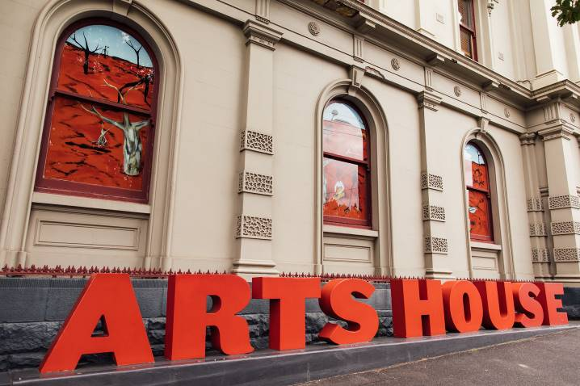

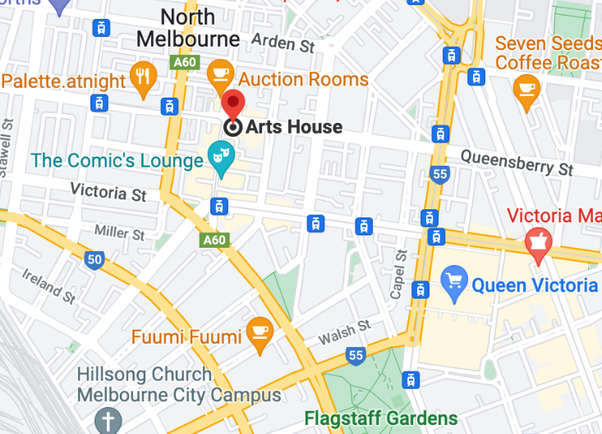

Image: North Melbourne Town Hall features giant red letters that say ARTS HOUSE out the front of it.

Image: A map of Arts House and its surrounding area. [LINK TO MAP](https://www.google.com/maps/place/Arts+House/@-37.802973,144.9486818,17z/data=!4m5!3m4!1s0x0:0x64c465ac7ef21cff!8m2!3d-37.803239!4d144.9498609?shorturl=1)

## **Front Entrance**

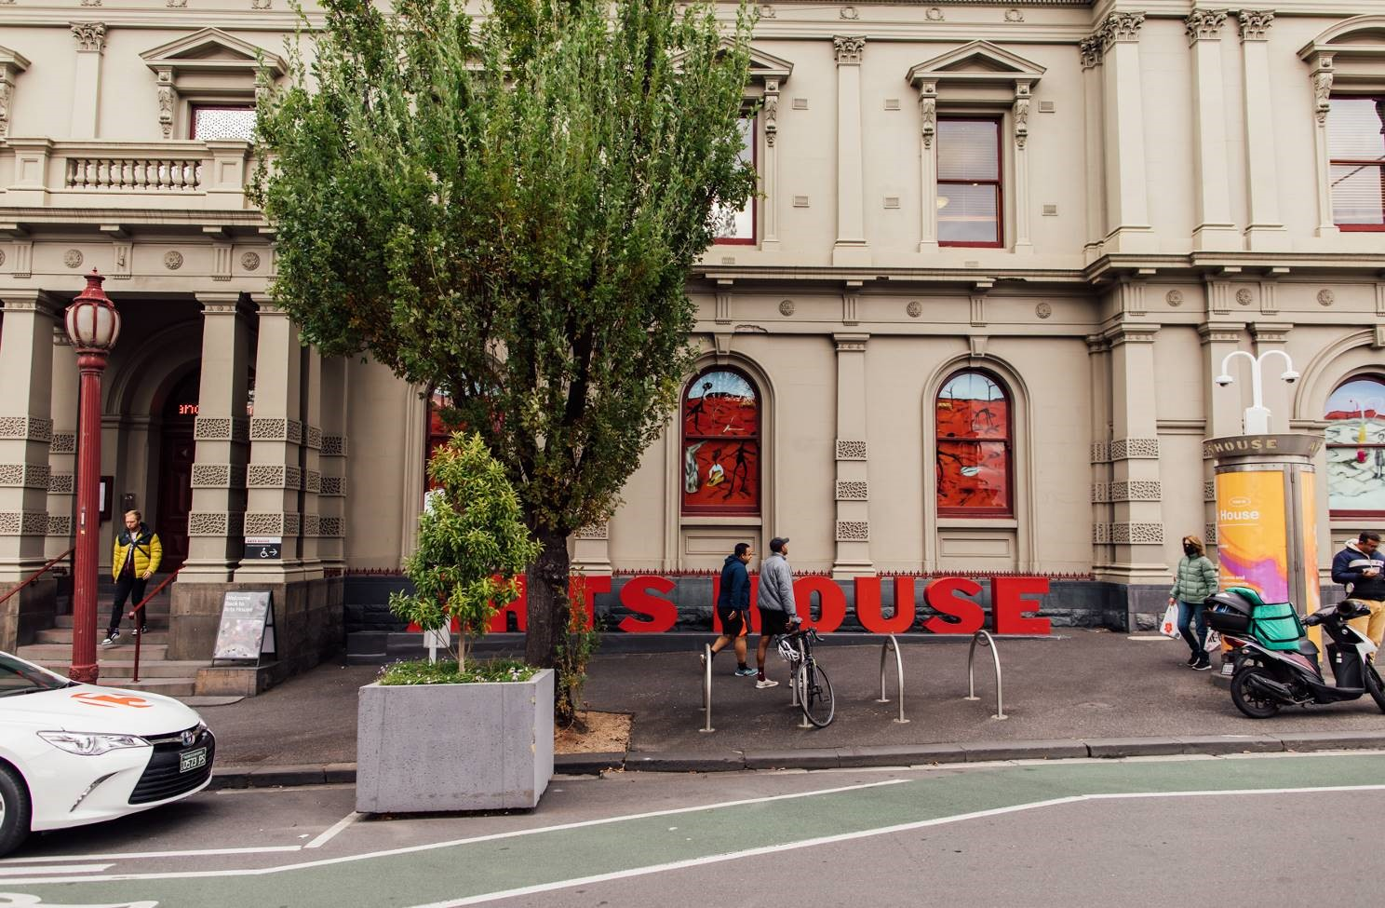

## **Accessible Entrances**



There are two Accessible Entrances. The first is on Errol St next to the Post Office.

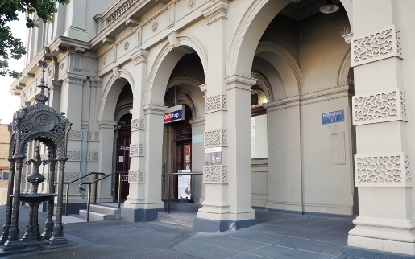

Image: Errol Street entrance next to the Post office with wheelchair accessible ramp or two steps with grab rails.

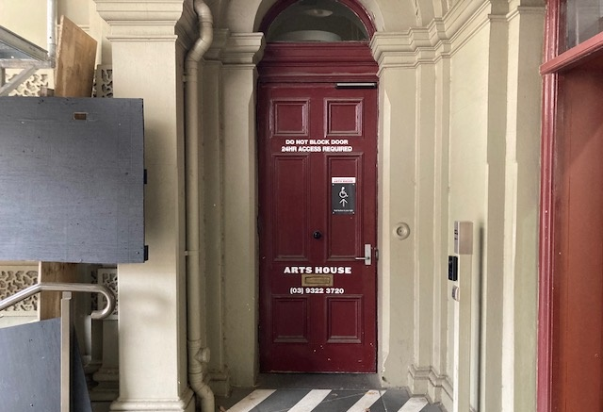

Image: View of door entrance.

The second Accessible Entrance is towards the end of George Johnson Lane.

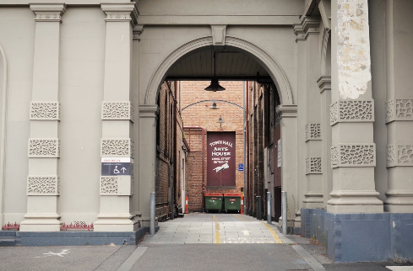

Image: View of George Johnson Lane from Errol St. The laneway passes through an archway with a brick wall at the end.

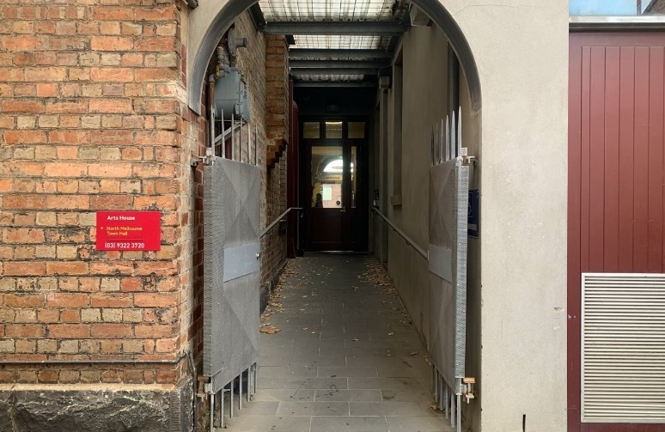

Image: view of the ramp leading from George Johnson Lane to the automated door which opens into the Arts House foyer.

## **Box Office**

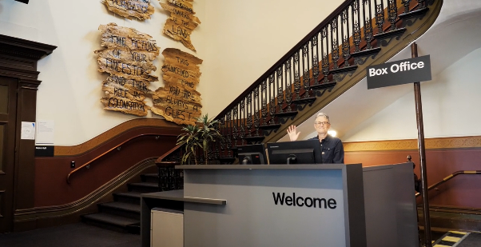

Image:Box Office is located in the foyer under the stairwell.

## **Ushers**

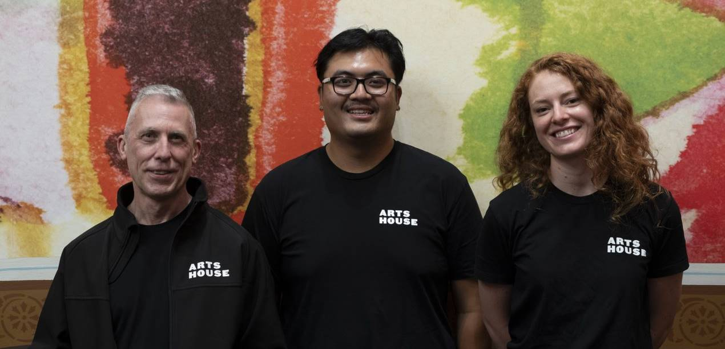

Image: Ushers wearing black with an Arts House Logo on the left hand shoulder.

## **Bar**

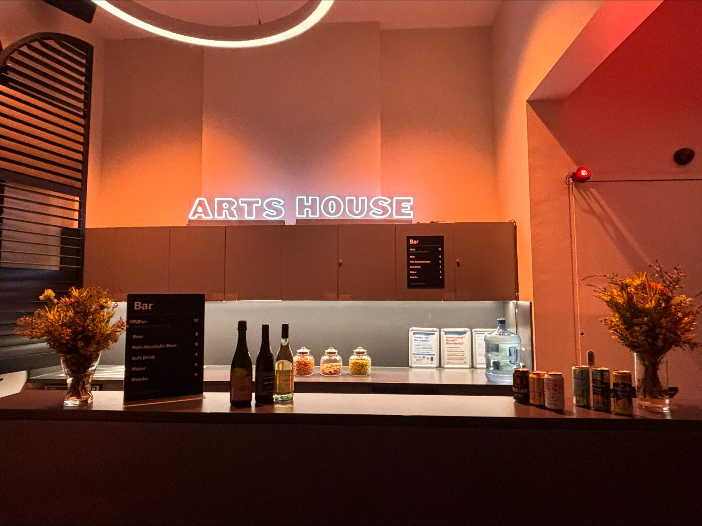

Image Description: The Arts House Bar located on the ground floor.  
  
Bar staff will be wearing black with an Arts House Logo.

We have a range of alcoholic and non-alcoholic beverages for sale.

We are a cashless venue and accept EFTPOS, Visa and Mastercard payments.

## **Quiet Space**

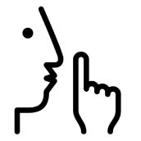

Arts House Quiet Space is located on Ground Level and is nearby reception and opposite the accessible bathrooms. It includes a range of seating options including soft furnishings, dimmable lights, sensory and stim objects. It is open during venue opening hours and events as a quiet space, prayer or parenting space.

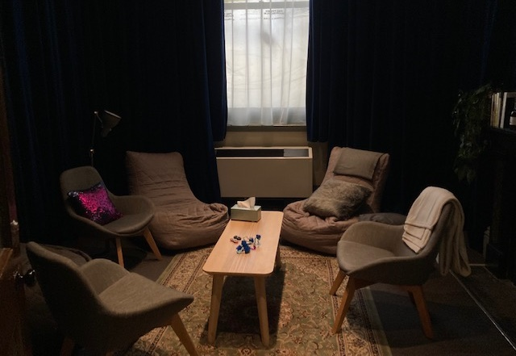

Image: Quiet space with lights dimmed

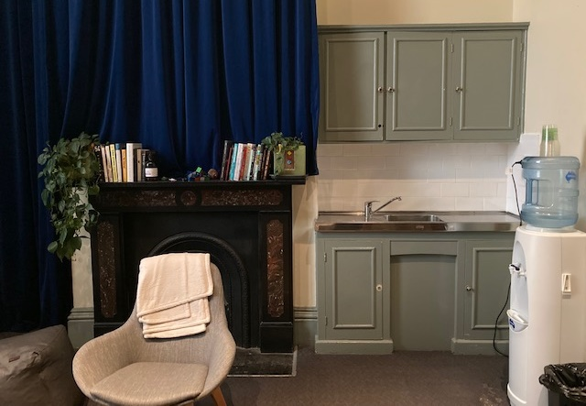

Image: Quiet space kitchenette and book shelf

## **Bathrooms**

All bathrooms have Dyson hand dryers with sensor activation. There is an accessible bathroom that is single use on ground level opposite the Quiet Space. There is another accessible bathroom upstairs – this is accessible via lift or stairs.

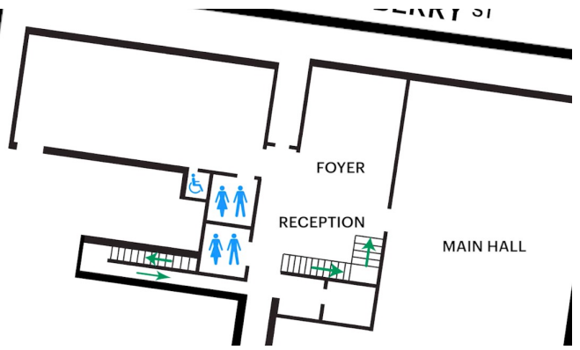

Image: Map of the bathrooms located on the ground floor. All of the bathrooms at Arts House are unisex.

## **Door to Main Hall**

The first event space is the Main Hall.

It is on the ground floor.

It is to the left of the box office desk and right of the bar.

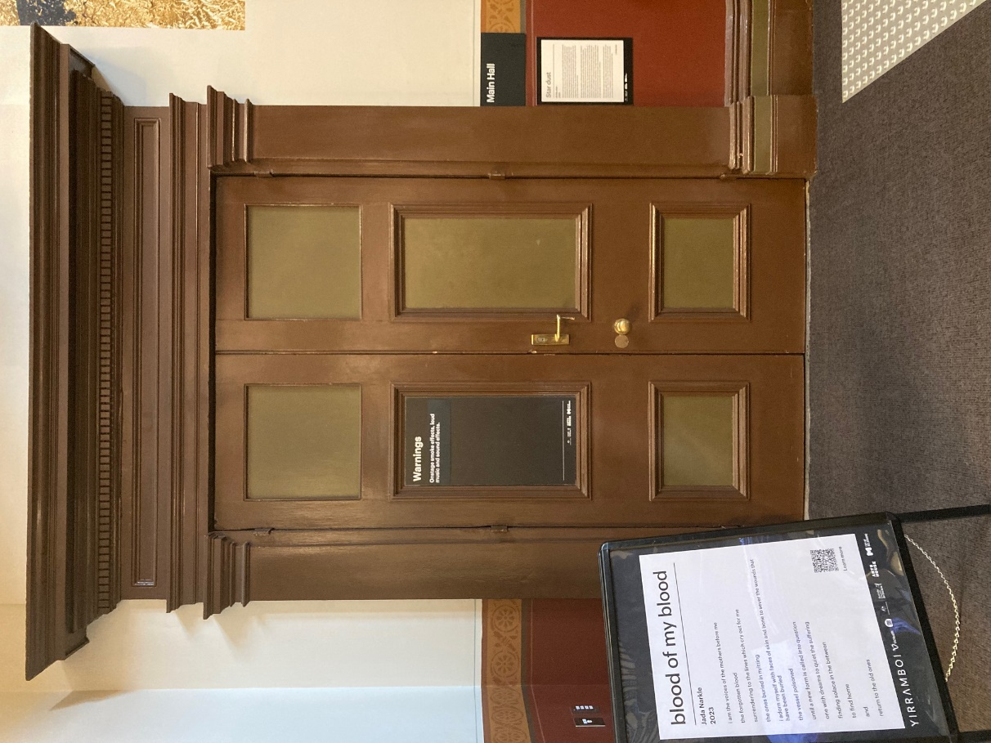

Image: Doors to The Main Hall.

## **Door to Studio 1**

The second event space is Studio 1.

It is on the first floor.

You can access these spaces via stairs with hand-railing or the lift.

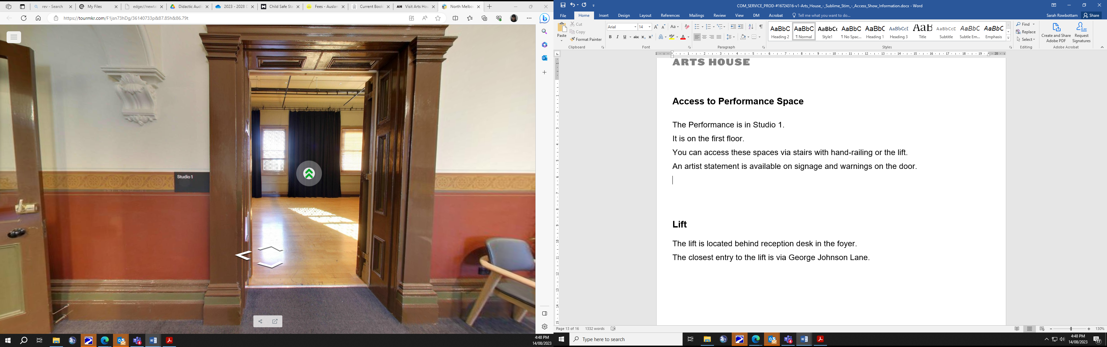

Image: Doorway to Studio 1.

## **Lift**

The lift is located behind reception desk in the foyer.

The closest entry to the lift is via George Johnson Lane.

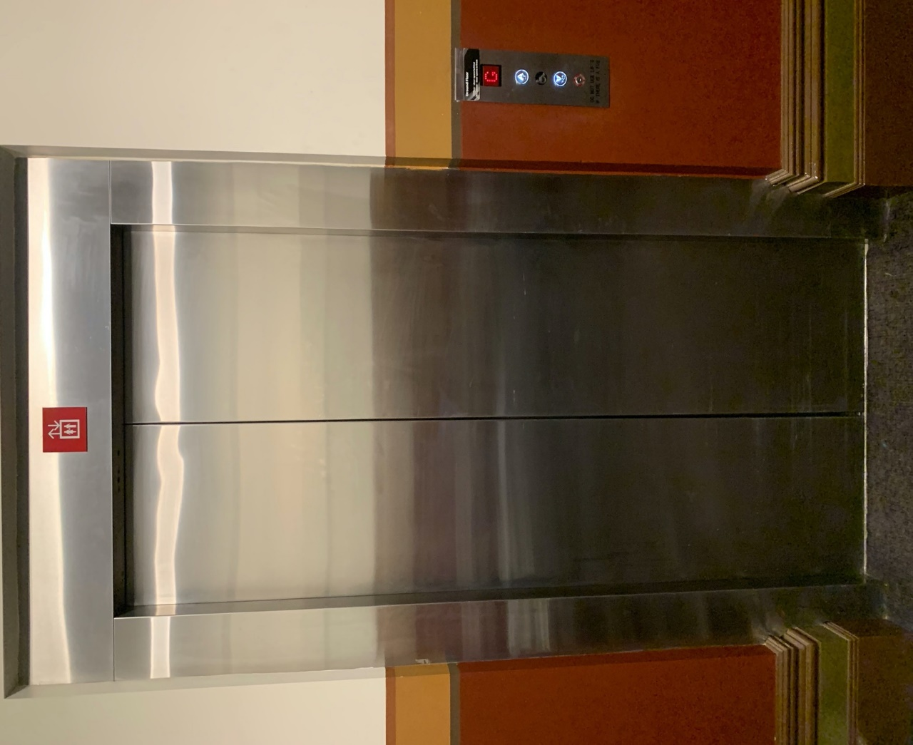

Image: The elevator. Located behind the Box Office desk on the ground floor foyer.

# **Transport**

## **Tram**

Route 57 (High Floor trams only)

Stop 12, North Melbourne Town Hall.

Please note, this is not a wheelchair accessible tram

[GETTING TO ARTS HOUSE VIDEO LINK](https://vimeo.com/544169506)

## **Train**

Arts House is 1.1km from   
North Melbourne Train Station,   
approximately 16 minute walk

[North Melbourne Station Information](https://www.ptv.vic.gov.au/stop/1144/north-melbourne-station/0/train/)

1.2km from Flagstaff Station,   
approximately 15 minute walk

[Flagstaff Station Information](https://www.ptv.vic.gov.au/stop/1068/flagstaff-station/0/train/#StopPage:::datetime=2023-04-06T04%3A41%3A27.669Z&directionId=-1&showAllDay=false&_auth=408ac3b1e97f4b0beb5bdf00c2f797057d10dd6e6cf2ad40a69334c4dfdf5e21)

## **Bus**

Bus number: 216

## **Parking**

There is limited paid on-street parking on Queensberry Street and Errol Street.

There are two accessible on street car parking spaces on Queensberry Street (150m to our accessible Errol Street entrance) for holders of a Parking Permit for Disabled people.

# **COVID Safety**

Please note: If you have a cough, sore throat, fever, shortness of breath or flu-like symptoms, you must not attend our venue or programs in person.

We will provide a refund if you need to cancel your attendance due to illness. Please [contact us](mailto:ArtsHouse.Ticketing@melbourne.vic.gov.au) by 9am on the day of the event.

To minimise the risk of COVID-19 transmission, we advise all patrons, artists and staff to:

* Practise physical distancing where possible
* Practise good hygiene by washing and or sanitising your hands often
* Wear a mask as directed by Victorian Government guidelines

Throughout the venue you will find:

* hand sanitiser stations available
* masks available (ask one of our staff for assistance)​
* increased signage to direct patron movement and avoid crowd congestion

We also ensure that spaces are well ventilated.

Staying COVID-safe remains important. We must all follow these steps:

* Follow the [Victorian Government’s measures on how to stay safe.](https://www.betterhealth.vic.gov.au/coronavirus-covid-19-victoria)
* When you cannot safely socially distance it is recommended to wear a well fitted mask where required.
* Practise [COVID-safe hygiene protocols.](https://www.health.gov.au/news/health-alerts/novel-coronavirus-2019-ncov-health-alert/how-to-protect-yourself-and-others-from-coronavirus-covid-19/good-hygiene-for-coronavirus-covid-19)