**MONOLITH**

By Joel Bray Dance

Access Guide  
  
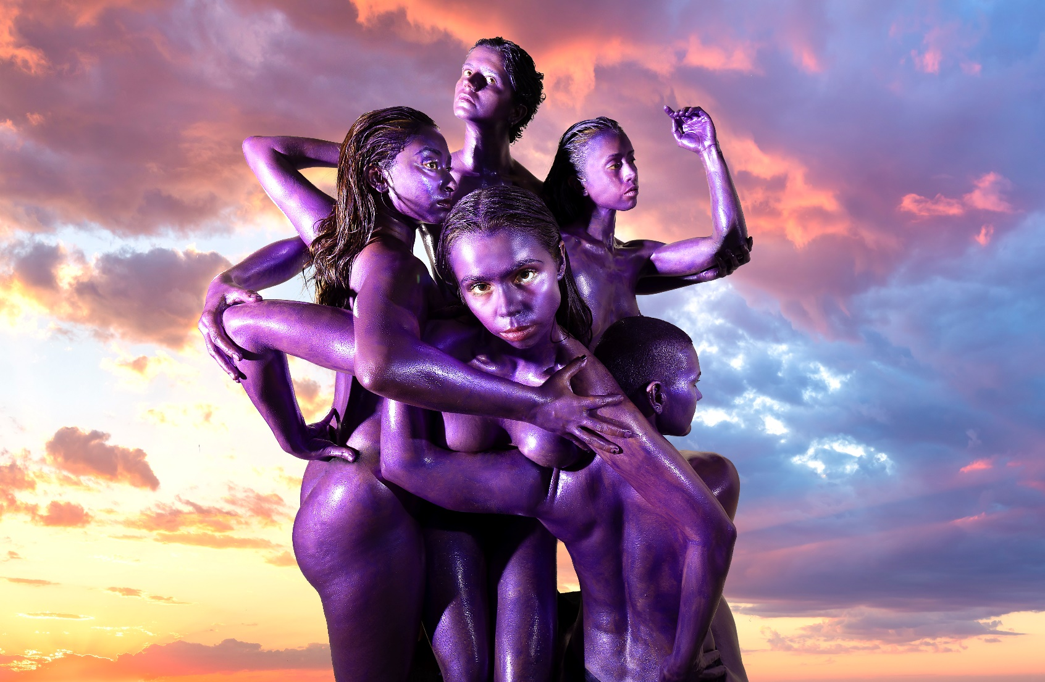

Image credit:Tamarah Scott & Davey Simmons

Image description:Five women, with long or short dark hair and covered in purple paint, gather very close together holding onto each other. One of the women is gazing at the viewer. The backdrop is a dramatic sunset with clouds in orange, yellow and blue hues.

# **Updates to this document**

Please note, this is a new performance and changes are being made by the artists until opening. We will endeavour to provide the latest access information on performances to ticket holders across key stages of rehearsal and presentation.

Arts House website will contain the most up to date version of this document and all ticket holders will be notified of any revisions made 3 days and 1 day prior to the event.

This document was created: 16 May 2025

Revision 1: 23 May 2025

Revision 2: 30 May 2025

Revision 3: 03 June 2025

**Contents**

Updates to this document 2

Where 4

When 4

Access Services 4

Performers 6

Sensory Elements 7

Sound 7

Lighting 8

Physical 8

Smell 8

Visual 8

Entry to space 9

Shocks or surprises 9

Audience experience 9

Social expectations 10

Performance expectations 10

Other 10

Content Warnings 10

General Notes 10

The Venue 11

Front Entrance 11

Accessible Entrances 12

Box Office 13

Ushers 13

Bar 14

Quiet Space 15

Bathrooms 16

Door to Main Hall 17

Lift 18

Transport 19

Tram 19

Train 19

Bus 19

Parking 19

COVID Safety 20

# **Where**

Arts House

521 Queensberry Street

North Melbourne VIC

# **When**

Tuesday 3 June – Sunday 15 June 2025

Preview: Tues 3 June, 7.30pm

Wed – Sat, 7.30pm

Sun, 5pm

Duration: 50 minutes, no interval   
  
Post-show Artist Talk - Wed 11 June for all ticketholders

# **Access Services**

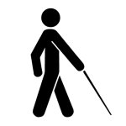 

Tactile Tour and Audio Described performance

Thurs 12 June, 7.30pm  
  


Assistance Animals are welcome.

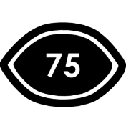

Visual Rating 75%– has minimal dialogue and some background music or sounds, or may be fully subtitled, so Deaf and hard of hearing audiences can have close to the full experience of the event.



This performance is fully wheelchair accessible. More information is provided further below in this guide about the accessible entrances at Arts House and bathrooms.  
  
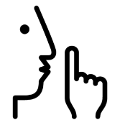

Quite Space Available - The quiet space will be available for you to use before, during and after the show. More information about the quiet space can be found later in this guide.

  
Companion Card - Arts House supports the Companion Card program.

# **Performers**

There are 5 performers in this work.

Photo of the performer Zoe Brown-Holten



Zoe Brown-Holten

Image Description: A black and white studio portrait of a young woman with a composed, confident expression. She has long, wavy dark hair, parted in the middle and styled over one shoulder. Her gaze is directed straight at the camera, creating a strong sense of presence. She is wearing a sleeveless, dark-coloured top.

Photo of the performer Samakshi Sidhu



Samakshi Sidhu

Image Description: A black and white portrait of a young woman seated against a textured wall. She has short, dark, textured hair and wears a subtle smile, creating a relaxed and confident presence. She has a nose ring, an eyebrow piercing, and hoop earrings, adding a touch of personal style. She is dressed in a slightly crinkled, metallic-look zip-up jacket over a patterned top, and wears a delicate chain necklace.

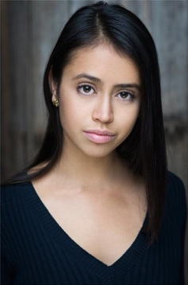

Katherine Hegeman

Image Description: A colour headshot of a young woman with long, straight dark hair, styled neatly and parted slightly to the side. She has a calm and poised expression, with soft makeup that enhances her natural features. She is wearing a dark V-neck ribbed top and small, elegant gold earrings.

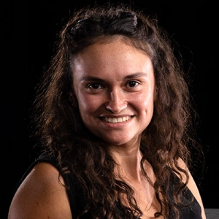Glory Tuohy-Daniell

Image Description: A woman with curly, dark brown hair cascading past her shoulders. She has a natural, friendly smile and is wearing a sleeveless black top. Her complexion is medium with a warm undertone, and she is lit against a solid black background that gives a dramatic contrast to her features. Her expression is engaging and approachable.

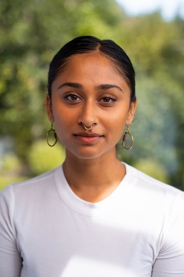

Nadiyah Akbar

Image Description: A young woman with smooth brown skin and sleek, dark hair neatly parted in the centre and tied back. She wears a white ribbed top and gold hoop earring, one of which has red accents. She also has a gold septum piercing. Her expression is calm and confident, and she is photographed in natural light with a softly blurred green outdoor background.

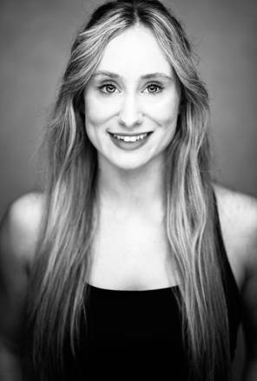Sammie Lester

Image Description: A black-and-white portrait of a woman with long, light hair that flows past her shoulders. She has a broad smile, revealing her teeth, and her facial expression is bright and welcoming. She is wearing a black sleeveless top, and the grayscale tones give the image a timeless, classic feel. The background is plain and softly lit, focusing attention on her face.

# **Sensory Elements**

## **Sound**

Complexly layered rhythmical sound is a prominent feature in this work.

A soundtrack plays throughout the entirety of the performance. It features overlapping textural recordings and low frequencies which reverberate through the subwoofers placed beneath the seating bank.

Towards the end of the performance, once goo (slime) begins to spill out onto the stage, the music becomes quite loud and heightened. This loud music fades to a moment of silence and gentle pre-recorded textural sounds of the goo at the conclusion of the show.

There are no high pitch or sudden noises.

## **Lighting**

Dynamic lighting states are featured in this performance, which includes moments of quick flashing lights, strobe lighting and changes in colour and intensity.

On entering the space, orange-coloured lights are pointed at the audience. The first half of the performance features a single stark white lighting state, emitted from a lighting rig that hangs low over the stage. The second half of the performance features the more dynamic lighting including sudden black outs, blinders towards the audience, strobe, and a bright purple wash.

The flooring is a silver coated Tarkett that reflects lights and figures on the stage.

## **Physical**

Seating for this performance will be a standard seating bank. You might feel some vibration from the subwoofer under the seating bank.

Towards the end of the performance, the dancers perform with a thick purple goo (slime) onstage. There is a small risk of little bits of the goo flying onto the audience in the front rows when the dancers are performing.

## **Smell**

There are no smells or scents in this performance. You may smell the theatrical haze used to fill the space from time to time.

## **Visual**

The dancers will be wearing two sets of costumes throughout the show. First, a set of brightly colored textural hooded tracksuit, and later a set of purple textured underwear and tops.

The dancers perform a variety of dynamic movements in this show ranging from slow and small movements in the beginning, to large, quick, thrashing movements towards the end.

There is a medium sized metal tower-like structure onstage throughout the show that gets pushed or carried around the space in different configurations. The structure never crashes to the ground or makes a loud noise.   
  
Example image below:

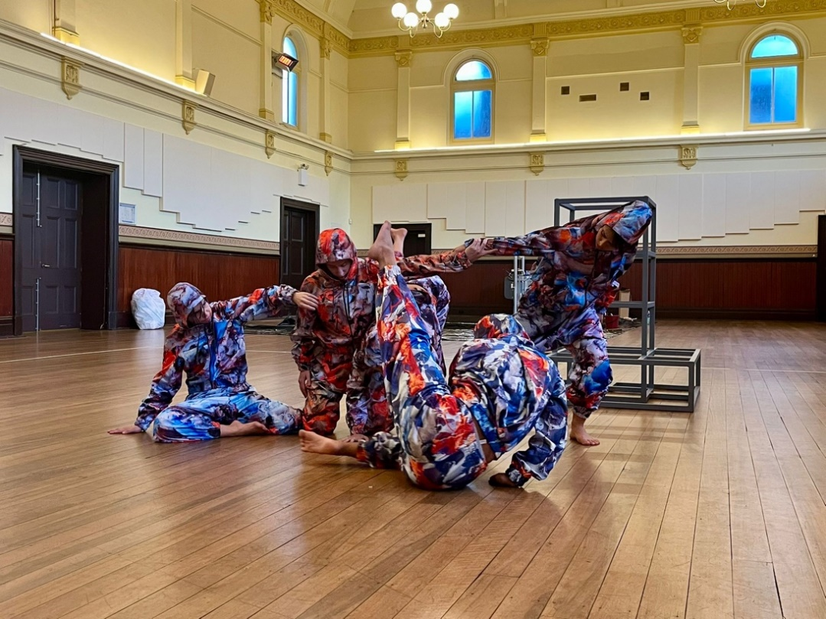

Image Description: Costumes and Metal Structure in MONOLITH

Audience Experience

## **Entry to space**

The audience will enter from the main doors of the foyer into the Main Hall.

The performance space will be open only 5 minutes prior to start time. Upon entering, the dancers will already be onstage. The main hall doors will close at the performance start time.

## **Shocks or surprises**

The use of strobes, sudden blackouts or blinders may shock the audience members at times. The dancers’ interaction with the metal structure may appear risky, but there is no need to worry as all moments are tightly rehearsed and choregraphed.

## **Audience experience**

The dancers may make eye contact with the audience at times during the performance, but there is no physical touch or close proximity with the audience at any time.

## **Social expectations**

Audience members will be sitting on a seating bank. Seating is general admission, so we advise patrons to pick at seat at the beginning of the show and refrain from moving seats during the performance.

There will be a lockout once the show begins. This means that once the performance has started, you should stay in your seat and not leave the performance space.

If you need to leave the performance space, you will not be allowed to re-enter. Please

speak to the front of house staff for assistance.

Please feel free to bring whatever that would help you feel comfortable to watch a 50-minute performance, whether this be toys or snacks purchased from the bar. Making noise or stimming is not an issue as the performance contains a lot of loud music and movement.

## **Performance expectations**

There are 5 dancers in this work, who may be hard to distinguish from one another in the beginning due to their uniform hooded costumes. The 5 dancers remain onstage for the whole performance.

There is no dialogue in the show, and no intended narrative arc – only an abstract dramaturgical arc.

# **Other**

## **Content Warnings**

Suitable for 16+

MONOLITH contains partial nudity and the use of strobe, haze, loud music, and flashing lights.

## **General Notes**

A strict lockout applies. No latecomers will be admitted. Please arrive early to avoid disappointment.

Acknowledgement of Country, a recording of Joel Bray’s voice, will play at the beginning of the performance once audience is seated.

# **The Venue**

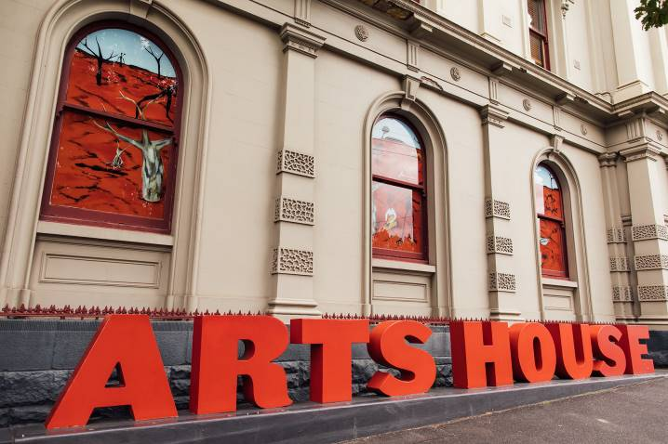

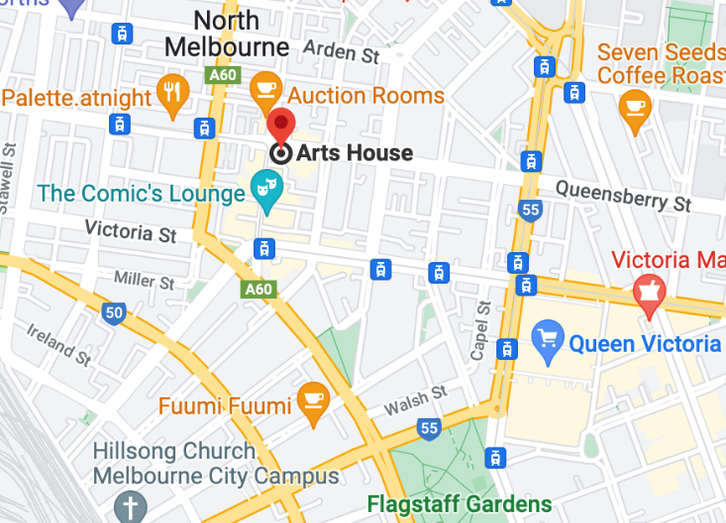

Image: North Melbourne Town Hall features giant red letters that say ARTS HOUSE out the front of it.

Image: a map of Arts House and its surrounding area. [LINK TO MAP](https://www.google.com/maps/place/Arts+House/@-37.802973,144.9486818,17z/data=!4m5!3m4!1s0x0:0x64c465ac7ef21cff!8m2!3d-37.803239!4d144.9498609?shorturl=1)

## **Front Entrance**

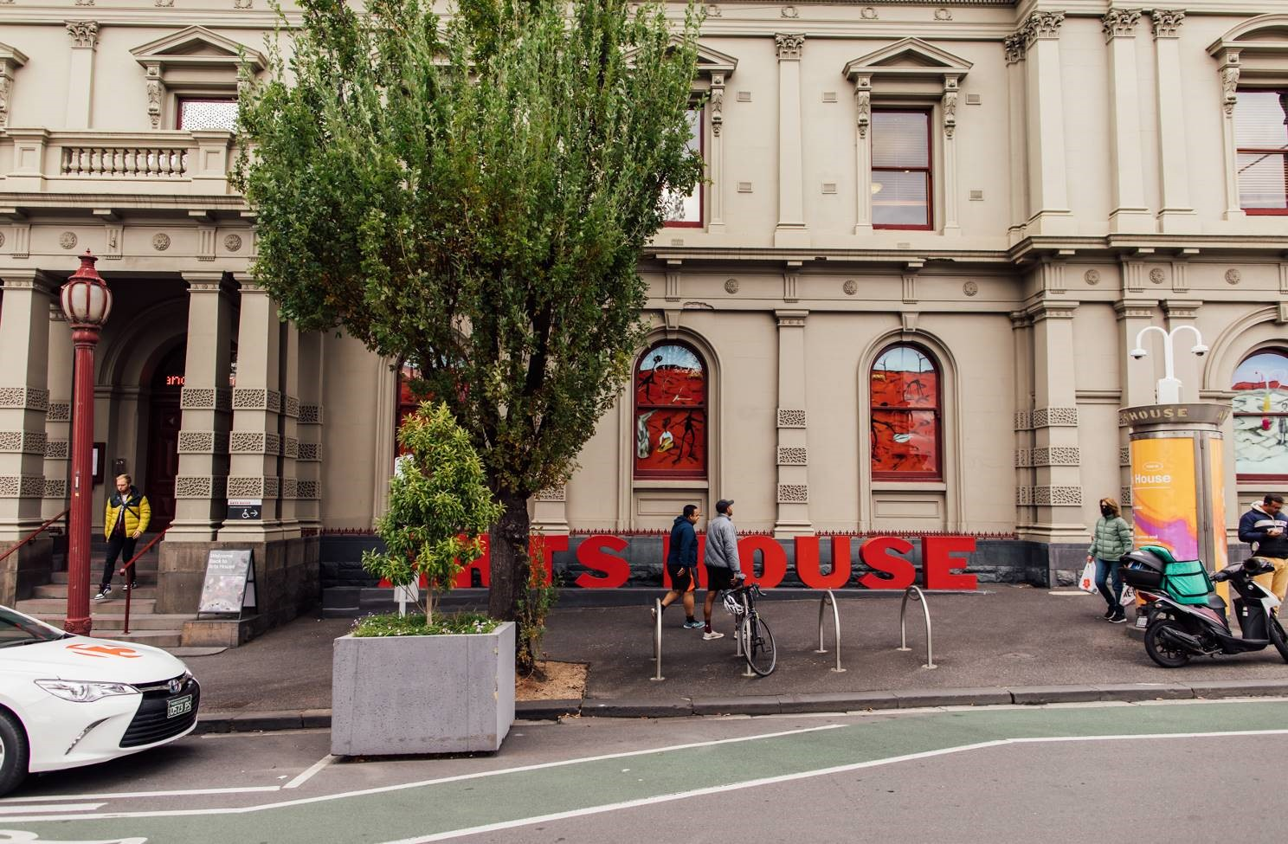

## **Accessible Entrances**



There are two Accessible Entrances. The first is on Errol St next to the Post Office.

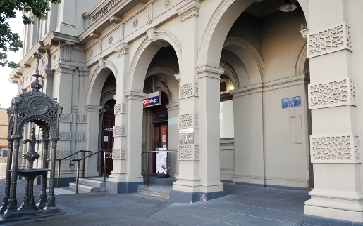

Image: Errol Street entrance next to the Post office with wheelchair accessible ramp or two steps with grab rails.

Post Office accessible entrance


Image: View of door entrance.

The second Accessible Entrance is towards the end of George Johnson Lane.

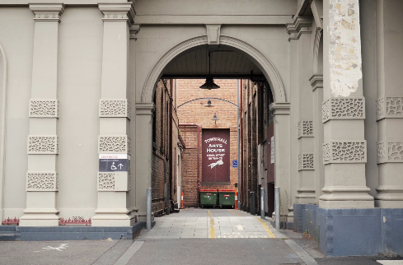

Image: View of George Johnson Lane from Errol St. The laneway passes through an archway with a brick wall at the end.

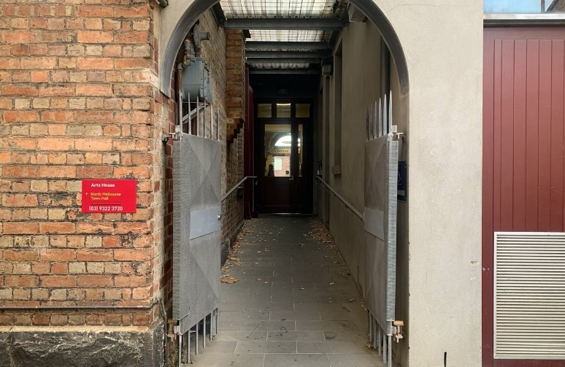

Image: view of the ramp leading from George Johnson Lane to the automated door which opens into the Arts House foyer.

## **Box Office**

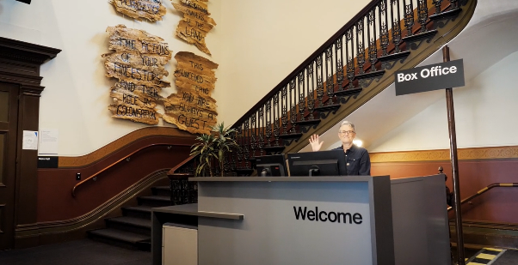

Image:Box Office is located in the foyer under the stairwell.

## **Ushers**

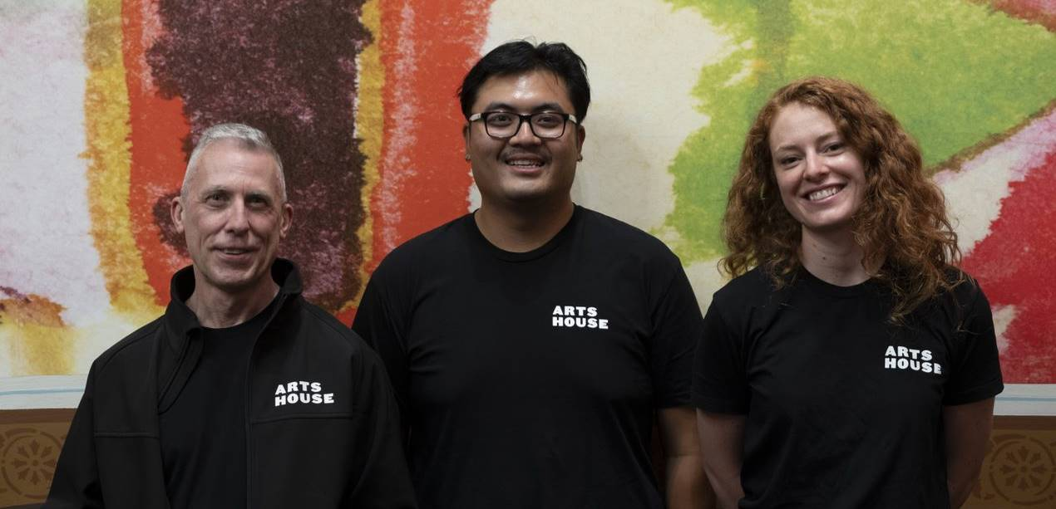

Image: Ushers wearing black with an Arts House Logo on the left hand shoulder.

## **Bar**

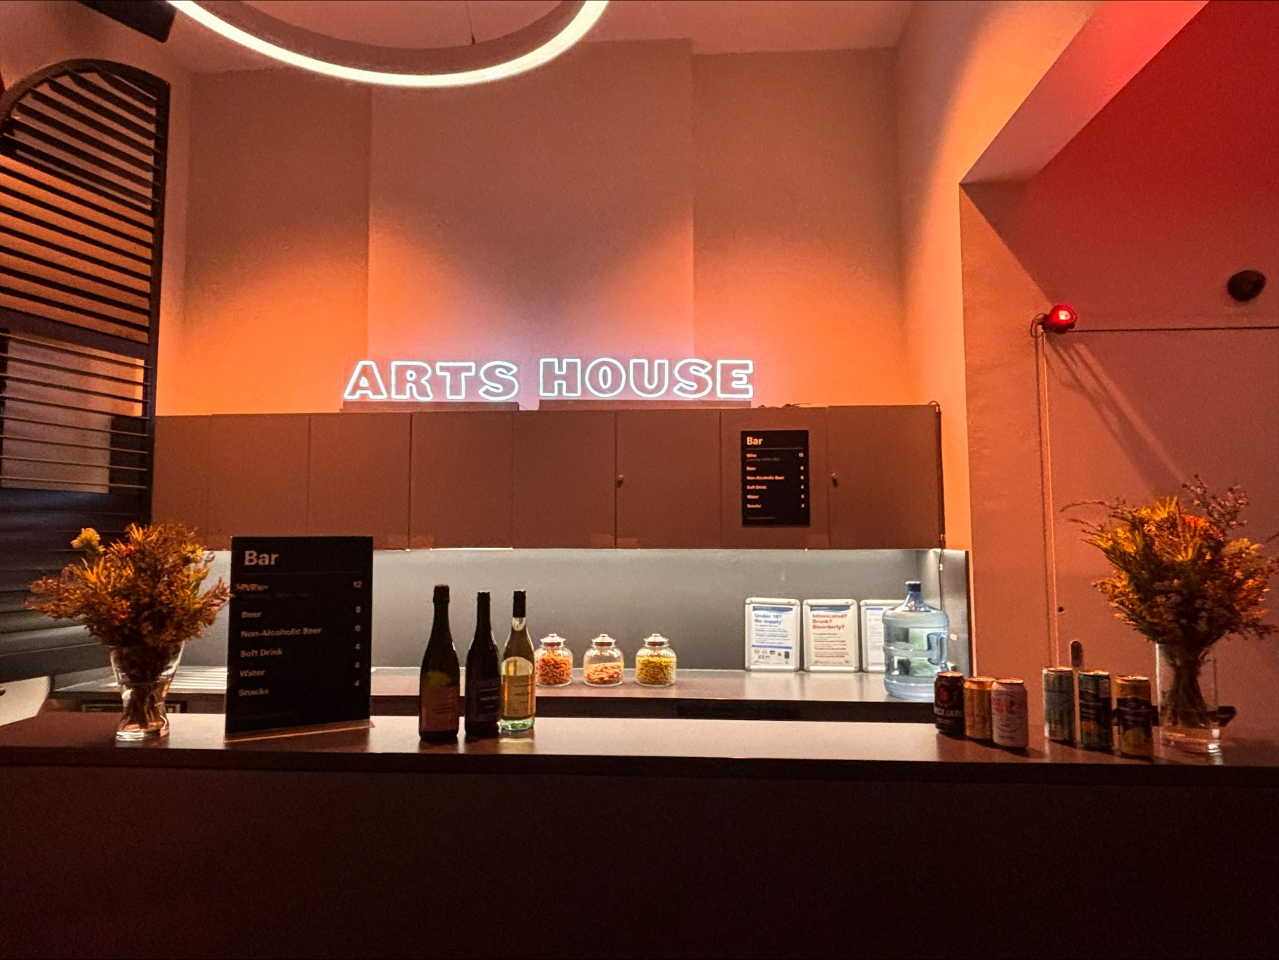

Image Description: The Arts House Bar located on the ground floor.  
  
Bar staff will be wearing black with an Arts House Logo.

We have a range of alcoholic and non-alcoholic beverages for sale.

We are a cashless venue and accept EFTPOS, Visa and Mastercard payments.

## **Quiet Space**

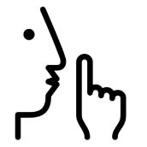

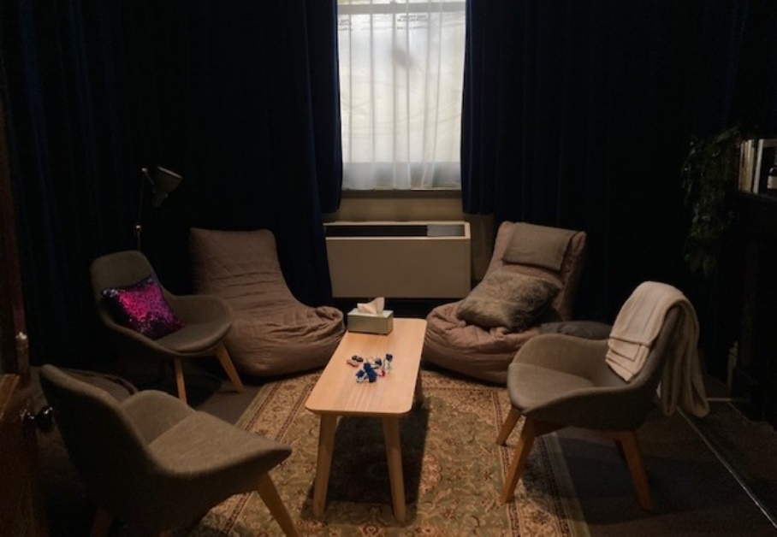Arts House Quiet Space is located on Ground Level and is nearby reception and opposite the accessible bathrooms. It includes a range of seating options including soft furnishings, dimmable lights, sensory and stim objects. It is open during venue opening hours and events as a quiet space, prayer or parenting space.

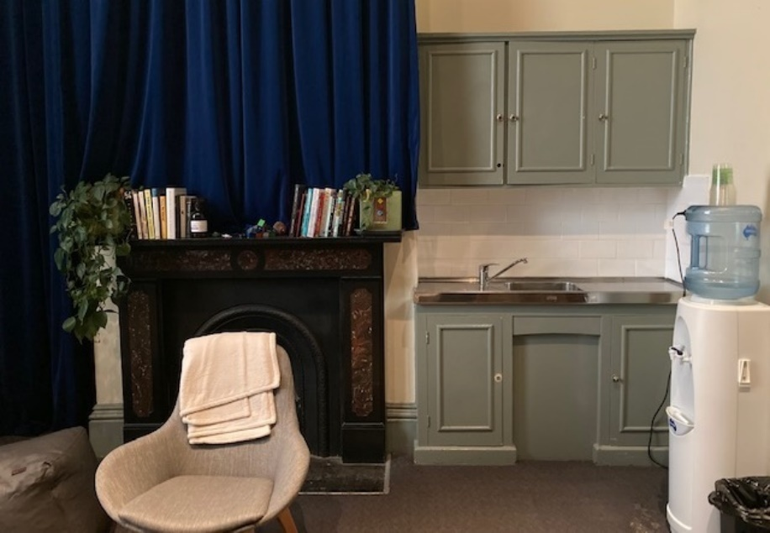Image: Quiet space with lights dimmed

Image: Quiet space kitchenette and book shelf

## **Bathrooms**

All bathrooms have Dyson hand dryers with sensor activation. There is an accessible bathroom that is single use on ground level opposite the Quiet Space. There is another accessible bathroom upstairs – this is accessible via lift or stairs.

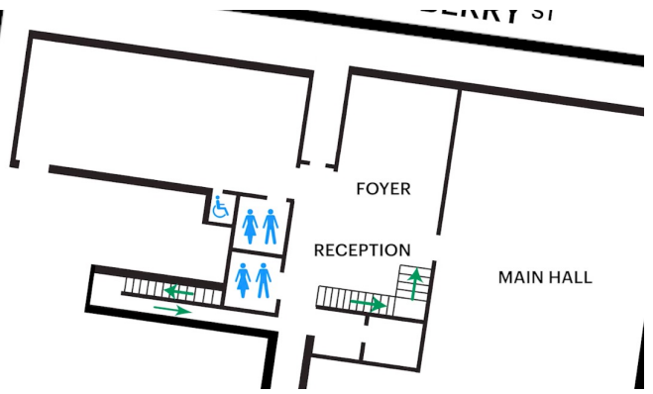

Image: Map of the bathrooms located on the ground floor. All of the bathrooms at Arts House are unisex.

## **Door to Main Hall**

The Performance is in the Main Hall.

It is on the ground floor.

It is to the left of the box office desk and right of the bar.

An artist statement is available via QR code on signage and warnings are on the door.

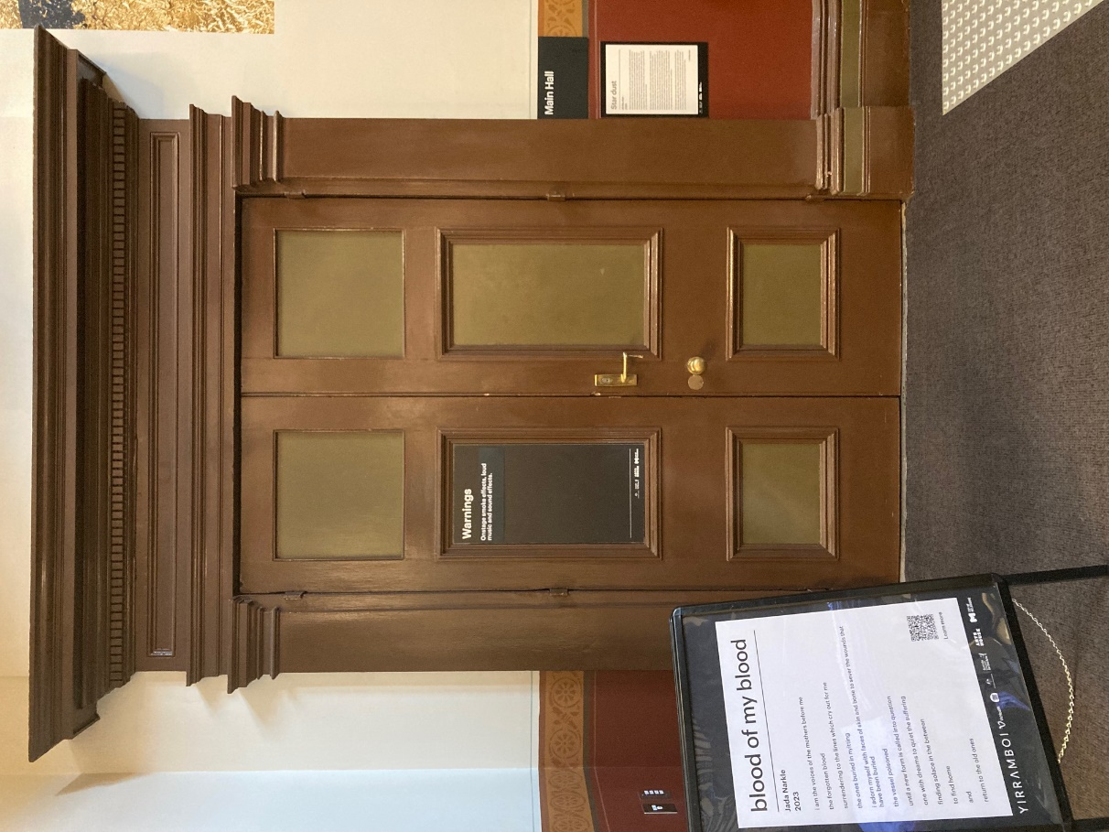

Image: Doors to The Main Hall.

## **Lift**

The lift is located behind reception desk in the foyer.

The closest entry to the lift is via George Johnson Lane.

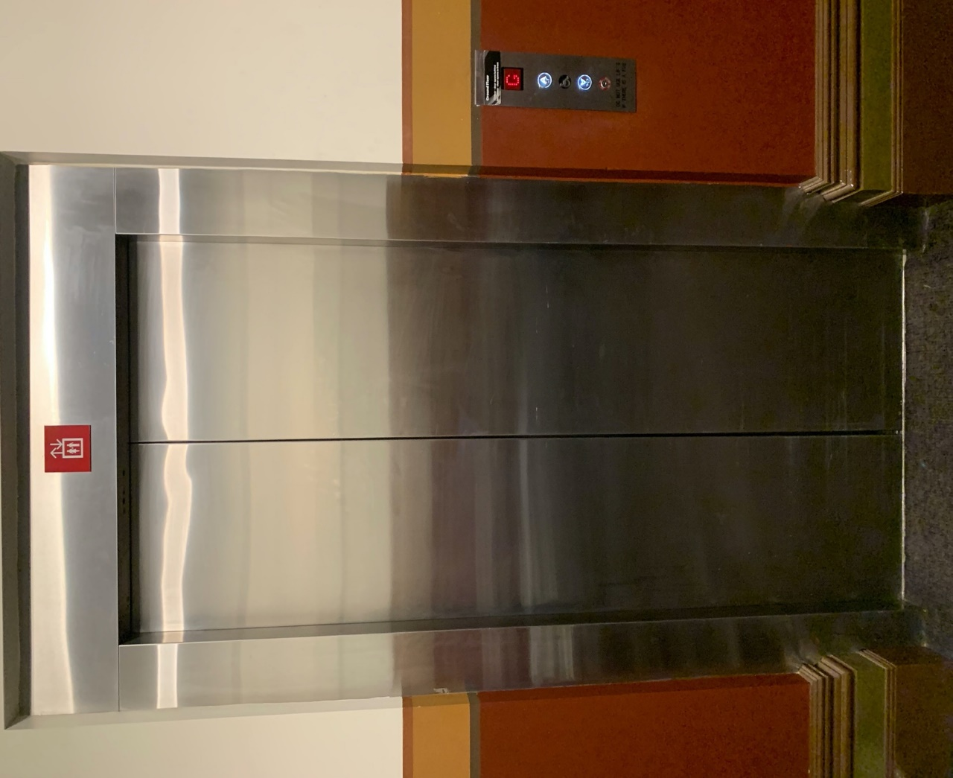

Image: The elevator. Located behind the Box Office desk on the ground floor foyer.

# **Transport**

## **Tram**

Route 57 (High Floor trams only)

Stop 12, North Melbourne Town Hall.

Please note, this is not a wheelchair accessible tram

[GETTING TO ARTS HOUSE VIDEO LINK](https://vimeo.com/544169506)

## **Train**

Arts House is 1.1km from   
North Melbourne Train Station,   
approximately 16 minute walk

[North Melbourne Station Information](https://www.ptv.vic.gov.au/stop/1144/north-melbourne-station/0/train/)

1.2km from Flagstaff Station,   
approximately 15 minute walk

[Flagstaff Station Information](https://www.ptv.vic.gov.au/stop/1068/flagstaff-station/0/train/#StopPage:::datetime=2023-04-06T04%3A41%3A27.669Z&directionId=-1&showAllDay=false&_auth=408ac3b1e97f4b0beb5bdf00c2f797057d10dd6e6cf2ad40a69334c4dfdf5e21)

## **Bus**

Bus number: 216

## **Parking**

There is limited paid on-street parking on Queensberry Street and Errol Street.

There are two accessible on street car parking spaces on Queensberry Street (150m to our accessible Errol Street entrance) for holders of a Parking Permit for Disabled people.

# **COVID Safety**

Please note: If you have a cough, sore throat, fever, shortness of breath or flu-like symptoms, you must not attend our venue or programs in person.

We will provide a refund if you need to cancel your attendance due to illness. Please [contact us](mailto:ArtsHouse.Ticketing@melbourne.vic.gov.au) by 9am on the day of the event.

To minimise the risk of COVID-19 transmission, we advise all patrons, artists and staff to:

* Practise physical distancing where possible
* Practise good hygiene by washing and or sanitising your hands often
* Wear a mask as directed by Victorian Government guidelines

Throughout the venue you will find:

* hand sanitiser stations available
* masks available (ask one of our staff for assistance)​

We also ensure that spaces are well ventilated.

Staying COVID-safe remains important. We must all follow these steps:

* Follow the [Victorian Government’s measures on how to stay safe.](https://www.betterhealth.vic.gov.au/coronavirus-covid-19-victoria)
* When you cannot safely socially distance it is recommended to wear a well fitted mask where required.
* Practise [COVID-safe hygiene protocols.](https://www.health.gov.au/news/health-alerts/novel-coronavirus-2019-ncov-health-alert/how-to-protect-yourself-and-others-from-coronavirus-covid-19/good-hygiene-for-coronavirus-covid-19)