**Inter.Sonix: Hand To Earth (AUS) with solo performance from Sipaningkah (IDN)**  
Presented by Arts House and curated by Liquid Architecture

Access Guide

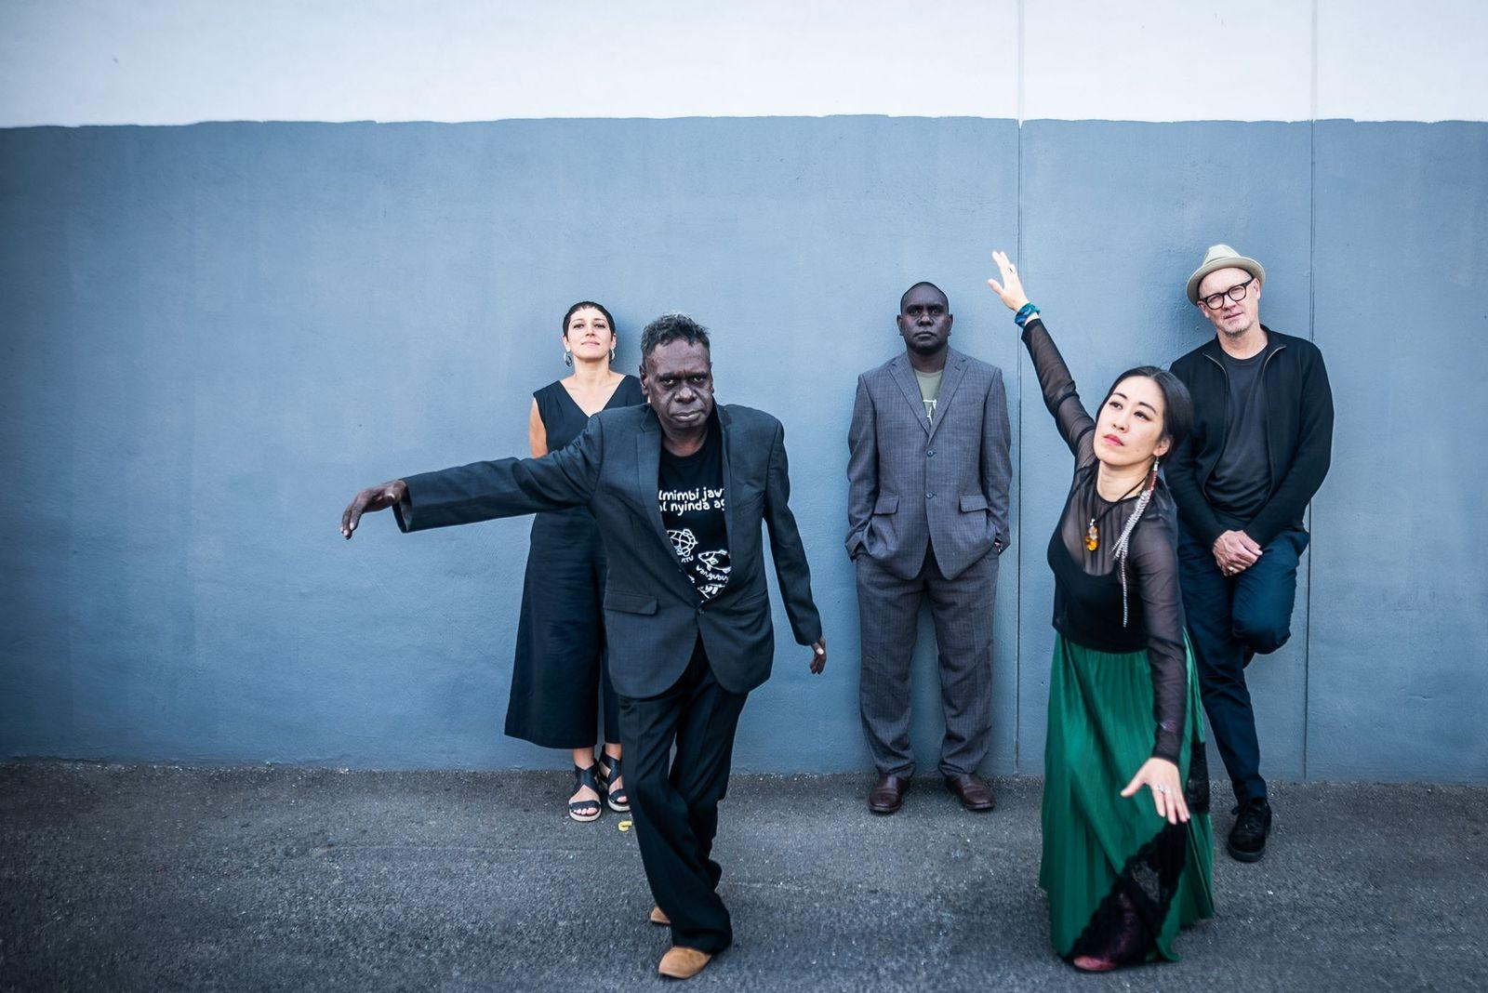

Image: Hand to Earth by Emma Luker

Image Description: Five people stand in front of a tall concrete wall. A man of dark skin and a woman with fair complexion stand forward in a dance-like pose while the other three people – a woman, and two men – are standing against the concrete wall in a calm and relaxed fashion.

# **Updates to this document**

Please note, this performance is a new work and changes are being made by artists until opening. We will endeavour to provide the latest access information on performances to ticket holders across key stages of rehearsal and presentation.

Arts House website will contain the most up to date version of this document and all ticket holders will be notified of any revisions made 3 days and 1 day prior to the event.

This document was created: 10 June 2025

**Contents**

**Updates to this document** 2

**Where** 4

**When** 4

**Access Services** 4

**Performers** 6

**Sensory Elements** 7

Sound 7

Lighting 8

Physical 8

Smell 8

Visual 8

Entry to space 8

Shocks or surprises 8

Audience experience 9

Social expectations 9

**Other** 9

Content Warnings 9

General Notes 9

**The Venue** 10

Front Entrance 10

Accessible Entrances 11

Box Office 12

Ushers 12

Bar 13

Quiet Space 14

Bathrooms 15

Door to Main Hall 16

Lift 17

**Transport** 18

Tram 18

Train 18

Bus 18

Parking 18

**COVID Safety** 19

# **Where**

Arts House

521 Queensberry Street

North Melbourne VIC

# **When**

Friday 20 June 2025

7.00pm – 7.30pm Doors   
7.30pm – 8.10pm Sipaningkah   
8.30pm – 9.30pm Hand To Earth 

Duration: 2 hours

# **Access Services**



Assistance Animals are welcome.



Assistive Listening is available free of charge. Ask staff for assistance on arrival.



Aural Rating 75%– Mainly sound-based with visuals only incidental to the work, so blind or low vision audiences can have close to the full experience of the event.



This performance is fully wheelchair accessible. More information is provided further below in this guide about the accessible entrances at Arts House and bathrooms.  
  


Quite Space Available - The quiet space will be available for you to use before, during and after the show. More information about the quiet space can be found later in this guide.

  
Companion Card - Arts House supports the Companion Card program.

# **Performers**

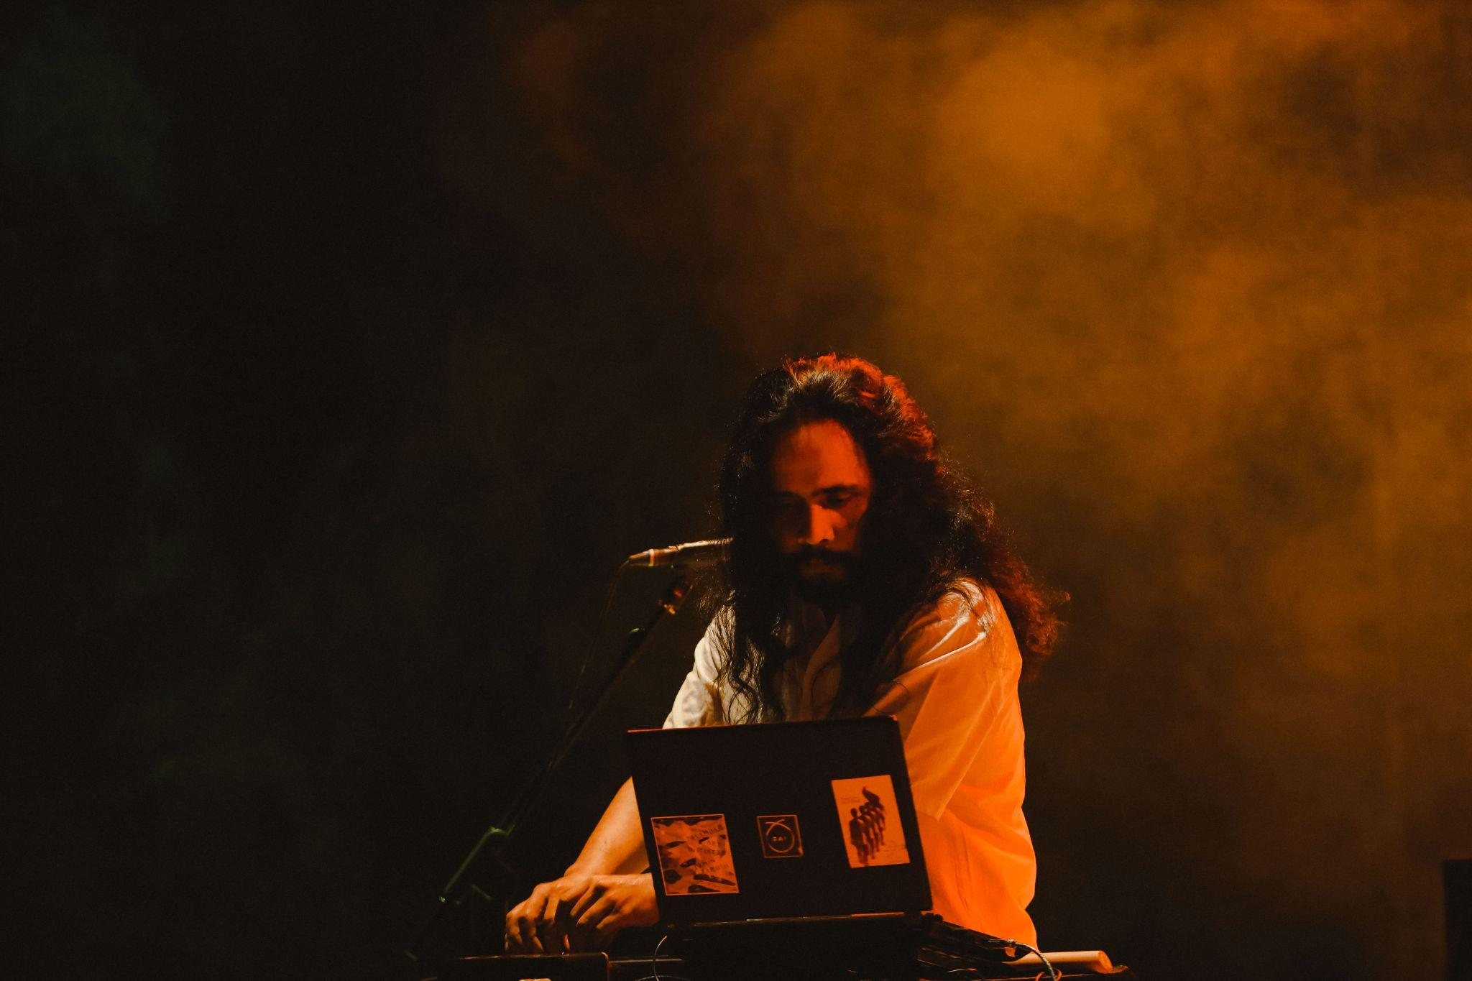

Sipaningkah

**Hand To Earth:**

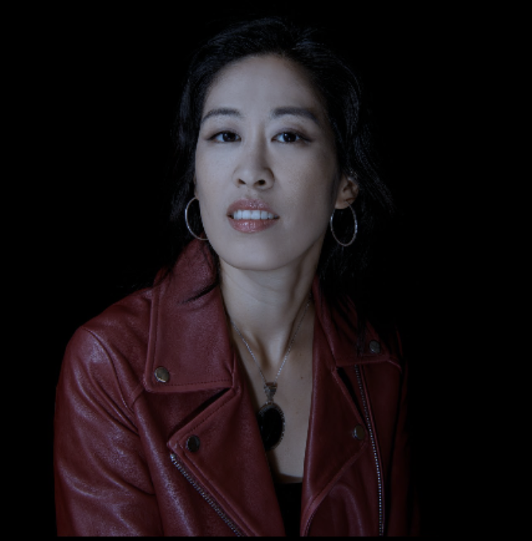 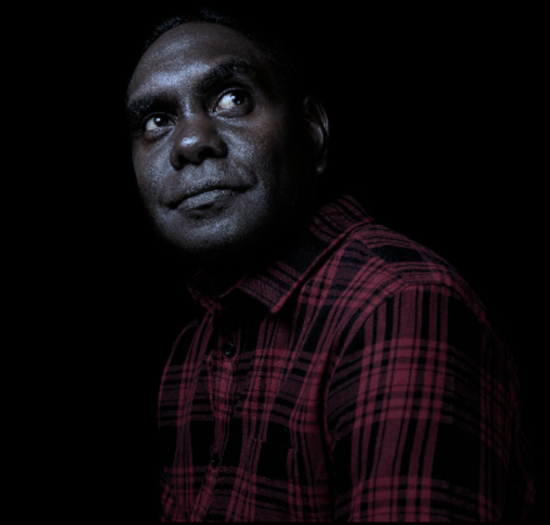 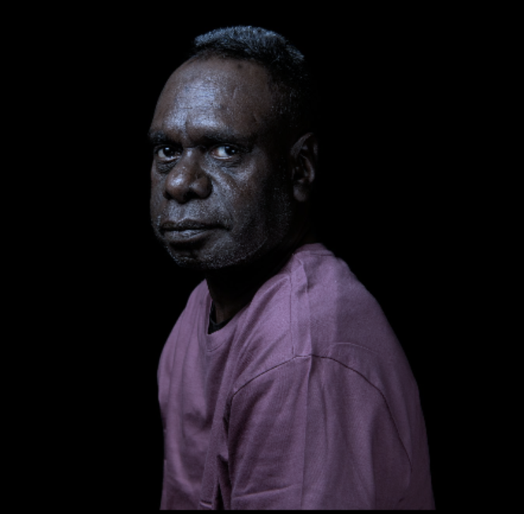

Sunny (Yoon Sun) Kim Daniel Wilfred David Wilfred

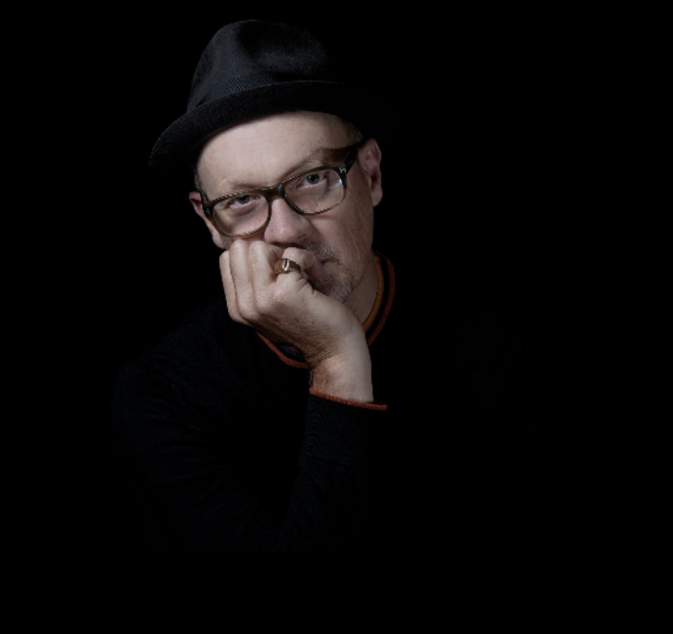 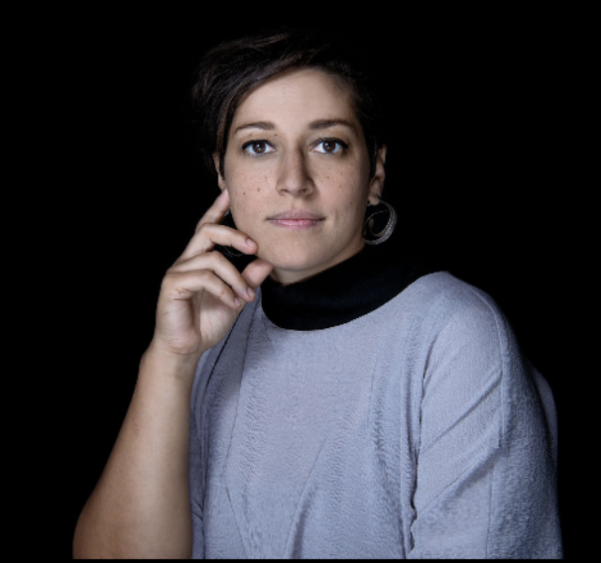

Peter Knight Aviva Endean

# 

# 

# **Sensory Elements**

## **Sound**

**Hand To Earth:**

**Volume and Dynamics**: The performances are generally at moderate volume levels, focusing on subtlety and nuance rather than loud or abrupt sounds.

**Vocal Elements**: The ensemble features the deep, resonant vocals of Daniel Wilfred, delivering Yolŋu manikay in his native language, and the ethereal voice of Sunny Kim, who sings in English, Korean, and wordless vocalizations. Their voices intertwine, creating a dialogue between ancient and contemporary narratives.

**Instrumentation**: The soundscape includes the traditional yidaki (didgeridoo) played by David Wilfred, providing a continuous, earthy drone. Peter Knight contributes with trumpet and electronic textures, while Aviva Endean adds layers using clarinets, harmonic flute, and various objects.

**Musical Style**: The music is a seamless blend of structured compositions and improvisation, described by the artists as a form of "weaving" different musical threads together. This approach results in a meditative and immersive auditory experience.

**Atmosphere**: The overall ambiance is contemplative and atmospheric, with influences from minimalism akin to the works of Brian Eno and Jon Hassell. The performances often evoke natural elements, such as the sounds of stars, fire, and rain, creating a connection between the music and the environment.

**Sipaningkah**

**Volume and Dynamics:** Performances typically maintain moderate volume levels. There may be occasional dynamic shifts to emphasize certain elements, but abrupt or excessively loud sounds are uncommon.

**Instrumentation**: Sipaningkah employs a range of traditional Minangkabau instruments, including the *pupuik soroang* (a wind instrument inspired by elephant calls), *canang* (gong), *serunai* (flute), and *sampleong* (pipe). He also utilizes a self-created percussion instrument called the "Tasauff," which is inspired by the Tasa drum, Talempong gong, and Rabab string instrument.

**Musical Style**: His compositions fuse elements of folk music with avant-garde noise and electronic textures, resulting in a sound that is both hypnotic and richly textured. The music often features layered rhythms and ambient soundscapes that evoke a sense of movement and introspection.

**Atmosphere**: The overall ambiance of Sipaningkah's performances is immersive and contemplative, inviting listeners into a sonic environment that bridges the past and the future. The music is designed to be experienced as a journey, with each piece unfolding organically to reveal new textures and patterns.

## **Lighting**

Visual elements are generally minimal and subdued, aligning with the introspective nature of the music. This creates an environment conducive to focused listening and personal reflection.

## **Physical**

The bass volumes may be occasionally felt in the body. The concert will be seated on a flat surface. The venue will be comfortable and accessible in order for the audience to immersive themselves in the detailed sounds.

## **Smell**

There is no use of scent in the performance.

## **Visual**

The performers will be on stage throughout the show with an assortment of instruments. The overall visual feeling of the concert is subdued.

**Audience Experience**

## **Entry to space**

Audience members enter through the main hall doors from the foyer.

## **Shocks or surprises**

There are moments of loud noises and lights that change in colour and intensity.

## **Audience experience**

There will be no up close and personal experience between performer and audience. Audience members will not be physically touched.

## **Social expectations**

Please feel free to bring whatever that would help you feel comfortable to watch 2 hour performance, whether this be toys or snacks purchased from the bar. Making noise or stimming is not an issue as the performance contains a lot of loud music.

There is a Quite Space available outside of the concert space, where patrons are welcome to access at any point during the show too. Information on the Quite Space can be found further down in this document

# **Other**

## **Content Warnings**

This performance contains loud noises and lights that change colour and intensity.

## **General Notes**

Guests under the age of 18 must be accompanied by a parent or guardian.

# 

# 

# 

# 

# **The Venue**

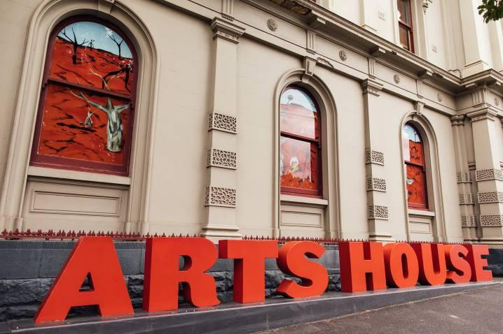

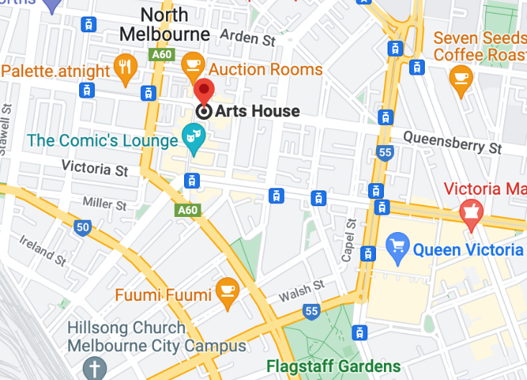

Image: North Melbourne Town Hall features giant red letters that say ARTS HOUSE out the front of it.

Image: a map of Arts House and its surrounding area. [LINK TO MAP](https://www.google.com/maps/place/Arts+House/@-37.802973,144.9486818,17z/data=!4m5!3m4!1s0x0:0x64c465ac7ef21cff!8m2!3d-37.803239!4d144.9498609?shorturl=1)

## **Front Entrance**

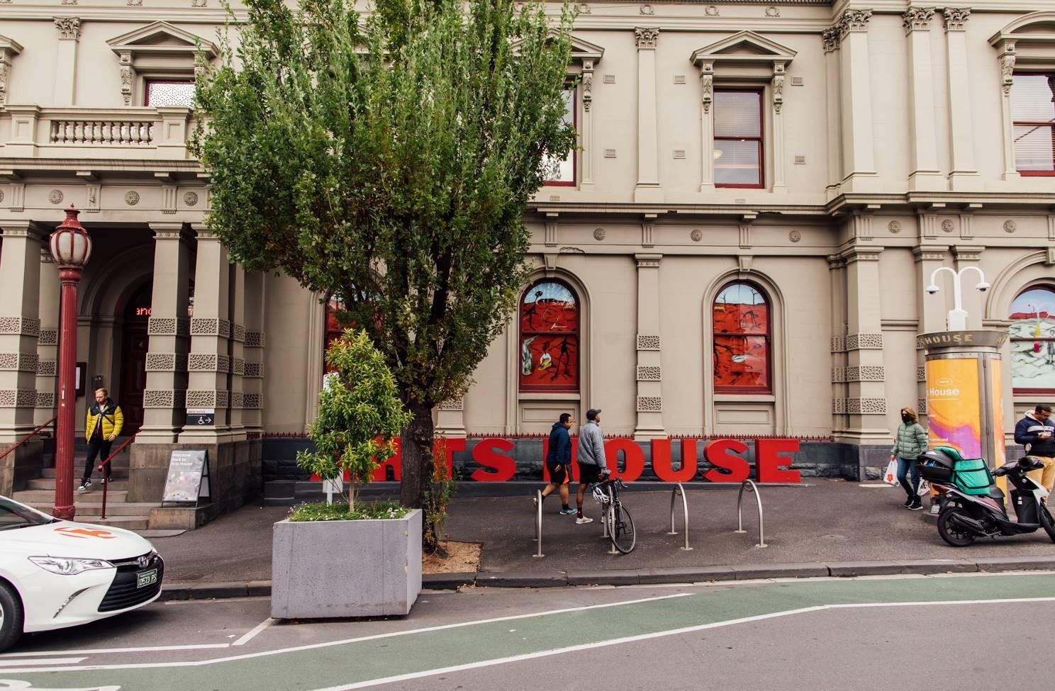

## **Accessible Entrances**



There are two Accessible Entrances. The first is on Errol St next to the Post Office.

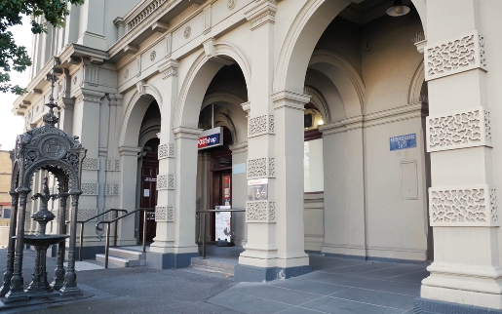

Image: Errol Street entrance next to the Post office with wheelchair accessible ramp or two steps with grab rails.

Post Office accessible entrance


Image: View of door entrance.

The second Accessible Entrance is towards the end of George Johnson Lane.

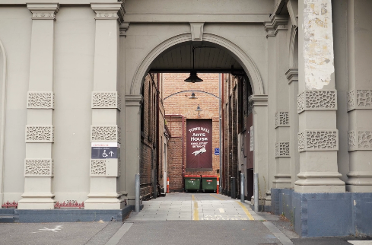

Image: View of George Johnson Lane from Errol St. The laneway passes through an archway with a brick wall at the end.

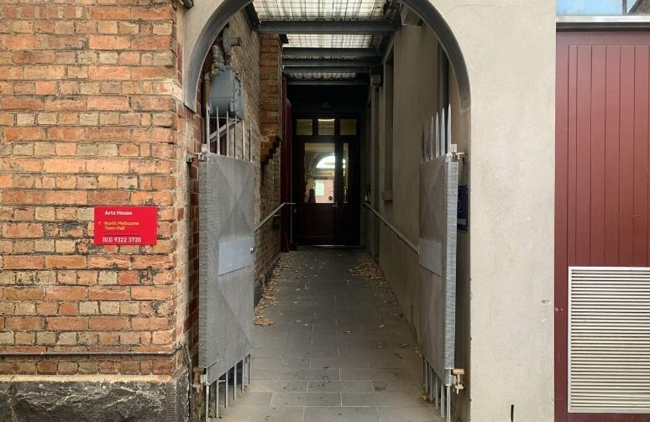

Image: view of the ramp leading from George Johnson Lane to the automated door which opens into the Arts House foyer.

## **Box Office**

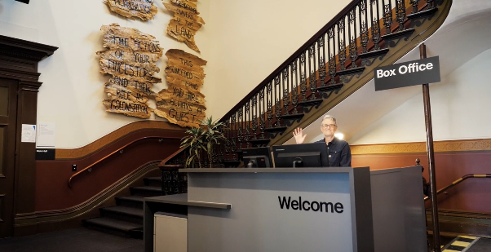

Image:Box Office is located in the foyer under the stairwell.

## **Ushers**

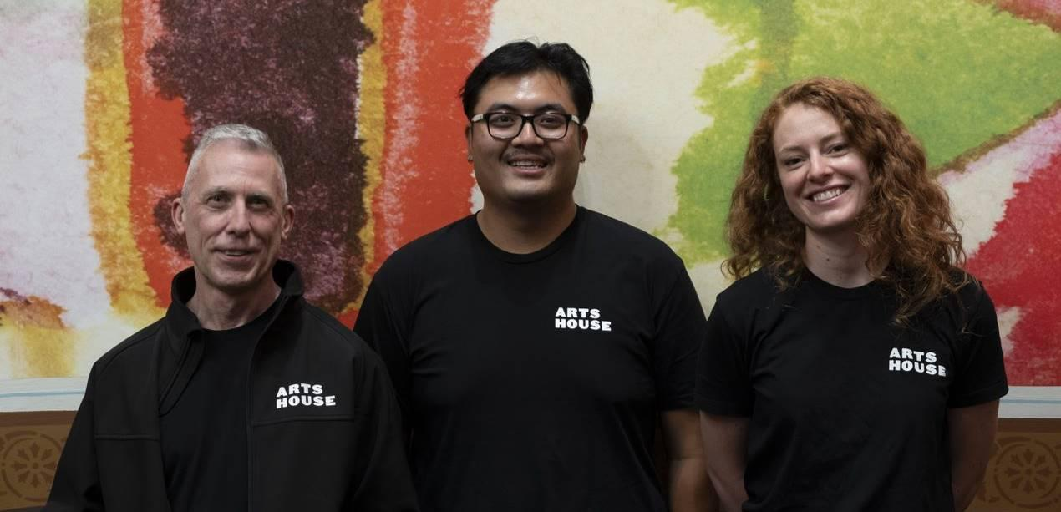

Image: Ushers wearing black with an Arts House Logo on the left hand shoulder.

## **Bar**

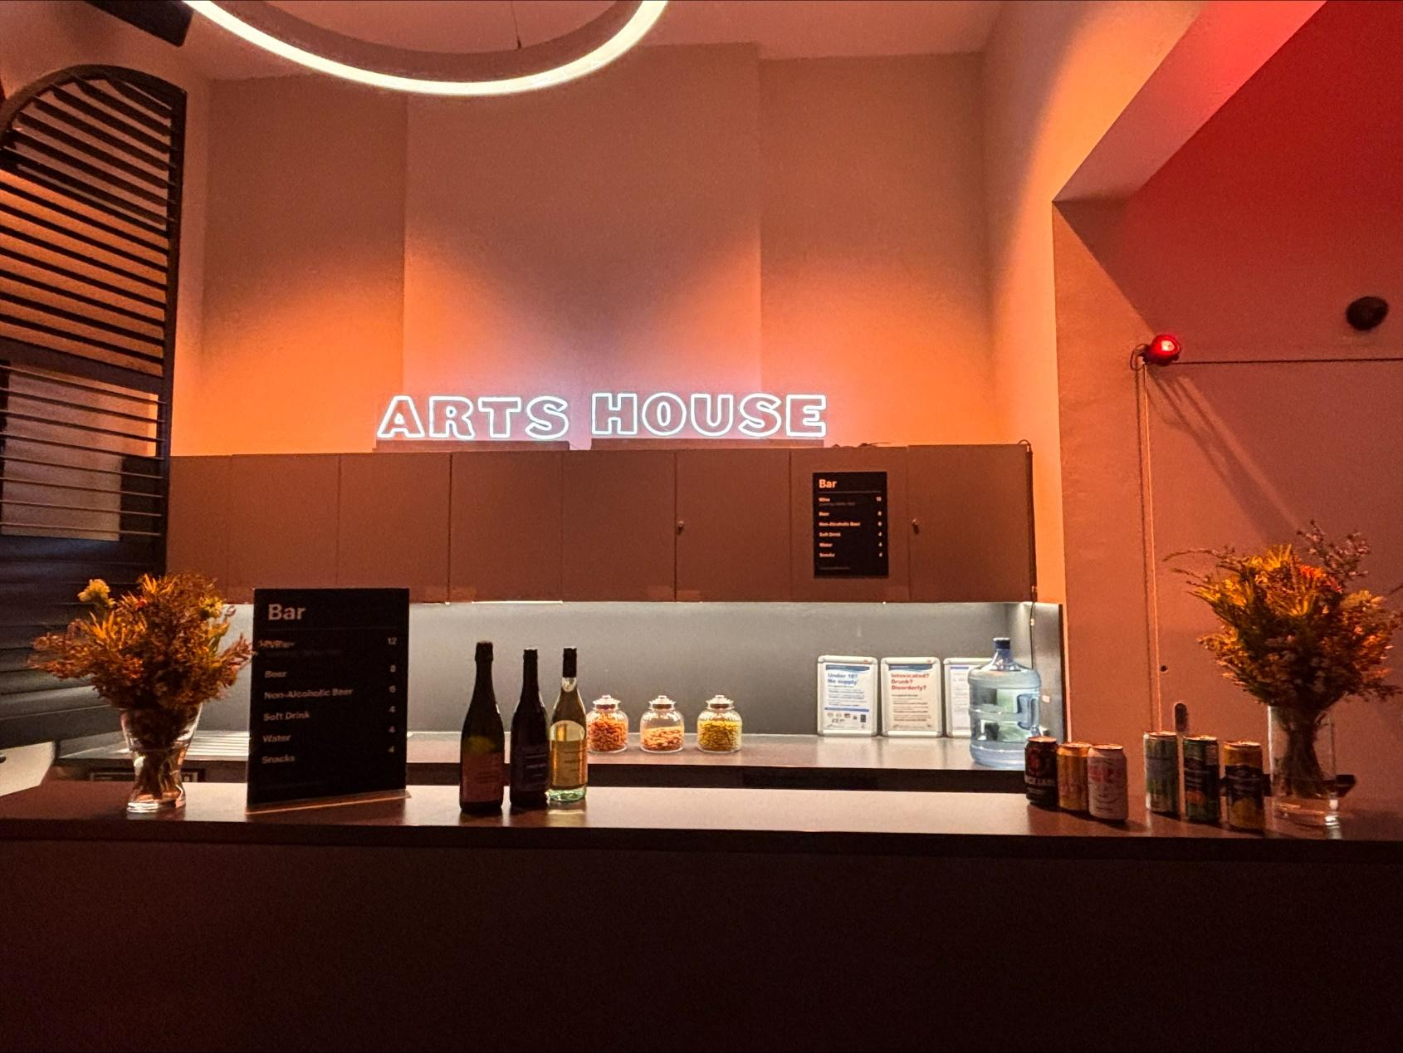

Image Description: The Arts House Bar located on the ground floor.  
  
Bar staff will be wearing black with an Arts House Logo.

We have a range of alcoholic and non-alcoholic beverages for sale.

We are a cashless venue and accept EFTPOS, Visa and Mastercard payments.

## **Quiet Space**



Arts House Quiet Space is located on Ground Level and is nearby reception and opposite the accessible bathrooms. It includes a range of seating options including soft furnishings, dimmable lights, sensory and stim objects. It is open during venue opening hours and events as a quiet space, prayer or parenting space.

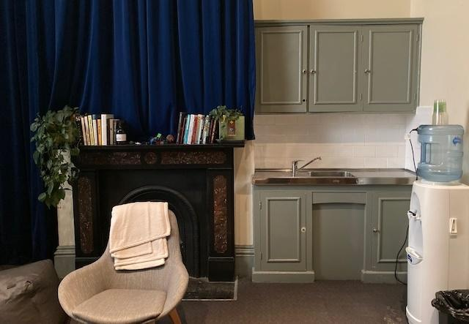

Image: Quiet space kitchenette and bookshelf.

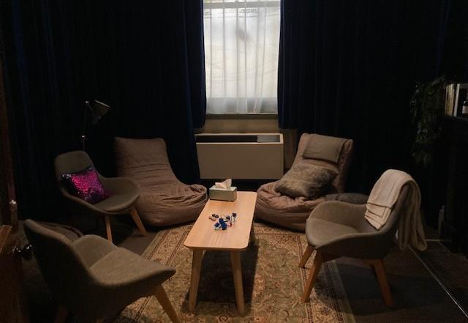

Image: Quiet space with lights dimmed.

## **Bathrooms**

All bathrooms have Dyson hand dryers with sensor activation. There is an accessible bathroom that is single use on ground level opposite the Quiet Space. There is another accessible bathroom upstairs – this is accessible via lift or stairs.

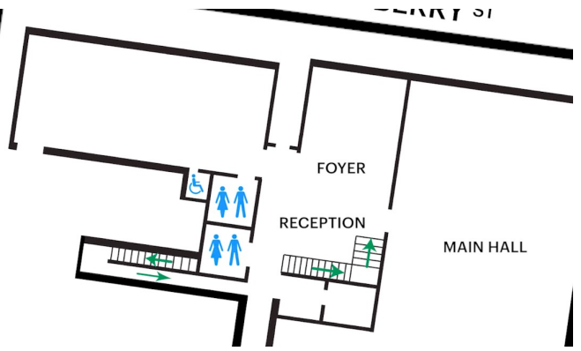

Image: Map of the bathrooms located on the ground floor. All of the bathrooms at Arts House are unisex.

## **Door to Main Hall**

The Performance is in the Main Hall.

It is on the ground floor.

It is to the left of the box office desk and right of the bar.

An artist statement is available on a QR code on signage.

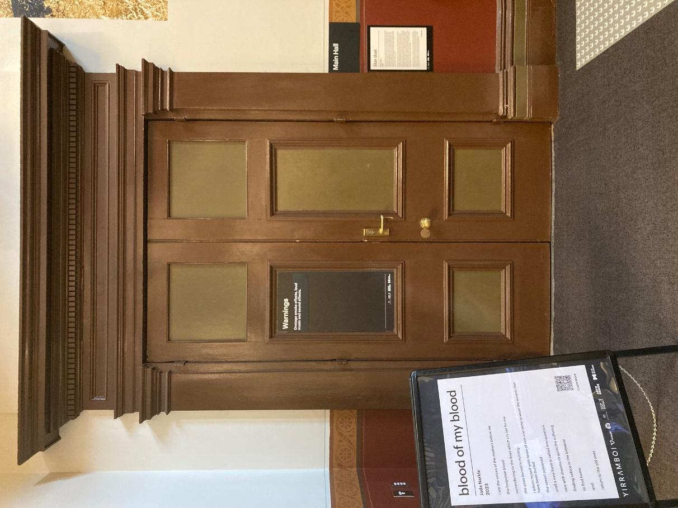

Image: Doors to The Main Hall.

## **Lift**

The lift is located behind reception desk in the foyer.

The closest entry to the lift is via George Johnson Lane.

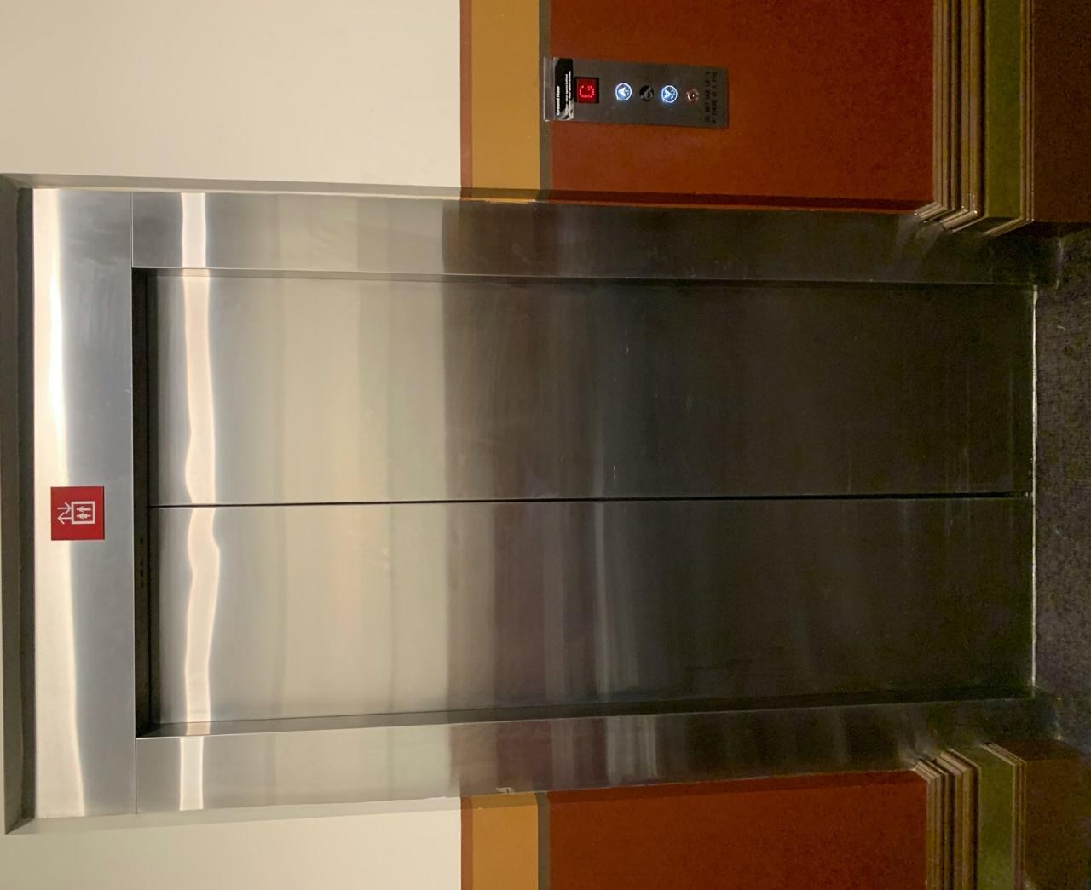

Image: The elevator. Located behind the Box Office desk on the ground floor foyer.

# **Transport**

## **Tram**

Route 57 (High Floor trams only)

Stop 12, North Melbourne Town Hall.

Please note, this is not a wheelchair accessible tram

[GETTING TO ARTS HOUSE VIDEO LINK](https://vimeo.com/544169506)

## **Train**

Arts House is 1.1km from   
North Melbourne Train Station,   
approximately 16 minute walk

[North Melbourne Station Information](https://www.ptv.vic.gov.au/stop/1144/north-melbourne-station/0/train/)

1.2km from Flagstaff Station,   
approximately 15 minute walk

[Flagstaff Station Information](https://www.ptv.vic.gov.au/stop/1068/flagstaff-station/0/train/#StopPage:::datetime=2023-04-06T04%3A41%3A27.669Z&directionId=-1&showAllDay=false&_auth=408ac3b1e97f4b0beb5bdf00c2f797057d10dd6e6cf2ad40a69334c4dfdf5e21)

## **Bus**

Bus number: 216

## **Parking**

There is limited paid on-street parking on Queensberry Street and Errol Street.

There are two accessible on street car parking spaces on Queensberry Street (150m to our accessible Errol Street entrance) for holders of a Parking Permit for Disabled people.

# **COVID Safety**

Please note: If you have a cough, sore throat, fever, shortness of breath or flu-like symptoms, you must not attend our venue or programs in person.

We will provide a refund if you need to cancel your attendance due to illness. Please [contact us](mailto:ArtsHouse.Ticketing@melbourne.vic.gov.au) by 9am on the day of the event.

To minimise the risk of COVID-19 transmission, we advise all patrons, artists and staff to:

* Practise physical distancing where possible
* Practise good hygiene by washing and or sanitising your hands often
* Wear a mask as directed by Victorian Government guidelines

Throughout the venue you will find:

* hand sanitiser stations available
* masks available (ask one of our staff for assistance)​

We also ensure that spaces are well ventilated.

Staying COVID-safe remains important. We must all follow these steps:

* Follow the [Victorian Government’s measures on how to stay safe.](https://www.betterhealth.vic.gov.au/coronavirus-covid-19-victoria)
* When you cannot safely socially distance it is recommended to wear a well fitted mask where required.
* Practise [COVID-safe hygiene protocols.](https://www.health.gov.au/news/health-alerts/novel-coronavirus-2019-ncov-health-alert/how-to-protect-yourself-and-others-from-coronavirus-covid-19/good-hygiene-for-coronavirus-covid-19)