**Zaffé**

By Stéphanie Ghajar & Collaborators

Access Guide

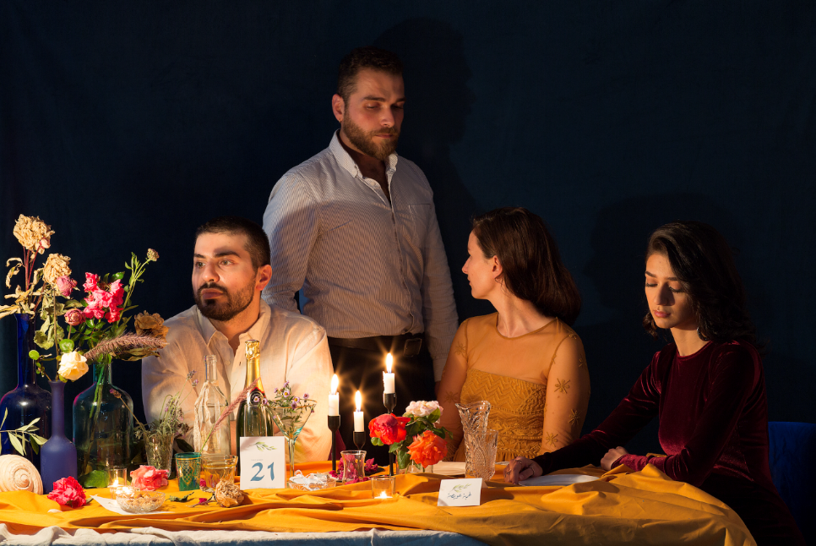

Image description: Three people seated at a banquet table, with a fourth person standing behind them. Each person faces a different direction. The table is set with burning candles, empty bottles, wilting flowers, and Arabic-language place cards.

# **Updates to this document**

Please note, this performance is a new work and changes are being made by artists until opening. We will endeavour to provide the latest access information on performances to ticket holders across key stages of rehearsal and presentation.

Arts House website will contain the most up to date version of this document and all ticket holders will be notified of any revisions made 3 days and 1 day prior to the event.

This document was created: 20/11/2024

**Contents**

**Updates to this document** 1

**Where** 3

**When** 3

**Access Services** 3

**Performers** 6

**Sensory Elements** 2

Sound 2

Lighting 2

Physical 3

Smell 3

Visual 3

**Audience Experience** 5

Entry to space 5

Shocks or surprises 6

Audience experience and social expectations 6

Performance expectations 7

**Other** 8

Content Warnings 8

General Notes 8

**The Venue** 9

Front Entrance 9

Accessible Entrances 10

Box Office 11

Ushers 12

Bar 13

Quiet Space 14

Bathrooms 15

**Transport** 16

Tram 16

Train 16

Bus 16

Parking 16

**COVID Safety** 17

# **Where**

Arts House

521 Queensberry Street

North Melbourne VIC

# **When**

Tuesday 26 – Saturday 30 November 2024

Tue – Sat, 8.30pm

Duration: 75 Minutes

Post-show Artist Talk: Wednesday 27 November, 30 minutes

# **Access Services**

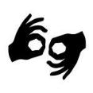Auslan Interpreted and Post-Show Artist Talk

Social interpreters will be available throughout the event

Wednesday 27 November, 8.30pm

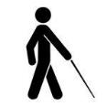

Tactile Tour

Friday 29 November, 7.30pm (Commences 1 hour before performance).

  
Audio Describer Guides

Friday 29 November, 8.30pm  
Describer guides available for meet and greet on arrival and one-on-one live descriptions of the performance.



Assistance Animals are welcome.

  
Assistive Listening is available free of charge. Ask staff for assistance on arrival.

  
Visual Rating 50% – this performance has music and sounds in the background.



Aural Rating 50% – contains both sound and visual components, but sight is not essential to be able to engage with the event.



This performance is fully wheelchair accessible. More information is provided further below in this guide about the accessible entrances at Arts House and bathrooms.  
  
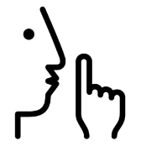

Quite Space Available - The quiet space will be available for you to use before, during and after the show. More information about the quiet space can be found later in this guide.

  
Companion Card - Arts House supports the Companion Card program.

# **Performers**

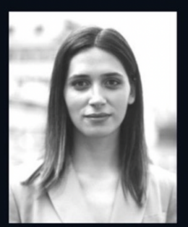

Stephanie Ghajar

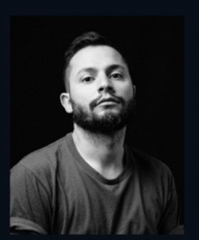

Ayman Kaake

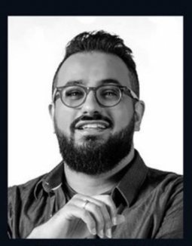

Meena Shamaly

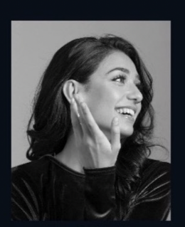

Taj Aldeeb

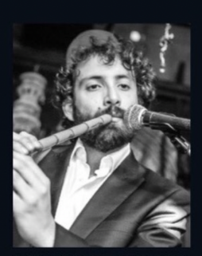

Camille El Feghali

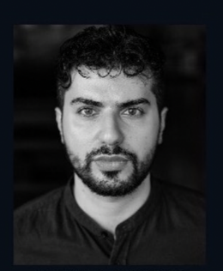

Jean Bachoura

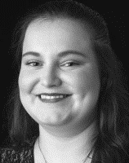

Jessica Smart

Description:Each image is a headshot of each performer joining live in the space.

**Performers – via video call**

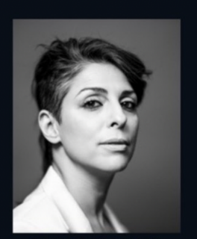

Rawya El Chab

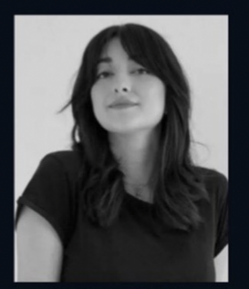

Mia Shouha

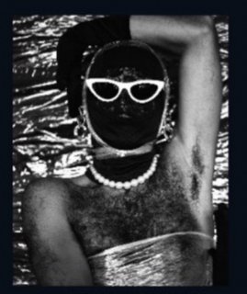

Salma Zahor

Description:headshot of each performer joining **via video call** from overseas during the show on phones and tablets. Salma Zahore is a drag performer whose headshot is of them in drag.

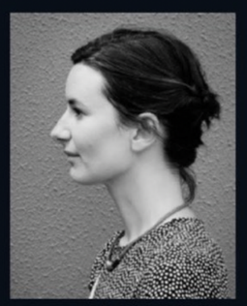

Lara Week

Description: Photo of Lara who will be stage managing and assisting throughout the performance.

# **Sensory Elements**

## Sound

A band plays live music in the background as you enter. The audience will be talking with one another as well as the performers. There will also be performers joining us on video calls via phones and tablets which you can speak to while wearing headphones. You can speak casually as you would at a wedding party with your friends and other guests. There will be times where people will whisper in your ear a story that you will be asked to pass on.

The performers will be speaking through microphones, singing in different genres in Arabic and English. There will be sound effects played as well through a laptop. They will be triggered during different monologues or as performers speak.

There are sounds of ululations throughout the show and loud calls in the space when the invitation for the party takes place.

There is dancing where the music gets loud.

There are instruments that are high pitched and a big drum that engulfs the space with its beat. The music will suddenly cut out.

## Lighting

The venue will be lit with colourful stage lighting that makes it feel like a wedding venue. The tables are lit with battery operated candles and warm coloured lamps as well. For most of the show, the lighting state remains the same.

When people start dancing, the lights flash gently. During the dancing, all the stage lighting will cut out suddenly and only the candle light will remain. The room will be very dim but it will not be fully dark.

## 

## Physical

You will be sitting in a plastic chair around a long table with other members of the audience. You can choose where you sit.

Performers and the audience will exist in the same space at varying proximities.

There will be smoke triggered in the venue at different times for comedic effect.

The music will have a bass quality that will vibrate the space softly.

## Smell

Some performers and other audience members will wear perfume.

A performer will prepare cardamom coffee in the show.

The smoke effect will have the smell of haze in the venue.

## Visual

Seating Arrangement:

* The room contains eight long tables, each surrounded by 13 chairs
* 4 tables are positioned on either side of the dancefloor
* Tables are adorned with a mix of dead flowers, wilting blooms, and plastic floral arrangements

Lighting:

* Each table is illuminated by battery-powered candle lights with small table lamps
* The light is mostly pinkish, purple and well-lit throughout

Band Area:

Located in the centre of the hall by the wall, the band area features an arrangement of musical instruments:

* + A guitar
  + An oud
  + A qanun (a traditional string instrument)
  + A derbakke (a Middle Eastern drum)
  + A mixing desk for sound control
  + Two musicians

Dance Floor:

* The dance floor is centrally positioned
* A visible cable installation runs overhead, that is reminiscent of power cables hanging over the streets in our home countries

Bridal Table:

* This table looks like an altar across the dancefloor from the band
* It's mostly set like the other tables in regards to lighting and flower arrangements
* The six chairs behind it remain empty throughout the show
* The two central chairs are covered with colourful plastic roses
* The two chairs on either side are covered with ivy

The hall has a distinctly intimate and slightly unconventional vibe, blending the modern with elements of natural decay and nostalgia.

# **Audience Experience**

## Entry to space

As people arrive at Arts House, Front of House ushers will invite them to enter the performance space through the laneway beside the venue on Queensberry Street if they’re okay with using stairs, otherwise through a more direct step-free route via a door in the foyer. Performers will be at either door to meet audience on arrival and invite them to take a seat wherever they feel comfortable.

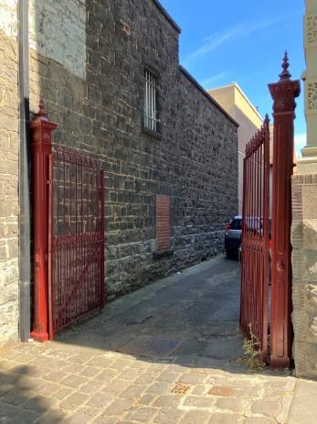 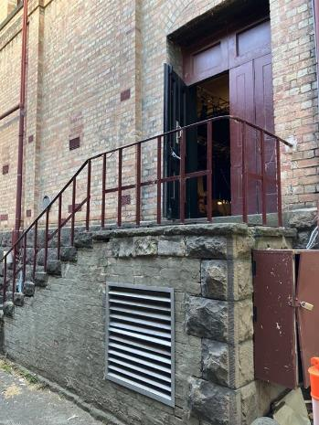 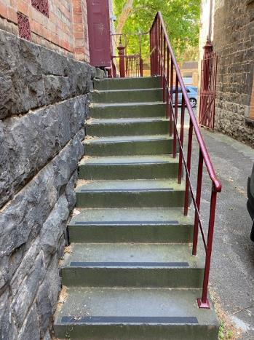

Image description: three images showing the pathway to the performance entry. The first image shows cobblestone pathway through large metal gates that will be open. The second image shows the stairway, grabrail and performance entry door. The third image shows 10 concrete steps with grab rail on right side and venue wall on left side. There are tactile strips on the stairs.

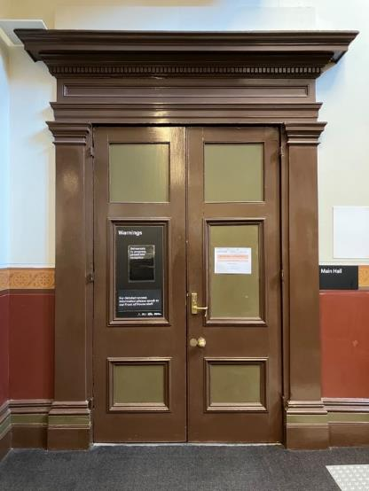

Image description: Closed brown doors that lead into the Main Hall. This is a flat floor entry point into the performance.

## Shocks or surprises

There will be a moment in the show where there will be a simulated power failure in the venue, but the space will remain lit with battery-powered candle lights. This will happen while the dabke dance is taking place.

## Audience experience and social expectations

You will be sitting in a plastic chair around a long table with other members of the audience. You can choose where you sit. If you sit at the end of the table, then you’ll have the most control about how much proximity you have with other people.

A performer may offer you a phone or a tablet attached to headphones, where you can speak to another performer via video call. You can choose in the moment whether you want to speak with them or not and they will offer it to someone else.

A performer will offer you an alcohol-free drink, made from pomegranate molasses, soda water, and fresh mint. You have the option to take it or not.

Performers and the audience will exist in the same space at varying proximities.

The performers will invite the audience to get up and join a dance lesson from a belly dancer. You have the option to join or not.

A performer will spread rumours around and ask the audience to pass it on. Other guests might touch your arm or shoulder to get your attention to whisper the rumour in your ear or say it face-to-face to you.

The performers will offer the audience vanilla cupcakes (allergens contains egg, milk, gluten, soy and may contain tree nuts), with flavoured frosting, packaged from the supermarket. You have the option to take it or just pass it on.

A performer will prepare cardamom coffee. He will offer it to some audience guests. If he offers it to you, you have the option to take it or not.

You are welcome to bring stim toys into the space.

## Performance expectations

There is an MC in the show that will explain what this wedding party is and welcome all the guests. The event planners are performers. The photographer is a performer. The singer is a performer and the life coach uncle is also a performer wearing an abaya. There are a total of 7 performers in the space.

# **Other**

## Content Warnings

Zaffé contains loud music, flashing and low lights, lights that change in colour and intensity and contains coarse language, adult themes and triggering content including references to death and war.

## General Notes

Acknowledgement of Country is said by the MC at this wedding party, Meena Shamaly.

# **The Venue**

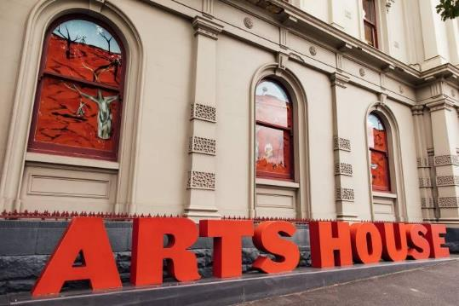

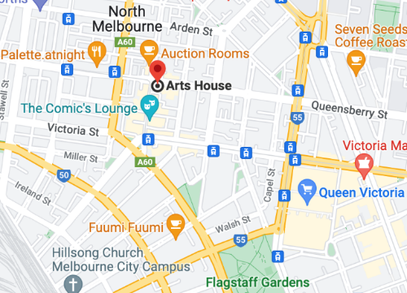

Image: North Melbourne Town Hall features giant red letters that say ARTS HOUSE out the front of it.

Image: a map of Arts House and its surrounding area. [LINK TO MAP](https://www.google.com/maps/place/Arts+House/@-37.802973,144.9486818,17z/data=!4m5!3m4!1s0x0:0x64c465ac7ef21cff!8m2!3d-37.803239!4d144.9498609?shorturl=1)

## **Front Entrance**

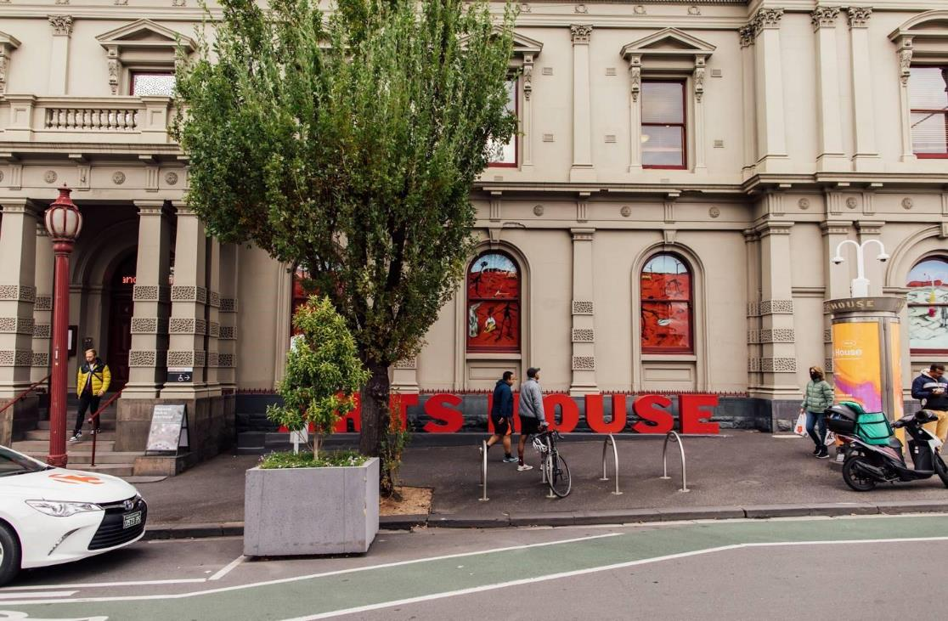

## **Accessible Entrances**



There are two Accessible Entrances. The first is on Errol St next to the Post Office.

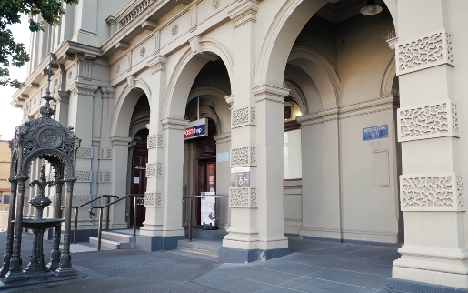

Image: Errol Street entrance next to the Post Office with wheelchair accessible ramp and handrails.

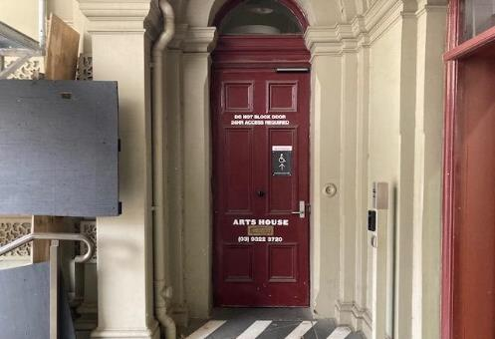

Image: View of door entrance via Errol St. The door is maroon with Arts House displayed on the door.

The second Accessible Entrance is towards the end of George Johnson Lane.

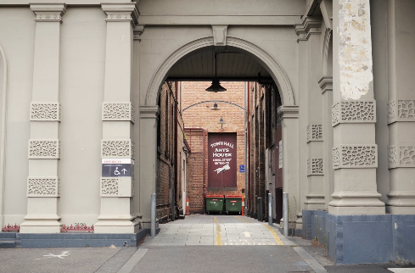

Image: View of George Johnson Lane from Errol St.

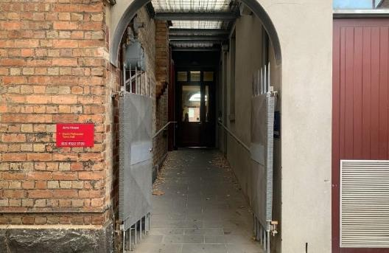Image: View of the ramp leading from George Johnson Lane to the automated door which opens into the Arts House foyer.

## **Box Office**

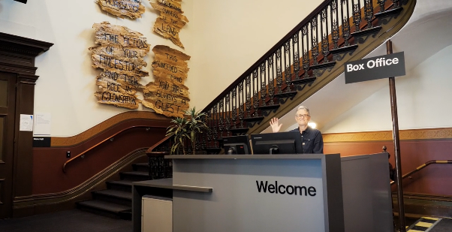

Image Description: Image is of reception desk, showing one of our receptionist's waving. To the left of the reception desk is the main stair case, showcasing some art work on the walls.

Box Office is in the foyer under the stairwell.

## **Ushers**

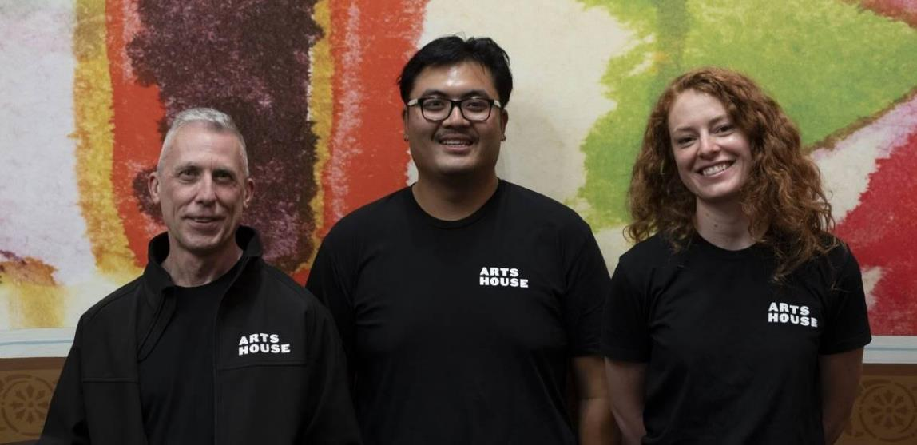

Image Description: Three ushers wearing black with an Arts House Logo on the left-hand shoulder.

Arts House Ushers can be identified by their Arts House logo uniforms. They are there to assist with any access requirements and getting people safely seated into the performance space. For any access needs, please approach our friendly team.

## **Bar**

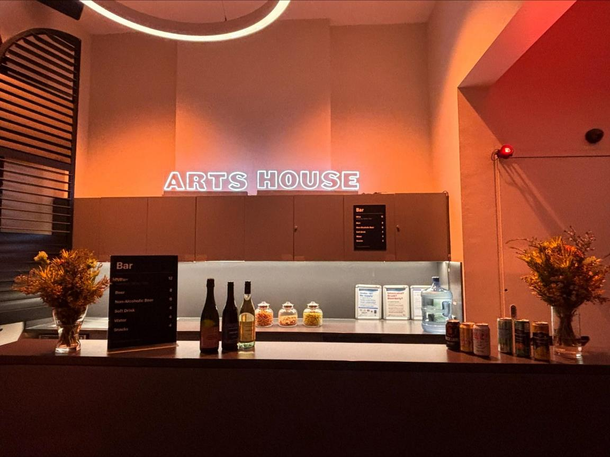

Image Description: The Arts House Bar with vases on each side of the bar filled with native flowers. In the centre there is a bar menu displayed with drinks set up on the top level on the bar. Towards the back wall there is a Arts House sign that is lit up. The lighting of the space is lit up orange.

The bar will not be open for this performance, except on opening night.

## **Quiet Space**

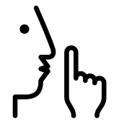

Arts House Quiet Space is located on Ground Level and is nearby reception and opposite the accessible bathrooms. It includes a range of seating options including soft furnishings, dimmable lights, sensory and stim objects. It is open during venue opening hours and events as a quiet space, prayer or parenting space.

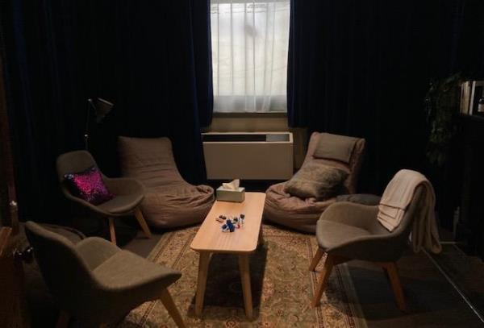

Image description: Quiet space with lights dimmed and chairs in a circle.

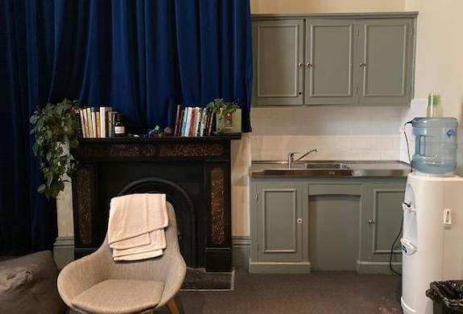

Image description: A corner of the Quiet Space, showing the kitchenette and bookshelf.

## **Bathrooms**

All bathrooms have Dyson hand dryers with sensor activation. There is an accessible bathroom that is single use on ground level opposite the Quiet Space. There is another accessible bathroom upstairs – this is accessible via lift or stairs.

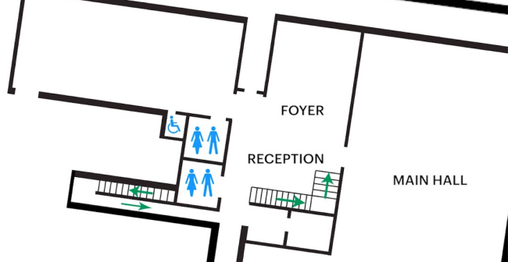

Image description: Map of ground floor bathroom locations, including entrances and locations with stairs.

# **Transport**

[This video](https://vimeo.com/544169506) shows some of the ways you can get to Arts House by tram, train, bus, car and bike.  [Read the transcript of this video](https://www.artshouse.com.au/wp-content/uploads/2021/05/Getting_to_Arts_House_-_Transcript_WORD.docx).

## **Tram**

Route 57 (High Floor trams only)

Stop 12, North Melbourne Town Hall.

Please note, this is not a wheelchair accessible tram.

## **Train**

Arts House is 1.1km from   
North Melbourne Train Station,   
approximately 16 minute walk

[North Melbourne Station Information](https://www.ptv.vic.gov.au/stop/1144/north-melbourne-station/0/train/)

1.2km from Flagstaff Station,   
approximately 15 minute walk

[Flagstaff Station Information](https://www.ptv.vic.gov.au/stop/1068/flagstaff-station/0/train/#StopPage:::datetime=2023-04-06T04%3A41%3A27.669Z&directionId=-1&showAllDay=false&_auth=408ac3b1e97f4b0beb5bdf00c2f797057d10dd6e6cf2ad40a69334c4dfdf5e21)

## **Bus**

Bus number: 216

## **Parking**

There is limited paid on-street parking on Queensberry Street and Errol Street.

There are two accessible on street car parking spaces on Queensberry Street (150m to our accessible Errol Street entrance) for holders of a Parking Permit for Disabled people.

# **COVID Safety**

Please note: If you have a cough, sore throat, fever, shortness of breath or flu-like symptoms, you must not attend our venue or programs in person.

We will provide a refund if you need to cancel your attendance due to illness. Please [contact us](mailto:ArtsHouse.Ticketing@melbourne.vic.gov.au) by 9am on the day of the event.

To minimise the risk of COVID-19 transmission, we advise all patrons, artists and staff to:

* Practise physical distancing where possible
* Practise good hygiene by washing and or sanitising your hands often
* Wear a mask as directed by Victorian Government guidelines

Throughout the venue you will find:

* hand sanitiser stations available
* N95 masks available at entries

We also ensure that spaces are well ventilated.

Staying COVID-safe remains important. We must all follow these steps:

* Follow the [Victorian Government’s measures on how to stay safe.](https://www.betterhealth.vic.gov.au/coronavirus-covid-19-victoria)
* When you cannot safely socially distance it is recommended to wear a well fitted mask where required.
* Practise [COVID-safe hygiene protocols.](https://www.health.gov.au/news/health-alerts/novel-coronavirus-2019-ncov-health-alert/how-to-protect-yourself-and-others-from-coronavirus-covid-19/good-hygiene-for-coronavirus-covid-19)