Access Guide Template

Hi there!

Thanks for downloading Arts House Access Guide template.

This template was developed with advice from Deaf and Disabled consultants.

We tweak and complete this document with artists/ companies and aim to publish 2 weeks in advance of opening night.

Feel free to adapt and use this template for your own event.

View an example of a completed Access Guide here:

The Bridal Lament PDF | Word Doc

CUDDLE PDF | Word Doc

Dissent PDF | Word Doc

If you have suggestions to make this template better – we would love to hear from you!
Email artshouse@melbourne.vic.gov.au

Arts House Team

Insert Title of Show
By Insert Artist/Company

Access Guide

Insert Hero Image

Photo: insert credit, work, photographer
Image description: insert visual description

Updates to this document

Please note, this performance is a new work and changes are being made by artists until opening. We will endeavour to provide the latest access information on performances to ticket holders across key stages of rehearsal and presentation.

Arts House website will contain the most up to date version of this document and all ticket holders will be notified of any revisions made 3 days and 1 day prior to the event.

This document was created: insert date

Revision 1: insert date
Revision 2: insert date

Contents
Updates to this document 1
Where 3
When 3
Access Services 3
Digital 4
Performers 5
Sensory Elements 5
Sound 5
Lighting 5
Physical 5
Smell 5
Visual 5
Entry to space 6
Shocks or surprises 6
Audience experience 6
Social expectations 6
Performance expectations 6
Other 6
Content Warnings 6
General Notes 7
The Venue 8
Front Entrance 8
Accessible Entrances 9
Box Office 10
Ushers 10
Bar 11
Quiet Space 12
Bathrooms 12
Door to Main Hall 13
Lift 14
Transport 14
Tram 14
Train 15
Bus 15
Parking 15
COVID Safety 15

Where

Replace with your venue details
Arts House
521 Queensberry Street
North Melbourne VIC

When

Insert Dates & Times

Duration: Insert duration

Access Services
Update with relevant access services information & symbols
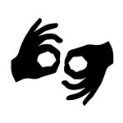
Auslan Interpreted Performance

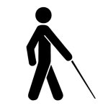
Tactile Tour and Audio Described Performance

Assistance Animal are welcome.


Assistive Listening is available free of charge. Ask staff for assistance on arrival.


Visual Rating 50% – this performance has music and sounds in the background.
[Note: update if a different visual rating]
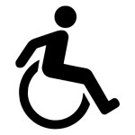
This performance is fully wheelchair accessible.

Digital
[Update if there are digital offers or remove]

Performers

[Insert image of performer/s]

[Insert image description]

Sensory Elements

Sound

Replace this copy with information relating to sound - e.g. is the sound loud at times, low frequencies, vibrations, sudden noises or high pitched etc? Is there sound without a clear source? Are there overlapping voices, whispering or hard to hear moments?

Lighting

E.g. does the lighting change in colour and intensity, does the lights go on or off, is the room ever dark, is there any strobe or flashing lights? Do the lighting stages change quickly? Is there any lighting or projection directly onto the audience?

Physical

E.g. can you feel vibrations, is there any touch, are the performers or audience in close proximity etc? Are there uneven floors, audiences proximity in space, anything that plays with temperature, if air is blowing on people. Are there any moments which are physically scary or challenging.

Smell

E.g. are there any smells or scents used and what are they?

Visual

E.g. what is the overall visual experience? Are there any patterns, or anything visually busy or loud? Anything unstable or might fall over, anything in the show that might move suddenly or without warning? Uncanny visuals or likeness?

Audience Experience

Entry to space

E.g. How and where do audiences enter from and are they asked to do anything?

Shocks or surprises

E.g. is there any lighting, sound or physical shocks? Is there any strobe, flashing lights, loud moments etc

Audience experience

E.g. do the performers come up close, are audience in close proximity, is there eye contact, touch, participation, what is the expectations from the audience? etc

Social expectations

E.g. where will audience sit, are people interacting, can we see everything, can audiences come and go, can audiences move in the space, can audience make noise or stim in the space? Are there any designated places to move around? Can people bring in snacks or stim toys?

Performance expectations

E.g. is there dialogue, is there a storyline to follow, how many people are on stage, what do the performers look like and how can I tell them apart from staff.

Other

Content Warnings

E.g. please list all content warnings, when/ how they occur throughout the work.

General Notes

E.g. is there other important elements you wish to communicate about the sensory elements, audience experience or expectations of your work, does an Acknowledgment of Country play in the space or any other announcements?

The Venue

[Replace images/text with venue relevant info – this is an example of ours]

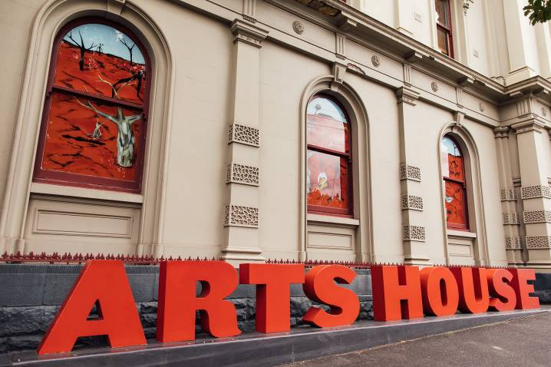
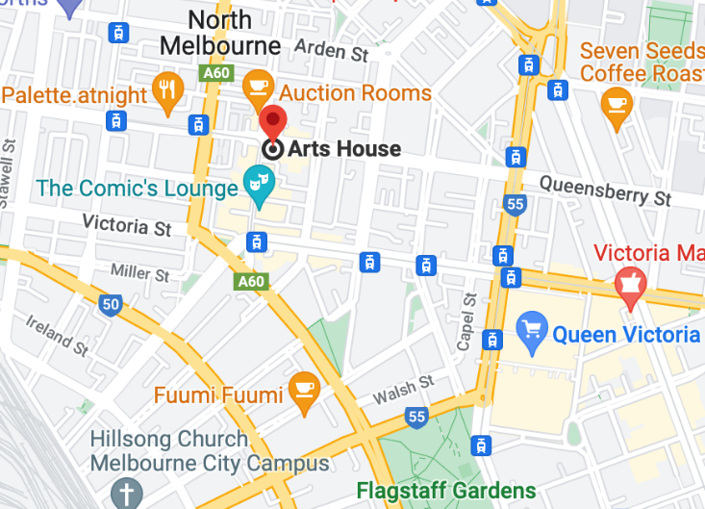

Image: North Melbourne Town Hall features giant red letters that say ARTS HOUSE out the front of it.

Image: a map of Arts House and its surrounding area. LINK TO MAP

Front Entrance

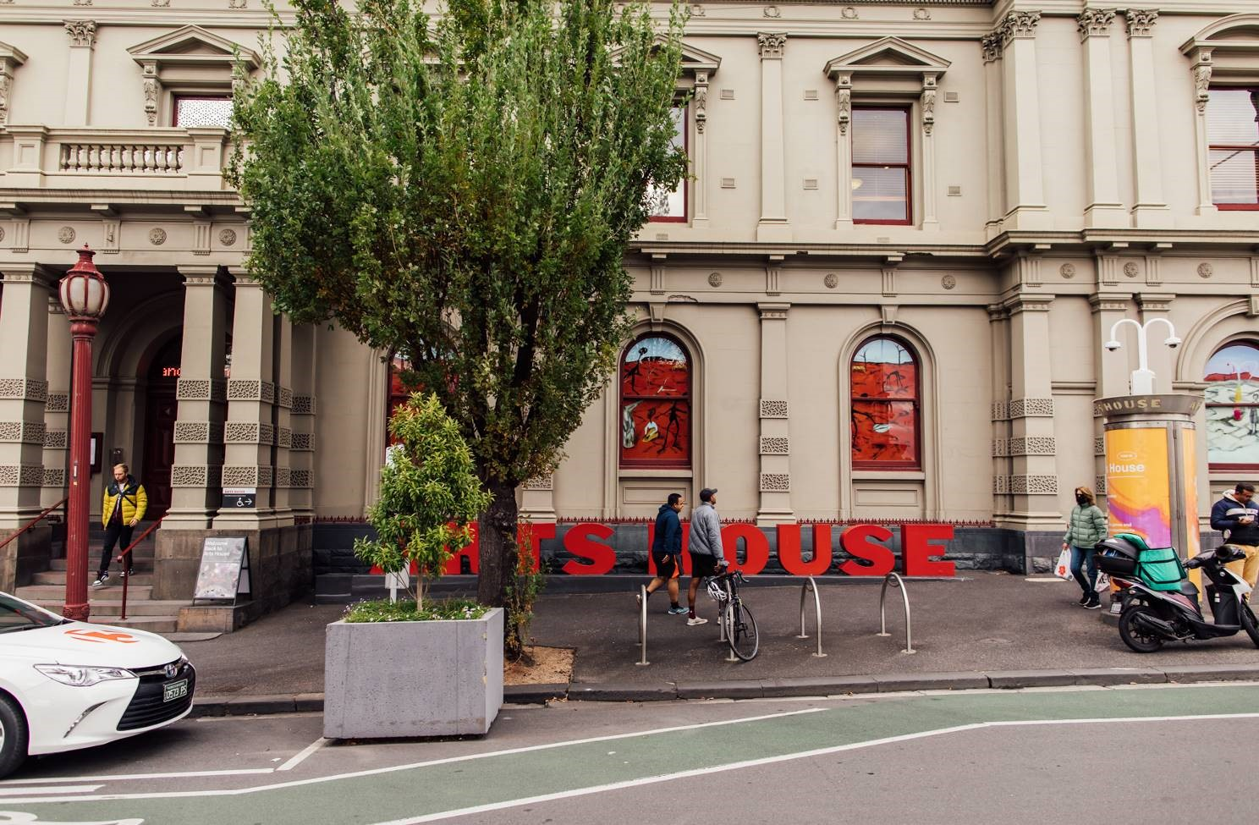

Accessible Entrances

There are two Accessible Entrances. The first is on Errol St next to the Post Office.

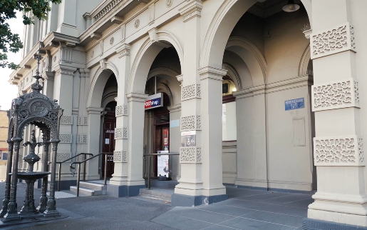

Image: Errol Street entrance next to the Post office with wheelchair accessible ramp or two steps with grab rails.
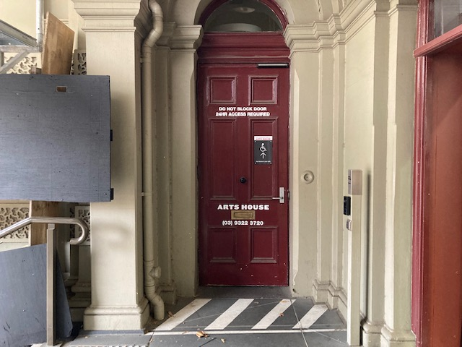
Image: View of door entrance.

The second Accessible Entrance is towards the end of George Johnson Lane.

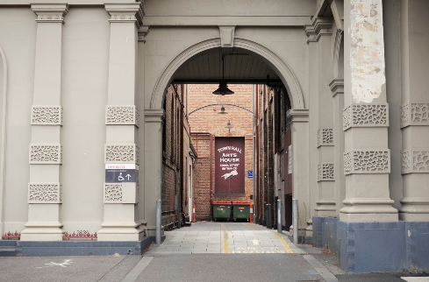

Image: View of George Johnson Lane from Errol St. The laneway passes through an archway with a brick wall at the end.
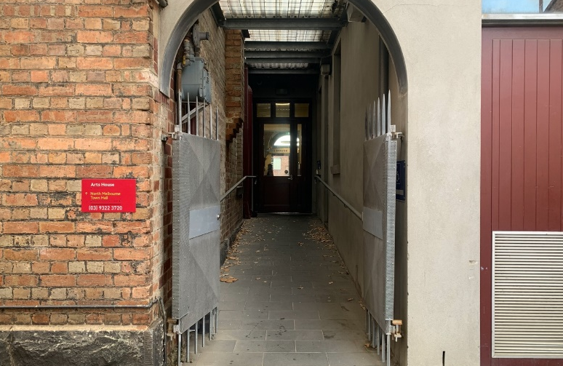

Image: view of the ramp leading from George Johnson Lane to the automated door which opens into the Arts House foyer.

Box Office

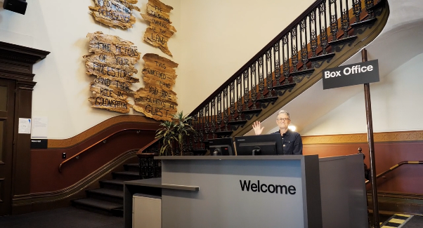

Box Office is located in the foyer under the stairwell.

Ushers

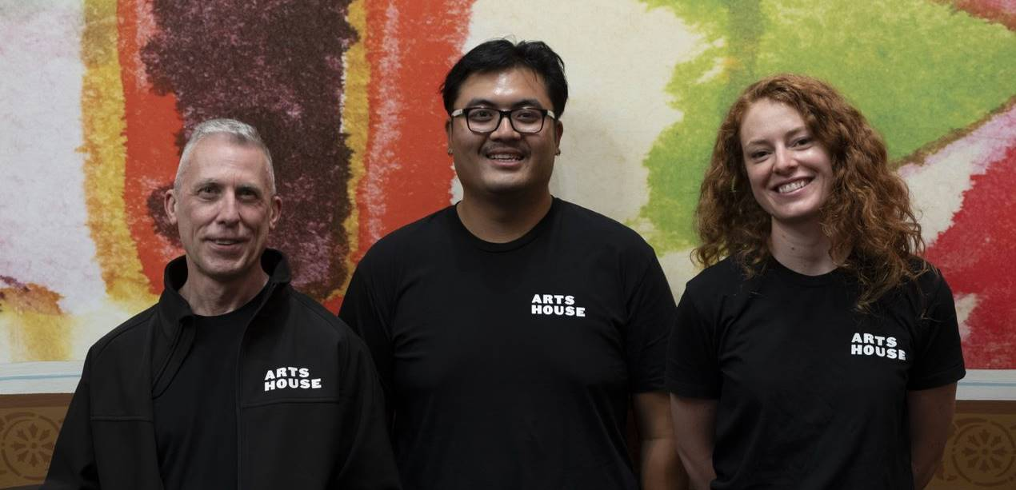

Ushers will be wearing black t-shirts with an Arts House Logo on the left hand shoulder.

Bar

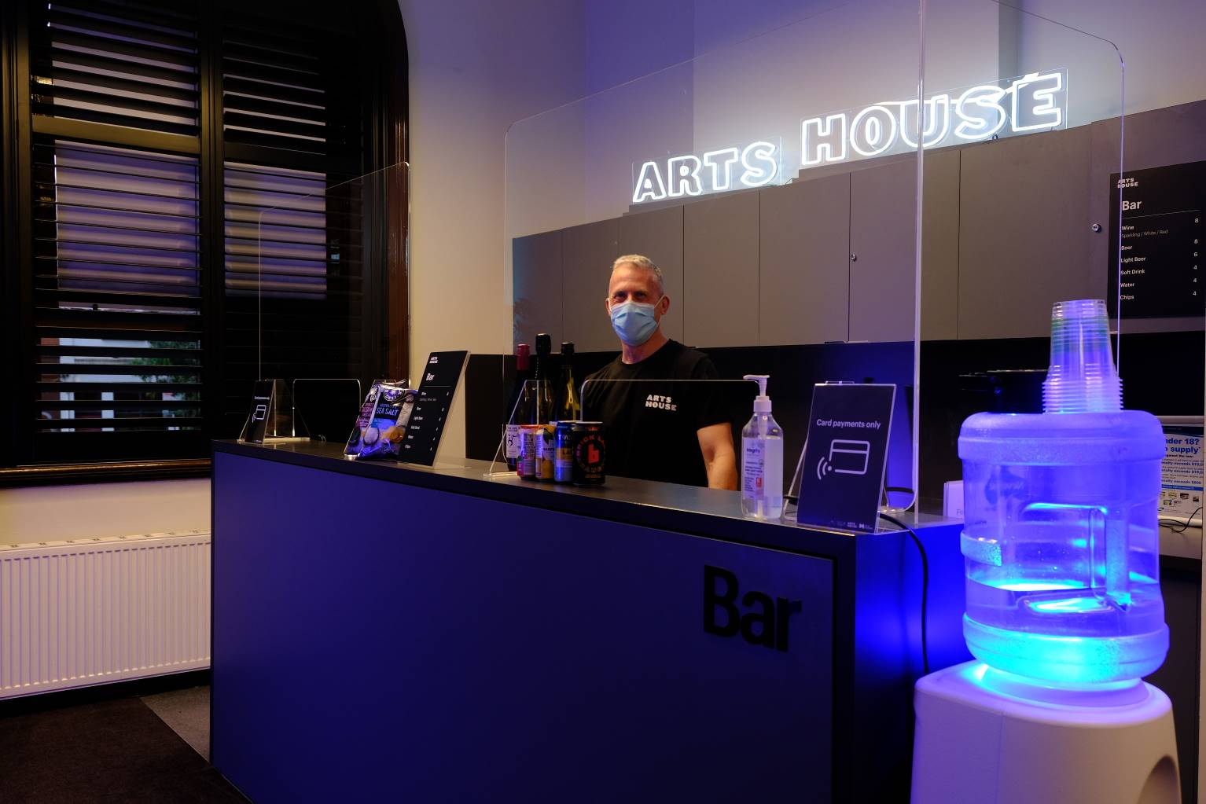

Bar staff will be wearing black with an Arts House Logo.

We have a range of alcoholic and non-alcoholic beverages for sale.

We are a cashless venue and accept EFTPOS, Visa and Mastercard payments.

Quiet Space

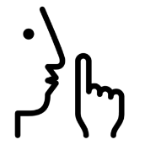
Arts House Quiet Space is located on Ground Level and is nearby reception and opposite the accessible bathrooms. It includes a range of seating options including soft furnishings, dimmable lights, sensory and stim objects. It is open during venue opening hours and events as a quiet space, prayer or parenting space.

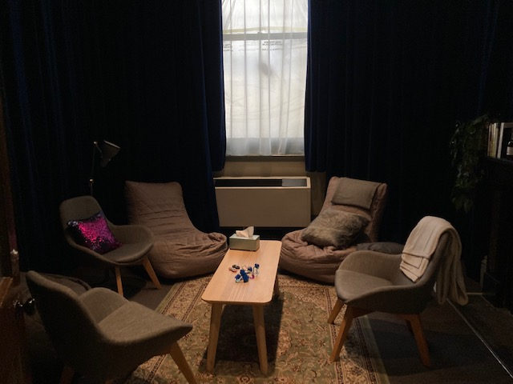

Image: Quiet space with lights dimmed
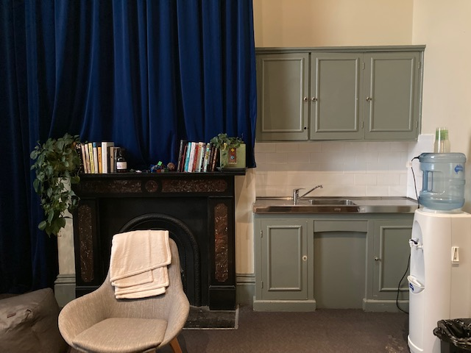

Image: Quiet space kitchenette and book shelf

Bathrooms

All bathrooms have Dyson hand dryers with sensor activation. There is an accessible bathroom that is single use on ground level opposite the Quiet Space. There is another accessible bathroom upstairs – this is accessible via lift or stairs.
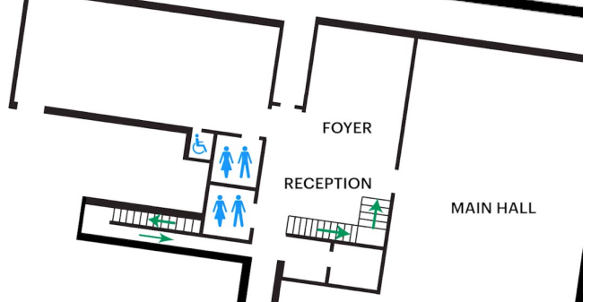

[Update with relevance performance space & info]

Door to Main Hall

The Performance is in the Main Hall.
It is on the ground floor.
It is to the left of the box office desk and right of the bar.
An artist statement is available on signage and warnings on the door.

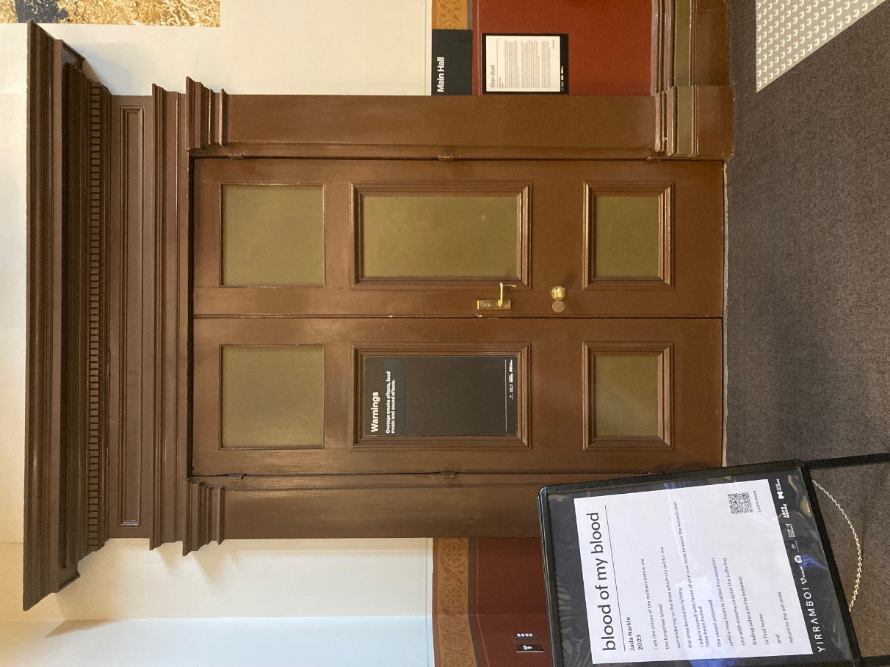

Lift

The lift is located behind reception desk in the foyer.
The closest entry to the lift is via George Johnson Lane.

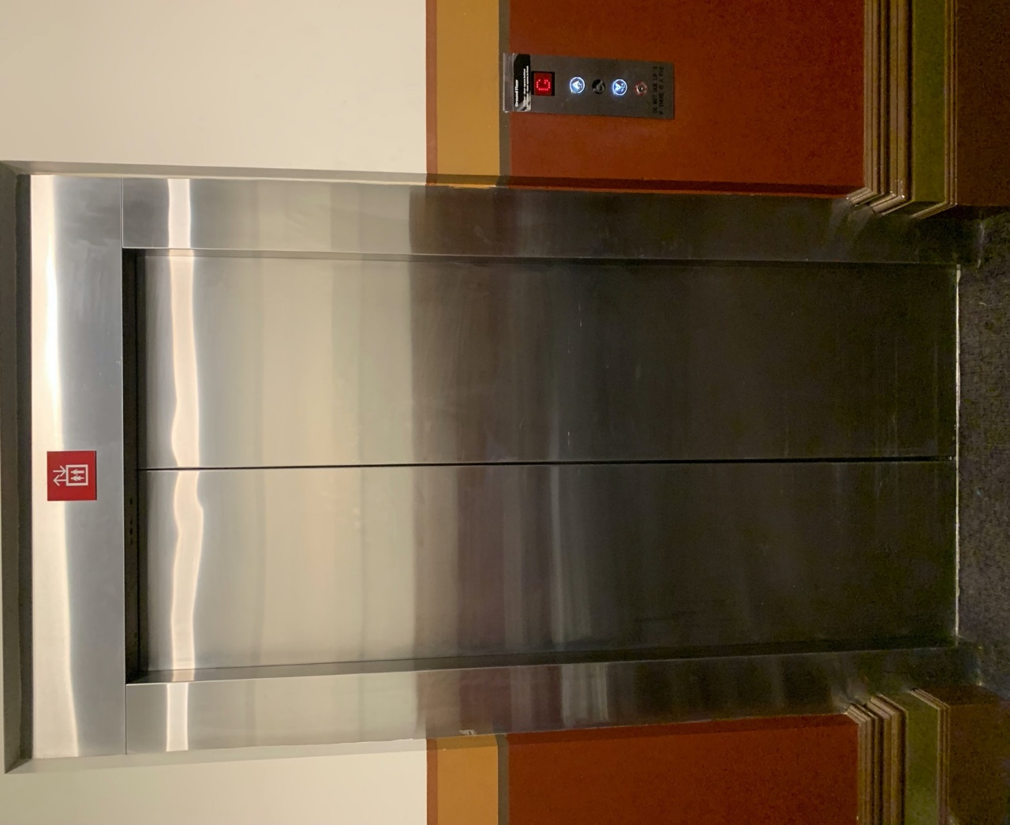

Transport

[Update with relevance transport info to venue]

Tram

Route 57 (High Floor trams only)
Stop 12, North Melbourne Town Hall.
Please note, this is not a wheelchair accessible tram
GETTING TO ARTS HOUSE VIDEO LINK

Train

Arts House is 1.1km from
North Melbourne Train Station,
approximately 16 minute walk
North Melbourne Station Information
1.2km from Flagstaff Station,
approximately 15 minute walk
Flagstaff Station Information

Bus

Bus number: 216

Parking

There is limited paid on-street parking on Queensberry Street and Errol Street.

There are two accessible on street car parking spaces on Queensberry Street (150m to our accessible Errol Street entrance) for holders of a Parking Permit for Disabled people.

COVID Safety

[Update with your relevant COVID safety information]
Please note: If you have a cough, sore throat, fever, shortness of breath or flu-like symptoms, you must not attend our venue or programs in person.
We will provide a refund if you need to cancel your attendance due to illness. Please contact us by 9am on the day of the event.
To minimise the risk of COVID-19 transmission, we advise all patrons, artists and staff to:
- Practise physical distancing where possible
- Practise good hygiene by washing and or sanitising your hands often
- Wear a mask as directed by Victorian Government guidelines
Throughout the venue you will find:
- hand sanitiser stations available
- masks available (ask one of our staff for assistance)​
- increased signage to direct patron movement and avoid crowd congestion
We also ensure that spaces are well ventilated.
Staying COVID-safe remains important. We must all follow these steps:
- Follow the Victorian Government’s measures on how to stay safe.
- Wear face masks where required or when you cannot safely socially distance.
- Practice COVID-safe hygiene protocols.
- Test for COVID and get free rapid antigen tests​ at nominated City of Melbourne customer service and library sites.

