**Dissent**

By Daley Rangi

Access Guide

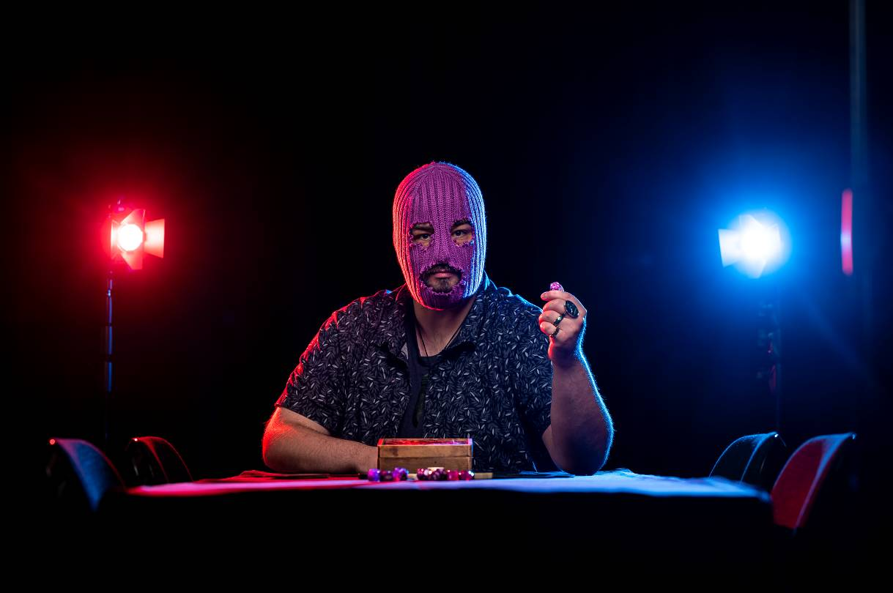

**Image Credit:**Tiffany Garvie

**Image Description:**A photo of non-binary writer and performer Daley Rangi, sitting at a table, which is covered in a smooth, black cloth. Daley is wearing a black t-shirt, over which is an open, button-up shirt, which has a forest-green olive leaf pattern. Around their neck, they wear a Māori greenstone pendant in the shape of a small club. Daley is also wearing a neon purple beanie which covers their entire face, with rough-cut holes for their eyes and mouth. Daley has a beard, which is poking through the mouth-hole of the beanie. Their eyes look black, and they are gazing intensely at the camera. They hold a neon purple twenty-sided die in their left hand, their elbow resting on the table. They are wearing two rings on their left hand, made out of paua shell – which comprises iridescent blues, greens, and purples. Their right hand is flat on the table. On the table is a wooden box, with an assortment of dice and game pieces piled in front of it. The scene is lit with a cold, white front light, and, on either side of Daley, is a visible blue and red flash.

# **Updates to this document**

Please note, we will endeavour to provide the latest access information on performances to ticket holders across key stages of rehearsal and presentation.

Arts House website will contain the most up to date version of this document and all ticket holders will be notified of any final revisions made 3 days prior to the event.

This document was created: **13 March 2024**

**Contents**

**Updates to this document** 2

**Where** 4

**When** 4

**Access Services** 4

Social expectations 7

Performance expectations 8

Entry to space 8

Shocks or surprises 8

**Sensory Elements** 8

Sound 8

Lighting 9

Physical 9

Smell 9

Visual 9

**Other** 10

Content Warnings 10

**The Venue** 11

Front Entrance 11

Accessible Entrances 12

Box Office 13

Ushers 13

Bar 14

Quiet Space 15

Bathrooms 15

Performance Space 16

Lift 18

**Transport** 19

Tram 19

Train 19

Bus 19

Parking 19

**COVID Safety** 20

# **Where**

Arts House

521 Queensberry Street

North Melbourne VIC

# **When**

Wednesday 20 March, 7pm

Thursday 21 March, 7pm

Friday 22 March, 7pm

Saturday 23 March, 3pm & 7pm

Duration: 90 minutes, includes 2 short 5 minute intervals

**Want to be a player?**   
Indicate your interest in the booking process. Players will be selected as part of the show, however there is no guarantee that you will be asked to participate.

**Warnings**   
Suitable for ages 16 +

*Dissent* contains haze, occasional loud sounds, and invited audience participation.

# **Access Services**

**Pre-Show Access Session**   
All shows include a 15-minute drop-in session 1 hour prior to start time for anyone who would benefit from being in the performance space beforehand, to learn more about the work and meet the performer in a relaxed setting.

**Relaxed space**   
These are not relaxed performances in the usual sense, but audience members are welcome to come and go as they please, be themselves, make noise, stim, and respond to the work for the duration.

Visual descriptions will be integrated into performances.



Assistance Animal are welcome.



Aural Rating 50% - this performance has both sound and visual components, but sight is not essential to be able to engage with the event.



This performance is fully wheelchair accessible.

# **Performers**

There is 1 performer in this show – Daley Rangi.

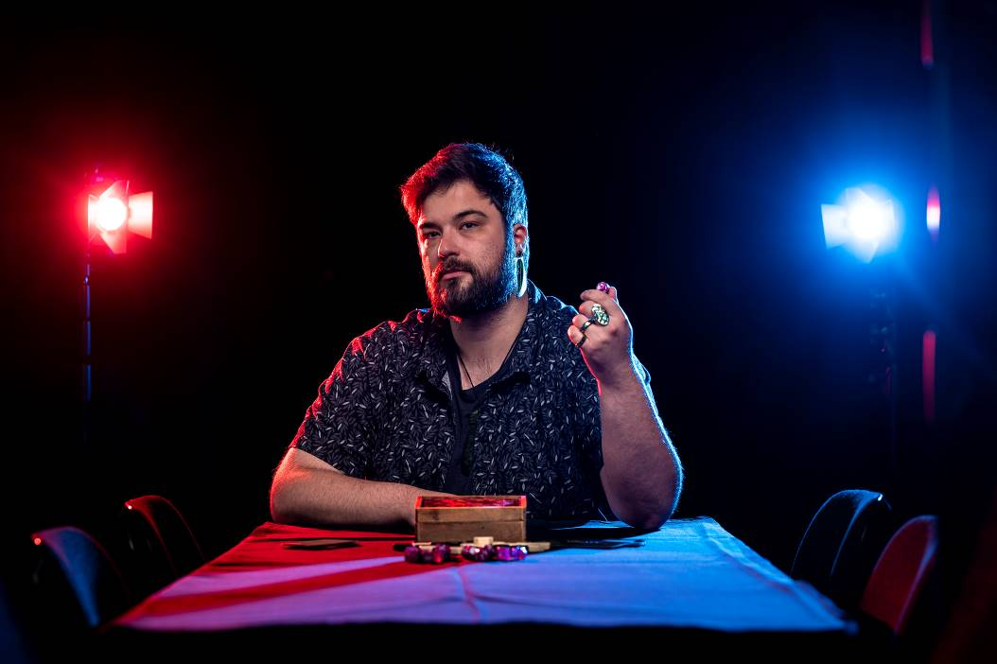

Image description: A photo of non-binary writer and performer Daley Rangi, sitting at a table, which is covered in a smooth, black cloth. Daley is wearing a black t-shirt, over which is an open, button-up shirt, which has a forest-green olive leaf pattern. Daley is gazing into the camera, their head turned to their right side, with a mysterious, but welcoming expression – a sparkle in their eyes.

Daley has a beard and short hair, both brown in colour. They hold a neon purple twenty-sided die in their left hand, their elbow resting on the table. They are wearing two rings on their left hand, made out of paua shell – which comprises iridescent blues, greens, and purples. Their right hand is flat on the table. On the table is a wooden box, with an assortment of dice and game pieces piled in front of it. The scene is lit with a cold, white front light, and, on either side of Daley, is a visible blue and red flash.

There are also four audience participants in this show who are selected at the start of each performance.

Audience Experience

Dissent involves role-play and invites four players, and the audience, to make choices and respond to provocations.

On entry, an Arts House front of house staff member will greet you and offer you a green, red or yellow sticker. These stickers are a visual tool to indicate how much you want to participate in the performance.

Green indicates you’re interested in being invited to play and be asked questions as an audience member.

Yellow indicates you do not want to play, but you’re happy to be asked questions as an audience member. It is okay to pass on the questions in the moment.

Red indicates you prefer to watch and do not want to play or be asked questions.

If you choose to play you will be asked questions, respond to choices and encouraged to verbally or non-verbally interact with the performer.

The performer, Daley Rangi, will guide players and the audience through the performance.

The performer will offer tea to the players.

There will be a lot of eye contact from the performer towards the players, and sometimes towards the audience. You do not have to make eye contact with the performer.

Every 25 minutes there will be a 5-minute break.

## **Social expectations**

Audience will have multiple seating options including:

* Standard seat with back in close proximity to playing space
* High bar stool with back with bar table behind standard seats
* Cushioned chairs and floor seating is available further away from the playing space for those who like to listen but not watch

The four players will have standard seats with backs, evenly spaced around a round table. The performer, Daley, does not sit at the playing table and will be walking around the space.

Audience can leave and re-enter the space throughout the performance.

Audiences are welcome to physically stim and be themselves, however the work is primarily told through spoken interactions with the participants, and loud noises may distract other audience members from the performance.

## **Performance expectations**

The performer will be wearing a purple ski mask. There is a session one hour before each show where you can meet the performer without them wearing the mask and explore the space. The performer will also remove the mask at the end of the show.

## **Entry to space**

On arrival the audience will be directed to the Supper Room, located at the basement level, via either the stairs or the lift.

## **Shocks or surprises**

The table is lit by a single overhead lamp. The lamp will move seemingly by itself two times during the show and will be accompanied by a rumbling sound.

The table will vibrate noticeably when this happens, and it is likely it will scatter the playing pieces.

# **Sensory Elements**

## **Sound**

The work takes place mainly through spoken interactions between the performer and four participants. Quiet low frequency atmospheric sound plays throughout the work.

There are four speakers spread through the space. The performer will speak loudly and may have a headset microphone to support this, and the participants and audience will be encouraged to speak as loud as possible if they are engaging with the performer.

## **Lighting**

The space is lit dimly with red, blue, and purple lights. There is a hanging bulb over the main playing table. The lights do not change at any point and the space does not go dark.

## **Physical**

The performer will not touch players or audience during the show.

Audience members and players sit in close proximity to one another.

## **Smell**

The room may smell musty.

## **Visual**

The space has been designed to look like a messy storage room.

There are tables on their side tucked up against one end of the room, and stacks of chairs all around the space. Some of the chair stacks are higher than others, but won’t fall over during the performance.

There is a round white table in the middle of the room, with a map marked out on it using different kinds of tape in red, blue and purple. Some of the sections of tape are raised off the table higher than others.

There are colourful and differently shaped tokens placed purposefully across the map, indicating characters, buildings, trees and modes of transport.

The seating is arranged around the playing table in a diamond formation, with up to three rows of chairs, as well as five tall round bar tables with tall stools.

There is a bar in the space, and the wall behind is lit with purple lights along its whole length.

Daley will be wearing a bright purple balaclava for the duration of the performance, and a grey t-shirt with green cartoon image of two dice holding hands with the caption “All Cubes Are Beautiful”.

# **Other**

## **Content Warnings**

Dissent involves role-play and invites four players, and the audience, to make choices and respond to provocations. These provocations encourage facilitated, but improvised and sometimes unplanned, exploration of hyperlocal social, political, or economic class systems and dynamics, and may imagine situations which involve acts of authoritarianism, aggression, coarse language, and other forms of violence.

There is a chance that the players/participants may offer up content or language that could be discomforting or triggering to some audience members – the performer will actively engage in defusing or reorienting such content where necessary for audience safety.

Please feel free to openly communicate to the performer or front of house team if you find yourself in distress.

Audience members are welcome to exit and return to the room at any time.

**General Notes**

The performer will Acknowledge Country in their storytelling at the beginning and end of the performance.

An announcement will be made to remind the audience of the Artist Talk on Thursday March 21. The Artist Talk will run for approximately 30 minutes post-show and it is optional for audience to stay.

# **The Venue**

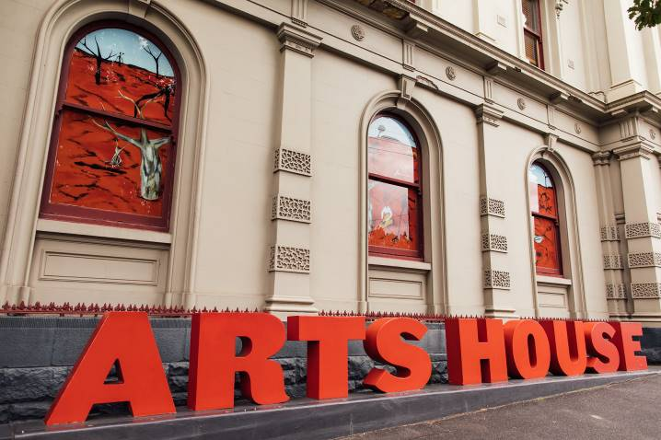

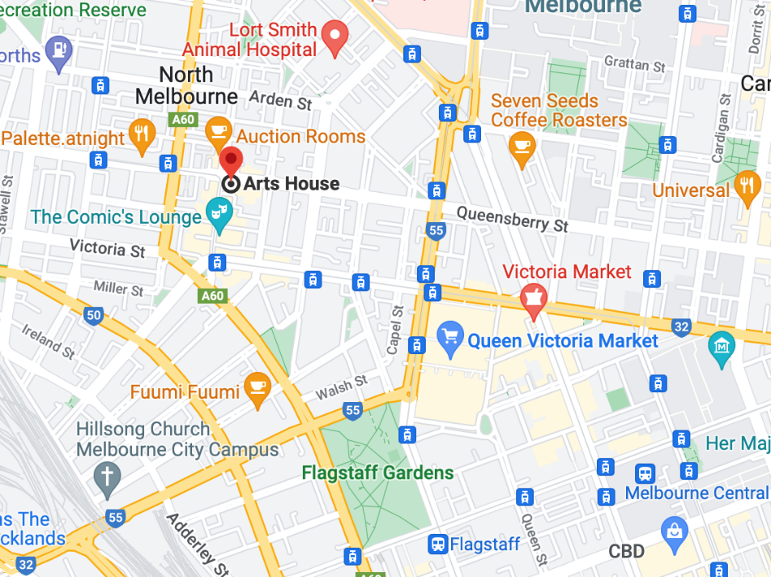

Image: North Melbourne Town Hall features giant red letters that say ARTS HOUSE out the front of it.

Image: a map of Arts House and its surrounding area. [LINK TO MAP](https://www.google.com/maps/place/Arts+House/@-37.802973,144.9486818,17z/data=!4m5!3m4!1s0x0:0x64c465ac7ef21cff!8m2!3d-37.803239!4d144.9498609?shorturl=1)

## **Front Entrance**

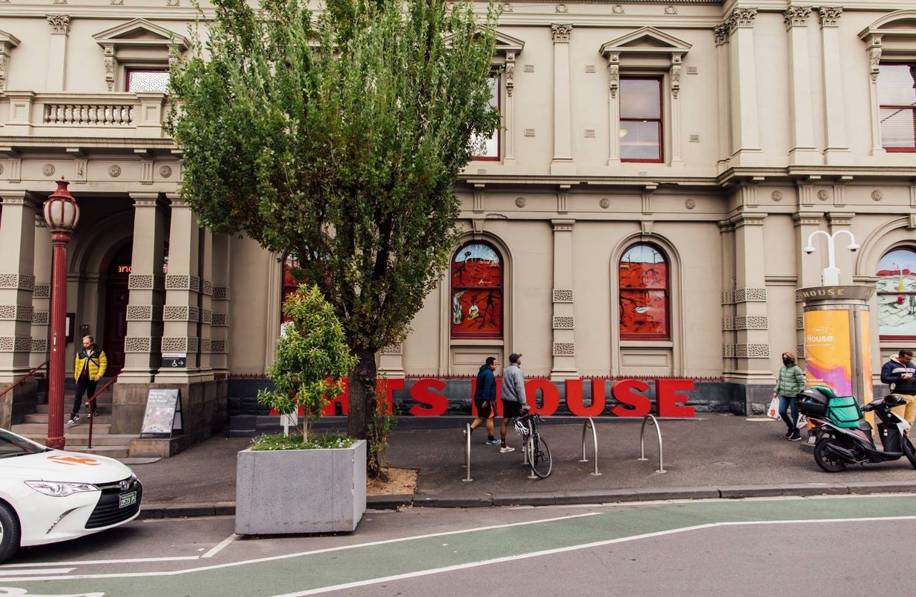

## **Accessible Entrances**



There are two Accessible Entrances. The first is on Errol St next to the Post Office.

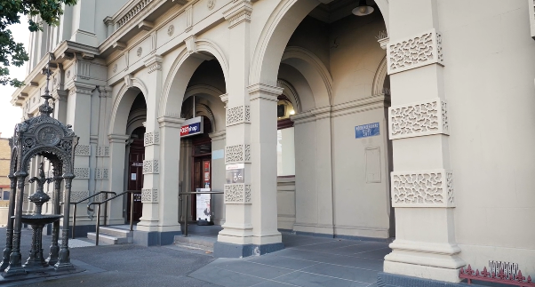

Image: Errol Street entrance next to the Post office with wheelchair accessible ramp or two steps with grab rails.

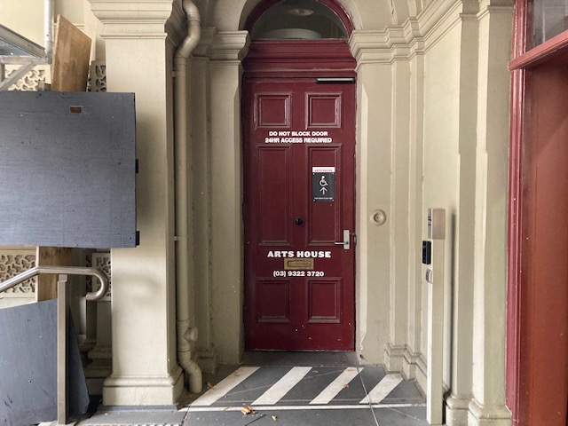

Image: View of door entrance.

The second Accessible Entrance is towards the end of George Johnson Lane.

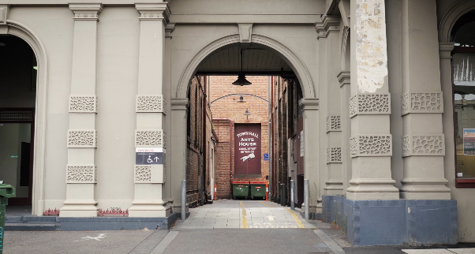

Image: View of George Johnson Lane from Errol St. The laneway passes through an archway with a brick wall at the end.

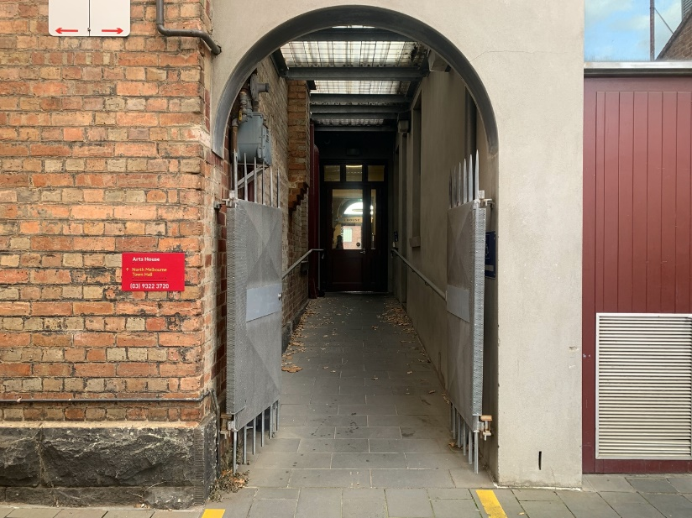

Image: view of the ramp leading from George Johnson Lane to the automated door which opens into the Arts House foyer.

## **Box Office**

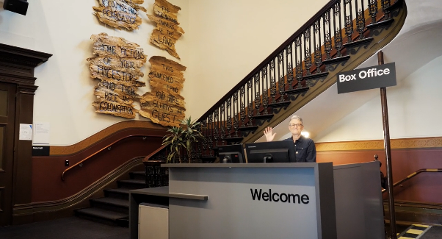

Box Office is located in the foyer under the stairwell.

## **Ushers**

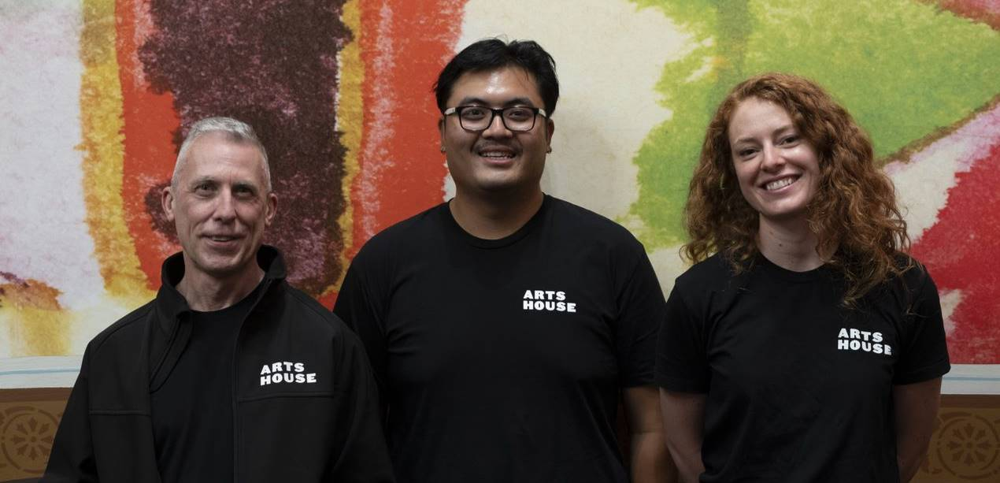

Ushers will be wearing black with an Arts House Logo on the left hand shoulder.

## **Bar**

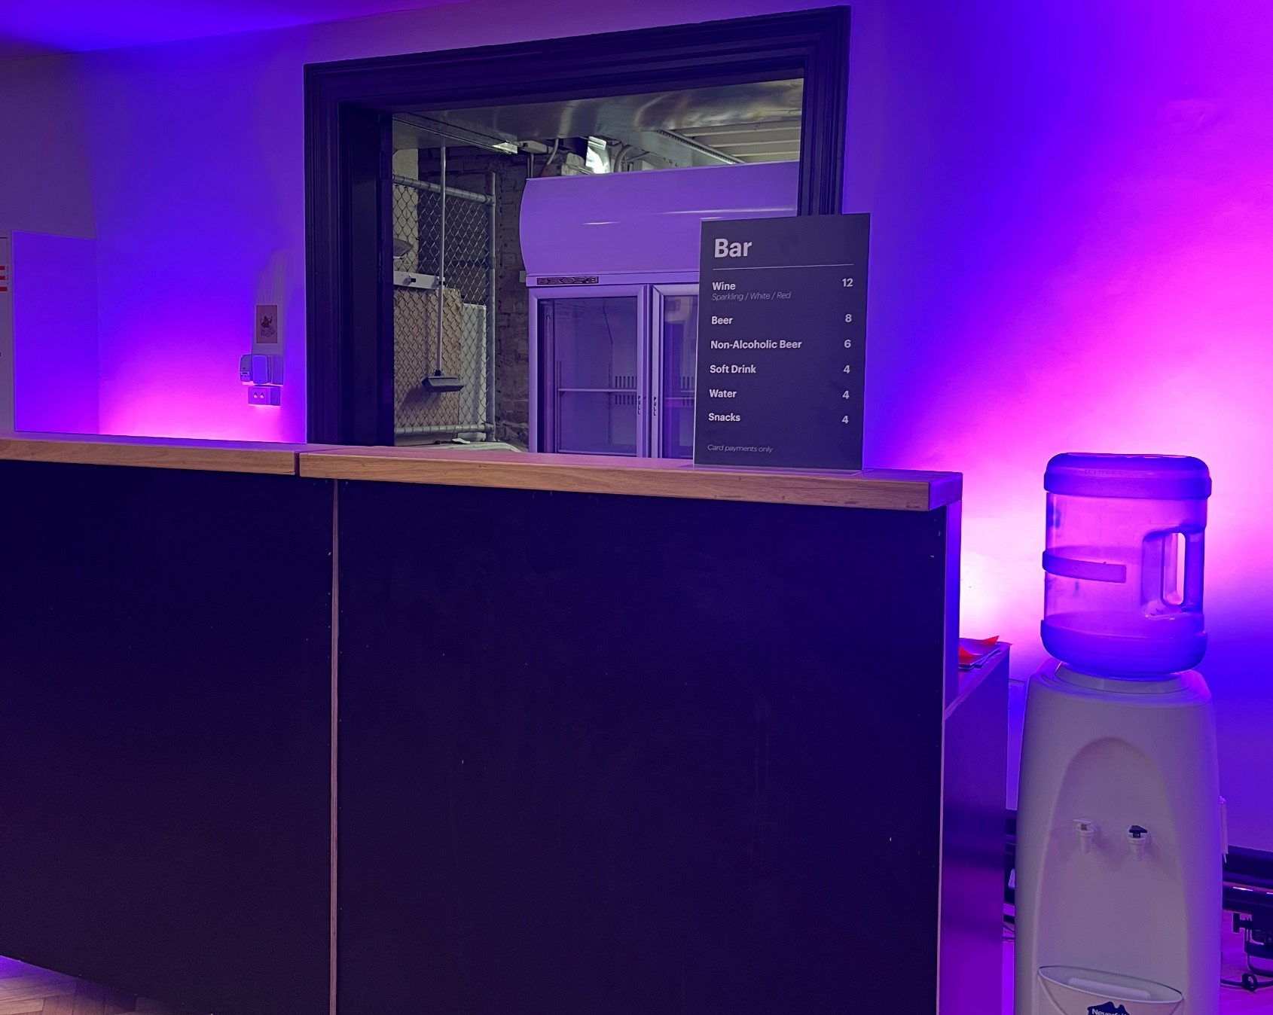

Bar staff will be wearing black with an Arts House Logo.

We have a range of alcoholic and non-alcoholic beverages for sale downstairs

We are a cashless venue and accept EFTPOS, Visa and Mastercard payments.

## **Quiet Space**

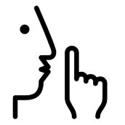

Arts House Quiet Space is located on Ground Level and is nearby reception and opposite the accessible bathrooms. It includes a range of seating options including soft furnishings, dimmable lights, sensory and stim objects. It is open during venue opening hours and events as a quiet space, prayer or parenting space.

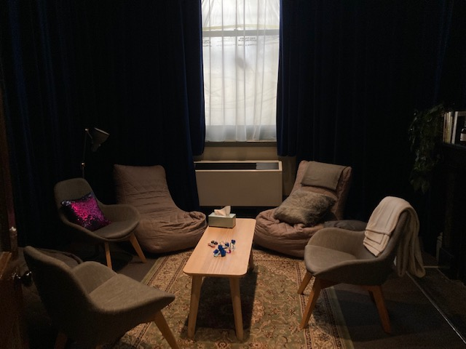

Image: Quiet space with lights dimmed

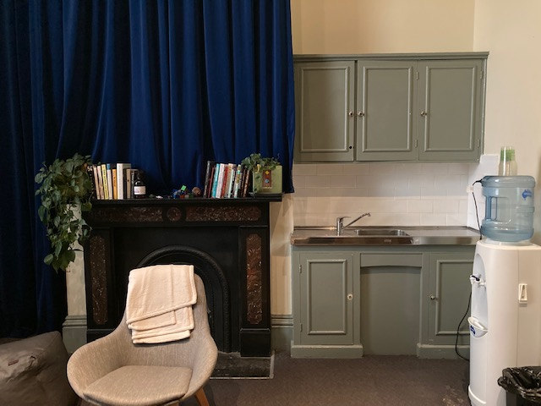

Image: Quiet space kitchenette and book shelf

## **Bathrooms**

All bathrooms have Dyson hand dryers with sensor activation. There is an accessible bathroom that is single use on ground level opposite the Quiet Space. There is another accessible bathroom upstairs – this is accessible via lift or stairs.

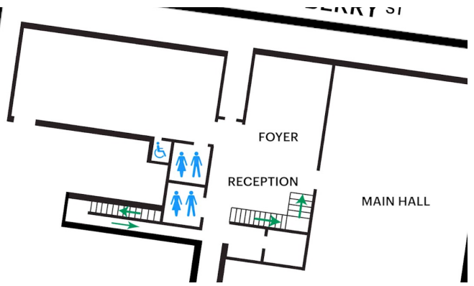

## **Performance Space**

The Performance is in the Supper Room.

It is on the basement level.

It is behind the box office desk.

There is lift and stair access to this space.

An artist statement is available on signage and warnings on the door.

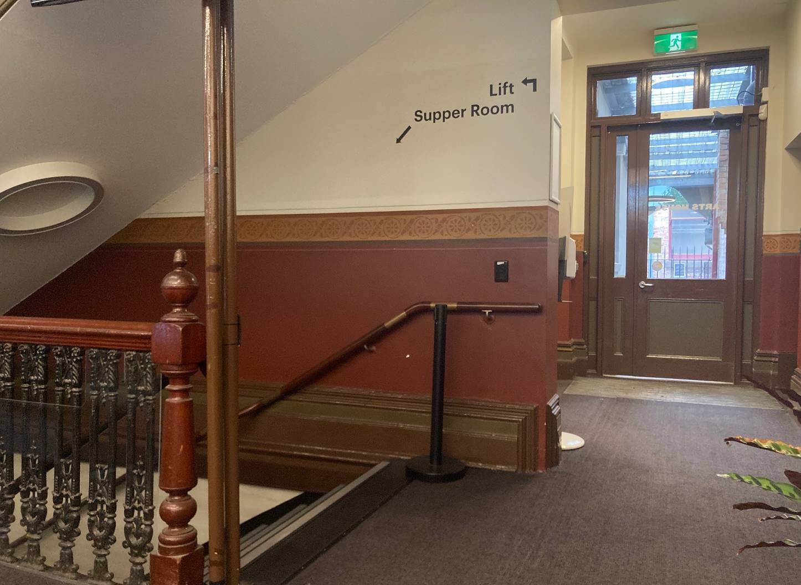

Image: Entry to Supper Room via stairs or lift located behind reception.

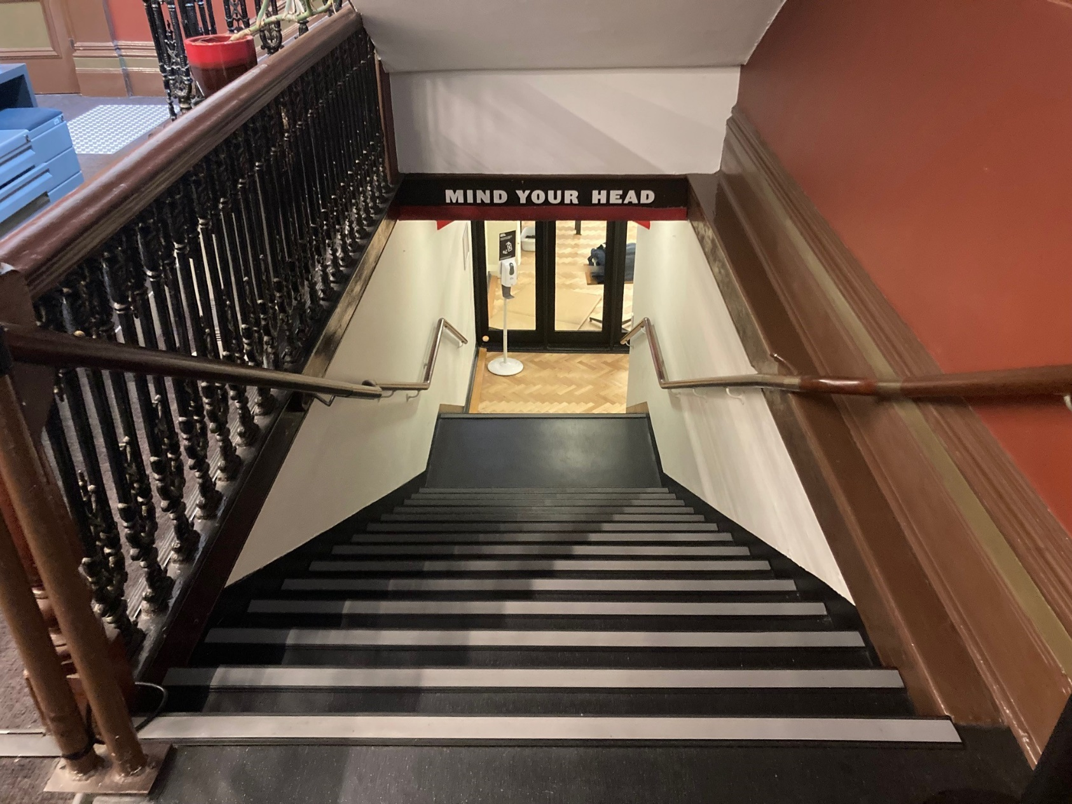

Image: There are 20 stairs with grab rails either side.

## **Lift**

The lift is located behind reception desk in the foyer.

The closest entry to the lift is via George Johnson Lane.

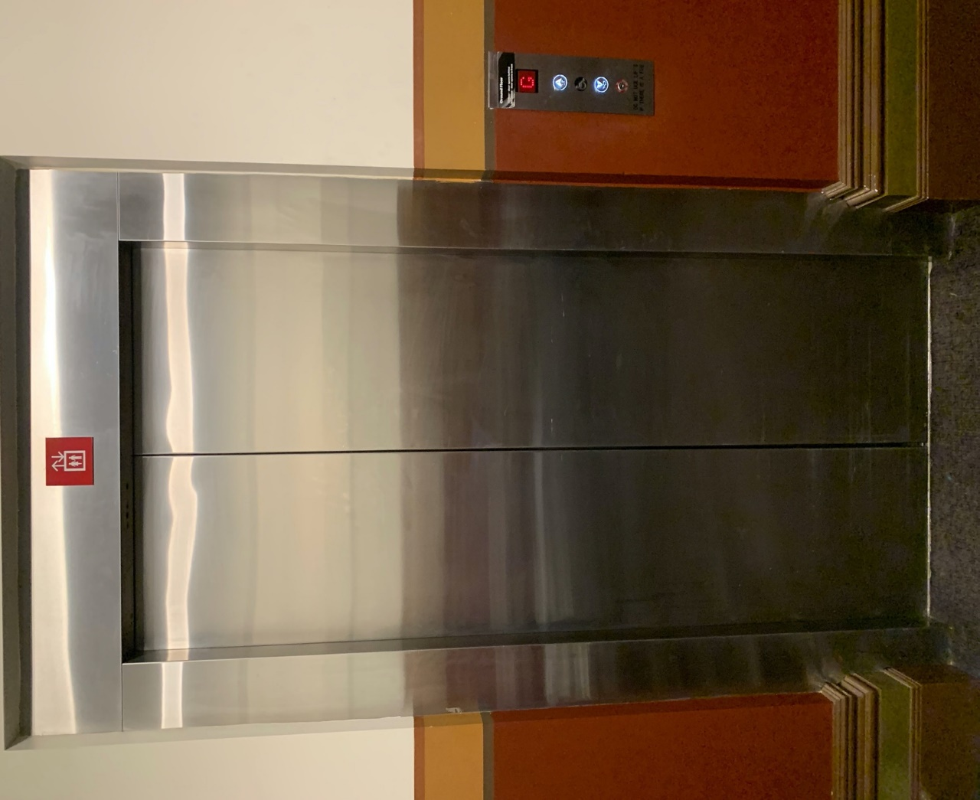

# **Transport**

## **Tram**

Route 57 (High Floor trams only)

Stop 12, North Melbourne Town Hall.

Please note, this is not a wheelchair accessible tram

[GETTING TO ARTS HOUSE VIDEO LINK](https://vimeo.com/544169506)

## **Train**

Arts House is 1.1km from   
North Melbourne Train Station,   
approximately 16 minute walk

[North Melbourne Station Information](https://www.ptv.vic.gov.au/stop/1144/north-melbourne-station/0/train/)

1.2km from Flagstaff Station,   
approximately 15 minute walk

[Flagstaff Station Information](https://www.ptv.vic.gov.au/stop/1068/flagstaff-station/0/train/#StopPage:::datetime=2023-04-06T04%3A41%3A27.669Z&directionId=-1&showAllDay=false&_auth=408ac3b1e97f4b0beb5bdf00c2f797057d10dd6e6cf2ad40a69334c4dfdf5e21)

## **Bus**

Bus number: 216

## **Parking**

There is limited paid on-street parking on Queensberry Street and Errol Street.

There are two accessible on street car parking spaces on Queensberry Street (150m to our accessible Errol Street entrance) for holders of a Parking Permit for Disabled people.

# **COVID Safety**

Please note: If you have a cough, sore throat, fever, shortness of breath or flu-like symptoms, you must not attend our venue or programs in person.

We will provide a refund if you need to cancel your attendance due to illness. Please [contact us](mailto:ArtsHouse.Ticketing@melbourne.vic.gov.au) by 9am on the day of the event.

To minimise the risk of COVID-19 transmission, we advise all patrons, artists and staff to:

* Practise physical distancing where possible
* Practise good hygiene by washing and or sanitising your hands often
* Wear a mask as directed by Victorian Government guidelines

Throughout the venue you will find:

* hand sanitiser stations available
* masks available (ask one of our staff for assistance)​
* increased signage to direct patron movement and avoid crowd congestion

We also ensure that spaces are well ventilated.

Staying COVID-safe remains important. We must all follow these steps:

* Follow the [Victorian Government’s measures on how to stay safe.](https://www.betterhealth.vic.gov.au/coronavirus-covid-19-victoria)
* Wear[face masks](https://www.betterhealth.vic.gov.au/coronavirus-covid-19-victoria) where required or when you cannot safely socially distance.
* Practise [COVID-safe hygiene protocols.](https://www.health.gov.au/news/health-alerts/novel-coronavirus-2019-ncov-health-alert/how-to-protect-yourself-and-others-from-coronavirus-covid-19/good-hygiene-for-coronavirus-covid-19)
* Test for COVID and get [free rapid antigen tests​](https://www.melbourne.vic.gov.au/community/health-support-services/health-services/Pages/free-rapid-antigen-tests.aspx) at nominated City of Melbourne customer service and library sites.