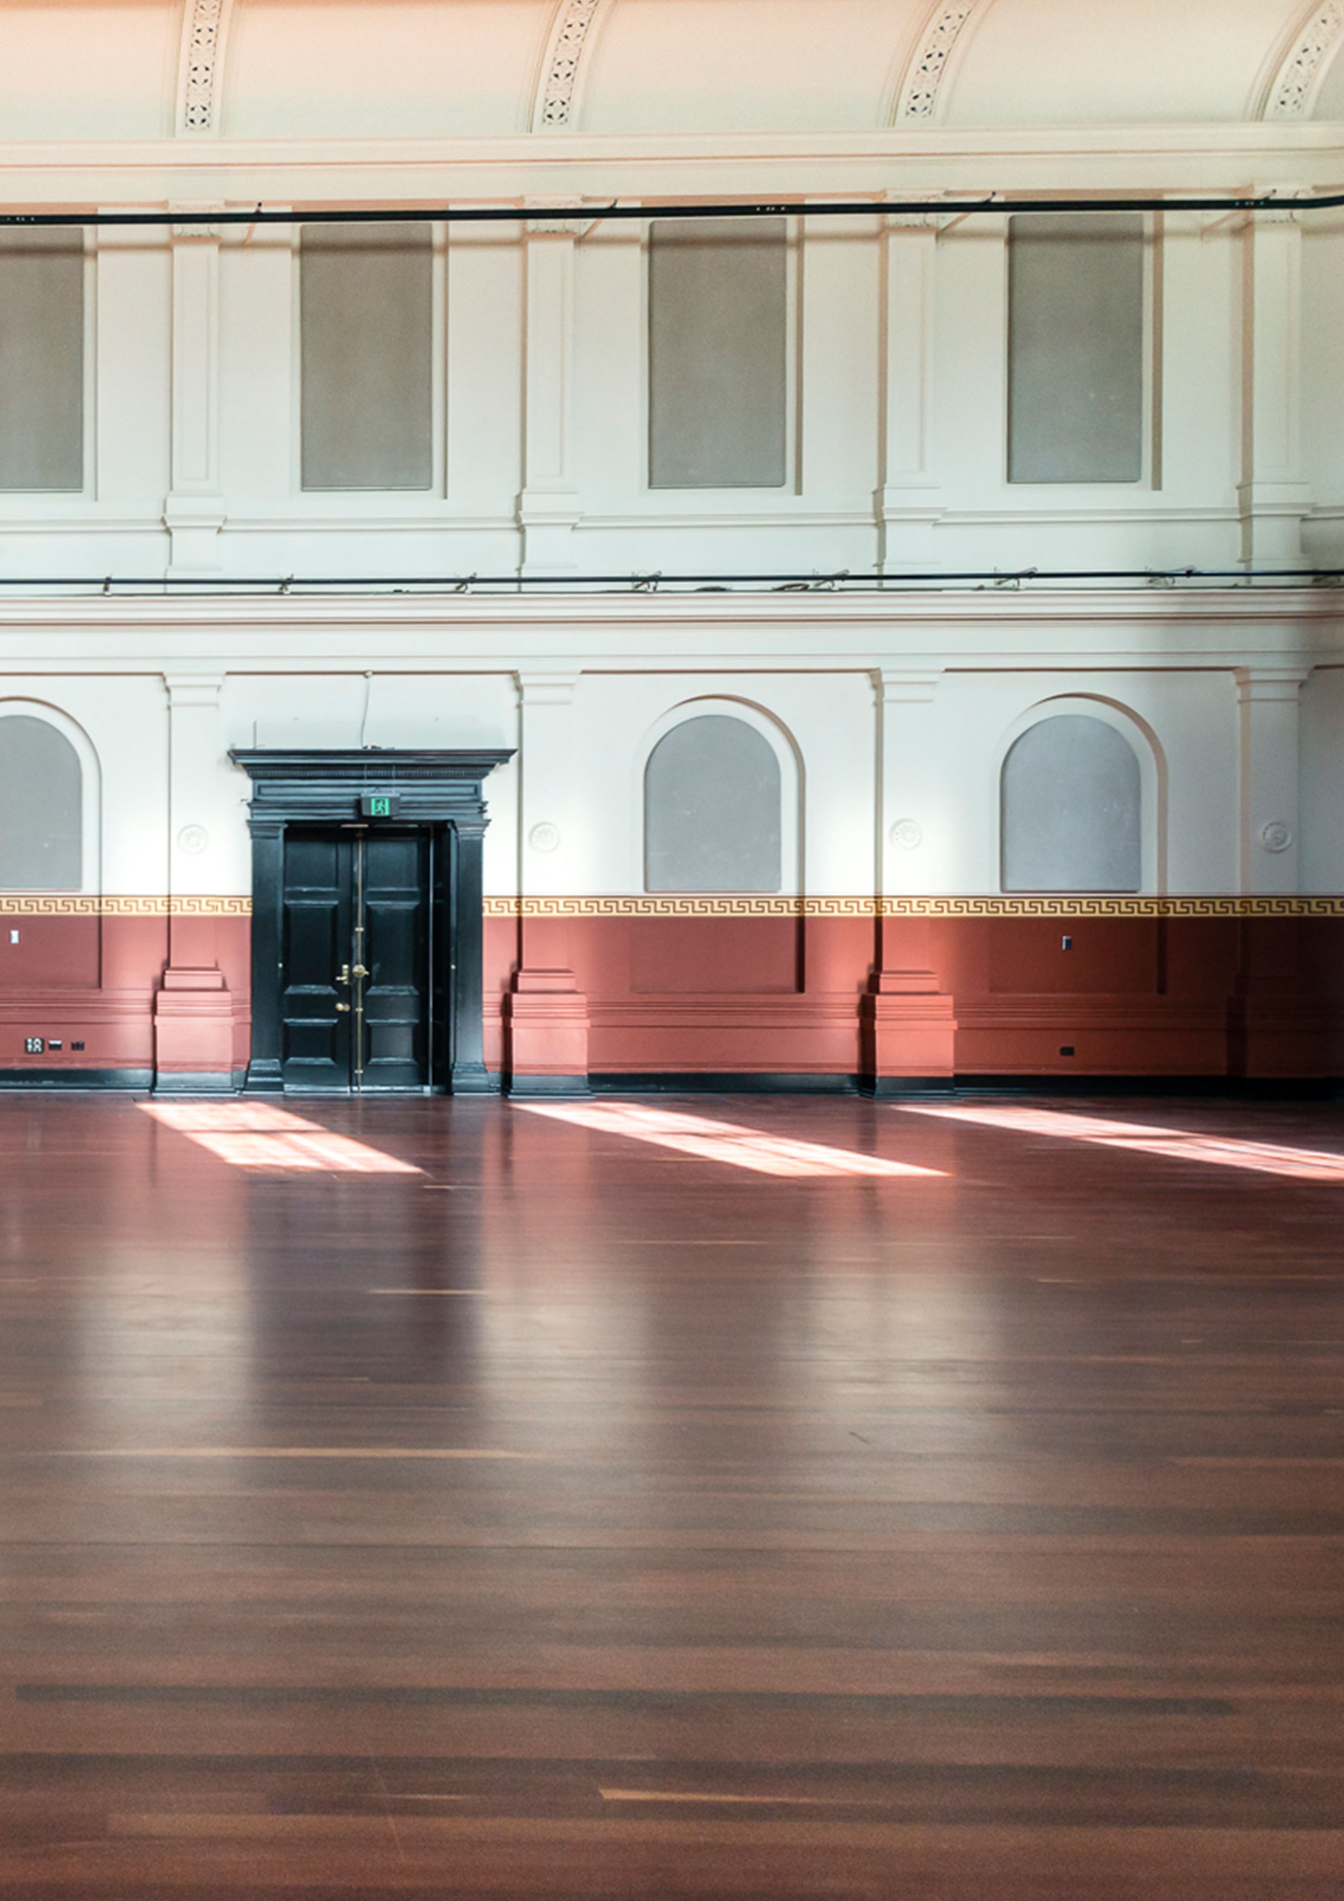

Building Information

About This Guide
This document has information about Arts House’s buildings and its amenities. For information on development and performance spaces, please see our Creative Venue Information document.
If you would like more information or support accessing Arts House or its facilities, you can call reception on (03) 9322 3720 or text 0447 570 178 between business hours Monday - Friday 9am - 5pm AEST. You can also email us at artshouse@melbourne.vic.gov.au
Arts House is located at 521 Queensberry Street, North Melbourne VIC 3051.
This document was last updated: February 2024
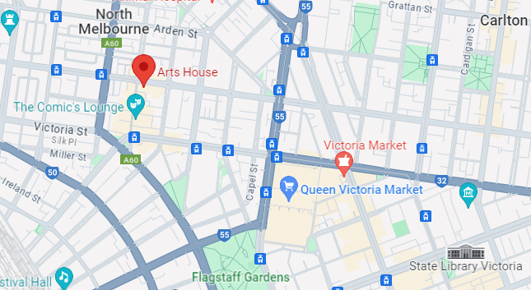Image: a map of Arts House and its surrounding area.

Contents
About Arts House 4
What is Arts House? 4
Spaces at Arts House 5
Getting to Arts House 6
Public Transport Information 6
Parking and drop-off points 7
Main Building Entrances 8
Queensberry Street 8
Errol Street 9
George Johnson Lane 12
General Building Information 14
Foyer and reception 14
Meeting Room 15
Quiet Space 17
Bar 19
Lift 20
Ground Floor Bathrooms 21
Level 1 Bathrooms 25
The Warehouse 30
Warehouse Entrance 31
Warehouse Bathrooms 32

About Arts House

What is Arts House?
Arts House is an arts venue with five dedicated arts spaces suitable for a range of activities.
It is part of City of Melbourne.
Arts House offers space for artists to develop, create and present their work.
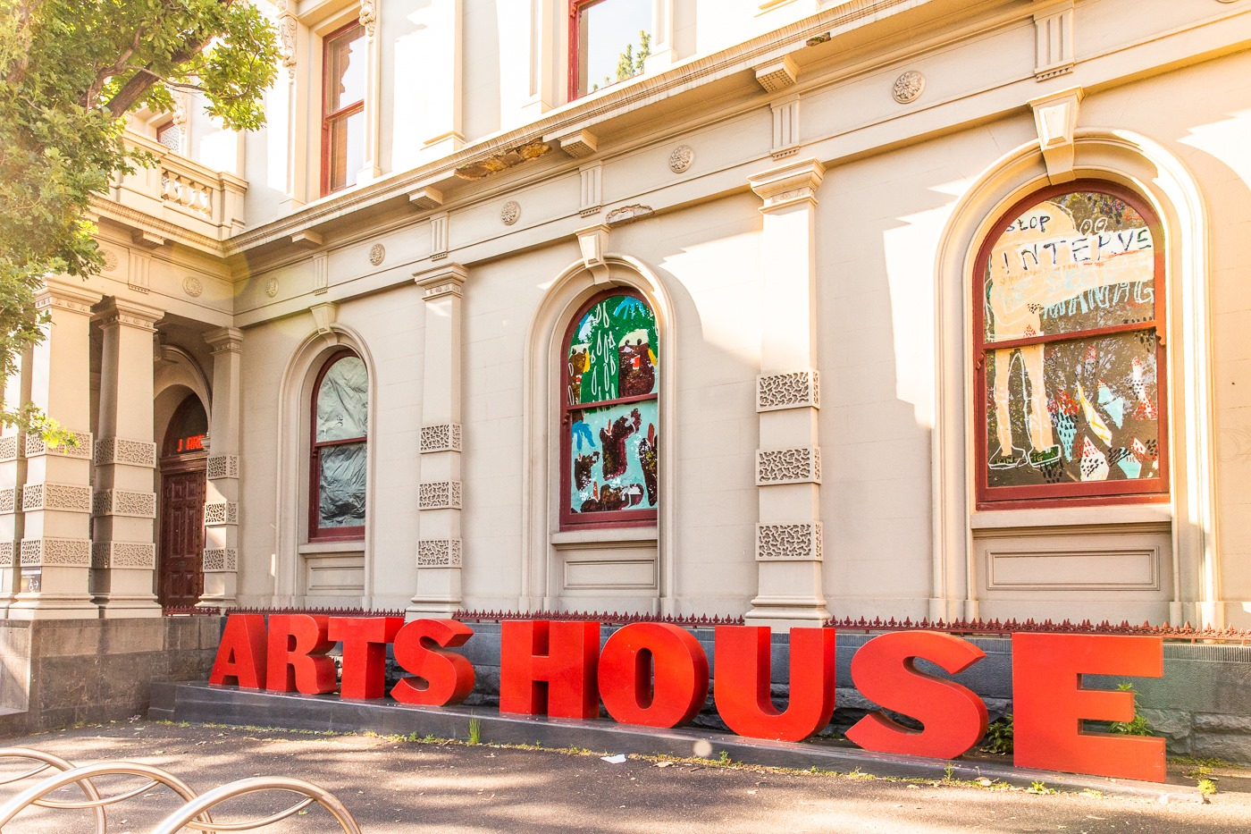
Image: The facade of North Melbourne Town Hall building that features giant red letters that say ARTS HOUSE out the front of it. The building is an old, beige colour building built in the 1800s and has big arched windows. There are leafy trees on the pavement in front of the building.

Spaces at Arts House
Arts House is based at North Melbourne Town Hall – which is a heritage listed building – and a nearby building called The Warehouse.
There are three different entry points to North Melbourne Town Hall (also called the main building). Two of these are wheelchair accessible entrances. All levels inside the main building are accessible by both stairs and lift.
Both levels of the main building have accessible bathrooms, but the bathrooms on the ground level are more suitable for people using larger mobility aids such as motorised wheelchairs and scooters.
The Warehouse is a studio in a separate building to North Melbourne Town Hall. It has its own accessible bathroom, two additional bathroom stalls and a kitchenette available to use.
The Arts House team can set up each space to suit the needs of any artists or participants using our venue.
Please note, Arts House operates under a COVID Safe plan informed by Victorian government guidelines.
Click here to view an interactive building scan of Arts House.

Getting to Arts House

Public Transport Information
The most direct way to get to Arts House on public transport is by tram on Route 57. Arts House is opposite Tram Stop number 12 on this route.
Stop number 12 is located on the corner of Errol St and Queensberry St and is directly opposite North Melbourne Town.
Arts House can also be accessed via train and walking. It is approximately twenty minutes’ walk from both Flagstaff and North Melbourne stations.
For more information on getting to Arts House, please see our “Getting Here” video.

More information on arriving by tram:
- Trams that service Route 57 are not low-floor trams, and this stop does not have level access. As such, Tram 57 and Stop 12 are not wheelchair or mobility aid accessible.
- Stop 12 is positioned in the middle of the road with a railing to the left when disembarking, and a pedestrian crossing button on a pole. The actual pedestrian crossing at this intersection is located 4 metres in front of this pole.
- Turn right at the pedestrian crossing from Stop 12 (from City) to get to Arts House and the Errol St entrance.
- At the kerb on the corner of Errol St and Queensberry St there is a tactile surface indicator and partial cobblestone kerb cut-out.

Parking and drop-off points
The best drop-off point for taxis, Ubers or other vehicles is at the entrance of George Johnson Lane, just off Errol St.
There are a range of parking spaces available on both Queensberry St and Errol St. These are paid parking spaces managed by the City of Melbourne.
There are parking pay stations on the street or visitors can pay via phone using the EasyPark app. Most parking spaces are available for a maximum of 2 hours at a time. More information about parking and drop-off points:
- There are two accessible parking spaces on Queensberry St, however it should be noted that the nearest entrance to the pathway is via a cobblestoned laneway and may not be suitable for some wheelchairs or mobility aids. You may need to travel along the road to the kerb cut-out at the corner of Errol St if using a wheelchair or mobility aid.
- There are two accessible parking spaces on Errol St that feature a raised kerb on the footpath side. These spaces have access to the street and Arts House entrances via a cobblestone driveway with a small lip at the kerb cut-out.
- There is a wheelchair accessible kerb cut-out on Queensberry St at the corner of Errol St. This kerb cut-out is partially cobblestoned.
- Category Two parking permit holders may park in any accessible parking space in the City of Melbourne for double the time indicated on the parking limited signage. City Access parking permit holders may park in any accessible parking space for the whole day, but this is to be displayed in conjunction with an Accessible Parking Permit (category one or two). For more information see: Parking permits for people with disabilities.

Main Building Entrances

Queensberry Street
The Queensberry St entrance to Arts House is the entrance to the left of the large red letters that say ARTS HOUSE.
This entrance has 9 steps with grab rails on both sides for all steps except the last two. The door for this entrance is a double glass door that opens automatically.
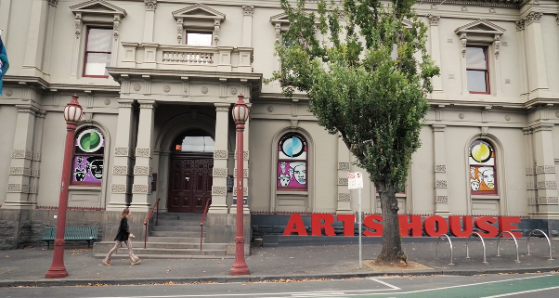
Image: View of the main building’s Queensberry Street entrance with large red letters outside the building that say ARTS HOUSE.

Errol Street
The Errol St entrance is to the left of the Post Office. This entrance has an automatic door which is 850mm wide and operated by a push button to the right. This door will remain in its open position for approximately 20 seconds.
This entrance can be accessed either via a ramp to the right of the Post Office entrance, or via three steps. The steps have tactile surface indicators and grab rails on either side. The button to open the automatic door is on the wall directly in front of the steps, and the automatic door will open to the left of this button.
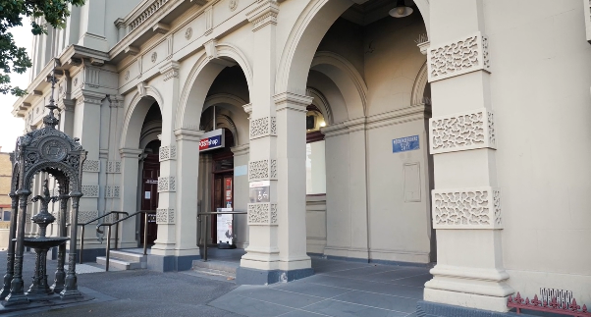Image: view of Errol Street entrance next to the Post office with wheelchair accessible ramp or two steps with grab rails and tactile surface indicators.
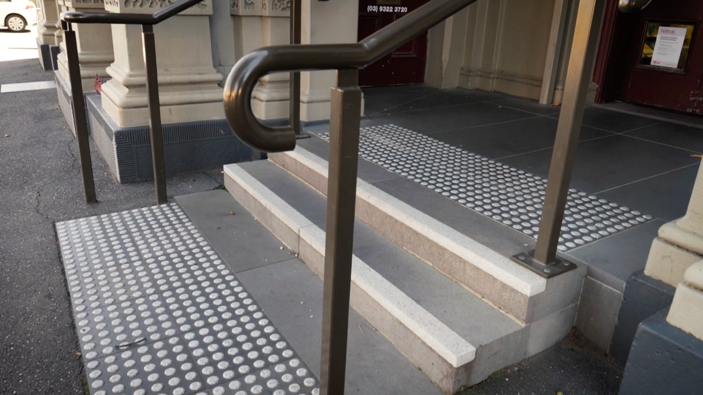Image: View of stairway to entrance from Errol Street. This entrance features grab rails either side and tactile surface indicators at both the top and the bottom of the two steps.

Upon entering the building via this entrance, medium to large mobility aids will need to make a tight, right hand turn to enter the hallway.
This hallway opens into the foyer of the Main Building which has carpeted flooring. This hallway is 1100mm wide and is suitable for larger wheelchairs and mobility aids.
The accessible bathroom, Meeting Room and Quiet Space are located off this hallway.
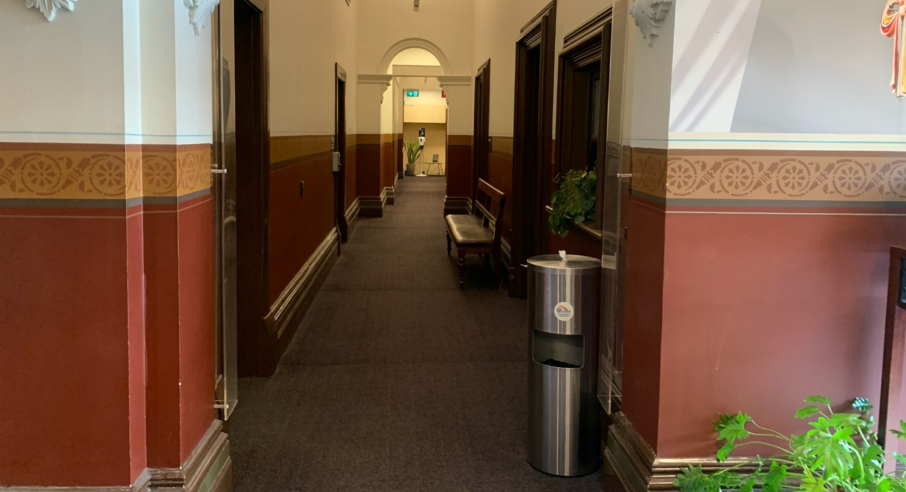
Image: View of the Ground Floor hallway in the main Building as seen from the foyer, looking towards the Errol St entrance. It has dark coloured carpet and walls painted half red and half cream.

George Johnson Lane
George Johnson Lane is located to the right of the Main Building, off Errol St. The laneway has faded, yellow, directional paint on the pavement, leading towards the Arts House entrance. There is also a large maroon and white sign at the end of the laneway, pointing towards this entrance.

Please note - this laneway also functions as the post office’s loading zone. Occasionally, post office vehicles may obstruct this entrance. If this is the case, we recommend using the Errol St entrance.
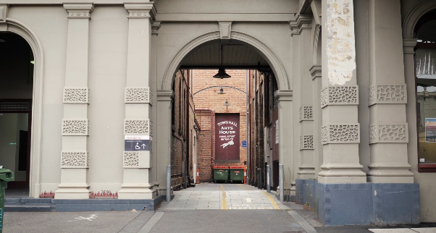
Image: View of George Johnson Lane from Errol St. The laneway passes through an archway with a brick wall at the end. There is a large maroon sign at the end of the laneway pointing towards the entrance.
Towards the end of George Johnson Lane, and off to the left is a wheelchair accessible ramp which leads to an automated push button entry to the Arts House foyer. This ramp has a smooth, paved surface and grab rails on both sides.
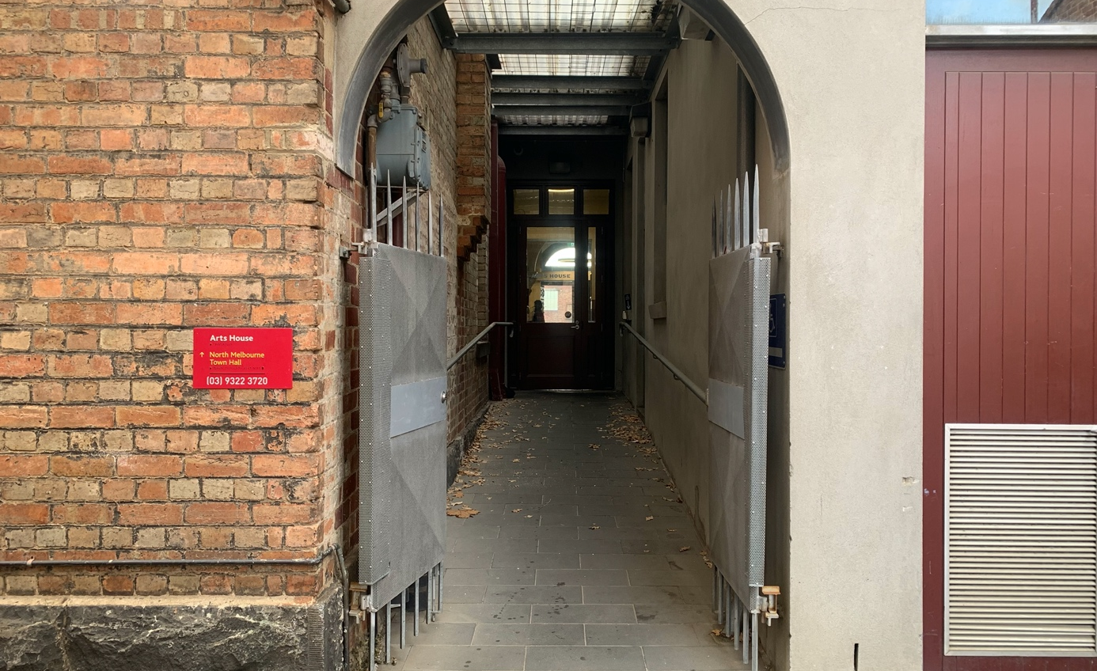
Image: view of the ramp leading from George Johnson Lane to the automated door which opens into the Arts House foyer. The archway to this ramp is bordered with a brick wall to the left with a sign in raised print and braille, reading: Arts House, North Melbourne Town Hall, (03) 9322 3720.

The automated door at the end of this ramp is 840mm wide and stays in its open position for approximately 20 seconds. The push button for this door is on the right-hand wall at the end of the grab rail.

General Building Information

Foyer and reception
The reception and box office desk is located in the main building, in the centre of the foyer. This desk features a lowered section to the left as you are facing it. Our friendly front of house staff will be able to assist you with your requirements or any questions at this desk. 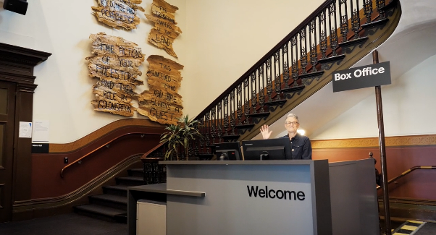
Image: A front of house staff member waves from the grey welcome desk. Behind them is a large staircase with a wooden banister to their right.

Meeting Room
The Meeting Room is located on Ground Level and is the closest space to reception. This space is set-up for meetings but can be used for other purposes as well.

Key features
- Carpet floor that is flat
- One large window
- An ornate fireplace (not functional)
- Square meeting table with chairs
- Video conferencing equipment

Capacity
- Comfortably fits 10 people standing and 8 people seated

Access to space
- The Meeting Room is located off the hallway connecting the foyer area and Errol St.
- It is located opposite the Accessible Toilet on the Ground Floor of the Main Building.
- Entry to the Meeting Room is through a single door 870mm wide.

Space measurements
- Dimensions of the floor space available to use is 3.75m x 4.35m.
- Height from floor to ceiling is 4m.
- Height from floor to the central light fixture is 2.8m.

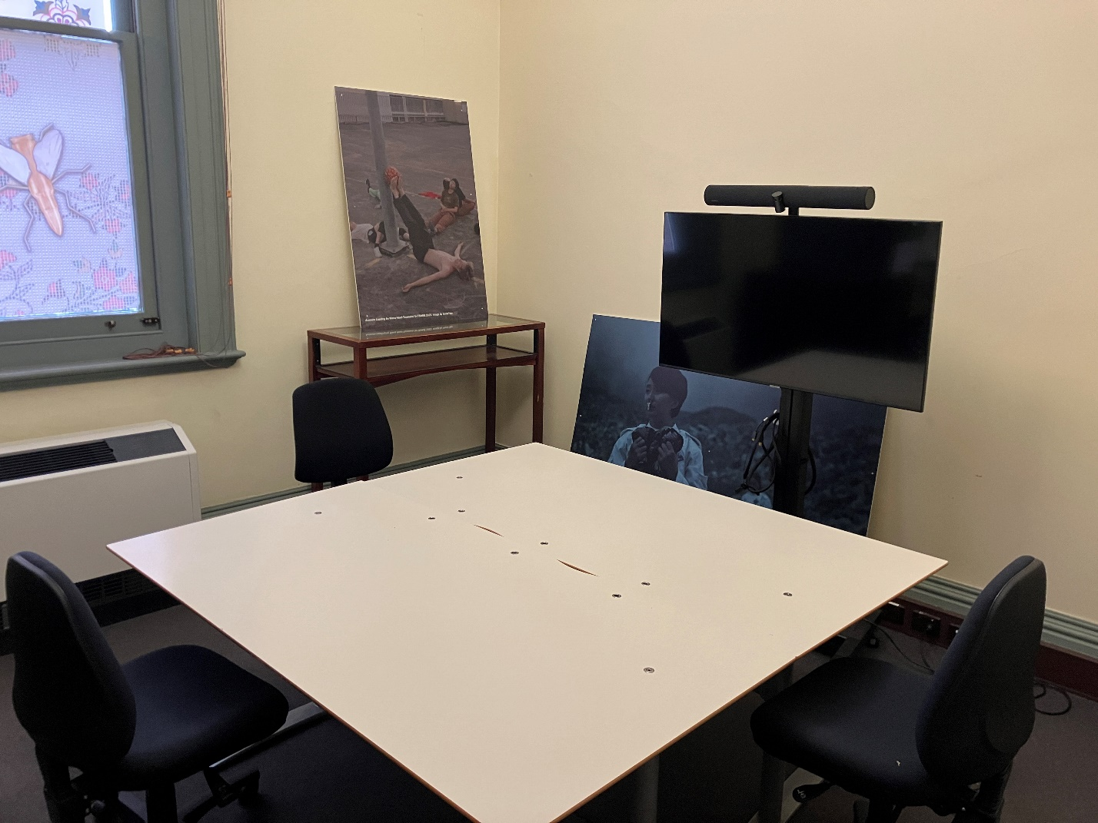
Image: view of Meeting Room from the doorway. There are three chairs and a meeting table in the centre of the room, and a mobile video conferencing setup on the right. There is a window on the opposite wall from the doorway.

Quiet Space
The Arts House Quiet Space is located on Ground Level and is nearby reception. This space is suitable as a quiet space, prayer room, and parenting room.

Key features
- Carpet floor that is flat
- One large window
- An ornate fireplace (not functional)
- A kitchen sink with cups
- Various chairs and a coffee table
- Dimmable lights
- Sensory and stim objects

Capacity
- Comfortably fits six people seated

Access to space
- The Quiet Space is located off the hallway connecting the foyer area and Errol St.
- It is located opposite the Accessible Toilet on the Ground Floor of the Main Building.
- Entry to the Quiet Space is through a single door 870mm wide.
- The door to the quiet space can be closed, but it cannot be locked.

Space measurements
- Dimensions of the floor space available to use is 3.75m x 4.35m.
- Height from floor to ceiling is 4m.
- Height from floor to the central light fixture is 2.8m.
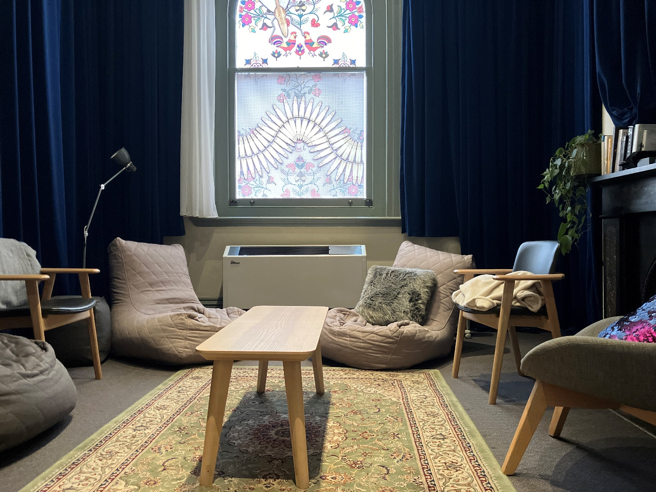
Image: view of Quiet Space from the doorway. There are three chairs and three beanbags in various shapes, two pillows and a rug set up around a coffee table. There is a large patterned rug in the centre of the room and an ornate fireplace on the right-hand side with a pot plant ontop of the mantle. There is a window on the opposite wall from the doorway with a patterned artwork.

Bar
There is a bar that is open during events located directly opposite the reception desk. The bar does not have a lowered section, but our front of house staff are available to assist in accessing the bar’s services.

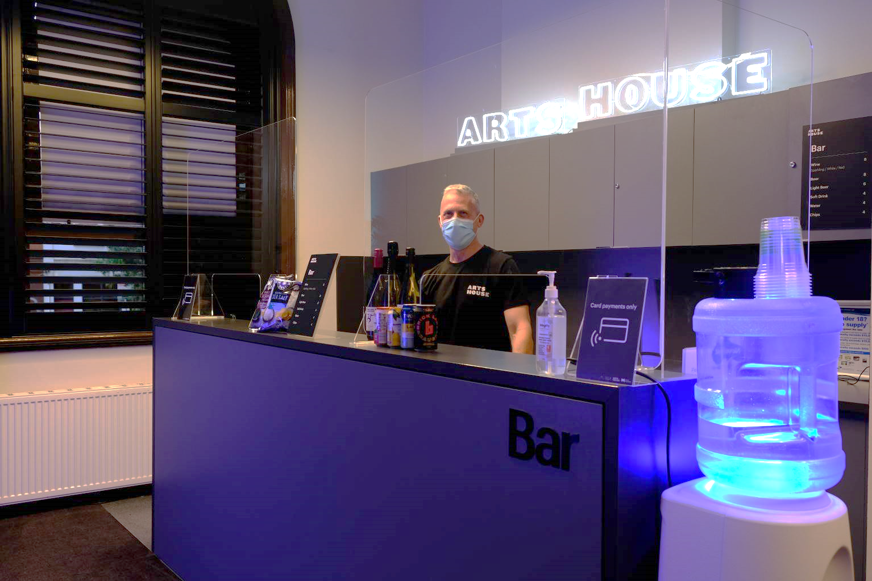
Image: An image of the bar service area. The bar is grey and has raised lettering on the top right corner that says BAR. To the right of the bar is a stand-alone water cooler.

Lift
The accessible lift is located on the right when you enter through the George Johnson Lane entrance. If entering from Queensberry or Errol St entrances, you will find the lift in the alcove behind the reception desk and descending stairs, to your left.
The lift can accommodate one wheelchair/mobility scooter at a time. The door width is 860mm.
Please note that some floors open with the door in front and some behind. Check signage when entering the lift for this information.
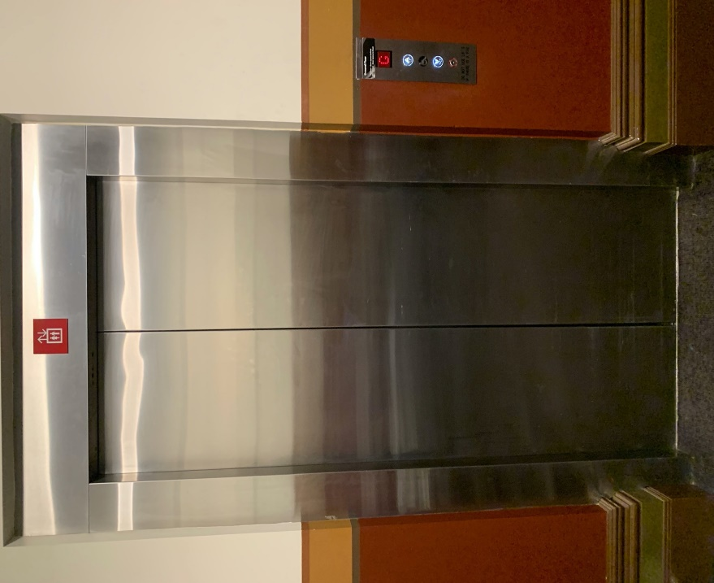
Image: external view of the lift from the ground floor foyer. The lift has silver metal automated doors and a button mount to the right of the doorframe.

Ground Floor Bathrooms
In the main building, there is one wheelchair accessible toilet with an automated door controlled via push button. It is located on the ground floor, down the hallway off the foyer and to your left.
The door width for this toilet is 760mm. The door will remain in its open position for approximately 20 seconds after pushing the button.
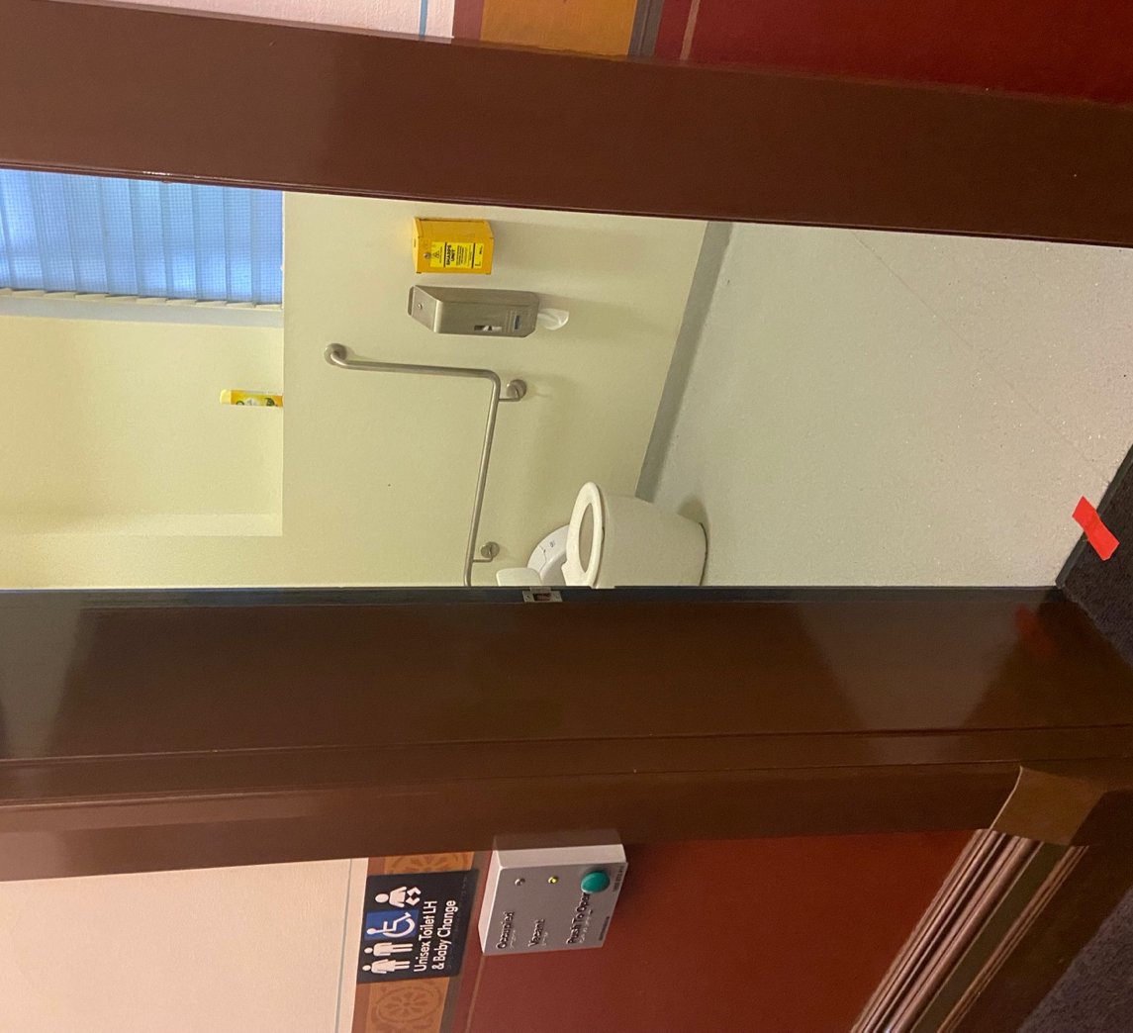
Image: view from the doorway of the bathroom. There is a green button on a panel to the left of the door that automatically opens the door. There is braille signage on this panel.
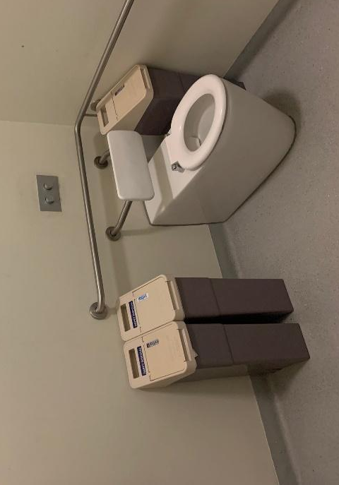
Image: interior of the accessible Ground Floor bathroom with grab rails behind and to the left of the toilet.
There are also two unisex bathrooms with multiple toilet stalls located on ground level of the main building. Each bathroom has one ambulant toilet cubicle, with grab rails on both sides of the cubicle, and a second toilet cubicle with grab rails on one side.

Bathroom 1 is located towards the rear of the foyer, to the right of the reception desk.

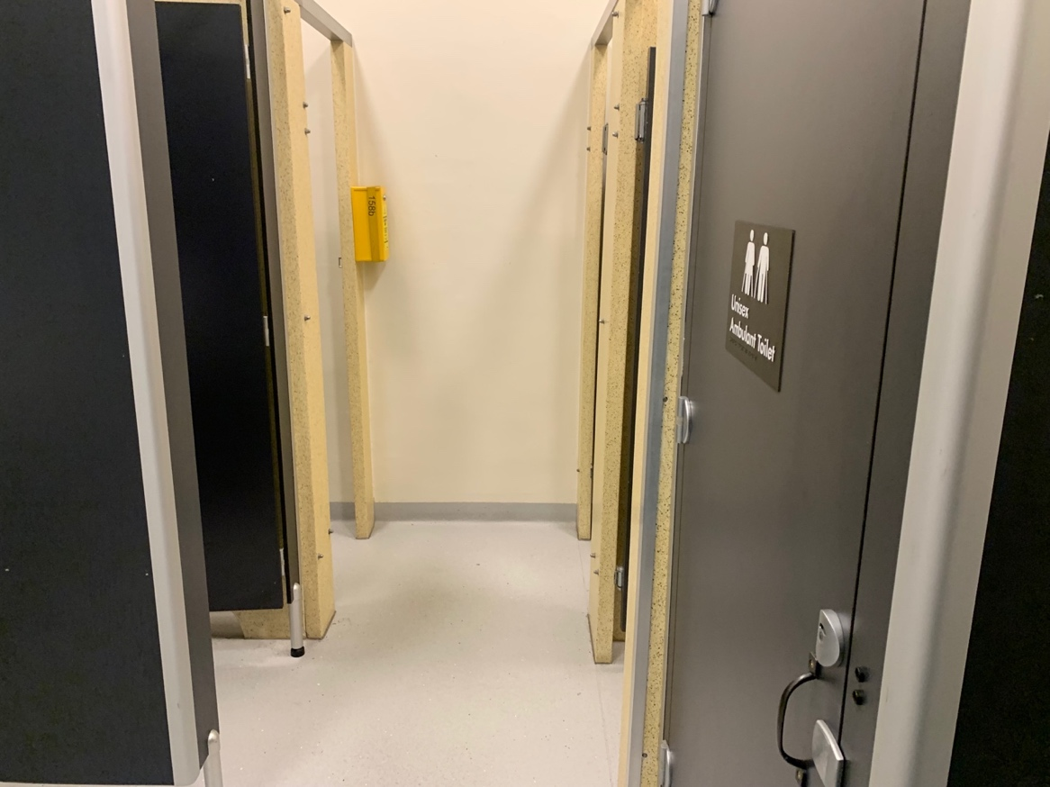
Image: Interior of Bathroom 1 on Ground Floor of the main building. The ambulant toilet is the first cubicle on the right row of these toilets.

Bathroom 2 is located just inside the hallway which joins the foyer to the Errol St entrance. This bathroom can be found behind the first door to your left from the foyer.
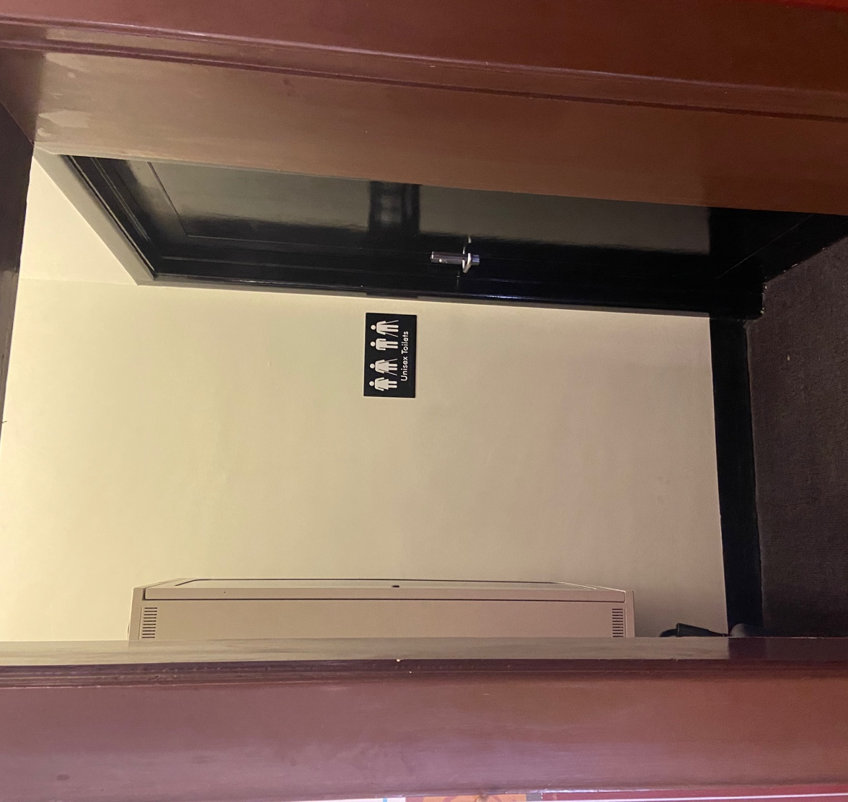
Image: the entrance to Bathroom 2 located in the hallway off the foyer. Turn left into the open doorway/alcove and find the bathroom door to your right. There is a sign on the wall that says Unisex Toilets in raised print and braille with symbols for an ambulant toilet.

Level 1 Bathrooms
There are three bathrooms on Level 1, two of which are partially accessible and include showers.
Bathroom 1 is to the right of the kitchenette on Level 1 which is straight ahead if accessing this level via the lift, or down the corridor to the left if accessing this level via the stairs.
It features two standard sized toilet cubicles to the left and a sink to the right as you enter the bathroom. There is no signage on the exterior door to this bathroom. 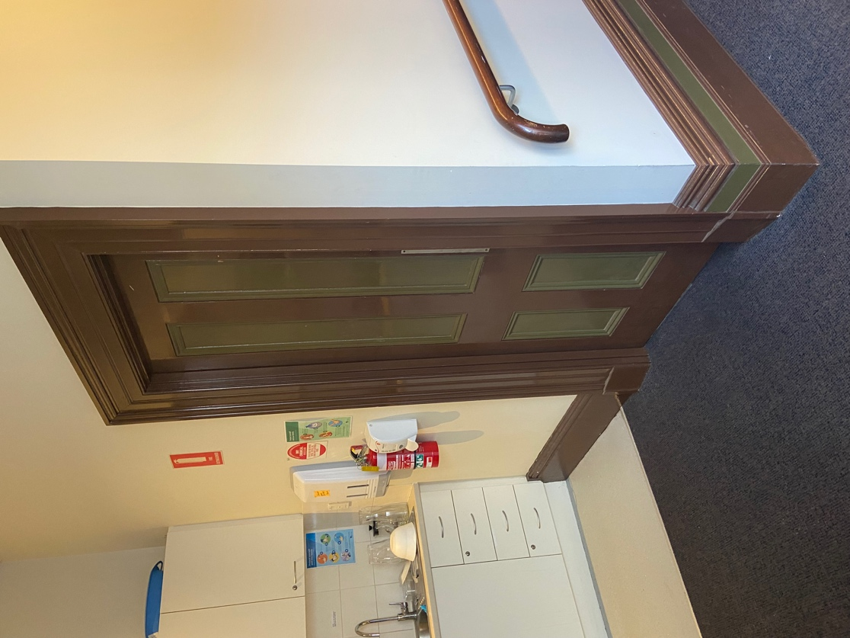
Image: Door to Bathroom 1 which is located to the right of the kitchenette and to the left of the hallway leading to Studios 1 and 2, on Level 1 from the lift.
To access Bathroom 2 when exiting the lift, continue straight and turn right into the hallway just before the kitchenette.
This hallway is carpeted, with a slight incline and has grab rails on both sides.
Bathroom 2 has a push button to open the door automatically. This is located to the left of the door and the door opens inwards, remaining in its open position for approximately 20 seconds.
This bathroom has grab rails to the left of the toilet and on the rear wall to the right. There is a shower in the left-hand corner of this room.
Please note – The hallway to access Bathroom 2 is narrow and may not be suitable for large mobility scooters or larger motorised wheelchairs due to limited turning room.
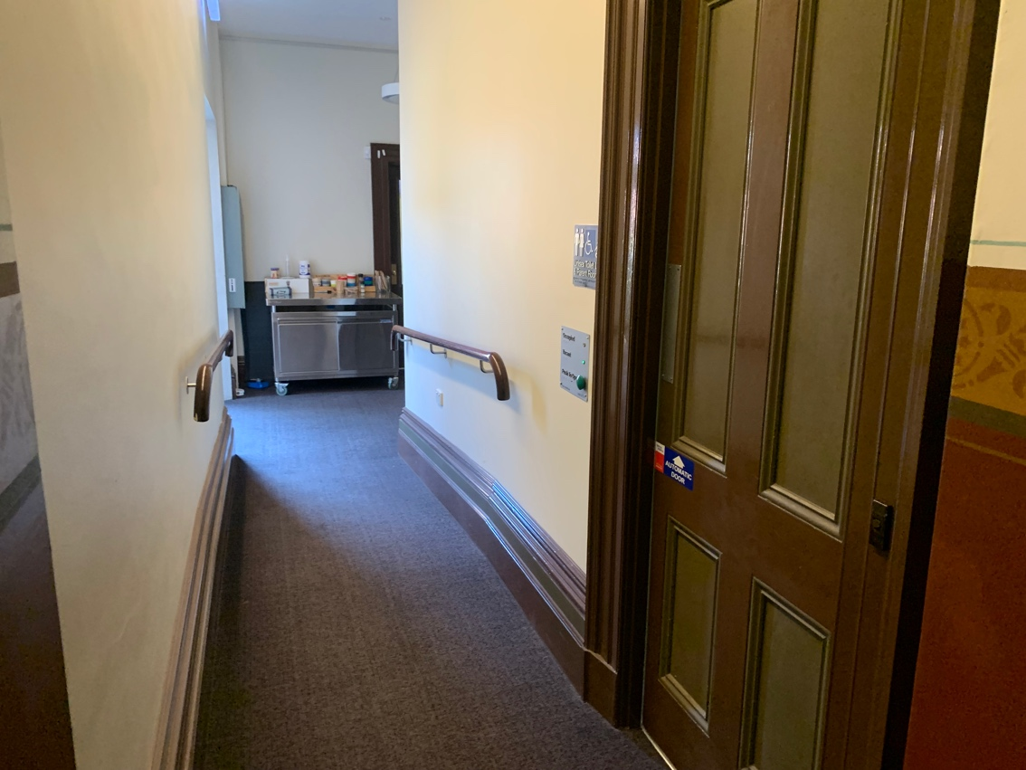
Image: Door to Bathroom 2 at the top of the ramp. Buttons to open the door are along the left wall as you approach from the bottom of the ramp.
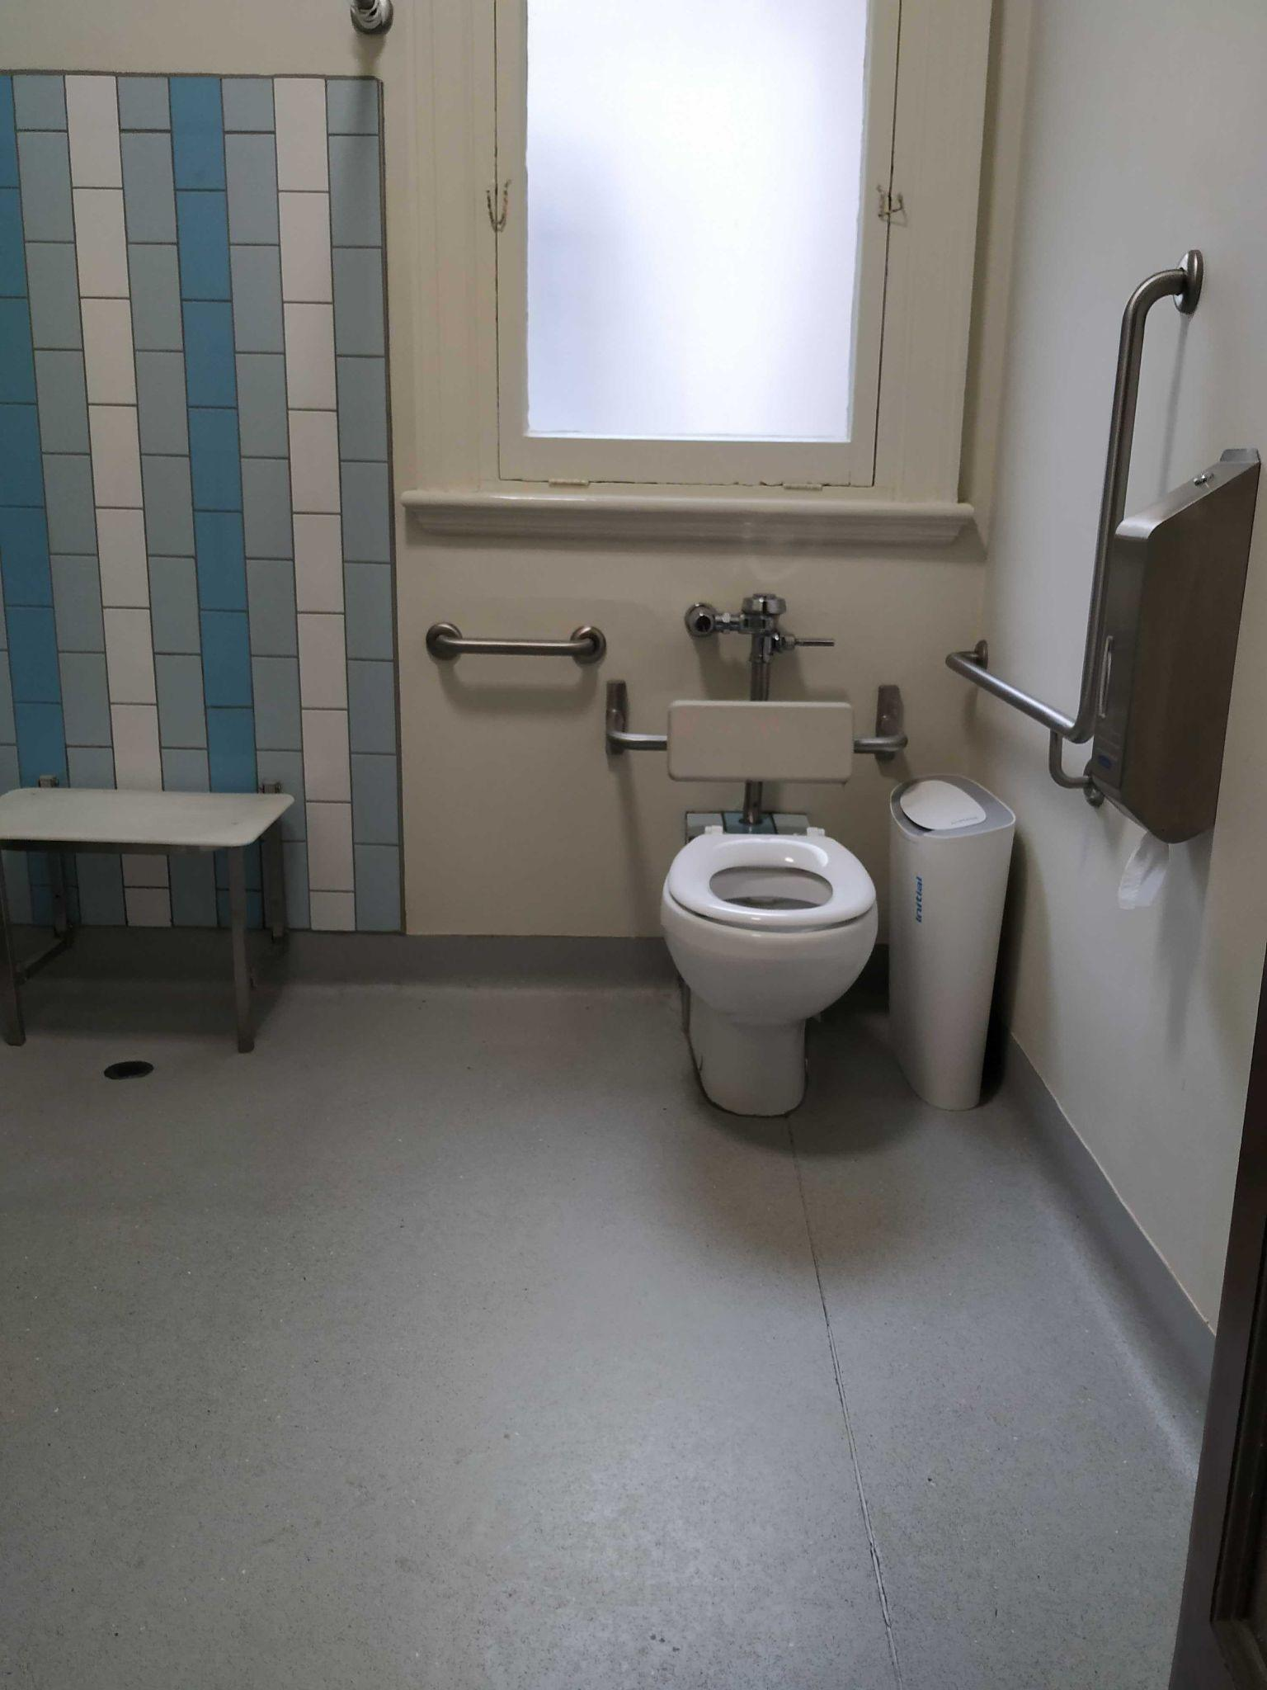
Image: view from the doorway of the Bathroom 2. The image shows the level shower facility to the left of the room with a foldable seat and the toilet with grab rails to the right of the room.

Bathroom 3 is the closest to Studio 2. It is located just short of the Studio 2 doorway, to the left. This bathroom (and Studio 2) can be reached by turning left at the top of the Level 1 staircase and/or adjoining hallway from the lift and heading straight along the corridor. There are Arts House staff offices to the right of this corridor, often concealed behind heavy black curtains.
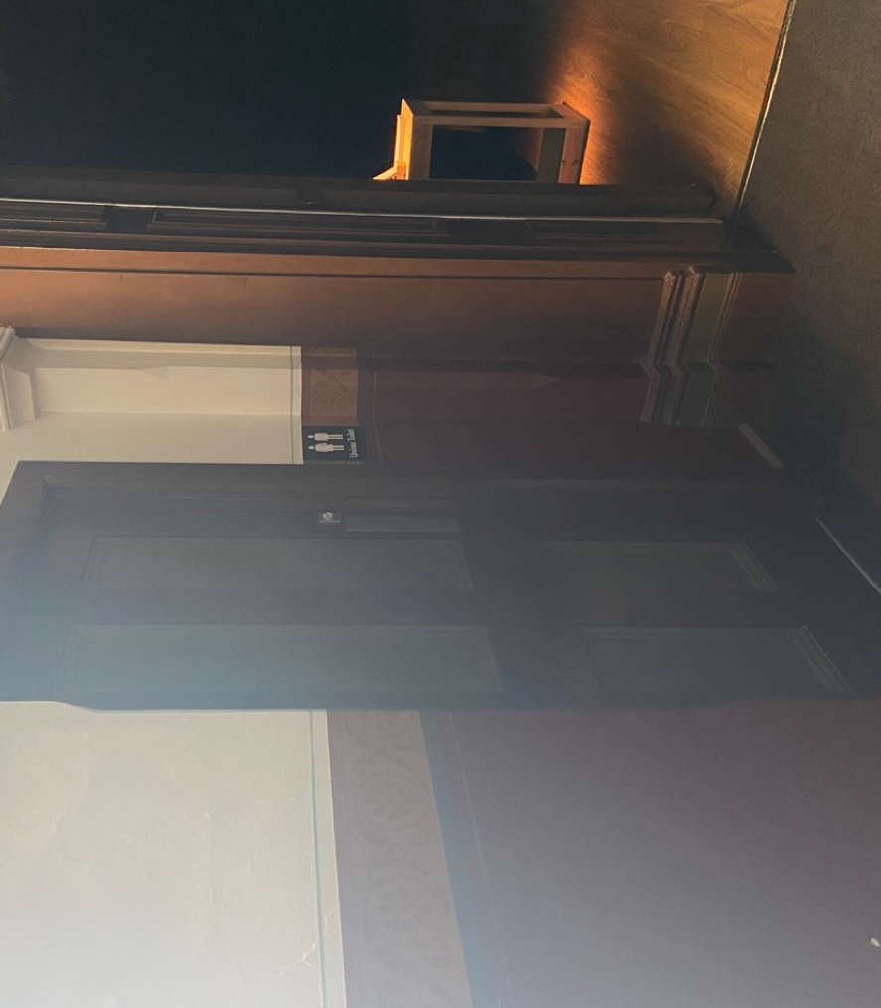
Image: The door to Bathroom 3 from the hallway. The open door to Studio 2 can be seen directly to the right of the door to Bathroom 3.Bathroom 3 has a heavy, manually opened door which opens inwards to the bathroom. It features both a toilet and shower facilities. There are no grab rails in this bathroom and there is a small, raised step to the shower area.

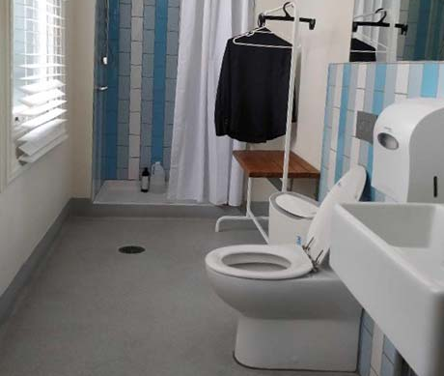
Image: Interior of Bathroom 3. There is a shower with blue tiles at the opposite end of the space. There are blue tiles on the right side above the toilet and sink and a window on the left side of the room.

The Warehouse
The Warehouse is separate to the main building of Arts House. You can find the Warehouse by following George Johnson Lane as it snakes around the back of the main Arts House building.
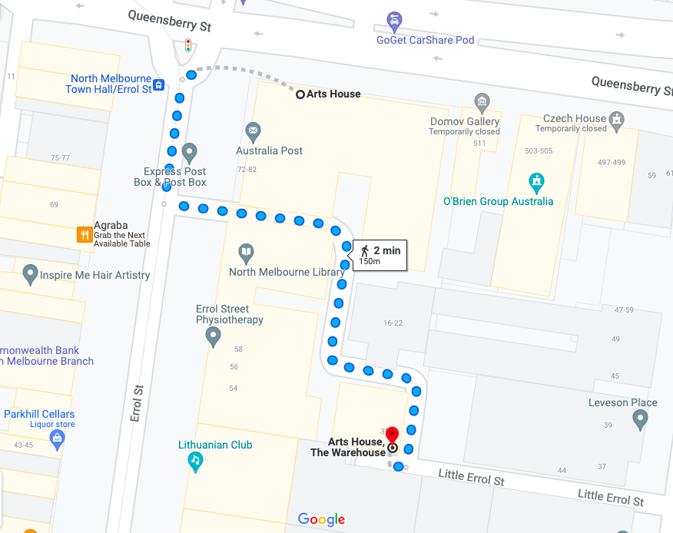Image: a screenshot of a map with walking directions from the front of the main building of Arts House to the Warehouse behind it. The map indicates a 2 minute walk.The path to the Warehouse from George Johnson Lane is a smooth asphalt surface with a cobblestone strip in the centre for part of the journey.

Warehouse Entrance
The main Warehouse entrance has a wheelchair accessible ramp that is 1150mm wide. The bottom section of the ramp has a gradient of 1:6 and has no handrails. The upper section has a gradient of 1:12 and has handrails on both sides.
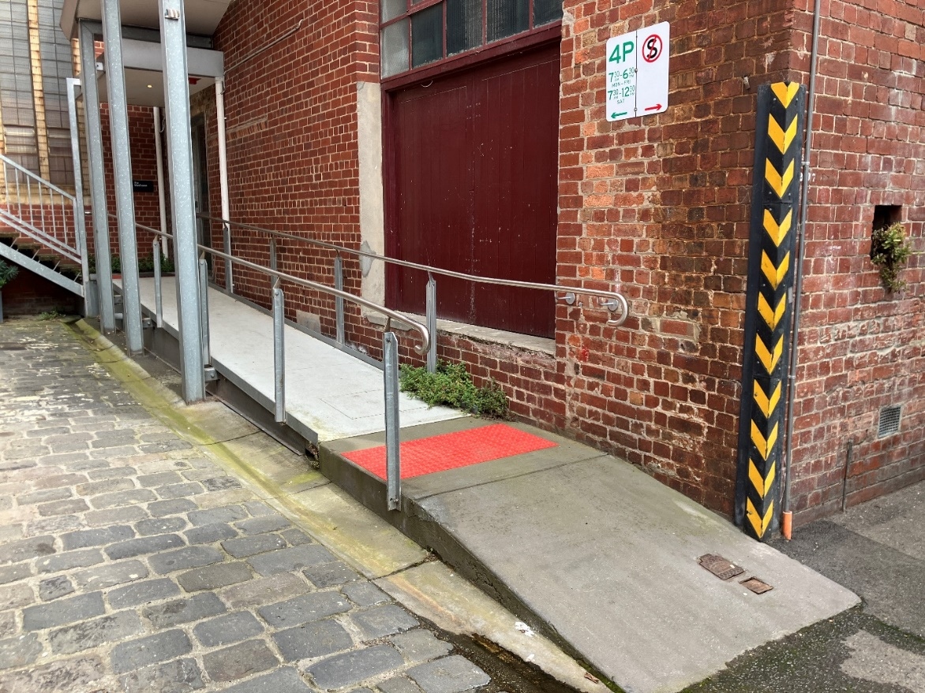
Image: view of the ramp leading to the main entrance of the Warehouse. The bottom section has no handrails. There are handrails either side of the ramp at the top section and a large red tactile surface indicator on the flat middle section. The door to Warehouse is on the right at the top of this ramp.
This main entry to the Warehouse is through an automated, glass sliding door.
For regular users of the Warehouse, a keypad entry code can be arranged with Arts House staff to access the door at the rear of the building.

Warehouse Bathrooms
The Warehouse space has three separate bathrooms located on the opposite, far right corner from the main entrance. These are all self-contained and fully enclosed spaces, accessible from a corridor which leads off the main Warehouse space.
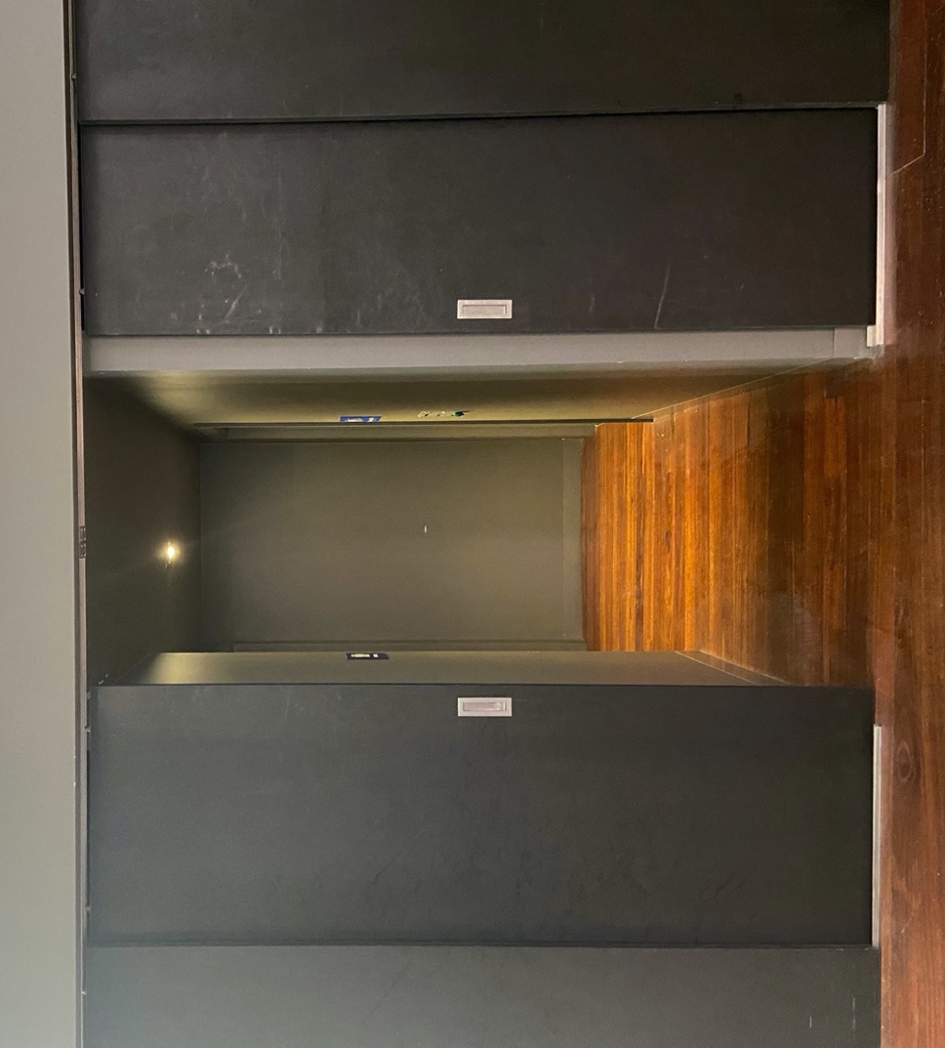
Image: Entrance to the block of toilets off the main area of the Warehouse space.
The first bathroom on the left of this corridor is a small room with a toilet, sink and mirror. This toilet area does not feature grab rails and is not wheelchair or mobility aid accessible.
The second bathroom on the left has a urinal only with a sink and mirror.
The toilet on the right is an accessible bathroom with an automatic door which is operated by a push button. The panel with the button to open the door is to the right of the doorframe and features raised print and braille signage. The door to this toilet opens inwards and remains in its open position for around 20 seconds. This toilet cubicle features an accessible toilet with grab rails, a sink and mirror and has enough turning room for a wheelchair or mobility aid.
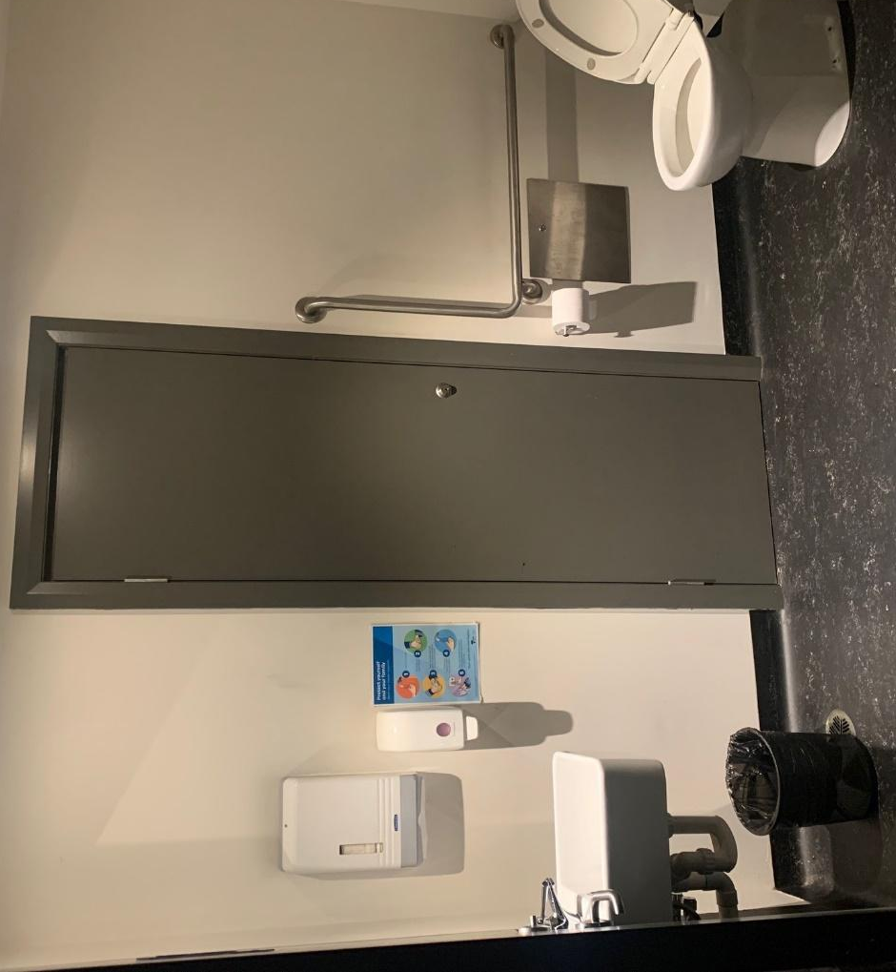
Image: view of the accessible bathroom located in the Warehouse from the toilet doorway. On the left-hand side is the wash basin and on the right-hand side is the toilet with a handrail on the right.

For information on performance and development spaces at Arts House please see our Creative Venues document.
This document has been prepared in consultation with Loom Arts and Management and its team of consultants with lived experience of disability.
For more information, please visit www.loom.org.au
