**ನಿರೀಕ್ಷಣೆ nireekshane**

Curated by Vishal Kumaraswamy as part of PHOTO 2024

Access Guide

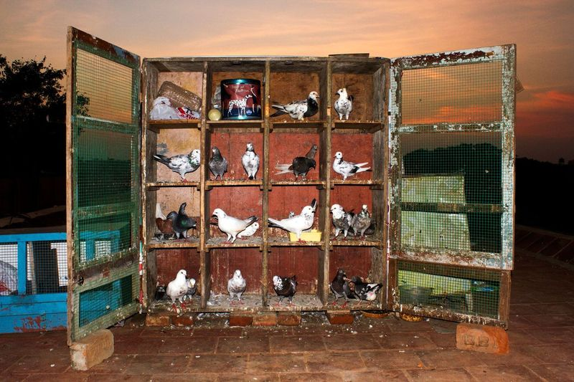

Image Description: A wooden cupboard with square shelves sits on bricks outside. There is a sunset in the background. The shelves have pigeons on them, sometimes two to a shelf.

# **Updates to this document**

Please note, this performance is a new work and changes are being made by artists until opening. We will endeavour to provide the latest access information on performances to ticket holders across key stages of rehearsal and presentation.

Arts House website will contain the most up to date version of this document and all ticket holders will be notified of any revisions made 3 days and 1 day prior to the event.

This document was created: 20 March 2024

**Contents**

**Updates to this document** 1

**Where** 3

**When** 3

**Access Services** 3

**Digital** 4

**Performers** 5

**Sensory Elements** 5

Sound 5

Lighting 5

Physical 5

Smell 5

Visual 5

Entry to space 6

Shocks or surprises 6

Audience experience 6

Social expectations 6

Performance expectations 6

**Other** 6

Content Warnings 6

General Notes 7

**The Venue** 8

Front Entrance 8

Accessible Entrances 9

Box Office 10

Ushers 10

Bar 11

Quiet Space 12

Bathrooms 12

Door to Studio 1 13

Door to Main Hall 13

Lift 15

**Transport** 15

Tram 15

Train 16

Bus 16

Parking 16

**COVID Safety** 16

# **Where**

Arts House

521 Queensberry Street

North Melbourne VIC

# **When**

Friday 1 March – Saturday 27 April

Mon – Fri, 10:30am – 4:30pm

Sat, 11am – 4pm

Closed Sun and Public Holidays  
 **Access Services**



Assistance Animal are welcome.



Visual Rating 100% – this exhibition contains entirely visual components.

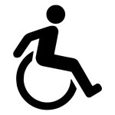

This exhibition is fully wheelchair accessible.

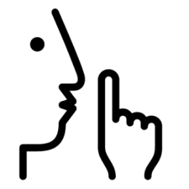   
Quiet Space – located on Ground Level near reception, this is a shared space suitable for recovery from sensory overload, prayer, or parenting. It features a range of seating options, dimmable lights, sensory and stimming objects. Anyone is welcome to access this space during venue operating hours and events.

# **About the exhibition**

ನಿರೀಕ್ಷಣೆ nireekshane is an exhibition of more than 150 photographs that takes place across Studio 1 and Studio 2 inside Arts House. The exhibition can be viewed in any order. You are welcome to engage with the exhibition at your own pace.

The exhibition is curated by Vishal Kumaraswamy and the artists featured in the exhibition are Arun Vijai Mathavan, Jaisingh Nageswaran, Krithika Sriram, M. Palani Kumar, Priya Suresh Kambli and Sadia Marium.

## **Studio 1**

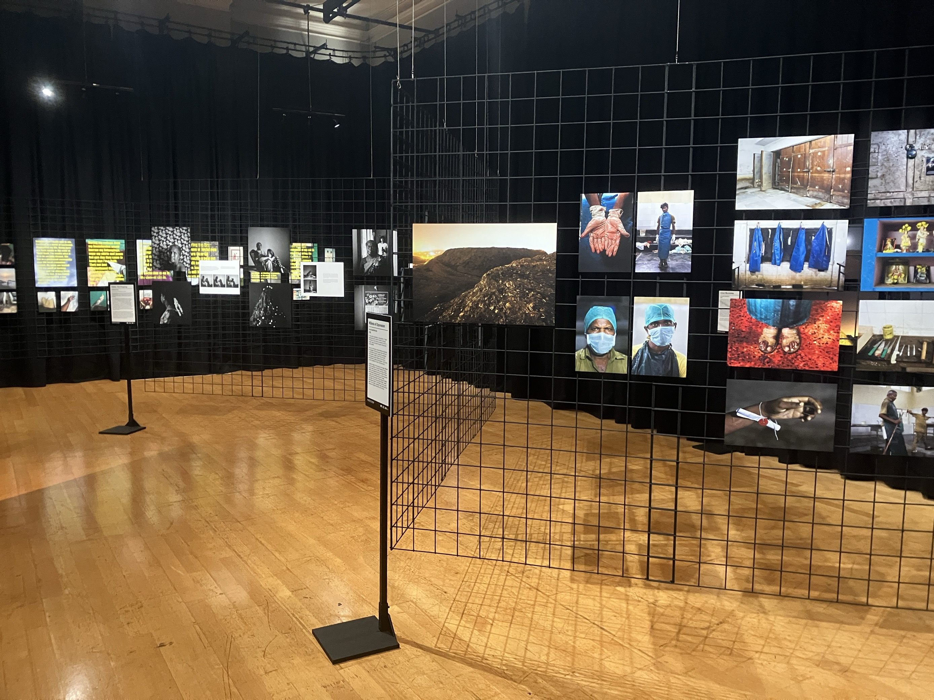

**Location**: This series of works is located in Studio 1 on level one of Arts House. Studio 1 is directly across from the top of the stairs. Artists featured in Studio 1 are Krithika Sriram, Jaisingh Nageswaran, M. Palani Kumar, Arun Vijai Mathavan and Sadia Marium.  
**Sound:** There is no sound in this exhibition.  
**Lighting:** There is bright, warm white overhead lighting.  
**Physical:** The venue has air-conditioning and the rooms are temperate.  
**Smell:** There are no scents or smells in this exhibition.  
**Visual:** Black curtains are hung against the walls. The photographs are displayed on black grid fencing that is hung against the curtains and suspended from the ceiling in a zig zag shape in the centre of the room.

## **Studio 2**

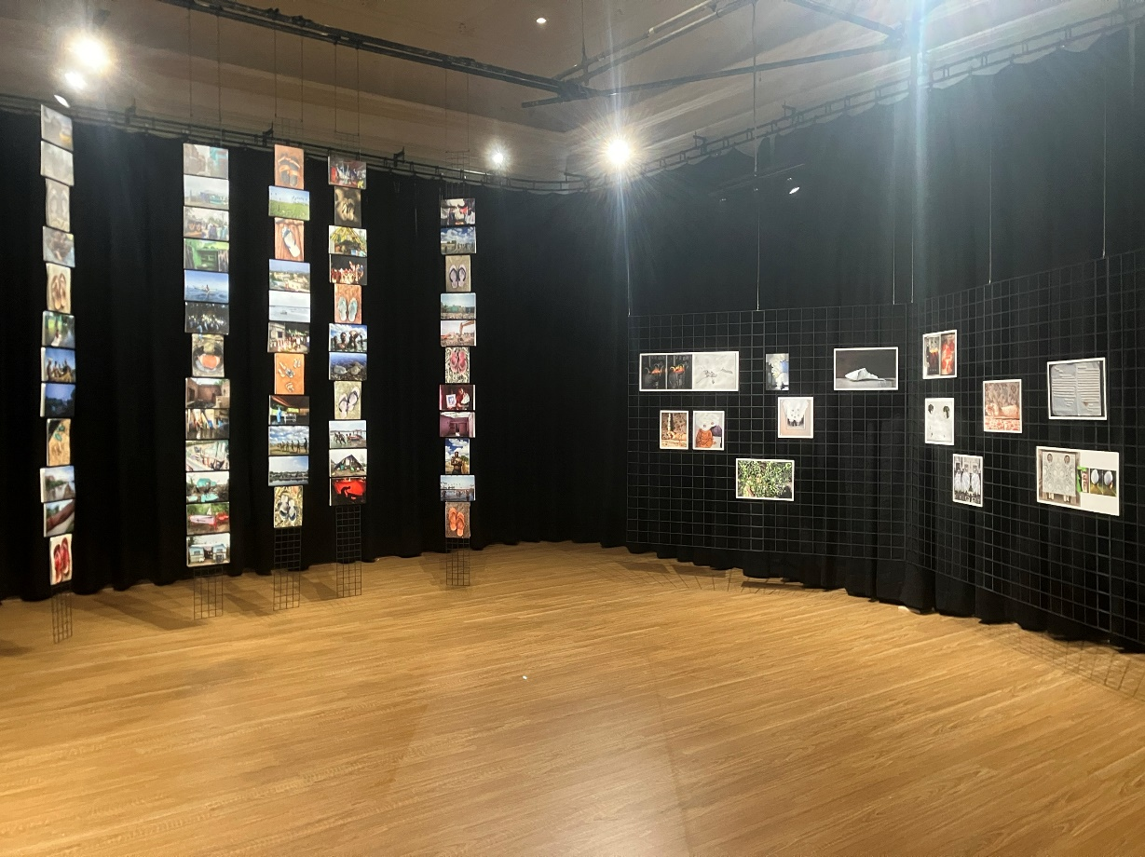

**Location:** This series of works is located in Studio 2 on level 1 of Arts House. Studio 2 is through the glass door to the left of the stairs. Artists featured in Studio 2 are M. Palani Kumar and Priya Suresh Kambli.  
**Sound:** There is no sound in this exhibition.  
**Lighting:** There is bright, warm white overhead lighting.  
**Physical:** The venue has air-conditioning and the rooms are temperate.  
**Smell:** There are no scents or smells in this exhibition.  
**Visual:** Black curtains are hung against the walls. The photographs are displayed on black grid fencing that is hung against the curtains and suspended from the ceiling in two areas of the room - a wide v-shape near to the wall opposite the door and in five tall narrow rectangles in the back corner of the room. The display of photographs on the narrow rectangles is double sided so people are invited to walk behind the display to view the other side.

Audience Experience

## **Entry to space**

The artworks in this exhibition are in Studio 1 and Studio 2 inside Arts House on the first floor.

Access to the foyer:  

* There are three different entry points to the main building. Two of these are wheelchair accessible entrances.
* The **Queensberry St** entrance has 9 steps with grab rails on both sides for all steps except the bottom two. The door for this entrance is a double glass door that opens automatically.
* The **Errol St** entrance is to the left of the Post Office. This entrance has an automatic door which is 850mm wide and operated by a push button to the right. This door will remain in its open position for approximately 20 seconds. This entrance can be accessed either via a ramp to the right of the Post Office entrance, or via three steps. The steps have tactile surface indicators and grab rails on either side. The button to open the automatic door is on the wall directly in front of the steps, and the automatic door will open to the left of this button.
* George Johnson Lane is located to the right of the Main Building. As this entrance is sometimes obstructed, we recommend using the Errol St entrance.

Access to Level 1:

Level 1 can be accessed either via lift or stairs from the foyer area

The stairs to Level 1 have grab rails on either side. Please note – the staircase is very wide, so grab rails are not able to be used on both sides at the same time. Studio 1 and Studio 2 are on this level.

## **Shocks or surprises**

There are no shocks or surprises.

## **Audience experience**

There is no expectation for audiences. You can experience the exhibition at any distance and pace.

## **Social expectations**

Audiences are able to move freely around the space. There may be staff, artists and other visitors in the building, however there is no requirement to interact with them. Our friendly reception staff will be able to guide you to information about the exhibition or assist with any technical questions.

There are chairs available in the foyer and on Level 1 outside Studio 1 and 2.

# **Other**

Curator Talk + Tour

Thursday 21 March, 6:30pm

During the Curator Talk + Tour, attendees will be invited to hear from curator Vishal Kumaraswamy and move throughout the exhibition on a guided tour. During this tour, attendees will not be called upon to speak or participate but may ask questions if they wish. Attendees will have time to experience the exhibition at their own space as part of this event.

# **The Venue**

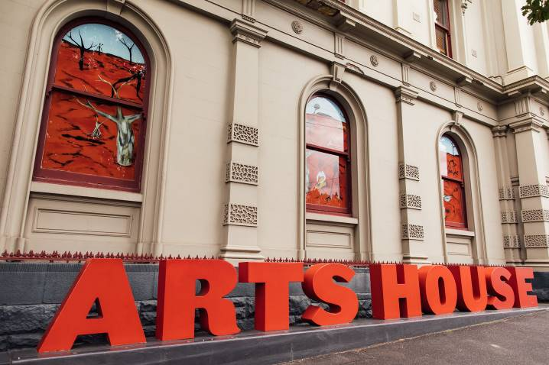

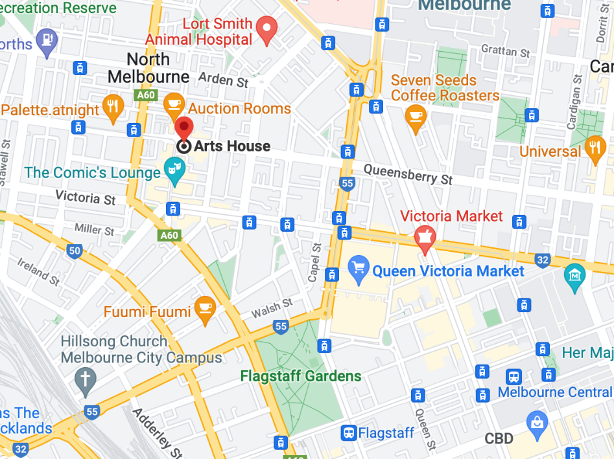

Image: North Melbourne Town Hall features giant red letters that say ARTS HOUSE out the   
front of it.

Image: a map of Arts House and its surrounding area. [LINK TO MAP](https://www.google.com/maps/place/Arts+House/@-37.802973,144.9486818,17z/data=!4m5!3m4!1s0x0:0x64c465ac7ef21cff!8m2!3d-37.803239!4d144.9498609?shorturl=1)

## **Front Entrance**

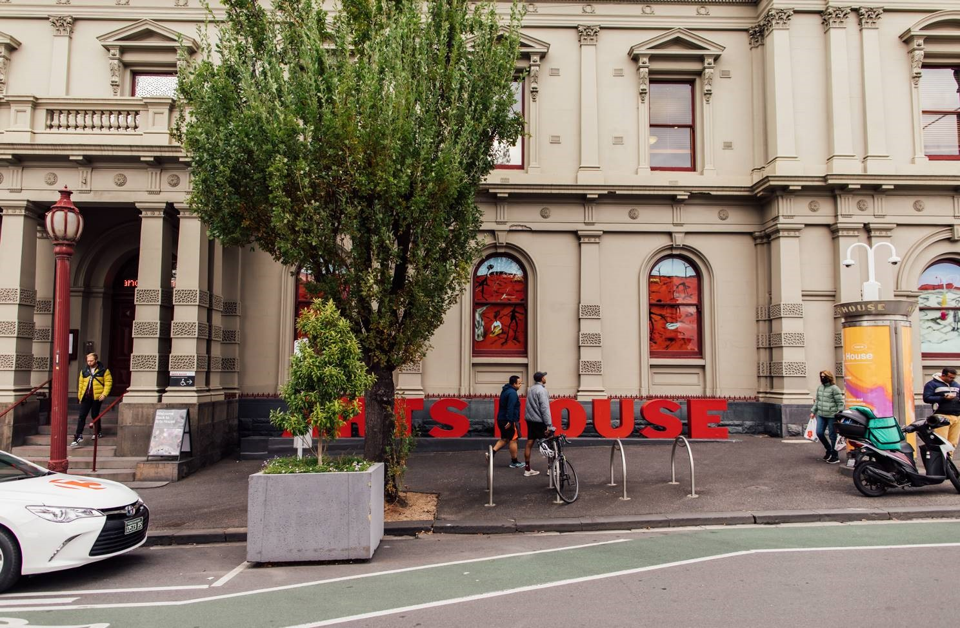

## **Accessible Entrances**



There are two Accessible Entrances. The first is on Errol St next to the Post Office.

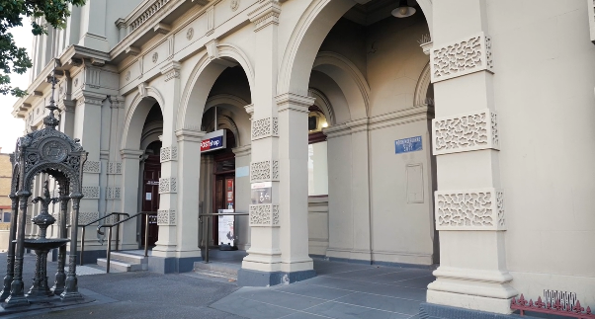

Image: Errol Street entrance next to the Post office with wheelchair accessible ramp or two steps with grab rails.

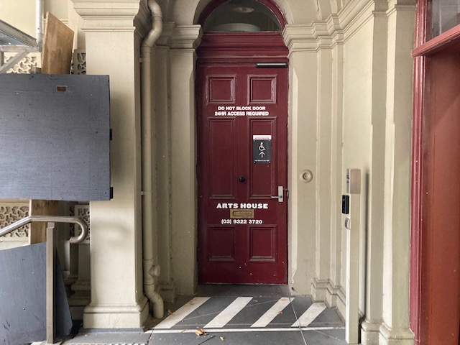

Image: View of door entrance.

The second Accessible Entrance is towards the end of George Johnson Lane.

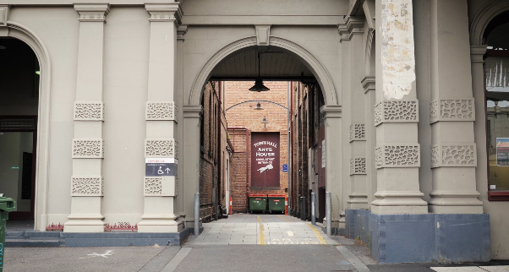

Image: View of George Johnson Lane from Errol St. The laneway passes through an archway with a brick wall at the end.

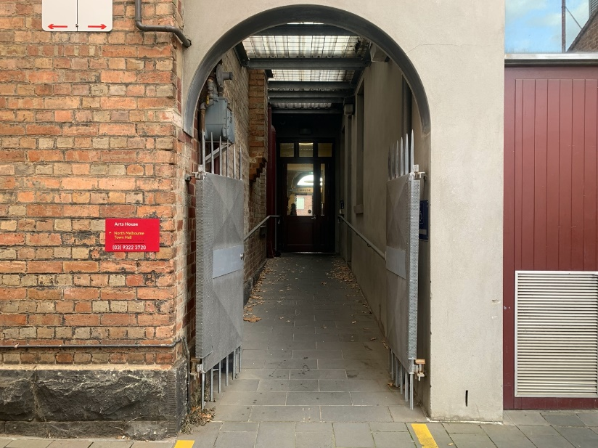

Image: view of the ramp leading from George Johnson Lane to the automated door which opens into the Arts House foyer.

## **Reception**

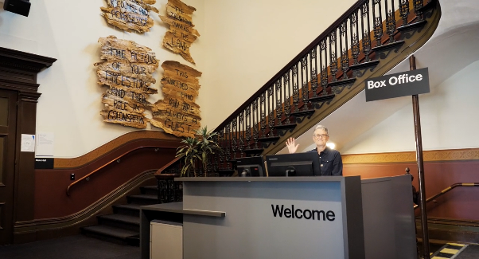

Box Office is located in the foyer under the stairwell.

## **Quiet Space**

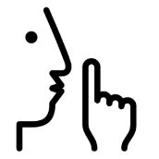

Arts House Quiet Space is located on Ground Level and is nearby reception and opposite the accessible bathrooms. It includes a range of seating options including soft furnishings, dimmable lights, sensory and stim objects. It is open during venue opening hours and events as a quiet space, prayer or parenting space.

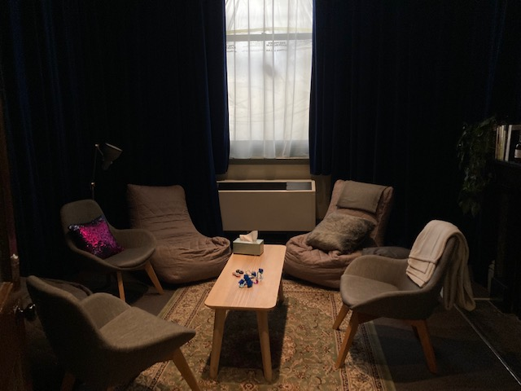

Image: Quiet space with lights dimmed

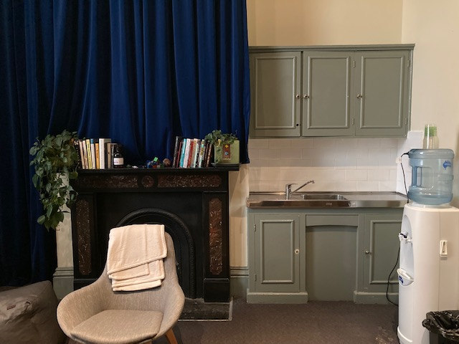

Image: Quiet space kitchenette and book shelf

## **Bathrooms**

All bathrooms have Dyson hand dryers with sensor activation. There is an accessible bathroom that is single use on ground level opposite the Quiet Space. There is another accessible bathroom upstairs – this is accessible via lift or stairs.

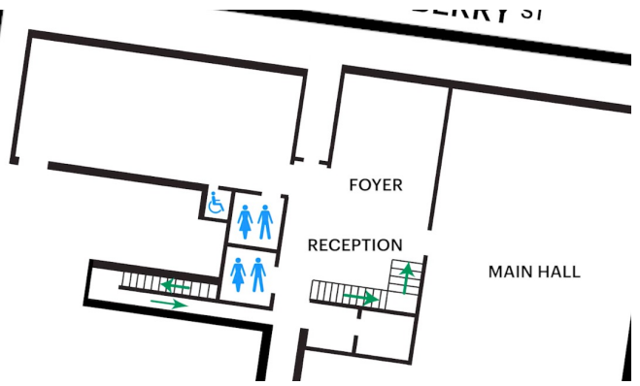

## **Lift**

The lift is located behind reception desk in the foyer.

The closest entry to the lift is via George Johnson Lane.

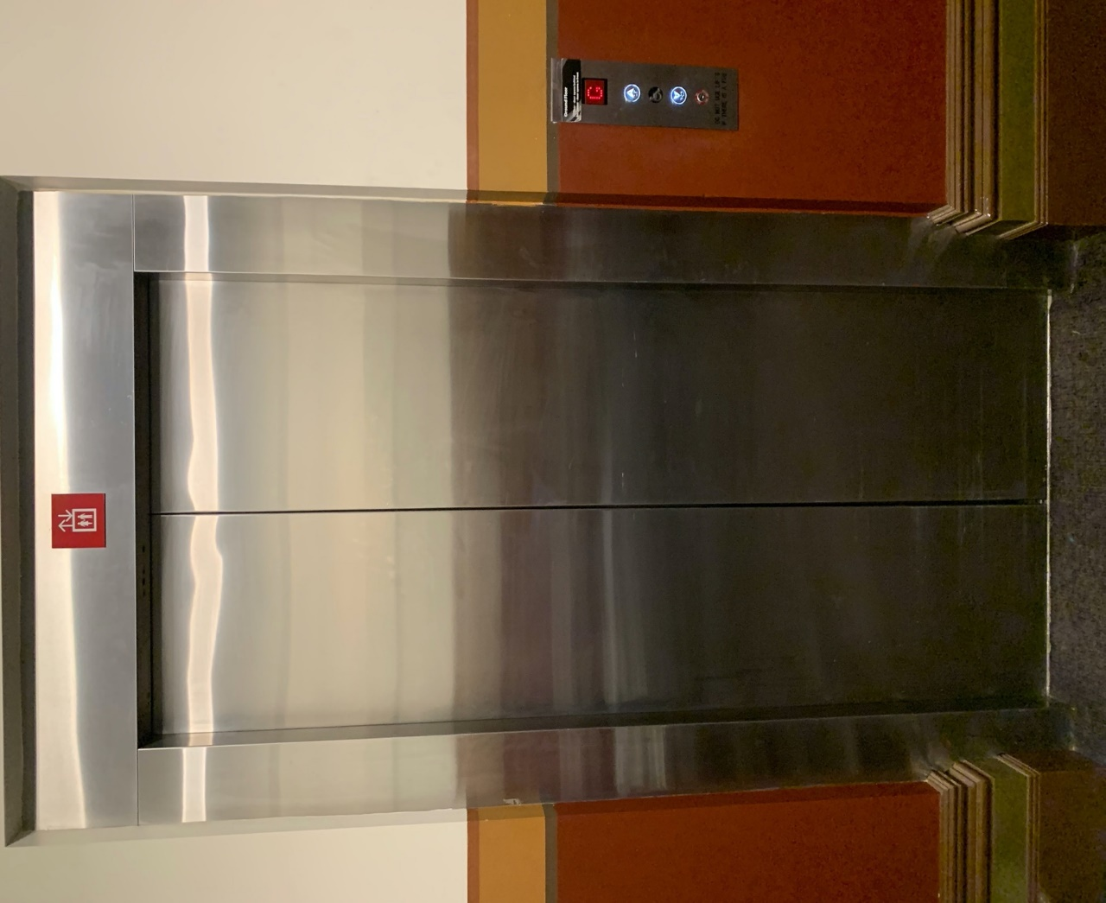

# **Transport**

## **Tram**

Route 57 (High Floor trams only)

Stop 12, North Melbourne Town Hall.

Please note, this is not a wheelchair accessible tram

[GETTING TO ARTS HOUSE VIDEO LINK](https://vimeo.com/544169506)

## **Train**

Arts House is 1.1km from   
North Melbourne Train Station,   
approximately 16 minute walk

[North Melbourne Station Information](https://www.ptv.vic.gov.au/stop/1144/north-melbourne-station/0/train/)

1.2km from Flagstaff Station,   
approximately 15 minute walk

[Flagstaff Station Information](https://www.ptv.vic.gov.au/stop/1068/flagstaff-station/0/train/#StopPage:::datetime=2023-04-06T04%3A41%3A27.669Z&directionId=-1&showAllDay=false&_auth=408ac3b1e97f4b0beb5bdf00c2f797057d10dd6e6cf2ad40a69334c4dfdf5e21)

## **Bus**

Bus number: 216

## **Parking**

There is limited paid on-street parking on Queensberry Street and Errol Street.

There are two accessible on street car parking spaces on Queensberry Street (150m to our accessible Errol Street entrance) for holders of a Parking Permit for Disabled people.

# **COVID Safety**

Please note: If you have a cough, sore throat, fever, shortness of breath or flu-like symptoms, you must not attend our venue or programs in person.

We will provide a refund if you need to cancel your attendance due to illness. Please [contact us](mailto:ArtsHouse.Ticketing@melbourne.vic.gov.au) by 9am on the day of the event.

To minimise the risk of COVID-19 transmission, we advise all patrons, artists and staff to:

* Practise physical distancing where possible
* Practise good hygiene by washing and or sanitising your hands often
* Wear a mask as directed by Victorian Government guidelines

Throughout the venue you will find:

* hand sanitiser stations available
* masks available (ask one of our staff for assistance)​
* increased signage to direct patron movement and avoid crowd congestion

We also ensure that spaces are well ventilated.

Staying COVID-safe remains important. We must all follow these steps:

* Follow the [Victorian Government’s measures on how to stay safe.](https://www.betterhealth.vic.gov.au/coronavirus-covid-19-victoria)
* Wear[face masks](https://www.betterhealth.vic.gov.au/coronavirus-covid-19-victoria) where required or when you cannot safely socially distance.
* Practise [COVID-safe hygiene protocols.](https://www.health.gov.au/news/health-alerts/novel-coronavirus-2019-ncov-health-alert/how-to-protect-yourself-and-others-from-coronavirus-covid-19/good-hygiene-for-coronavirus-covid-19)
* Test for COVID and get [free rapid antigen tests​](https://www.melbourne.vic.gov.au/community/health-support-services/health-services/Pages/free-rapid-antigen-tests.aspx) at nominated City of Melbourne customer service and library sites.