**Neighbourhood Gathering**

Hosted by Arts House

Access Guide

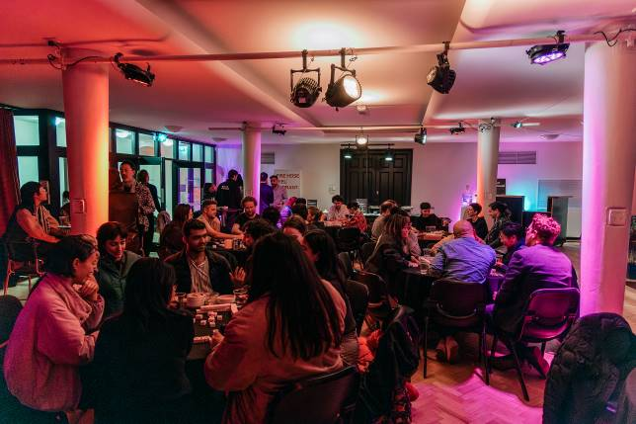

Image: *CAAP Longhouse* presented as part of Season 1, 2023. Photo by Jacinta Keefe

Image Description: A group of people sit around round tables, they are chatting and playing mahjong. The room is lit with pink toned lights.

# **Updates to this document**

Please note, we will endeavour to provide the latest access information on this event.

Arts House website will contain the most up to date version of this document and all ticket holders will be notified of any revisions made 3 days and 1 day prior to the event.

This document was created: 18 January 2024 Last update: 1 February 2024

**Contents**

**Updates to this document** 1

**Where** 3

**When** 3

**Access Services** 3

**Host** 4

**Running Order** 6

**Sensory Elements** 6

Sound 6

Lighting 6

Physical 6

Smell 7

Visual 7

Entry to space 7

Shocks or surprises 8

Audience experience 8

Social expectations 8

**Other** 8

Content Warnings 8

**General Notes** 9

**The Venue** 10

Front Entrance 10

Building Access Information 11

Accessible Entrances 11

Reception 12

Quiet Space 14

Bathrooms 14

Lift 15

**Transport** 16

Tram 16

Train 16

Bus 16

Parking 16

**COVID Safety** 17

# **Where**

Arts House

521 Queensberry Street

North Melbourne VIC

# **When**

Wednesday 14 February  
10.30am  
Duration: 90 minutes

# **Access Services**

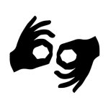

Auslan Interpreted – on request, email [artshouseticketing@melbourne.vic.gov.au](mailto:artshouseticketing@melbourne.vic.gov.au)    
by Friday 9 February.



Assistance Animal are welcome.



This session is fully wheelchair accessible.

# **Hosts**

This event will be hosted by three speakers: Acting Artistic Director Olivia Anderson, local resident Lorna Hannan and access consultant Jonathan Craig.

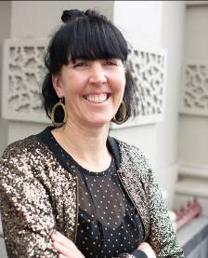

Image description: Olivia is wearing a sparkly gold jacket in front of a textured beige wall.

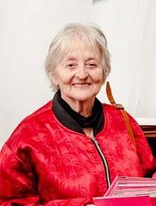

Image: Lorna Hannan wearing a bright red jacket zipped up in front of draped white material.

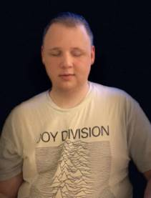

Image: Jonathan is wearing white shirt with a illustrative drawing of mountains and JOY DIVISION written at the top.

Approximately 14 members of the Arts House staff will also be in attendance:



**Amrit**  
Creative Program Lead



**Louana**  
Creative Producer



**Sarah**  
Acting Program Manager

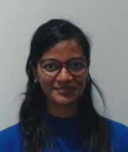

**Varsha**  
Associate Producer



**Tony**  
Production Manager

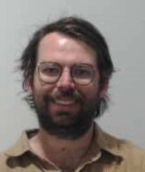

**Bart**  
Technical Coordinator

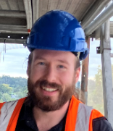

**Taran**  
Venue Technician

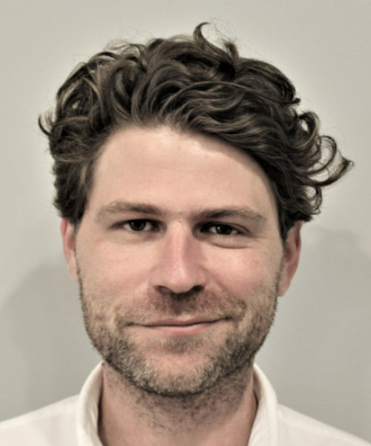

**Jake**  
Marketing Manager

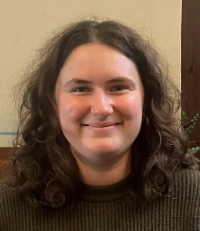

**Lucy**  
Audience Engagement Coordinator

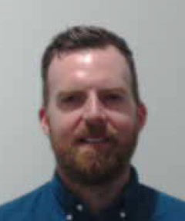

**Adam**  
Front of House Manager

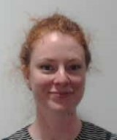

**Charlie**  
Ticketing & House Supervisor

Brian

**Brian**  
Business Manager

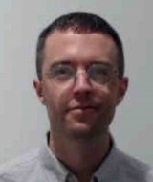

**Bas**  
Business Administrator

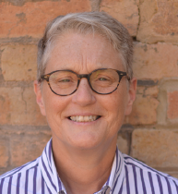

**Trudy**  
Business Support Officer

# **Running Order**

10.15am Doors Open & light refreshments available

10.30am Acknowledgement of Country Welcome to Arts House, Introduction to speakers and what today is all about – hosted by Olivia Anderson

10.40am Some of the Arts House staff will introduce themselves and shares insight into their role

10.50am Discussion about [Season 1, 2024 program](https://www.artshouse.com.au/whats-on/) between Olivia Anderson, Jonathan Craig and Lorna Hannan

11.25am We will move to Arts House Main Hall to watch a short excerpt from [CUDDLE](https://www.artshouse.com.au/events/cuddle/) by performers Harrison Ritchie-Jones and Michaela Tancheff + a short Q&A

11.45am Wrap-up & light refreshments

12.00pm Finish

# **Sensory Elements**

## **Sound**

The first part of this event is conversational and speakers will use microphones. Soft background music will be playing in the venue foyer as people arrive.

Part way through this event we will move to the main hall to experience a short performance excerpt of CUDDLE. There will be music played during this excerpt and potentially voice manipulation.

## **Lighting**

The Neighbourhood Gathering conversation will be standard interior building lighting with no flashing or moving lights. The excerpt of CUDDLE may involve low lights and lights that change colour and intensity – we will provide more details prior to event.

## **Physical**

The venue has air conditioning. Rooms are an adequate temperature.

## **Smell**

There will be light vegetarian catering available in the space from Asylum Seeker Resource Centre that will include the smell of spices, fruit and other ingredients.

The menu includes:

* Feta and spinach triangles baked with sesame seeds and sumac
* Rice paper rolls with noodles, red cabbage, carrot, tofu, aromatic herbs, chilli cider sauce (DF, OGF, V, WGF)
* Ganache filled profiterole
* ASRC selected Danishes

## **Visual**

The speakers will sit in a row on chairs marked out by a rug. At the side of the speakers, there will be a large screen playing a slideshow of images from our Season 1 artists. There will be a number of seats in the space and high bars for guests.

The excerpt of CUDDLE will be performed by two people – Harrison Ritchie-Jones and Michaela Tancheff. The performers may be partially nude and wear balaclavas. They will perform a range of contemporary dance movements with elements from martial arts, figure skating and rodeo barnyard dance. We will provide more visual details prior to event.

Audience Experience

## **Entry to space**

The first part of this event will take place in Studio 2 at Arts House. This space is located on Level 1 of the main building. Front of house will guide you from the foyer.

Access to space:

* Studio 2 can be accessed either via the lift or stairs from the foyer area
* There are 25-carpeted stairs to Studio 2 with grab rails either side. *Please note -* this staircase is very wide, so grab rails are not able to be used on both sides at the same time.
* Entry to Studio 2 is through a double door. When both doors are open the doorway is 1390mm wide.

The performance will take place in the Main Hall at Arts House. This space is located on Ground Floor of the main building. Front of house will guide you to the space.

Access to space:

* Main Hall can be accessed either via the lift or stairs
* There are 25-carpeted stairs to the Main hall with grab rails either side. *Please note -* this staircase is very wide, so grab rails are not able to be used on both sides at the same time.
* Entry to the main hall is through large double doors in the main foyer. The doors open towards you.

## **Shocks or surprises**

There are currently no shocks or surprises - we will provide more details prior to event

## **Audience experience**

This session involves optional light social interaction with other members of the public and Arts House staff.

## **Social expectations**

There will be a variety of seating options. There is no allocated seating - You are welcome to sit anywhere you like in the room or stand if you prefer.

You are welcome to come and go in the space and have a cuppa or snack whilst the session is happening.

You are welcome to sit or stand during the performance excerpt.

# **Other**

## **Content Warnings**

The excerpt of *CUDDLE* contains partial nudity, possible haze effects, low lights and lights that change colour and intensity, voice manipulation.

## **General Notes**

The session will commence with an Acknowledgment of Country in the space.

There may be two Auslan interpreters if someone has requested this service.

# **The Venue**

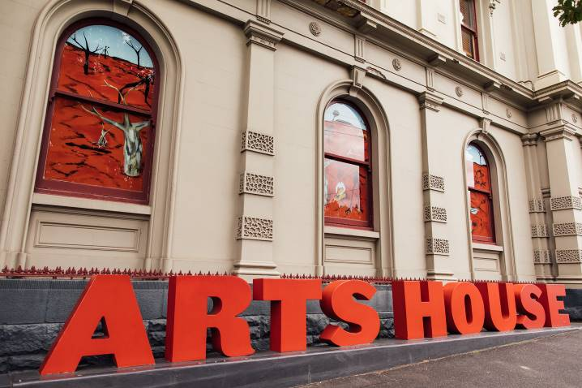

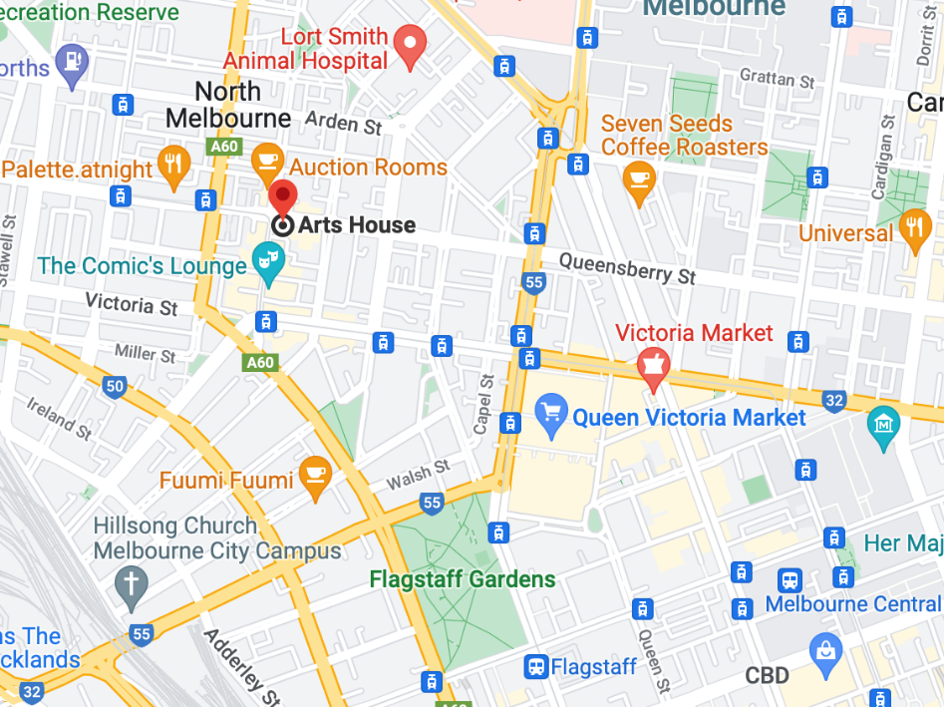

Image: North Melbourne Town Hall features giant red letters that say ARTS HOUSE out the front of it.

Image: a map of Arts House and its surrounding area. [LINK TO MAP](https://www.google.com/maps/place/Arts+House/@-37.802973,144.9486818,17z/data=!4m5!3m4!1s0x0:0x64c465ac7ef21cff!8m2!3d-37.803239!4d144.9498609?shorturl=1)

## **Front Entrance**

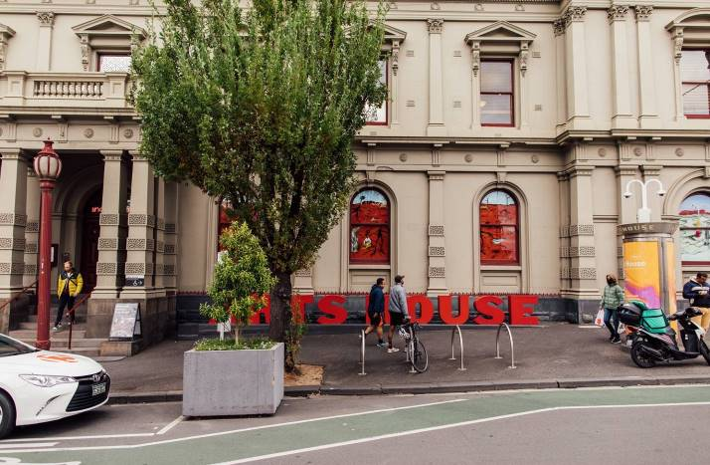

## **Building Access Information**

To familiarise yourself with the space before you arrive, explore Arts House virtually through a 3D scan of the building by clicking [here](https://tourmkr.com/F1jsn73hDg/36140818p&49.3h&89.59t).

To download a verbal map to help with navigation throughout the building, please click [here](https://www.artshouse.com.au/wp-content/uploads/2022/11/Verbal_Map_of_Arts_House_2022.docx).

To download a building document that outlines detailed information on amenities, access, navigation, parking and drop-off, please click [here](https://www.artshouse.com.au/wp-content/uploads/2022/11/Arts_House_Building_Information_2022.docx).

## **Accessible Entrances**



There are two Accessible Entrances. The first is on Errol St next to the Post Office.

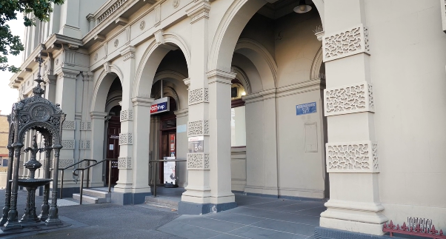

Image: Errol Street entrance next to the Post office with wheelchair accessible ramp or two steps with grab rails.

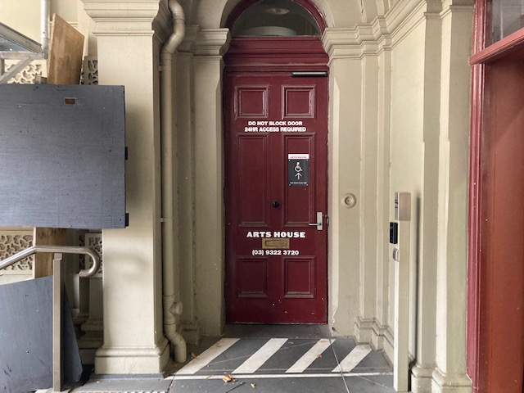

Image: View of door entrance.

The second Accessible Entrance is towards the end of George Johnson Lane.

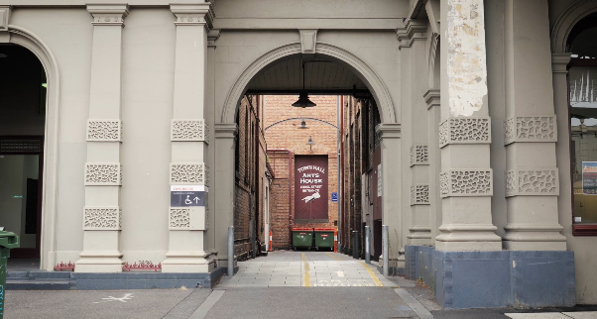

Image: View of George Johnson Lane from Errol St. The laneway passes through an archway with a brick wall at the end.

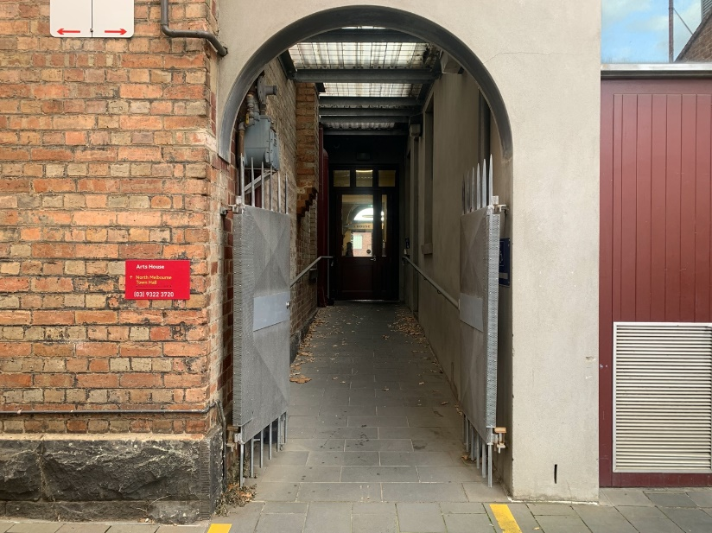

Image: view of the ramp leading from George Johnson Lane to the automated door which opens into the Arts House foyer.

## **Reception**

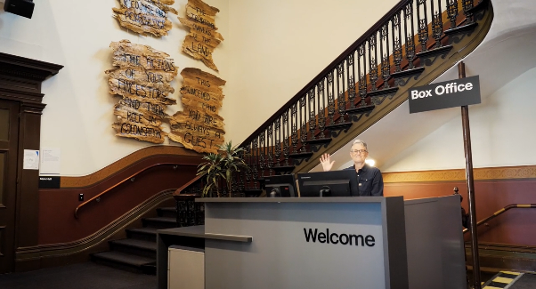

Reception is located in the foyer under the stairwell.

## **Event Space**

The event is in Studio 2.

It is on Level 1.

You can access this space via the staircase or lift.

Front of house staff will direct you.

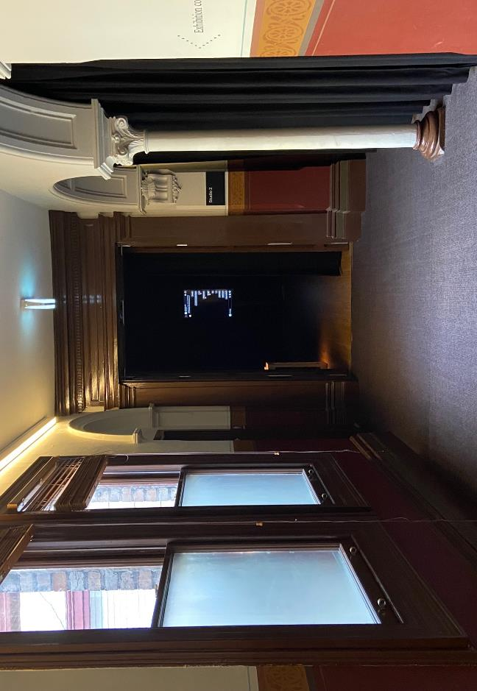

Image: view of the entrance to Studio 2 with doors open from midway down the hallway at the top of the stairs on Level 1. There are two windows with natural light coming in from the left, a white pillar and black curtain at the edge of the space to the right.

## **Quiet Space**

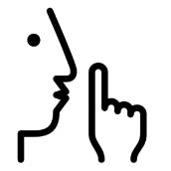

Arts House Quiet Space is located on Ground Level and is nearby reception and opposite the accessible bathrooms. It includes a range of seating options including soft furnishings, dimmable lights, sensory and stim objects. It is open during venue opening hours and events as a quiet space, prayer or parenting space.

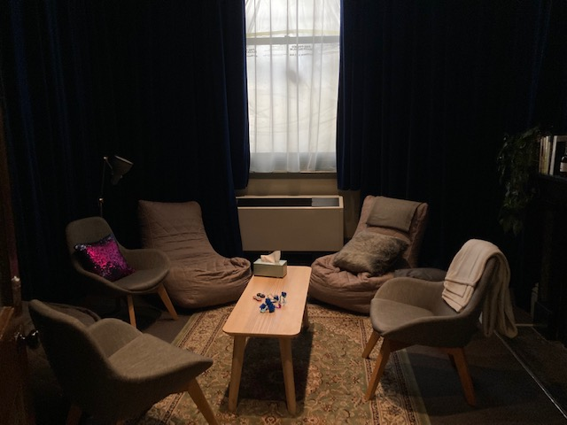

Image: Quiet space with lights dimmed

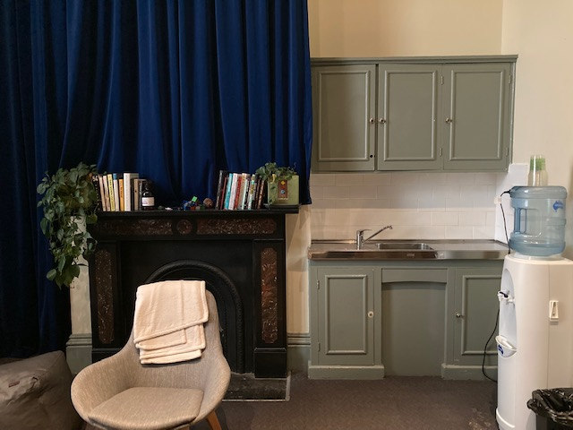

Image: Quiet space kitchenette and book shelf

## **Bathrooms**

All bathrooms have Dyson hand dryers with sensor activation. There is an accessible bathroom that is single use on ground level opposite the Quiet Space. There is another accessible bathroom upstairs – this is accessible via lift or stairs.

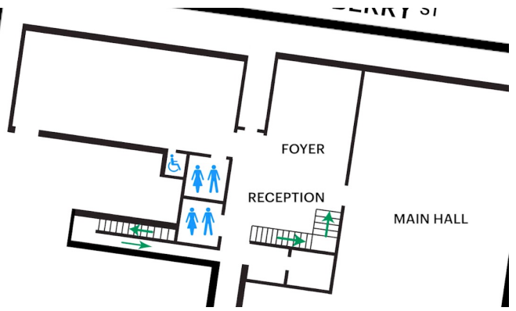

## **Lift**

The lift is located behind reception desk in the foyer.

The closest entry to the lift is via George Johnson Lane.

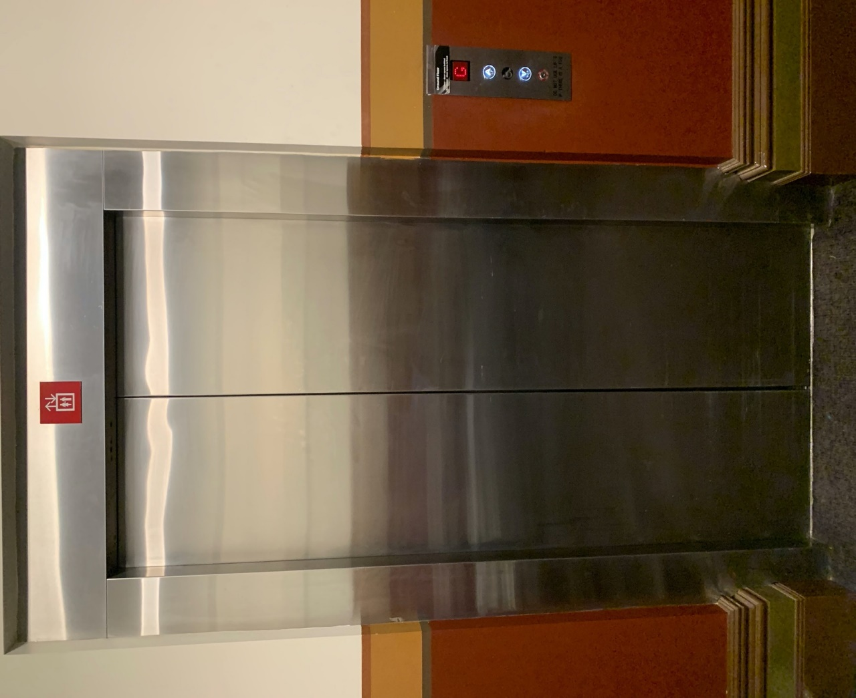

# **Transport**

## **Tram**

Route 57 (High Floor trams only)

Stop 12, North Melbourne Town Hall.

Please note, this is not a wheelchair accessible tram

[GETTING TO ARTS HOUSE VIDEO LINK](https://vimeo.com/544169506)

## **Train**

Arts House is 1.1km from   
North Melbourne Train Station,   
approximately 16 minute walk

[North Melbourne Station Information](https://www.ptv.vic.gov.au/stop/1144/north-melbourne-station/0/train/)

1.2km from Flagstaff Station,   
approximately 15 minute walk

[Flagstaff Station Information](https://www.ptv.vic.gov.au/stop/1068/flagstaff-station/0/train/#StopPage:::datetime=2023-04-06T04%3A41%3A27.669Z&directionId=-1&showAllDay=false&_auth=408ac3b1e97f4b0beb5bdf00c2f797057d10dd6e6cf2ad40a69334c4dfdf5e21)

## **Bus**

Bus number: 216

## **Parking**

There is limited paid on-street parking on Queensberry Street and Errol Street.

There are two accessible on street car parking spaces on Queensberry Street (150m to our accessible Errol Street entrance) for holders of a Parking Permit for Disabled people.

# **COVID Safety**

Please note: If you have a cough, sore throat, fever, shortness of breath or flu-like symptoms, you must not attend our venue or programs in person.

We will provide a refund if you need to cancel your attendance due to illness. Please [contact us](mailto:ArtsHouse.Ticketing@melbourne.vic.gov.au) by 9am on the day of the event.

To minimise the risk of COVID-19 transmission, we advise all patrons, artists and staff to:

* Practise physical distancing where possible
* Practise good hygiene by washing and or sanitising your hands often
* Wear a mask as directed by Victorian Government guidelines

Throughout the venue you will find:

* hand sanitiser stations available
* masks available (ask one of our staff for assistance)​
* increased signage to direct patron movement and avoid crowd congestion

We also ensure that spaces are well-ventilated.

Staying COVID-safe remains important. We must all follow these steps:

* Follow the [Victorian Government’s measures on how to stay safe.](https://www.betterhealth.vic.gov.au/coronavirus-covid-19-victoria)
* Wear[face masks](https://www.betterhealth.vic.gov.au/coronavirus-covid-19-victoria) where required or when you cannot safely socially distance.
* Practise [COVID-safe hygiene protocols.](https://www.health.gov.au/news/health-alerts/novel-coronavirus-2019-ncov-health-alert/how-to-protect-yourself-and-others-from-coronavirus-covid-19/good-hygiene-for-coronavirus-covid-19)
* Test for COVID and get [free rapid antigen tests​](https://www.melbourne.vic.gov.au/community/health-support-services/health-services/Pages/free-rapid-antigen-tests.aspx) at nominated City of Melbourne customer service and library sites.