**Weredingo**

By Karul Projects

Access Guide

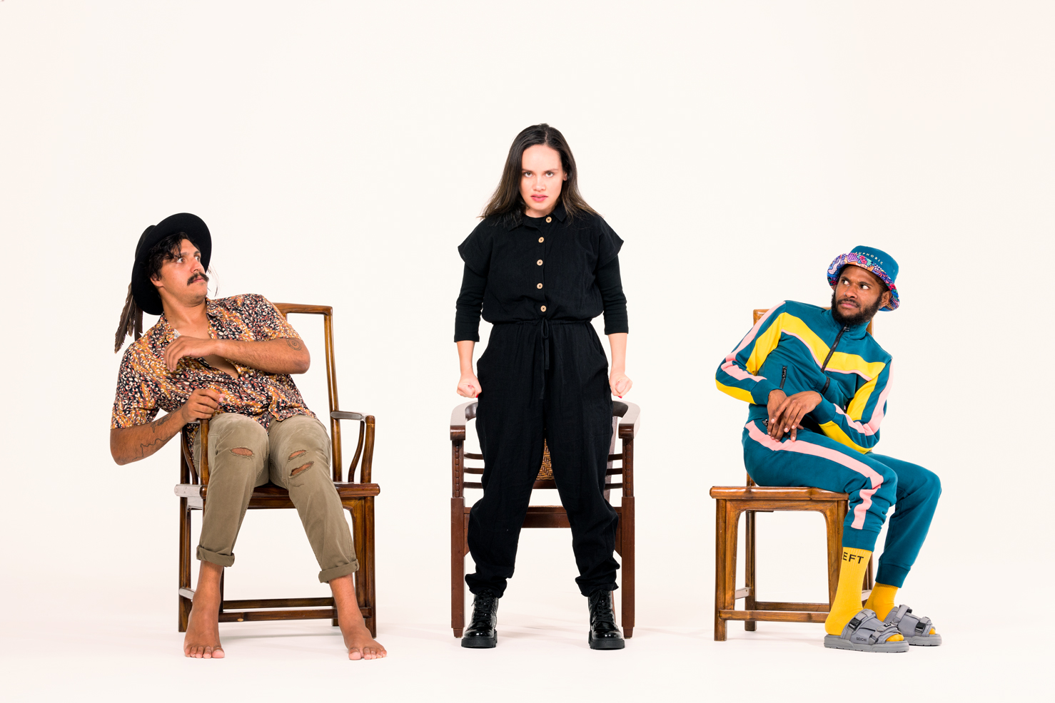

Image: promotional image for the show. Photo by Mick Richards.

This document was created: 13 October 2023

**Contents**

**Where** 3

**When** 3

**Access Services** 3 - 5

**Performers** 6

**Sensory Elements** 7

Sound 7

Lighting 7

Physical 7

Smell 7

Visual 7

Entry to space 8

Shocks or surprises 8

Audience experience 8

Social expectations 8

Performance expectations 9

**Other** 9

Content Warnings 9

General Notes 9

**The Venue** 10

**Front Entrance** 10

**Accessible Entrances** 11

**Box Office** 12

**Ushers** 12

**Bar** 13

**Quiet Space** 14

**Bathrooms** 14

**Door to Main Hall** 15

**Lift** 16

**Transport** 17

**Tram** 17

**Train** 17

**Bus** 17

**Parking** 17

**COVID Safety** 18

# 

# **Where**

Arts House

521 Queensberry Street

North Melbourne VIC

# **When**

**Wednesday 1 – Sunday 5 November**

Wednesday – Saturday, **7.30pm**

Sunday, **5.30pm**

Duration: 50 minutes

**Post-show artist talk**  
Thursday 2 November, free for all ticketholders

**Tactile Tour and Audio Described Performance**  
Friday 3 November

**Access Services**



**Audio description** – Audio describers provide verbal descriptions of actions, costumes, scenery and other visual elements of performances. Audio description can be live via personal headsets, pre-recorded or one-on-one with personal describer guides. See individual events for details on service.

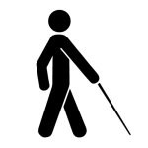

**Tactile Tours** – this service invites patrons who are blind or have low vision and their companions to explore the set, props and costumes prior to the performance. This service is often offered in conjunction with Audio Description.



**Assistance Animal –** assistance animals are welcome at Arts House.



**Assistive Listening –** is available free of charge to help amplify or enhance the sound quality of an event. Ask staff for assistance on arrival.



**Aural Rating 50%** – contains both sound and visual components, but sight is not essential to be able to engage with the event.



**Visual Rating 50%** – includes dialogue and background music or sounds, so Deaf and hard of hearing audiences can have some engagement with the event. 



**Wheelchair Accessible** – physical accessibility varies from event to event, and if a show includes the symbol, this indicates the performance is fully wheelchair accessible. If there is no wheelchair symbol, access may be partial – get in touch if you’d like more info.



**Companion Card –** You can book your complimentary companion ticket online or over the phone when purchasing tickets to any show. Contact our box office team for more information.



**Quiet Space –** located on Ground Level near reception, this is a shared space suitable for recovery from sensory overload, prayer, or parenting. It features a range of seating options, dimmable lights, sensory and stimming objects. Anyone is welcome to access this space during venue operating hours and events.

# **Performers**

Thomas E.S Kelly – Co-Artistic Director of Karul Projects / Performer

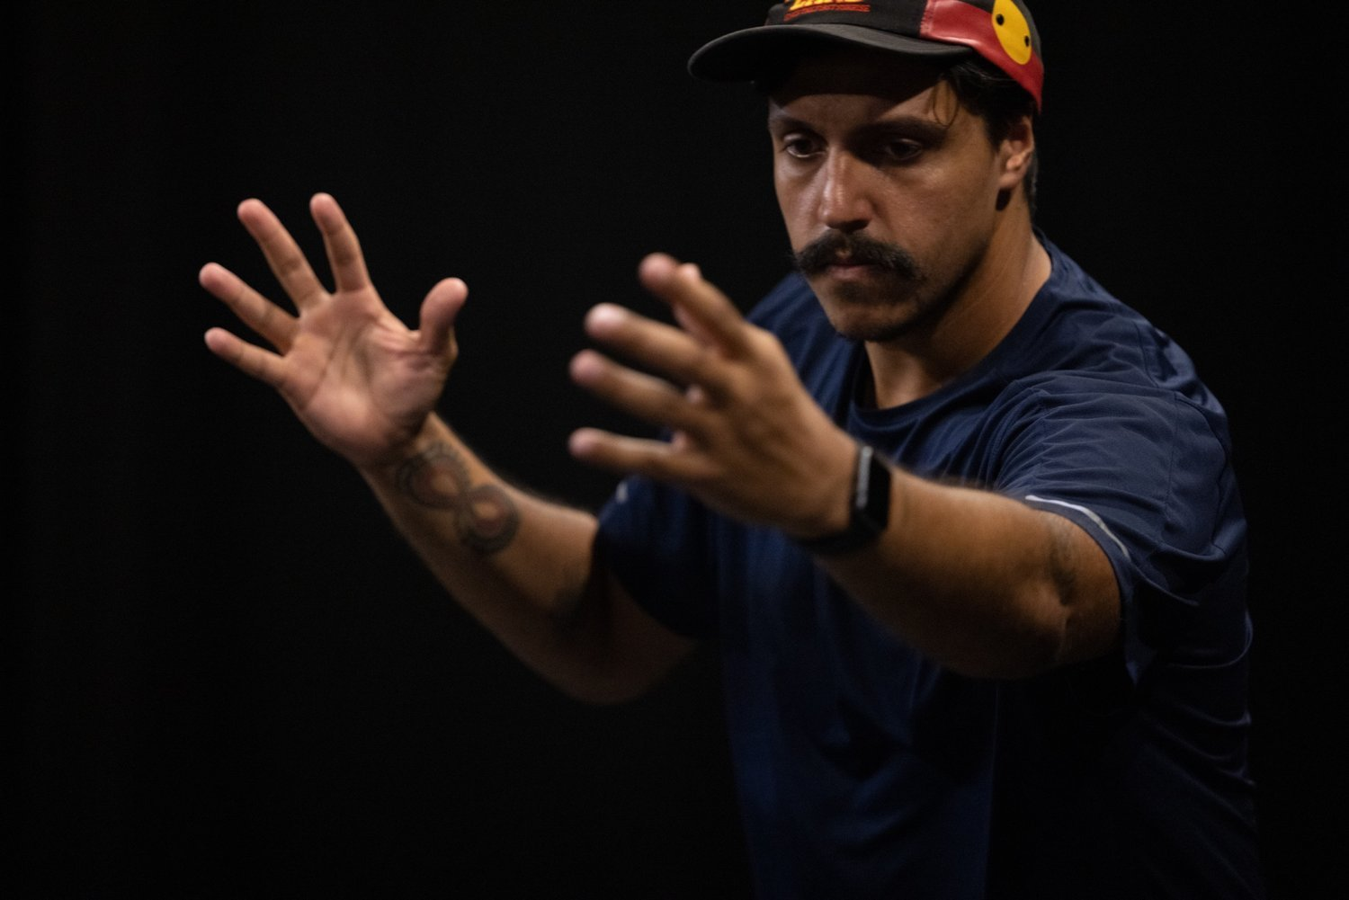

Vicki Van Hout – Performer

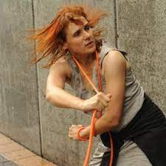

Benjin Maza – Performer

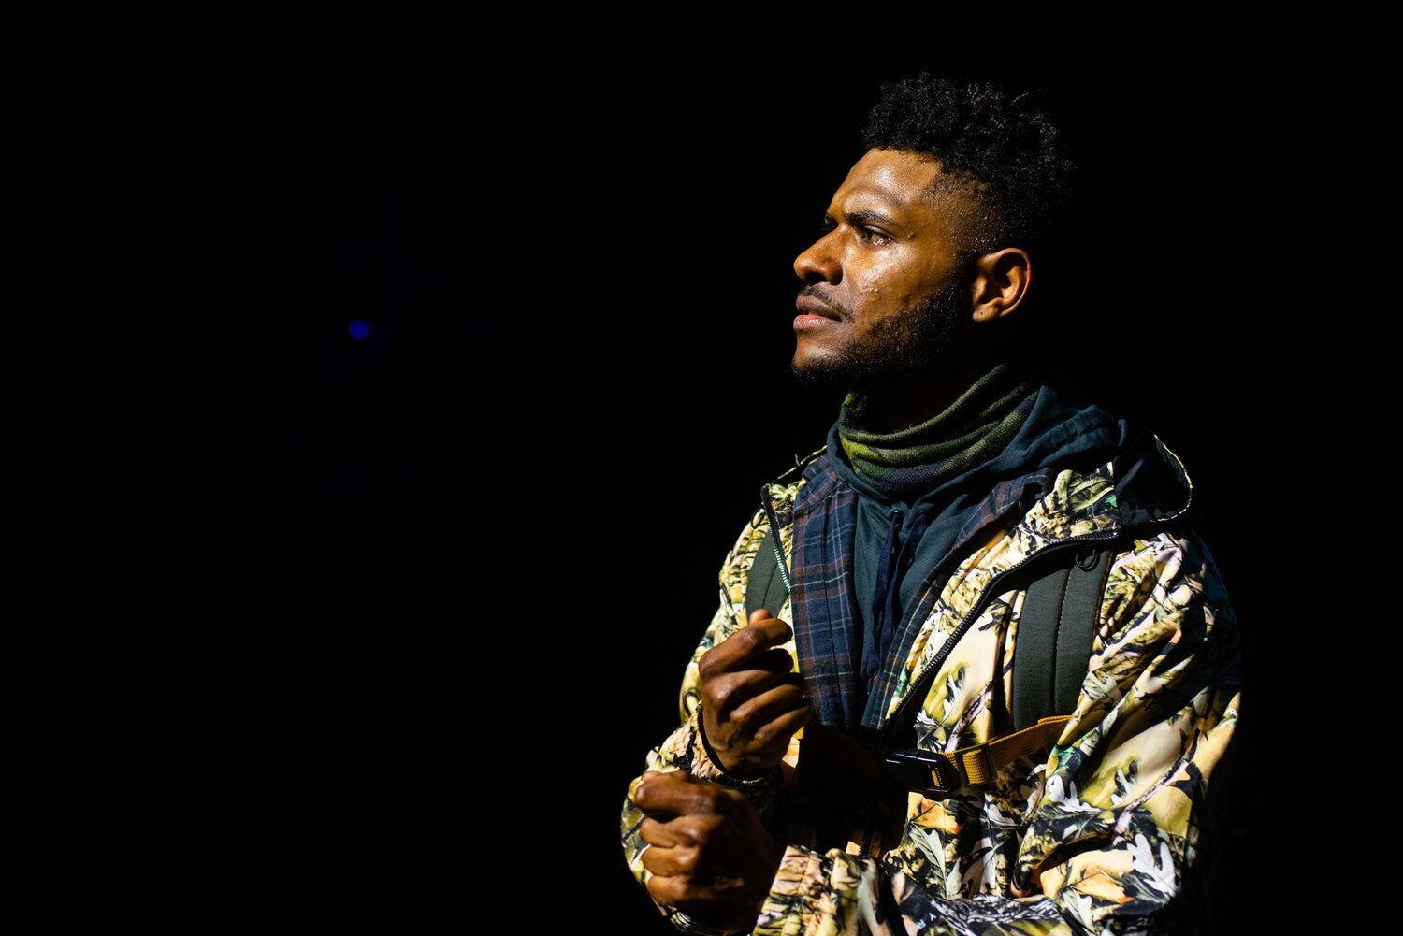

Glory Tuohy – Performer

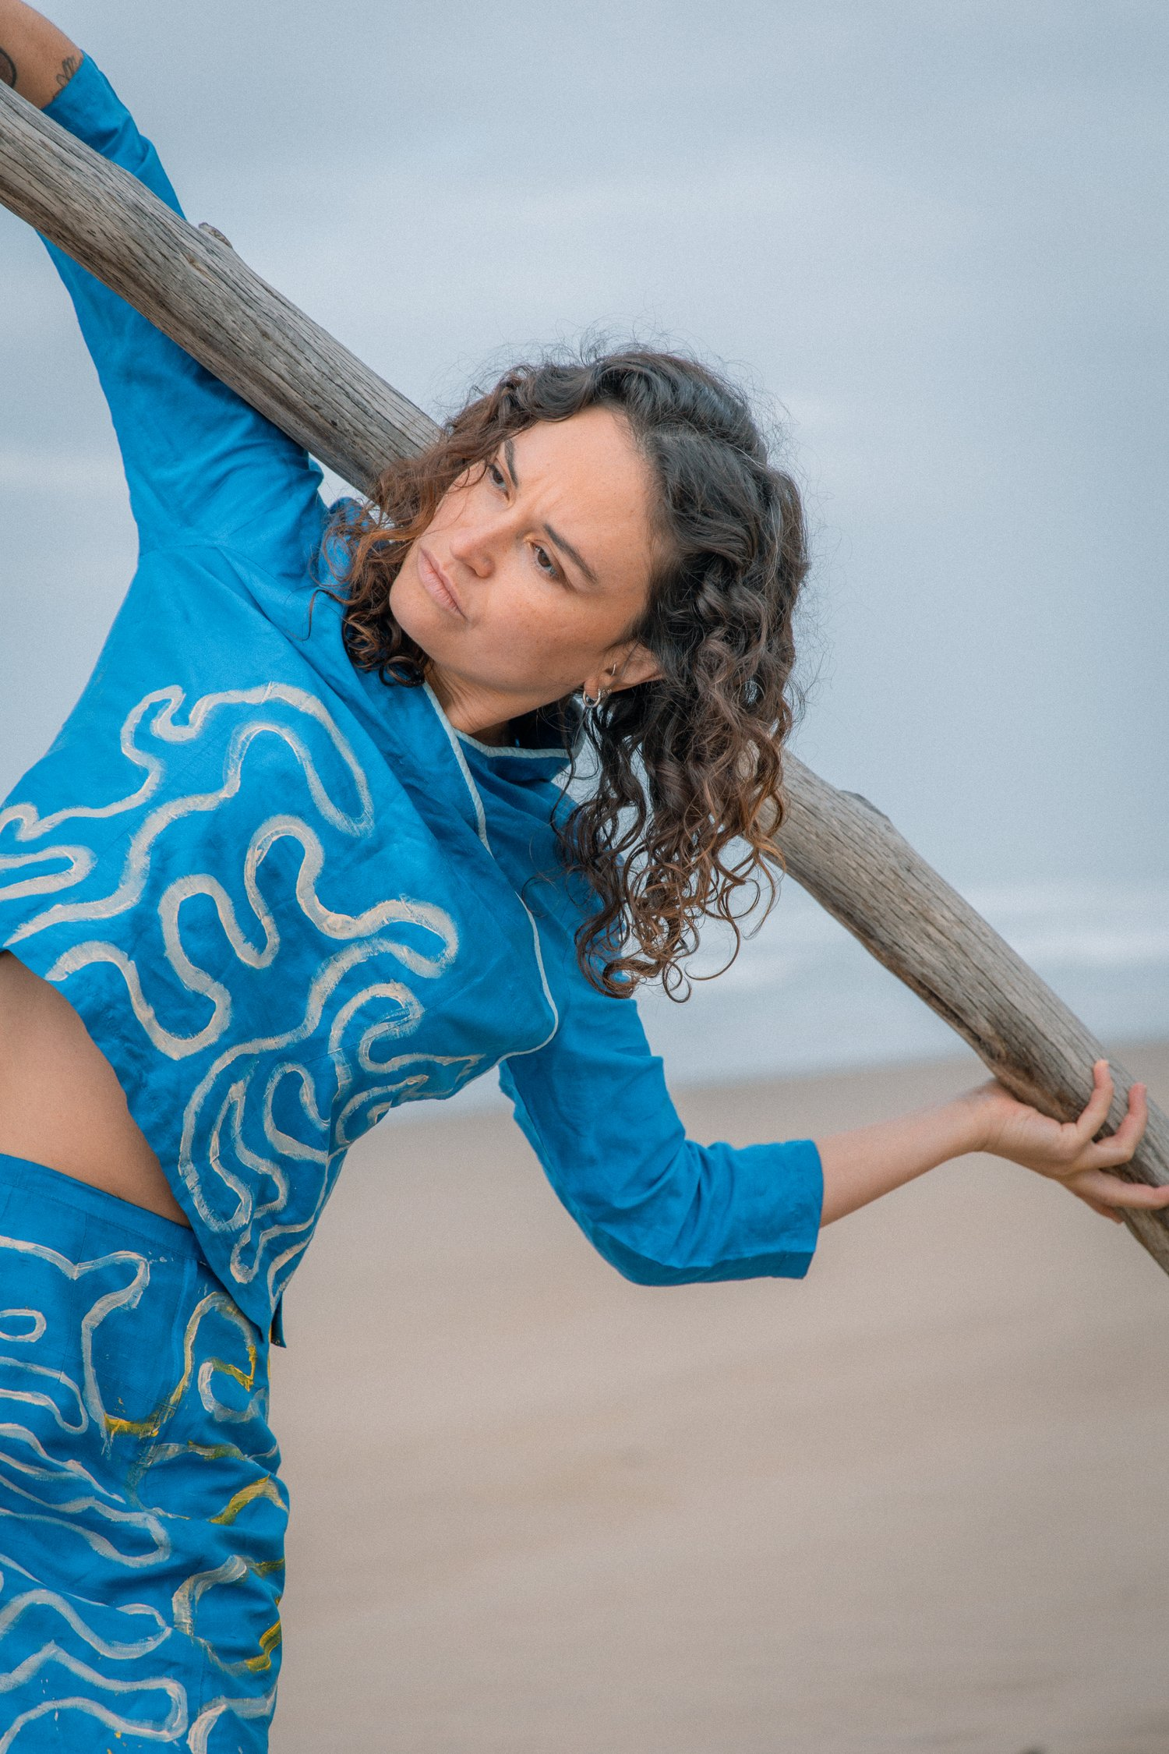

# **Sensory Elements**

## Sound

There is a lot of sound throughout Weredingo including live dialogue and songs as well as a pre-recorded soundtrack. The show has a lot of dialogue, including monologues, discussion between characters and talking directly to the audience. Sometimes there are overlapping voices and overlapping whispering.

The soundtrack includes includes low-pitched moody synthesised music tracks as well as upbeat tracks to accompany dance and movement sequences. Audiences will hear the sound of the performers bodies moving and dancing in the space. There are also live-performed songs with voices, clapping hands and stomping feet. The performers also make animal sounds, such as howling, in line with their characters as shapeshifters.

## Lighting

The lighting state changes throughout the show, usually this is noticeable with the change of scene or sequence. At different points during the show, there is black-out, low-lighting and flashing lights. There is also 3 projection screens as part of the set, located behind the performers. Animations are projected onto these screens.

## Physical

E.g. can you feel vibrations, is there any touch, are the performers or audience in close proximity etc? Are there uneven floors, audiences proximity in space, anything that plays with temperature, if air is blowing on people. Are there any moments which are physically scary or challenging.

## Smell - N/A

## Visual

The floor of the stage space is a black tarkett dance floor. There are three projection screens at the back of the stage space, which will show animations throughout the show. Many of the animations include animals and animal motifs. There is a table and chairs, with some cups and a tea station set-up on stage left which the performers use throughout the show.

Audience Experience

## **Entry to space**

The audience will enter via the main door into the Main Hall space. Upon entry, one of the performers will ask people questions, as if they’re coming to a shapeshifter ‘support group’ session. These may include:

* Were you followed coming here tonight?
* What shift have you come as tonight?
* When I go roar, you go…?

Before they take their seats, people will be invited to take and wear an animal mask during the show if they wish.

## **Shocks or surprises**

Haze and strobe lighting are used. There are some moments of flashing lights, but this is minimal.

## **Audience experience**

One performer will be interacting with the audience as they enter the space. Once people are seated, this performer will move to the top of the seating back in preparation for the second scene. At the beginning of the second scene, the performer will run down the seating bank stairs and onto the stage.

The audience will stay seated for the duration of the show and the performers will mostly remain on the stage. There will be some talking and joking with the audience and the audience will be encouraged to cheer or make animal sounds at some points.

## **Social expectations**

Audience will sit on the Arts House seating bank in the main hall. One of the performers will interact with the audience as they come into the space. The performer will ask people questions, as if they’re coming to a shapeshifter ‘support group’. These may include:

* Were you followed coming here tonight?
* What shift have you come as tonight?
* When I go roar, you go…?

Audiences are invited to come in costume as an animal shapeshifter. People will also be invited to take an animal mask when they come into the space if they wish. There will be a temporary lockout when the show starts, but after the first couple of minutes late-comers will be let in and people can come and go from the space if needed.

People may bring snacks and drinks into the space, but no alcohol.

## **Performance expectations**

There are four performers, two men and two women. The performers will be on the stage for the duration of the performance, with the exception of one performer who will interact with the audience near the door as they enter the space, asking questions of people as they enter the space, such as:

* Were you followed coming here tonight?
* What shift have you come as tonight?
* When I go roar, you go…?

The show follows a narrative format with a story arc. There is dialogue between performers and also to the audience. It’s an interactive show but audience don’t need to interact if they don’t wish to. The interactivity is limited to the performers sometimes talking and joking with the audience.

# **Other**

## Content Warnings

Haze and strobe lighting are used.

## General Notes

There will be an Acknowledgment of Country done by one of the performers in the space as part of the show.

# **The Venue**

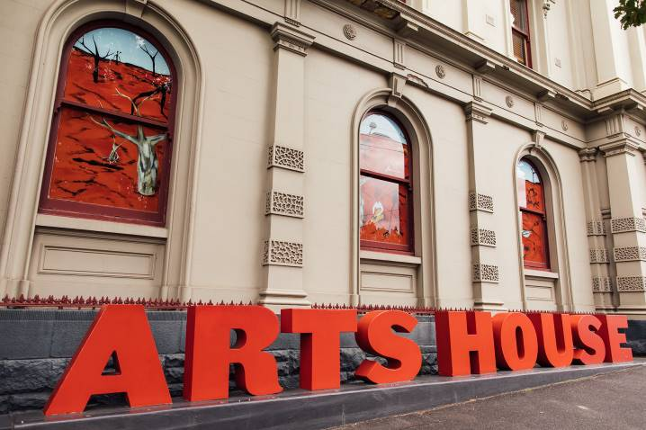

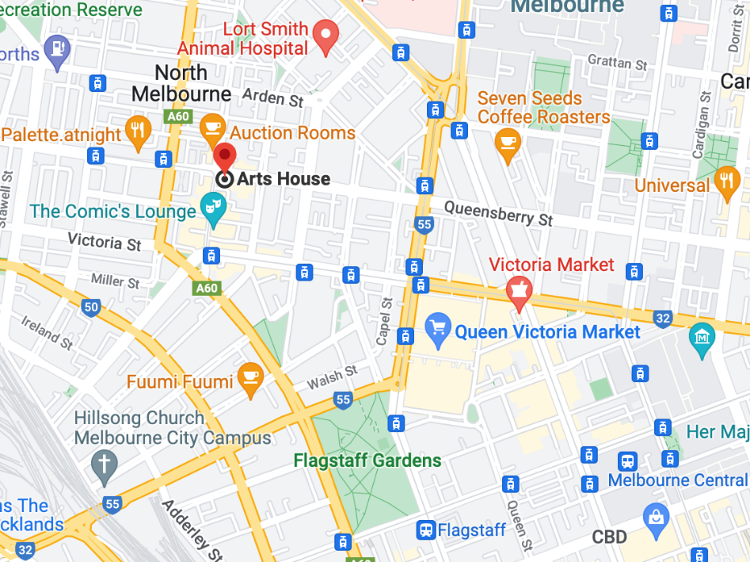

Image: North Melbourne Town Hall features giant red letters that say ARTS HOUSE out the front of it.

Image: a map of Arts House and its surrounding area. [LINK TO MAP](https://www.google.com/maps/place/Arts+House/@-37.802973,144.9486818,17z/data=!4m5!3m4!1s0x0:0x64c465ac7ef21cff!8m2!3d-37.803239!4d144.9498609?shorturl=1)

## **Front Entrance**

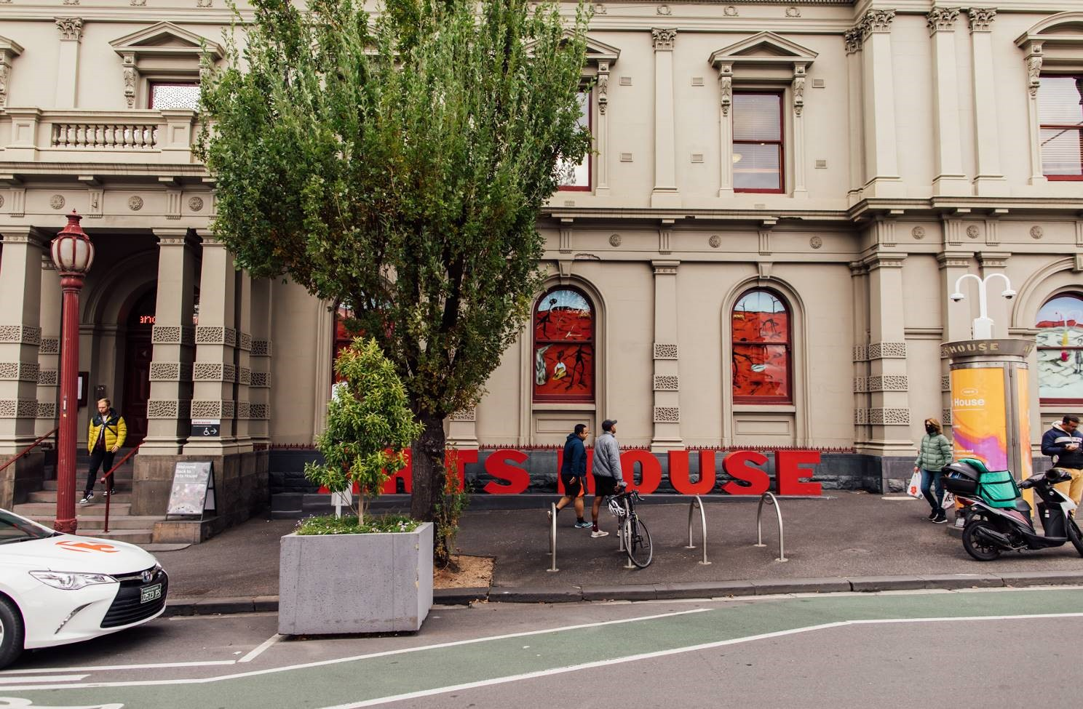

## **Accessible Entrances**



There are two Accessible Entrances. The first is on Errol St next to the Post Office.

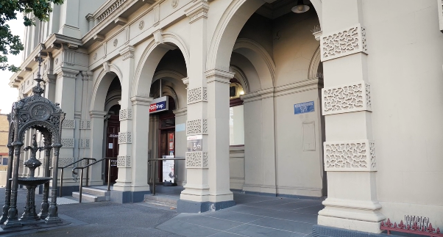

Image: Errol Street entrance next to the Post office with wheelchair accessible ramp or two steps with grab rails.

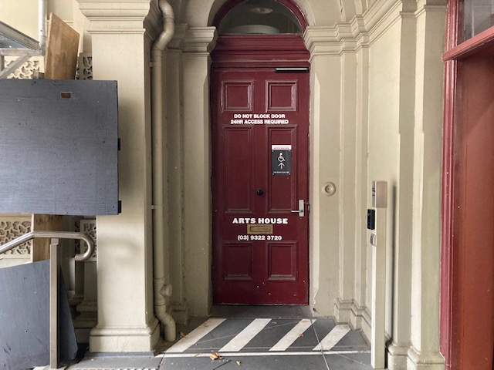

Image: View of door entrance.

The second Accessible Entrance is towards the end of George Johnson Lane.

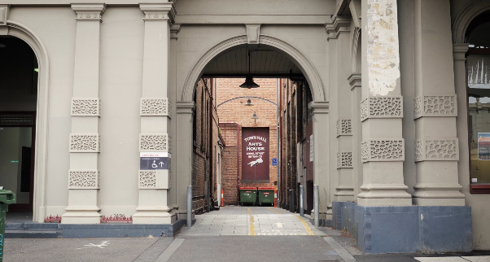

Image: View of George Johnson Lane from Errol St. The laneway passes through an archway with a brick wall at the end.

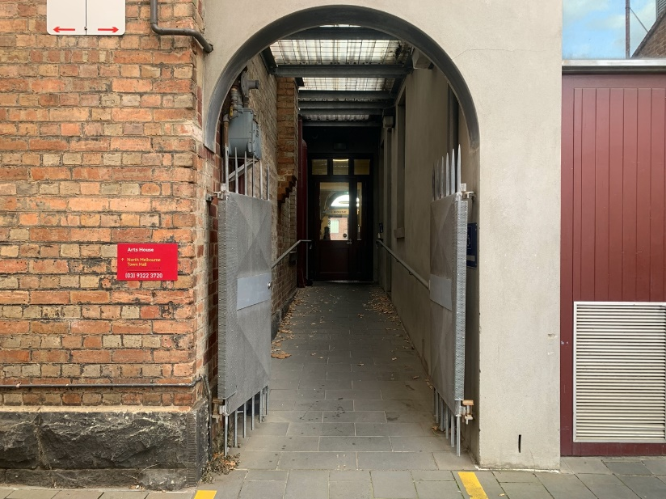

Image: view of the ramp leading from George Johnson Lane to the automated door which opens into the Arts House foyer.

## **Box Office**

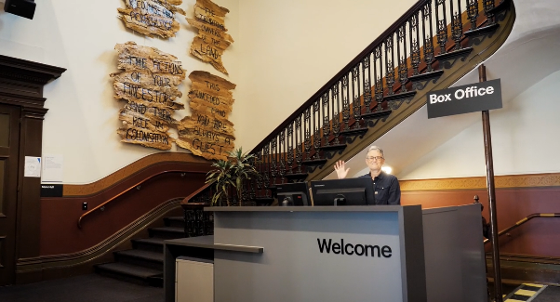

Box Office is located in the foyer under the stairwell.

## **Ushers**

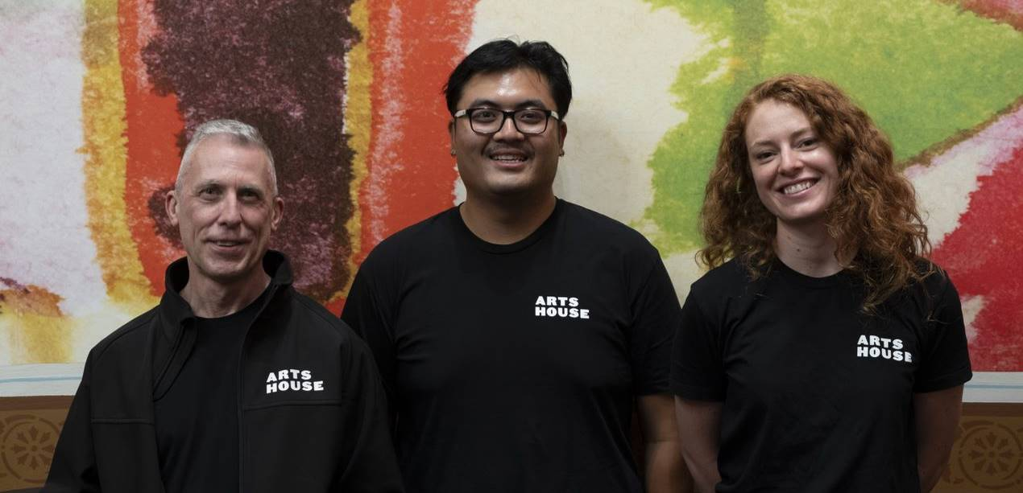

Ushers will be wearing black with an Arts House Logo on the left hand shoulder.

## **Bar**

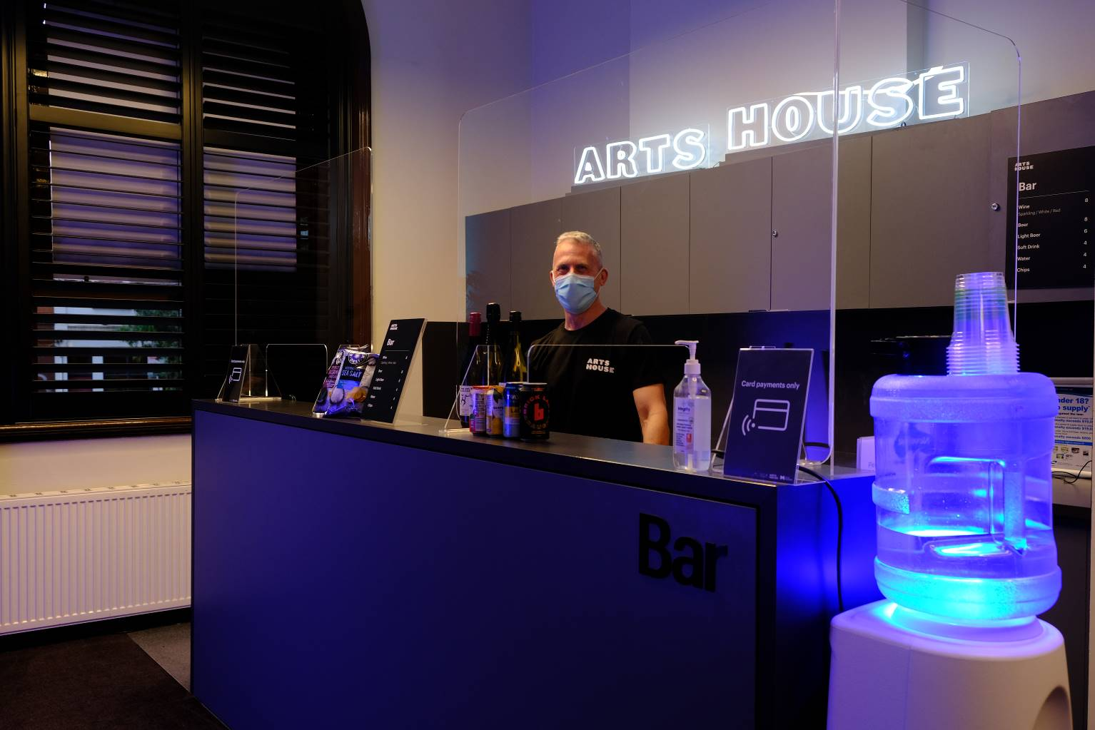

Bar staff will be wearing black with an Arts House Logo.

We have a range of alcoholic and non-alcoholic beverages for sale.

We are a cashless venue and accept EFTPOS, Visa and Mastercard payments.

## **Quiet Space**



Arts House Quiet Space is located on Ground Level and is nearby reception and opposite the accessible bathrooms. It includes a range of seating options including soft furnishings, dimmable lights, sensory and stim objects. It is open during venue opening hours and events as a quiet space, prayer or parenting space.

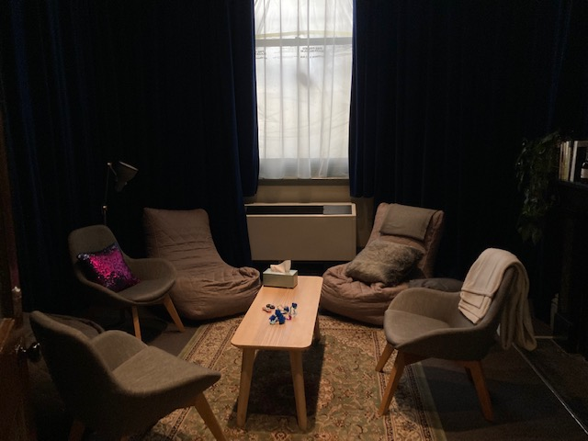

Image: Quiet space with lights dimmed

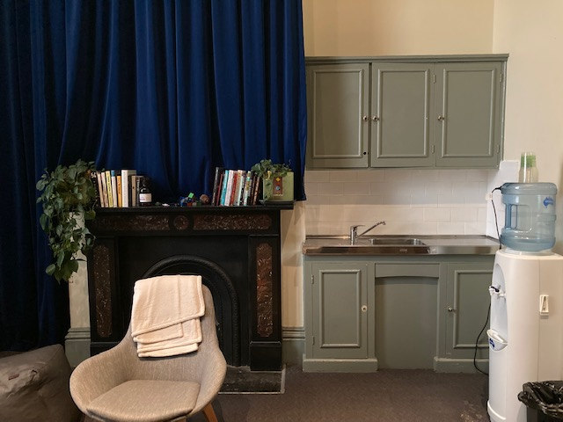

Image: Quiet space kitchenette and book shelf

## **Bathrooms**

All bathrooms have Dyson hand dryers with sensor activation. There is an accessible bathroom that is single use on ground level opposite the Quiet Space. There is another accessible bathroom upstairs – this is accessible via lift or stairs.

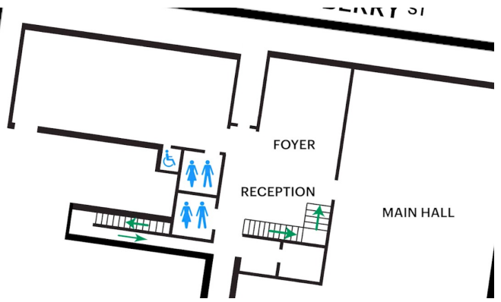

## **Door to Main Hall**

The Performance is in the Main Hall.

It is on the ground floor.

It is to the left of the box office desk and right of the bar.

An artist statement is available on signage and warnings on the door.

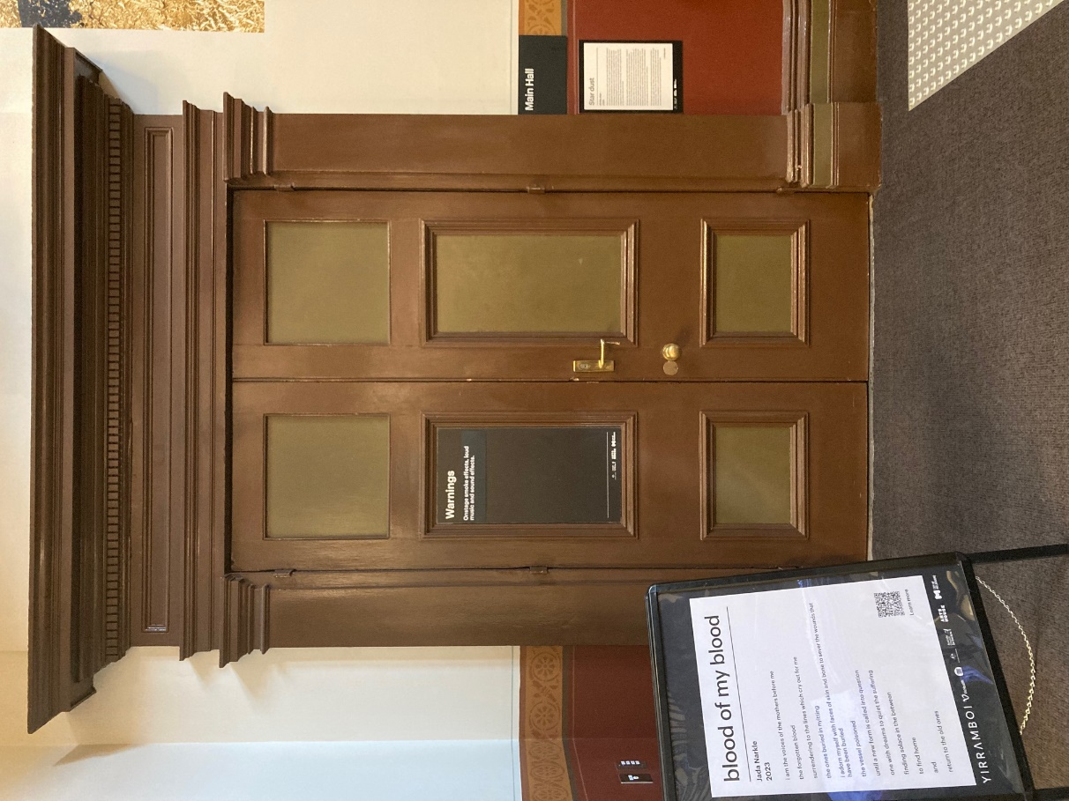

## **Lift**

The lift is located behind reception desk in the foyer.

The closest entry to the lift is via George Johnson Lane.

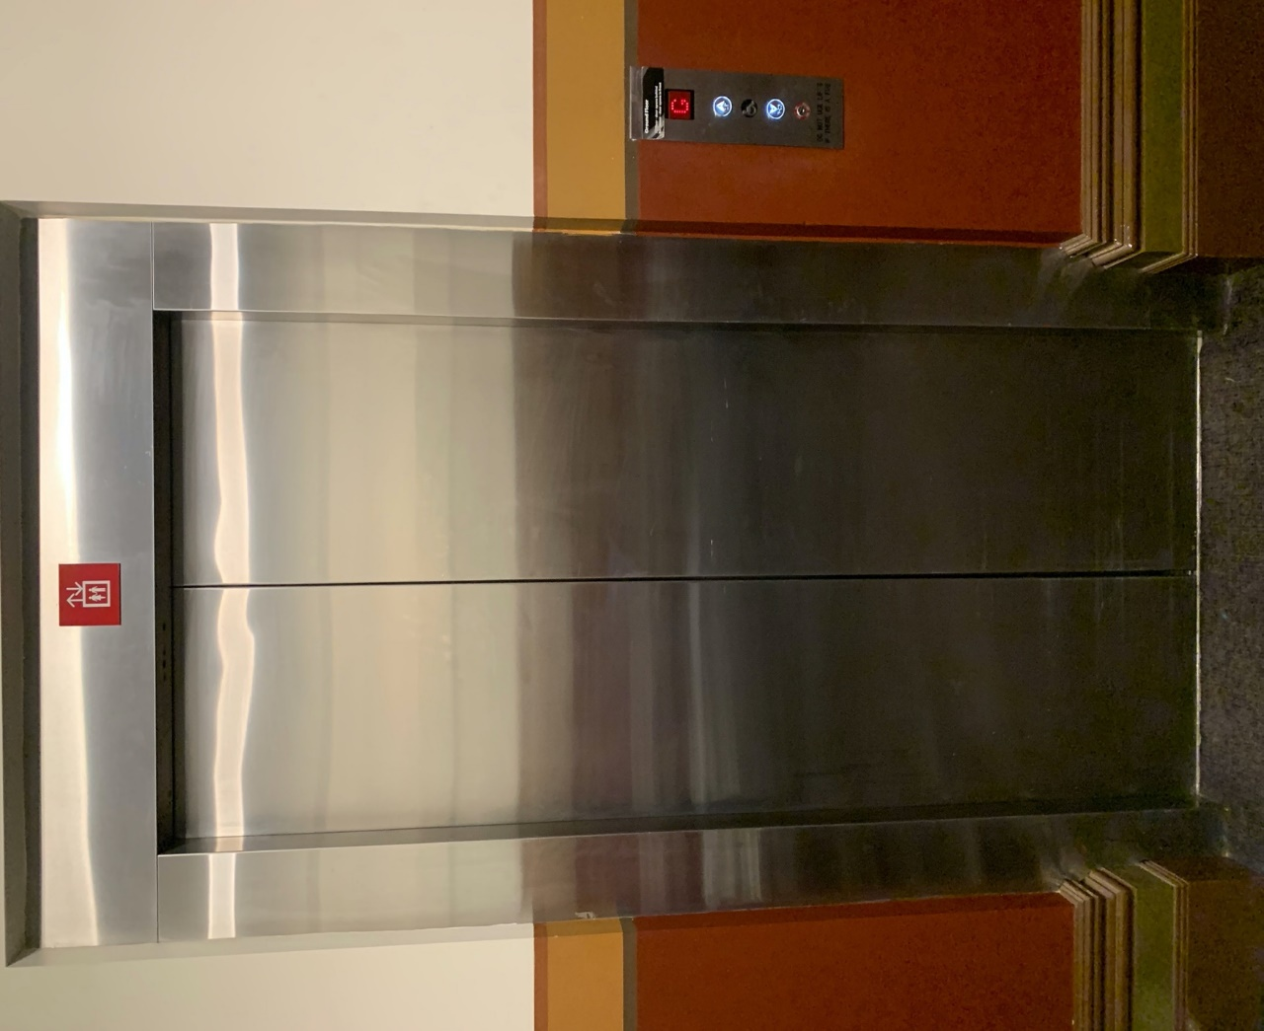

# 

# **Transport**

## **Tram**

Route 57 (High Floor trams only)

Stop 12, North Melbourne Town Hall.

Please note, this is not a wheelchair accessible tram

[GETTING TO ARTS HOUSE VIDEO LINK](https://vimeo.com/544169506)

## **Train**

Arts House is 1.1km from   
North Melbourne Train Station,   
approximately 16 minute walk

[North Melbourne Station Information](https://www.ptv.vic.gov.au/stop/1144/north-melbourne-station/0/train/)

1.2km from Flagstaff Station,   
approximately 15 minute walk

[Flagstaff Station Information](https://www.ptv.vic.gov.au/stop/1068/flagstaff-station/0/train/#StopPage:::datetime=2023-04-06T04%3A41%3A27.669Z&directionId=-1&showAllDay=false&_auth=408ac3b1e97f4b0beb5bdf00c2f797057d10dd6e6cf2ad40a69334c4dfdf5e21)

## **Bus**

Bus number: 216

## **Parking**

There is limited paid on-street parking on Queensberry Street and Errol Street.

There are two accessible on street car parking spaces on Queensberry Street (150m to our accessible Errol Street entrance) for holders of a Parking Permit for Disabled people.

# **COVID Safety**

Please follow good health and hygiene practices when visiting Arts House.

Ticket holders who cannot attend their performance due to COVID-19 illness or symptoms are entitled to a full refund.

**Facemasks**

We strongly recommend wearing a face mask while indoors. We have disposable masks available at reception and in the foyer.

**Cleaning**

Arts House buildings are cleaned nightly Monday-Friday and on weekends as required.

We conduct touchpoint cleaning of spaces between performances.

**Hygiene Stations**

Arts House provides handwashing and hygiene stations in each amenities area, studio, and office including: hand sanitizer, disinfectant wipes, rubbish bin.

More information about COVID-19 Safety can be found through the links below:

[Our COVID-19 Safety Plan - Arts House - Melbourne](https://www.artshouse.com.au/our-covid-19-safety-plan/)