**Enemies of Grooviness Eat Sh!t**

By Betty Grumble

Access Guide

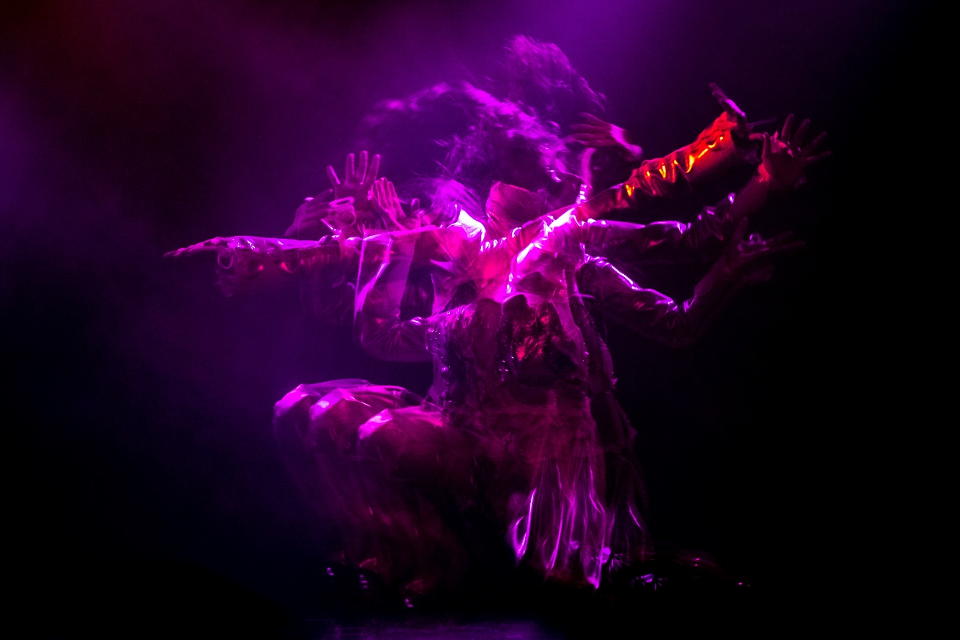

Image: A surreal image of performance artist Betty Grumble with many arms, legs and heads, tossing her hair around wildly. She is a caucasian woman in her 30s and in the image she is awash with purple light while wearing a white and silver custom jumpsuit in a cowboy style. The many limbed effect is created with multiple exposures layered on the one image, giving the effect of frenzied movement.

**Image credit:** Joseph Myers

Arts House website will contain the most up to date version of this document and all ticket holders will be notified of any revisions made 3 days and 1 day prior to the event.

This document was created: 9 October

**Contents**

**Where** 3

**When** 3

**Access Services** 3

**Performers** 5

**Sensory Elements** 5

Sound 5

Lighting 6

Physical 6

Smell 6

Visual 6

Entry to space 7

Shocks or surprises 7

Audience experience 7

Social expectations 8

Performance expectations 8

**Other** 8

Content Warnings 8

General Notes 8

**The Venue** 9

Front Entrance 9

Accessible Entrances 10

Box Office 11

Ushers 11

Bar 12

Quiet Space 13

Bathrooms 13

Door to Studio 1 14

Door to Main Hall 14

Lift 16

**Transport** 16

Tram 16

Train 17

Bus 17

Parking 17

**COVID Safety** 17

# **Where**

Arts House

521 Queensberry Street

North Melbourne

# **When**

Tuesday 17 October, 8.30pm

Wednesday 18 October, 8.30pm

Thursday 19 October, 8.30pm

Friday 20 October, 8.30pm

Saturday 21 October, 8.30pm

**Duration: 90 minutes, no interval**

**Post show discussion**: Wednesday 18 October

# 

# **Access Services**

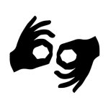

**Auslan Interpreted Performance**

Wednesday 18 October, 8.30pm

The post show discussion will also be Auslan interpreted after this performance



Assistance Animal are welcome.

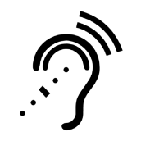

Assistive Listening is available free of charge. Ask staff for assistance on arrival.



Visual Rating 50% – this performance has music and sounds in the background.

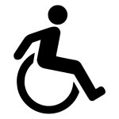

This performance is fully wheelchair accessible.

# 

# **Performers**

There are two performers in the show:

Emma Maye Gibson – performs as Betty Grumble

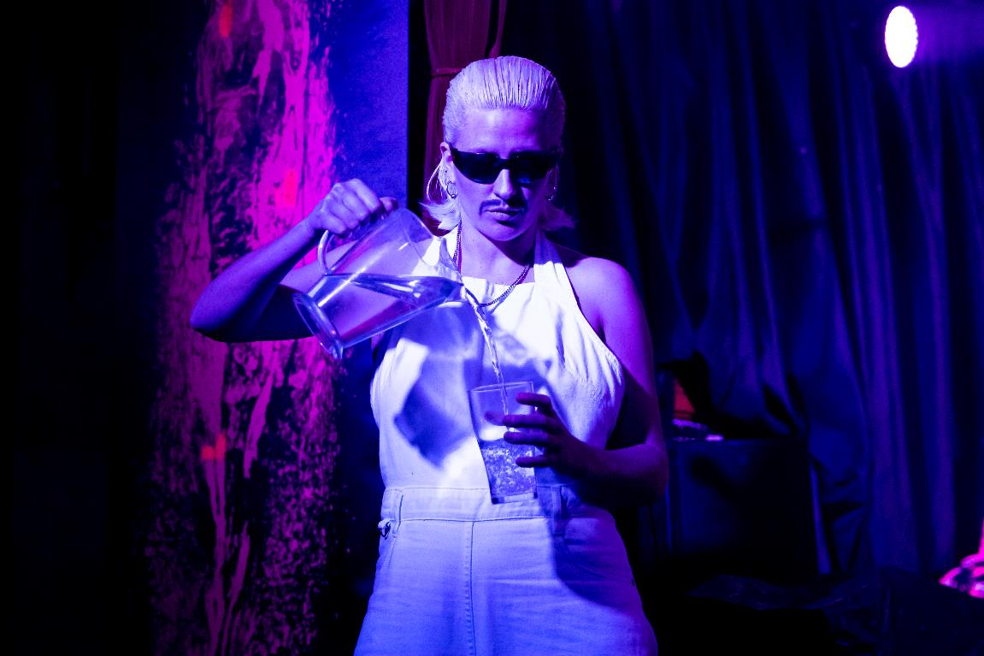

Megan Holloway – Performs as Craig Slist

# **Sensory Elements**

## **Sound**

There is live and recorded sound in this show, mostly pre-recorded music played as part of the performance. Loud music is played throughout the performance.

The performance begins with an extended onstage dance warmup to music that gets louder as it progresses. Both performers are mic-ed throughout the show.

The performer sings several songs over backing tracks. There is a moment of live music with a bass guitar playing low frequency sound while audience members use shakers.

There are voice modulators used at points to change the frequency of both performers voices. A poem is delivered using voice modulation over a low frequency drone sound, after which there is a song sung using the modulator set to a deep frequency.

There is a recording of baby noises that is played, referenced by the performer.

## **Lighting**

Lighting changes quite regularly through the show, and haze is used throughout. A smoke machine is used at one point. Lights flash at points, during loud music moments. There are one or two quick lighting changes, the majority is gradual. There are no blackouts, but there is one very low-light moment.

There is use of black light in two scenes that run one after the other.

## **Physical**

The audience can choose where to sit, at tables in front of the stage or a seating bank behind the tables. If seated close to a speaker, there will be sound vibration throughout. The performers leave the stage and dance in the audience at several points. There is no uninvited interaction. One audience member is invited to volunteer to paint Betty Grumble’s makeup on stage.

## **Smell**

There is the smell of incense in the space, and incense is lit at one point in the show. There are a small number of fresh flowers used as part of the set. There is haze used throughout the performance and a smoke machine at two points.

## **Visual**

The show begins with a dark bare stage and the performer warming up. There is a microphone, some low lighting, and a performer getting ready. Items are added to the space throughout the show.

The space transforms in feel throughout the show from a subdued poetic space to an angry punk rock space and back again.

There are large banners used to make the set of the performance, and these are revealed one by one throughout the show. These are revealed through black fabric falling away to reveal the banners. The artist discusses them each of them in the show. In order, they are:

* A giant screen print of the artist’s vulva, painted in black, pink and orange fluro paint
* Large-scale photographs of poet Candy Royalle and artist Annie Sprinkle
* Large-scale photographs of artist Elizabeth Burton and a tree

Betty has a costume that transforms throughout the show, moving from a more-fully clothed Elvis-style costume to coming apart to create a harness and an elaborate headpiece out of the breast and crotch pieces.

Audience Experience

## **Entry to space**

Audiences may chose to sit at either cabaret tables in front of the stage, or further back in a seating bank. The closer you sit, the more intense the lighting and sound will be. There are points were the performers dance in the audience, but this is the extent of interaction.

## **Shocks or surprises**

There are two very loud songs accompanied by more intense lighting effects. The first is set to the song ‘Relax’ by Frankie Goes To Hollywood, and the second is set to L7’s ‘Shitlist’ and is cover of ‘Don’t Cha’ by The Pussycat Dolls.

There is a loud sting played as an interlude between scenes that the performer sings over. Quiet space is available in the venue if needed.

## **Audience experience**

There is eye contact with the performers. The performers leave the stage to dance in the crowd at two points. There are shakers (musical instruments) on every seat that audience members may use to interact with the performance. There is a scene of masturbation that audience members are encouraged to use the shakers in.

One audience member will be invited to come onto stage to do Betty Grumble’s makeup. This is entirely voluntary.

## **Social expectations**

The audience can chose to sit in the seating or at the tables in front of the stage. Audience members are welcome to move about the space or outside during the show, and the performer mentions this at the start of the performance. Ushers will open the doors to the foyer as needed. Audiences are welcome to stim in the space and bring stim toys. The performance builds in energy and anger throughout, and can be overwhelming at times. It ends in a joyful moment of celebration and catharsis.

## **Performance expectations**

There are two performers onstage, Betty Grumble the lead, and Craig Slist her assistant. There is no storyline, but there are stories from the performer’s life and experiences. Words are spoken live and prerecorded, are amplified throughout, and are modulated at points.

The lead performer wears a white costume that is altered throughout the show. She ends the performance unclothed. The assistant wears a black version of the same costume, and a pair of dark sunglasses throughout. The costuming is highly theatrical.

# **Other**

## **Content Warnings**

The show is about and frankly discusses intimate partner violence, sexual assault and abuse, experiences in the criminal justice system including attending court and cross-examination, and violence against the environment.

The show contains nudity and a sex act (masturbation). It contains strobe, haze, incense, water, loud sound and a naked flame at one point.

## **General Notes**

There is an Acknowledgement of Country delivered by the performer as part of the opening monologue of the show.

# **The Venue**

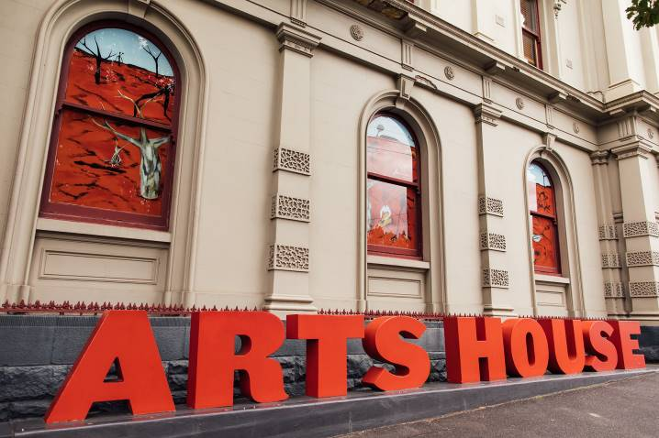

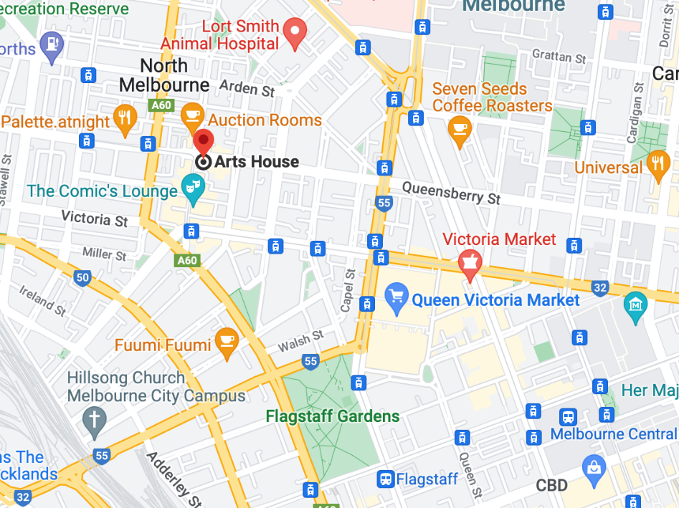

Image: North Melbourne Town Hall features giant red letters that say ARTS HOUSE out the front of it.

Image: a map of Arts House and its surrounding area. [LINK TO MAP](https://www.google.com/maps/place/Arts+House/@-37.802973,144.9486818,17z/data=!4m5!3m4!1s0x0:0x64c465ac7ef21cff!8m2!3d-37.803239!4d144.9498609?shorturl=1)

## **Front Entrance**

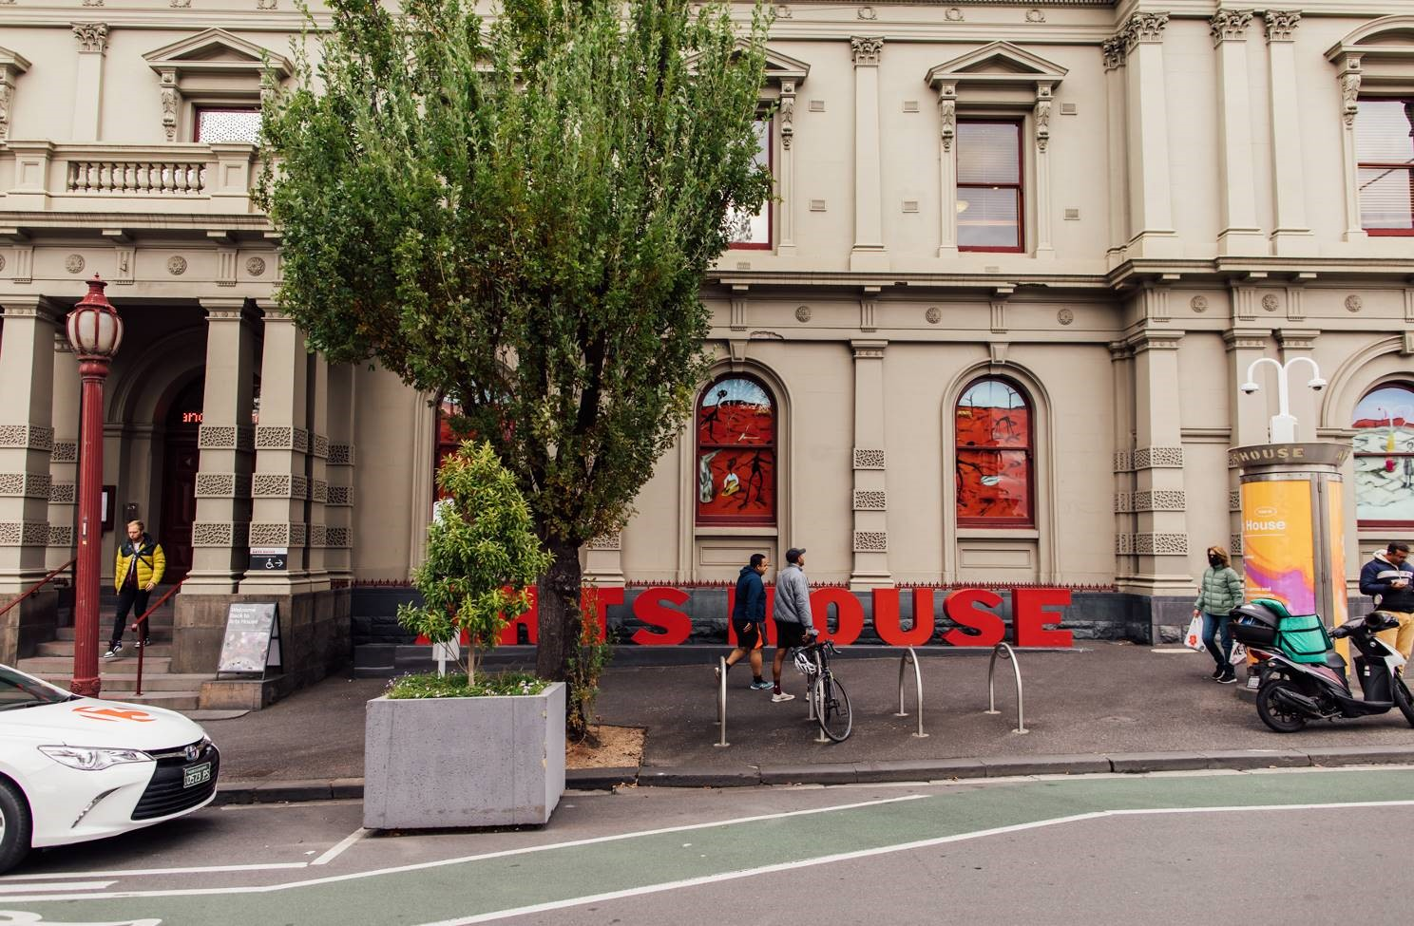

## **Accessible Entrances**



There are two Accessible Entrances. The first is on Errol St next to the Post Office.

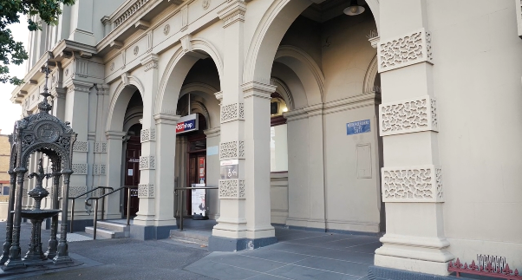

Image: Errol Street entrance next to the Post office with wheelchair accessible ramp or two steps with grab rails.

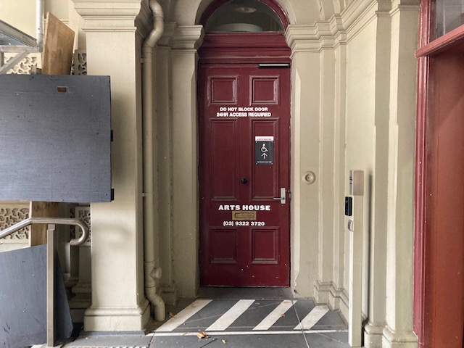

Image: View of door entrance.

The second Accessible Entrance is towards the end of George Johnson Lane.

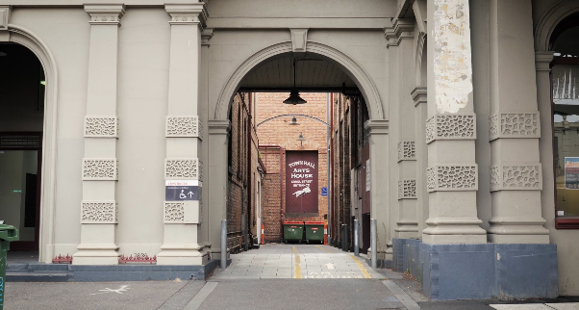

Image: View of George Johnson Lane from Errol St. The laneway passes through an archway with a brick wall at the end.

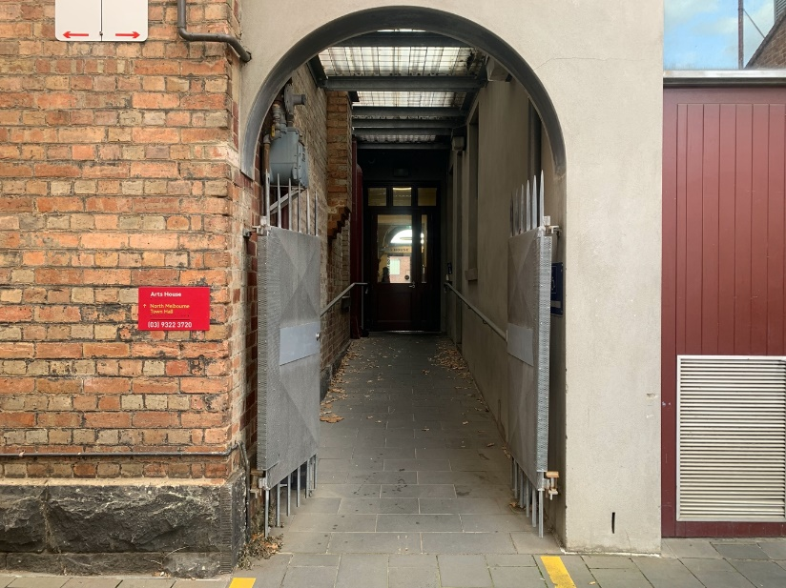

Image: view of the ramp leading from George Johnson Lane to the automated door which opens into the Arts House foyer.

## **Box Office**

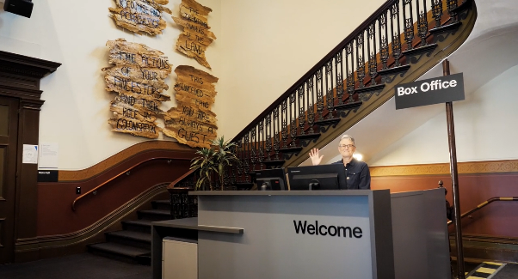

Box Office is located in the foyer under the stairwell.

## **Ushers**

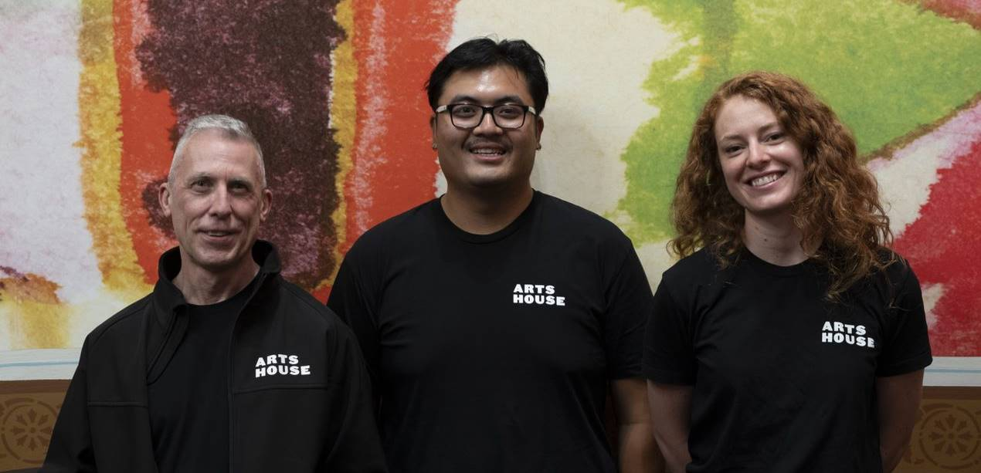

Ushers will be wearing black with an Arts House Logo on the left hand shoulder.

## **Bar**

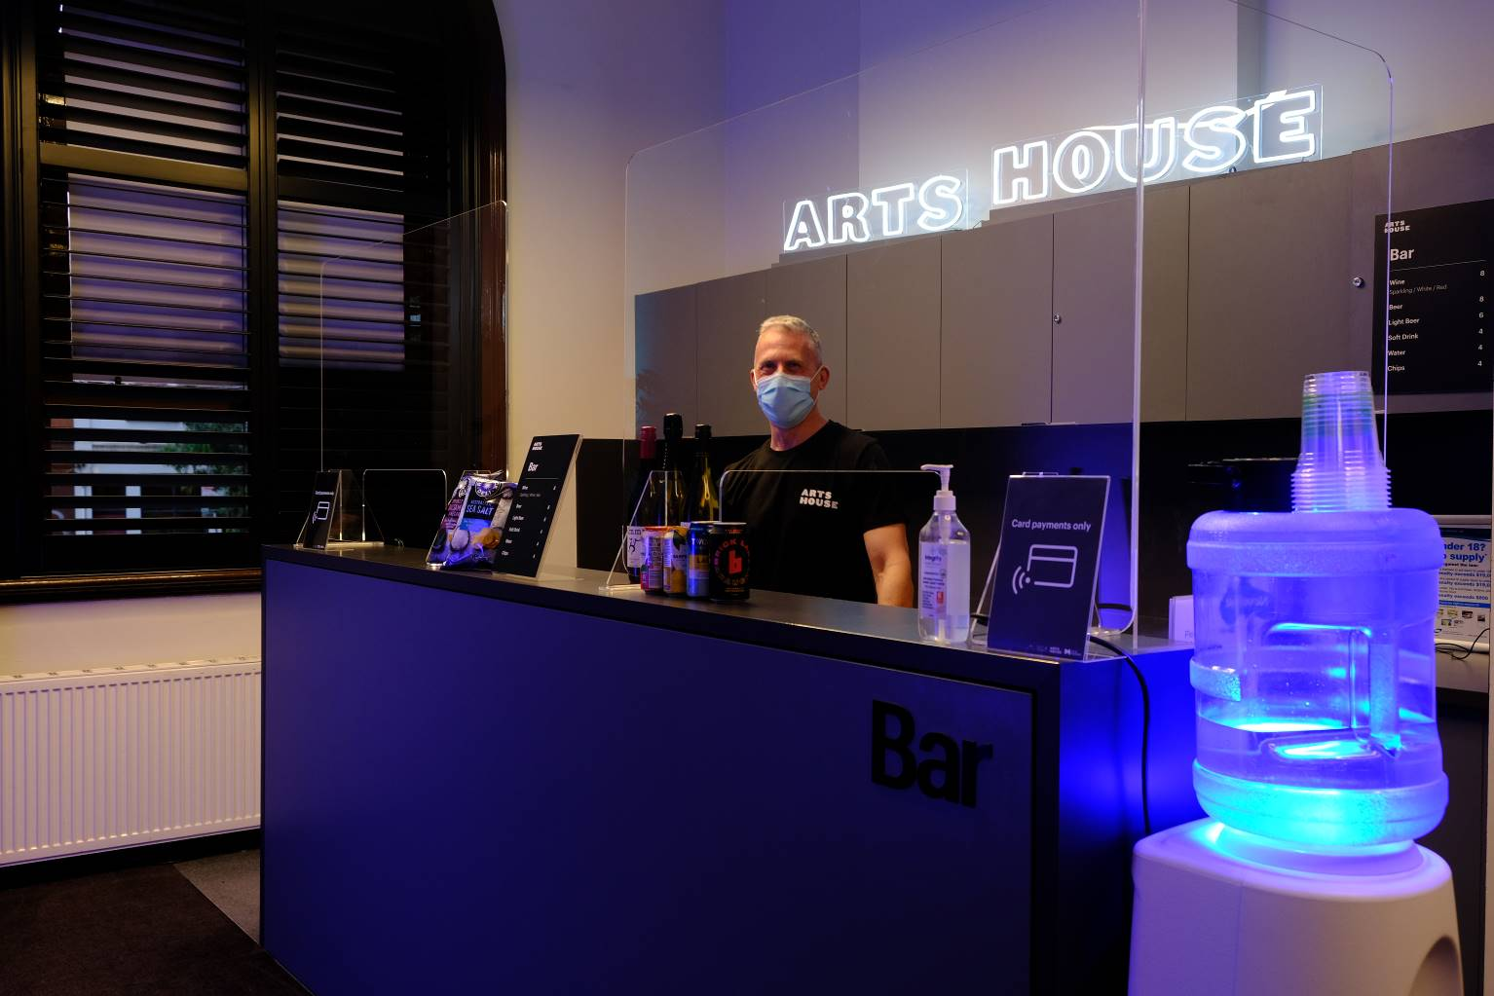

Bar staff will be wearing black with an Arts House Logo.

We have a range of alcoholic and non-alcoholic beverages for sale.

We are a cashless venue and accept EFTPOS, Visa and Mastercard payments.

## **Quiet Space**

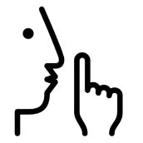

Arts House Quiet Space is located on Ground Level and is nearby reception and opposite the accessible bathrooms. It includes a range of seating options including soft furnishings, dimmable lights, sensory and stim objects. It is open during venue opening hours and events as a quiet space, prayer or parenting space.

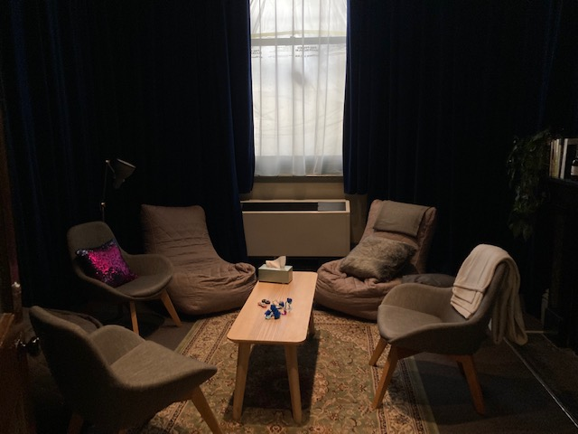

Image: Quiet space with lights dimmed

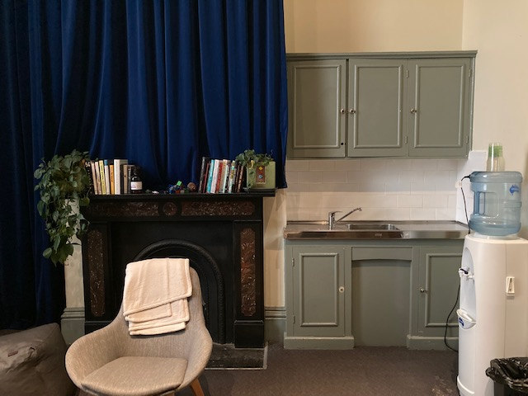

Image: Quiet space kitchenette and book shelf

## **Bathrooms**

All bathrooms have Dyson hand dryers with sensor activation. There is an accessible bathroom that is single use on ground level opposite the Quiet Space. There is another accessible bathroom upstairs – this is accessible via lift or stairs.

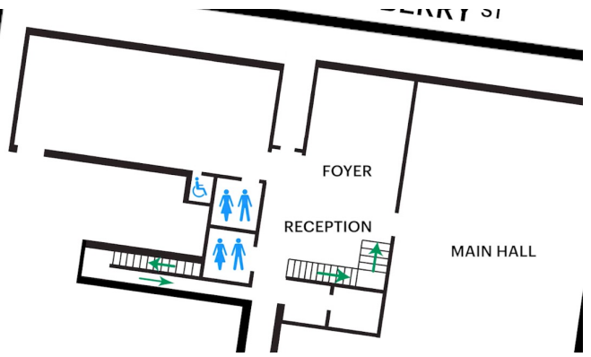

[Update with relevance performance space & info]

## **Door to Studio 1**

The Performance is in Studio 1.

It is on the first floor.

You can access these spaces via stairs with hand-railing or the lift.

An artist statement is available on signage and warnings on the door.

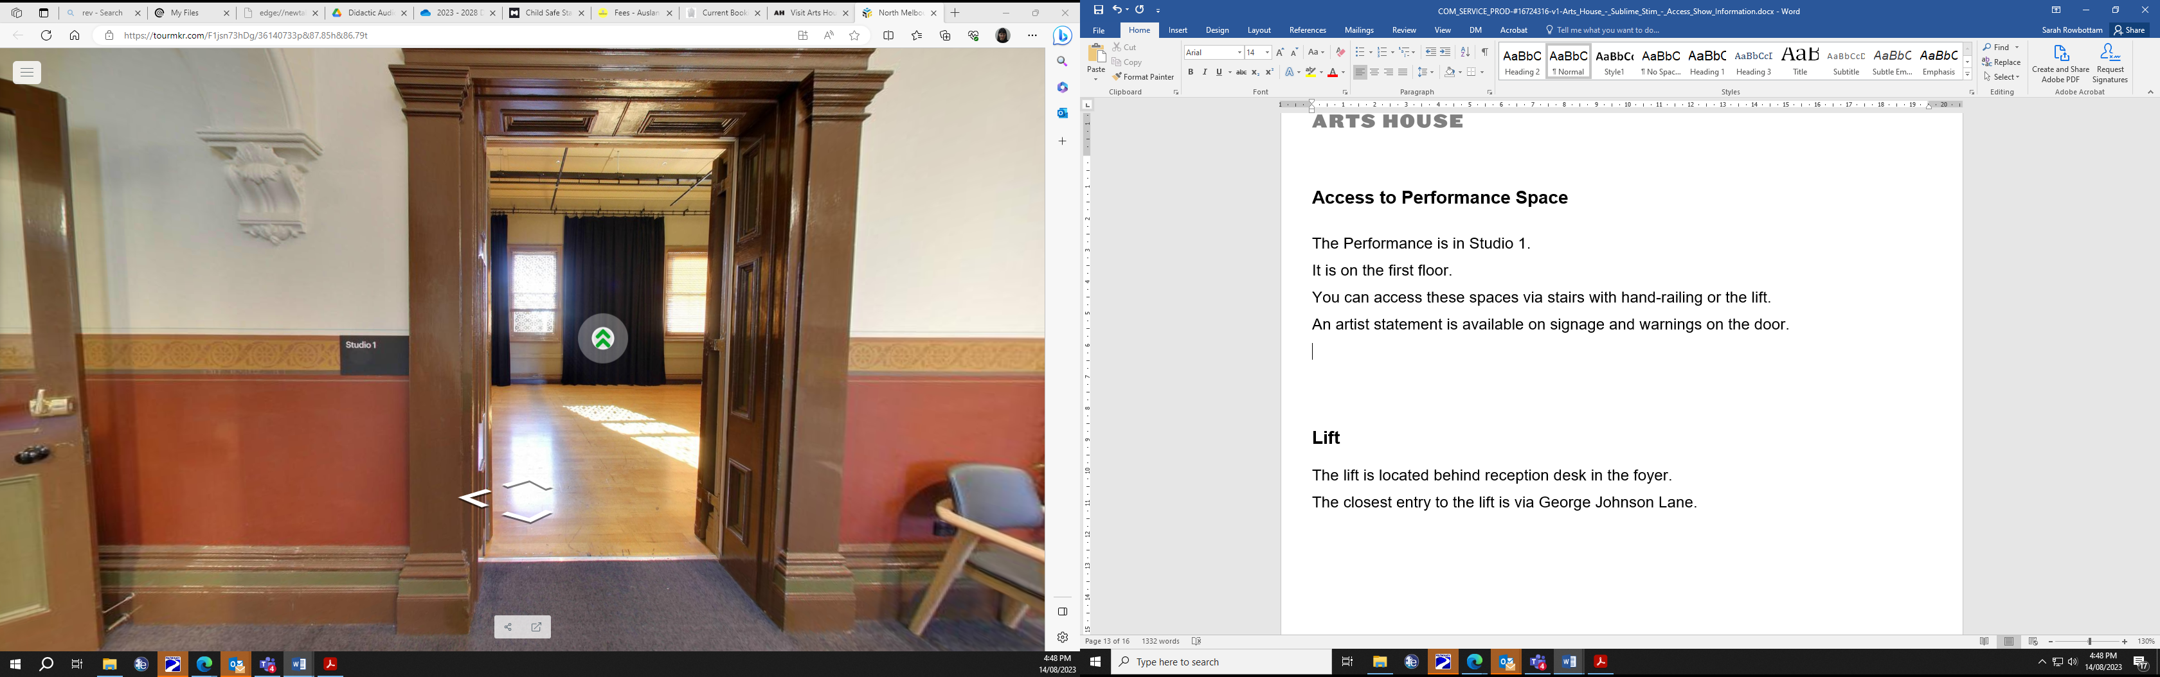

## **Door to Main Hall**

The Performance is in the Main Hall.

It is on the ground floor.

It is to the left of the box office desk and right of the bar.

An artist statement is available on signage and warnings on the door.

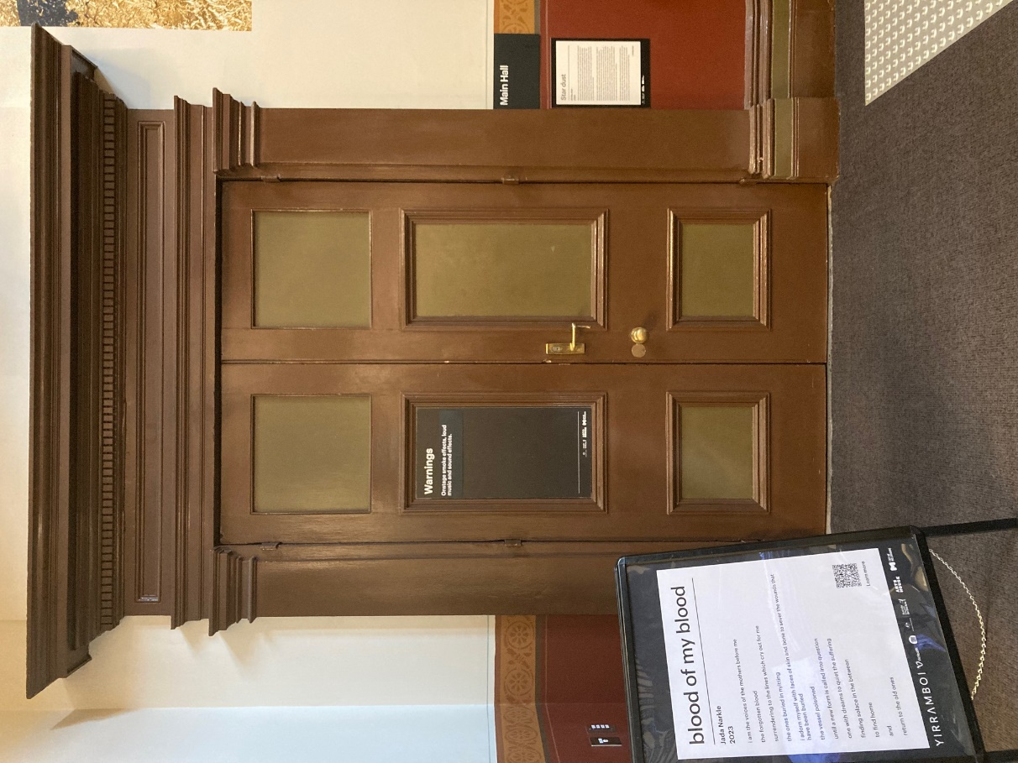

## **Lift**

The lift is located behind reception desk in the foyer.

The closest entry to the lift is via George Johnson Lane.

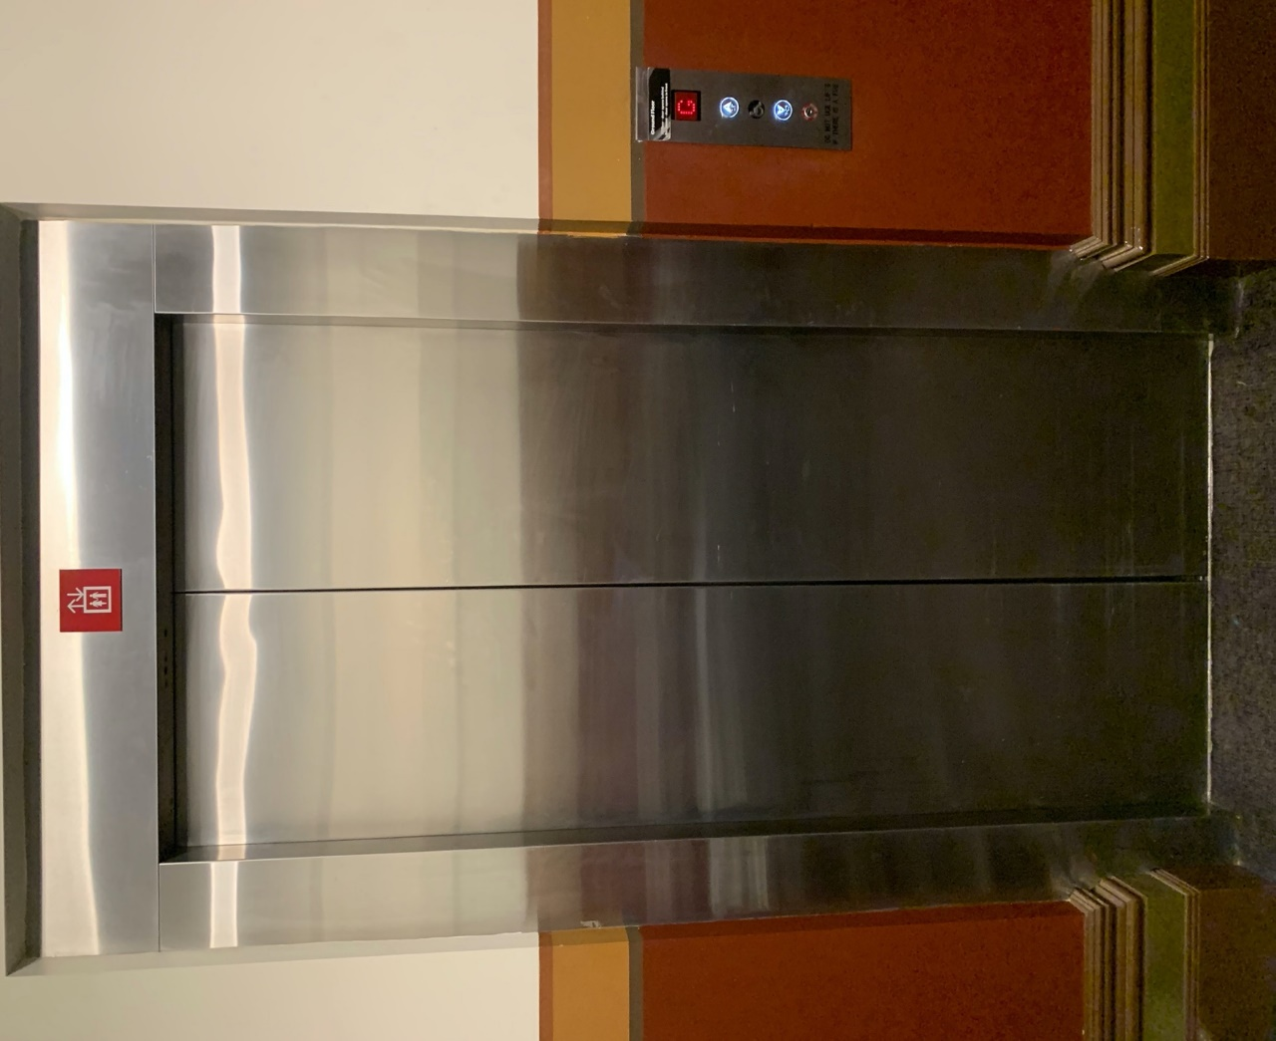

# **Transport**

## **Tram**

Route 57 (High Floor trams only)

Stop 12, North Melbourne Town Hall.

Please note, this is not a wheelchair accessible tram

[GETTING TO ARTS HOUSE VIDEO LINK](https://vimeo.com/544169506)

## **Train**

Arts House is 1.1km from   
North Melbourne Train Station,   
approximately 16 minute walk

[North Melbourne Station Information](https://www.ptv.vic.gov.au/stop/1144/north-melbourne-station/0/train/)

1.2km from Flagstaff Station,   
approximately 15 minute walk

[Flagstaff Station Information](https://www.ptv.vic.gov.au/stop/1068/flagstaff-station/0/train/#StopPage:::datetime=2023-04-06T04%3A41%3A27.669Z&directionId=-1&showAllDay=false&_auth=408ac3b1e97f4b0beb5bdf00c2f797057d10dd6e6cf2ad40a69334c4dfdf5e21)

## **Bus**

Bus number: 216

## **Parking**

There is limited paid on-street parking on Queensberry Street and Errol Street.

There are two accessible on street car parking spaces on Queensberry Street (150m to our accessible Errol Street entrance) for holders of a Parking Permit for Disabled people.

# **COVID Safety**

Please follow good health and hygiene practices when visiting Arts House.

Ticket holders who cannot attend their performance due to COVID-19 illness or symptoms are entitled to a full refund.

**Facemasks**

We strongly recommend wearing a face mask while indoors. We have disposable masks available at reception and in the foyer.

**Cleaning**

Arts House buildings are cleaned nightly Monday-Friday and on weekends as required.

We conduct touchpoint cleaning of spaces between performances.

**Hygiene Stations**

Arts House provides handwashing and hygiene stations in each amenities area, studio, and office including: hand sanitizer, disinfectant wipes, rubbish bin.

More information about COVID-19 Safety can be found through the links below:

[Our COVID-19 Safety Plan - Arts House - Melbourne](https://www.artshouse.com.au/our-covid-19-safety-plan/)