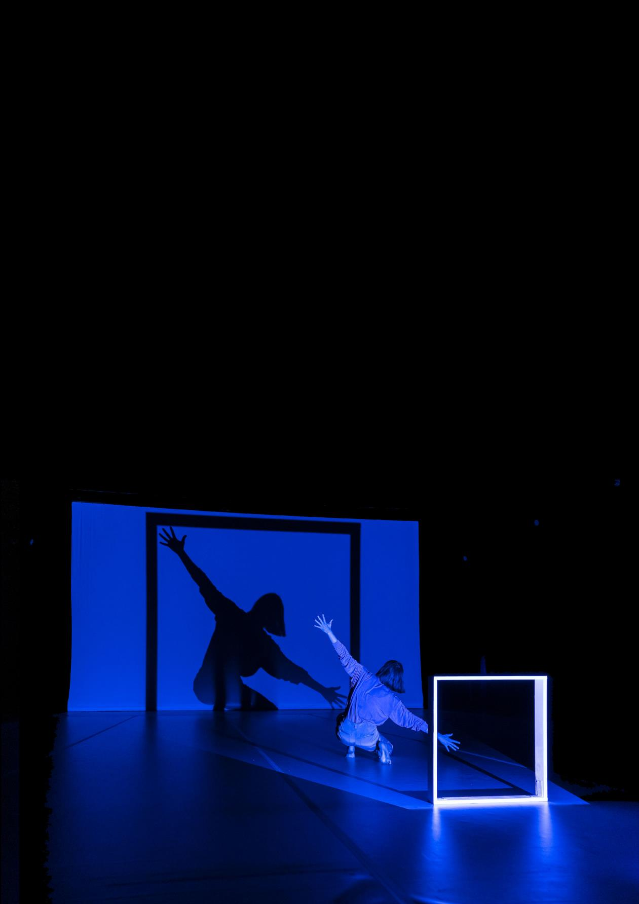

Creative Venue Information

ABOUT THIS GUIDE

This document has information about Arts House’s North Melbourne Town Hall spaces and resources for creative activities. For information on Arts House’s public spaces and buildings please see our General Building Information Document.

If you would like any more information or support accessing Arts House or its facilities, you can call reception on (03) 9322 3720 or text 0447 570 178 between business hours Monday - Friday 9am - 5pm AEST.
You can also email us at artshouse@melbourne.vic.gov.au

CONTENTS

Creative Venue Information 1
ABOUT THIS GUIDE 2
CONTENTS 3
About Arts House 4
What is Arts House? 4
Spaces at Arts House 4
Development and Performance Spaces 6
Main Hall 6
Studio 1 10
Studio 2 14
Supper Room 17
The Warehouse 19

About Arts House

What is Arts House?
Arts House is an arts centre with five dedicated creative spaces suitable for a range of activities. It is part of Melbourne City Council.
Arts House offers space for artists to develop, create and present their work.

Spaces at Arts House
Arts House is based at North Melbourne Town Hall which is a heritage listed building. Arts House also uses a building at the back of North Melbourne Town Hall called the Warehouse.
Arts House is located at 521 Queensberry Street, North Melbourne VIC 3051.
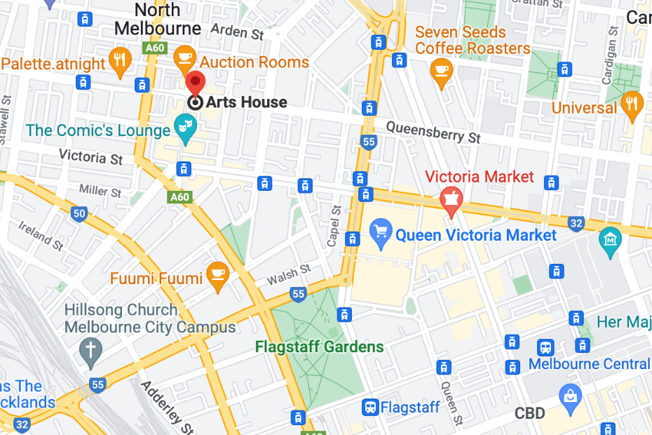Image: A map of Arts House and its surrounding area.

There are three different entry points to North Melbourne Town Hall (also called the main building). Two of these are wheelchair accessible entrances. All levels inside the main building are accessible by both stairs and lift.

All levels of the main building have at least partially accessible bathrooms, but the bathrooms on the ground level are more suitable for people using larger mobility aids such as motorised wheelchairs and scooters.

The Warehouse is a studio in a separate building to North Melbourne Town Hall. It has its own accessible bathroom, two additional bathroom stalls and a kitchenette available to use.
The Arts House team can set up each space to suit the needs of any artists or participants using our venue.

Please note, all Arts House activities operate under a COVID Safe plan and within current government restrictions. We encourage everyone to wear masks and socially distance where possible.

Click here to view an interactive building scan of Arts House.

Development and Performance Spaces

Main Hall
The Main Hall is located on the ground floor and is the largest and most versatile space at Arts House used for development and presentation.
This space is suitable for large scale performances, exhibitions, live music events, installations, parties, public talks, gatherings, and more.

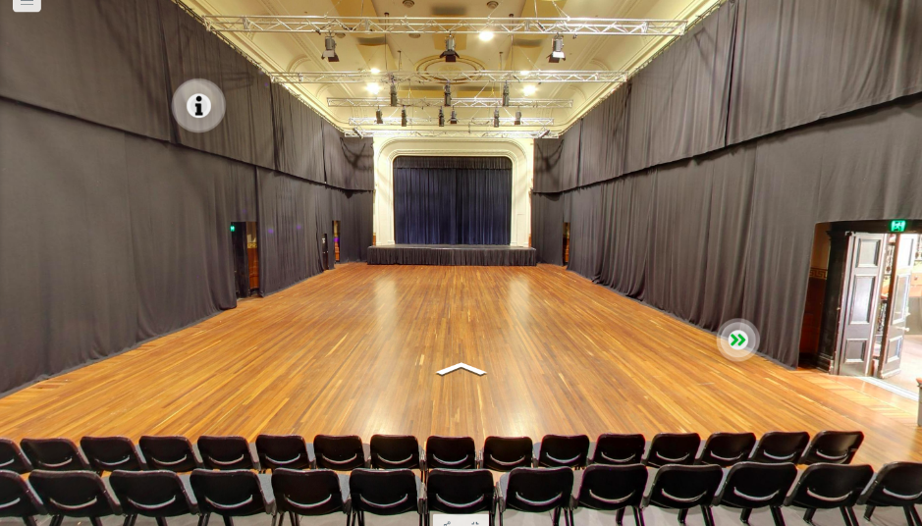
Image: view of main hall from the third row of the seating bank. There is an empty hardwood floor with black heavy drapes pulled around the parameter of the space. A raised stage is visible at the far end of the hall, with black drapes pulled across. The ceiling has ornate fixtures and there are four trusses visible, with theatre lighting.

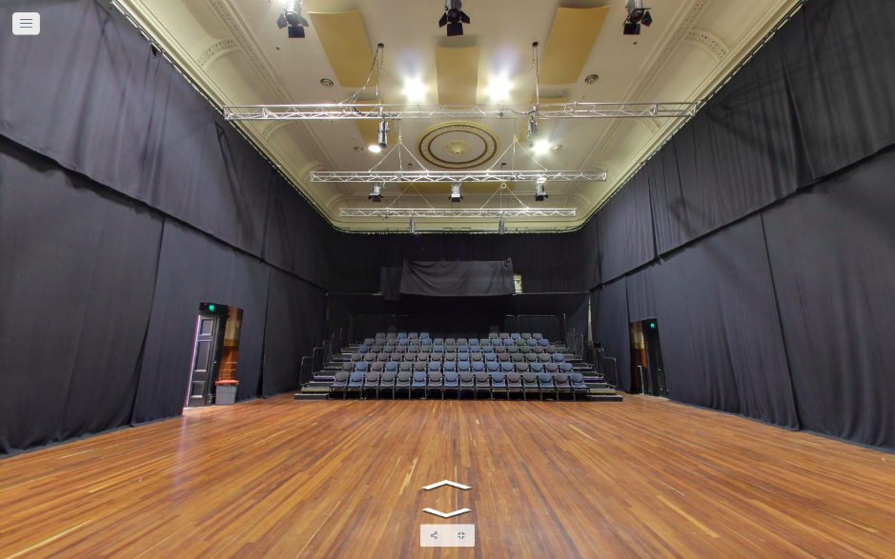
Image: a reverse view of the Main Hall from the stage looking towards the seating bank at the Queensberry Street end of the space. The seats are various shades of blue and grey.

Key features
- Polished dark hardwood flooring which is sprung
- Flat flooring
- Raised stage with battery operated mobile chair lift (not permanently installed, please ask our staff for assistance in using this equipment)
- High ceilings
- Several windows onto Queensberry Street
- Ornate ceiling and fixtures
- This space has heavy black drapes that can be drawn around the whole space to achieve black out
- This space has a lighting rig across the ceiling
- The stage can be converted into a greenroom
- There are two backstage dressing rooms with bathrooms. Please note – these dressing rooms have sharp turns from the stage and are not fully accessible for wheelchair or larger mobility aid users. Alternate dressing rooms can be arranged that are fully accessible.
- Comfortably fits 400 people standing and 132 people using a raked seating bank, depending on the set-up.

Access to space
- Entry to the Main Hall is via large double doors in the main foyer.
- The main foyer is accessed via stairs from Queensberry Street, or George Johnson Lane ramp (suitable for wheelchair access). The foyer can also be accessed via the hallway from the entrance on Errol Street next to the Post Office (suitable for wheelchair access).
- The doors to the Main Hall open towards you, and there is a handle on the left edge of the right door, towards the centre of the two. There are also vertical bolts at the top and bottom of both doors which may need to be slid open to enter.
- Staff are available at the reception desk / box office to open these doors if assistance is needed.
- The stage in the Main Hall can be accessed via a narrow flight of stairs to the left of the stage, or a motorised wheelchair lift that has a 576kg weight limit. The doorway to the wheelchair lift is 90cm wide and 210cm high. The floor area of the wheelchair lift is 150cm x 150cm.
Please speak to one of our staff members should you need to use the wheelchair lift to access the stage area.

Space measurements
- Length from rear wall (Queensberry Street end) to front of stage is 25.2m.
- Width wall to wall from main doors to opposite side is 13.7m.
- Height from floor to ceiling is 9.84m.
- Height from floor to acoustic panels on ceiling is 9.11m. This is the height that should be considered for any installations in this space.

Studio 1
Studio 1 is located on level one of the main building. This space can be used as a development or presentation space.

Studio 1 is suitable for a diverse range of activities including public talks, exhibition, medium-scale performances including dance, artist labs, projection, and more.

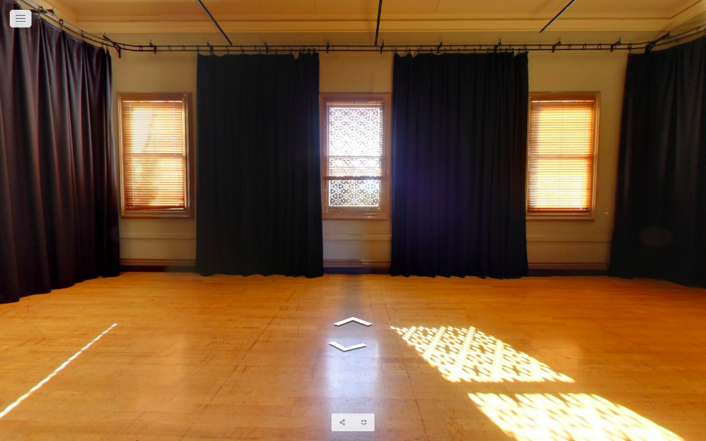
Image: a photo of Studio 1, looking from the doorway into the room. The floors are polished hardwood and black drapes separate three windows with natural light streaming through, on the opposite side of the room.
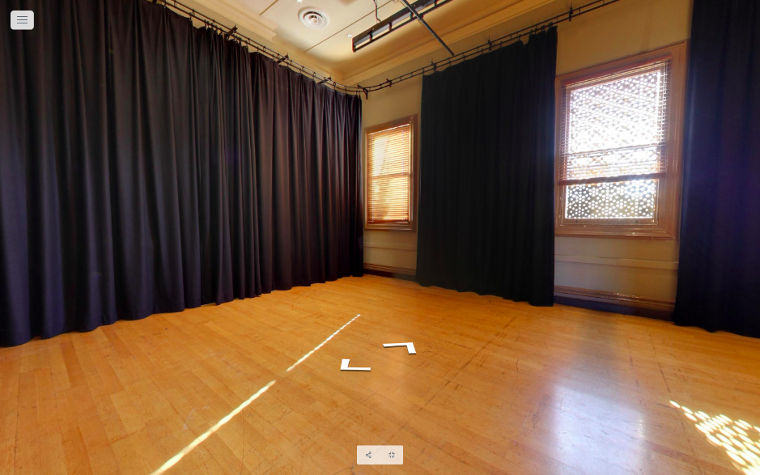Image: view of Studio 1 looking from inside the room. Heavy black curtains that may be used to black out the room can be seen to the left and in-between two windows.

Key features
- Polished dark hardwood floor which is flat
- Three large windows with wooden venetian blinds
- An ornate fireplace (not functional)
- This space has weighted black drapes that can be drawn around the whole space to achieve black out
- This space is equipped with a lighting rig

Space measurements
- Dimensions of the floorspace available to use is 11.5m x 5.9m
- Height from floor to ceiling is 5.6m
- Height from floor to lighting bars is 5m

Capacity
- Studio 1 comfortably fits 50-60 people standing and up to 70 people sitting for a standard panel discussion, depending on the set-up.

Access to space
- Entry to Studio 1 is through a double door. When both doors are open the doorway is 1390mm wide. When one single door is open the doorway is 710mm wide.
- Studio 1 is situated directly at the top of the main staircase. The main staircase has 25 carpeted stairs and grab rails on either side. Please note - this staircase is very wide, so grab rails are not able to be used on both sides at the same time. This can be seen in the image below.

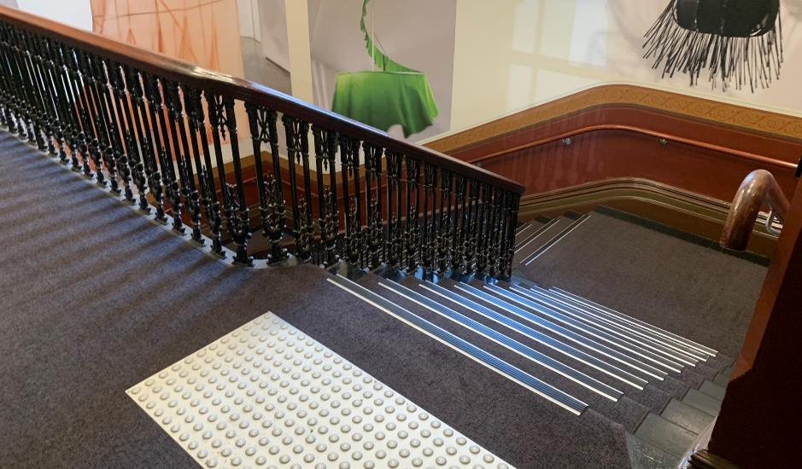
Image: view of the staircase leading to the Ground Floor from the landing on Level 1. The entrance to Studio 1 is straight ahead at the top of these stairs, beyond the tactile surface indicators.

- Studio 1 is also accessible via the lift. Lift access to Level 1 opens onto a wide hallway with a kitchenette at the opposite end, and an outdoor terrace space to the left.
- To access Studio 1 from the lift, turn right before the kitchenette into a narrow hallway. Studio 1 is at the end of this hallway, diagonally to your right across the carpeted landing.
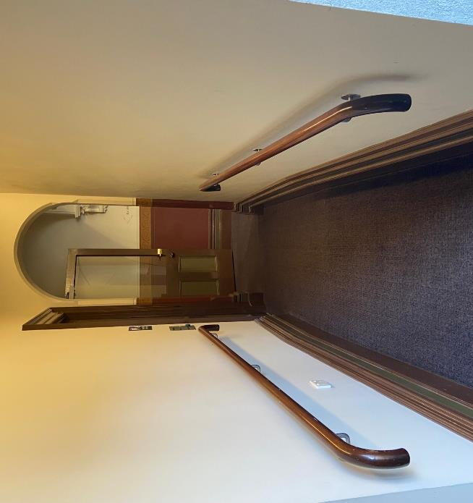
Image: A carpeted hallway with grab rails either side and an archway at the end. Studio 1 is located to the right at the end of this hallway. Studio 2 can be accessed by turning left at the end of this hallway.

Studio 2
Studio 2 is located on level one of the main building. It can be used as a development or presentation space.

Studio 2 is suitable for a diverse range of activities including public talks, exhibition, medium-scale performances, artist labs, projection and more.
Please note – Studio 2 is not suitable for dance activities.

Key features
- Polished dark hardwood floor which is flat
- Three large windows with wooden venetian blinds
- An ornate fireplace (not functional)
- This space has weighted black drapes that can be drawn around the whole space to achieve black out
- This space has a lighting rig

Capacity
- Studio 2 comfortably fits 50-60 people standing and up to 70 people sitting for a standard panel discussion, depending on the set-up.

Access to space
- Studio 2 is situated to the left of the top of the main staircase, at the very end of the carpeted hallway. This can be seen in the image below.
- The main staircase has 25 carpeted stairs and grab rails on either side. Please note - this staircase is very wide, so grab rails are not able to be used on both sides at the same time.
- Studio 2 is also accessible via the lift.
- To access Studio 2 from the lift, turn right before the kitchenette into a narrow hallway. At the end of this hallway, turn left into the main hallway of Level 1. Studio 2 is at the end of this hallway.
- Entry to Studio 2 is through a double door. When both doors are open the doorway is 1390mm wide. When one single door is open the doorway is 710mm wide.
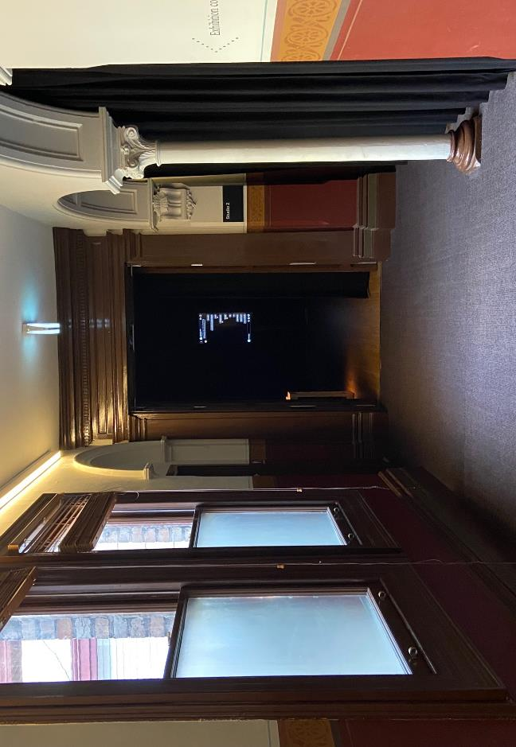
Image: view of the entrance to Studio 2 from midway down the hallway at the top of the stairs on Level 1. There are two windows with natural light coming in from the left, a white pillar and black curtain at the edge of the space to the right and a darkened studio ahead.

Space measurements
- Dimensions of the floorspace available to use is 10m x 7.45m.
- Height from floor to ceiling is 5.5m.
- Height from floor to lighting bars is 4.6m.
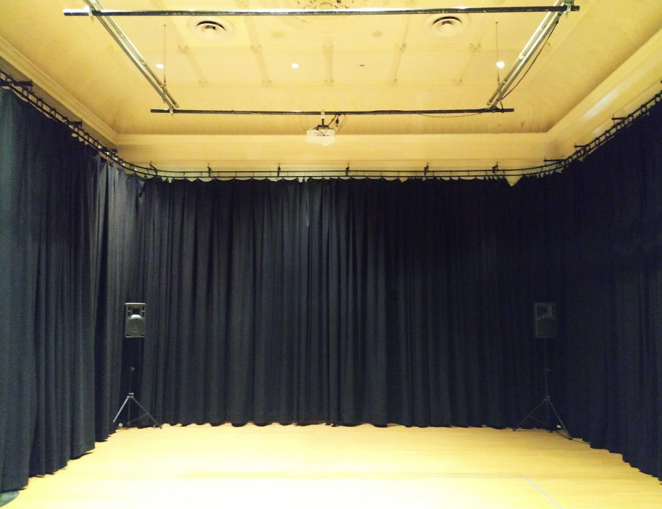
Image: View of Studio 2 with heavy black curtains around three sides of the room. The ceiling is a cream colour and the floor is a light-coloured wood. The lighting rig can be seen attached to the ceiling.

Supper Room
The Supper Room is located on the basement level of the main building. It is directly under the Main Hall.
The Supper Room is suitable for rehearsals, screen space, public talks and gatherings, exhibitions, parties and is often converted into a bar space or green room.
Please note - there can be noise bleed and vibrations in this room from activities in the Main Hall. As such, it may not be suitable for sound sensitive activities.

Key features
- Polished parquetry floor that is flat
- Six pillars in the middle of the room. These pillars are spaced 4.2m apart
- Self-contained kitchen
- Partially accessible bathroom
- Partial lighting rig
- Adjustable lighting with soft, indirect light available

Capacity
- It comfortably fits 120 people standing and up to 80 people sitting, depending on the set-up.

Access to space
- The Supper Room can be accessed either via the lift or stairs from the foyer area.
- There are 20 stairs to the Supper Room with grab rails either side. Please note - the staircase has a low archway, and it is wide, so grab rails are not able to be used on both sides at the same time.
- Entry to Supper Room is through a glass door which is 150cm wide.

Space measurements
- Dimensions of the floorspace available to use is 10m x 16m.
- Height from floor to ceiling is 2.7m.
- Height from floor to lighting bar is 2.5m.
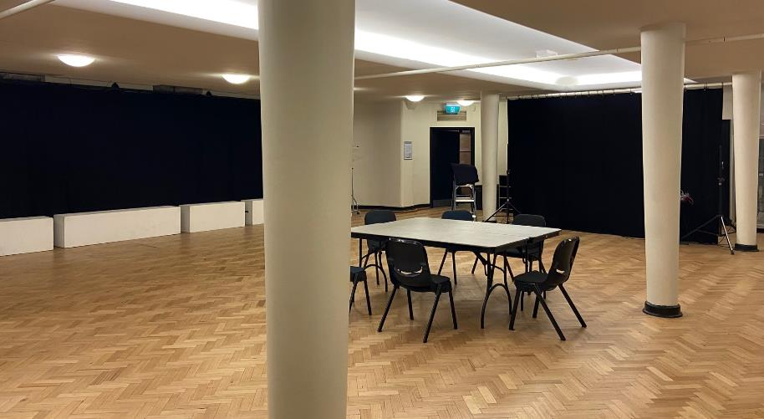
Image: view of Supper Room from main doorway. We can see 3 concrete pillars, evenly spaced across the parquetry floor. There is a table with chairs surrounding it in the middle of the room.

The Warehouse
The Warehouse is in a separate building from Arts House’s other spaces. You can find the Warehouse by following George Johnson Lane as it snakes around the back of the main Arts House building.
The Warehouse can be used as a development and presentation space.
It is a multi-purpose space suitable for medium-sized performances including dance, exhibitions, artist workshops and labs, installations, public talks, gatherings, and more.

Key features
- Polished dark hardwood floor that is flat
- Heavy black curtains and blind to achieve a partial black out
- Four steel pillars which are 4.3m to 4.6m apart
- 3 circuit lighting tracks with modular fixtures
- Self-contained kitchen with a dishwasher and a fridge
- Three toilets including one accessible bathroom and a second toilet with grabrails on one side

Capacity
- The Warehouse comfortably fits 100 people standing and up to 50 people sitting, depending on the set-up

Access to space
- Entry to the Warehouse from Errol Street and George Johnson Lane is via smooth asphalt surface with a cobblestone strip in the centre for part of the journey.
- The Warehouse has two entrances. The rear entrance is closest to the main Arts House building and has one step up from the laneway and three steps up to the Warehouse space itself. This entrance requires a key code and is for staff and artists only. This is a shared entrance.
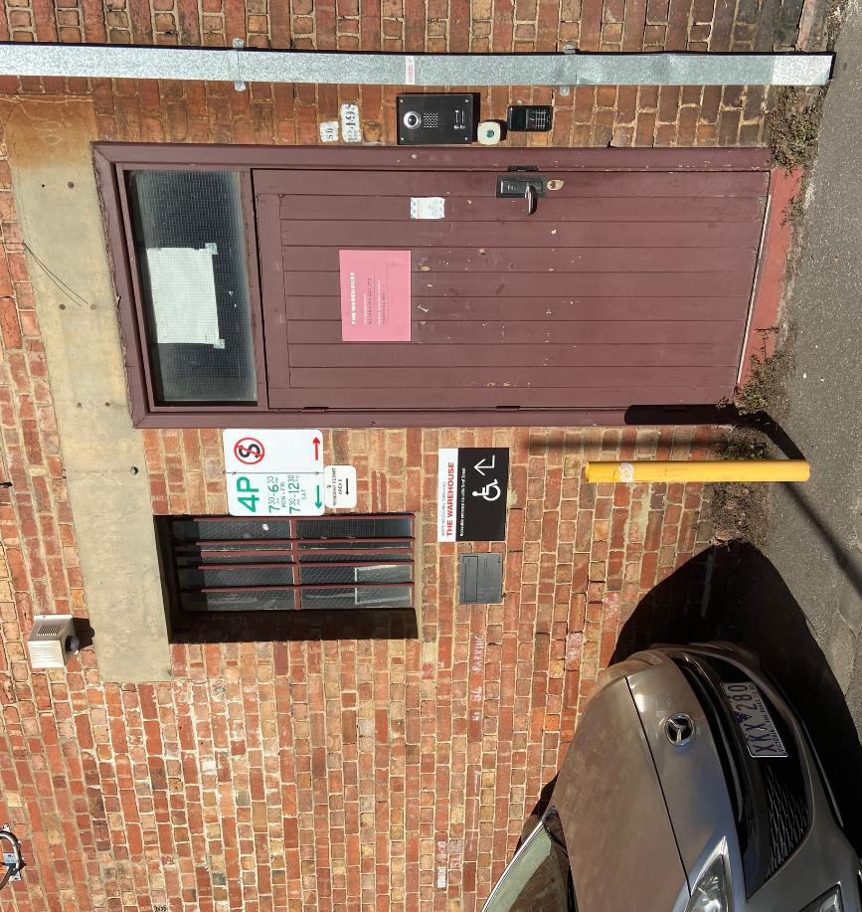
Image: view from the laneway to the rear entrance of the Warehouse, which is an old brick building. This entrance has a maroon-coloured door and a keypad for entry to the right of it. There is a silver car parked directly to the left of this door.
- The main entrance to the Warehouse is located around the opposite side of the building. It has a wheelchair accessible ramp with grab rails on either side and is 1150mm wide.
- The ramp is in two sections - the first half of the ramp has a gradient of 1:6 and the next half has a gradient of 1:12.
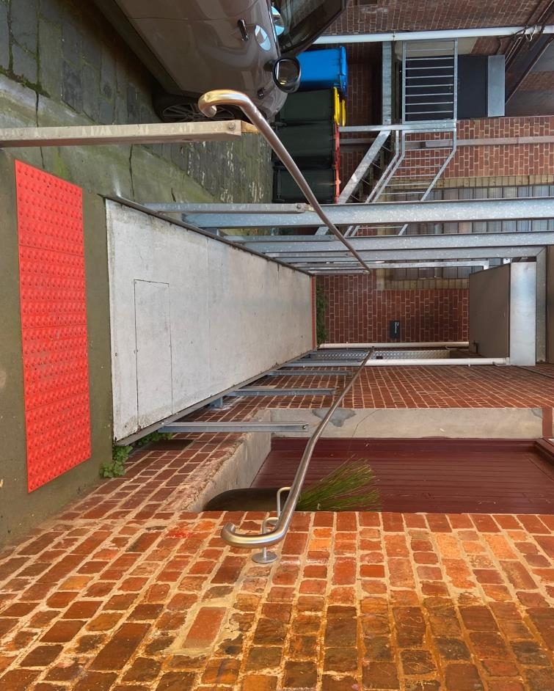
Image: view of the ramp leading to the main entrance of the Warehouse. There are handrails either side of the ramp and a large red tactile surface indicator at the start of the ramp. The door to Warehouse is on the right at the top of this ramp.

- Entry to The Warehouse is through a glass sliding door which is automatic.

Space measurements
- Dimensions of the floorspace available to use is 13.4m x 11.2m.
- Height from floor to ceiling is 4m.
- Height from floor to lighting bars is 3.3m.
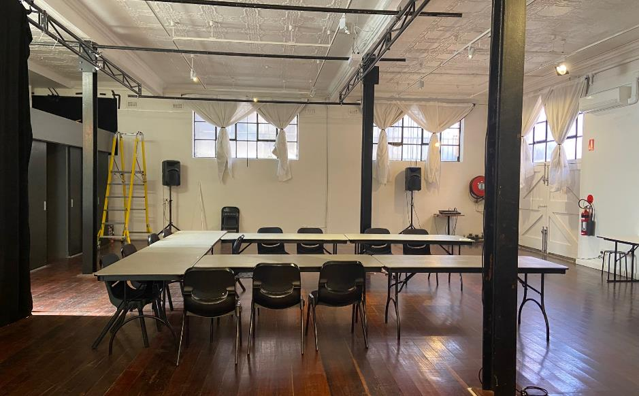
Image: view of the Warehouse space. The hallway to the bathrooms can be seen to the left of the room. The Warehouse has white walls, high windows with white curtains, and dark wooden floorboards. There are four metal poles in the centre of the room. In this picture several tables and chairs are set up in the middle of the space in a U-shape.

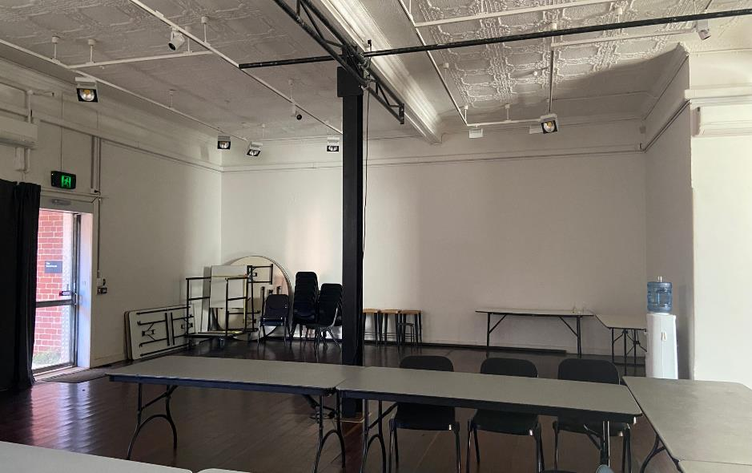
Image: view of the Warehouse space from the doorway of the bathroom corridor. The door to the main entrance can be seen to the left. One of four of the metal poles can be seen in the centre of the room. Several tables and chairs are set up in the middle of the space. There is a water cooler in the right-hand corner of the room and spare chairs stacked up against the far wall.

For information about the Arts House building and amenities, please see our General Building Information document.

This document has been prepared in consultation with Loom Arts and Management and its team of consultants with lived experience of disability. For more information, please visit www.loom.org.au

