GENESIS

By Kianna Oricci, Lay The Mystic, Efren Pamilacan

Access Guide

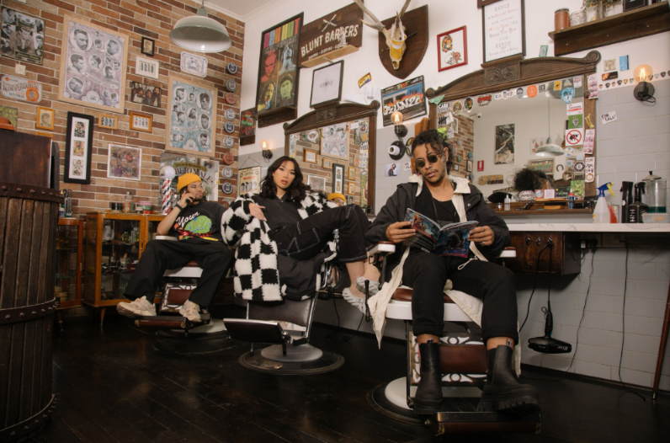

Image credit: Laura Du Vè
Image Description: Efren, Kianna and Lay sit in barber chairs in a hair salon. Lay sits in front with sunglasses and an open magazine, Kianna is in the middle wearing a fabulous white and black checked jacket looking directly at us, and Efren wears a yellow beanie and talks on his phone facing a mirror.

Updates to this document

Please note, this event is highly improvised and changes are being made by artists until opening. We will endeavor to provide the latest access information on performances to ticket holders across key stages of rehearsal and presentation.

Arts House website will contain the most up to date version of this document and all ticket holders will be notified of any final revisions made 3 days prior to the event.

This document was created: 21 November 2023 Last updated: 29 November 2023

Contents
Updates to this document 1
Where 3
When 3
Access Services 3
Performers 5
Running Order 6
Sensory Elements 6
Sound 6
Lighting 6
Physical 6
Smell 7
Visual 7
Entry to space 7
Shocks or surprises 7
Audience experience 7
Social expectations 8
Performance expectations 8
Other 9
Content Warnings 9
The Venue 10
Entry to Event 10
Event Space 11
Box Office 12
Ushers 12
Bar 13
Quiet Space 14
Bathrooms 15
Lift 15
Transport 16
Tram 16
Train 16
Bus 16
Parking 16
COVID Safety 17

Where

Arts House
521 Queensberry Street
North Melbourne VIC
Entry will be via George Johnston Lane, located beside North Melbourne Library on Errol street.

When

Saturday 2 December
Doors open 6pm for a 6.30pm start
Duration: 4 hours

Please note this is an 18+ event. Guests under the age of 18 must be accompanied by a parent or guardian

If you require a meet and assist service please email or call Arts House.

Access Services

Audio Describer Guides
Personal describer guides available for meet & greet on arrival and one-on-one live descriptions of the performance. This services needs to be pre-booked.

Visual Rating 50% – includes dialogue and background music or sounds, so Deaf and hard of hearing audiences can have some engagement with the event.
Aural Rating 50% - this performance has both sound and visual components.
This event is wheelchair accessible.

Assistance Animal are welcome.

Quiet Space - is located on Ground Level near reception, this is a shared space suitable for recovery from sensory overload, prayer, or parenting. It features a range of seating options, dimmable lights, sensory and stimming objects. Anyone is welcome to access this space during the event.

Companion Card – You can book your complimentary companion ticket online or over the phone when purchasing tickets to this show. Contact our box office team for more information.

Performers

There are 2 MC’s in this event – Kianna Oricci and Jamaica Moana.

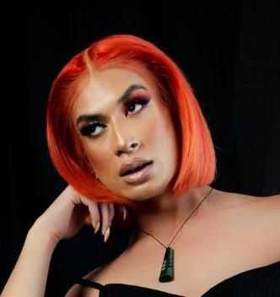
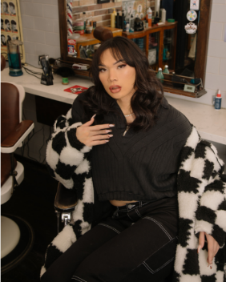

There are 4 judges in this event on stage - Kilia Pahulu, Xuela, Jaycee Tanuvasa and Mataya Magpayo.

There will also be 15 ballroom walkers and 2 DJs.
We will know who they are just before the event.

Running Order

6:00-6:30 Welcome and Exhibit exploration
6:30-6:45 Judges Performance
6:45-7:00 Ballroom community roll call
7:00-7:40 Category 1: Runway
7:40-8:00 Category 2: Bizarre
8:00-8:30 Category 3: Sex Siren
8:30-8:40 Intermission
8:40-9:10 Category 4: Realness
9:10-9:40 Category 5: OTA Performance
9:45-10:00 After party announcement

Sensory Elements

Sound

There will be consistent loud noises throughout the event. Music will be played from a live DJ and MC’s will commentate on top of the music. There will be shouting and encouragement from both the creatives and the audience.

Lighting

The lighting surrounding the stage will be colourful. The lighting on the runway/stage will be bright white and consistent. There will be minimal flashing.

Physical

Vibration will be felt from the music and performers as they will be dynamic and will be jumping on the runway/stage. There may be potential for physical interaction between audience as everyone is allowed to freely move around throughout the event.

Smell

There may be the smell of sweat from the performers on stage.

Visual

Upon entry, the main hall has a large “Y” shaped runway/stage placed in the middle that will be well lit. There will be “walkers”, “judges”, and “MC’s” on stage.

A smaller stage will be located against the right wall upon entry. There will be DJ’s on stage.

A bar and small self-service cloak area is located in the left side area of the space upon entry. The cloaking service is unmonitored.

The foyer and relaxed space will be activated with soft and colourful lighting. There will be visual loops on the TV screens located on the walls. There will be footage of archived vogue dance.

Audience Experience

Entry to space

Entry to Arts House on the night will be via George Johnson Laneway. This is a stepfree entrance. Upon entry into the building audience are able to enter straight into the main hall where the performance will take place.

Shocks or surprises

There will be loud moments as the MC’s will be chanting musically on top of the music playing. The movements by the “walkers” will be dynamic.

Audience experience

Audiences are allowed to come close to the stage/runway. There is no expectation for audiences to be close and can experience the work from any distance that is comfortable.

Social expectations

The audience will be allowed to move freely around the runway where accessible. There will be a large crowd around the stage/runway. There will be designated relaxed and “chill out” spaces located beyond the main hall in rooms that are part of the foyer area.

During the performance, the MC’s will announce an “open call” to notify the ballroom community if they would like to participate in the current category.

Audience participation is optional, walkers from the ballroom community come prepared as each category has specific has requirements. Details of the categories can be found on the Arts House website.

Walkers
- Look after yourself
- Dip at your own risk
- Don't jump off the stage
- Follow the guidance of MCs
- Have fun!

Performance expectations

The MCs will navigate the performance and narrate what is currently happening on stage. There will be categories as part of the performance that are described on the GENESIS and Arts House website.

The categories are:
Bizarre
Runway
Realness
Sex Siren
OTA Performance with a prop

Other

Content Warnings

Language warning and nudity warning.

General Notes

There will be loudness both visually and auditory within the main hall. If this becomes overwhelming there are designated quiet and relaxed spaces available.

There will be a security guard on the entry to Arts House building directing patrons and making sure patrons do not bring alcohol outside.

The Venue

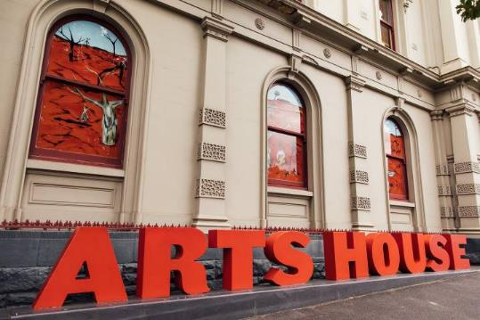
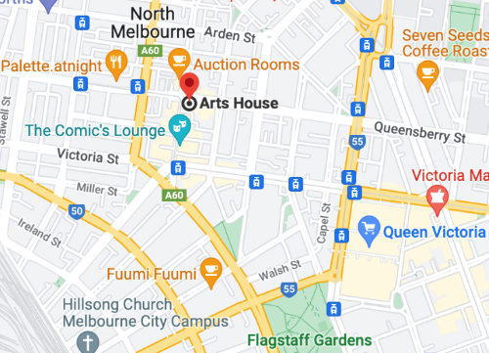

Image: North Melbourne Town Hall features giant red letters that say ARTS HOUSE out the front of it.

Image: a map of Arts House and its surrounding area. LINK TO MAP

Entry to Event

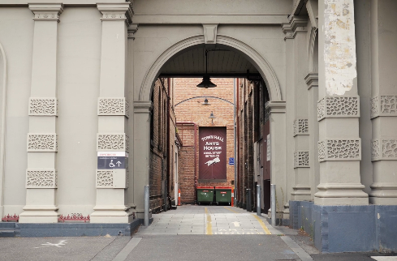

Entry to this event is via George Jonson Laneway, located beside North Melbourne Library on Errol street. This is an accessible, step free entry.

Image: View of George Johnson Lane from Errol St. The laneway passes through an archway with a brick wall at the end.
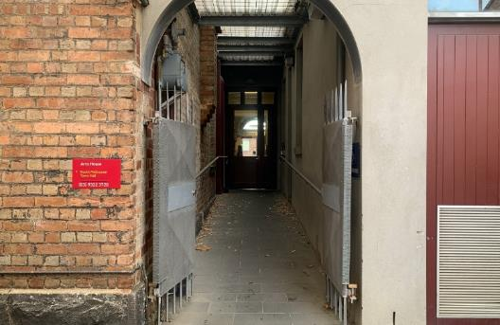

Image: view of the ramp leading from George Johnson Lane to the automated door which opens into the Arts House foyer.

Event Space

The Performance is in the Main Hall.
It is on the ground floor.
It is to the left of the box office desk and right of the bar.
An artist statement is available on signage and warnings on the door.
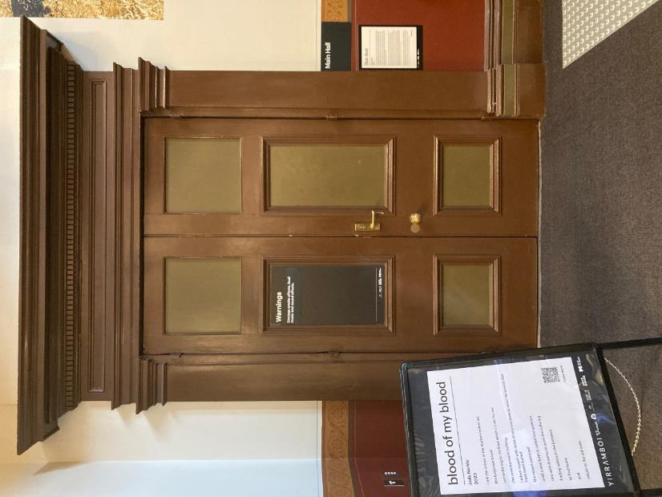

Box Office

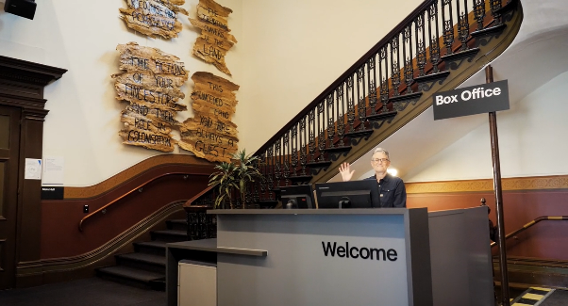

Box Office is located in the foyer under the stairwell.

Ushers

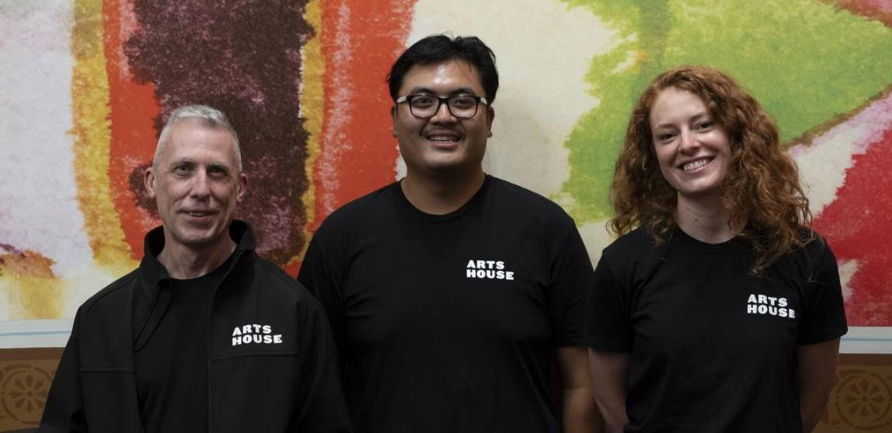

Ushers will be wearing black with an Arts House Logo on the left hand shoulder.

Bar

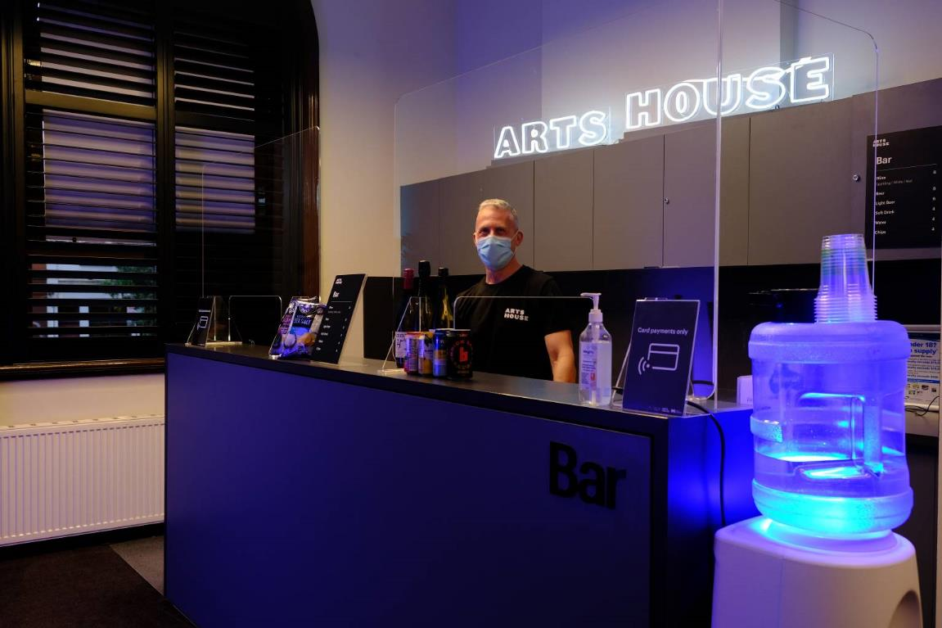

Bar staff will be wearing black with an Arts House Logo.

We have a range of alcoholic and non-alcoholic beverages for sale.

We are a cashless venue and accept EFTPOS, Visa and Mastercard payments.

Quiet Space

Arts House Quiet Space is located on Ground Level and is nearby reception and opposite the accessible bathrooms. It includes a range of seating options including soft furnishings, dimmable lights, sensory and stim objects. It is open during venue opening hours and events as a quiet space, prayer or parenting space.

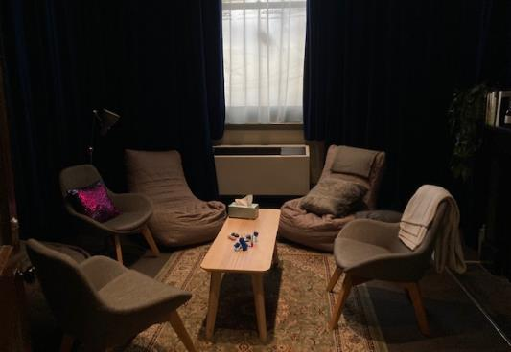

Image: Quiet space with lights dimmed
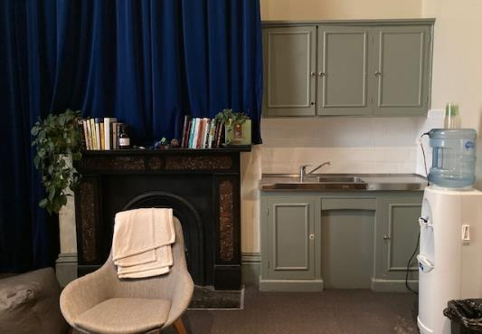

Image: Quiet space kitchenette and book shelf

Bathrooms

All bathrooms have Dyson hand dryers with sensor activation. There is an accessible bathroom that is single use on ground level opposite the Quiet Space. There is another accessible bathroom upstairs – this is accessible via lift or stairs.

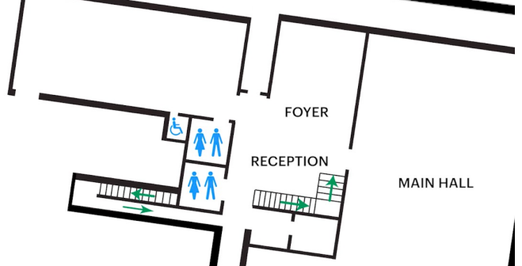

Lift

The lift is located behind reception desk in the foyer.
The closest entry to the lift is via George Johnson Lane.

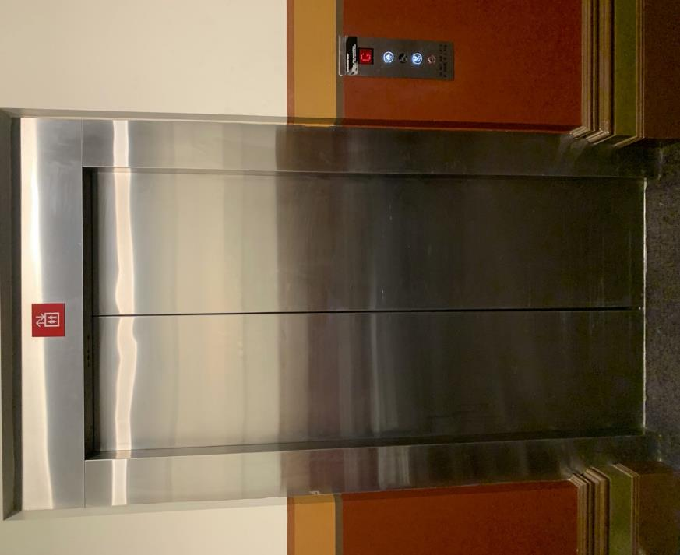

Transport

Tram

Route 57 (High Floor trams only)
Stop 12, North Melbourne Town Hall.
Please note, this is not a wheelchair accessible tram
GETTING TO ARTS HOUSE VIDEO LINK

Train

Arts House is 1.1km from
North Melbourne Train Station,
approximately 16 minute walk
North Melbourne Station Information
1.2km from Flagstaff Station,
approximately 15 minute walk
Flagstaff Station Information

Bus

Bus number: 216

Parking

There is limited paid on-street parking on Queensberry Street and Errol Street.

There are two accessible on street car parking spaces on Queensberry Street (150m to our accessible Errol Street entrance) for holders of a Parking Permit for Disabled people.

COVID Safety

Please follow good health and hygiene practices when visiting Arts House.

Ticket holders who cannot attend their performance due to COVID-19 illness or symptoms are entitled to a full refund.

Facemasks

We have disposable masks available at reception and in the foyer.

Cleaning

Arts House buildings are cleaned nightly Monday-Friday and on weekends as required.
We conduct touchpoint cleaning of spaces between performances.

Hygiene Stations

Arts House provides handwashing and hygiene stations in each amenities area, studio, and office including: hand sanitizer, disinfectant wipes, rubbish bin.
More information about COVID-19 Safety can be found through the links below:
Our COVID-19 Safety Plan - Arts House - Melbourne

