The Birth and Death of a Physical Artist

By roya the destroya and Peter Sette

Access Guide - Digital

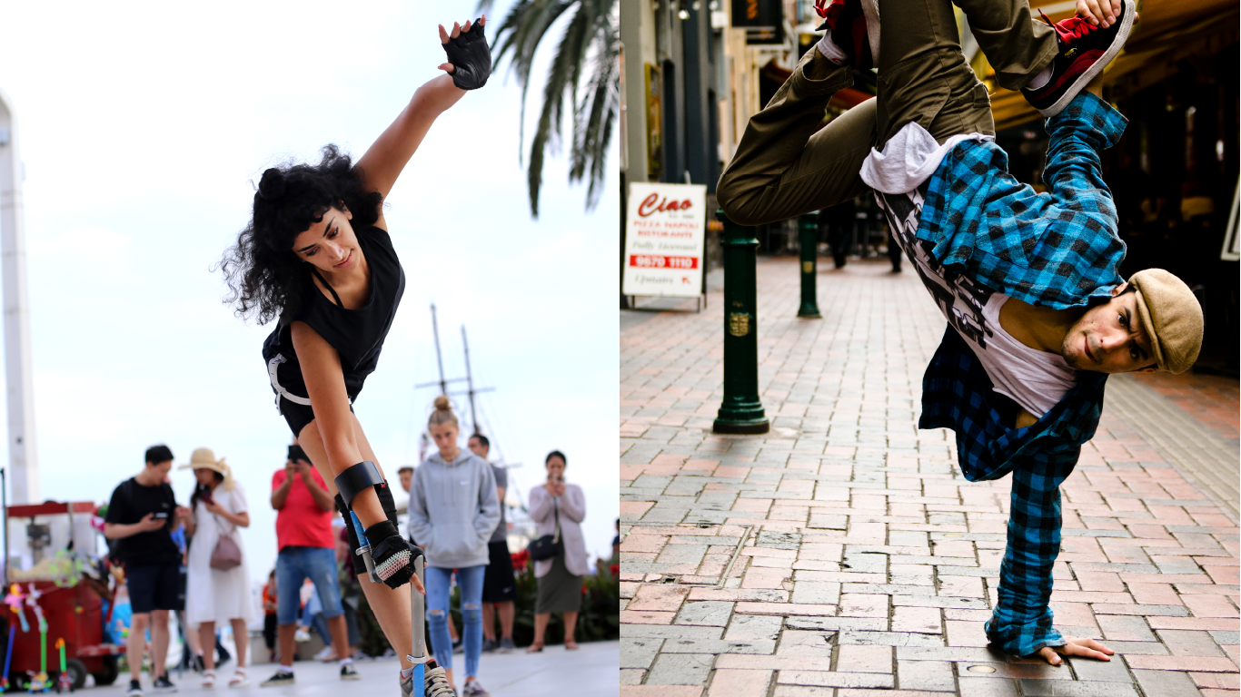

Image: Two images side by side. On the left, Roya is performing in front of a small crowd on the street. She has a crutch in her right hand, captured in the middle of an acrobatic sequence and is wearing a black singlet and shorts. On the right, Peter is doing a breaking (breakdancing) freeze, in a one handed handstand, wearing a black and blue checked shirt on a brick street.

Updates to this document

This document has been adjusted from the live performance for digital viewing.

This document was created: 29 September 2023

Contents
Updates to this document 1
Where 3
When 3
Access Services 3
Performers 4
Sensory Elements 4
Sound 4
Lighting 5
Physical 5
Visual 6
Shocks or surprises 6
Audience experience 6
Performance expectations 6
Other 7
Content Warnings 7

Where

Digital Fringe

When

Available on demand
Monday 9 October 2023, 10:00am - Sunday 22 October 2023, 11:59pm
Duration: 65 minutes
This pre-recorded video can be accessed anytime, anywhere between the dates and times available. It will be hosted on vimeo platform and accessed via Digital Fringe website.

Access Services
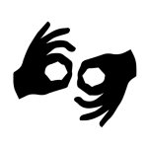
Auslan Interpreted
All spoken words will be Auslan interpreted.
Audio Described
A link to the audio described version is available in the “important information”.
Visual Rating 50% – this performance has music and sounds in the background.

Performers

Peter Sette (left) and roya the destroya (right)

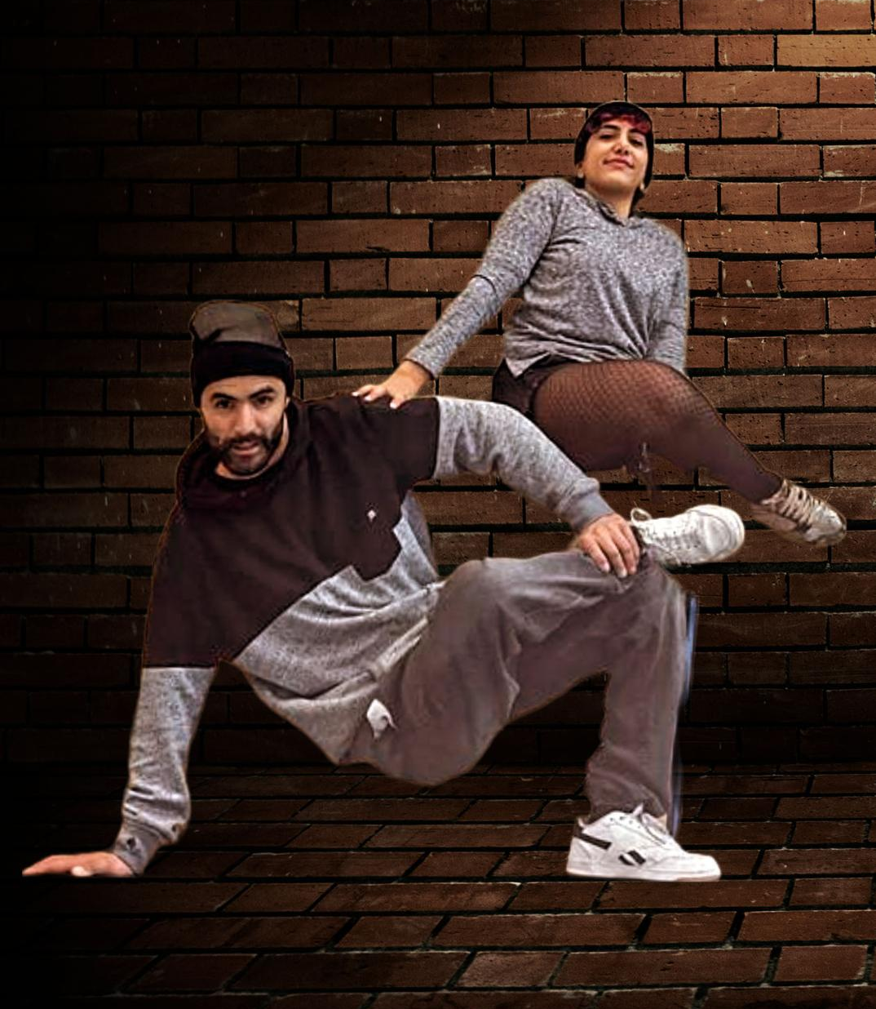

Image: Peter and roya are posing against a brick wall in street dancing style with their legs crossing over and arms supporting one another.

Sensory Elements

Sound

The Birth and Death of a Physical Artist features loud music and sound effects throughout the show. The music changes rapidly at times and sound effects used in the show include sudden sounds, sound of alarms, sounds of banging on a door, street noises such as car horns and traffic noises, repetitive sounds, and distorted music.

The dialogue in the show is mostly pre-recorded and played as voice overs. Dialogue features voices coming from off-stage, overlapping voices, whispering or hard to hear voices and occasional yelling.

Lighting

There are some sudden lighting changes during the show, however most lighting changes happen slowly and with scene changes.

There is an isolated lighting stage at the front of the stage which has flickering lights that shine directly onto the performers.

There is one scene where the lights on stage turn off and on quickly and include red lights. This lighting stage does not feature strobe lights, but does occur across the whole stage.

There is no lighting directed on or towards the audience until the very last section, when the house lights will go up on the audience as well as the lights on stage remaining on.

Lighting is often dimmed in-between scenes. There is one total black out towards the end of the show.

Physical

The Birth and Death of a Physical Artist begins with the performers being in close proximity to the audience, with the possibility of touching of arms or legs in passing, or moving behind people at close range.

The digital version contains a recording of audience participation element which took place in the live performance towards the end of the show. There is no audience participation in the digital version.

The show is very physical in nature and features lots of fast movement. At times the show features one performer physically handling the other as part of a routine, but this is done safely and with consent.

Visual

The show features quick costume and scene changes, but no patterns or visuals that are busy or potentially overstimulating.

Audience Experience

The Birth and Death of a Physical Artist digital version can be viewed on demand in a location of your choice.

Shocks or surprises

There is a sudden change to both lighting and sound in the first half of the show, where a loud sound effect will play and white and red lights will flash on and off.

Audience experience

From the beginning of the show, the performers engage directly with the live audience in the recording. This includes walking or running among the audience, establishing eye contact with audience members, and encouraging active participation. At times the recording features a slight touch (e.g. on the arm, or lightly on the shoulder) between an audience member and performers in passing, or during audience participation.

Performance expectations

The recording of this performance switches between viewing the whole stage and close up elements of the performers.

For most of the performance, there are two performers on stage who play different roles representing both their experience and the general experience of being a professional physical artist.

While the show is predominantly a dance performance, there is a narrative element with some dialogue. The narrative is chronological, but not presented as one story, rather smaller scenes that make up the broader story.

Other

Content Warnings

“The Birth and Death of a Physical Artist” is a show about doing a job that relies on your body and therefore explores themes of injury and ableism and how this might affect someone.

The show also has themes of anxiety and depression and the personal and professional toll this may take.

