**How Do I Let You Die?**

By Michele Lee

Access Guide

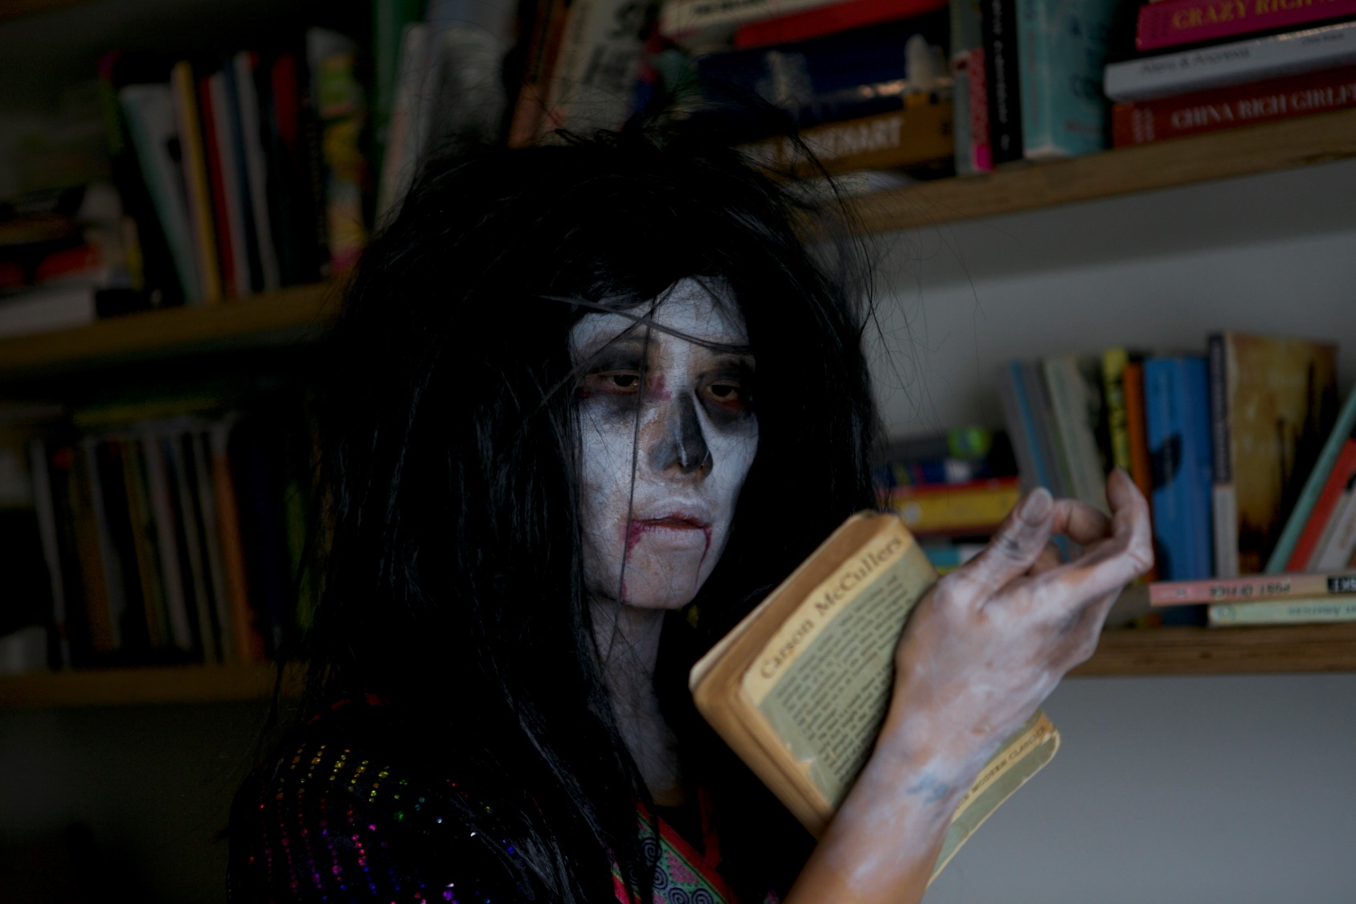

Image: promotional image for the show

Image credit: Eugyeene Teh

Image description: A Hmong-Australian woman is dressed in a black wig and ceremonial Hmong clothes, and she has ghostly white paint on her face. The woman holds a book in her hand and stares at it blankly. Behind the woman is a bookshelf of more books.

# **Updates to this document**

Please note, this performance is a new work and changes are being made by artists until opening. We will endeavour to provide the latest access information on performances to ticket holders across key stages of rehearsal and presentation.

Arts House website will contain the most up to date version of this document and all ticket holders will be notified of any revisions made 3 days and 1 day prior to the event.

This document was created: 3 November 2023

Revision 1: [insert date]

Revision 2: [insert date]

**Contents**

**Where** 4

**When** 4

**Access Services** 4

**Performers** 7

**Sensory Elements** 9

Sound 9

Lighting 9

Physical 9

Smell 10

Visual 10

Entry to space 10

Shocks or surprises 10

Audience experience 11

Social expectations 11

Performance expectations 11

**Other** 12

Content Warnings 12

General Notes 12

**The Venue** 13

**Front Entrance** 13

**Accessible Entrances** 14

**Box Office** 15

**Ushers** 15

**Bar** 16

**Quiet Space** 17

**Bathrooms** 17

**Performance Space** 18

**Lift** 19

**Transport** 19

**Tram** 19

**Train** 20

**Bus** 20

**Parking** 20

**COVID Safety** 20

# **Where**

Arts House

521 Queensberry Street

North Melbourne VIC

# **When**

Wednesday 22 November, 7.30pm

Thursday 23 November, 7.30pm

Friday 24 November, 7.30pm

Saturday 25 November, 7.30pm

Sunday 26 November, 5pm

Duration: 90 minutes

# **Access Services**

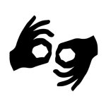

**Auslan Interpreted Performance and Post show Artist Talk**  
Thursday 23 November, 7.30pm

Post show artist talk will be 30 minutes in duration.

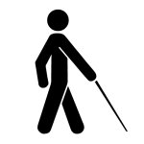

**Tactile Tour and Audio Described Performance**Friday 24 November

Tactile Tour, 6.30pm

Performance, 7.30pm



Assistance Animal are welcome.



Assistive Listening is available free of charge. Ask staff for assistance on arrival.



**Visual Rating 50%** – includes dialogue and background music or sounds, so Deaf and hard of hearing audiences can have some engagement with the event.



**Aural Rating 50%** – contains both sound and visual components, but sight is not essential to be able to engage with the event.

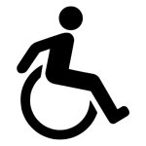

This performance is fully wheelchair accessible.

# **Performers**

There is 1 live performer in this show – Alice Qin.

Alice Qin performs as Michele Lee onstage and in the projected film.

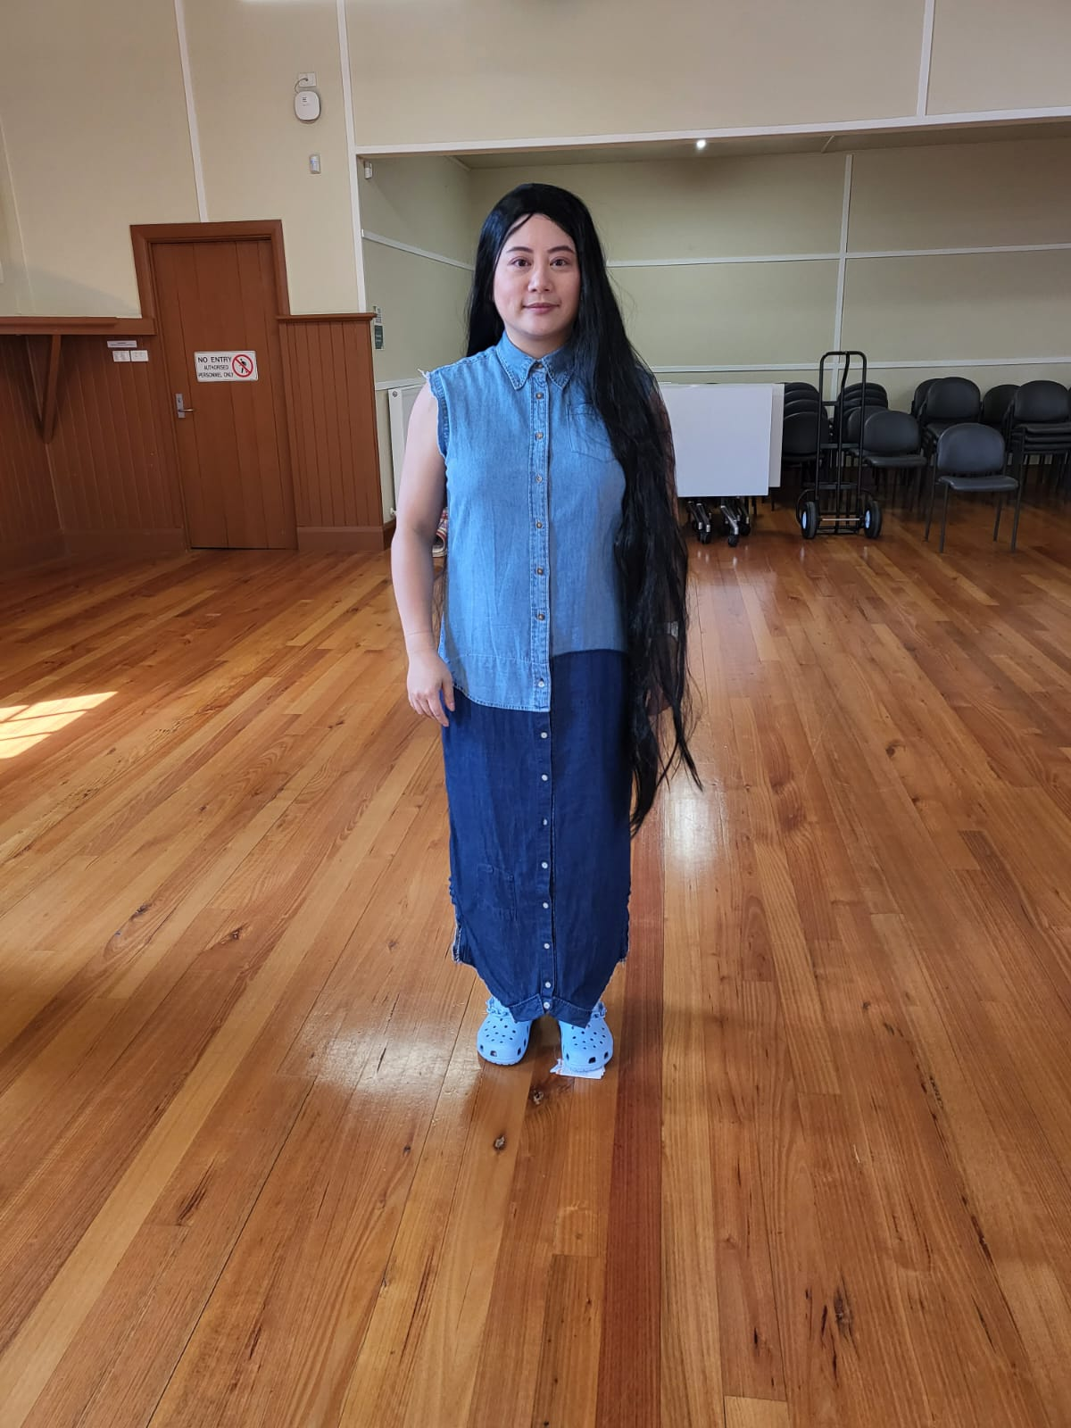

Image description: A fem-presenting person of Asian descent with long black hair. She is wearing a dress that looks like a light wash sleeveless denim shirt sewn to a mirror-image medium wash denim shirt as the skirt. She is also wearing light blue crocs with a chain detail.

In the projected film, Michele Lee performs as Ghost Woman.

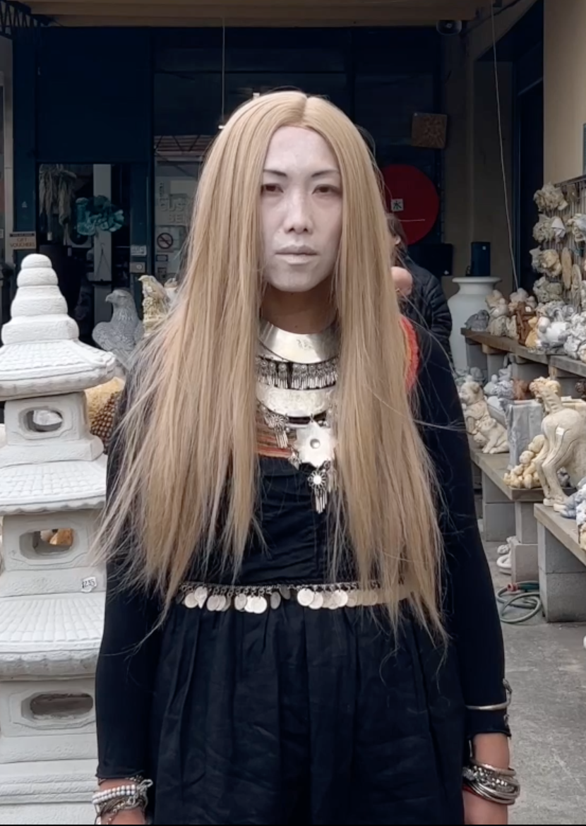

Image description: A Hmong-Australian woman is dressed in a blonde wig, ghostly white paint on her face, wearing a black dress with silver coin detail along the waist, multiple silver necklaces including a Hmong xauv necklace over a red base layer, and multiple silver bracelets.

Images of Michele Lee as herself are also projected onstage during the play.

# **Sensory Elements**

## Sound

The performer is mic-ed throughout the show. Pre-recorded sounds play throughout the show, including: phone calls; atmospheric and ambient music which plays at times over the performer speaking, such as samples of bells, insects, phone ringing, robotic, electronic sounds, low frequency and high frequency vibrations, and occasional sudden, louder noises. Some sounds have clear sources, such as the performer from in front of the audience. Some sounds may come from behind, overhead, underneath the seating bank, or a corner of the room. Some sounds move around the room or have varying directions and effects.

Some of the phone calls have their own ambient sounds, for example, children chattering in the background, that may result in overlapping voices or hard to hear moments. Phone calls will have surtitles in English and Hmong.

Sounds from the film include: instrumental music, sound effects such as sudden, sharp noises to indicate a change in action, and diegetic sounds — sounds that come from the film’s action and location, for example, sounds from a shop, the characters speaking and sounds from the character’s front yard.

## Lighting

Lighting goes on and off throughout the show. It will change in intensity and colour, at a mix of fast and gradual speeds, including flashing.

Lighting will be from the top and the sides of the room. Any lights that are in audiences’ line of sight will be dim, frosted, and the acting will be at a different angle to the light.

Lighting may be dim during parts of the performance. The room may go dark at select moments and at the end of the performance, however with emergency lighting it will not be fully dark.

Projections and screens go on and off throughout the show on designated surfaces; nothing is projected on audiences.

## Physical

There will be some vibrations.

There will be no physical contact with the actor.

Seating is relatively low and close to the performance area.

Flooring is even except for taped down cables.

## Smell

There may be forest scents and incense used in the play.

There may be stage haze and smoke machine used.

## Visual

Seating is configured on a slant diagonally across the room, with 3 seating bank options. The performer moves across the performance space throughout the show to minimise keeping audiences' heads turned at a particular angle for too long.

Videos, images, and text are played on a suspended projector screen, on 2 TV screens, and on the floor, that are in different parts of the room.

Netting is suspended in the middle of the performance space about 3.6m up, with objects in it.

There are jump scares and uncanny visuals in the film. There are none onstage.

There may be fake blood used towards the end of the play.

Audience Experience

## Entry to space

Audiences enter from the foyer to the Main Hall via the door between the bar and the stairs.

There are 3 seating banks, you can choose which seat to sit in. While crossing the space to sit, please do not touch the technical elements nor the props, and please do not step on the grey vinyl mat if you have heels on.

Audiences will not be asked to do anything as part of entering the space.

## Shocks or surprises

There will be eye contact with the performer. There is breaking of the fourth wall. There is no touch nor participation.

## Audience experience

There will be eye contact with the performer. There is breaking of the fourth wall. There is no touch nor participation.

## Social expectations

Audiences are welcome to enter and exit if needed – you may have to walk across a light. Ushers will open the doors as needed. Due to the placement of technical elements and audience sight lines, seating is in the designated seating banks and audiences cannot move around the space beyond what’s mentioned above.

All front rows of every seating bank can be wheelchair users’ seating, please inform the Front of House staff of your preferred seat.

Audiences can see the performance space and elements from their seats but it will require turning of the head or torso, or adjusting of the angle of their body in the seat. Please let Front of House staff know if you need more space or seats for this.

There is no audience participation. There is breaking of the fourth wall, where the performer talks to the audience as a whole directly, but it is not an invitation for verbal interaction. Laughter, crying, all emotional responses are welcome. Audiences can stim and snack, although please avoid stimming with sound during the performance.

## Performance expectations

With one live performer on stage, this performance is largely a monologue relaying conversations, events, thoughts and feelings. There is some dialogue in pre-recorded phone calls and videos played.

The performer is wearing a blue costume and will be the only person speaking during the performance in the middle of the performance space. Staff will not be on stage, and will be wearing black clothing or a staff lanyard.

The performance does not follow a narrative story per se, but rather follows the play’s writer, Michele Lee, figuring out how to talk to her parents about death through 30 minute daily phone calls she had with her parents during February 2020. Michele and her parents are Hmong, so these conversations are also influenced by Hmong culture, Hmong experiences and Hmong spiritual beliefs.

Some of the audio that is used in the show is in Hmong. This is to be subtitled in English.

# **Other**

## Content Warnings

Themes of death and grief — permeates the play, including death of relatives, parents ageing and anticipatory grief, child death, near death experiences, mental health and trauma, isolation, wars and fleeing.

Towards the end of the play, a rubber chicken is cut with a fake knife and fake blood is poured out.

Ghosts — mentioned throughout the play, as well as a story involving curses

Sexism — a few anecdotes contain experiences of sexism and there is one mention of sexual assault

Racism — two anecdotes contain experiences of racism, one in relation to language, and one conflating two cultures.

Coarse language — the words sh*t and f*ck are used a few times throughout the play

Low lighting

Flashing lights

Loud sound

Haze, stage smoke, incense, naked flame

## General Notes

An Acknowledgment of Country will be played in the theatre space directly prior to the performance starting.

# **The Venue**

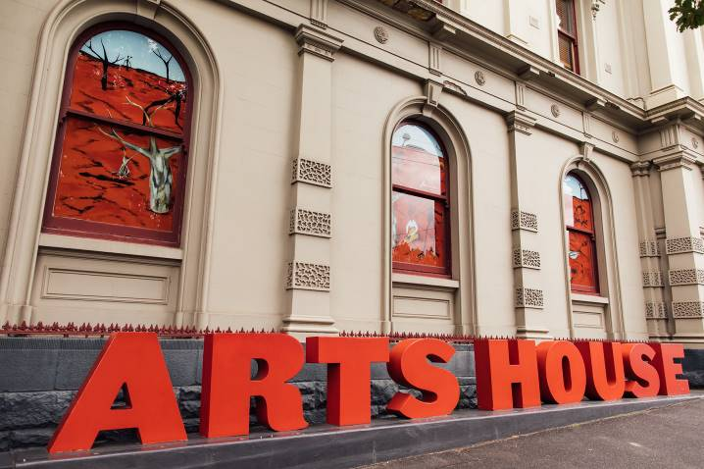

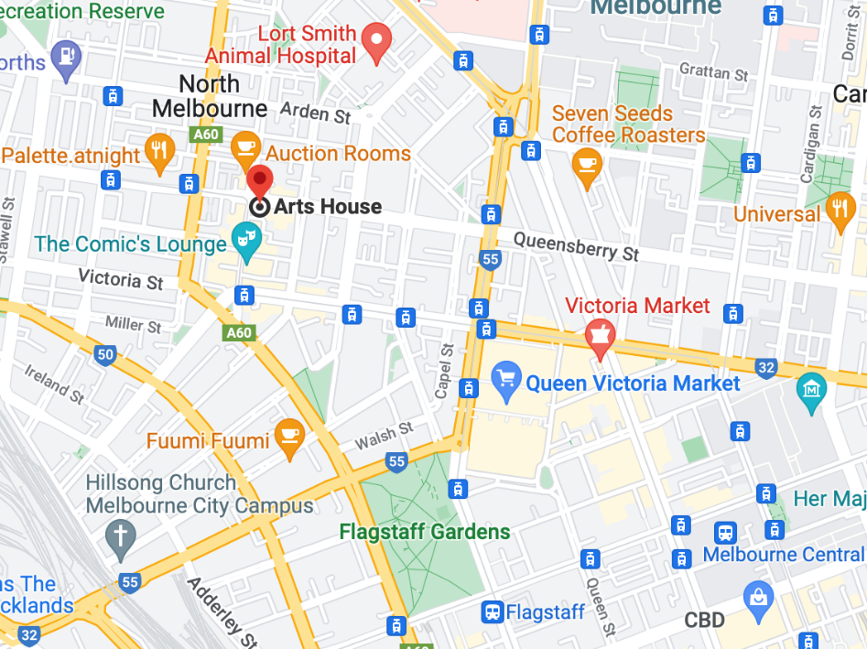

Image: North Melbourne Town Hall features giant red letters that say ARTS HOUSE out the front of it.

Image: a map of Arts House and its surrounding area. [LINK TO MAP](https://www.google.com/maps/place/Arts+House/@-37.802973,144.9486818,17z/data=!4m5!3m4!1s0x0:0x64c465ac7ef21cff!8m2!3d-37.803239!4d144.9498609?shorturl=1)

## **Front Entrance**

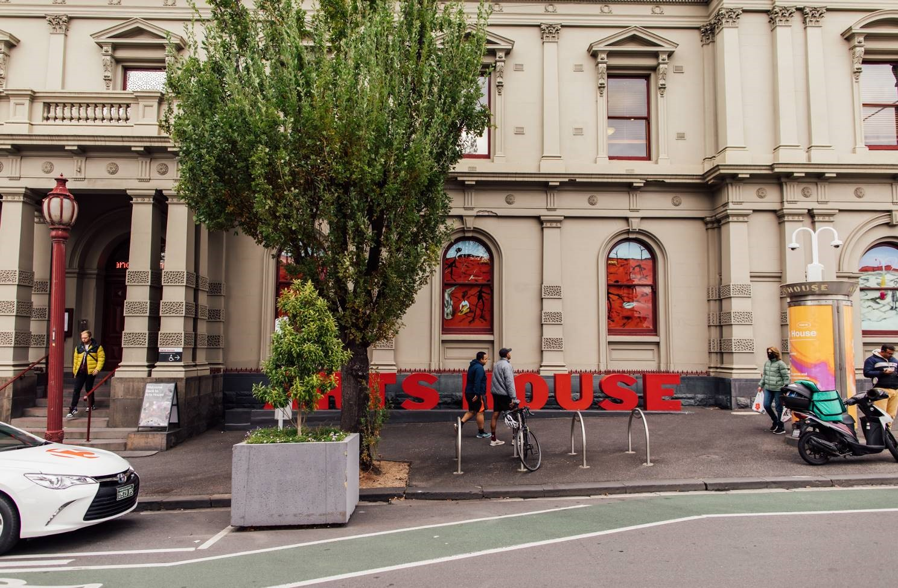

## **Accessible Entrances**



There are two Accessible Entrances. The first is on Errol St next to the Post Office.

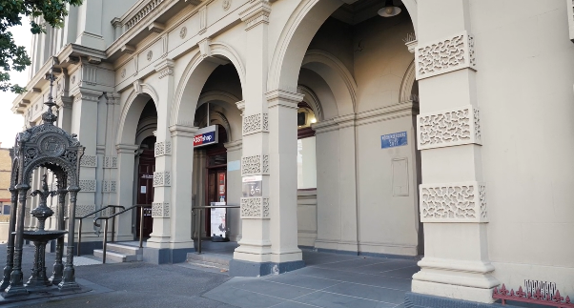

Image: Errol Street entrance next to the Post office with wheelchair accessible ramp or two steps with grab rails.

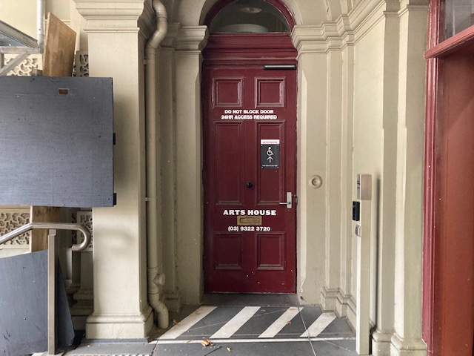

Image: View of door entrance.

The second Accessible Entrance is towards the end of George Johnson Lane.

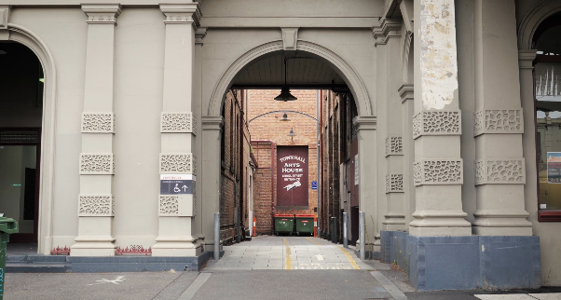

Image: View of George Johnson Lane from Errol St. The laneway passes through an archway with a brick wall at the end.

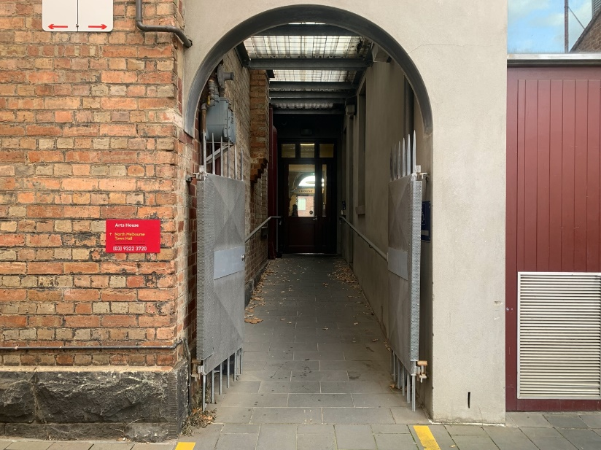

Image: view of the ramp leading from George Johnson Lane to the automated door which opens into the Arts House foyer.

## **Box Office**

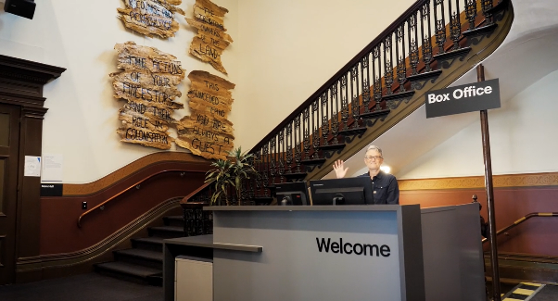

Box Office is located in the foyer under the stairwell.

## **Ushers**

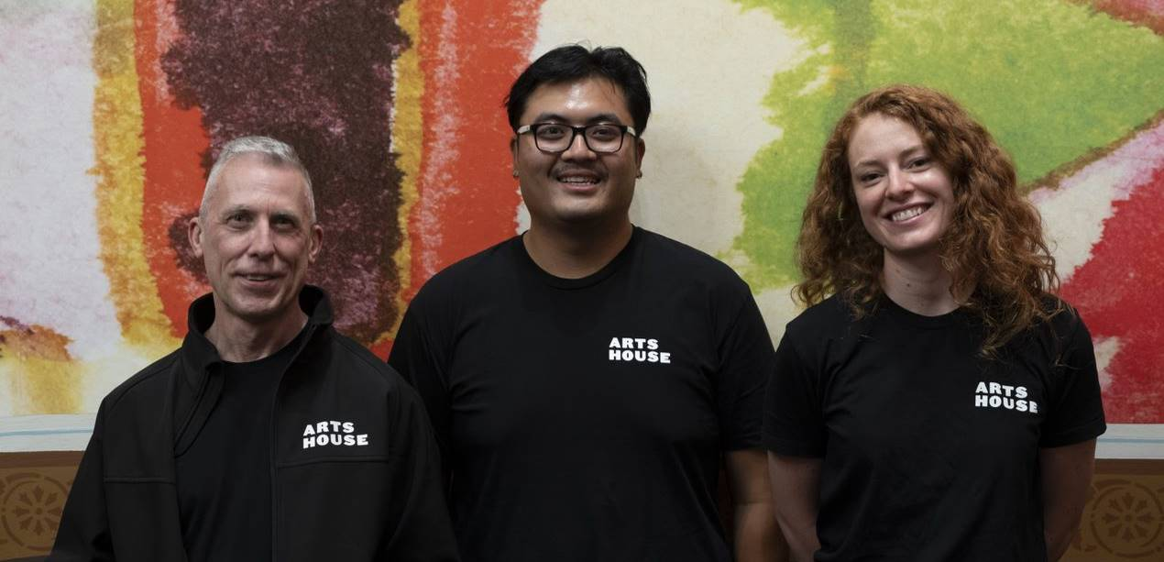

Ushers will be wearing black with an Arts House Logo on the left hand shoulder.

## **Bar**

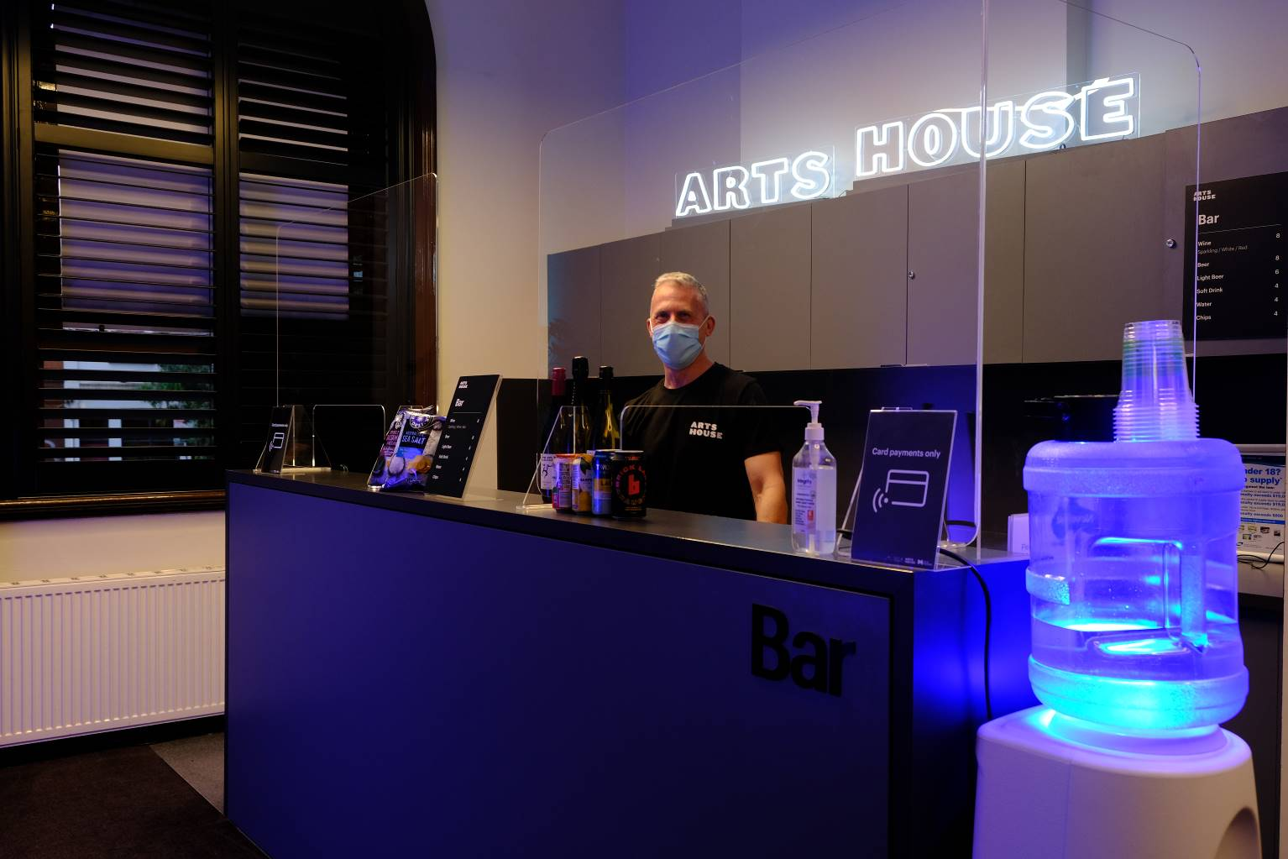

Bar staff will be wearing black with an Arts House Logo.

We have a range of alcoholic and non-alcoholic beverages for sale.

We are a cashless venue and accept EFTPOS, Visa and Mastercard payments.

## **Quiet Space**



Arts House Quiet Space is located on Ground Level and is nearby reception and opposite the accessible bathrooms. It includes a range of seating options including soft furnishings, dimmable lights, sensory and stim objects. It is open during venue opening hours and events as a quiet space, prayer or parenting space.

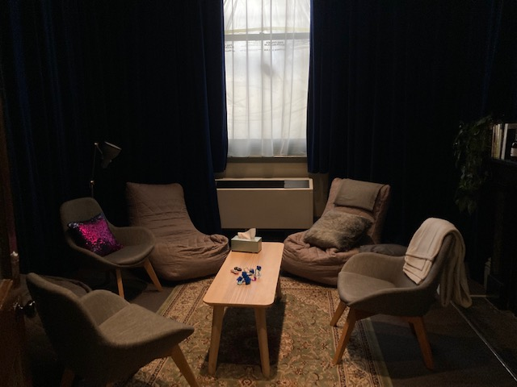

Image: Quiet space with lights dimmed

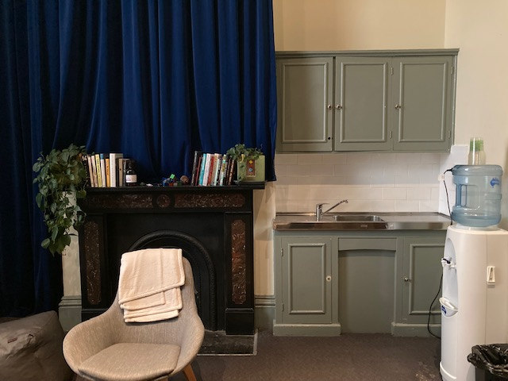

Image: Quiet space kitchenette and book shelf

## **Bathrooms**

All bathrooms have Dyson hand dryers with sensor activation. There is an accessible bathroom that is single use on ground level opposite the Quiet Space. There is another accessible bathroom upstairs – this is accessible via lift or stairs.

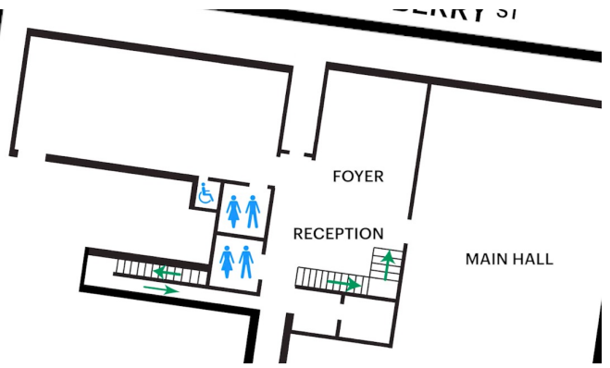

## **Performance Space**

The Performance is in the Main Hall. Studio 1.

It is on the ground floor.

It is to the left of the box office desk and right of the bar.

An artist statement is available on signage and warnings on the door.

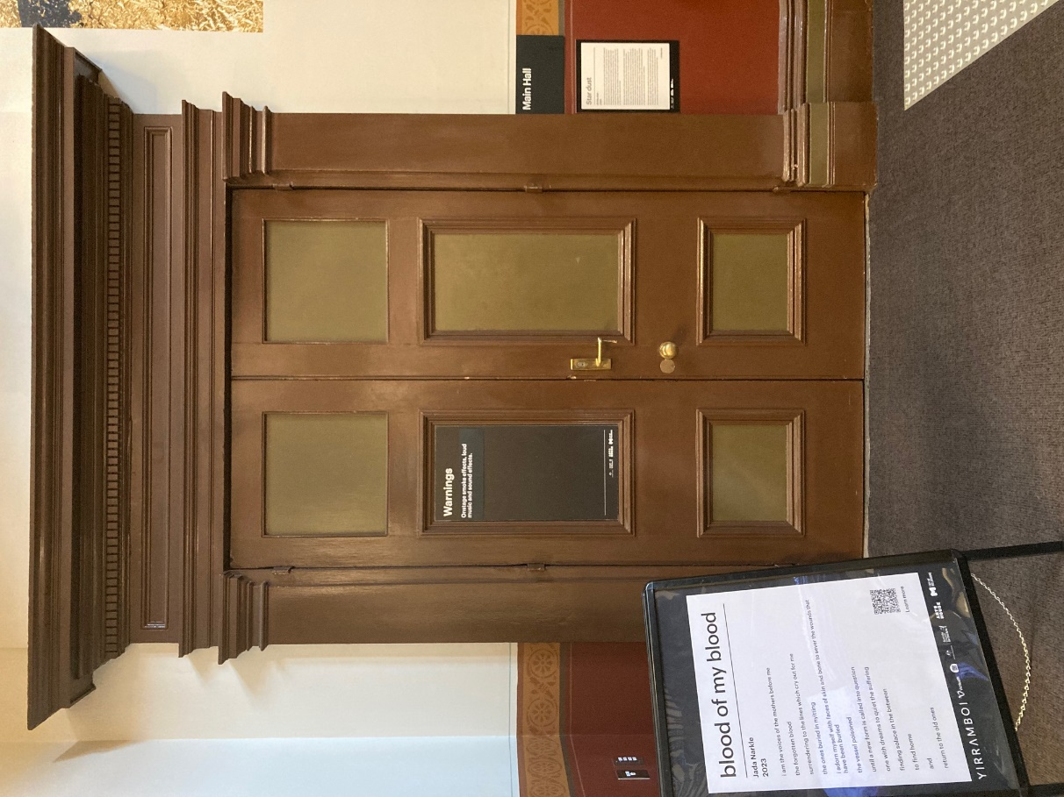

## **Lift**

The lift is located behind reception desk in the foyer.

The closest entry to the lift is via George Johnson Lane.

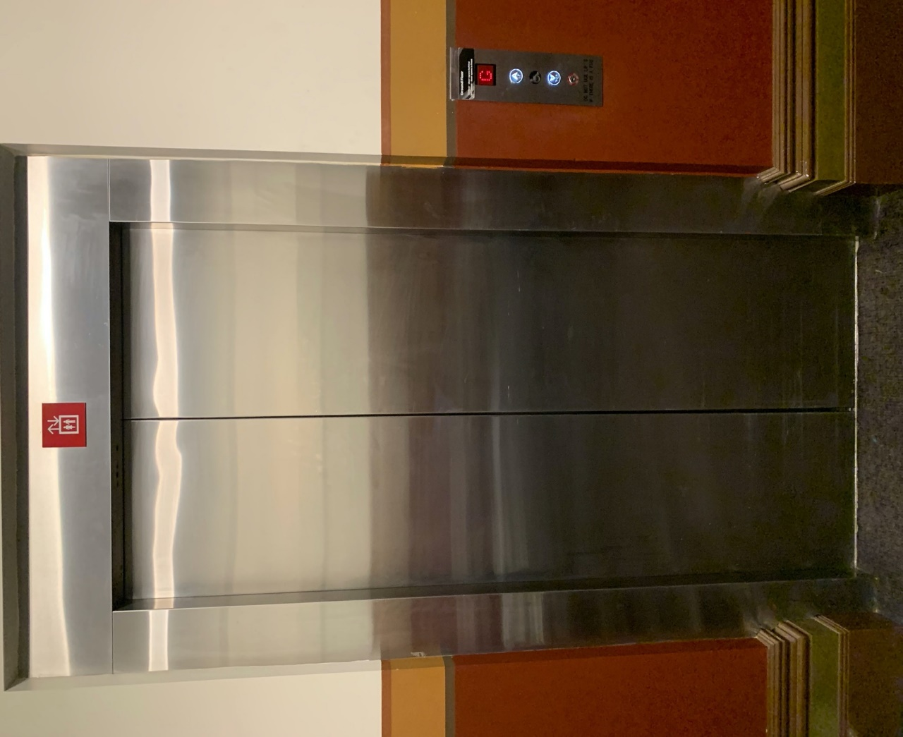

# **Transport**

## **Tram**

Route 57 (High Floor trams only)

Stop 12, North Melbourne Town Hall.

Please note, this is not a wheelchair accessible tram

[GETTING TO ARTS HOUSE VIDEO LINK](https://vimeo.com/544169506)

## **Train**

Arts House is 1.1km from   
North Melbourne Train Station,   
approximately 16 minute walk

[North Melbourne Station Information](https://www.ptv.vic.gov.au/stop/1144/north-melbourne-station/0/train/)

1.2km from Flagstaff Station,   
approximately 15 minute walk

[Flagstaff Station Information](https://www.ptv.vic.gov.au/stop/1068/flagstaff-station/0/train/#StopPage:::datetime=2023-04-06T04%3A41%3A27.669Z&directionId=-1&showAllDay=false&_auth=408ac3b1e97f4b0beb5bdf00c2f797057d10dd6e6cf2ad40a69334c4dfdf5e21)

## **Bus**

Bus number: 216

## **Parking**

There is limited paid on-street parking on Queensberry Street and Errol Street.

There are two accessible on street car parking spaces on Queensberry Street (150m to our accessible Errol Street entrance) for holders of a Parking Permit for Disabled people.

# **COVID Safety**

Please follow good health and hygiene practices when visiting Arts House.

Ticket holders who cannot attend their performance due to COVID-19 illness or symptoms are entitled to a full refund.

**Facemasks**

We have disposable masks available at reception and in the foyer.

**Cleaning**

Arts House buildings are cleaned nightly Monday-Friday and on weekends as required.

We conduct touchpoint cleaning of spaces between performances.

**Hygiene Stations**

Arts House provides handwashing and hygiene stations in each amenities area, studio, and office including: hand sanitizer, disinfectant wipes, rubbish bin.

More information about COVID-19 Safety can be found through the links below:

[Our COVID-19 Safety Plan - Arts House - Melbourne](https://www.artshouse.com.au/our-covid-19-safety-plan/)