**EOI Venue Tour and Morning Tea**

By Arts House

Access Guide

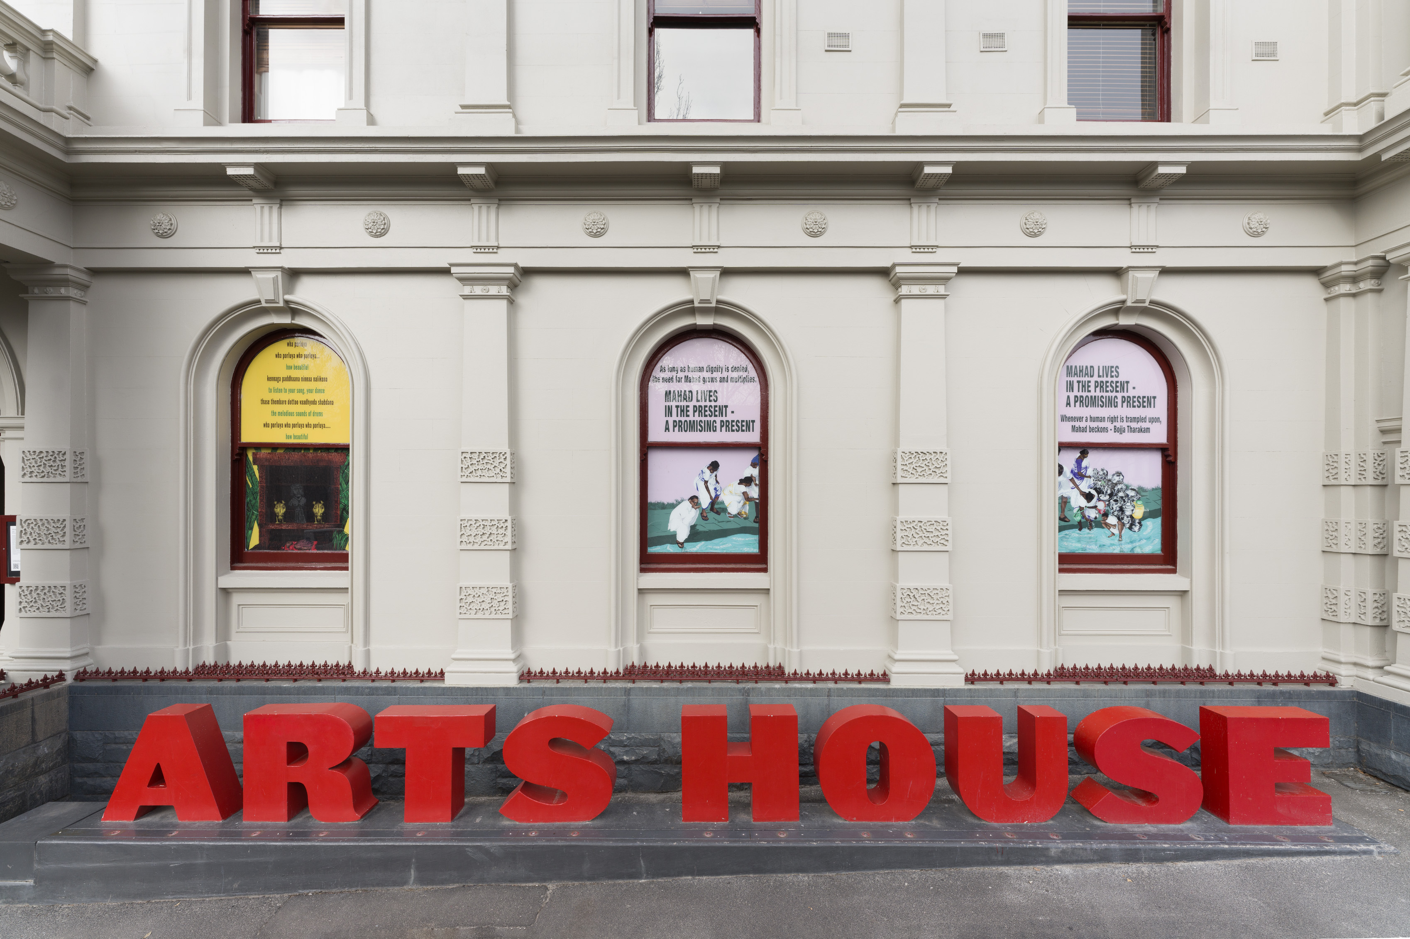

Image: *this way, emancipation,*Shrujana Shridhar, photo: Matthew Stanton

Image description: Three pieces of visual artwork adorn the windows of Arts House, which has been photographed from the exterior.

# **Updates to this document**

Please note, we will endeavour to provide the latest access information on this event.

Arts House website will contain the most up to date version of this document and all ticket holders will be notified of any revisions made 3 days and 1 day prior to the event.

This document was created: 28 November 2023

**Contents**

**Updates to this document** 1

**Where** 3

**When** 3

**Access Services** 3

**Host** 5

**Running Order** 7

**Sensory Elements** 7

Sound 7

Lighting 7

Physical 7

Smell 8

Visual 8

Entry to space 8

Shocks or surprises 8

Audience experience 9

Social expectations 9

**Other** 9

Content Warnings 9

**General Notes** 9

**The Venue** 10

Front Entrance 10

Building Access Information 11

Accessible Entrances 11

Reception 12

Quiet Space 13

Bathrooms 13

Lift 14

**Transport** 15

Tram 15

Train 15

Bus 15

Parking 15

**COVID Safety** 16

# **Where**

Arts House

521 Queensberry Street

North Melbourne VIC

# **When**

**Thursday 7 December, 11am – 1pm**

Duration: 2 hours 

# **Access Services**



Auslan Interpreted – on request, please provide 72-hours’ notice if you would like to book



Assistance Animal are welcome.



This session is fully wheelchair accessible.

# **Host**

This event will be hosted by Emily Sexton, Artistic Director of Arts House

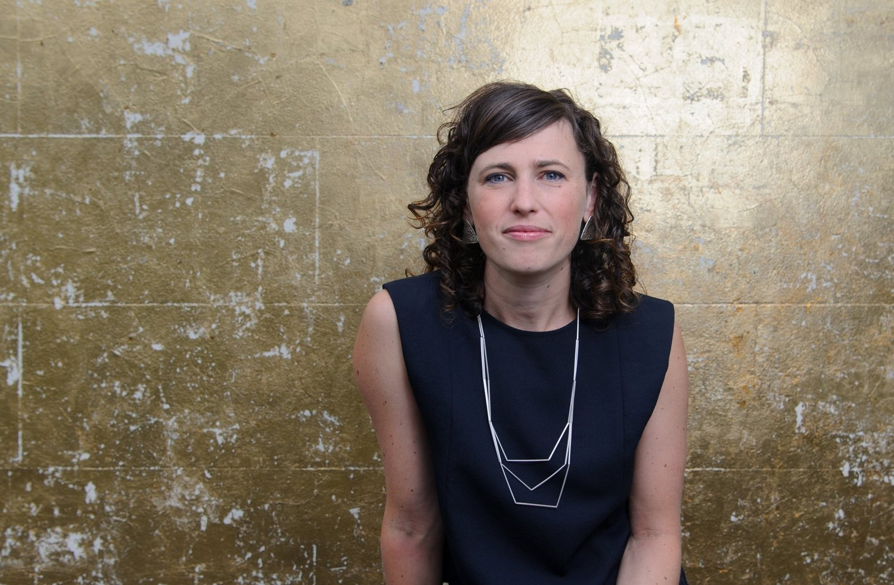

Image description: Emily sits in front of a textured gold wall. She is wearing a sleavless dark blue top with a long silver chain.

Approximately 16 members of the Arts House staff will also be in attendance at this session.



**Amrit**  
Creative Program Lead



**Emily**  
Co-Artistic Director



**Louana**  
Creative Producer



**Olivia**  
Program Manager



**Sarah**  
Creative Producer

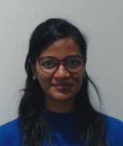

**Varsha**  
Associate Producer



**Tony**  
Production Manager



**Bart**  
Technical Coordinator



**Taran**  
Venue Technician

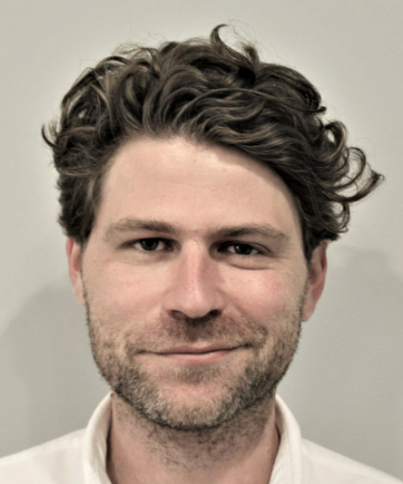

**Jake**  
Marketing Manager

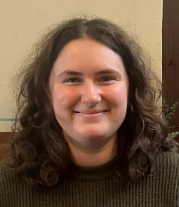

**Lucy**  
Audience Engagement Coordinator

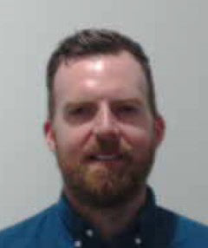

**Adam**  
Front of House Manager



**Charlie**  
Ticketing & House Supervisor

Brian

**Brian**  
Business Manager



**Bas**  
Business Administrator

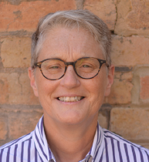

**Trudy**  
Business Support Officer

# **Running Order**

11.00am Arrive & light refreshments available

11.10am Acknowledgement of Country, Introduction to Arts House and programs, how the morning will run – hosted by Emily Sexton

11.20am Some of the Arts House staff will introduce themselves and share a favourite Arts House memory (1 minute each) 

11.40am Venue tour commences – we will split into two separate groups, with each group hosted by a different Arts House staff member

Journey for each group:

Group 1 – Hosted by Olly: Main Hall, Quiet space, Studio 1, Studio 2, Terrace, Warehouse, Supper Room 

Group 2 – Hosted by Sarah: Main Hall, Warehouse, Quiet space, Studio 1, Studio 2, Terrace, Supper Room

12.30pm Q&A discussion hosted by Emily Sexton

# **Sensory Elements**

## **Sound**

This information session is predominantly speaking. Speakers will use microphones for the first part of the session. Soft background music will be playing in the venue foyer and meeting space as people arrive.

## **Lighting**

No flashing or moving lights. Standard interior building lighting.

## **Physical**

The venue currently does not have heating. Rooms are an adequate temperature.

## **Smell**

There will be light vegetarian catering available in the space from Asylum Seeker Resource Centre that will include the smell of spices, fruit and other ingredients.

The menu includes:

* Feta and spinach triangles baked with sesame seeds and sumac
* Harchana's vegetable and potato curry puff with Malay spices
* Persian love cake, rosewater, citrus, almond icing
* Ganache filled profiterole
* Seasonal fruit to share (V, WGF)

## **Visual**

This session does not include any visual presentations on screens. When we move into the tour component of the venue you will see different development and performance spaces. The Warehouse is a separate self-contained venue and involves walking outside the building for approximately 2 minutes.

Audience Experience

## **Entry to space**

This session will commence in the Supper Room. This space is located on the basement level of the main building. It is directly under the Main Hall.

Access to space:

* The Supper Room can be accessed either via the lift or stairs from the foyer area
* There are 20 stairs to the Supper Room with grab rails either side. *Please note* - the staircase has a low archway, and it is wide, so grab rails are not able to be used on both sides at the same time
* Entry to Supper Room is through a glass door which is 150cm wide.

## **Shocks or surprises**

There are no shocks or surprises.

## **Audience experience**

This session involves light social interaction with other artists and Arts House staff and moving around the venue.

## **Social expectations**

The first part of this session is seated around circular tables with 3 – 4 other guests.

You are welcome to sit anywhere you like in the room or stand if you prefer.

You are welcome to come and go in the space and have a cuppa or snack whilst we are doing introductions.

# **Other**

## **Content Warnings**

No warnings.

## **General Notes**

The session will commence with an Acknowledgment of Country in the space.

# **The Venue**

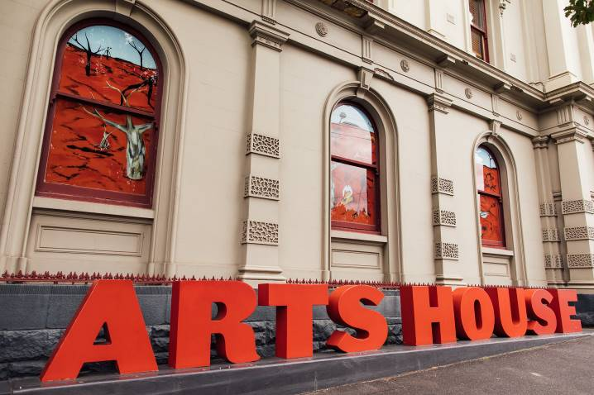

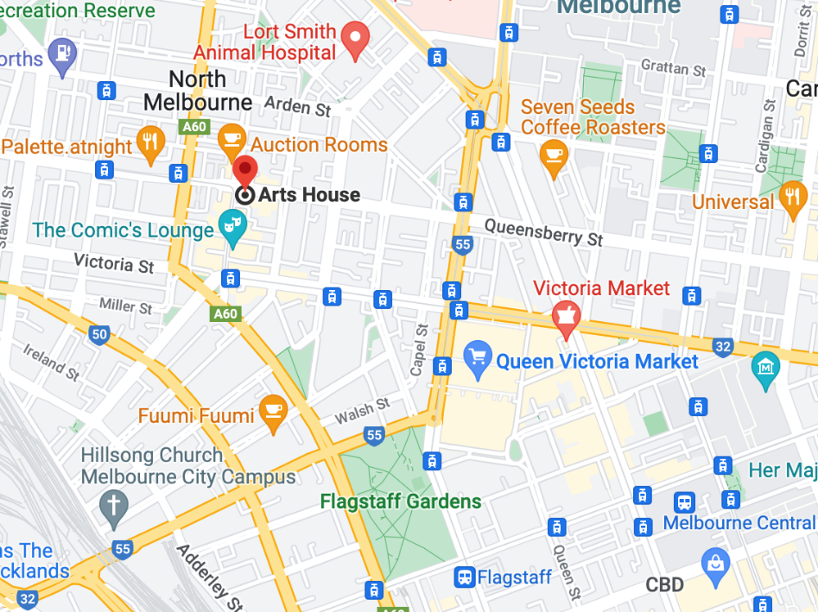

Image: North Melbourne Town Hall features giant red letters that say ARTS HOUSE out the front of it.

Image: a map of Arts House and its surrounding area. [LINK TO MAP](https://www.google.com/maps/place/Arts+House/@-37.802973,144.9486818,17z/data=!4m5!3m4!1s0x0:0x64c465ac7ef21cff!8m2!3d-37.803239!4d144.9498609?shorturl=1)

## **Front Entrance**

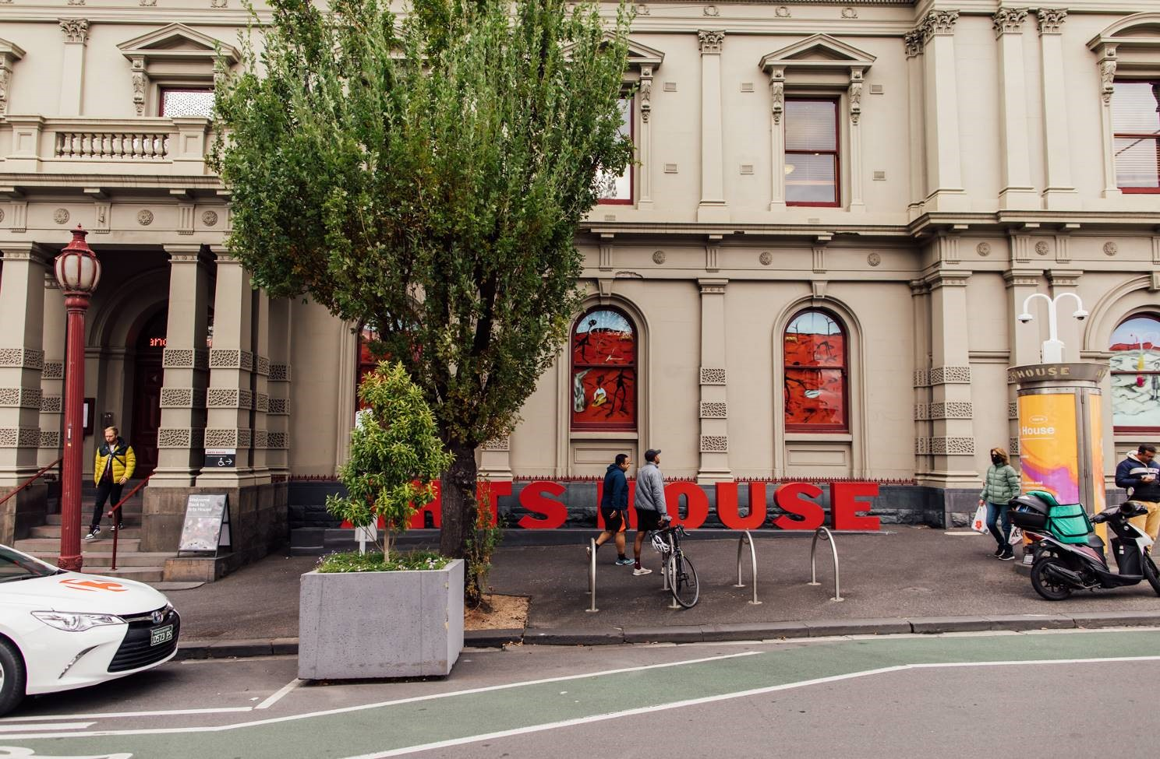

## **Building Access Information**

To familiarise yourself with the space before you arrive, explore Arts House virtually through a 3D scan of the building by clicking [here](https://tourmkr.com/F1jsn73hDg/36140818p&49.3h&89.59t).

To download a verbal map to help with navigation throughout the building, please click [here](https://www.artshouse.com.au/wp-content/uploads/2022/11/Verbal_Map_of_Arts_House_2022.docx).

To download a building document that outlines detailed information on amenities, access, navigation, parking and drop-off, please click [here](https://www.artshouse.com.au/wp-content/uploads/2022/11/Arts_House_Building_Information_2022.docx).

## **Accessible Entrances**



There are two Accessible Entrances. The first is on Errol St next to the Post Office.

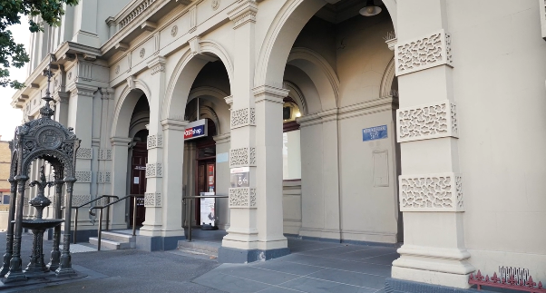

Image: Errol Street entrance next to the Post office with wheelchair accessible ramp or two steps with grab rails.

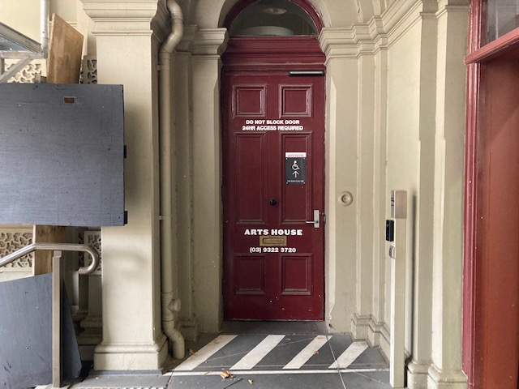

Image: View of door entrance.

The second Accessible Entrance is towards the end of George Johnson Lane.

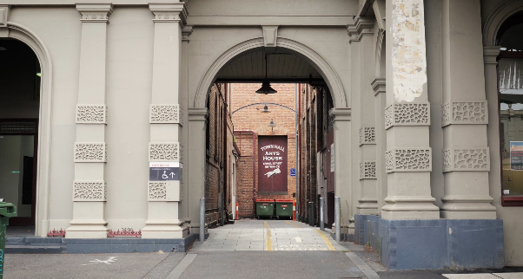

Image: View of George Johnson Lane from Errol St. The laneway passes through an archway with a brick wall at the end.

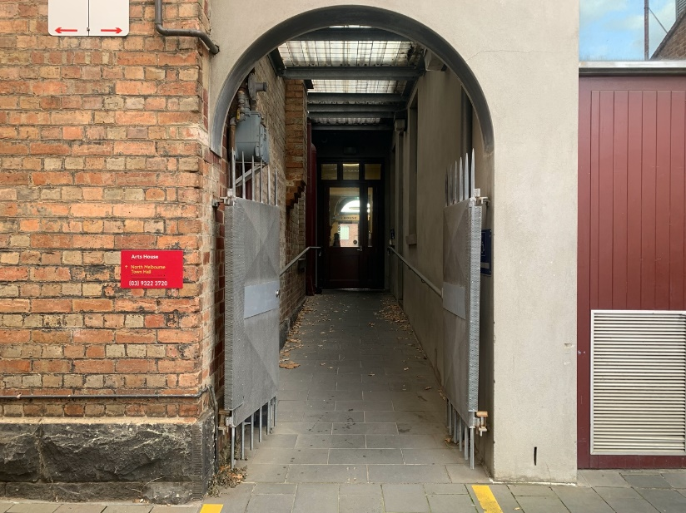

Image: view of the ramp leading from George Johnson Lane to the automated door which opens into the Arts House foyer.

## **Reception**

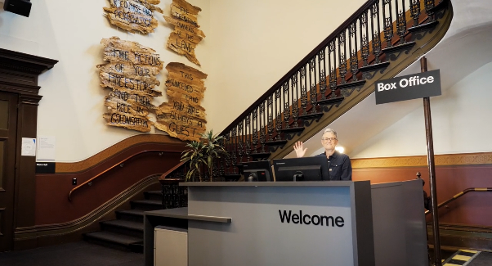

Reception is located in the foyer under the stairwell.

## **Quiet Space**



Arts House Quiet Space is located on Ground Level and is nearby reception and opposite the accessible bathrooms. It includes a range of seating options including soft furnishings, dimmable lights, sensory and stim objects. It is open during venue opening hours and events as a quiet space, prayer or parenting space.

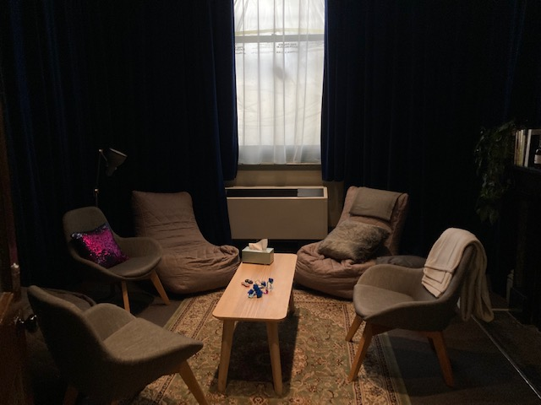

Image: Quiet space with lights dimmed

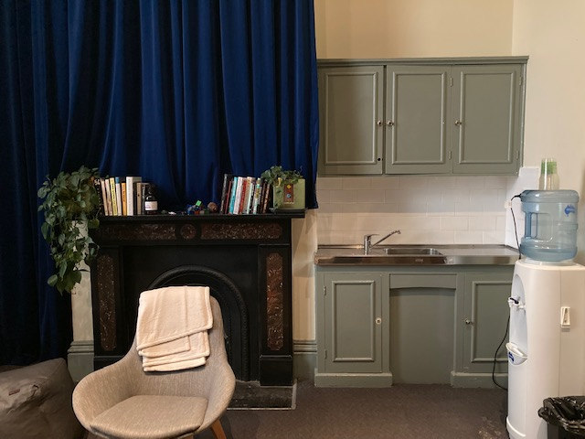

Image: Quiet space kitchenette and book shelf

## **Bathrooms**

All bathrooms have Dyson hand dryers with sensor activation. There is an accessible bathroom that is single use on ground level opposite the Quiet Space. There is another accessible bathroom upstairs – this is accessible via lift or stairs.

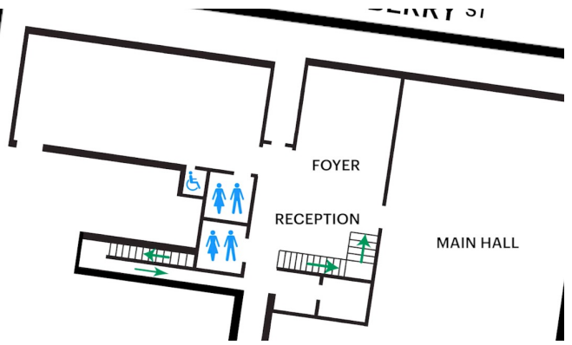

## **Lift**

The lift is located behind reception desk in the foyer.

The closest entry to the lift is via George Johnson Lane.

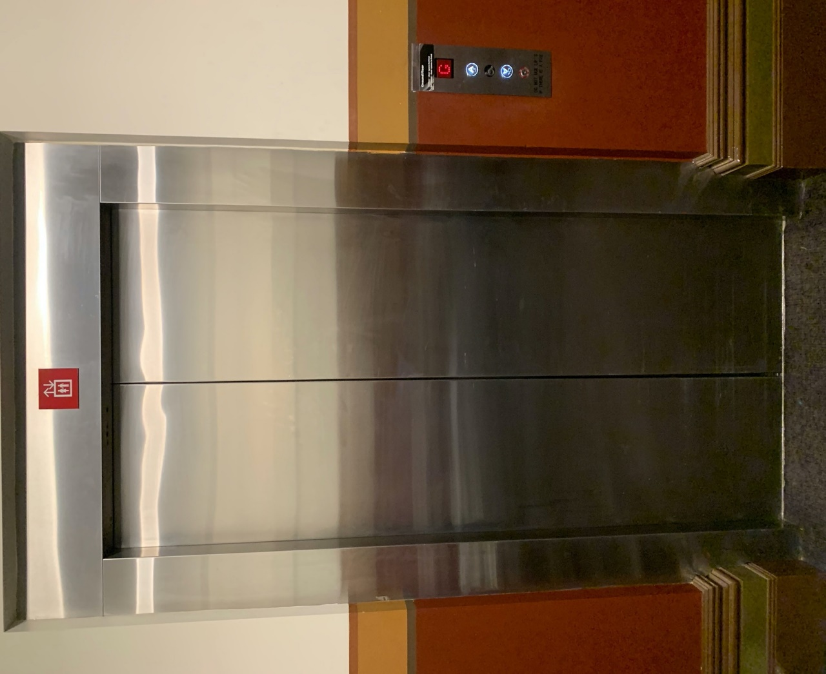

# **Transport**

## **Tram**

Route 57 (High Floor trams only)

Stop 12, North Melbourne Town Hall.

Please note, this is not a wheelchair accessible tram

[GETTING TO ARTS HOUSE VIDEO LINK](https://vimeo.com/544169506)

## **Train**

Arts House is 1.1km from   
North Melbourne Train Station,   
approximately 16 minute walk

[North Melbourne Station Information](https://www.ptv.vic.gov.au/stop/1144/north-melbourne-station/0/train/)

1.2km from Flagstaff Station,   
approximately 15 minute walk

[Flagstaff Station Information](https://www.ptv.vic.gov.au/stop/1068/flagstaff-station/0/train/#StopPage:::datetime=2023-04-06T04%3A41%3A27.669Z&directionId=-1&showAllDay=false&_auth=408ac3b1e97f4b0beb5bdf00c2f797057d10dd6e6cf2ad40a69334c4dfdf5e21)

## **Bus**

Bus number: 216

## **Parking**

There is limited paid on-street parking on Queensberry Street and Errol Street.

There are two accessible on street car parking spaces on Queensberry Street (150m to our accessible Errol Street entrance) for holders of a Parking Permit for Disabled people.

# **COVID Safety**

Please follow good health and hygiene practices when visiting Arts House.

Ticket holders who cannot attend their performance due to COVID-19 illness or symptoms are entitled to a full refund.

**Facemasks**

We strongly recommend wearing a face mask while indoors. We have disposable masks available at reception and in the foyer.

**Cleaning**

Arts House buildings are cleaned nightly Monday-Friday and on weekends as required.

We conduct touchpoint cleaning of spaces between performances.

**Hygiene Stations**

Arts House provides handwashing and hygiene stations in each amenities area, studio, and office including: hand sanitizer, disinfectant wipes, rubbish bin.

More information about COVID-19 Safety can be found through the links below:

[Our COVID-19 Safety Plan - Arts House - Melbourne](https://www.artshouse.com.au/our-covid-19-safety-plan/)