I Am (Not) This Body

By Leisa Prowd

Access Guide

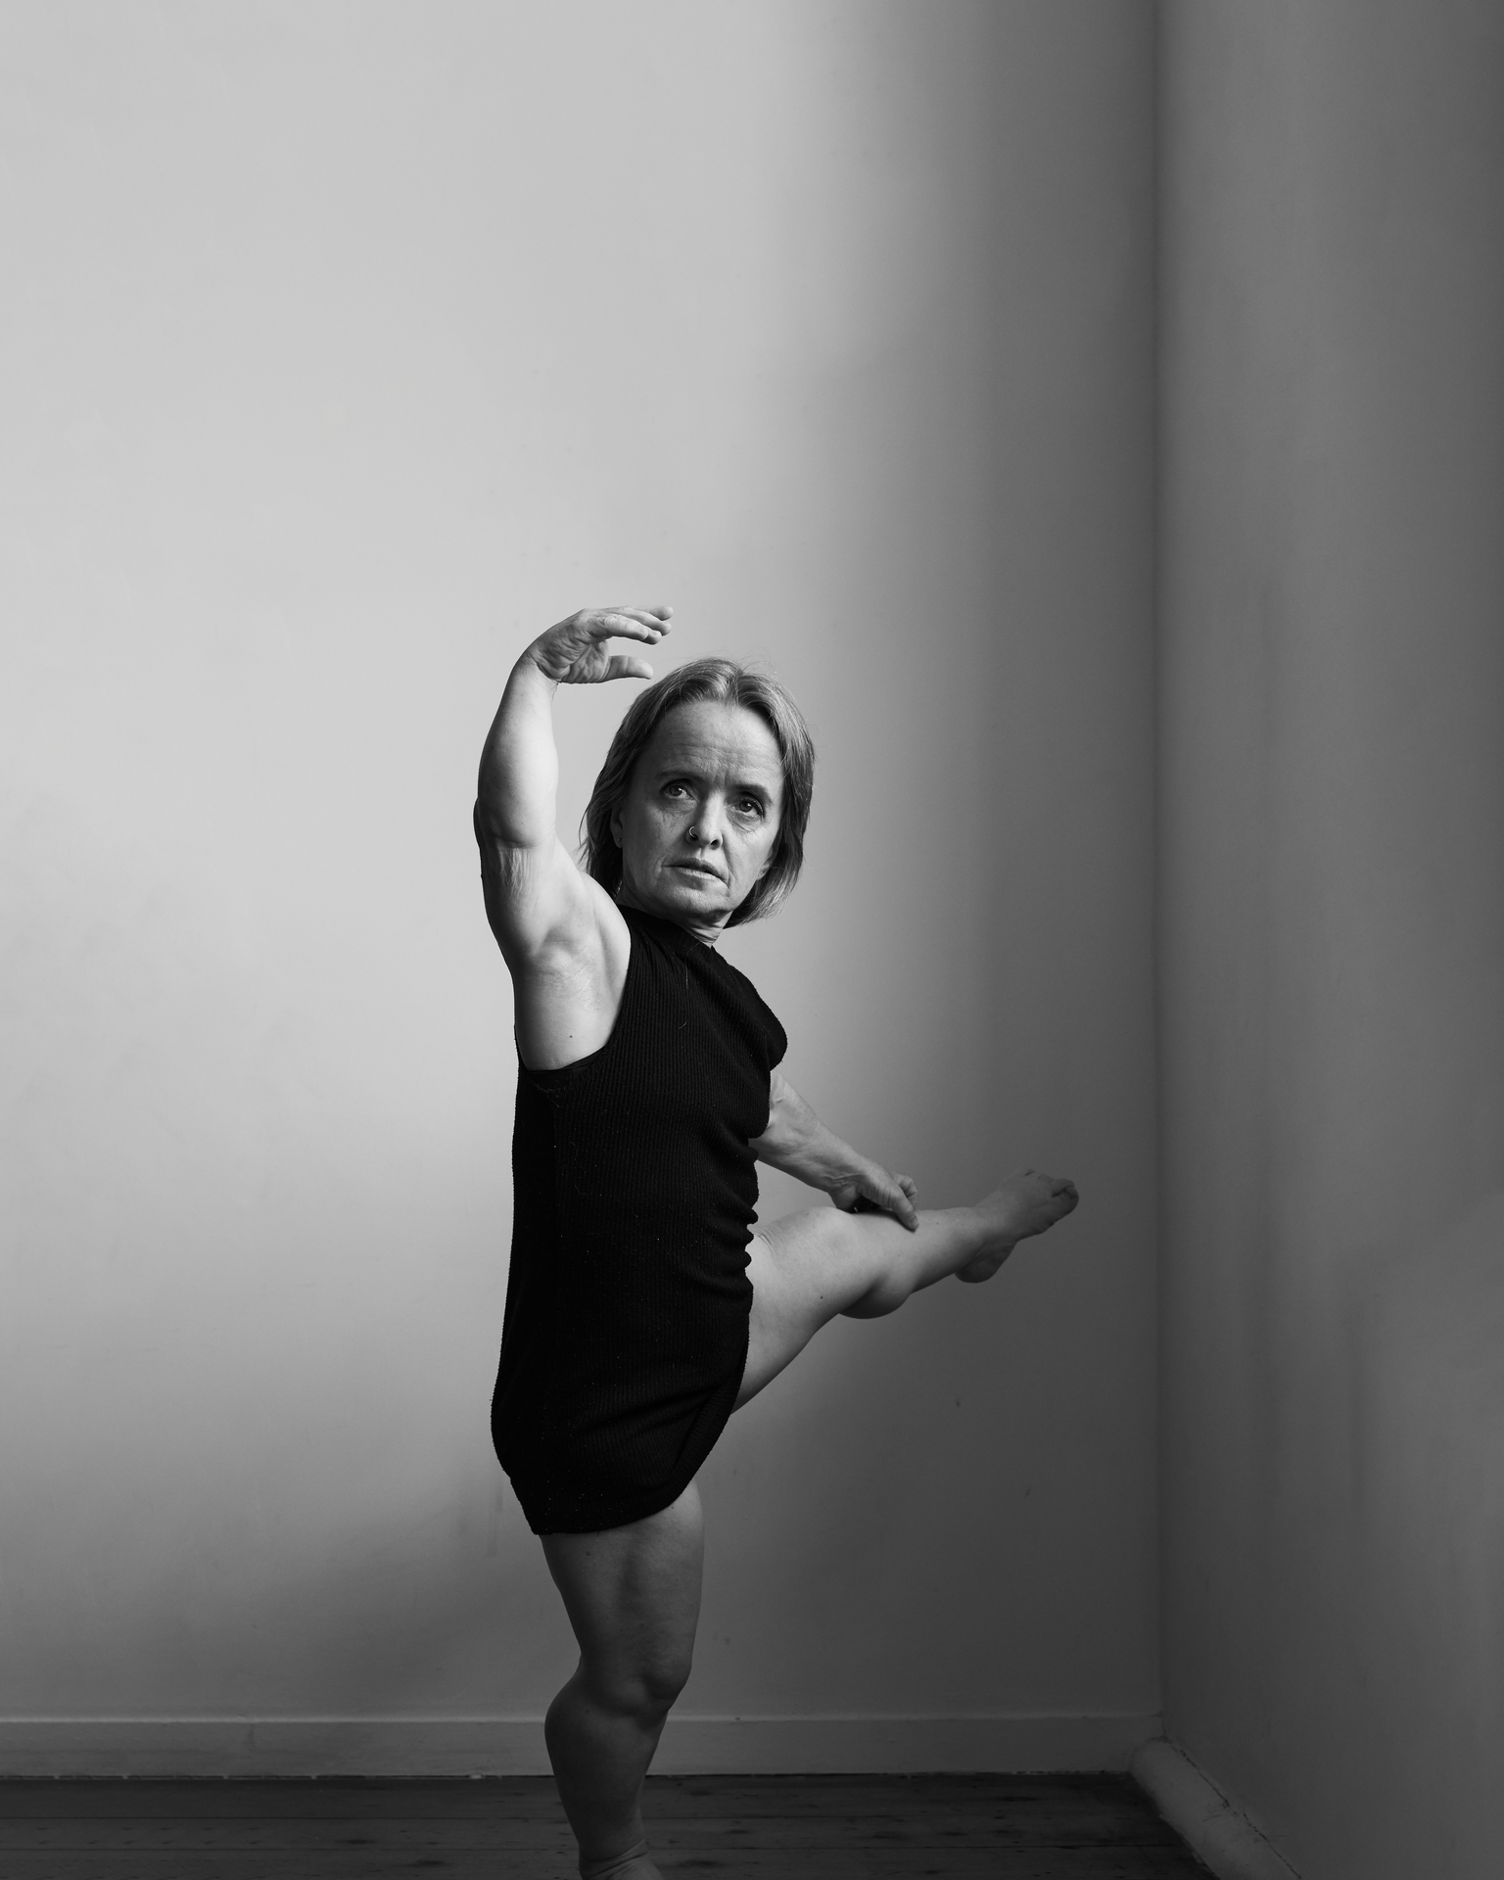
Image Description: A black and white photo of a woman of short stature with light coloured hair in a bob. She wears a long black tank top and lifts her left leg away from the camera with her right hand raised above her head, balletically. She is dancing in front of a white wall, in the corner of a room with wooden floors.
Image Credit: Amanda Fordyce

Updates to this document

Please note, this performance is a new work and changes are being made by artists until opening. We will endeavour to provide the latest access information on performances to ticket holders across key stages of rehearsal and presentation.

Arts House website will contain the most up to date version of this document and all ticket holders will be notified of any revisions made 3 days and 1 day prior to the event.

This document was updated: 5 October 2023
Contents
Updates to this document 1
Where 3
When 3
Access Services 3
Digital 5
Performers 5
Sensory Elements 6
Sound 6
Lighting 6
Physical 6
Smell Error! Bookmark not defined.
Visual 6
Entry to space 7
Shocks or surprises 7
Audience experience 7
Social expectations 7
Performance expectations 7
Other 8
Content Warnings 8
General Notes 8
The Venue 9
Front Entrance 9
Accessible Entrances 10
Box Office 11
Ushers 11
Bar 12
Quiet Space 13
Bathrooms 13
Door to Main Hall 14
Lift 15
Transport 15
Tram 15
Train 16
Bus 16
Parking 16
COVID Safety 16

Where

Arts House
521 Queensberry Street
North Melbourne VIC

When
Wednesday 11 October, 7.30pm
Thursday 12 October, 7.30pm
Friday 13 October, 7.30pm
Saturday 14 October, 2.00pm & 7.30pm
Sunday 15 October, 5.00pm

Duration: 50 minutes

Access Services

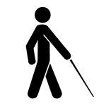
Tactile Tour and Audio Described Performance
All shows offer live audio description and an optional pre-show tactile tour 1 hour prior to start time.

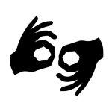
Auslan Interpreted Performance & Post-show Artist Talk
Thursday 12 October, 7.30pm

This performance contains Open Captioning of spoken word that is always in view.
Assistance Animals are welcome.

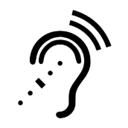
Assistive Listening is available free of charge. Ask staff for assistance on arrival.

Visual Rating 50% – this performance has music and sounds in the background.
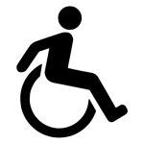
This performance is fully wheelchair accessible.

Arts House supports the Companion Card program. You can book your companion ticket online when purchasing tickets to any show.

Digital
Watch at Home Monday 16 – Sunday 22 October.
A digital recording with audio description, Auslan interpretation and closed captioning is available for on demand viewing.

Performers

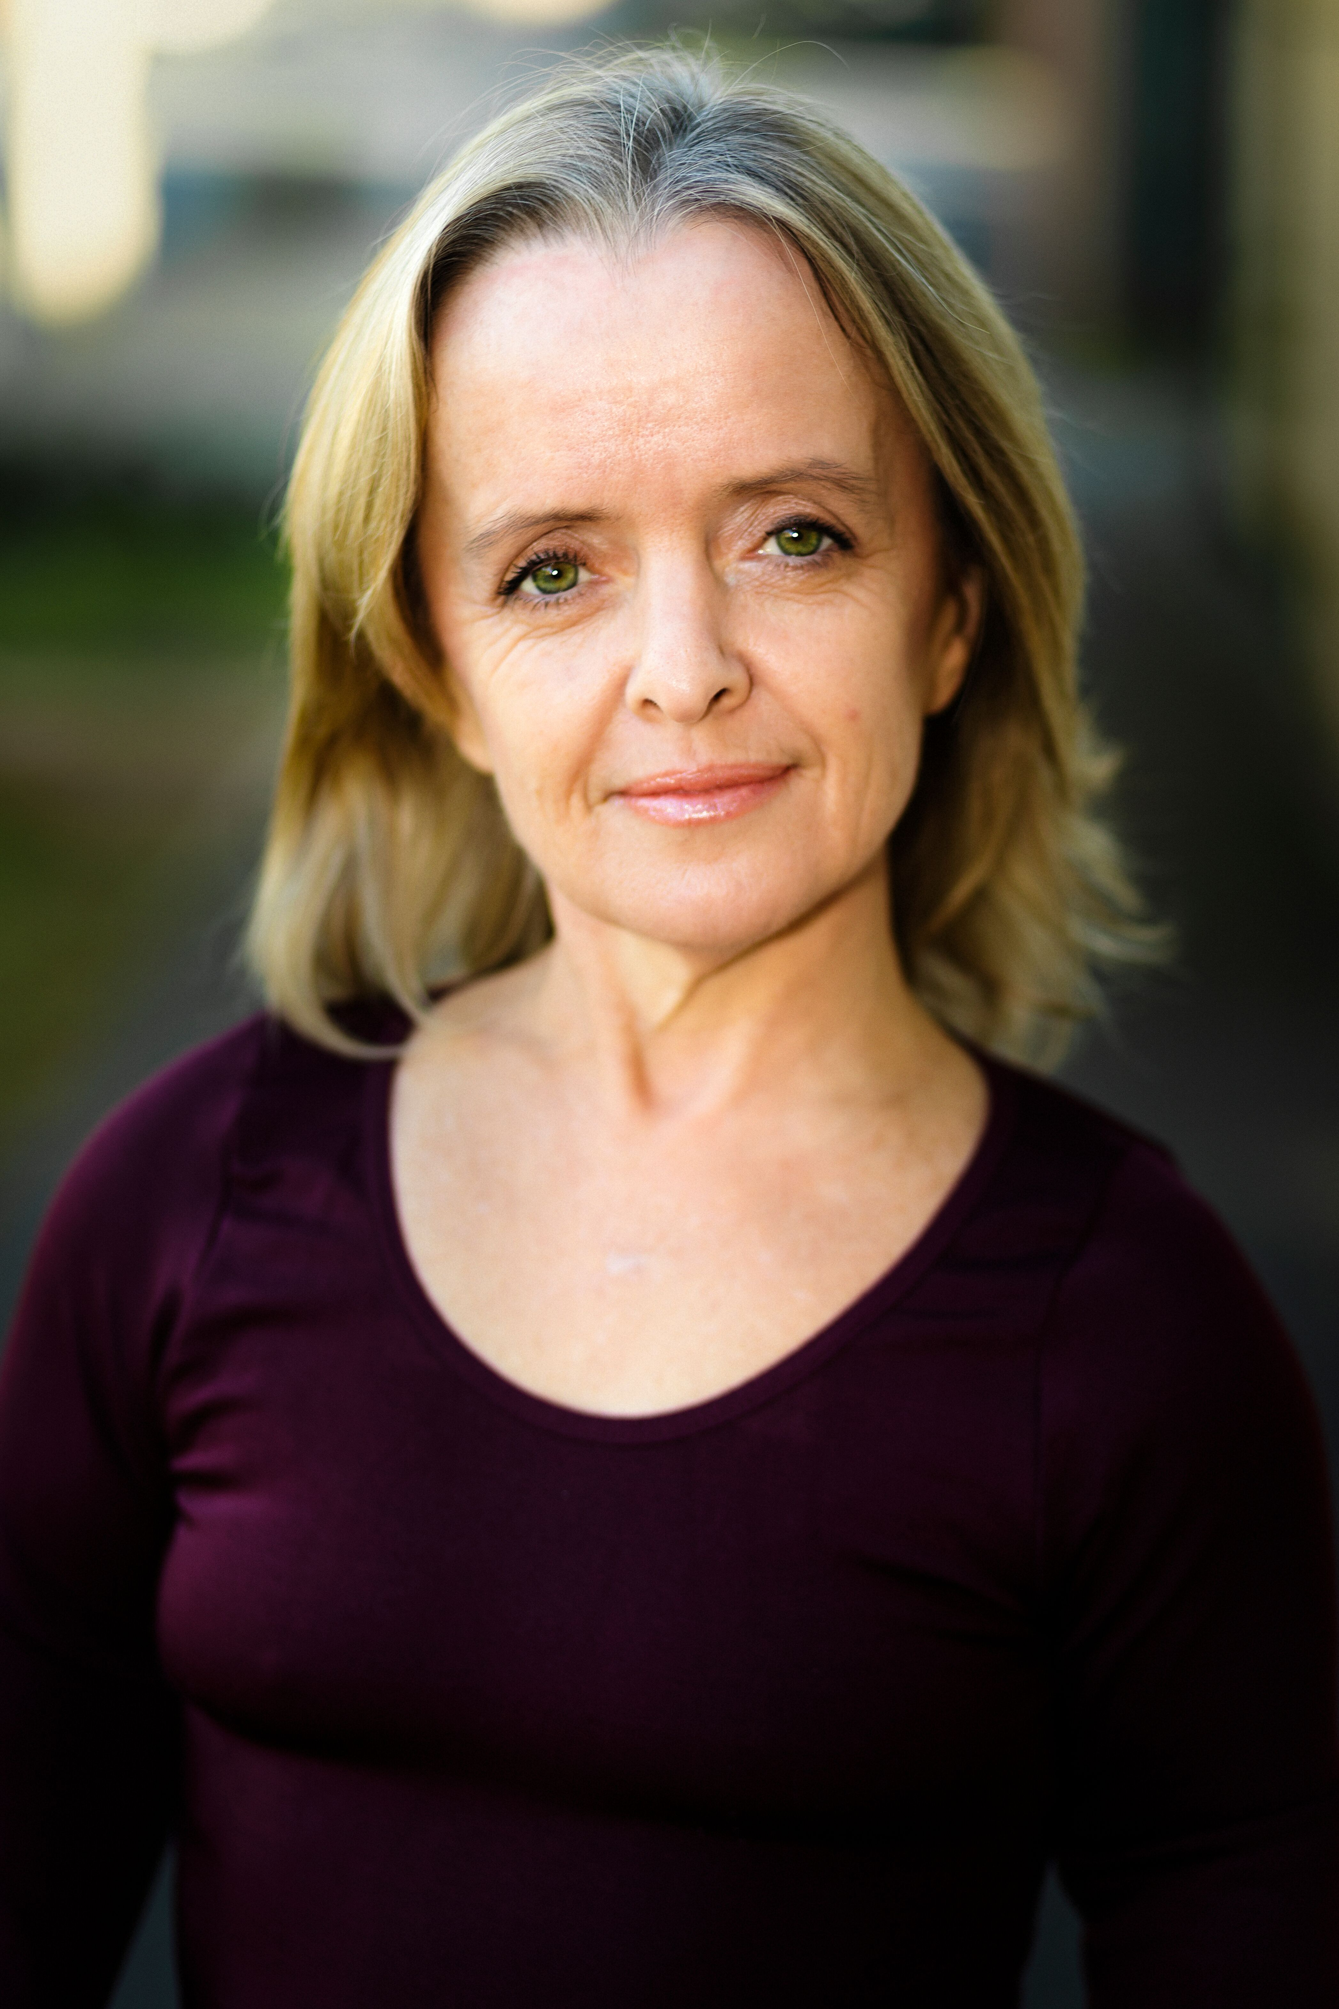

Image description: a headshot of Leisa, a white woman of short stature with shoulder length blonde hair and green eyes. She wears a burgundy-coloured top and smiles into the camera.

There is 1 performer in this show – Leisa Prowd.

Sensory Elements

Sound

Sound is a prominent feature in this show. There is an almost constant musical score played throughout with speakers facing the audience from multiple directions. At times this will be quite loud and features distorted electronic instrumentation which some people may find abrasive. The Main Hall has high ceilings and polished wooden floorboards, meaning the sound has a tendency to echo at times.

Lighting

There will be no use of strobe or rapid flashing lights in this performance. There will be a brief moment of blackout at the very end of the show. There will be video projected into different areas of the performance space. No lighting or projection will be angled towards the audience.

There is a large tri-folding mirror on a dresser at the back of the space which faces the audience. This may cause light and/or projection to reflect into the audience occasionally.

Physical

It may be possible to feel vibrations from the speakers through the floor at loud points in the musical score. There will be a variety of seating options available including traditional chairs and some more relaxed options such as bean bags on the floor.

If you would like to reserve alternative seating for access reasons, please email at artshouse.ticketing@melbourne.vic.gov.au or phone on 03 9322 3720.

Smell

There are no scents or smells used in the show.

Visual

During the performance, Leisa may climb onto platforms and balance in ways that look unstable. This is pre-rehearsed and safe.

There will be projections of moving images used during the show. This includes a series of facial reactions from people who may feel like they are looking directly at you.

Projections also include footage of people attending church services and religious imagery.

Audience Experience

Entry to space

The audience will enter from the main doors off the foyer and will be asked to sit where they feel comfortable. As there is no allocated seating for this performance, please let front of house staff know if you would be most comfortable in a particular spot before the doors open.

Shocks or surprises

There are loud moments during the musical score but these are built to rather than sudden.

Audience experience

Leisa may come close to the front row of the audience towards the end of the show and offer eye contact. You do not have to make eye contact with Leisa if you do not wish to.

Social expectations

There will be a variety of seating options including chairs and a limited number of bean bags. As there is no allocated seating for this performance, please let the front of house staff know if you would be most comfortable in a particular spot before the doors open.

There is no lock out (or lock in) for this performance. Audience members are welcome to come and go as they please.

Performance expectations

There is a small amount of spoken words both live and pre-recorded in this show. The performance tells the story of Leisa’s relationship to her body but it does this mostly through physical movement.

Leisa is the only performer and is a white person of short stature.

Other

Content Warnings

Ableism
There is derogatory language used in this show which will be played over the speakers and projected as text:

Midget
Dwarf
Walking blow job
Belongs in the abortion bin

There are video sequences which are projected into the space of people laughing, pointing and looking shocked and disgusted. These feature close up images of people’s faces and may feel as though they are looking directly into the audience.

There are frequent moments where Leisa compares her body to standardised mannequins.

Implied self-harm
There is a frenzied movement sequence where Leisa uses a pair of scissors to cut up clothing she is wearing and gestures towards cutting her hair.

Religion
There is projected video footage of church sermons and various religious imagery. There is a bible onstage and Leisa performs a movement sequence which has religious reference.

General Notes

An Acknowledgment of Country will play pre-show.

The Venue

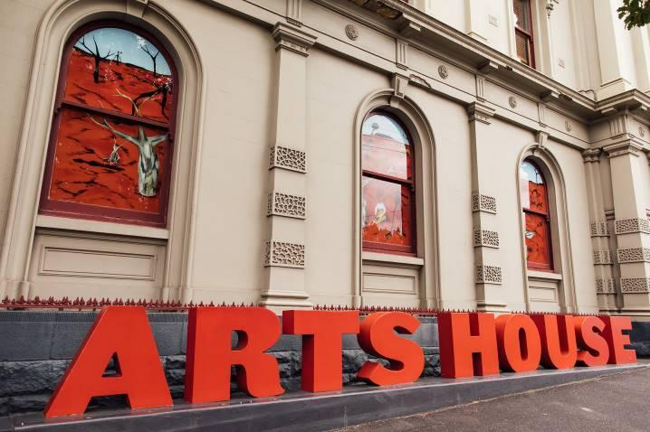
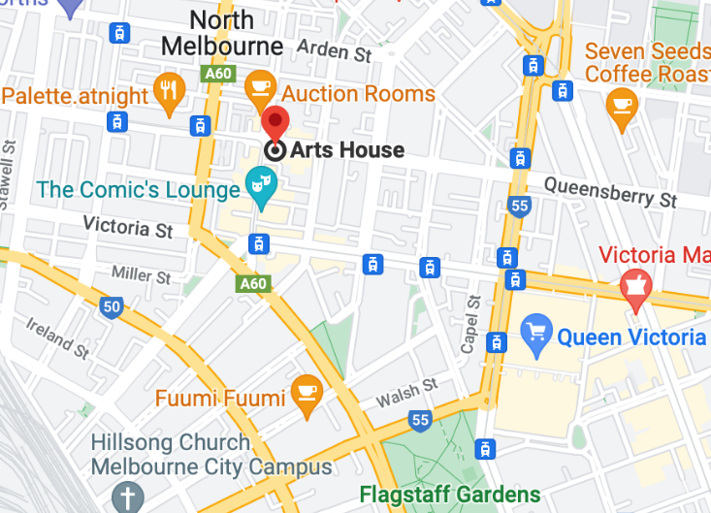

Image: North Melbourne Town Hall features giant red letters that say ARTS HOUSE out the front of it.

Image: a map of Arts House and its surrounding area. LINK TO MAP

Front Entrance

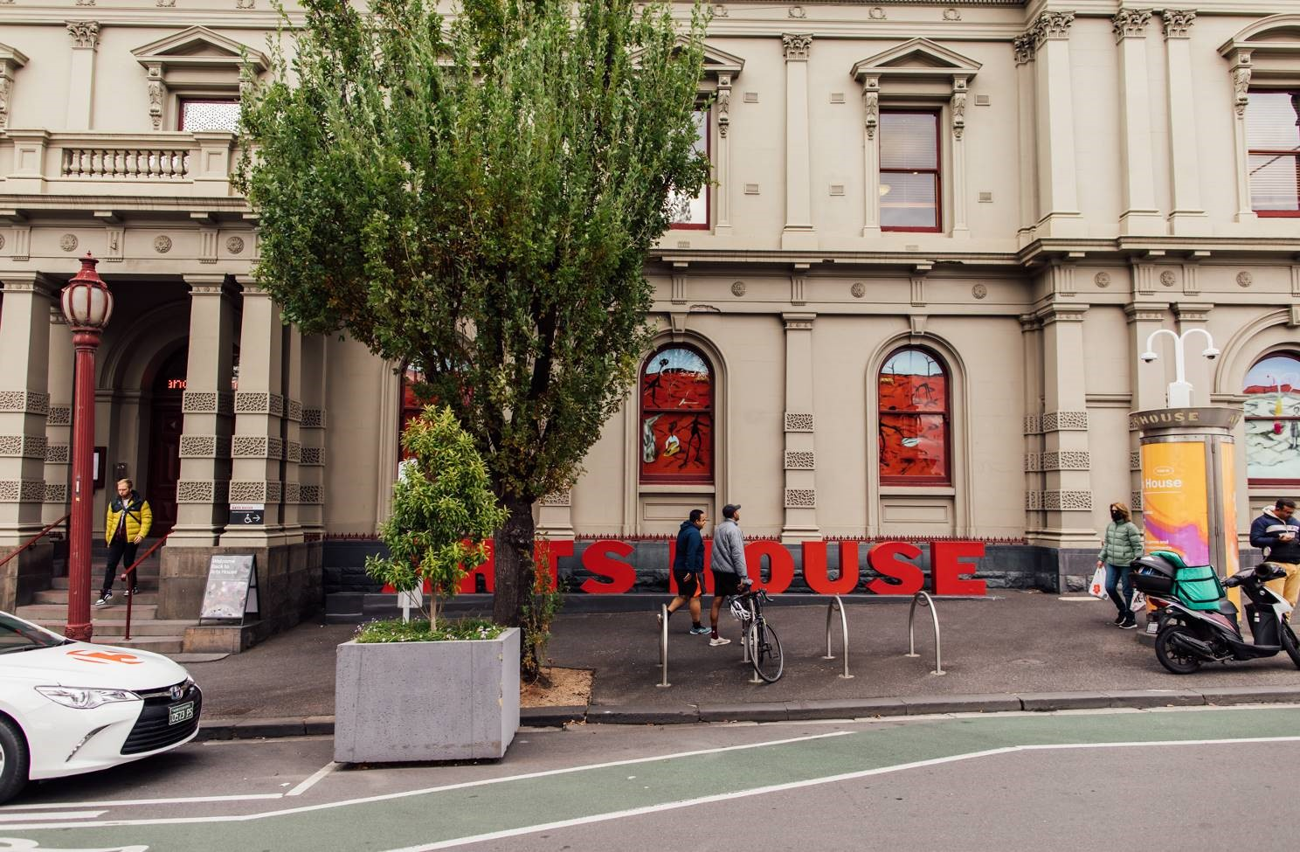

Accessible Entrances

There are two Accessible Entrances. The first is on Errol St next to the Post Office.

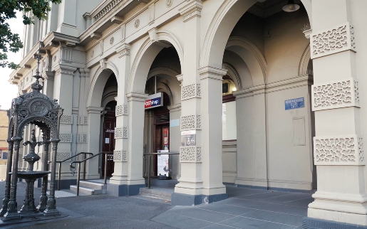

Image: Errol Street entrance next to the Post office with wheelchair accessible ramp or two steps with grab rails.
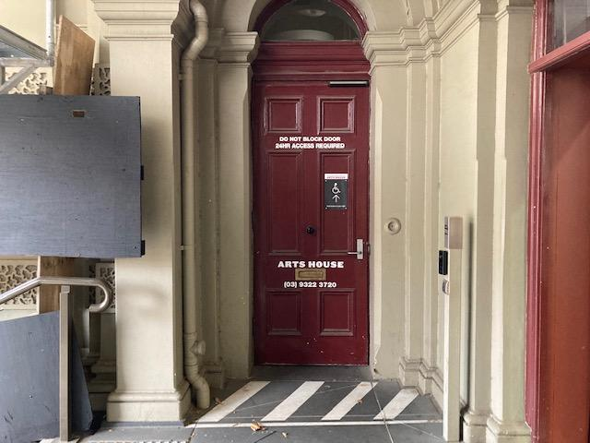
Image: View of door entrance.

The second Accessible Entrance is towards the end of George Johnson Lane.

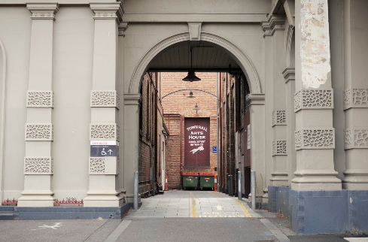

Image: View of George Johnson Lane from Errol St. The laneway passes through an archway with a brick wall at the end.
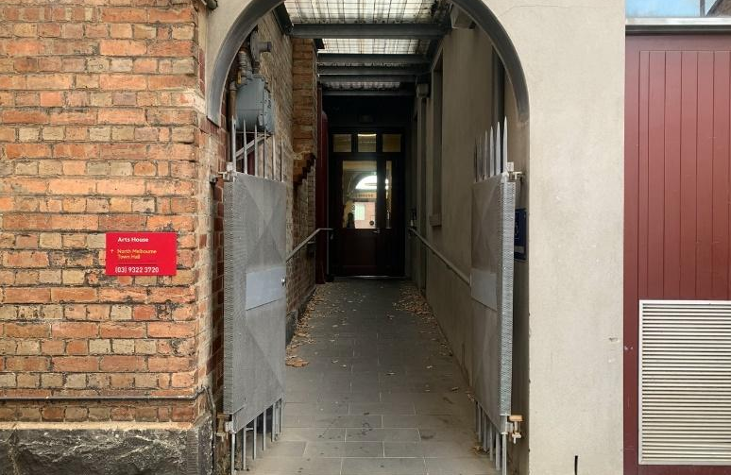

Image: view of the ramp leading from George Johnson Lane to the automated door which opens into the Arts House foyer.

Box Office

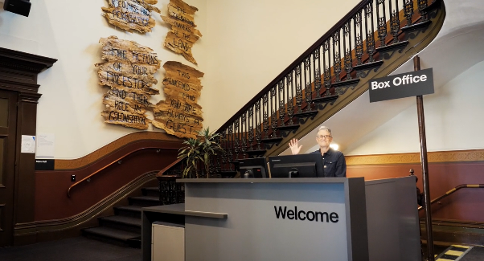

Box Office is located in the foyer under the stairwell.

Ushers

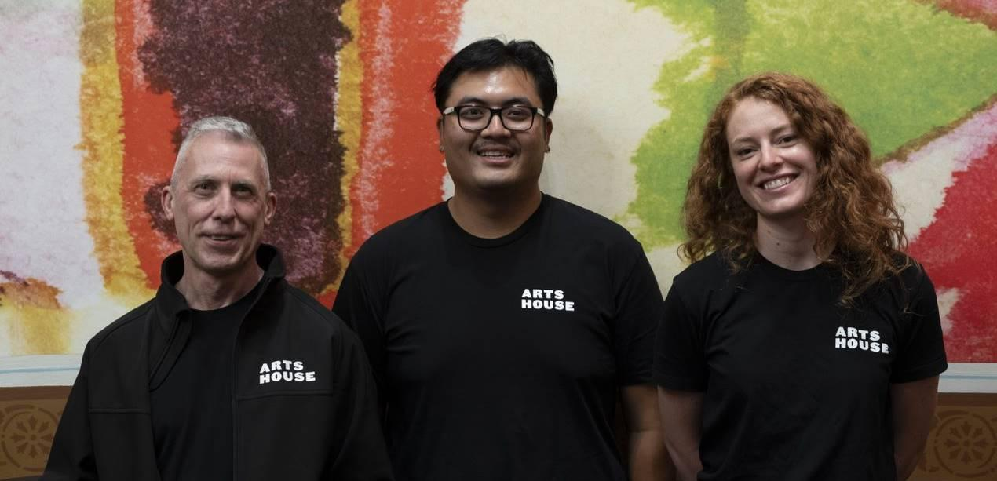

Ushers will be wearing black with an Arts House Logo on the left hand shoulder.

Bar

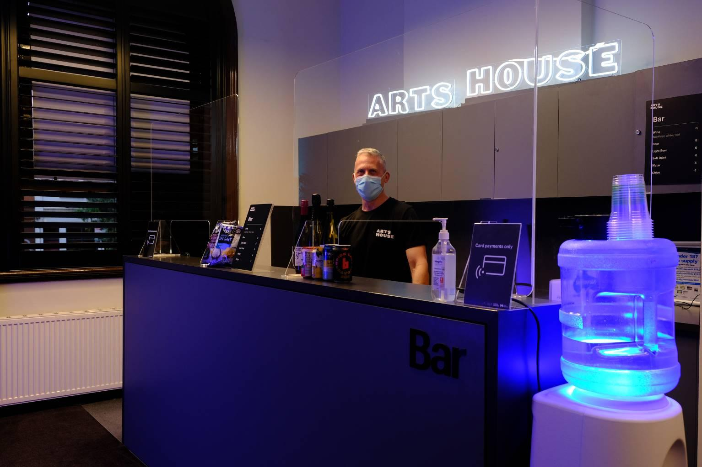

Bar staff will be wearing black with an Arts House Logo.

We have a range of alcoholic and non-alcoholic beverages for sale.

We are a cashless venue and accept EFTPOS, Visa and Mastercard payments.

Quiet Space

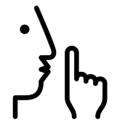
Arts House Quiet Space is located on Ground Level and is nearby reception and opposite the accessible bathrooms. It includes a range of seating options including soft furnishings, dimmable lights, sensory and stim objects. It is open during venue opening hours and events as a quiet space, prayer or parenting space.
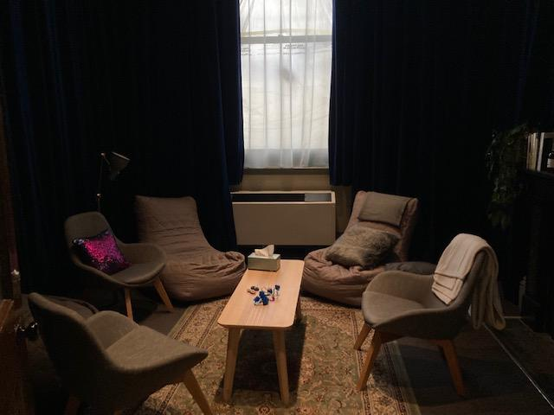

Image: Quiet space with lights dimmed
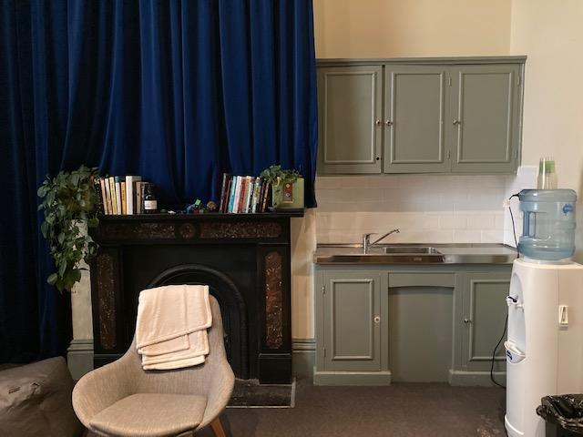

Image: Quiet space kitchenette and book shelf

Bathrooms

All bathrooms have Dyson hand dryers with sensor activation. There is an accessible bathroom that is single use on ground level opposite the Quiet Space. There is another accessible bathroom upstairs – this is accessible via lift or stairs.
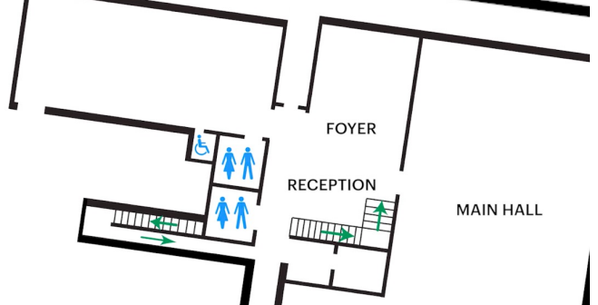

Door to Main Hall

The Performance is in the Main Hall.
It is on the ground floor.
It is to the left of the box office desk and right of the bar.
An artist statement is available on signage and warnings on the door.

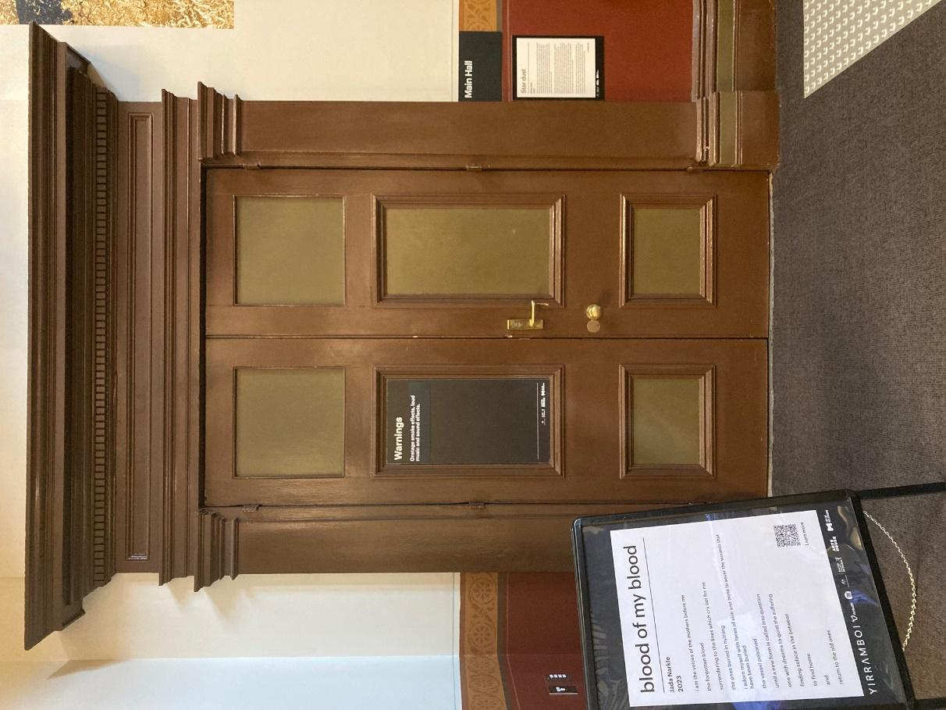

Lift

The lift is located behind reception desk in the foyer.
The closest entry to the lift is via George Johnson Lane.

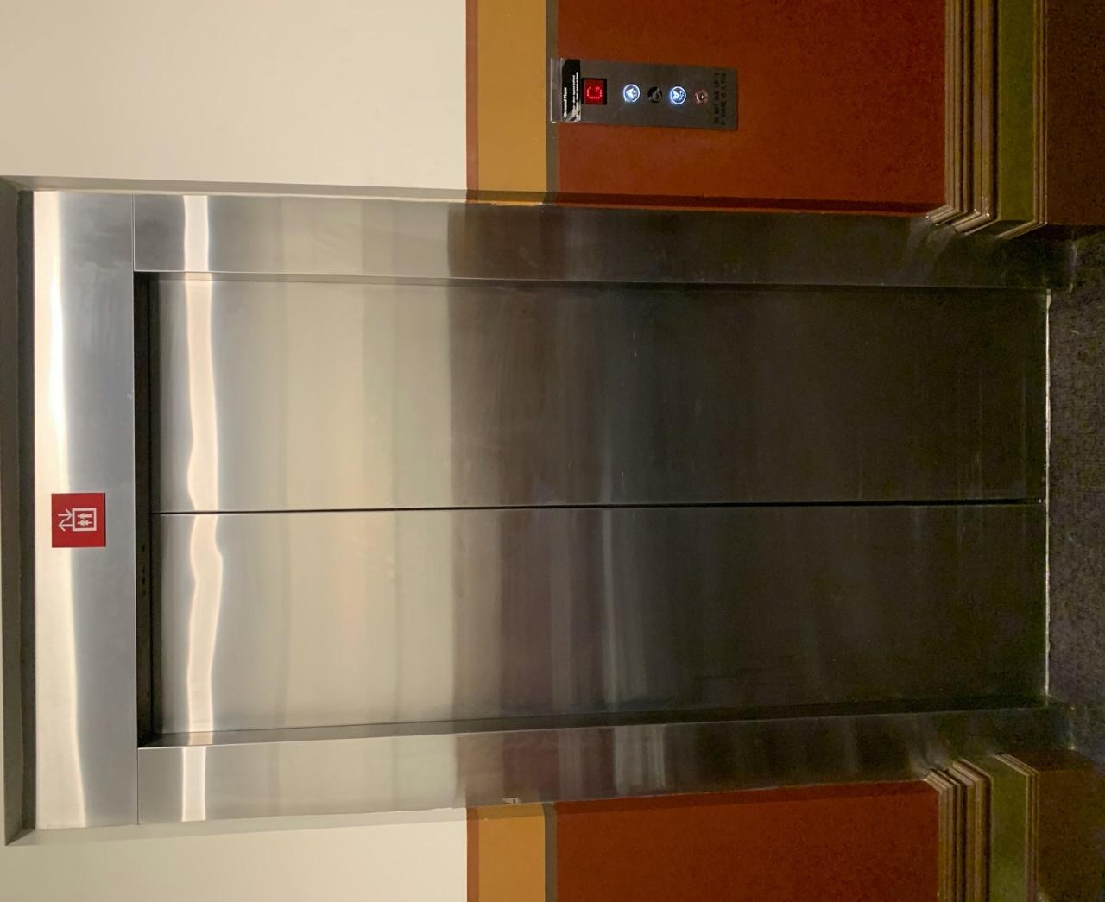

Transport

Tram

Route 57 (High Floor trams only)
Stop 12, North Melbourne Town Hall.
Please note, this is not a wheelchair accessible tram
GETTING TO ARTS HOUSE VIDEO LINK

Train

Arts House is 1.1km from
North Melbourne Train Station,
approximately 16 minute walk
North Melbourne Station Information
1.2km from Flagstaff Station,
approximately 15 minute walk
Flagstaff Station Information

Bus

Bus number: 216

Parking

There is limited paid on-street parking on Queensberry Street and Errol Street.

There are two accessible on street car parking spaces on Queensberry Street (150m to our accessible Errol Street entrance) for holders of a Parking Permit for Disabled people.

COVID Safety

Please follow good health and hygiene practices when visiting Arts House.

Ticket holders who cannot attend their performance due to COVID-19 illness or symptoms are entitled to a full refund.

Facemasks

We strongly recommend wearing a face mask while indoors. We have disposable masks available at reception and in the foyer.

Cleaning

Arts House buildings are cleaned nightly Monday-Friday and on weekends as required.
We conduct touchpoint cleaning of spaces between performances.

Hygiene Stations

Arts House provides handwashing and hygiene stations in each amenities area, studio, and office including: hand sanitizer, disinfectant wipes, rubbish bin.
More information about COVID-19 Safety can be found through the links below:
Our COVID-19 Safety Plan - Arts House - Melbourne

