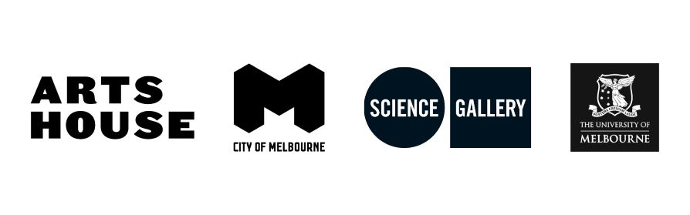
Terms & Conditions - Listening Club
To register
- Book via the Arts House website. Registrations are open until the start of each session.
- Once registered you will be sent a confirmation email with a link to the Zoom session. No password is needed
- The sessions will have live AI generated captions.
Further information
- Never used Zoom? Here’s how to join a meeting (by email invitation): https://support.zoom.us/hc/en-us/articles/201362193-How-Do-I-Join-A-Meeting-
- Please note that your mic will be muted upon entry into the Zoom session. In order to ask a question press the ‘Q&A button’ at the bottom of the screen and your question will be seen by the host.
- Please respect the speakers by not recording any content of the session without advanced written permission.
- By accessing this service you must respect the rights of others, including their privacy and intellectual property rights.
- Please note this session will be recorded.

Moderation of public comments
- We encourage comments in the chat function, but expect participants to behave in a respectful manner. There is no Q&A as part of this event.
- We reserve the right to delete comments that are:
  - knowingly false or mischievous complaints or statements about individuals, companies or the government
  - misleading, obscene, off-topic, sexist, racist or spam
  - promotional or commercial in nature
  - unlawful or incite others to break the law
  - defamatory or harassing of our employees, volunteers or the participants in our channels
  - information that may compromise the safety or security of the public
  - repetitive posts copied and pasted or duplicated by single or multiple users
  - any other inappropriate content or comments as determined by City of Melbourne.

By participating in the sessions you agree to all terms.
If you have any comments, questions or concerns about our policies, or if you wish to make an inquiry please contact us at Artshouse@melbourne.vic.gov.au

