Arts House Building Information

Arts House, based at North Melbourne Town Hall is a heritage listed building with five dedicated arts spaces suitable for a range of activities. There are three different entry points to the main building, and two wheelchair accessible entrances. All levels inside the building are accessible by stairs and lift with accessible bathrooms. The Warehouse is a separate studio and building to North Melbourne Town Hall and includes its own accessible bathroom, kitchen and studio space. The Arts House team can configure each space to suit your needs.
Please note, all Arts House activities operate under a COVID Safe plan
and within current government restrictions.
Click here to view an interactive building scan of Arts House.

Contents
Development and Performance Spaces 2
Main Hall 2
Studio 1 3
Studio 2 5
Supper Room 6
Artist Room 1 8
Warehouse 10
Entrances 14
Queensberry Street Entrance 14
Errol Street Entrance 14
George Johnson Lane Entry 16
Ground Floor, Lift & Bathrooms 18
Foyer and reception 18
Lift 18
Hallway 19
Ground Floor Bathrooms 20
Level 1 Bathrooms 21

Development and Performance Spaces

Main Hall
The Main Hall is located on the ground floor and is the largest and most versatile space at Arts House used for development and presentation.
This space is suitable for main stage performances, large scale exhibitions, live music events, installations, parties, public talks, gatherings, and more.
- Key features: Polished dark hardwood sprung, flat floor (no rake), raised stage with battery operated mobile chair lift (not permanently installed), high ceilings, several windows and ornate ceiling and fixtures. This space has weighted black drapes that can be drawn around the whole space to achieve black out, as well as a lighting rig. The stage can be converted into a greenroom. There are two backstage dressing rooms with bathrooms. These spaces have sharp turns and may not be suitable for large mobility aids.
- Capacity: It comfortably fits 400 people standing and 132 raked seating bank, depending on the set-up.
- Access to space: Entry to the Main Hall is via the main foyer. The main foyer is accessed via stairs from Queensberry Street, or George Johnson Lane ramp (suitable for wheelchair access) off Errol St.

- Space measurements:
Length rear wall to front of fore stage: 25.2m
Width wall to wall: 13.7m Height floor to ceiling: 9.84m
Floor to acoustic panels – effective height. 9.11m

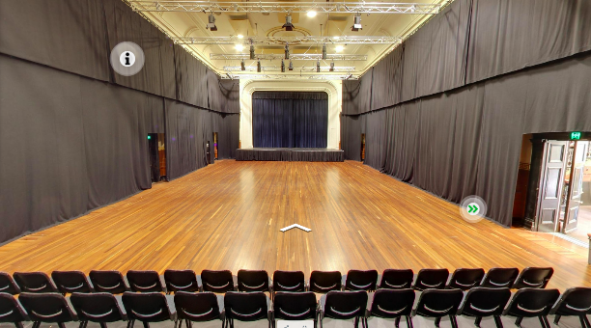
Image: view of main hall from the second row of the seating bank with drapes pulled around the parameter of the space and house lights are on.
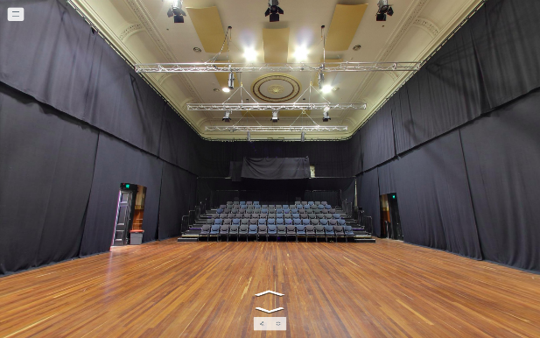
Image: view of the main hall from the stage, looking out to raked seating bank. The drapes are pulled around the parameter of the space and house lights are on.

Studio 1
Studio 1 is located on level one and is used as a development or presentation space.
This space is suitable for a diverse range of activities including public talks, exhibition, medium-scale performances including dance, artist labs, projection, performances and more.
- Key features: polished dark hardwood floor, three large windows with wooden venetian blinds and an ornate fireplace. This space has weighted black drapes that can be drawn around the whole space to achieve black out, as well as a lighting rig.
- Capacity: comfortably fits 50-60 people standing and up to 70 people sitting for a standard panel discussion, depending on the set-up.
- Access to space: There are 25 carpeted stairs and grab rails either side to access this space from ground floor or the lift. Entry to Studio 1 is through a double door - 1390mm both doors 710mm single door.
- Space measurements:
Floor dimension: 11.5m x 5.9m usable space
Height: 5.6m to ceiling, 5m to lighting bars
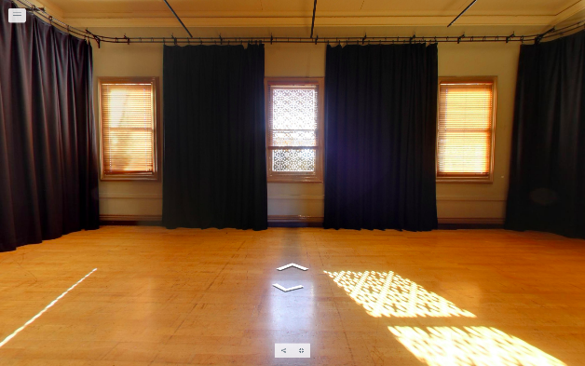
Image: view of Studio 1 from the doorway entry at centre of room, hardwood floor is clear and there are three window with natural light and partially curtained drapes.
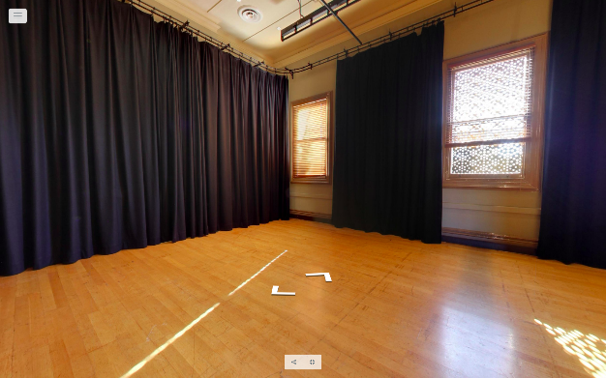
Image: view of left hand side of Studio 1 from the doorway entry, hardwood floor is clear and there are three window with natural light and partially curtained drapes.
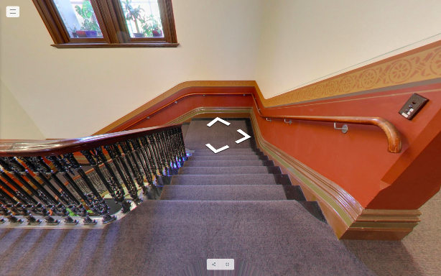
Image: view of carpeted stairwell with grab rails either side from entry of Studio 1.

Studio 2
Studio 2 is located on level one and is used as a development or presentation space.
This space is suitable for a diverse range of activities including public talks, exhibition, medium-scale performances, artist labs, projection, performances and more.This space is not suitable for dance.
- Key features: Polished dark hardwood sprung, flat floor (no rake), three large windows with wooden venetian blinds and an ornate fireplace. This space has weighted black drapes that can be drawn around the whole space to achieve black out, as well as a lighting rig.
- Capacity: Comfortably fits 50-60 people standing and up to 70 people sitting for a standard panel discussion, depending on the set-up.
- Access to space: There are 25 carpeted stairs and grab rails either side to access this space from ground floor or the lift. Entry to Studio 2 is through a double door - 1390mm both doors 710mm single door.
- Space measurements:
Floor dimension: 10m x 7.45m usable space
Heights: 5.53m to ceiling, 4.6m to lighting bars
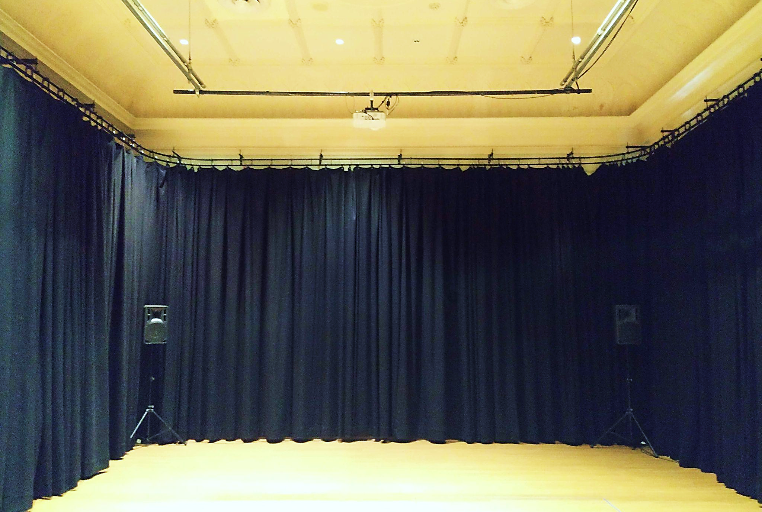
Image: view of Studio 2 from centre of the room with drapes fully drawn around 3 walls, and 2 speakers on stands sitting in each corner.

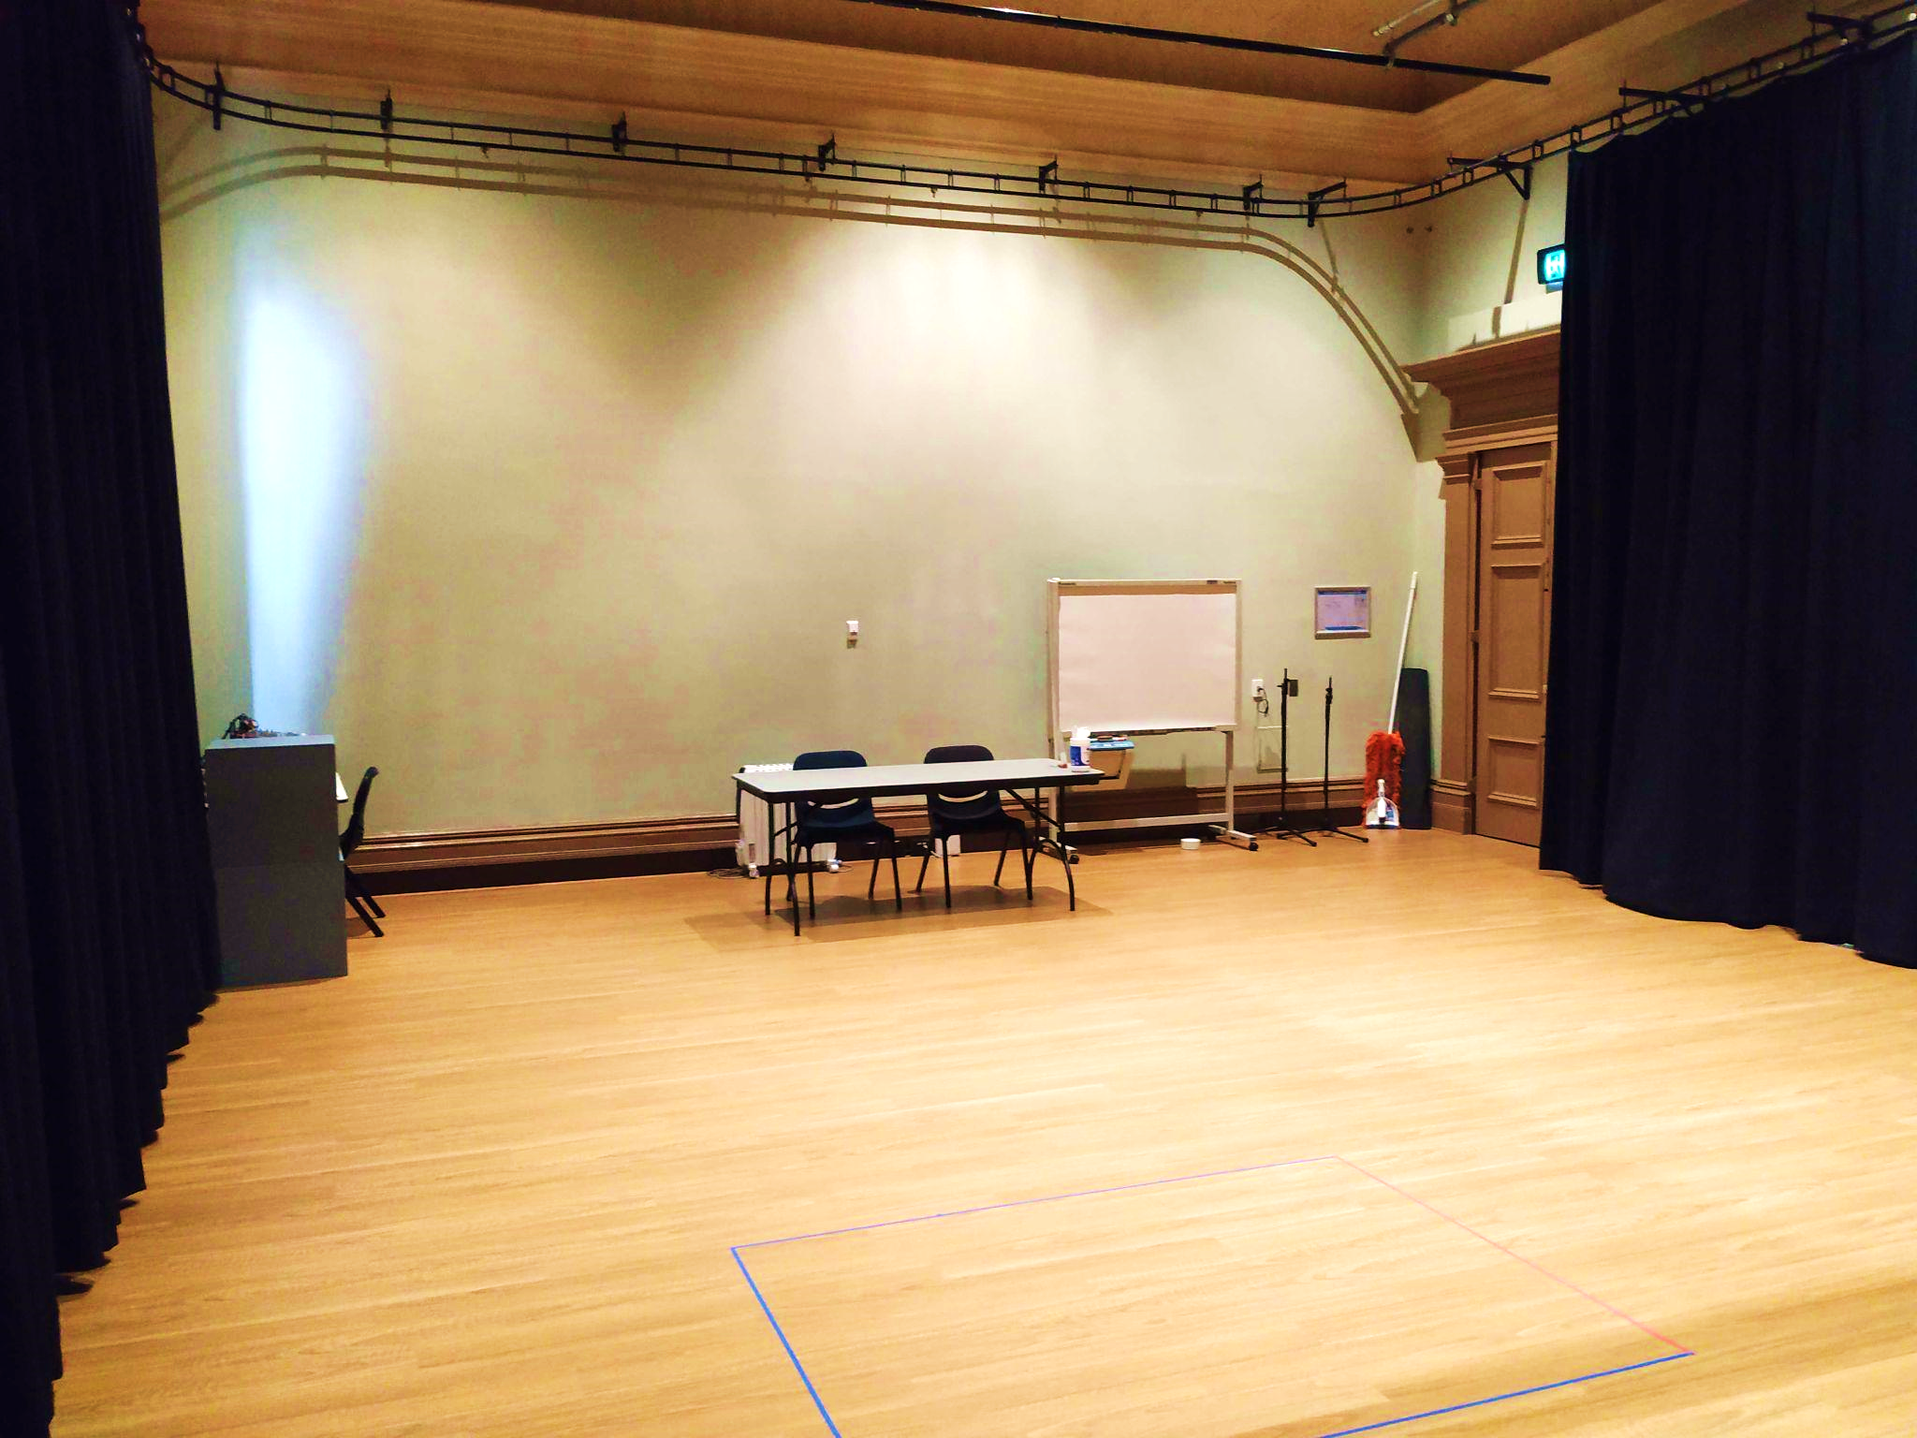
Image: view of studio 2 from centre of the room with drapes partially open. The entry is on the far right and there is a whiteboard, trestle table and two chairs in the space.

Supper Room
The Supper Room is located on the basement level and is directly under the main hall.
It is suitable for rehearsals, screen space, public talks and gatherings, exhibitions, parties and is often converted into a bar space or green room.
- Key features: Polished parquetry floor, six central pillars spaced 4.2m apart, self-contained kitchen, partially accessible bathroom. Please note there is noise bleed and vibrational impact from the main hall.
- Capacity: It comfortably fits 120 people standing and up to 80 people sitting, depending on the set-up.
- Access to space: Entry to Supper Room is via the lift or 20 stairs with grab rails either side. Please note the stairs has a low archway. Entry to Supper Room is through a double glass door - 1500mm both doors 750mm single door.
- Space measurements:
Floor dimension: 16m x 10m usable space
Heights: 2.7m to ceiling, 2.5m to lighting bars

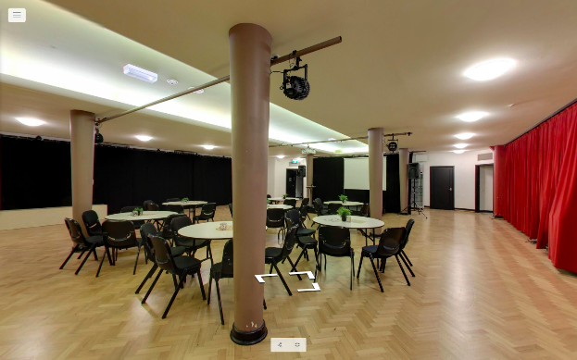
Image: view of Supper Room from doorway entry with cabaret table set-up. There are four pillars with two lighting rigs and a projector screen hangs at the far end of the room.
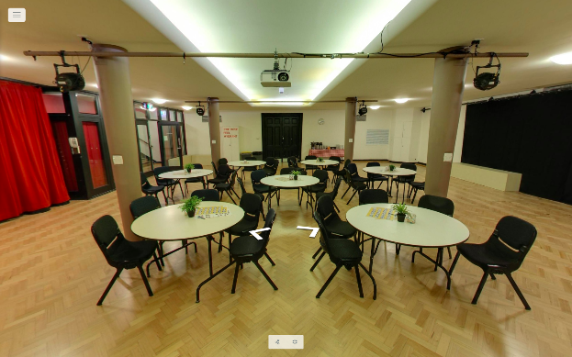
Image: central view of Supper Room from the far end with cabaret table set-up. There are four pillars with two lighting rigs and a projector screen hangs in the top centre.
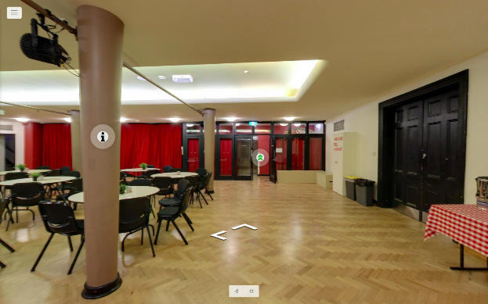
Image: view of Supper Room facing the door entry with cabaret table set-up. There are six panels of glass doors, with one door open in the centre.

Artist Room 1
Artist Room 1 is located on Ground Level and is the closest space to reception. This space is suitable for meetings, prayer room, reading nook or intimate performance.
- Key features: Carpet floor, one large window and an ornate fireplace. There is a small ‘tuck-shop’ style window which is accessible from the hallway.
- Capacity: Comfortably fits 10 people standing and 8 people seated.
- Access to space: Entry to Artist Room 1 is through a single door 870mm wide.
- Space measurements:
Floor dimensions: 3.75m x 4.35m usable space
Heights: 4m to ceiling, 2.8m to central pedant light
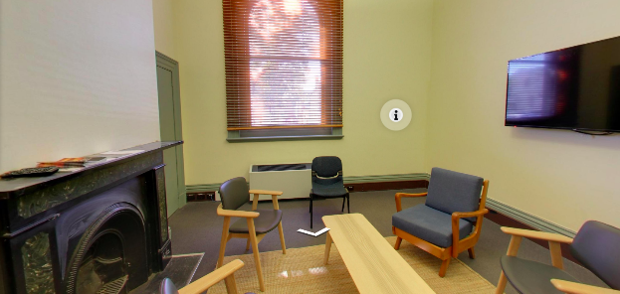
Image: view of Artist Room 1 set-up with five seats, coffee table, LCD TV on far right wall and fireplace on left. There is one window with blinds partially open.
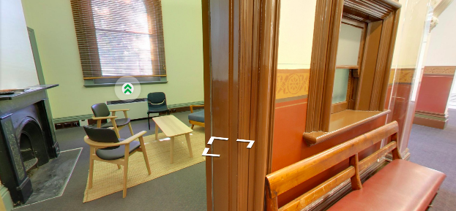
Image: Artist Room 1 from doorway. A ‘tuck shop’ style window is visible from hallway.

Warehouse
The Warehouse is an independent, self-contained building separate to North Melbourne Town Hall and is used as a development and presentation space.
The Warehouse is a multi-purpose space suitable for medium-sized performances including dance, exhibitions, artist workshops and labs, installations, public talks, gatherings, and more.
- Key features: polished dark hardwood floor, partial black out, four steel pillars (4.3m to 4.6m apart), 3 circuit lighting track with modular fixtures, self-contained kitchen with dishwasher and fridge. There are two bathrooms which are partially accessible and one bathroom is wheelchair accessible and has grab rails.
- Capacity: It comfortably fits 100 people standing and up to 50 people sitting, depending on the set-up.
- Access to space: The Warehouse building entrance has a wheelchair accessible ramp with grab rails on either side and is 1150mm wide. The ramp is in two sections the first 960mm of the ramp has a gradient of 1:6 and the next 10m has a gradient of 1:12. Entry is through a glass sliding door.
Entry to the Warehouse from Errol Street and George Johnson Lane is via smooth asphalt surface with a cobblestone strip in the centre. It can also be accessed via 29/33 Little Errol St, via a cobblestone path.
- Space measurements:
Floor dimension: 13.4m x 11.2m usable space (excludes kitchenette/ bathrooms)
Heights: 4m to ceiling 3.3m to lighting bars
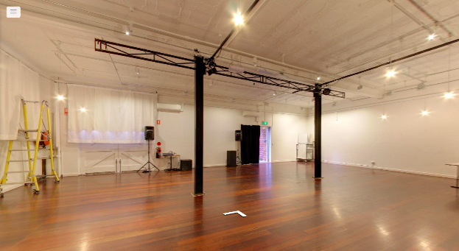
Image: view of Warehouse looking towards glass doorway entry. There are black drapes partially covering the door, two steel pillars in centre of room and a ladder, speakers and projector in left corner. The widows are covered with white curtains.
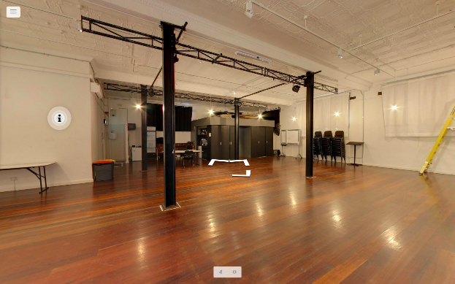
Image: view of Warehouse taken from entry looking towards open-planned kitchen. The bathroom entry is on the far right and there are two pillars in centre of the space.
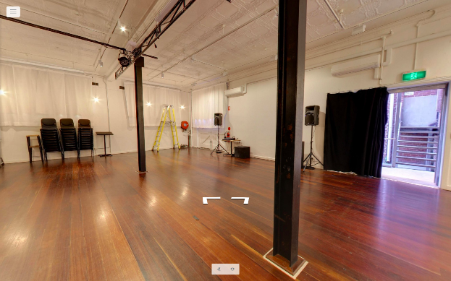
Image: central view of Warehouse with main entry to the right. There are black drapes partially covering the door. In the centre of the room there are two steel pillars (4.3m apart). In the far back corner there is a removable ladder, speakers, stack of chairs and two speakers. The widows are covered with white curtains.
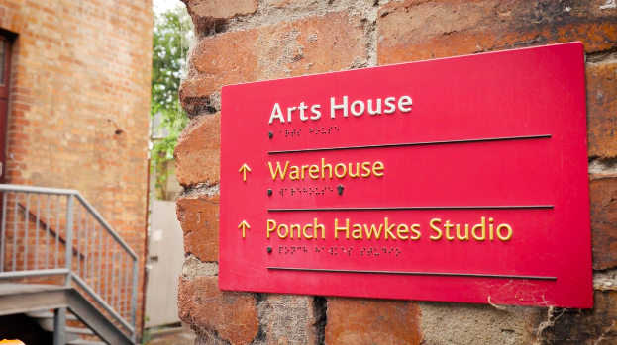
Image: directional signage for the Warehouse on George Johnson laneway. Text is yellow on red background with braille translation.
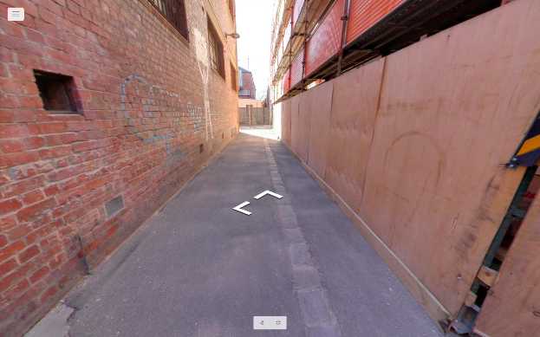
Image: view of George Johnson Lane featuring smooth asphalt surface with a cobblestone strip in the centre.
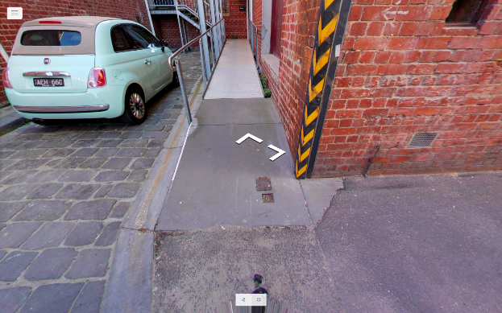
Image: view of the Warehouse building entrance with wheelchair accessible ramp with grab rails on either side.
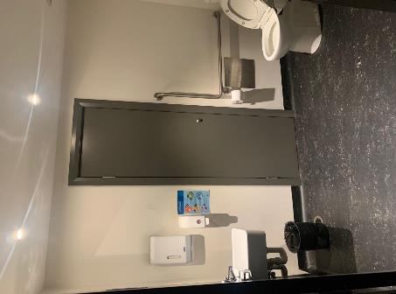
Image: view of accessible bathroom suitable for large mobility aids in Warehouse.
There is a wash basin on left and toilet on right which has a right-side handrail.

Entrances

Queensberry Street Entrance
The Queensberry St entrance to Arts House has 9 steps with grab rails on both sides for all steps except the last two, and features automatic double glass doors.
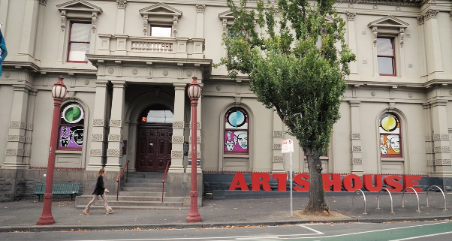
Image: wide-shot view of Arts House from Queensberry street showing stepped entrance and the giant red Arts House sign to the right.

Errol Street Entrance
The Errol St entrance is next to the Post Office. This entrance is an automatic door (850mm wide) operated by button and will take you directly to the hallway on ground floor.
To get to this automatic door, you can use either the wheelchair accessible ramp - 2200mm wide with a gradient of 1:11 or climb up three steps (150mm high 1700mm wide) with grab rails and tactile surface indicators.
To get into the building from Errol Street wheelchair ramp, medium to large mobility aids will need to make a tight right hand turn.
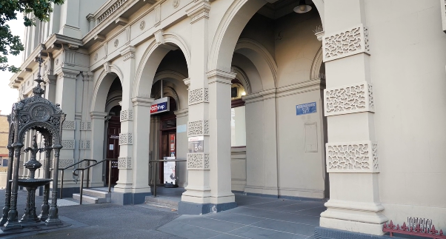
Image: view of Errol Street entrance next to the Post office.Far left of the image is the stepped entrance and to the right is the ramped entrance.
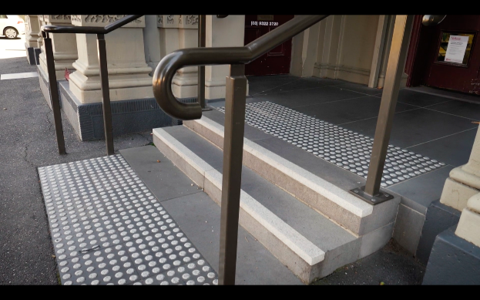
Image: view of step entry on Errol Street next to the Post office with grab rails and tactile surface indicators.
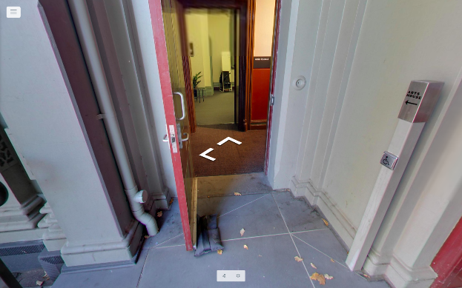
Image: view of Errol street automatic door entrance with button on right hand side

George Johnson Lane Entry
George Johnson Lane entry is to the right of the post office and is a wheelchair accessible entrance. It is clearly signed and has high contrast yellow lines to the doorway.
Entry is via a smooth ramp with grab rails either side and button operated, automatic door (840mm wide). This laneway is also the post office’s loading zone so there may be vehicles blocking the way. If this is the case, we recommend you to use the Errol St entrance.
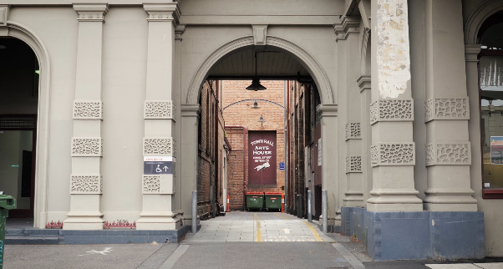
Image: view of George Johnson lane between Post office and Library with high contrast yellow lines on the ground leading to the doorway entry at end of laneway.
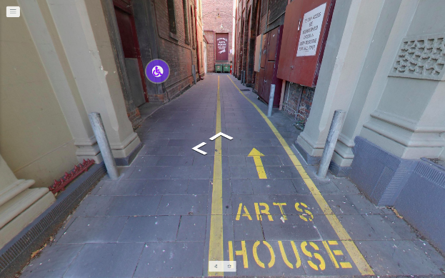
Image: view of George Johnson Laneway ground with high contrast yellow lines and arrow pointing to the entry. Arts House is written in bold yellow capitals.
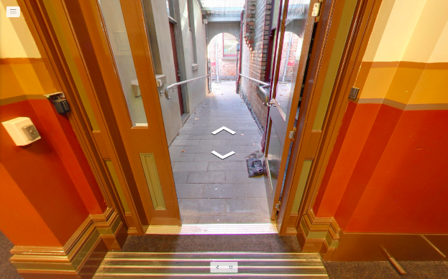
Image: view of smooth ramp with grab rails and button operated automatic door.
There is a tactile surface indicator once you enter into the building.

Ground Floor, Lift & Bathrooms

Foyer and reception
The reception and box office is a desk located in the foyer. This desk features a lower section, with our friendly front of house staff who can assist with your requirements.
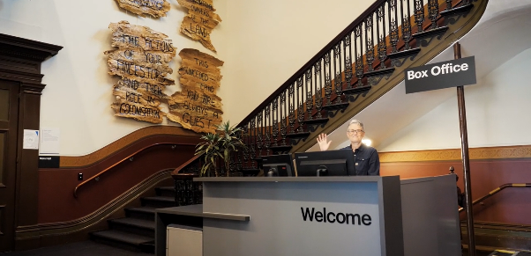
Image: view of Welcome desk in Arts House foyer with staff Trudy Hayter waving and smiling. To the left of the desk is the main stairwell, showcasing artwork on the walls.

Lift
The accessible lift is located on the right when you enter through the George Johnson Lane entrance or behind reception if you enter from Queensberry or Errol St entrance. The lift can accommodate one wheelchair / mobility scooter at a time. Door width is 860mm. Please note that some floors open with the door in front and some behind. Check signage on the lift operation buttons on each floor.
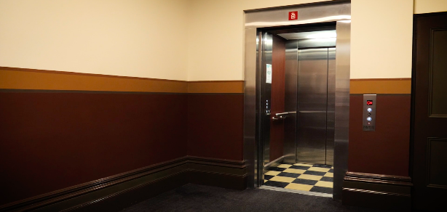
Image: view of lift with open doors and operator buttons to the right.

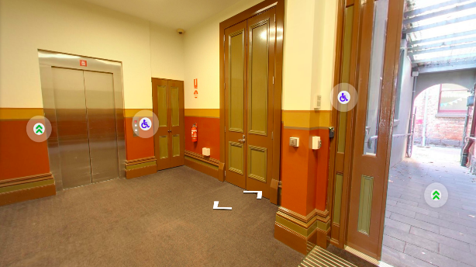
Image: view of lift with closed doors on left and George Johnson laneway entry on right. The technical room is in the middle with closed doors.

Hallway
There is one main hallway on Ground Floor is 1100mm wide and suitable for large mobility aids. The floor is carpeted. The accessible bathroom is located in this hallway.
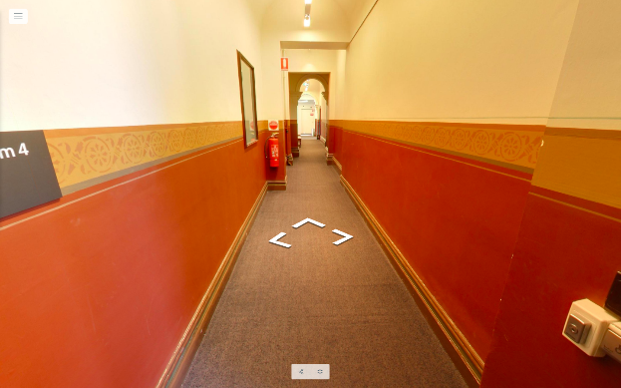
Image: view of carpeted hallway corridor on ground level from Errol St entrance end.

Ground Floor Bathrooms
There is one wheelchair accessible toilet with an automatic button located in the ground floor hallway just off the foyer. Door width is 760mm. There are two ambulant toilets with grab rails located in the unisex bathrooms located next to reception.
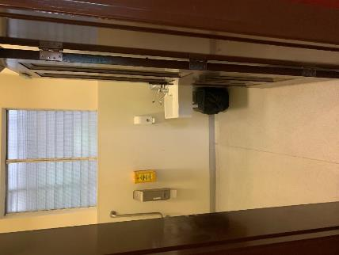
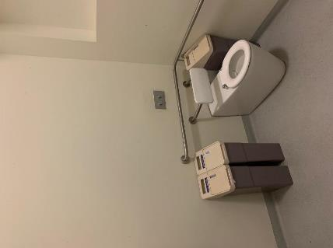
Images: view of accessible bathroom entry and toilet with handrail on ground floor.

Level 1 Bathrooms
There are two toilets on Level 1, which are partially accessible and include showers. The one closest to the lift has grab rails. The hallway is narrow and may not be suitable for large mobility scooters. Both have heavy, manually operated doors.
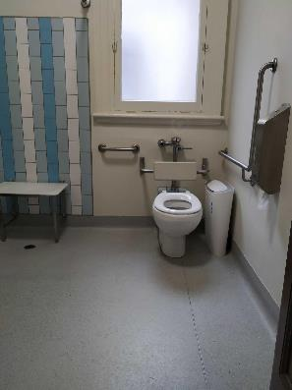
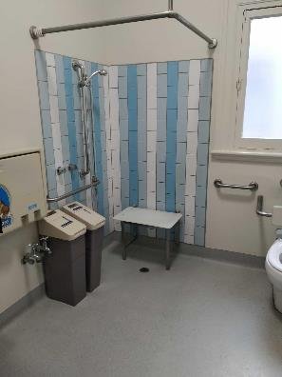
Images: view of partially accessible bathroom and shower closest to Studio 1. The shower has no step entry and a grab rail underneath taps. There is a small movable seat in the shower. A baby change table is positioned left of the shower and the toilet is in the far right with ah grab rail on left and right hand side.
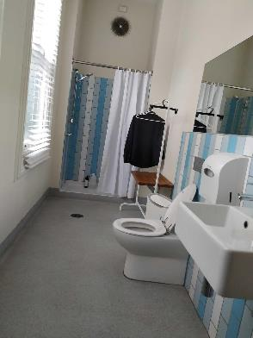
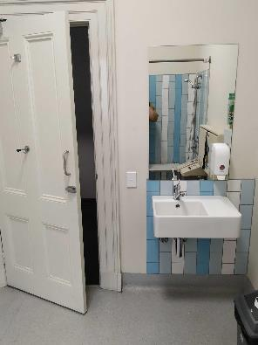
Images: view of partially accessible bathroom and shower closest to Studio 2. Image is of bathroom with sink directly on entry to the right, with toilet, clothing rack and bench directly in line against the right hand wall. There is a shower with a small step entry at the far end with partially open curtain.

