# **MASS MOVEMENT ACCESS GUIDE**

## About Mass Movement

MASS MOVEMENT FOLAU: The Arrival – is the culminating finale of Latai Taumoepeau's Mass Movement, a poetic pilgrimage tracing our waterways.

An orchestrated movement of drumming and simple body percussion movements, FOLAU responds to the injustice of forced relocation, inspired by the majestic currents and waves of Oceania.

Join 100 bodies in an urgent semaphore action at Flagstaff Gardens accompanied by F7 Vaerua Kaara (Soul Drummers) in amplification of the climate emergency.

Mass Movement is a participatory event where you are invited to perform a simple body percussion with a group of 100 people. You do not need dance experience to participate in this work, and all bodies and ages are welcome.

We have collaborated with Deaf, disabled and neurodiverse consultants with experience in inclusive practice to create adapted choreography.

[Click here to watch the instructional body percussion video](https://vimeo.com/545932668) and learn the movement prior to attending.

Commissioned by Arts House as part of Refuge 2021

## Times and Dates

Participate in MASS MOVEMENT FOLAU: The Arrival

Sunday 16 May 2021

3pm

45 minutes duration

Free Event, registration required

This is a participatory outdoor event taking place on grass and will occur in most weather conditions.

Front of House and ticketing will be open 30 minutes prior to the event start time.

If you are blind or have low vision and require meet and assist from transport hub or taxi drop-off points please contact Adam Seymour to arrange before 5pm Friday 14 May on (03) 9322 3720; text 0447 570 178; or email [artshouse@melbourne.vic.gov.au](mailto:artshouse@melbourne.vic.gov.au)

## Access at a glance

* Location is wheelchair accessible and there are pathways running alongside the edge of the event area with smooth transition to grass
* Auslan interpreters are available on the day
* Learn the movement before you attend via a video with closed captions and voice over instructions – [watch video here](https://vimeo.com/545932668)
* Staff are available to meet and assist blind and low vision attendees
* The movement has been made in consultation with people with disabilities
* The event will involve loud drumming. You are welcome to come and go at any time – quiet areas of the park are available
* You can just rock up and learn the movement on the day.

## What will we do?

Mass Movement is a participatory event where you are invited to perform a simple body percussion with a group of 100 people. You do not need dance experience to participate in this work, and all bodies and ages are welcome.

We have collaborated with Deaf, disabled and neurodiverse consultants with experience in inclusive practice to create adapted choreography.

[Click here to watch the instructional body percussion video](https://vimeo.com/545932668) and learn the movement prior to attending.

Registered participants will:

* Will learn simple choreography and perform it together as a group
* A video of this movement will be sent to you in advance with closed captions and Auslan interpreting
* There may be other audiences, spontaneous or planned, who observe the movement as non-participants

## What do I bring?

* We recommend travelling light and only bringing your essentials as there will not be cloak or bag check-in on site
* Wear clothing and shoes you feel comfortable moving in
* Bring a refillable water bottle as there are public water fountains on site

## What happens when I arrive?

* When you arrive at Flagstaff Gardens you will be greeted by Arts House front of house staff who will assist you with COVID-safe check in and answer any of your questions
* You will be offered assistance to a designated spot on the lawn alongside a group of 100 people. If you are participating with a guest or group of people you are welcome to stay together, but will be separated 1m apart
* Participants attending with a support person or young children can remain together for the duration of the event
* Artist Latai Taumoepeau will guide the event and your involvement

## What do you hear?

Mass Movement will

* Take place in spoken English and Auslan
* The event will involve loud drumming by F7 Vaerua Kaara (Soul Drummers) who perform with traditional and contemporary drums including small and medium-sized lali (log drums), and tyco drums.
* [Watch an excerpt of F7 performing](https://www.facebook.com/304992956694788/videos/319201831940567) before you attend to know what to expect
* If the drumming is too loud on the day for you, there are quieter areas of the park available.

## What do you see?

At Mass Movement you will see:

* The country we are exploring and meeting on
* A performance by F7 Drumming Group
* A performance by Latai Taumoepeau and collaborators with semaphore flags
* Choreography being demonstrated
* A large group of 100 participants evenly spaced out on the lawn performing a simple body percussion in unison
* Red Cross volunteers in their uniform
* SES volunteers in their uniform
* Bright orange bollards and SES tape marking out the event area

## Content Warnings

This event includes themes of distress and dislocation due to climate change.

## Meet the Team

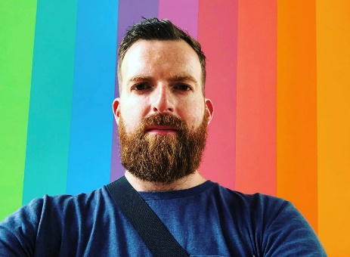

Image caption: Adam Seymour

Adam is Arts House Front of House Manager and will greet you on arrival at the event. Adam will assist you with your check-in and answer your questions.

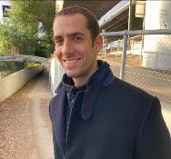

Image caption: Otto Enos

Otto is Arts House Front of House Supervisor and will greet you on arrival at the event. Otto will assist you with your check-in and answer your questions on the day.

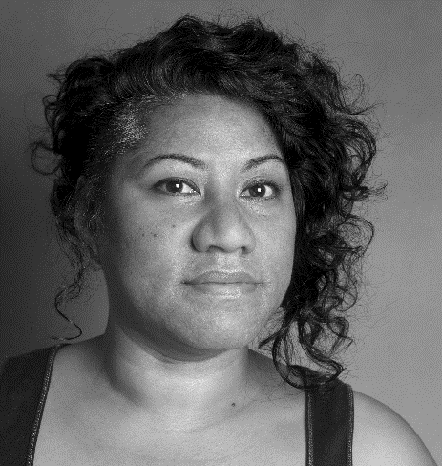

Image caption: Latai Taumoepeau

Latai Taumoepeau is the creator of Mass Movement. Latai will be leading the event and directing the movement on the day and sharing what it’s all about.

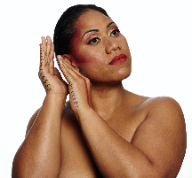

Image caption: Seini Taumoepeau

Seini Taumoepeau is the host of Mass Movement on the day. Seini will help Latai lead the event and teaching the movement.

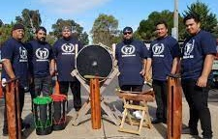

Image caption: F7 drumming group

F7 are the drumming group performing on the day. There are 6 performers in the group. They perform with traditional and contemporary drums including small and medium-sized lali (log drums), and tyco drums

## Location

Flagstaff Gardens is located at 309-311 William St, West Melbourne VIC 3003.

Mass Movement Folau event will take place in the centre of Flagstaff Gardens, Lawn 7 where an outdoor stage is located.

This area of the park has a sloping hill on the West side but level event areas at the South end. There are large mature trees set in open lawns.

A performance area has been selected that is flatter and easier to access.

Arts House staff will be able to guide you to the most accessible points in this location. Auslan interpreters will also be available to assist communication.

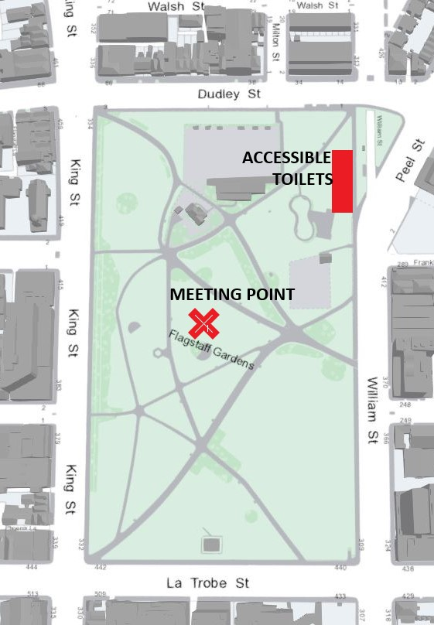

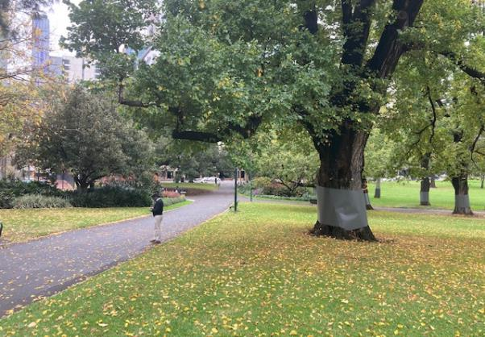

Image caption: Front of House point for event entry will be alongside directly next to a large tree. This area will be fenced with orange bollards with SES tape around the edge.

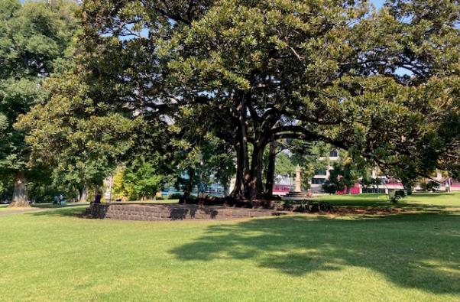

Image caption: this grassed area is where we will gather and perform together. It is next to a cobblestone stage with a large mature tree which casts shadows over the verdant grass.

## Transport and Parking

There are five ways to get from Melbourne city to Flagstaff Gardens by train, tram, taxi, bike or foot.

### Train

Catch a train to Flagstaff station in the loop. There are lifts to ground level. Turn left along William Street when you exit the station. Cross La Trobe St at the traffic lights and continue for 180 meters to the main entrance.

Note: at the time of writing, the traffic lights to cross La Trobe St have broken audible signals. There is a station exit on the corner of La Trobe and William, accessible via stairs only. After exiting, turn left onto William and continue to the gardens entrance.

For Attendees who are Blind or have Low Vision:

If you are coming from Flagstaff station, walk down the left hand side of William St. Once you have crossed La Trobe St, on your left there will be a grassy edge on the footpath if you wish to shoreline. This will occasionally be replaced by patches of dirt, and intermittent metal grates can be found on the footpath. The grassy edge will end, and you will come to a low metal fence, roughly at knee height. This fence will turn a corner, which indicates the first entrance to the gardens. If you continue straight along William St past the metal fence and the gardens entrance, a solid, rocky edging runs along the footpath. You will pass a pedestrian crossing on your right hand side, and eventually come to the intersection of William and Dudley streets where there is a second entrance to the gardens. Staff will be able to provide assistance to the event from either of these entrances.

### Tram

The number 19 tram from Elizabeth Street in Melbourne city and from Coburg along Sydney Road and Royal Parade in the other direction. There is an accessible stop in Elizabeth Street in front of the Victoria Market. Go west to the other side of the Market to Peel Street which becomes William Street at the roundabout. Flagstaff Gardens are next to the roundabout on the west side of William Street.

### Taxi/ Rideshare

Taxi drop-off is easiest in Dudley St on the north side of the Gardens.

For Attendees who are blind or have low vision:

If you are travelling to the gardens by taxi, you may be dropped near a bus stop on Dudley Street, not far from the corner of William St. You may like to mention it as a useful landmark for the driver. Once you get out of the taxi, turn left and walk towards William St. The buildings will be on your right if you wish to shoreline. The entrance to the gardens is on the corner of William and Dudley Streets. Audible traffic lights indicate the intersection, but you will not need to cross over. Staff will be able to meet you at this corner to provide assistance to the event.

### Parking

There are two 4 hour accessible parking spaces in Dudley St near the corner of William St, next to the Gardens.

### Bike

There are limited places to secure your bicycle. Cycling is not permitted in the park.

Walking

Flagstaff Gardens is a 9 minute walk from Melbourne Central via La Trobe and William Street and a 21 minute walk from Flinders Street Station via Flinders and William Street.