africa

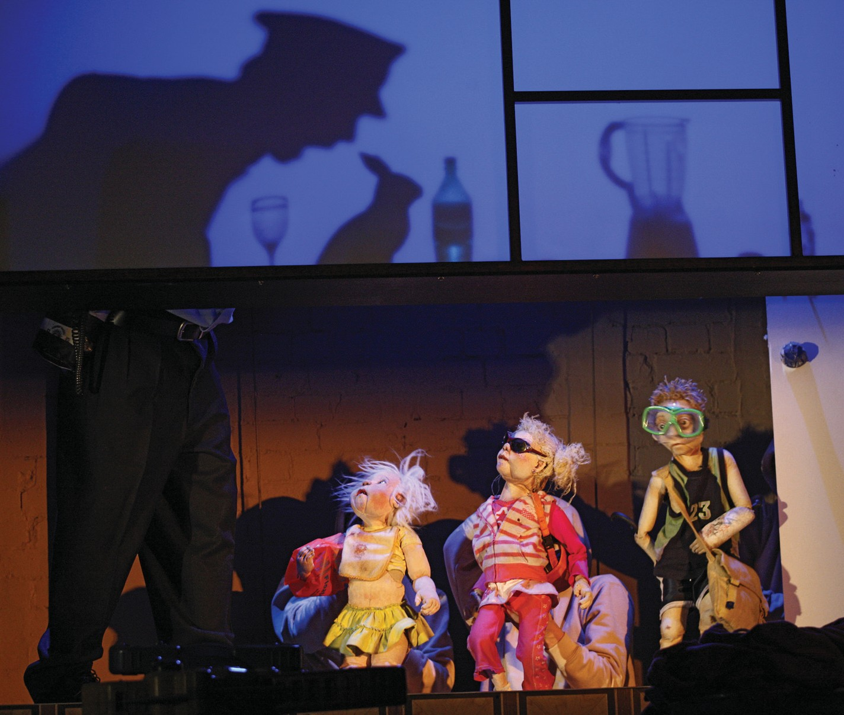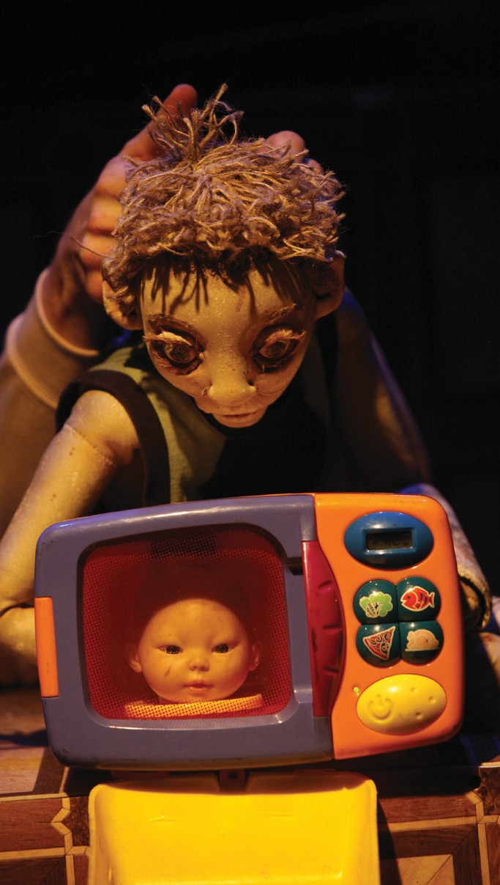

my darling patricia



biographies (cont.)

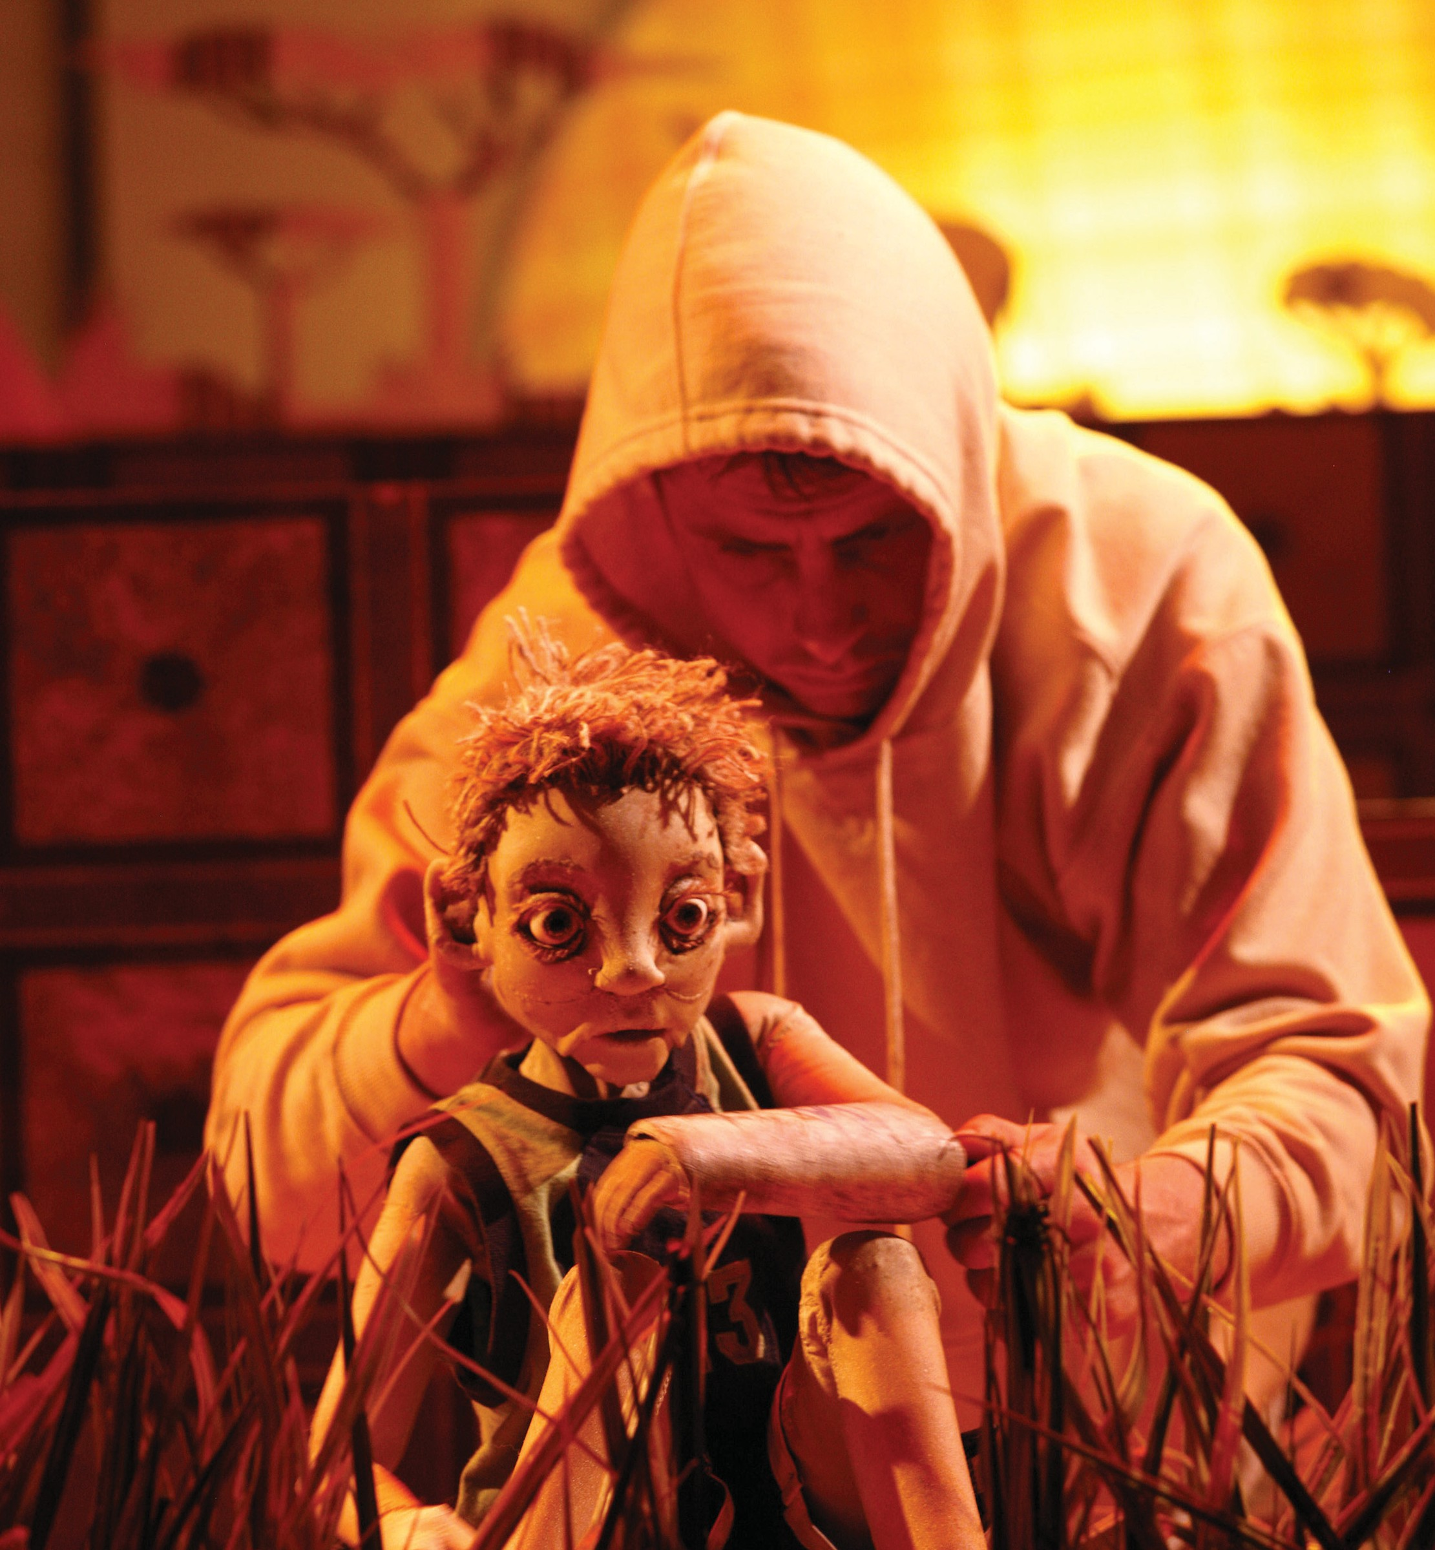

michelle robin anderson is a performer and collaborator with a passion for puppetry. since completing her training in contemporary performance at Waapa and scoa she has focused on devising work

that embraces a combination of acting, puppetry, movement and dance. she has worked extensively with spare parts puppet theatre in perth, performing in The Birthday, The Velveteen Rabbit, The Man From Snowy River, and The Mary Surefoot Shoe Collection. other performances include: lotterywest festival celebration opening for the perth international arts festival with la fura dels baus, Hope is the Saddest at the brisbane festival and The Blue Room (equity guild award winner for best newcomer and Winner of best production at the blue

room awards), Red Lashes at city farm for the uniMa international puppetry festival in perth, Don’t Look Back at the perth international arts festival, Lipstick and Hessian and Blueberry Beard at the blue

room, The Laramie Project with black swan theatre company, and Motor City Blues at the adelaide fringe festival.

in 2006 Michelle participated in the spark mentorship program through the australia council, developing her skills in puppetry with mentor philip Mitchell – The Mary Surefoot Shoe Collection was the result of this partnership. in 2009, Michelle travelled overseas to work with the royal academy

of dramatic art and frantic assembly in london. 2010 was a year of creative developments – working on Prompter Live Studio with artist sam fox, independent theatre work The Pigeon, and The DIY Project

- a commission for barking gecko theatre company that is composed entirely from cardboard boxes.

Jodie le Vesconte began her training at Qut and received a performing arts scholarship to study at the shakespeare

& company summer training institute (boston). she has appeared in numerous plays with Qtc, reat t v, Zen Zen Zo, la boite theatre, fractal theatre, the nest, backyard productions and arena theatre. in 2010 Jodie toured nationally with Shape of a Girl (sydney opera House) and to austria and italy with Hoods (real t v). she was

co-deviser and performer in Mdp’s africa

at the Malthouse theatre, Melbourne.

performing lines

africa is toured by performing lines for Mobile states, a national consortium of venues with a commitment to presenting the best of australia’s contemporar y

per for mance. per for ming l ine s develops, produces and tours new australian performance nationally and internationally. since its inception in

1990, performing lines has worked with companies large and small throughout australia to tour over 150 productions to more than 500 locations around the world.

[www.performinglines.org.au](http://www.performinglines.org.au/)

africa is a Malthouse theatre commission produced by Marguerite pepper productions. toured by per forming lines for Mobile states, with the support of the australian gover nment through the austr alia council, its ar ts funding and advisor y body, and through the national performing arts touring program, playing australia.

images: Jeff busby

arts house

521 Queensberr y street north Melbourne vic 3051 [w w w.artshouse.com.au](http://www.artshouse.com.au/)

[artshouse@melbourne.vic.gov.au](mailto:artshouse@melbourne.vic.gov.au) tel: 03 9322 3719

arts House is a city of Melbourne contemporar y arts initiative. each year arts House presents a curated program of contemporary art featuring performances, exhibitions, live art, installations and cultural events.

arts House operates as a multi- dimensional resource hub for artists: producing, programming, devising, supporting and funding. Work is presented across two sites: arts House, north Melbourne town Hall and arts House, Meat Market.

arts House values arts and culture that help create a world where people are actively engaged, aware and empowered to participate, politically and culturally, to make positive change.

presented by arts house and mobile states

arts House

Meat Market

wed 27 – sat 30 april

“africa is beautiful and savage tHeatre, Marrying virtuosic tecHnical accoMplisHMent to

an eMpatHetic and rutHlessly obs erved understanding of tHe dynaMics of doMestic

abuse” The Age



conceived, designed and created by

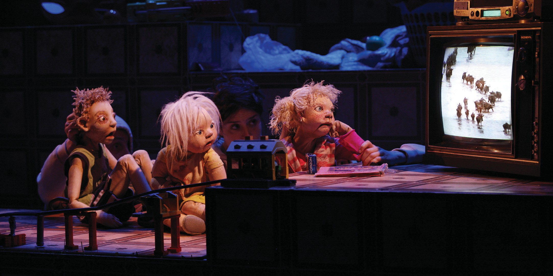

my darling patricia concept: sam routledge Writer/director: halcyon macleod design: clare britton, bridget dolan

composer/sound designer: declan Kelly

puppets: bryony anderson

lighting designer: lucy birkinshaw

dramaturgy: chris ryan

props & set dressing: tim mcgaw sound operator: marco cher-gibard production Manager: bindi green

performers/puppeteers: michelle robin anderson, anthony ahern, clare britton, sam routledge, Jodie le Vesconte

original cast also included matt prest, alice osborne

german loVers – aged siX

and fiVe – try to elope to africa

the guardian, 5 January 2009

“it is a dream that has been shared by lovers across the centuries – the chance to elope to exotic lands. but few would have been as bold and spontaneous as six-year-old Mika and his five-year-old

sweetheart anna-bell who, after mulling over their options in secret packed their suitcases on new years eve and set off from the german city of Hanover to tie the knot under the heat of the african sun.

the children left their homes at dawn while their unwitting parents were apparently sleeping, and took along Mika’s seven-year-old sister, anna-lena, as a witness to the wedding. donning sunglasses, swimming armbands and dragging a pink blow-up lilo and suitcases on wheels packed with summer clothes,

toys, and a few provisions, they walked a kilometre up the road, boarded a tram to

Hanover train station and got as far as the express train that would take them to the airport before a suspicious station guard alerted police.”

My darling patricia’s body of work explores domestic landscapes and the capacity of the inner life of their

inhabitants to transform these landscapes from the pedestrian to the fantastic. africa began with an idea for such a landscape

- a floor of garbage, toys and broken appliances, influenced by photographs of neglected family houses in adelaide and canberra. it was imagined as a children’s space, where the adults appear from the waist-down as in Tom and Jerry cartoons.

after this, the stor y of anna-bell, anna-lena and Mika arrived, its hope and optimism contrasting sharply with the situation of the children we had first imagined. from the clash of this heart-warming tale and the imager y of australian domestic degradation, africa has emerged.

this work was made through the Malthouse theatre’s “company in residence program”. We have created the work collaboratively, with all performers in the original cast contributing to the authorship of the work by generating original material through improvisation.

africa is My darling patricia’s fifth original work following on from Kissing the Mirror (2003), Dear Pat (2004), Politely Savage (2005-07) and Night Garden (2009). in 2011

My darling patricia will premiere a new work, Posts in the Paddock at performance space, and are developing a new work

for young audiences.

halcyon macleod

co-artistic director, My darling patricia

about my darling patricia

My darling patricia is an ensemble that fuses ever yday, domestic australia with the far reaches of the fantastic. drawing inspiration from all corners of the creative universe, the patricias create highly distinctive visual theatre that is at once intimate and epic.

approaching theatre from backgrounds in visual arts, puppetry, film and spectacle per for mance, the company dev ises its original works through a rigorous, collaborative process led by co-artistic directors clare britton and Halcyon Macleod.

My darling patricia has created five productions working together with associate artists and presenters at Melbourne’s arts House Meat Market, the victorian arts centre (fulltilt), the Malthouse theatre, sydney’s the per formance space and adelaide’s vitalstatistix. their breakthrough production Politely Savage won best theatre act at the adelaide fringe festival 2007, outstanding production and best design at the Melbourne fringe festival 2006 and best independent theatre show at the sydney theatre critics’ award in 2006. africa was shortlisted for the Helpmann award

for best physical or visual theatre production and received the Malcolm robertson prize in 2009.

My darling patricia is managed and produced by Marguerite pepper productions.

[www.mydarlingpatricia.com](http://www.mydarlingpatricia.com/)

biographies

clare britton is an artist who works to create original, visual theatre. clare’s approach to making theatre is hands on, experimental, intuitive and applies her experience as designer, puppeteer and theatre maker. clare is co-artistic director of My darling patricia with

longtime collaborator Halcyon Macleod. a founding member of My darling patricia (2003), clare has played an integral part

in devising, designing and performing all of My darling patricia’s productions. clare left her study of sculpture at cofa, unsW in 2000 to build puppets and set pieces and tour as a performer and rigger with erth visual and physical inc through australia, to singapore and korea. in

2006, clare received an australia council skills development grant to study under philippe genty at the vca. and has an ongoing collaboration with artist Matt prest creating performance/installation works The Tent (next Wave festival, live Works festival, darwin fesival, pica) and Hole in the Wall (campbelltown arts centre, next Wave festival, performance space). in

2010 clare completed residencies at the varcoe foundry in Mount gambier, Hot House theatre, bundanon artists trust, urban theatre projects, campbelltown arts centre and the rex cramphorn at sydney university. these residencies were towards the development of Hole in the Wall with Matt prest and Mad Dogs with Matt prest and branch nebula and My darling patricia’s works in development Posts in the Paddock, The Bear, Food Garden and Mantle.

halcyon macleod is a writer, animateur and a founding member of My darling patricia and co-artistic director. she has focused her practice on creating devised multi-disciplinary performance, working with image-based performance and exploring the role of active audiences. While studying painting at cofa unsW (1998-

2000), she participated in performance training and mentoring initiatives at pact centre for emerging artists. from 2000-

2003 Halcyon worked with erth visual

& physical inc as maker and performer. as a founding member of My darling patricia, Halcyon has played a key role in the creation of the group’s innovative,

multidisciplinary performance events since

2003 including Kissing The Mirror (2003), Dear Pat (2004), Politely Savage (pact theatre 2005, performance space 2006

& the arts centre & vitalstatistix 2007), Night Garden (arts House & performance space carriageworks 2009) and africa (Malthouse theatre, tower 2009). Halcyon also wrote the original texts for these works. in 2006 Halcyon completed a grad dip in animateuring at the vca where she

participated in philippe genty’s workshop Le Stage. in 2007 Halcyon received an australia council skills development grant to travel

to Quebec to observe robert lepage’s creative development process for his new work Lipsynch. Halcyon recently received the 2010 george fairfax Memorial award.

sam routledge is a performer, puppeteer and creator of visual theatre. He has a b.a. in communication (theatre and Media) from charles sturt university, bathurst and a post graduate diploma in puppetr y from the victorian college of the arts. He has gone on to perform and devise productions with terrapin puppet theatre, arena theatre company, latt children’s theatre, seoul and kim

carpenter’s theatre of image. as a creator of original performance, he initiated and co-created the object theatre production Men of steel, which has toured to Hong kong, china, korea, Japan, new Zealand and singapore and was noted in 2007 by time out Magazine as one of the top seven productions for children in the u.k. He recently performed with danish children’s theatre company gruppe 38 in their production The Holy Night and participated in the art of play workshop run by chiara guidi from socìetas raffaello sanzio.

declan Kelly is a Melbourne based composer, broadcaster, dJ and writer, the order of which is always changing. after releasing Theme From Juan with the trio tempo perdido (2005, soul Jazz records), declan completed a graduate diploma in sound design (vca, 2006). since finishing study declan has designed sound for Night Garden and africa (My darling patricia, 2009), The Lonely Instrument (Melbourne fringe 2008), Please Hold (next Wave festival, 2008) and Navigators (Melbourne international arts festival, 2006) and also worked in collaboration with dave franzke on La Douleur (Malthouse, 2006). early 2011 will see the release of declan’s first solo outing under the name dream kit and later in the year he will be developing Posts in the Paddock and The Bear, two new works with My darling patricia. somewhere in between all this you can catch declan behind the turntables

of clubs, festivals and bars around

Melbourne as well as the airwaves of

3rrr fM, one of the world’s great radio stations.

lucy birkinshaw graduated from Wa apa with an advanced diploma of lighting design for production and performance and also from curtin university with a bachelor of arts, fine arts. lucy is a

co-founder of filament design group. lucy’s lighting designs include africa (Malthouse theatre company & My darling patricia), Heart of Gold (Hold your Horses), Melburnalia 2 (White Whale theatre),

Becks Music Box (perth international arts festival 2009 & 2010), Matchmaker, Taking Liberty, Baby Boomer Blues (perth theatre company), The Messiah, Woyzeck, Falling Petals (black swan theatre company), Idomeneo (australian opera studio), Skylab (barking gecko), Life’s A Circus, The Thing About Men, Mary Bryant, Flora The Red Menace, Love Equals, Ozmade Musicals

2008 (Magnormos), Spring Awakening

(the Hayloft project), Looming the Memory (thomas pappasthanissiou), Dying City, Loveplay, Mozart Factions, Dealer’s Choice,

Moment on the Lips (red ryder), Inky (complete Works theatre company), The Manic Pony, Scarecrow (side pony productions), Danny and The Deep Blue Sea (Human sacrifice theatre), One Cloud

(lady Muck productions), The Red Room (channel 31 studios – television series) and Under The Weather (tracie Mitchell – short film). lucy’s distinctive approach to depth, contrast and beauty within her designs make her an identifiable theatre artist. she is resident lighting designer for Magnormos, an independent producer of

Musical theatre. Her Magnormos designs

include Life’s A Circus, The Thing About

Men, Mary Bryant, Flora The Red Menace and

Ozmade Musicals.

anthony ahern is an actor and writer. in 2001 he graduated from charles sturt university bathurst with a b.a. in communications (theatre and Media) and in 200 4 graduated from the victorian college of the arts with a b.a. in dramatic art (acting). after

vca, anthony joined Men of steel for the Melbourne international comedy festival (2005) before working as an actor and

writer for channel ten’s The Wedge (2005-2007). in 2007 he appeared as christopher Walken for Rockwiz Live at the comedy festival. anthony’s other theatre credits include A View From The Bridge for Melbourne theatre company (2005/ 2006), La Musica (vca director’s season 2007) and in 2009 took part in performed readings of new works Big Noise by aidan fennessy as part of the re ross trust award at 45 downstairs and Master of the Revels by ray lawler at

the Melbourne theatre company. in 2010 anthony played the bastard in eleventh Hour theatre company’s production The Life and Death of King John at the Queens theatre for the adelaide festival. that year he also performed his monologue A Man’s Description of A Hurricane at the 2010

Melbourne Writer’s festival. anthony’s other film and television credits include Rush, Lowdown and the feature film Animal Kingdom.

marco cher-gibard is an australian sound and visual artist living in Melbourne.

He works with and designs software for performance and composition, and is currently working on sampling

techniques for sound and video. He has performed nationally and internationally (most recently taiwan 2010) and recently completed a bachelor of fine arts (Hons.) from rMit.

Marco also works for the Melbourne recital centre as a sound engineer and has worked with chunky Move Mortal Engine, Mix Tape, Black Marrow, Moriarty’s project inc. Permanence and My darling patricia Night Garden.

Biographies continued on back page >