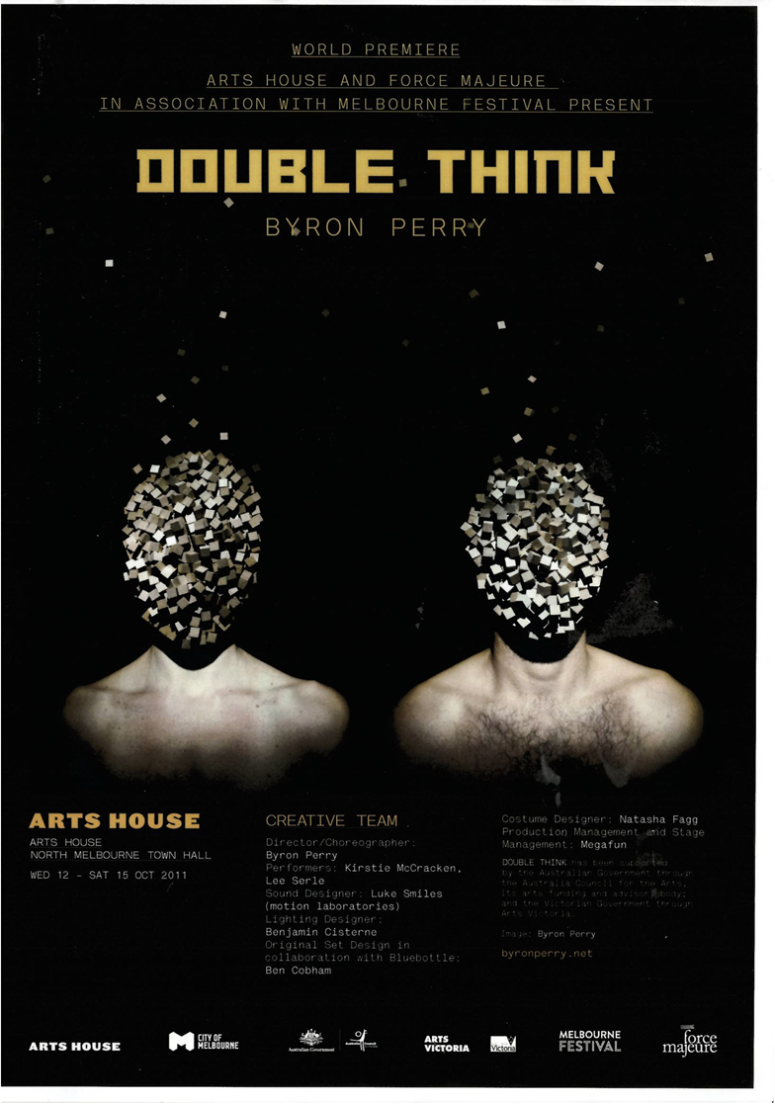
BYRON PERRY’S DOUBLE THINK
by Urszula Dawkins

Creating DOUBLE THINK, says Director/Choreographer Byron Perry, the aim was to fluctuate between localised sound and light shows, intricate and detailed choreography, playing with shadows, and improvising word games. At the same time, exploring a fairly abstract concept involiving not knowing what you really think” felt he says, "a little like sculpting a tiny clay figurine with a baseball mitt in a darkened room...”

Perry was driven to create DOUBLE THINK after reading an article called 'The Illusion of Opposites', he says, which proposed that the things we label as 'opposites' in fact tend to have more features in common than features that separate them. Perry remembered George Orwell's notion of 'double think' (in the novel 1984), and set out to explore "how it might exist in a performance environment".

"Double think is defined as the ability to believe two opposing or mutually exclusive ideas at the same time," Perry says, "drawing subconsciously on whichever one most benefits the individual in the moment."

"This led me to explore references to things like the Heisenberg uncertainty principal, which limits our observations of subatomic particles to either position or momentum, but never both at the same time.

The Orwellian 'double think' is generally seen as having strong negative connotations, but Perry was curious to explore the notion of unconsciously changing your beliefs based on who you might be talking to or what you might be looking for. "It also struck me as a subconscious act that each of us might well be doing in subtle ways every day.” he says.

"Opinions are normally considered so concrete, and I like the idea that it's quite possible we don't really know what we think or that we aren't as in-control-of-things as we might hope to be…

Perry confesses a fascination with allowing performers to be 'in control' of their own lighting and/or sound, so that the orchestration of those elements becomes "a kind of choreography in its own right".

"In order to develop this kind of work it is essential that you have these elements in the room with you as you are developing the material," he says. "Often a lighting idea will be the catalyst for a scene, and not simply a way to present it_ With this concept especially, the sound, light and set can really become as much a part of the investigation as the dance or text is. " In this way Perry's exploration of opposition and duality became grounded in the work itself, existing primarily in space and form rather than as an external idea. He talks about the way filmic impressions like the close-up, the point­ of-view shot or the zoom can be created through performer­ operated lighting, and says he enjoys circumventing the 'fade­ up' or 'fade-down' of traditional lighting by developing his own techniques.

Regarding the work's concept, Perry doesn't see it as 'Orwellian' in any sense.

“I am attempting to look at the performance itself through this lens of contrast, contradiction and opposition; the idea of the performance as the individual in the throes of double think I like the idea that this notion can be applied on as many levels as possible, to the structure and style of the work itself, to the scenes and the dance/text within it and also to the performers' understanding of what they are doing."

On the degree to which we all employ 'double think', Perry comments that it seems necessary to many of our interactions.

"I think every argument I have ever had involves being able to employ this process-and of course I still have trouble deciding between an Eskimo Pie and a Golden Gaytime - but I'm not sure that qualifies_• Explaining how DOUBLE THINK will unfold on the stage, he describes a work that oscillates between states - light and shadow, small and large, black and white - but he resists predicting the outcome.

"You know, you're making something and it involves a lot of work - but until the light is switched on, you're not sure exactly what it is_. The audience is that light and it will be interesting to see through their eyes the final form the piece takes.

Biographies

Byron Perry
Director/Choreographer

A graduate of the Victorian College of the Arts, Byron Perry has toured extensively, developing and performing roles with Douglas Wright, Leigh Warren, Chunky Move, Paul Selwyn Norton, Lucy Guerin Inc., BalletLab, DV8 Physical Theatre, Force Majeure, Antony Hamilton and Kate Denborough. In 2006 he received an Australian Dance Award for outstanding performance by a male dancer, and won Best Male Dancer at the Green Room Awards. He recently received the inaugural Harold Mitchell Fellowship for professional development in direction and choreography

Byron Perry's choreographic work includes Punctuated Equilibrium and The Hayflick Limit for Chunky Move, hest for the Victorian College of the Arts, Breaks of Asia for the Sydney Opera House Studio, A Volume Problem for Tasdance, and Goggle Box - for which he was nominated for a Green Room Award for best original choreography. Recently he was commissioned by Chunky Move to create I Like This for the Next Move program with co ­ director Antony Hamilton. He is currently developing a new work, One Show Only, for the Singapore­ based group, Frontier Danceland.

Kristie McCracken
Performer

Kirstie McCracken trained at the Victorian College of the Arts. She has toured nationally and internationally over the past 12 years, creating and performing works with Chunky Move (Flesh Meet, Body Ports, Live Acts, Singularity), Lucy Guerin Inc. (The Ends of Things, Melt, Plasticine Pork, On, Aether, Love Me, Structure and Sadness, Corridor), Force Majeure (Some, same but different, Already Elsewhere, The Sense of It, The Age I'm In), Tasdance (Hypermobile), Fiona Cameron (Looking for Life Cure), Byron Perry (Punctuated Equilibrium, Goggle Box) and Nicole Steven (Frome Chaser). She has also collaborated with Lisa Griffiths, choreographing and performing in two short works for the Sydney Opera House Studio; and has performed in various commercial projects. She is a multiple award nominee for the Green Room, Helpmann and Australian Dance Awards.

Lee Serle
Performer

Lee Serle completed a Bachelor of Dance at the Victorian College of the Arts in 2003. Since then he has collaborated with and performed the work of Lucy Guerin Inc., Chunky Move (Gideon Obarzanek), Shelley Lasica, Byron Perry, Antony Hamilton, Kota Yamasaki, Alisdair Macindoe and Neil Adams. In 2010/2011 He was selected by the Rolex Mentor and Protege Initiative to undertake a mentorship with Trisha Brown in New York, performing, touring and developing a new work with the Trisha Brown Dance Company. His choreographic credits include I Feel Love and On It Goes for Next Wave festival, A Little Murky for Lucy Guerin's Pieces for Small Spaces, Untitled (short film), and Tilted at the Red Bean Studios in New York. He is currently developing a solo work to be presented in November at the New York Public Library.

Luke Smiles
Composer

The introduction of a Commodore 64 computer into the family home in the early 1980s began Luke Smiles's fascination with computers and sound. Having had no formal musical training but instead yielding to a keen interest in how things work, he has developed a unique practice in the development of soundtracks for dance and theatre. His appreciation of cinema has inspired a diverse sound-making practice and led him to work in areas including sound design, Foley work, sound effects editing and music composition. He is renowned for producing detailed soundtracks with a focus on the complete sound experience; a pursuit rarely followed in live theatre and a quality that sees his work in great demand both nationally and internationally. Working under his business name, motion laboratories, Luke Smiles has composed and produced soundtracks for artists and companies including Australian Dance Theatre, Bare Bones Dance Company (UK), Chunky Move, Dancenorth, Gabrielle Nankivell, Nederlands Dans Theater, OX Co. (Belgium/Slovenia), Rambert Dance Company (UK), Splintergroup, Stompin, Tasdance, West Australian Ballet and Windmill Theatre Company.

Benjamin Cisterne
Lighting Designer

Benjamin Cisterne is renowned for creating bold designs, based in light, that are integral to a performance. He is passionate about the capability of light in performance design, and its role in art; and works collaboratively on projects across all art forms. Since completing his studies in 2002 at the WA Academy of Performing Arts he has been involved in the creation of lighting designs for exhibitions at the Australian. War Memorial and the National-Sports' Museum; for architecture, including the Darwin Entertainment Centre; and for performance projects including Tim Harbour's Halcyon for The Australian Ballet, Stephanie Lake's Mix Tope, and Gideon Obarzanek's Connected for Chunky Move. He has toured extensively as both designer and master electrician and has completed artistic and technical residencies in Australia and Europe. He has worked with choreographers including Gavin Webber (Dancenorth/independent), Phillip Adams (BalletLab), Luke George and Gabrielle Nankivell. His work has been recognised by the Green Room Awards on multiple occasions.

FORCE MAJEURE
Producer

Force Majeure produces award­ winning dance theatre works that reflect upon contemporary
life and explore the issues that affect us all. Established in 2002 and led by Artistic Director Kate Champion with Artistic Associates Geoff Cobham and Roz Hervey, Force Majeure is committed to supporting emerging artists that have worked closely with the company, and is thrilled to have produced DOUBLE THINK with Byron Perry.

Thank you and Acknowledgements

Thank you to Lucy Guerin Inc. for their support and assistance during the development of this work.

About Arts House

521 Queensberry Street North Melbourne VIC 3051 artshouse@melbourne.vic.gov.au
03 9322 3719

Arts House is a City of Melbourne contemporary arts initiative. Each year Arts House presents a curated program of contemporary art featuring performances, exhibitions, live art, installations and cultural events.

Arts House operates as a multi­ dimensional resource hub for artists: producing, programming, devising, supporting and funding. Work is presented across two sites: Arts House, North Melbourne Town Hall and Arts House, Meat Market.

Arts House values arts and culture that help create a world where people are actively engaged, aware and empowered to participate, politically and culturally, to make positive change.

