MALMÖ

TORQUE SHOW

ARTS HOUSE
NORTH MELBOURNE TOWN HALL
WED 13 – SUN 17 APRIL
“WE TURN TO WALLPAPER, BENCHES, PAINTINGS
AND STREETS TO STAUNCH THE DISAPPEARANCE OF OUR TRUE SELVES.”
Alain de Botton, The Architecture of Happiness

CREATORS NOTES

“Beauty is the promise of happiness”: Stendahl

At some point in our lives most of us will feel the urge to make our ‘home’, create our space, to etch our mark, to construct an expression of who we are or who we’d like to be seen as. To demolish, re-build, renovate, re-configure, re-design and
re-shape a small corner of the world we inhabit.
And in the process perhaps re-design,
re-shape, re-configure and re-invigorate ourselves.

Malmö examines that most quintessential of rites of passage for an Australian couple: Home renovation.

It’s a process that is fraught with pitfalls and uncertain outcomes and unpleasant surprises. And, inevitably, the collision between the ideal of a cr ystallized and perfect moment of self-expression
and the reality of compromise, negotiation, thwarted ambitions and unfulfilled dreams and desires.

Does the constant wear and tear of life together simply smooth off the rough edges or does it slowly erode the ver y ties that bind? Do we age together with nobility and grace or simply fall apart, tacky, broken, stained and torn?

Image: Justin Bernhaut

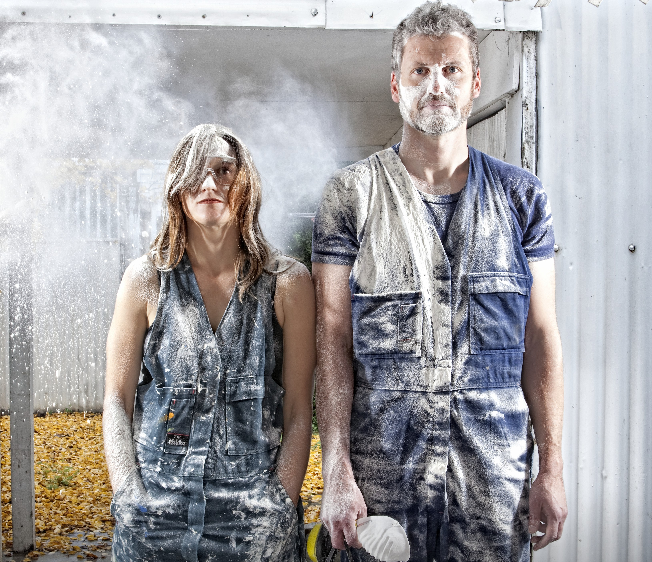

THE TEAM

Performers/Creators:
Vincent Crowley, Ingrid Weisfelt
Director/Creator: Ross Ganf
Set Design Concept: Geoff Cobham Sound Designer/Composer: Nick Roux Lighting Designer: Chris Petridis Lighting Design Mentor: Geoff Cobham Production Manager: Neil Jensen Movement Consultants:
Alejandro Rolandi, Fiona Cameron
Costume Designer: Noella Thomson

BIOGRAPHIES

Vincent Crowley, Ingrid Weisfelt and Ross Ganf are the founding members of Torque Show. They are a company committed to creating dramaturgically
focused dance theatre, physical theatre and contemporar y performance. Their work is an exciting departure from their professional engagements with Mer yl Tankard’s Australian Dance Theatre, Force Majeure, Splinter Group and TanzTheater Basel.

The company has two works in current development. The Dara Foundation climate change commission for the Malthouse Theatre and Tipping Point was awarded to Torque Show for their
work Riot in March 2011. Riot carries one ver y important purpose: to educate and re-ignite protest as a form of political expression for a contemporar y society. Riot will create a rehearsal for this
revolution and arm its participants with a contemporar y language through which to protest climate change.

Farrugia is a verbatim theatre piece
based on inter views with Joseph Farrugia a veteran of the adult entertainment industr y. Farrugia is supported by Vitalstatistix and will be created by actor Geoff Revell, dramaturge Rosyln Oades and theatre-maker Ross Ganf.

Vincent Crowley (Creator/Performer) Vincent has been a member of the ensembles of Mer yl Tankard’s Australian Dance Theatre (1993-97) and TanzTheater Basel (1998-2002) under the direction
of Joachim Schloemer. As a freelance performer he has worked with Theater Basel, Schauspielhaus Koeln, Salzburger Festspiel, Steirischer Herbst, Fischhouse Productions in San Francisco, the Adelaide Festival Centre Trust, Spike Jonze, Chunky Move, Ladykillers and Force Majeure. As
a co-founder of Splintergroup, Vincent created Lawn (Winner of 3 Green Room Awards and nominated for two Helpman Awards) and Underneath. In 2007 he created and directed Today in The Lumina Room for Schauspielhaus Koeln.

Ross Ganf (Creator/Director)
Ross Ganf is a director/dramaturge who’s maiden dance theatre work is Malmö. His verbatim work Farrugia, is currently in development, supported by Vitalstatistix and the Adelaide Festival. In March 2011
Ross was awarded the Dara Foundation
Climate Change Commission for work Riot.
His last theatre production was the Australian premiere of Red Light Winter by Adam Rapp Griffin Stablemates Sydney. Ross was an Associate Director with the Adelaide Festival Centre Inspace program, directing his mainstage debut A Thing Called Snake by Stephen House. Ross will collaborate in Force Majeure’s dance theatre laborator y Cultivate (2011) and with Geoff Cobham and Sophie Brous on the Adelaide Festival Club (2012).

Ingrid Weisfelt (Creator/Performer)
Ingrid Weisfelt was a company member of
2 Dance Plus (1992-93), Mer yl Tankard’s
Australian Dance Theatre (1994-97) and of TanzTheater Basel (1998-2002). As a freelance artist (2002-10) Ingrid
has performed with Kim Walker, Vincent Crowley, Joachim Schloemer, Vienna International Arts Festival, ChamberMade Opera, Kage Physical Theatre, Not Yet It’s Difficult, Chunky Move and Force Majeure. Professional credits include: Movement Trainer – Massacre - Vienna International Festival (2002); Movement Director – Crestfall, Red Stitch Actors Theatre (2005); Choreographic Assistant/Movement Trainer - Today in The Lumina Room, Schauspielhaus Koeln (2007); Assistant Director/Choreographer - The Coronation Of Poppea (2008); Choreographer - Don Giovanne (2009) and Associate Director/ Choreographer - Ariadne Auf Naxos for the Victorian Opera.

Alejandro Rolandi (Movement Consultant) Alejandro Rolandi has practiced Contact Improvisation for the last 14 years and
has been teaching in Sydney since 2002. Alejandro has worked with: Legs on
the Wall, Shaun Parker, Stalker, Force Majeure, Zen Zen Zo, ACPE and the dance department of UNSW. He is also the Artistic Director of Strings Attached.

Fiona Cameron (Movement Consultant) Fiona Cameron is a choreographer, dancer, teacher and filmmaker. A member of Chunky Move for nine years, she also performed with Compagnie Alias, Sydney Theatre Company, Garr y Stewart, Lucy Guerin Inc, David Pledger, Prue Lang,
Kage Physical Theatre and Force Majeure.

Nick Roux (Sound Designer/Composer) Nick makes work for sound and vision, creating sound for film and performance and video for live performance and
the screen. He has worked and toured extensively with Chunky Move operating and engineering the Kalypso motion tracking system for Glow and Mortal Engine and is in development with Global Creature’s new musical King Kong. Nick has also worked with Luke George, Robin Fox, Dario Vacirca and Jo Lloyd and will soon release material from his long time project Yaouk.

Geoff Cobham (Set Design Concept & Lighting Design Mentor)
After 3 years training to be a performer, Geoff discovered he was far better at lighting dance than he was at doing it. Although he has lit all forms of theatre the majority of his lighting over the past 25 years has been in dance. In the last 5 years he has designed many sets as well. Geoff
is Artistic Associate for Force Majeure and Production Manager for the Adelaide Festival.

Chris Petridis (Lighting Designer)
Chris Petridis is a recent graduate of the Adelaide Centre of the Arts’ Technical Production course. He has toured with Australian Dance Theatre’s Be Yourself European Tour as Head of Lighting and recently worked on When The Rain Stops Falling by Brink Productions as Touring Lighting Designer.

Noella Thomson (Costume Designer) Noella is a Melbourne based costume maker, pattern maker and designer.
She is currently working on a number of freelance designs and costume projects and as a dressmaker for June Designs,
the official costume designers for Channel Seven’s Dancing With the Stars. Previous costuming highlights include works for Sarah Blasko, Megan Washington and Patience Hodgson.

Neil Jensen (Production Management) Over the past 15 years Neil has worked primarily in the independent dance scene. Throughout the last 7 years, Neil has Production and Tour Managed for Stalker Theatre Company on their RED
and Stiltbreak shows, touring almost ever y continent and over 15 countries. He was recently Production Manager on Shaun Parker’s This show is About People, Malmö and Kelly Alexander’s Falling for Frank.

ARTS HOUSE
521 Queensberry Street North Melbourne VIC 3051 w w w.artshouse.com.au
artshouse@melbourne.vic.gov.au
Tel: 03 9322 3719

Arts House is a City of Melbourne contemporary arts initiative. Each year Arts House presents a curated program of contemporary art featuring performances, exhibitions, live art, installations and cultural events.

Arts House operates as a multi- dimensional resource hub for artists: producing, programming, devising, supporting and funding. Work is presented across two sites: Arts House, North Melbourne Town Hall and Arts House,
Meat Market.

Arts House values arts and culture that help create a world where people are actively engaged, aware and empowered to participate, politically and culturally,
to make positive change.

