Arts House Program Guide
Season 1, 2009
March - May

LOOK OUT

Simultaneously a warning and an instruction, Look Out turns our collective gaze outwards,beyond local boundaries of artform, geography,politics and culture to connect adventurous local audiences to prevailing global cultural meltdown. in 'looking out' we must inevitably examine the ground on which we currently stand, the values and beliefs that inform our gaze and colour what we see.

The artists presented here assist to navigate this territory and question our understanding.

The March to May Arts House program is drawn from fearless artists living in Australia and overseas but all working in the context of an international cultural landscape. An extraordinary array of diverse works - works where the boundaries between between high, low, fringe,mainstream art and popular culture are irretrievably blurred and increasing irrelevant.

In 2009 Arts House continues its commitment to boldly nurturing the development of new arts practices, works and audiences and to engaging with challenging contemporary arts practices and provocative ideas.

2009 also sees the arrival of the first Dance Massive.

This collection of work is a visually spectacular series of sensory and physical experiences that range in style and scope, from energetic and playful to the contemplative and intimate. enjoy this first edition of Dance Massive.

Steven Richardson
Artistic Director, Arts House

3 - 15 March Inert
5 - 7 March No Success Like Failure - The Fondue Set
5 - 8 March roadkill - Splintergroup
8 March 180 Seconds in (Disco) Heaven or Hell
10 - 15 March Morphia Series – Helen Herbertson and Ben Cobham
11 - 14 March Untrained – Lucy Guerin Inc
18 – 22 March Floating – Hoipolloi Theatre
24 - 29 March Night Garden – My Darling Patricia
3 and 4 April Three Landscapes – John Surman and Genevieve Lacey
15 - 19 April Controlled Falling Project - ThisSideUp
13 - 16 May Teuila Postcards - Polytoxic
Inert



‘…an intimate, intricately made work’
- The Australian

Presented by Arts House for Dance Massive

Two performers.
Two viewers.
Love in two parts.

How close is too close?

Inert is a performance experiemce that delves into the psychology of love and loss when one is heard and not seen-or-not-by an intimate other. Small in scale, yet broad in its sensory scope, Inert offers a boutique performance experience immersing its audience in a subtle and moving world.

Choreography and Performers: Simon Ellis, Shannon Bott
Sound Design: David Corbet
Environment: Scott Mitchell
Video: Cormac Lally

Inert was first developed with the support of Arts Victoria, Dancehouse and the University of Northhampton.
Arts House, North Melbourne Town Hall3
521 Queensberry Street
North Melbourne

Tuesday 3 – Sunday 15 March
Tuesday 10 – Friday 13
6pm, 6.30pm, 7pm, 8pm, 8.30pm, 9pm
Saturday 7 and Saturday 14
4pm, 4.30pm, 5pm, 6pm, 6.30pm, 7pm
Sunday 8 and Sunday 15
4pm, 4.30pm, 5pm, 5.30pm
20 minutes, no interval

Tickets: $22.50

Bookings: dancemassive.com.au or 03 9639 0096

Warning: Audiences will be moved
Image: Natalie Cursio

The Fondue Set
No Success Like Failure

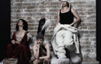

‘Failure never looked so good, so silly, so successful…and so intelligent as The Fondue Set achieve a new level of wit in a bizarrely coherent show that is as carefully paced as it is manic….‘
- RealTime

Presented by Arts House for Dance Massive

Part talent quest, part educational form and part cabaret, No Success Like Failure is an hilarious ‘how-to’ show that expertly leads dance in to new and playful territory.

With the help of UK director and performer Wendy Houstoun (Desert Island Dances and Happy Hour, Melbourne Festival,2008), The Fondue Set embark on a post, post-modern exploration of loss, emptiness, giving up, giving in and letting go.

At times both hilarious and poignant No Success Like Failure returns for a strictly limited Melbourne season.

Creators and Performers: Emma Saunders, Elizabeth Ryan, Jane Mckernan
Director: Wendy Houstoun
Collaborating Director: Julie-Anne Long
Lighting Design and Production Manager: Neil Simpson
Collaborating Designer: Agatha Goethe-Snape
Producer: Rosalind Richards, Artful Management

No Success Like Failure has been assisted by the Australian Government through the Australia Council, its arts funding and advisory body and by Arts NSW.
Arts House, North Melbourne Town Hall
521 Queensberry Street
North Melbourne

Thursday 5 – Saturday 7 March
7.30pm
70 minutes, no interval

Tickets: Full $25 Conc $18

Bookings: dancemassive.com.au or 03 9639 0096

Warning: Smoke effects

Image: Iren Skaarnes

Splintergroup
Roadkill

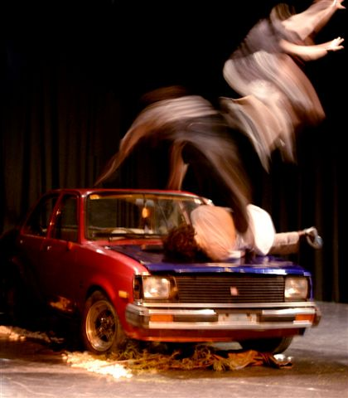

‘Fuelled by a collective creatively and inventive stagecraft, it is dark, primitive and very exciting.’
- Daily Express

Presented by Arts House and Mobile States for Dance Massive
A couple is stranded in the middle of nowhere with a car that won’t start next to a phone box doesn’t work. This is a road trip onto the agoraphobia and desolation of the Australian outback: a place of dreams and dust and ghosts. A land where backpackers disappear and tragedy strikes the vulnerable.

Roadkill is stunning, edge of your seat dance theatre: highly physical, and ultimately intensely unnerving.

Roadkill is toured by Performing Lines for Mobile States: Touring Contemporary Performance Australia with the assistance of the Australian Government through the Australia Council, its arts funding and advisory body.

Choreography: Splintergroup
Performers: Gavin Webber, Grayson Millwood, Sarah-Jane Howard
Dramaturgy: Andrew Ross
Sound Designer: Luke Smiles
Lightning Design: Mark Howett
Rehearsal Director: Michelle Ryan
Arts House, Meat Market
Thursday 5 – Sunday 8 March
Thursday 5 - Saturday 8
7.30pm
Sunday
6pm
Post show artist talk, Friday 6 March
75 minutes, no interval

Full $25 / Conc $18
Bookings: dancemassive.com.au or 03 9639 0096

Warning: Cigarette smoke, smoke effects

Image: Tim Page

180 Seconds in (Disco) Heaven or Hell



Presented by Arts House for Dance Massive
Infusing a little ‘Night Fever’ into Dance Massive, 180 Seconds in (Disco) Heaven or Hell presents a night of choreographic speed-dating meets po-mo disco.

Hosted by the glamorous and calamitous, The Fondue Set, 180 Seconds in (Disco) Heaven or Hell puts the TEMPO back in to contemporary dance with three-minute showcases of solid gold. In six arranged marriages, a handful of red-hot local choreographers add their signature groove to the likes of ballroom, breaking and bhangra.

It’s the bomb, it’s time limited, it’s disco, it’s crazy - 180 Seconds of SOLID GOLD.

Guest Artists: The Fondue Set: Emma Saunders, Elizabeth Ryan, Jane McKernan, Panther, WickidForce Breakers, Byron Perry, Kelly Ryall Moss Design and many more.

Arts House, Meat Market

Sunday 8 March
730pm – till with intervals

Tickets : $10

Bookings: dancemassive.com.au or 03 9639 0096

Warning: Strobe lightning, smoke effects, possible nudity, over 18 only

Image: Bryon Perry

Helen Herbertson and Ben Cobham
Morphia Series

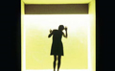

Presented by Arts House for Dance Massive
Described as one of the quietest smallest dance pieces ever seen, yet one of the bravest and most compelling.

Another remarkable work from the award-winning creative partnership behind Sunstruck (Melbourne Festival 2008).This intimate boutique performance transports the audience through a series of sensory experiences. Inspired by Morpheus, the Greek god of dreams, the piece is a vivid encounter with image, sound, text and movement, which will surprise and enchant.

The highly acclaimed Morphia Series has been performed for Melbourne and Adelaide audiences, and internationally: in Dublin, Glasgow, Zurich, Singapore and Portland

Artists: Helen and Ben Cobham

Morphia Series has been assisted by the Australian Government through the Australia Council, its arts funding and advisory body.

Arts House, North Melbourne Town Hall

Tuesday 10 – Sunday 15 March
Tuesday 10 – Saturday 14
7.30pm, 8.15pm, 9pm
Sunday 15
5.30pm, 6.15pm, 7pm

18 minutes, no interval

Tickets: $22.50

Bookings: dancemassive.com.au or 03 9639 0096

Warning: Adult themes

Image: Rachelle Roberts

Lucy Guerin Inc
Untrained

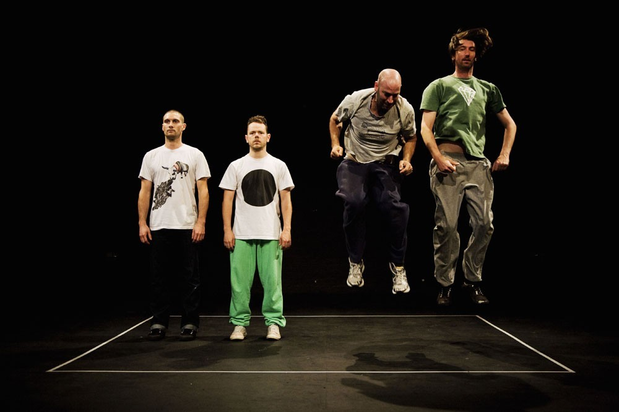

Presented by Arts House for Dance Massive with Lucy Guerin Inc
A new work by Lucy Guerin Inc which questions our ideas about what is worth watching in a performance. This casual theatrical exploration presents four men in a humorous and courageous examination of themselves and their art.

Two of these men are highly skilled, experienced dancers and two are acclaimed visual artists with no movement training whatsoever. The complex, refined movements that one man can do with ease, another can only approximate. But there are things that an untrained body can do that a trained one can’t.

All performers are given the same instructions. How they execute them constructs an individual portrait of each man and also an unavoidable comparison between them. This evolution of information, built up through units of action, points out what they have in common and where their physical histories set them apart.

Concept and Direction: Lucy Guerin
Outside eyes provided by: Ross Coulter, Antony Hamilton, Simon Obarzanek, Bryon Perry.
Producer: Michaela Coventry

Lucy Guerin Inc is supported by the Australian Government through the Australia Council, its arts funding and advisory body. Untrained was developed in the CultureLAB.

Arts House, Meat Market

Wed 11 - Sat 14 March
Wednesday 11 and Thursday 12
7.30pm
Friday 13
6.30pm and 9.30pm
Saturday 14
4pm and 7.30pm

Post show artist talk, Thu 12 March

60 minutes, no interval

Full $25 / Conc $18

Bookings: dancemassive.com.au or 03 9639 0096

Image: Untrained artists

Hoipolloi in association with Hugh Hughes Productions
Floating

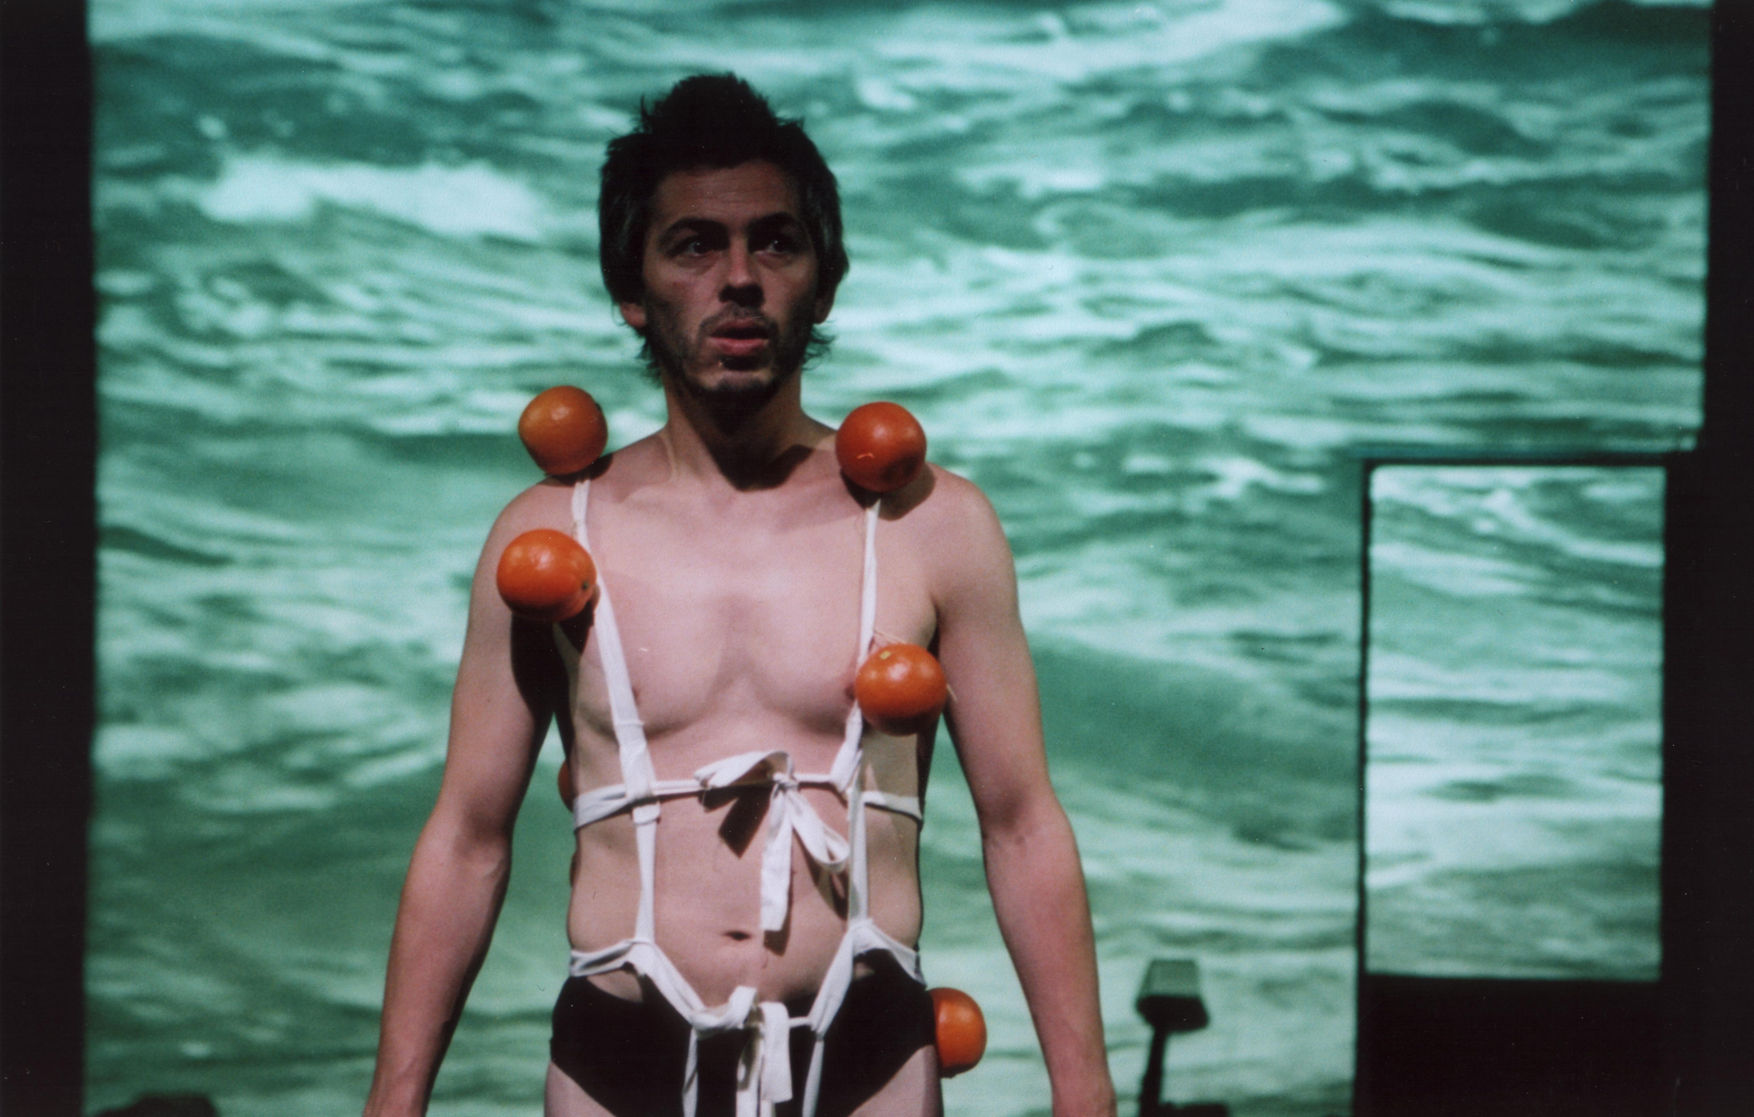

‘Mesmerising an extraordinary sight, hilarious yet touching in the human fragility it conveys.’
- The Guardian

1 April 1982. The Isle of Anglesey is hit by an earthquake, the Menai Bridge collapses and the island is torn from the mainland of Wales and swept into the terrible storms of the north Atlantic. Trapped on board is Hugh Hughes, desperate to escape and discover life outside his small island.

Internationally acclaimed theatre company Hoipolloi are proud to welcome you to the wonderful world of Hugh Hughes. Hugh and his collaborative partner Sioned Rowlands colourfully reconstruct the island’s journey across the Atlantic, up to the Arctic and beyond.

Floating is a comic and beautiful tale of the island that floated away.

Created and Performed by: Hugh Hughes, Sioned Rowlands
Artistic Associates: Alex Byrne, Shôn Dale- Jones, Stefanie Müller, Guy Myhill, Jill Norman.

Floating has been supported by the British Council and is presented by Arts House in association with Ten Days on the Island and Sydney Opera House.
Arts House, North Melbourne Town Hall

Wednesday 18 - Sunday 22 March
7.30pm

Full $25 / Conc $18

Bookings: artshouse.com.au or 03 9639 0096

Image: John Baucher

My Darling Patricia
Night Garden

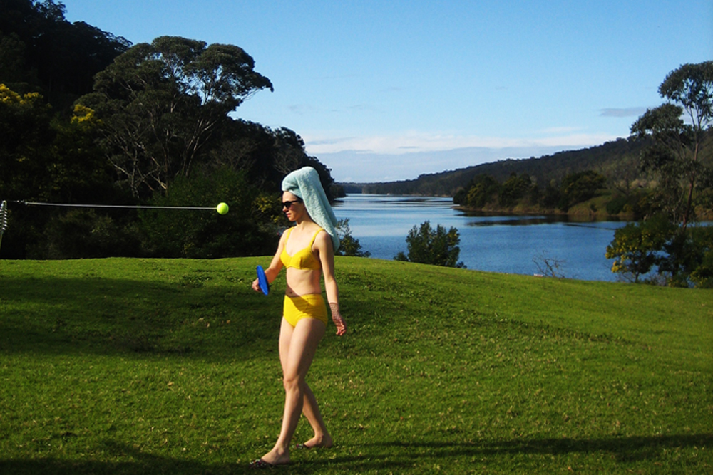

Ironic, eccentric and at times quietly devastating, they set a fresh breeze blowing through the Melbourne performance scene.‘
- Tony Reck, RealTime

Presented by My Darling Patricia in association with Arts House and Performance Space
Acclaimed ensemble My Darling Patricia’s new show Night Garden traces the destruction and reparation of a woman and her son in an Australian backyard. Using puppetry, film, sculpture and performance this dark suburban tale builds on their award winning work Politely Savage.

Outstanding Production & Best Design
Melbourne Fringe Festival 2006
Best Independent Production
Sydney Theatre Critics Award 2007
Best Theatre Act
Adelaide Fringe Festival 2007

Artists: Clare Britton, Halcyon Macleod, Katrina Gill, Bridget Dolan, Sam Routledge, Margaret Cameron, Declan Kelly, Chris Ryan, Sam James, Bryony Anderson, Tim McGaw, Neil Simpson, Nick Pledge, Wandjina.
Producer and Manager: Marguerite Pepper

Night Garden has been assisted by the Australian Government through the Australia Council, its arts funding and advisory body, and by Arts NSW and Arts Victoria.
Arts House, Meat Market

Tuesday 24 - Sunday 29 March
Tuesday 24 (Prev) - Friday 27, 7.30pm
Saturday 28, 5pm and 7.30pm
Sunday 29, 6pm
70 minutes no interval

Tickets: $20

Bookings: artshouse.com.au or 03 9639 0096

Warning: Smoke effects, some coarse language

Image: Clare Britton

John Surman and Genevieve Lacey
Three Landscapes

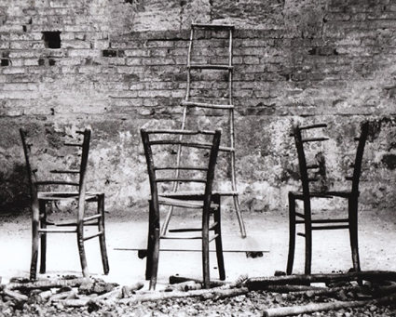

‘John Surman is perhaps the most gifted British jazzman of this generation‘
- The Times

Presented by Serious in association with Arts House

Three Landscapes is a new musical commission that brings together cult British jazz saxophonist and composer John Surman with Australian recorder virtuoso Genevieve Lacey and UK bassist Chris Laurence.
An architect of the European improvising scene and ECM stalwart, John Surman has recorded prolifically for the label since the 1970s, collaborating with artists including Jack DeJohnette, Gil Evans, Bill Frisell and now award-winning contemporary musician Genevieve Lacey.

The enduring pleasure of Surman’s art is the contrast of simple, haunting melody, lush orchestral textures and intense improvisation.

Friday Program - Part One with Andrea Keller on piano
Various works for saxophone, double bass and piano

Saturday Program - Part One
In the Distance for solo recorder 5 Pieces for saxophone, double bass and string quartet

Friday and Saturday Programs - Part Two
An Illusive Shadow for saxophone, double bass and string orchestra Three Landscapes for recorder, saxophone, double bass and string orchestra

Saxophones and Composition: John Surman
Recorders: Genevieve Lacey
Double Bass: Chris Laurence
Piano (Friday only): Andrea Keller
Conductor: Marco van Pagee
Strings: VCA Music String Ensemble

Arts House, North Melbourne Town Hall

Program One
Friday 3 April
7.30pm

Program Two
Saturday 4 April
7.30pm

120 minutes with interval

Full $25 / Conc $18

Bookings: artshouse.com.au or 03 9639 0096

Image: Elizabeth O’Donnell

ThisSideUp acrobatics
Controlled Falling Project

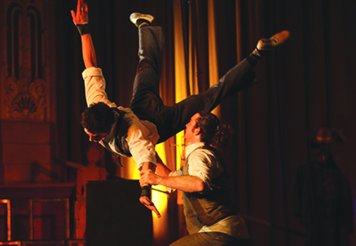

Resembling a classic silent adventure film, the latest work from ThisSideUp proves that actions speak louder than words with a physically compelling narrative in Controlled Falling Project.

Controlled Falling Project is a thrilling creative and physical experiment, flaunting the agility and ability of acrobats James Brown, Christian Schooneveldt- Reid and Casey Douglas with drummer David Joseph.

With live percussion accompaniment ThisSideUp strike a seamless balance between impulsive energy and systemically planned action, combining physical theatre and dance with a sophisticated and contemporary approach to traditional circus disciples.

Created and Performed by ThisSideUp acrobatics: Christian Schooneveldt-Reid, Casey
Douglas, James Brown
Musical Director/Drummer: David Joseph
Circus Director: Robin Laurie
Production Coordinator: Aneke McCulloch

Arts House, North Melbourne Town Hall
Wednesday 15 - Sunday 19 April
Wednesday 15 – Friday 17
7.30pm
Saturday 18
2pm and 7.30pm
Sunday 19
6pm
65 minutes, no interval

Full $25 / Conc $18

Bookings: artshouse.com.au or 03 9639 0096

Warning: Strobe lighting, smoke effects

Image: Michael Whiteman

Polytoxic
Teuila Postcards

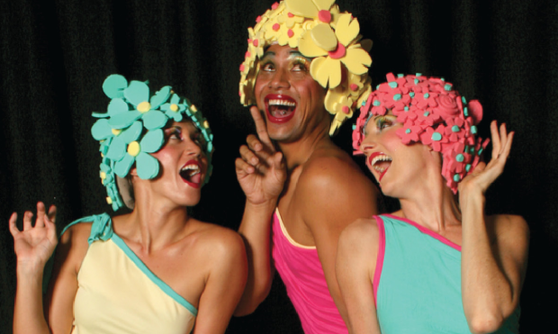

‘Teuila Postcards beautifully seams the kitsch with the intellectual, the erotic/exotic fantasy with the real and mundane colonial history with retro pop.‘
Scene Magazine

Presented by Arts House and Kultour with support from Footscray Community Arts Centre

Three tourists journey to a fantasy island expecting an exotic, blissful and dreamlike holiday.

Behind the glossy tourist brochure façade Polytoxic unveil the cultural reality of Polynesia with an episodic ride of postcard-like vignettes through past and present.

In a captivating fusion of traditional Polynesian and contemporary dance theatre. Teuila Postcards is a playful look at the oppression and evolution of an island. Amplified colours and glamourous costumes frame a seemingly simple yet clever and creatively inspired performance.

This tour is supported by Kultour – a proud initiative of the Australian Council, its arts funding and advisory body, and through Playing Australia, the national performing arts tiring program.

Artists and Creators: Efeso Fa’anana, Leah Shelton, Lisa Fa’alafi
Costume Design and Construction: Leah Shelton, Lisa Fa’alafi
Lighting Design: Andrew Meadows
Sound: Efeso Fa’anana, Leah Shelton
Visuals: Jaxzyn
Stage Manager: Justin Marshman
Set Design: Lisa Fa’alafi with Polytoxic
Set Consultant: Jonathan Oxlade
Set Construction: Troy Gilliland

Arts House, North Melbourne Town Hall
Wednesday 13 – Saturday 16 May
7.30pm
60 minutes, no interval
Full $25 / Conc $18

Bookings: artshouse.com.au or 03 9639 0096

Image: Dallas Blackmore

Australia is home to the oldest living culture on earth. Respect and engagement with this ancient culture and its contemporary lineage continues to make a unique contribution to creativity in this place and inspire our collective consciousness and understanding. Arts House acknowledges and respects the customs and traditions of Indigenous Australians and their special relationship with the land. The artists and organisers respectfully acknowledge that this program takes place on the land of the traditional owners of the Kulin Nation.

Arts House develops, produces and presents dynamic cultural experiences, which enable people to make meaningful connections on a local, national and international level.

Presented across two sites, Arts House, North Melbourne Town Hall and Arts House, Meat Market, the Arts House program values arts and culture that can help create a world where people are actively engaged, aware and willing to participate, politically and culturally, to make change.

Each year Arts House presents a curated program of contemporary art featuring performances, exhibitions, live art, installations and cultural events.

Arts House has made every effort to offer wheelchair and limited mobility access throughout the program. Please contact Arts House on 9322 3720 for further information.

Arts House is a City Of Melbourne contemporary arts initiative.

Arts House Reference Panel
Rinske Ginsberg - Chair
Sue McCauley
Siu Chan
Robin Laurie
Samantha Comte
Martin Brennan
Christabel Harvey - Arts Victoria representative for CultureLAB
Stuart Koop - Arts Victoria representative for CultureLAB

International Advisors
Helen Cole - Arnolfini, Bristol UK
Gyorgy Szabo - House of Contemporary Art, Budapest Hungary

Arts House People
Sue Beal - Team Leader
Steven Richardson - Artistic Director
Kate Ben-Tovim - Associate Producer
Jude Gun - Program Producer
Kara Ward - Associate Producer
Sarah Ernst - Artistic Administrator
Deanna Smart - Project Producer
Eleni Arbus – Creative Spaces Project Coordinator
Brian Horder - Business Coordinator
Adrian Aderhold - Venues Manager
Tom Howie - Technical Production Manager
Mike Mullins –Venue and Operations Manager
Lexie Wood - FOH and Technical Coordinator
Genine Romagnoli - Administrator
Jim Stenson - Technical & Maintenance Officer
Angela Calderwood - Bookings Officer

This program was printed on 100% recycled paper.

