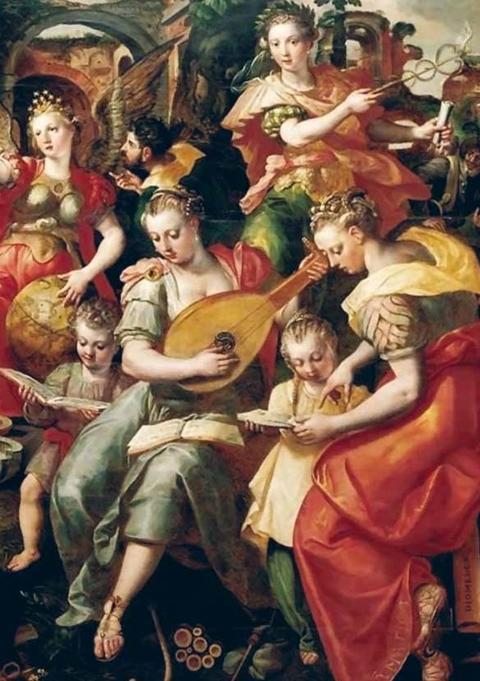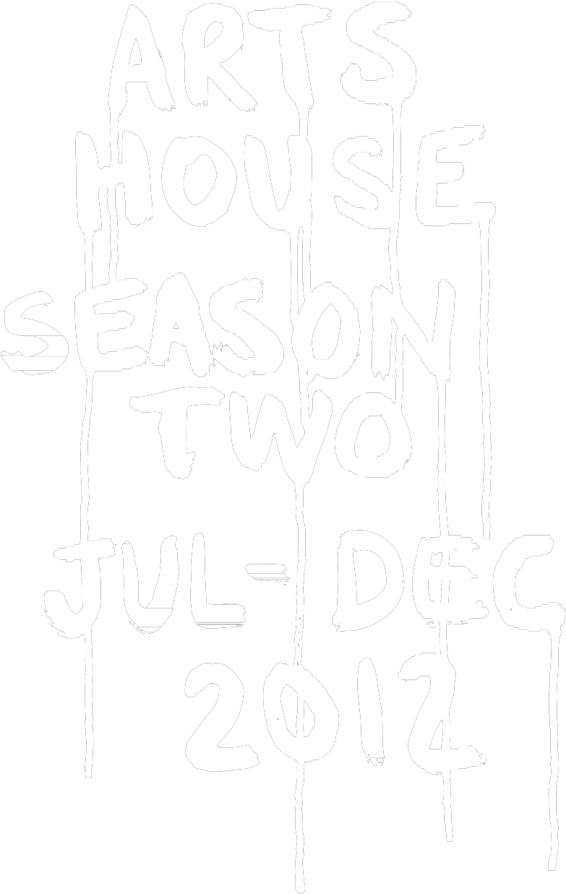

a r ts h o u s e . co m . a u

Subscribe to our E-News for updates:

artshouse.com.au

Jul – Dec 2012

Contents

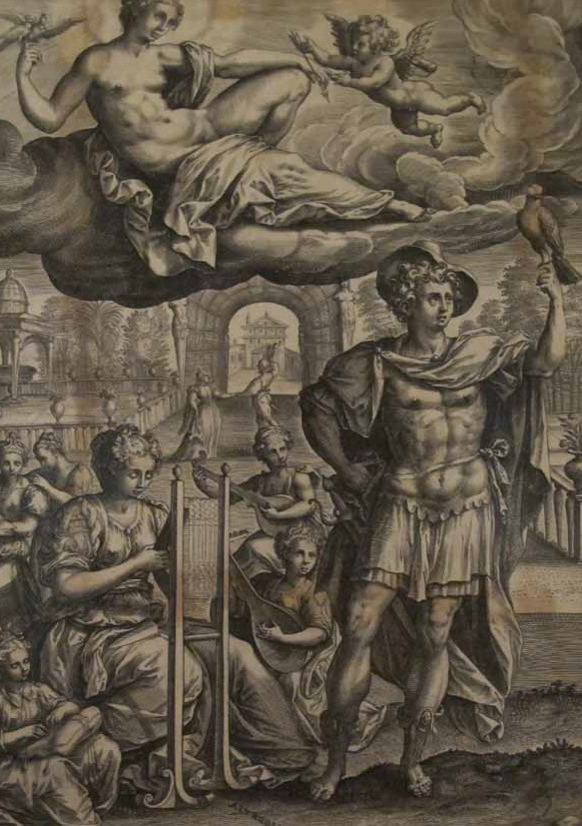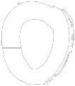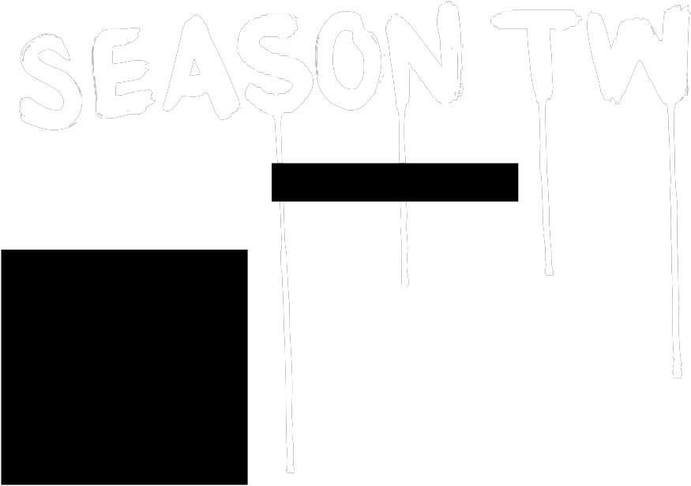

Welcome to Season Two – bursting with ideas, provocations and urgent calls to action; with playful seductions, intimate explorations

and an invitation to bring your questions to the gathering.

The performance companies, festivals and one-on-one experiences that make up Season Two all offer ways for you to complete their picture. Be part of the filmmaking of Back to Back’s Democratic Set or join in the forums at their re-presentation of morality-theatre text Hell House; contribute lyrics for Rose Ertler’s songwriting musicians as part of the Other Film Festival, or become a weather-maker in Madeleine Flynn and Tim Humphrey’s

Gauge. Witness the intimacies between Malcolm Whittaker and his girlfriend in Star******s and be

spellbound by Zoe Scoglio’s new

cosmology. Step literally inside

the installation experiences of Jeff Stein’s Impasse and David Cross’s Hold – they’re designed for you and only you.

Many of our international artists come from our own region – in particular East Timor (Black Lung collaborators Galaxy and Liurai Fo’er) and New Zealand (David Cross). For Going Nowhere, a multi-focal event that celebrates international exchange without anyone getting on plane, our

artist contributions come all the way from Europe, re-presented and responded to by some of Melbourne’s most adventurous performance makers.

Our Warehouse Salons take the shape of a forum and workshops led by UK writer Theron Schmidt – a chance to discuss and practise how we write about art and performance as it evolves before our very eyes.

Behind the scenes, our CultureLABs continue to give thrilling indications of

what’s bubbling in our artists’ imaginations: writer/dramaturge Maryanne Lynch collaborates with Rawcus’s Kate Sulan; Rhian

Hinkley and Chris Brown continue their development of *Human*;

and choreographer/dancer Luke George investigates in his unique way what it means to be really

‘with’ the audience.

Thanks again to our Arts Advisory

Panel for expert advice, to our new collaborators the Other Film Festival, our friends at Melbourne Festival, and the many other funders, producers, artists, families and friends that make the creation of all this work possible.

And thanks especially to you –

for your curiosity, your capacity and your enthusiasm for taking risks.

Angharad Wynne-Jones

Creative Producer, Arts House

2 – 3

Jon Rose, Atticus & Guests Metapraxis

19 – 21 JUL

4 – 5

Zoe Scoglio

Shifting Ground

19 – 22 JUL

6 – 7

Back to Back

Theatre

Hell House - Provocation,

Belief & Morality

3 – 5 AUG

8 – 9

Back to Back

Theatre

The Democratic Set

7 – 9 AUG

10 – 11

Black Lung

DOKU RAI

(you, dead man, I don’t

believe you)

29 AUG – 2 SEP

12 – 13

RRAMP

the Collector, the Archivist

& the Electrocrat

5 – 8 SEP

14 - 15

Laura Caesar & Malcolm Whittaker Star******s

6 – 8 SEP

16 – 17

The Other

Film Festival

& The Thoughtful

Song Society

19 – 23 SEP

18 – 19

Denis Beaubois, William McClure & Jeff Stein

Impasse

19 – 28 OCT

20 – 21

David Cross

Hold

19 – 28 OCT

22 – 23

Madeleine Flynn & Tim Humphrey Gauge

15 – 21 NOV

24 – 25

The Resonance

Project

21 JUL & 4 – 12 AUG

26 – 27

Going Nowhere

23 – 25 NOV

28 – 29

CultureLAB

30 – 31

Arts House

Supported by

32

Bookings

2 3

Arts House & Atticus present

“The function of music is to create soul, by creating conditions for myth, the root of all soul. Where there is no soul, music creates it.

Where there is soul, music sustains it.”

Jani Christou, 1968

Jon Rose, Atticus

& Guests

ARTS HOuSe,

NORTH MeLBOuRNe TOWN HALL

THu 19 – SAT 21 JuLy

7.30pm

DuRATION: 90 minutes

SuPPORT ACTS:

19 JuLy: James Rushford/Joe Talia

20 JuLy: Jon Rose, Palimpolin

21 JuLy: Anita Hustas/Andrea

Keeble

TICKeTS: Full $20 / Conc $15

BOOKINGS:

artshouse.com.au or 03 9322 3713

Warnings: Suitable for audiences over

the age of 10. Audience will be required to turn off all electronic devises that use Bluetooth as this will interfere with electronics and recording.

Image: Siobhan Fearon

A rare and exciting array of new-music talent takes to the stage for Metapraxis, presenting 20th- and 21st- century string compositions.

Iconic composer, violinist and innovator Jon Rose joins adventurous local string quartet Atticus and an eclectic range of guests for the Australian premiere of Greek composer Jani Christou’s rarely-performed 1966 masterpiece, *Praxis for 12* – a large-scale theatrical exploration of the tension between the expected and unexpected, the logical and illogical, played out through duelling strings.

Atticus also immerses you in the subtle sonic world of Anthony Pateras’s *Crystalline* and the explosive subversion of traditional string timbres via bass amps in Cat Hope’s *Cruel and Usual*; and the prolific and

treasured Jon Rose directs a new version of his *Strings and Fences II for amplified string octet and video*. Each night also features forays into improvisation from special support acts.

Jani Christou described a ‘metapraxis’ as an action that goes against the implied logic of an art form – a destabilisation, an implosive gesture, a push against the norms. Metapraxis is a bold venture into this experience.

Metapraxis

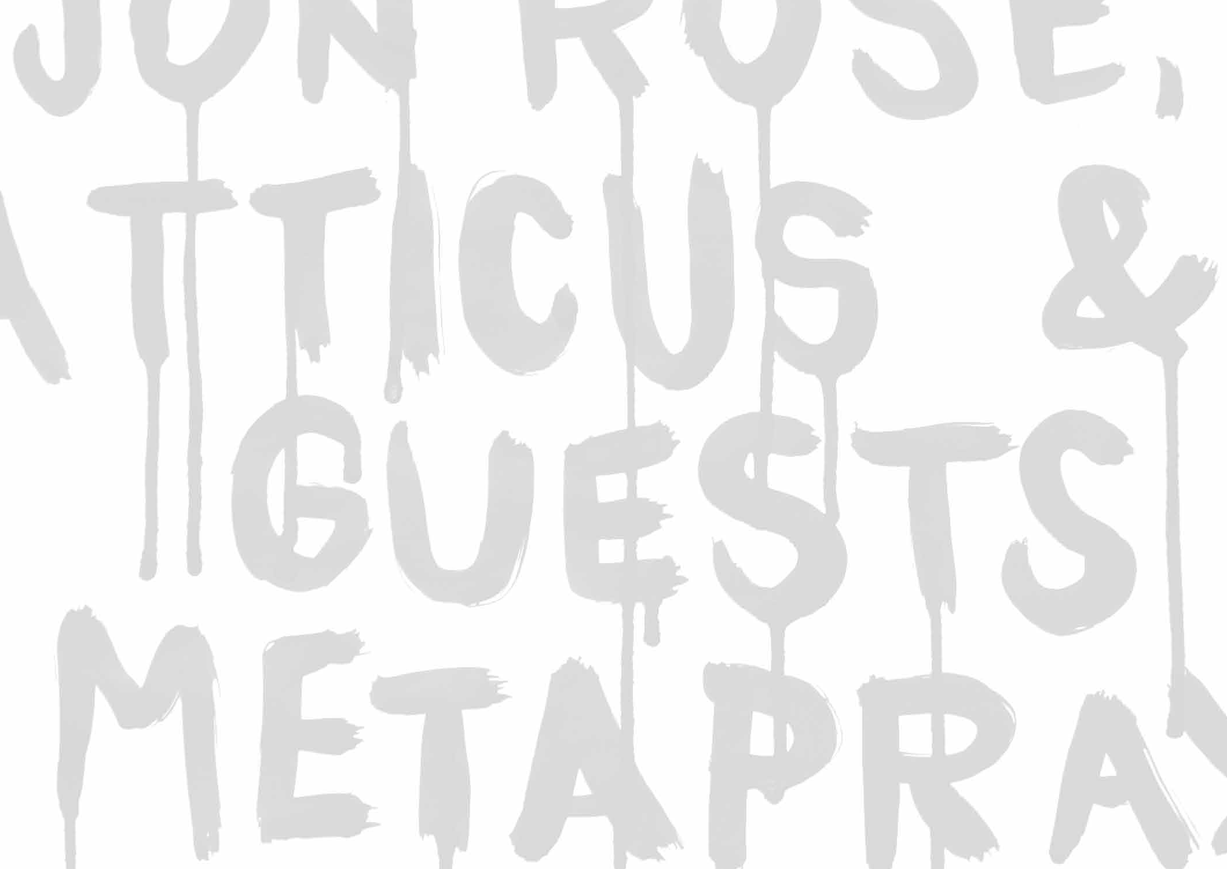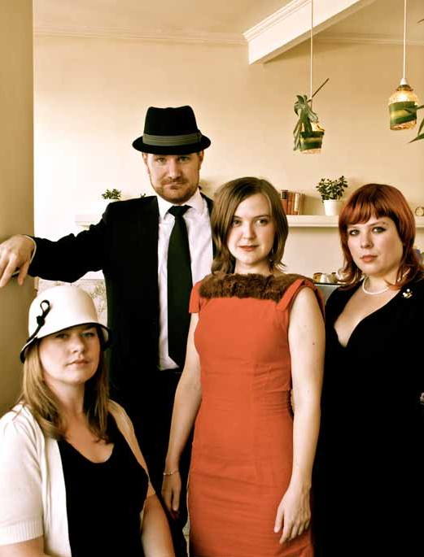

Artists: Jon Rose, Biddy Connor, Phoebe Green, Judith Hamann, Anita Hustas, Charlotte Jacke, Zac Johnston, Andrea Keeble, Kevin CK Lo, Leigh Raymond, James Rushford, Joe Talia, Lizzy Welsh

4 5

Arts House presents

World Premiere

“Most arcane is the relational world created by

Zoe Scoglio and Cait Foran…suggesting unseen energies brought to light…

the work is both playful and finely wrought”

*RealTime* (on Zoe Scoglio and Cait Foran’s *Inter-radiessence*)

Zoe Scoglio

Shifting Ground

Water to steam, lava to rock, fossil to fuel – Shifting Ground is a performance and installation that draws parallels between geological transformations and those found within the human race. Media artist and performer Zoe Scoglio unites gestural choreography,

object manipulation, physicalised sounds and projection mapping in a journey from the cosmic to the concrete.

The Meat Market’s Studio B becomes the site in which the boundaries between human and rock melt away,

as the presence of the earth’s minerals is revealed in the structures we create, the tools we use, and the bodies in which we live. Shifting Ground looks at our ever-changing relationship to geological substances, exploring the idea that all forms are temporal and metamorphic.

In a society defined by its seemingly solid and indestructible cities, Shifting Ground reminds us of the impermanent and fleeting nature of our time on this earth, and our symbiotic relationship with the elements that form it.

ARTS HOuSe, MeAT MARKeT

THuR 19 – SuN 22 JuLy

6.30pm & 8.30pm DuRATION: 45 minutes TICKeTS: $15

BOOKINGS: artshouse.com.au or

03 9322 3713

Image: Zoe Scoglio

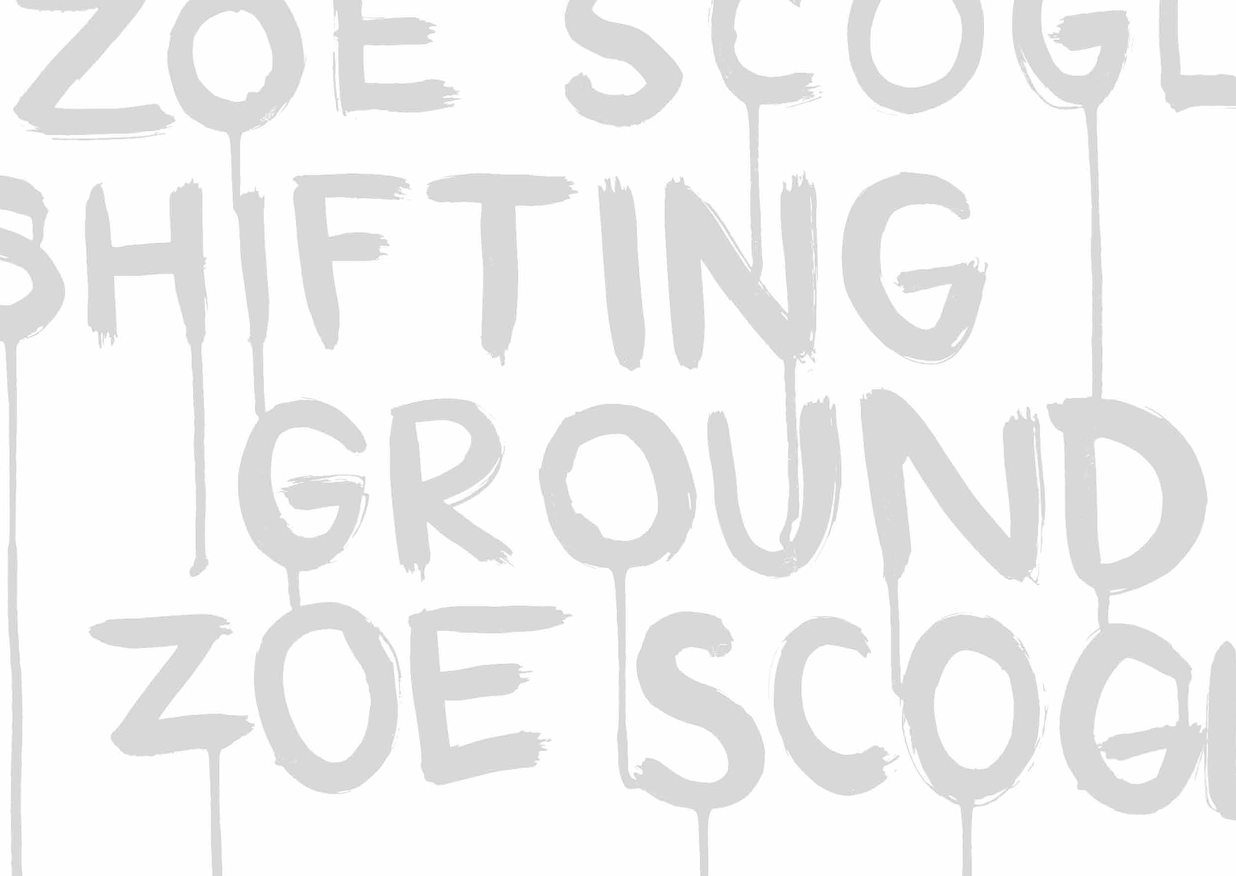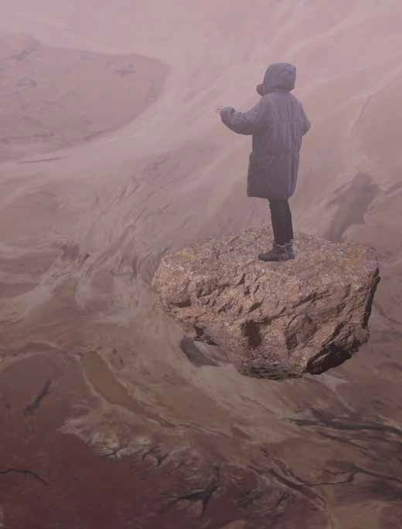

Concept, Performer and Videographer: Zoe Scoglio » Sound Designer: Nigel Brown » Interaction Designer: Chris Heywood » Set and Prop Designer: Zoe Stuart » Consultant: Human Ecologist, Asha Bee Abraham » Management: Moriarty’s Project

6 7

Arts House & Back to Back Theatre present

“They are, simply, our most important independent theatre company.”

Alison Croggon, *Theatre Notes*

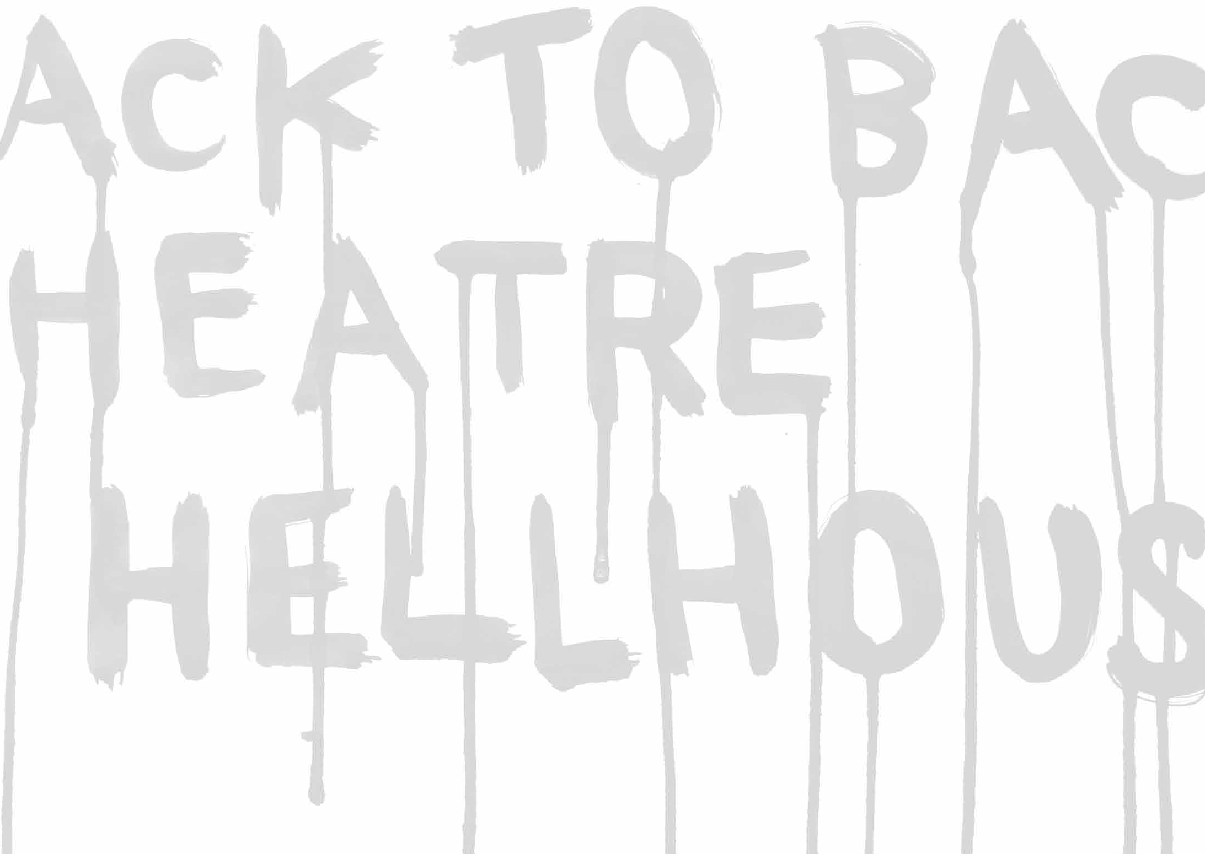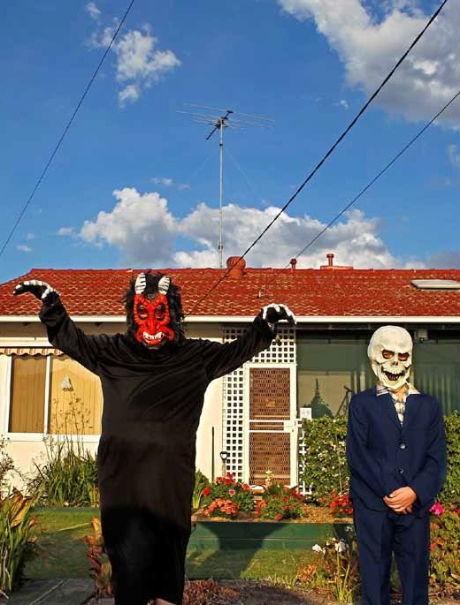

ARTS HOuSe, MeAT MARKeT FRI 3 – SuN 5 AuGuST

Fri 3 – Sat 4 Aug, Performances every ten minutes from 7pm, followed by the post performance forum at 8.30pm.

Sun 5 Aug, Performances every ten minutes from 2pm, followed by the post performance forum at 3.30pm.

Forum Topics

Fri 3 Aug – Provocation with

Scott Stephens

Sat 4 Aug – Belief with

Dr. Rachael Kohn

Sun 5 Aug - Morality with

Peter Mares

DuRATION: Performance: 40 minutes Forums: 60 minutes

TICKeTS: Full $25 / Conc $20

Ticket price includes admission to post-performance forum.

BOOKINGS:

artshouse.com.au or 03 9322 3713

Warnings: Themes and subject matter not suitable for persons under the age of 18. Performance explores moralistic and political views that may be sensitive to some. Also contains loud music, strobe lighting, fake blood and very loud effects.

Image: Jeff Busby

Using a staged performance of Hell House as a catalyst for discussion, Geelong’s world-renowned Back to Back Theatre invites you to three community forums on Provocation, Belief and Morality.

Every year in the USA’s Bible belt, thousands of Christians engage in a unique form of community theatre via a modern-day morality play called Hell House. Written by Baptist Minister, Pastor Keenan Roberts, the performance takes the form of a haunted- house tour, with each room themed around a sin – such as drug-taking, pre-marital sex, abortion, drink-driving or homosexuality. Designed to scare young audiences into confirming their commitment to Christianity, Hell House presents a black-and-white moral world where a wrong decision will send you to hell.

Performed by 40 community actors from Geelong and south-west Victoria, Back to Back Theatre will stage Hell House as a museum would exhibit a cultural or religious artefact. This event is a presentation of a

recruitment drive for evangelical belief. It is also a public discussion about matters important to us all.

Director: Bruce Gladwin » Forum Facilitators: Scott Stephens, Dr. Rachael

Kohn, Peter Mares » Designers: Mark Cuthbertson, emily Barrie » Sound Designer: David Franzke » Lighting Designer: Jennifer Hector » Costumes: emily Barrie

Back to Back Theatre

Hell House

Provocation, Belief & Morality

8 9

Arts House & Mobile States present

“Occasionally it’s like a dream sequence in a David Lynch film, disturbing, unstoppable… But mostly it’s full of laughter and hope, a feeling very much helped by the wide demographic of its contributors.” *RealTime*

Back to Back Theatre

The Democratic

Set

Award-winning Back to Back Theatre brings a visual soapbox to town: a 15-second timeframe, a grand theme of democracy and equality, and 25 years experience making extraordinary work.

The Democratic Set uses a custom-made film set; a neutral room with two opposing doors. Invited community groups collaborate with a resident creative team to create a rapidly moving series of short live performances and screen-based video portraits, with a live public ‘audience’. These are edited together into a single tracking shot through what seems to be a series of identical rooms. Disturbingly simple and tantalisingly strange, The Democratic Set shows how performance can, like democracy, allow people to be seen, to speak and to be heard.

From Bristol to Horsham and from Denmark to Castlemaine, The Democratic Set has generated performances that are insightful, funny, hard-hitting and heartfelt – but above all, deeply human. Join us to watch the filming and come to The Other Film Festival for a final screening of this unique collaborative work.

ARTS HOuSe,

NORTH MeLBOuRNe TOWN HALL

FILMING:

Tue 7 – THu 9 AuGuST

Tue, 3pm – 7pm

Wed – Thu, 11am – 1pm

& 2pm – 5pm

No bookings required to attend filming sessions.

SCReeNING:

Sat 22 September

As part of The Other Film Festival

(refer to pg 17)

eNquIRIeS:

artshouse.com.au or 03 9322 3713

Image: Carl Newland

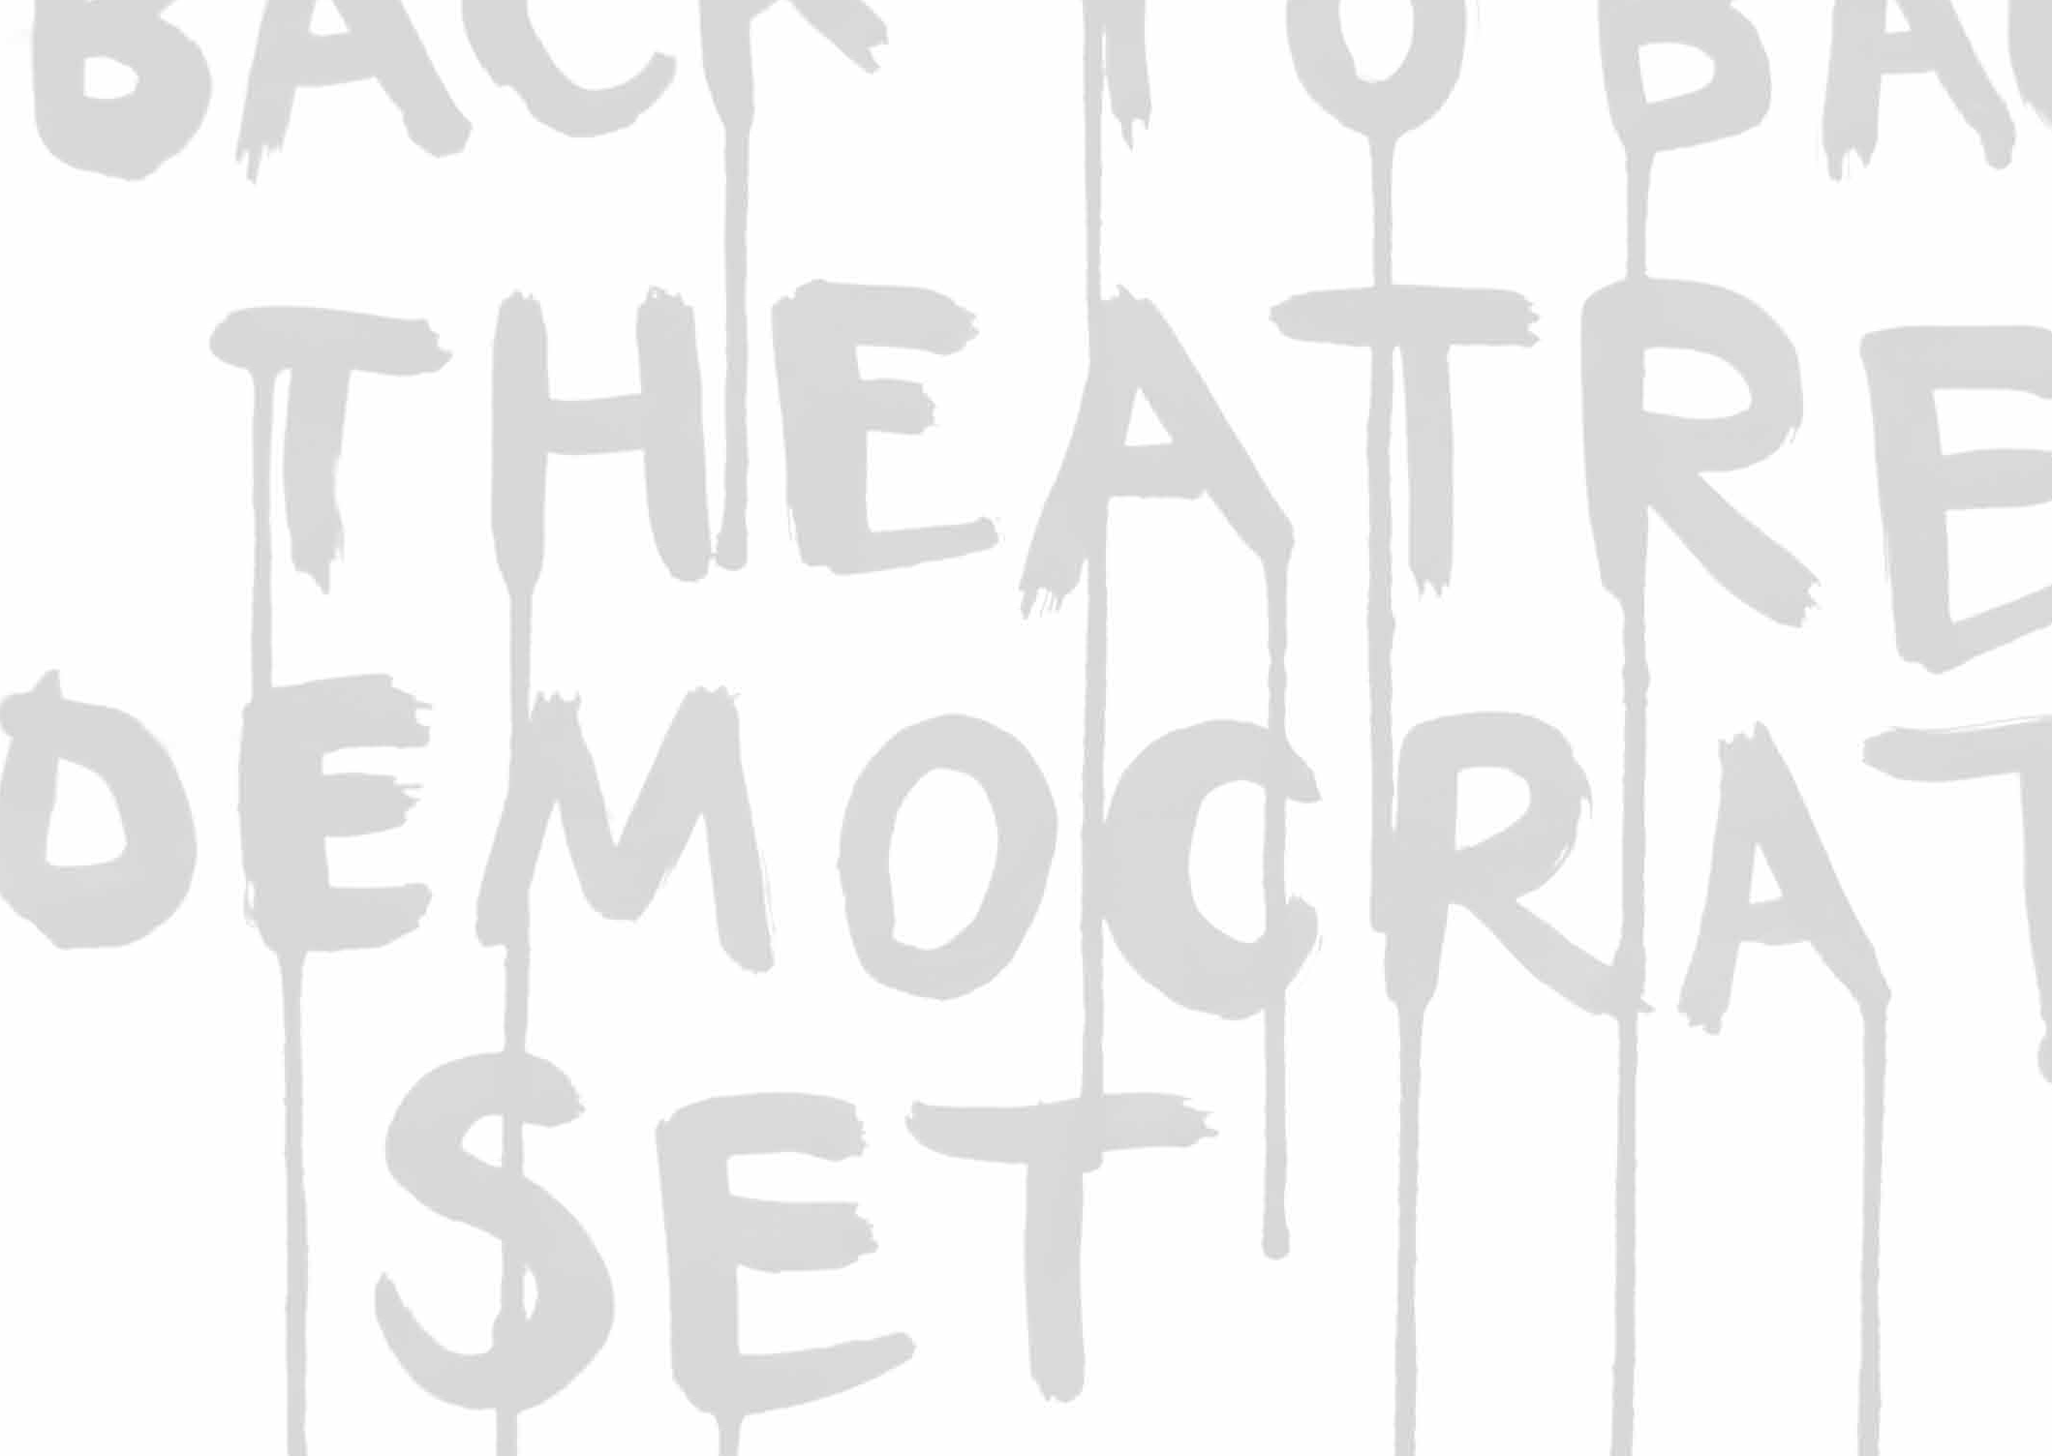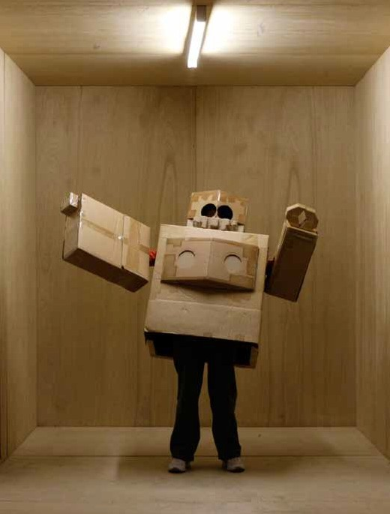

Original Concept & Set Design: Bruce Gladwin » Original Set Design

& Construction: Mark Cuthbertson

In collaboration with local community participants » Residency Director: Bruce Gladwin » Back to Back Ensemble Performer: Mark Deans » Videographer & Editor: Rhian Hinkley » Production Manager: Jennifer Hector

1 0 1 1

“…insanely fast-paced, witty, artfully arrhythmic, metatheatrical –

a breathtaking combination of precision and chaos.”

*RealTime (*on The Black Lung’s *Avast)*

Arts House, Darwin Festival, Brisbane Festival, Stealth Agency

& The Black Lung Theatre present

ARTS HOuSe, MeAT MARKeT

WeD 29 AuG – SuN 2 SePT

Wed – Sat, 7.30pm

Sun, 5pm

DuRATION: 80 - 100 minutes

TICKeTS: Full $25 / Conc $20

BOOKINGS:

artshouse.com.au or 03 9322 3713

Warnings: Performance explores themes of war, suicide, homicide, religious and political critique. The performance contains frequent course language, cigarette smoke & smoke effects, strobe lighting, very loud music

& effects.

Melbourne’s acclaimed Black Lung Theatre and Whaling Firm embarks on a unique collaboration with East Timorese companies Galaxy and Liurai Fo’er, in DOKu RAI (you, dead man, I don’t believe you).

Created over two months in an abandoned colonial hotel on a remote island off Timor-Leste, and directed by Thomas M Wright, DOKu RAI boldly defies limitations,

as the first international theatre production to be created in East Timor. Conceived during the filming of *Balibo*, DOKu RAI is a shared fiction, a narrative drawn from all the artists’ own stories and references.

Independent company Liurai Fo’er uses found objects and detritus to create installations and performance in contemporary forms; while Galaxy are Timor-Leste’s most renowned band, rising out of the ashes of the struggle for national independence. Their collaboration with the Black Lung is framed and documented by the work of award-winning filmmaker Amiel Courtin-Wilson (*Hail, Bastardy, Cicada*).

Created upriver and at the end of the road, DOKu RAI

is born of an improbable union of artists, drawn together

by their need to eat, sleep, to work with one another and

the bare materials – and to walk out of the wilds with

intense and consuming theatre.

Black Lung

DOKu RAI

( you, dead man, I don’t believe you )

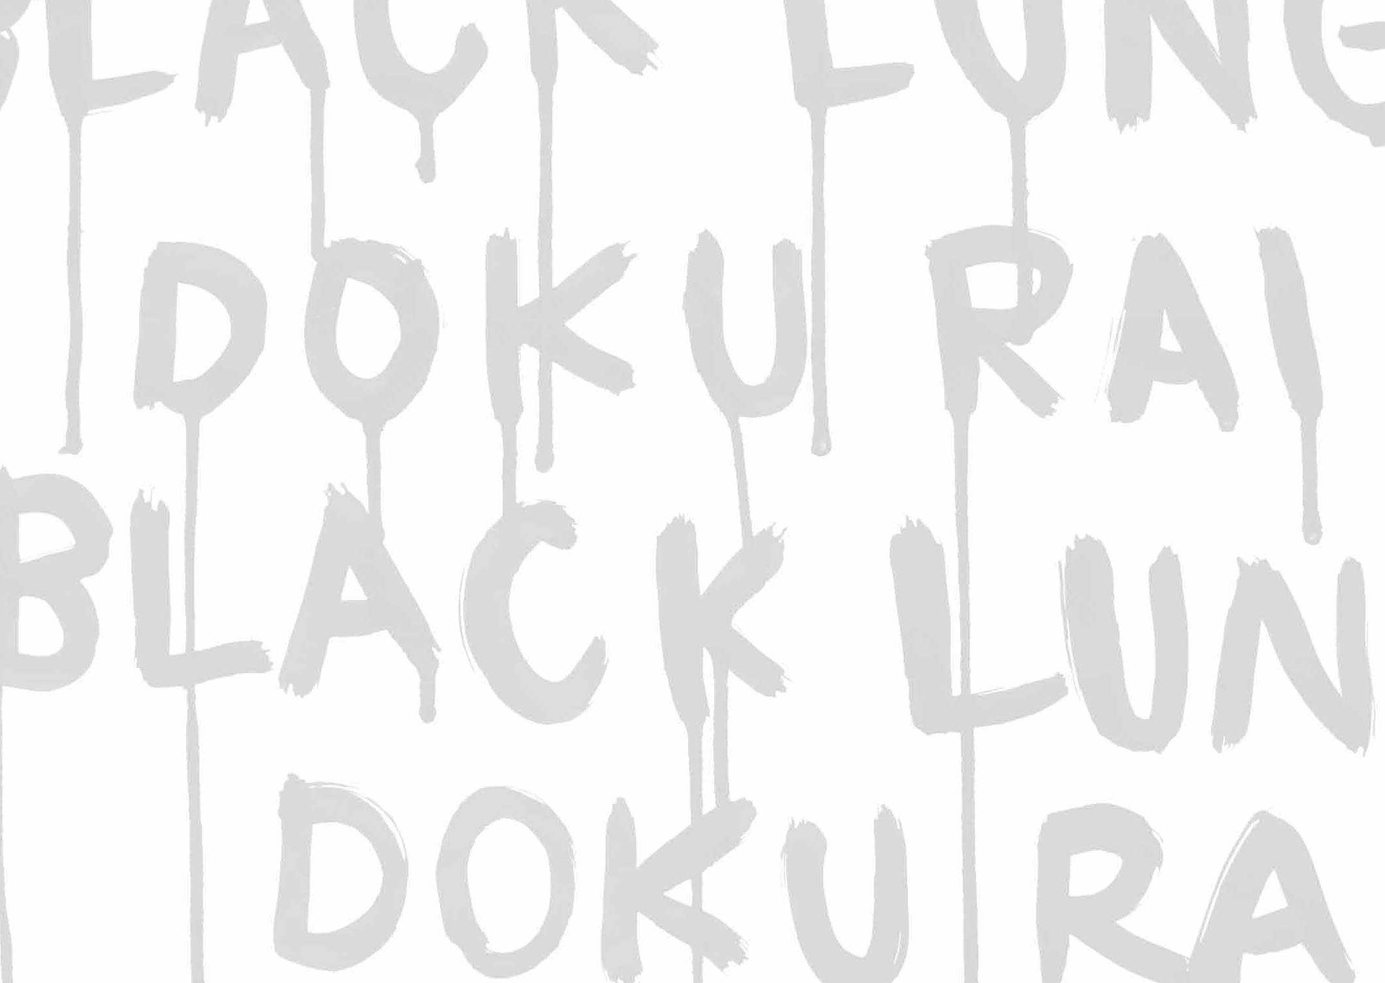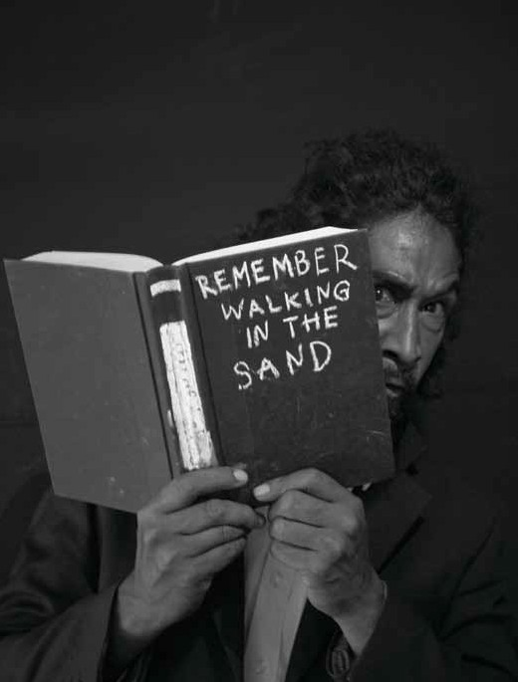

Director: Thomas M Wright » Performers: Liam Barton, etson Da Costa Caminha, Gareth Davies, Melchior Dias Fernandes, Osme Goncalves, Thomas Henning, Agivedo (Laca) Ribeiro, Vaczadenjo Wharton-Thomas

»Lighting Designer: Govin Ruben »Sound Designer: Liam Barton »Video Designer: Amiel Courtin-Wilson »Language Consultant and Translator: elizabeth Adams »Producer: Stealth Agency »Production Manager: emily O’Brian »Technical Management: The Rubix Cube

1 2 1 3

Arts House & Mobile States present

“It is at once mesmerising and shocking. But don’t let me spoil it for you. you’ll laugh, you’ll cry and you’ll ROCK! …Their own particular brand of brilliance seems endless.” Carol Lloyd, Railroad Gin

the Collector, the Archivist

& the electrocrat

A tall, lonesome lady lives with the precious objects and curious memories that she stores in jars in the rooms of her cavernous house. She has procured two unsuspecting members to join her band… An

electronica-dance-metal-rock outfit, RRAMP takes on unexpected and compelling tales of archives, collections, pets, childhood imaginings and human frailty.

RRAMP features the mesmerising vocals of Christine Johnston as the Collector; the intense precision of Lisa O’Neill as her dancing Archivist; and the dynamic

sounds of Peter Nelson as the Electrocrat, helping the Collector live her dream. Continuing a decade-long collaboration that crosses the boundaries of music, dance, theatre, comedy and new media, the three

return to the stage as a band, to the accompaniment of exquisite animations by Ahmarnya Price.

Laugh one minute and be gripped the next by this Lady of the House and her eclectic companions. From the finely-honed to the bizarre, RRAMP brings you selections…collections…recollections…

ARTS HOuSe,

NORTH MeLBOuRNe TOWN HALL

WeD 5 – SAT 8 SePTeMBeR

Wed - Fri, 7.30pm

Sat, 3pm & 7.30pm DuRATION: 60 minutes TICKeTS: Full $25 / Conc $20

GReeN TIX FOR NIX:

Sat 8 Sept, 3pm

See page 32 for details.

BOOKINGS:

artshouse.com.au or 03 9322 3713

Warnings: Suitable for audiences over the age of 15. Performance contains hazer effects.

Image: Sean young

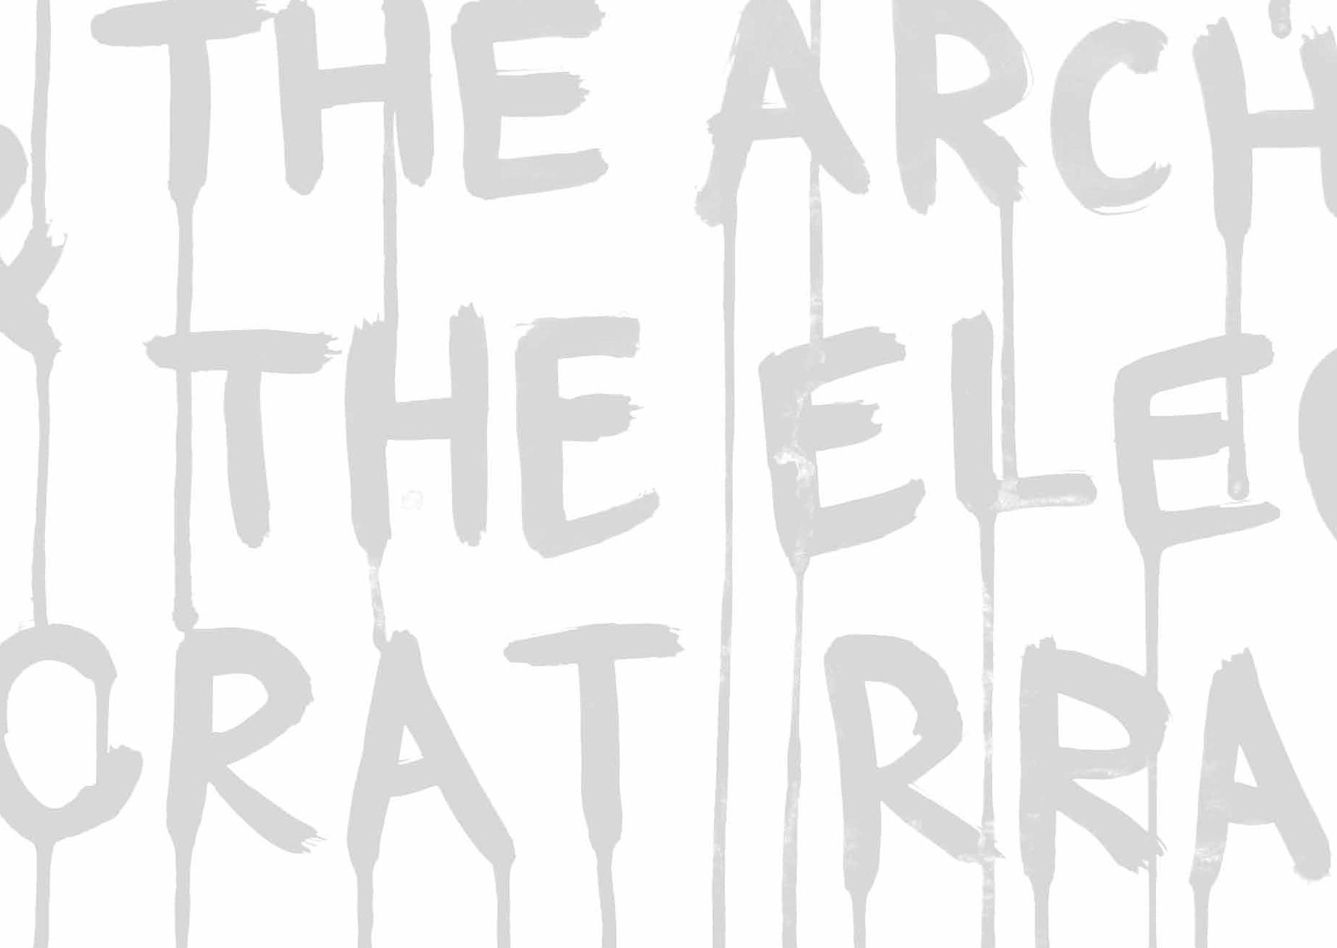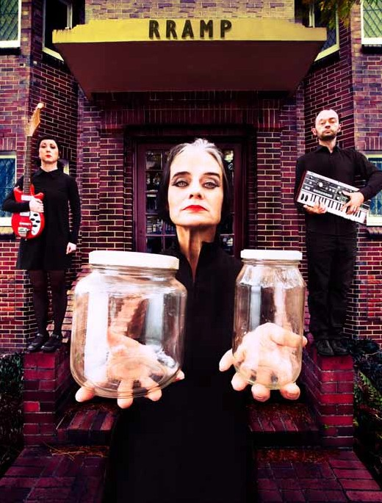

Devised and Performed by: Christine Johnston, Lisa O’Neill, Peter Nelson

» Animation: Ahmarnya Price » Costume Designer: Selene Cochrane » Lighting Designer: David Walters » Video Production: Jaxzyn » Production/Stage Manager: Leila Maraun

1 4 1 5

Arts House, Laura Caesar & Malcolm W hittaker present

“…a strangely unsentimental love-crafting, the product of an idiosyncratic confessional cottage industry. Against the saccharine celebrity romance sagas of the gossip magazines, Caesar and Whittaker insert

their more prosaic relationship perspectives, and do so in a gently self-deprecating way.” *RealTime*

Laura Caesar

& Malcolm Whittaker

ARTS HOuSe,

THu 6 – SAT 8 SePTeMBeR

*“This is our (every) moment in the spotlight. We hope*

*enough.”*

Star s

NORTH MeLBOuRNe TOWN HALL

6pm

DuRATION: 240 minutes.

Audience members are free to come and go during the performances.

TICKeTS: Full $25 / Conc $20

BOOKINGS:

artshouse.com.au or 03 9322 3713

Warnings: Adolescent themes.

Themes and subject matter suitable to audiences over the age of 15.

Image: Lucy Parakhina

*we are interesting enough, beautiful enough, enough of*

In Star******s, primary school teacher Laura Caesar and Sydney artist Malcolm Whittaker raise their own relationship to celebrity status by reading from the

personal diaries that document their ten years together. Every movement. Every moment. Together and apart. Broken down and made public.

Over the four hours of the durational performance the audience can come and go as they please, as stories continually unfold and everyday narratives undergo a seemingly never-ending process of construction and reconstruction.

As each diary page is read it is sculpted into a miniature papier-mâché representation of a pair of lovers – lovers from a seemingly infinite catalogue, conjured in makeshift caricature and caught in an ever-failing quest for lasting stability and contingency.

Star******s is about the construction and consumption of relationships by media and fairytale, and in turn the consumption of these relationships by the public. It’s

about the great suburban dream of fame and fortune and love – and finding it poetically in the banal and everyday.

******

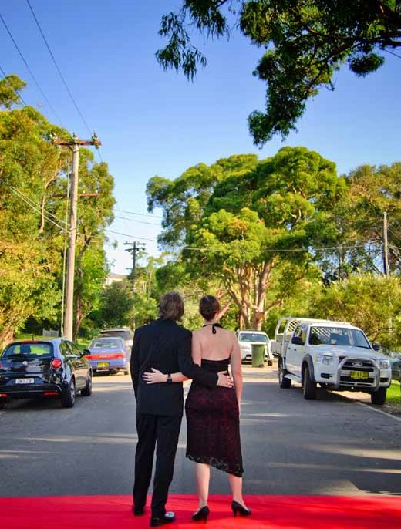

Made and Performed by Laura Caesar & Malcolm Whittaker

1 6

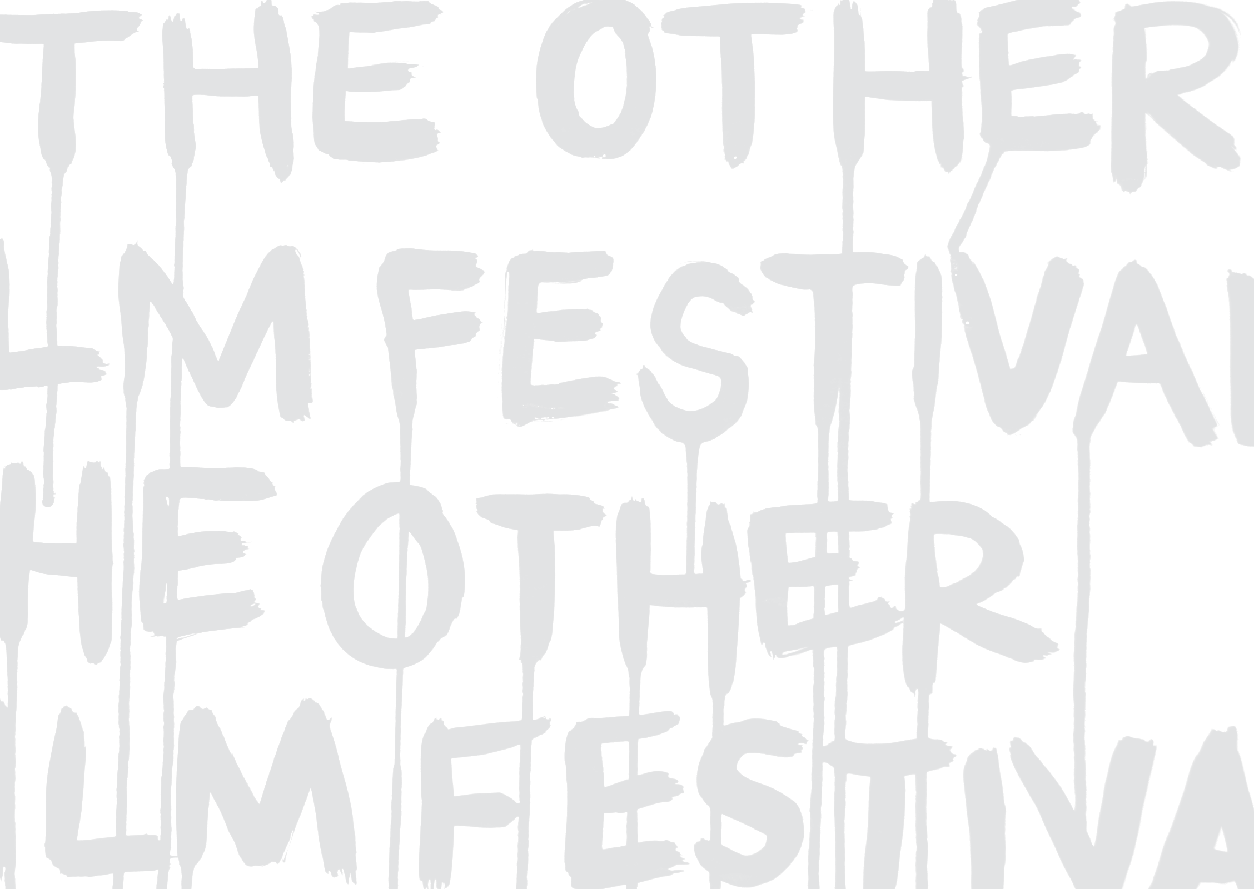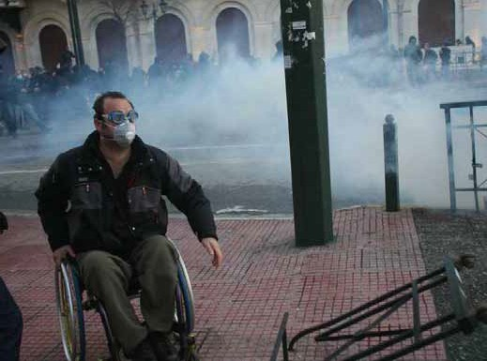

Arts Access Victoria presents

THe OTHeR FILM FeSTIVAL New cinema by, with and about

people with a disability

19 – 23 September 2012

1 7

*What are you looking at* ?

Since its inception in 2004, THe OTHeR FILM FeSTIVAL has cheerfully broken the first taboo of disability: Don’t Look! Arts House is proud to welcome the festival to North Melbourne Town Hall in 2012, where the festival shifts up a gear to fuel its potent reputation for presenting razor-sharp cinema from around the globe.

Experience the acceleration only cinema can deliver as North Melbourne Town Hall becomes the spinning hub for an inclusive and accessible five-day road

trip into disability screen culture. Embracing cinema for the first time, the Town Hall venues transform into dark and yielding spaces ripe for discovery, amazement and transformation. Put away any thoughts of sleep during these five days and nights

of films, guests, forums and professional development events for film practitioners with a disability – then refuel your body and brain at the Other Club!

THe OTHeR FILM FeSTIVAL has attracted a powerful program of contemporary international film, including an expanded program of Deaf cinema, a confronting report from the frontline in Athens and a controversial selection of films that will challenge every assumption ever made about sex, love, romance, marriage, gender reassignment and disability. Put your finger on the living pulse of disability at THe OTHeR FILM FeSTIVAL!

TICKeTS: Full $12 / Conc $8. Group discounts and festival passes available.

BOOKINGS: artshouse.com.au 03 9322 3713 or otherfilmfestival.com

The Thoughtful

Song Society

A unique Arts House event for THe OTHeR FILM FeSTIVAL

Friday 21 September, from 5.30pm

The Thoughtful Song

Society takes over

the Other Club for one

fabulous night! Led

by Society President,

composer/musician

Rose Ertler, they’ll be

collecting ideas for song

lyrics from film-goers

throughout the evening.

Watch The Thoughtful Song Society editors tap on their typewriters, whipping up your

words into brand new film-related hits played on the spot by some

of Melbourne’s finest musicians. Speak up and hear your own words sung on stage! And it’s FREE!

Image: Antonios Rellas *Disability demonstration, Athens, 2011*

1 8 1 9

World Premiere

“They make a magic cave of geometrical shapes that bulge,

shrink into concaves, overlap, trick the eye and stimulate the imagination.

But that is only the beginning.”

Jill Sykes, *Sydney Morning Herald* (on Gravity Feed Ensemble’s *Host*)

Arts House, Beaubois, McC lure & Stein

in association with Melbourne Festival present

ARTS HOuSe,

NORTH MeLBOuRNe TOWN HALL

FRI 19 – SuN 28 OCTOBeR Every twenty minutes between: Fri 19, 6pm – 9pm

Sat 20 – Sun 28, 12pm - 8pm

One person at a time will enter the space.

Limited capacity. Bookings essential.

DuRATION: 15 minutes TICKeTS: Free BOOKINGS:

artshouse.com.au or 03 9322 3713

Warnings: Children under 12 must accompanied by an adult. The works require a high level of physical mobility and personal responsibility

and is not accessible to wheelchair users.

Push your way into the experiential extreme of an

‘impossible space’ – where physical pressure, light and

sound combine to create a surreal accumulation of

sensations.

Creators Denis Beaubois, William McClure and Jeff Stein were members of Sydney’s Gravity Feed Ensemble – an architectural performance-theatre which employed

large sets to create potent, subversive and densely atmospheric events. Impasse is a tangible rendering and intensification of space, where space becomes substance, restricting both the visitor’s field of vision and their capacity to move.

Impasse creates a unique experience of ‘space’ as you struggle to carve out a path with your body. Its unique fusion of physical impression and surprising sounds makes for an extraordinary, densely- packed journey that will change the way you see, feel and hear the world!

Denis Beaubois, William McClure

& Jeff Stein

Impasse

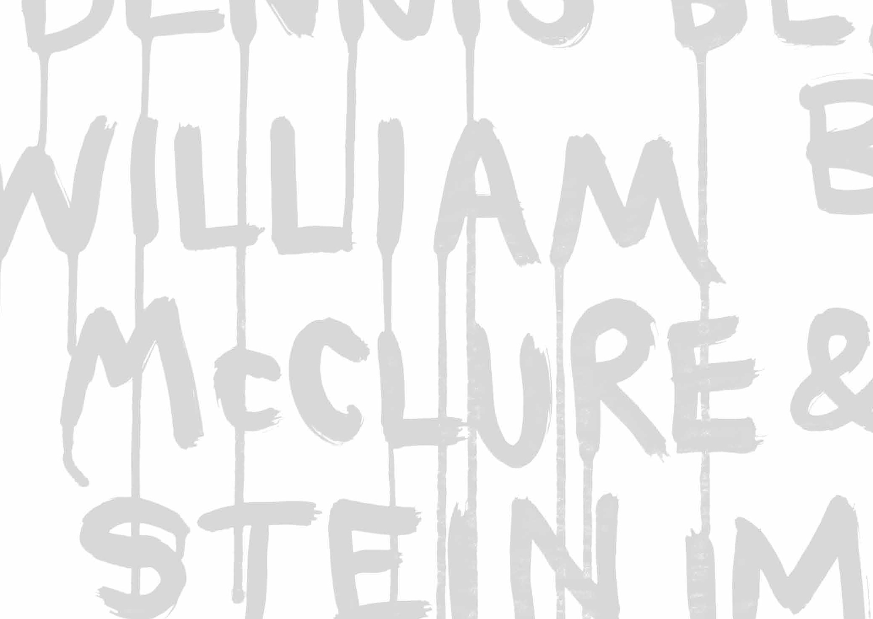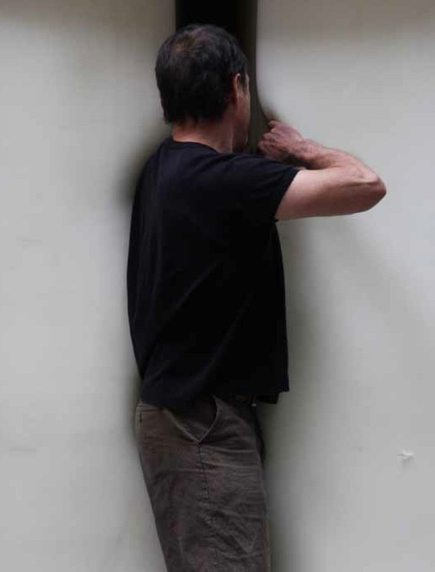

Created by: Denis Beaubois, William McClure & Jeff Stein » Sound Design:

Nick Wishart » Lighting Design: Sydney Bouhaniche » Production: Hedge

2 0 2 1

Arts House in association with Melbourne Festival present

“These artists’ talent for trail-blazing their way across the

bone-littered landscape of performance art and hacking through mediocrity with

their own particular brand of brilliance seems endless.” Carol Lloyd, Producer

David Cross

Hold

Would you willingly enter an artwork designed to

test your fear of dark, unstable spaces and our limits

of trust?

Hold is part reality-TV ordeal, and part extreme performance art engagement. A highly immersive, multi-sensory architectural experience, Hold draws participants into a dynamic relationship between play, interaction and phobic space as they push through an assortment of physical and psychological barriers.

Hold creates an uncanny yet intimate one-on-one encounter between the audience member and an unseen performer. Crucially, it also demands unusual levels of physical and psychological interaction as you

navigate a spatially complex and disorientating pathway

– all while being suspended above ground by air!

Leap into the shifting, fluid divide between fear and pleasure, with New Zealand-based artist David Cross’s unsettling and intriguing performance–installation, Hold.

ARTS HOuSe, MeAT MARKeT

FRI 19 – SuN 28 OCTOBeR Every fifteen minutes between: Fri 19, 6pm – 9pm

Sat 20 – Sun 28, 12pm - 8pm

One person at a time will enter the installation.

Limited capacity. Bookings essential.

DuRATION: 15 minutes TICKeTS: Free BOOKINGS:

artshouse.com.au or 03 9322 3713

Warnings: This performance/installation is not suitable for children under 16 years. The work requires a high level of physical mobility and personal responsibility and is not accessible

to wheelchair users. It is both physically & psychologically demanding. Anyone with a serious existing medical condition, including heart & respiratory problems, should not enter this work.

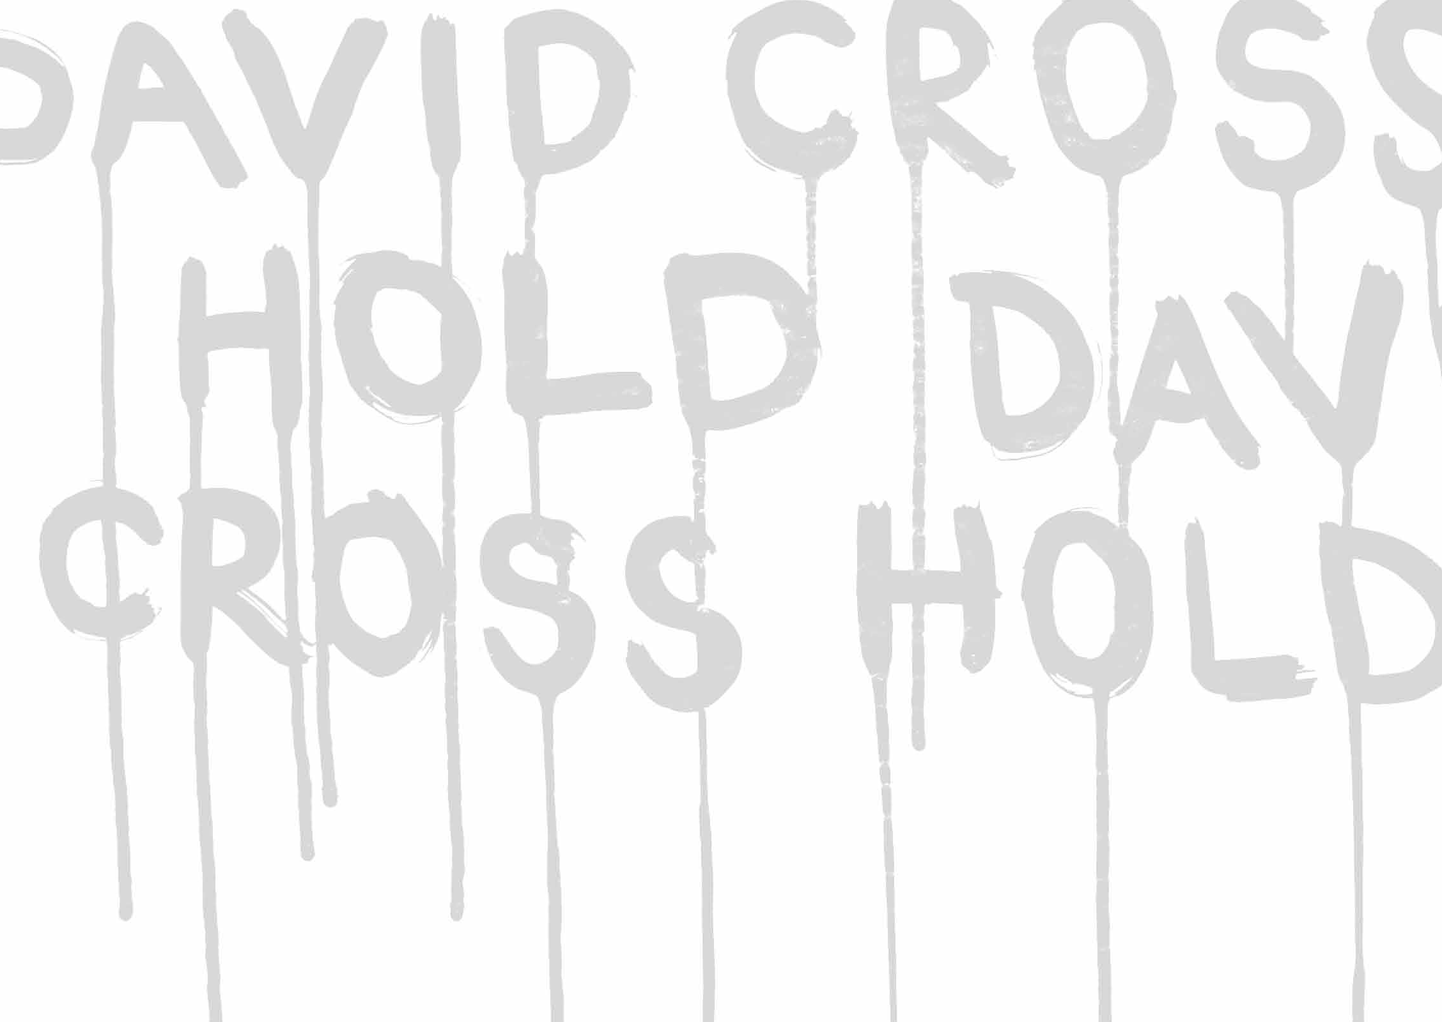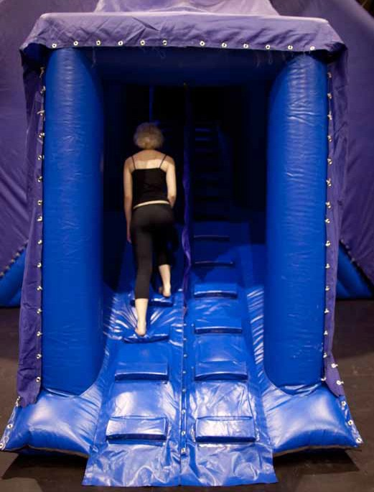

An artwork by David Cross

2 2 2 3

World Premiere

Arts House presents

“…perhaps the most beautifully judged site-specific work I have seen.

Mysteriously joyous and profoundly beautiful.”

Alison Croggon, *Theatre Notes* (on *Dwelling Structure*)

ARTS HOuSe, MeAT MARKeT

THuR 15 – WeD 21 NOVeMBeR Open daily from 12pm – 8pm. Opening night party, 6pm Thurs

15 Nov.

Gauge will be open from Fri 23 – Sun 25 November as part of Going Nowhere. Refer to page 26 & 27 for more details.

TICKeTS: Free

BOOKINGS:

artshouse.com.au or 03 9322 3713

Image: Cameron Robbins

Gauge is a playground of investigation into weather, water and scale. In the grand 19th-century surrounds of the Meat Market, five artists and two scientists create

a contemporary *Wunderkammer* – a curious space of exploration into a critical concern for our time.

Experience a hands-on encounter with a beguiling array of newly-created and historical apparatus – a collective artistic response to current debate around the water cycle and the distribution of water resources. Researching the work through a year of investigative excursions, both physical and virtual, its makers have drawn on their collective reservoir of knowledge and imagination to develop these enigmatic inventions.

The wondrous result of this unique collaboration is at once an exhibition, an installation, a catalogue, a set of talks, a series of performances by both performers

and audience, and a real-time-data-created work – all rebounding and resounding within Gauge’s carefully orchestrated space.

Madeleine Flynn & Tim Humphrey

Gauge

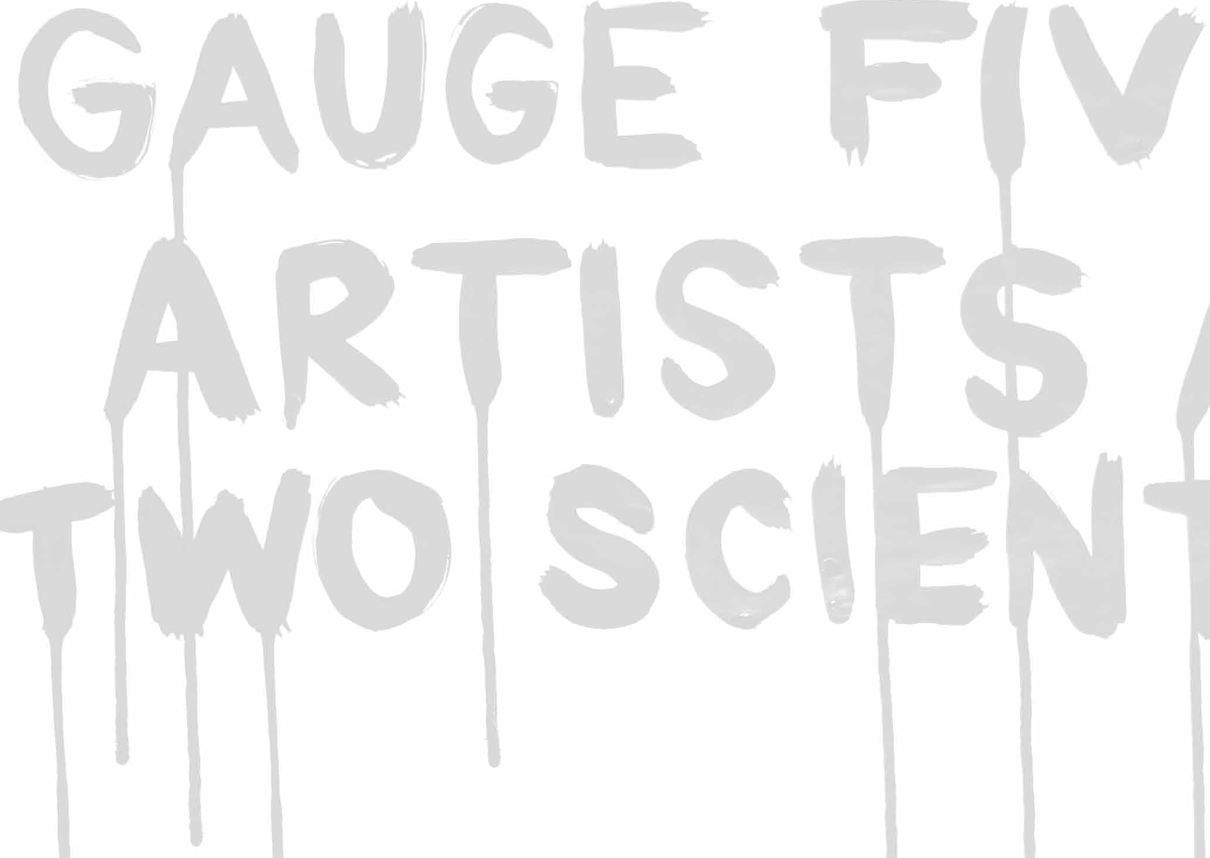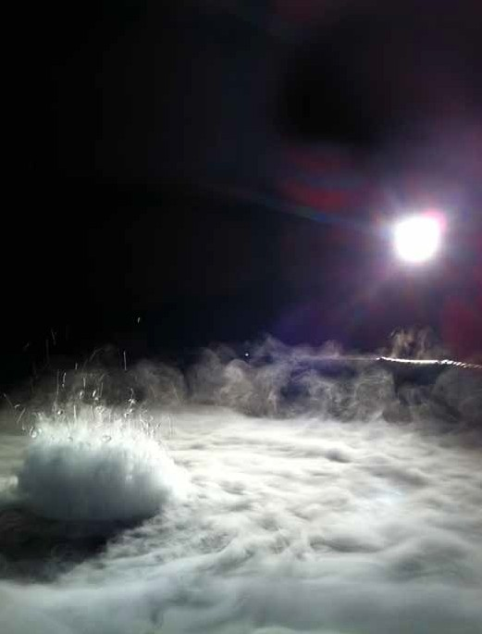

Created and Directed by: Madeleine Flynn and Tim Humphrey

In collaboration with; Performer/Composer/Inventor: Graeme Leak » Artist/ Miniature Percussion Designer: Rosemary Joy » Visual Artist/Sculptor/ Musician: Cameron Robbins, Dr Michael Roderick, Senior Fellow and Associate Professor, Research School of Earth Sciences and Research School of Biology, Australian National University and Dr Adrian Pearce Associate Professor, Department of Computer Science and Systems Engineering, University of Melbourne

2 4 2 5

The Warehouse Salons

The Warehouse Salons are a space for intimate work-in-progress showings, for talks and discussions, and for our audiences and artists to connect and share ideas, feedback and inspiration…

This season’s Warehouse

Salons bring together

Theron Schmidt

Theron Schmidt is a writer, teacher and performer. Currently a Lecturer in Theatre and Performance Studies at King’s College London, he has written widely about live art and performance for publications including *Contemporary Theatre Review*, *Dance Theatre Journal*, *The Live Art Almanac Vols. 1 & 2*, *Performance Research*, *RealTime* and *Total Theatre*. He

was convener and editor of *SPILL Stings* – a critical writing project alongside London’s 2011 SPILL Festival of Performance. He also convened a cross- disciplinary critical writing program as part of the 2010 *What if…* festival of dance, film, live and visual art, also in London.

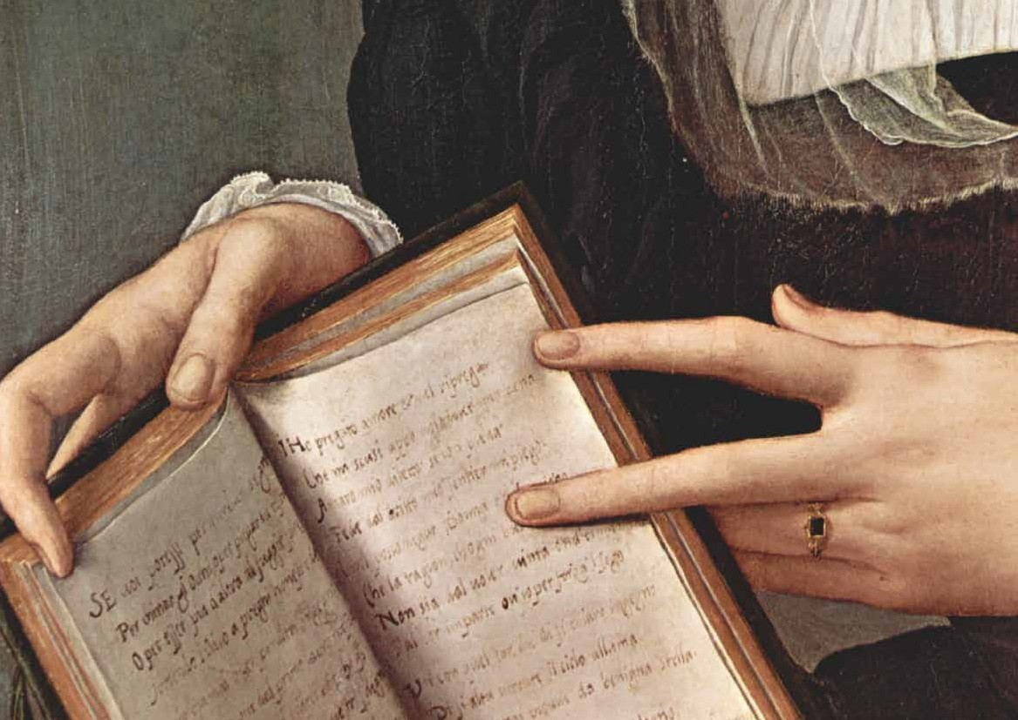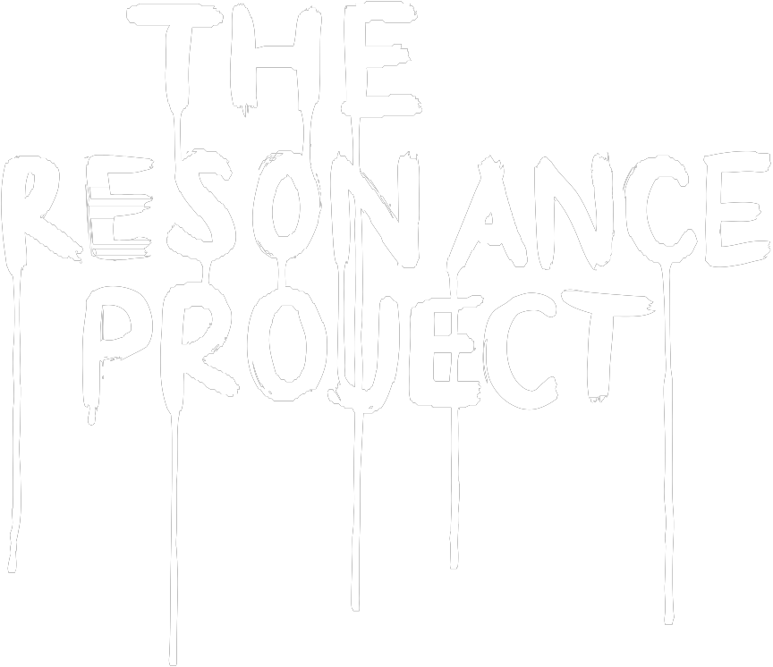

Forum & Workshops

critical and reflective writers, bloggers and responders from the

UK and Australia, joining performing-arts makers in a series of events initiated by creator and curator Leisa Shelton.

The Resonance Project encompasses a public forum and two weekend workshops led by UK-based writer Theron Schmidt, exploring how we write, respond

and reflect on art and performance. It proposes that rather than just describing or evaluating finished work, critical writing can be thought of as a ‘resonant performance outcome’– part of an ongoing exchange with artists, creating encounters that ‘resonate’ creatively.

ARTS HOuSe,

THe WAReHOuSe,

NORTH MeLBOuRNe TOWN HALL BOOKINGS:

artshouse.com.au or 03 9322 3713

Forum

The Resonance Project Forum

is your chance to explore some

‘resonant’ current practices and kick off the public discussion. The Forum is an opportunity to

encounter some of the artists who have initiated and contributed to projects like the *LALA* arts web site, *The Live Art Almanac*, *RealTime*, independent blogs and respondent writing sites.

*How might writing be useful not only in ‘reviewing’ finished work, but also as a part of an ongoing exchange between artists, audiences and writers? Rather than explaining the artist’s intentions, or standing in for*

*a hypothesised audience, how might writing produce a third space of encounter?*

Sat 21 July, 10am–2pm

TICKeTS: $25

Includes lunch.

Initiator:

Fragment 31/ Leisa Shelton

Forum Presenter: Theron Schmidt

Forum Guests: Martyn Coutts

& Other Guests

Workshops

The Resonance Project Workshops

will investigate how critical writing can relate actively to contemporary arts practices, furthering and deepening the discussion begun in the public Forum. Join Group 1 or Group 2 to explore and discuss a range of recent critical approaches, putting into practice some

creative methods for responsive writing – including collaborative and multi-vocal writing, the use

of observational filters, and other creative constraints. Back to Back’s Hell House and Democratic Set

will be the performance stimuli for the workshops.

GROuP 1: Sat 4 Aug & Sat 11 Aug,

10am–2pm

GROuP 2: Sun 5 Aug & Sun 12 Aug,

10am–2pm

TICKeTS: $125

Includes admission to Back to Back

Theatres work.

Initiator:

Fragment 31/ Leisa Shelton Workshops Presenter: Theron Schmidt

2 6 2 7

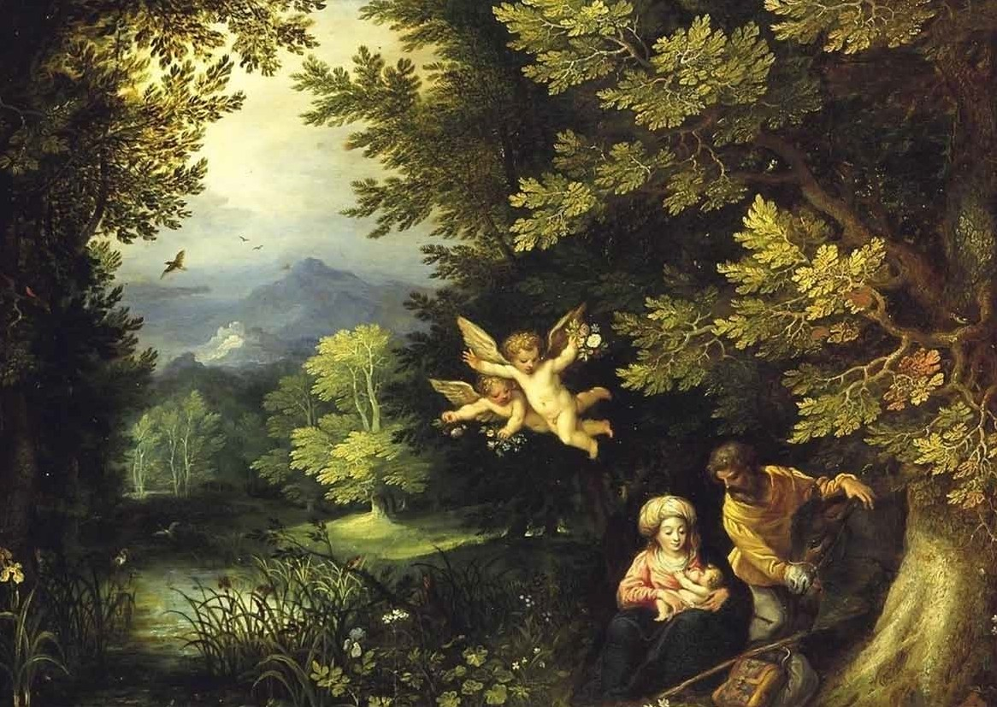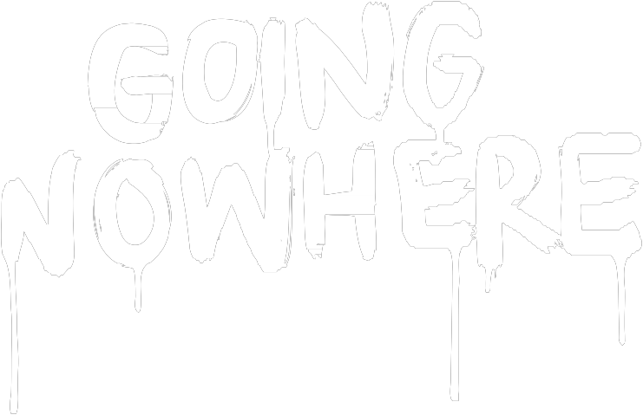

23 – 25 November

Join us over three days at Arts House, Meat Market, exploring the different ways that we – as artists and as audiences –

can sustainably generate and share creative experiences across the globe.

Without anyone getting on a plane.

FRI 23 NOV

OPeNING NIGHT PARTy

ARTS HOuSe, MeAT MARKeT

6 – 11pm

FRee!

Madeleine Flynn and Tim Humphrey’s intriguing, weather- inspired installation Gauge is

the backdrop for a Friday night party like no other. Grab a drink or snack and enjoy a hands-on encounter with Gauge’s curious contraptions, before enjoying the short screen films by UK cross-

artform artists Ackroyd & Harvey, Lucy Cash, Curious, Robin Deacon, Graeme Miller and Matthew Robins, exploring our fragile planet in What On earth.

At 7.30 it’s time for Pecha Kucha!

– as the scientist (David Karoly, Professor of Climate Science Melbourne University), the politician (Cathy Oke, The Greens), the

futurist ( Stuart Candy – ARUP) and others get 20 slides and three minutes each to share their

excitement at the thought of going nowhere. Then as night obliterates the jet trails and the sky glows with new ideas, we’ll have a DJ on hand to help you fire up your imagination for your own weekend of Going Nowhere, exploring creative and sustainable ways to make and experience art!

SAT 24 NOV

THINK IT, TALK IT, DO IT

A full-day program of workshops, forums and presentations

for artists, producers and interested others!

ARTS HOuSe, MeAT MARKeT AND ARTS HOuSe, WAReHOuSe

Achieving sustainable arts practice is both a challenge and a chance

to get super-creative about how

we do things, across the globe and on home ground. Discover how to reduce the environmental impact of touring in our Responsible Mobility workshop, with Suzanne Daley

from Live Performance Australia and co-presented by Greening Our Performance. See how Australian artists, (Dan Koop, Sarah Rodigari, One Step At A Time and Willoh S Weiland) paired with international collaborators, have met the challenge to create a project

that can be swapped, borrowed, franchised, gifted or stolen at the Ideas Lab presentation. And to round off a creative, productive and inspiring day of thinking, talking

and doing, contribute your ideas to our New Modes of Cultural exchange public forum.

TICKeTS: $10 per session or $20 for full-day pass

INFORMATION: going.nowhere@

melbourne.vic.gov.au

BOOKINGS: artshouse.com.au or (03) 9322 3713

SuN 25 NOV FORAGe & FeeD

ARTS HOuSe, MeAT MARKeT

Food Foraging

9.30am – 12.30pm

Learn how to gather edible plants with local permaculturist and poet Patrick Jones. Discover foods you didn’t know were there, as Patrick takes you on a foraging walk around North Melbourne – see a different side of the city and bring food to

the table!

Tickets: $15

Bookings: artshouse.com.au or (03) 9322 3713

Sunday Lunch

1 – 3pm

FRee!

It’s a (lunch) wrap! Help us celebrate the end of the inaugural Going Nowhere – bring a plate of food you’ve made yourself from locally grown food, and chow down on the inspiring words of eco-artists, including trans-cultural critic and weed specialist, Diego Bonetto.

For more details

or to get involved email

going.nowhere@

melbourne.vic.gov.au

2 8 2 9

Behind the Scenes

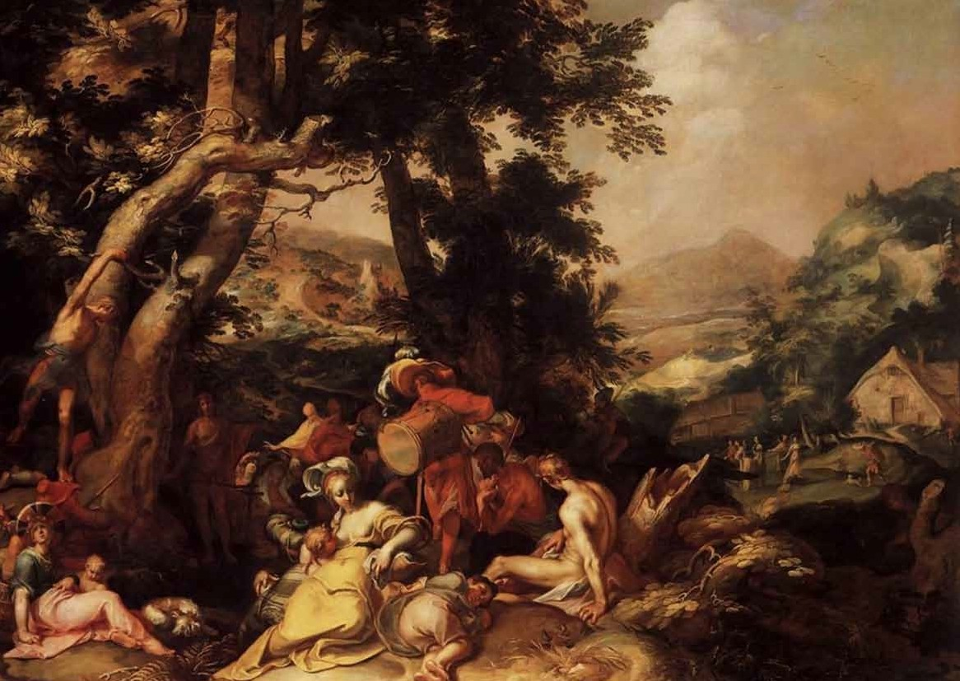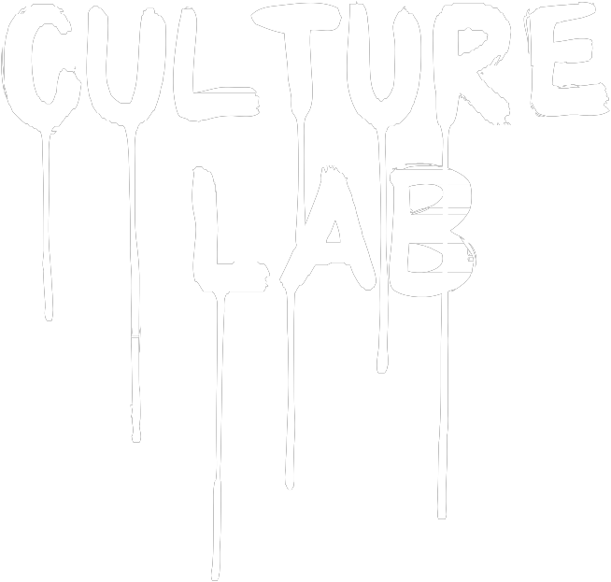

CultureLAB is Arts House’s dedicated,

venue-based creative development program, conducted in partnership

with Arts Victoria. From creative collaborations

and explorations to mentor programs, CultureLAB supports artists across all art

forms to create powerful, exciting, ground-breaking and original works.

Here’s the CultureLAB line-up for the second half of 2012…

NOT ABOuT FACe

Luke George

Luke George and collaborators are developing a new solo dance performance titled NOT ABOuT FACe. In this piece George is interested in accessing the supernatural and the scientific

as modalities to apply to the performative body and the performer/audience situation, as a way to explore the question: What is perceiving, knowing and believing?

*Do I need to believe it to perform it? Do I need to perform it to believe it?*

*What is my own and the audience’s commitment and investment in relation to the success of the performance?*

*How do I experience being both subject and object in the performance? Who is the author of this dance?*

Hide and Seek

Maryanne Lynch

The past, it’s said, is another country. But whose country is it?

In Hide and Seek seven artists from a range of disciplines, assisted by

a group of children, explore how children and adults see the world

in different ways. Led by Maryanne

Lynch, Hide and Seek is as much

a celebration of such difference

as a look at how it can sometimes

play out as fear, mistrust or plain

confusion. Sometimes hilariously

so; at other points with tragic

consequence.

Hide and Seek focuses on the relationship of child and adult, and seeks parallels with other, larger, relationships – most especially that between the ‘Australian citizen’

and the ‘other’. A multidisciplinary project with an open-ended artistic outcome, Hide and Seek involves artists Maryanne Lynch, Oren Ambarchi, Kate Sulan, Polixena Papapetrou, Natasha Herbert, Dan Witton and Jethro Woodward – and the contributions of ten children aged between eight and 12 years.

Shifting Ground

Zoe Scoglio

Shifting Ground is a performance/ installation that takes its inspiration from the geological world. Exploring the idea that all forms are temporal and metamorphic, media artist

and performer Zoe Scoglio will experiment with projection mapping, sound, movement, and ceremonial participation. Developed in collaboration with Nigel Brown, Zoe Stuart and Chris Heywood. This CultureLAB will result in a public event – check out Shifting Ground on page 4 & 5 for details!

3 0 3 1

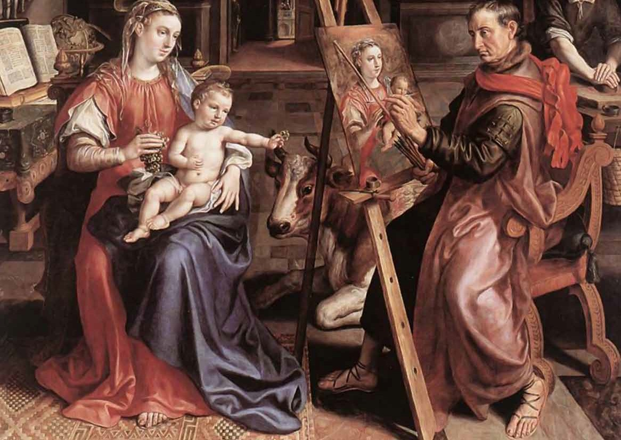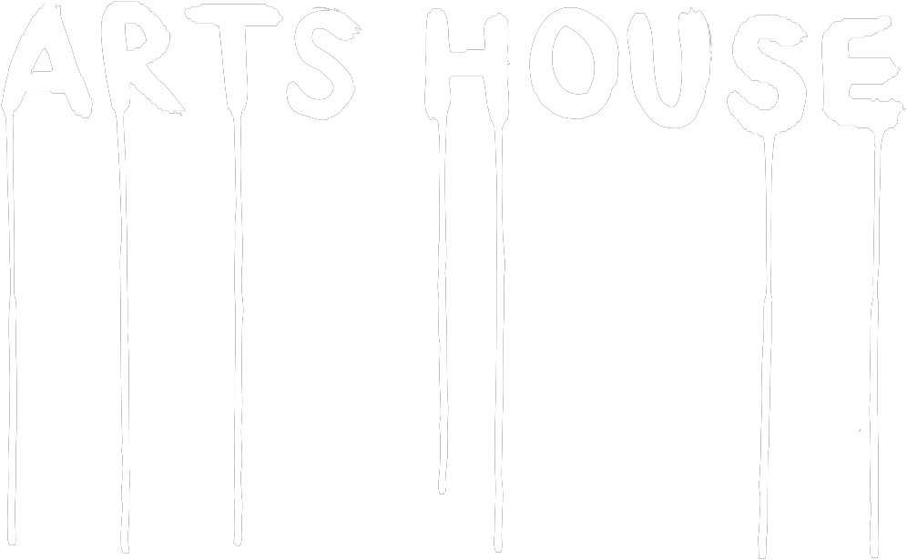

About Arts House

Arts House presents contemporary arts in programs encompassing performance, exhibitions, live art, installations, residencies, events and other activities that nurture, support and stimulate cultural engagement. We value work in which artists at different stages of their careers, as well as our diverse audiences and communities, are actively involved

in creating an imaginative, just and environmentally sustainable

global society.

Arts House’s programs include two curated public seasons of multidisciplinary work each year. From 2013, approximately half of each season’s programming will be selected through a new Expression of Interest process. We will be seeking artists who are responding to the urgent issues of our time in imaginative and surprising ways, taking artistic risks and offering multiple ways for audiences to engage with or co-author their work.

Arts House is a City of Melbourne contemporary arts initiative.

For more information about our programs or our Expression of Interest process, please contact us on 03 9322 3720 or visit artshouse.com.au.

Arts House People

Team Leader: Sue Beal » Creative

Producer: Angharad Wynne-Jones

»Associate Producer: Olivia Anderson » Associate Producer: Jackie Johnston » Technical Operations Manager: Adrian Aderhold » Technical Production Manager: Tom Howie » Technical

& Venue Coordinator: Jim Stenson » Front of House Manager: Lexie Wood » Venue

& Assets Manager: Mike

Mullins » Business Coordinator: Genine Romagnoli » Bookings Coordinator: emma

Beinke » Business Support Officer: Ruvi Amurtha » Engagement and Communications Coordinator: Bianca Charleston

Graphic Design:

Famous Visual Services

Copywriter: urszula Dawkins

Publicity: Ben Starick & Susanne Kean from Starling Communications

Arts House

Advisory Panel

Siu Chan Alison Halit Michaela Coventry Martin Brennan Michael Parry

Arts Victoria representative for

CultureLAB: Christabel Harvey

Supported by

Metapraxis

Metapraxis has been supported by the City of Melbourne through Arts House.

Shifting Ground

Shifting Ground has been supported by J.U.M.P, the National Mentoring Program for Young and Emerging Artists, the Australian Government through the Australia Council, its arts funding and advisory body and the City of Melbourne through Arts House.

Hell House

Hell House has been supported by the Australian Government through the Australia Council, its arts funding and advisory body, Arts Victoria, City of Greater Geelong, TAC, Give Where You Live, Helen Macpherson Smith Trust, Perpetual Trustees and the City of Melbourne through Arts House.

The provision of employment assistant services to people with a disability is funded by the Australian Government under the Disability Employment Assistant Program.

Democratic Set

Democratic Set has been toured by Performing Lines for Mobile States, with the support of the Australian Government through the Australia Council, its arts funding and advisory body, through the national performing arts touring program, Playing

Australia and through the City of

Melbourne through Arts House.

DOKu RAI

DOKu RAI has been assisted by

the Australian Government’s Major Festivals’ Initiative managed by the Australia Council, its arts funding and advisory body, in association with the Confederation of Australian International Arts Festivals, Darwin Festival, Brisbane Festival, Stealth Agency, The Black Lung Theatre

and the City of Melbourne through

Arts House.

RRAMP

RRAMP was a Brisbane Powerhouse commission. Toured by Performing Lines for Mobile States, with

the support of the Australian Government through the Australia Council, its arts funding and advisory body, and through the national performing arts touring program, Playing Australia and the City of Melbourne through Arts House.

Star******s

Star******s has been supported by Make It @Merrigong – making great theatre locally in Wollongong, the Australian Government through the Australia Council, its arts funding and advisory body and the City of Melbourne through Arts House. Star******s was originally presented by Merrigong Theatre Company

at the Illawarra Performing Arts

Centre, 2010.

Impasse

Impasse has been kindly supported by Dunlop Foams, the Australian Government through the Australia Council, its arts funding and advisory body, and the City of Melbourne through Arts House.

Hold

Hold has been supported by Litmus Research Initiative and Massey University College of Creative Arts, Wellington, New Zealand.

Gauge

Gauge has been supported by the Australian Government through the Australia Council, its arts funding and advisory body, Arts

Victoria, CultureLAB and the City of

Melbourne through Arts House.

The Resonance Project

The Resonance Project has been supported by the City of Melbourne through Arts House.

3 2

Subscribe to our E-News for updates:

artshouse.com.au

Green Tix for Nix

In case you haven’t heard, Arts House is paving the way to cleaner, more sustainable future with Green Tix for Nix! This season we’ve nominated Rramp - The Collector, the Collector, the Archivist, &

the electrocrat as our Green

Tix event. ALL tickets for the

3pm performance on Saturday 8

September are FREE if you follow the simple rule: get to the event without using the car.

Help us offset our carbon footprint by taking public transport, walking, cycling or one of the many other ways to travel green. We will want

to see your bike helmet, public transport ticket or smokin’ soles when you arrive. And although your ticket is free you will need to book

in advance either online, using the promo code GREEN, or by phoning (03) 9322 3713.

Get here green and we’ll keep the tickets lean. Completely, utterly and resolutely FREE!

Booking Information

Tickets can be purchased online at artshouse.com.au or 03 9322 3713.

Please note there will be a $1.50 transaction fee per booking when booking online or by phone.

Tickets may be purchased at the performance, subject to availability.

Public Transport

To Arts House, North Melbourne

Town Hall: Tram 57 - stop 12,

Corner Queensberry & Errol Streets

To Arts House, Meat Market: Tram 59 - stop 17,

Corner Flemington Road & Blackwood Streets

See [www.ptv.vic.gov.au](http://www.ptv.vic.gov.au/) for more info.

Access Information

For access enquiries please contact Arts House on 03 9322 3713.

Brochure available in large print online, visit artshouse.com.au

Australia is home to the oldest living culture on earth. Respect and engagement with this ancient culture and its contemporary

lineage continues to make a unique contribution to creativity in this place and inspire our collective consciousness and understanding. Arts House acknowledges

and respects the customs and traditions of Indigenous Australians and their special relationship with the land. The artists and organisers respectfully acknowledge that this program takes place on the land

of the traditional owners of the

Kulin Nation.

Arts House

North Melbourne Town Hall & Warehouse

521 Queensberry Street

North Melbourne

(03) 9322 3720

Melways: 2A J10

Arts House Meat Market

5 Blackwood Street North Melbourne (03) 9322 3720

Melways: 2B A9

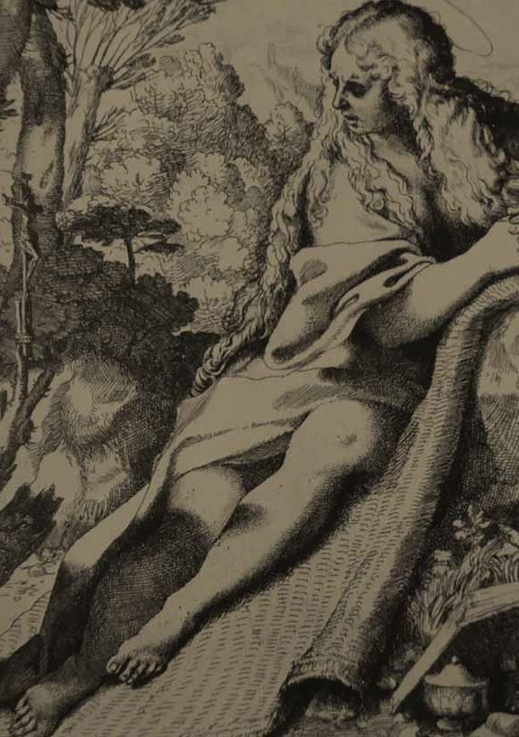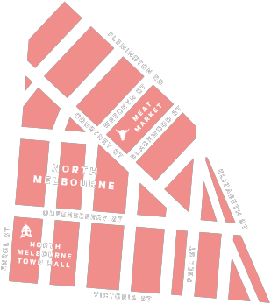

Program details are correct at the time of printing but are subject to change where necessary and without notice. Please check the website for updates.

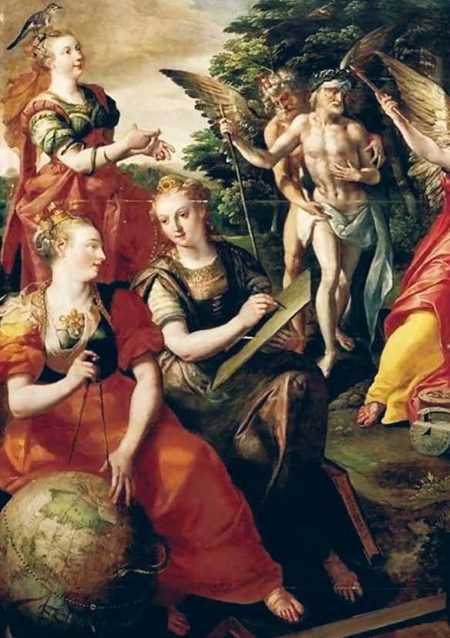

Arts House is a City of Melbourne contemporary arts initiative