Translation Credits

Dutch
Female voice: Veerle van Overloop
Male voice: Yorick Zwart
Translation: Martijn Boven
Sound Technician / Production: Henk Bothof
Edit and mastering: Anthony Hampton
co-producers Noordezon festival 2008 (www.noorderzon.nl)

French
Speaker A: Frédéric Pichon
Nora and Speaker B: Nathalie Lombardet-Pochic
Helmer: Pascal Dubois
Woman: Silvia Mercuriali
Sound tecnician: Guillaume Fournier
Edit and mastering: Anthony Hampton
Translator: Isabelle Osouf
Production: Association 3mètres: Bertrand Dubois, Caroline Imbert
Supported by King's Fountain (Barbara & Henry Pillsbury)

German
Übersetzung: Thomas Rach
Sprecher A: Heiko Senst
Sprecher B: Verena Schonlau
Nora: Susanne Sachsse
Torvald: Christian Wittmann
Tontechnik: Tito Toblerone
Edit and mastering: Anthony Hampton
co-producers Hebbel Am Ufer, Berlin (www.hebbel-am-ufer.de)

Hungarian
Direction: Anikó Varsányi
Edit and mastering: Károly Liszkai
Speaker A: Balázs Láng
Speaker B: Lili Horváth
Nora: Laura Ruttkay
Torvald: János Papp
Translation: Katalin Erdődi
Co-produced by Trafó – House of Contemporary Arts
Supported by: Toldi Art Cinema

Croatian
Glas A: Siniša Bahun
Glas B: Jana Škrgulja
Nora: Blanka Bukač
Torvald: Ivan Zaluški
Režija: Anthony Hampton
Oblikovanje i montaža zvuka: Darko Jeftić
Prijevod: Nataša Nikpalj-Juraić
Produkcija: Berislav Juraić
Co-produced by REZ
Supported by Ministry of culture of Croatia, British Council

Italiano
Voce A - Silvia Mercuriali
Voce B - Anthony Hampton
Helmer - Riccardo Magherini
Nora e Donna – Maria Eugenia D’Aquino
Traduzione - Marina Mercuriali
Edit and Mastering - Silvia Mercuriali and Anthony Hampton
Produzione in collaborazione con MilanOltre ed Es. Terni
Recorded in Brighton UK and Milano Italia, August - September 2008

Japanese
Speaker A: Sadao Ueda
Speaker B: Sachi Kimura
Nora: Kazuko Hokhi
Helmer: Kentaro Suyama
Edit and Mastering - Silvia Mercuriali and Anthony Hampton
Produced with the continued support of Paul Bennun (Somethin' Else)
funded by Sasakawa foundation

Polish Co-produced by Teatromania Festival, Bytom

Portuguese
Translation: Rita Valente
Male voice: José-Alberto Ferreira
Female voice: Rita Valente
Sound Technician: Nuno Morao
Edit and mastering: Anthony Hampton
co producers Escrita na Paisagem (www.escritanapaisagem.net)

Spanish
Translation: Alan Pauls
Speaker A: Darío Tangelson
Speaker B: Paula Salomon
Nora: Mónica Santibañez
Torvald: Alfredo Alcón
Mujer: Vivi Tellas
Recording, edit and mastering: Anthony Hampton
Recorded in Buenos Aires, Argentina - November 2007

Slovene
Govorec A: Gregor Gruden
Govorka B: Tamara Bračič
Nora: Nevenka Koprivšek
Torvald: Samo Selimović
Oblikovanje in montaža zvoka: Sašo Kalan, Anthony Hampton
Co-produced by Bunker

etiquette

By 

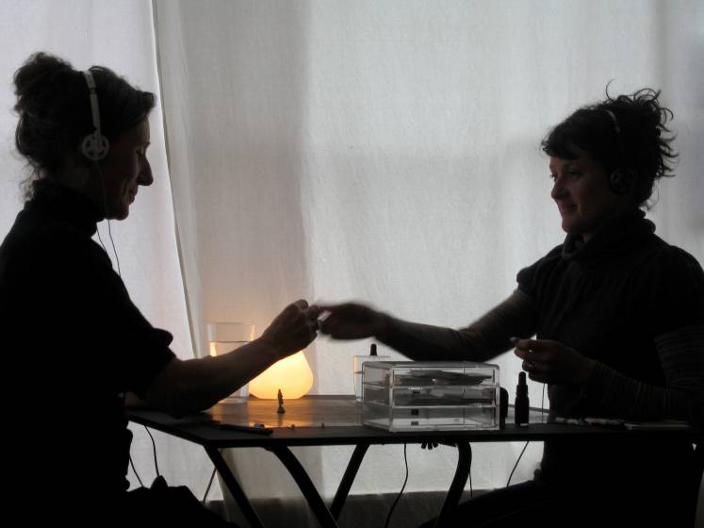

Written by Ant Hampton and Silvia Mercuriali

Etiquette is a half-hour experience for two people in a public space. There is no-one watching - other people in the cafe or bar are not aware of it. You wear headphones which tell you what to say to each other, or to use one of the objects positioned to the side. There is a kind of magic involved - for it to work you just need to listen and respond accordingly.

“Etiquette explores the gap between language and meaning. In creating an entirely private space in a public setting, something extraordinary happens.”
Lyn Gardner, The Guardian

Etiquette can also be done in English, Welsh, French, Portuguese, Dutch, Spanish, German, Italian, Japanese, Polish, Slovene, Hungarian and Croatian

The Company

Ant Hampton formed Rotozaza in 1998 and joined with Silvia Mercuriali shortly afterwards. They have been working together in different ways - and in different countries/languages - on over 20 Rotozaza productions since then, from early site-specific work in Milan and Paris, to a more recent strategy of selecting performers, different every night, who agree to take instructions, live and unrehearsed.
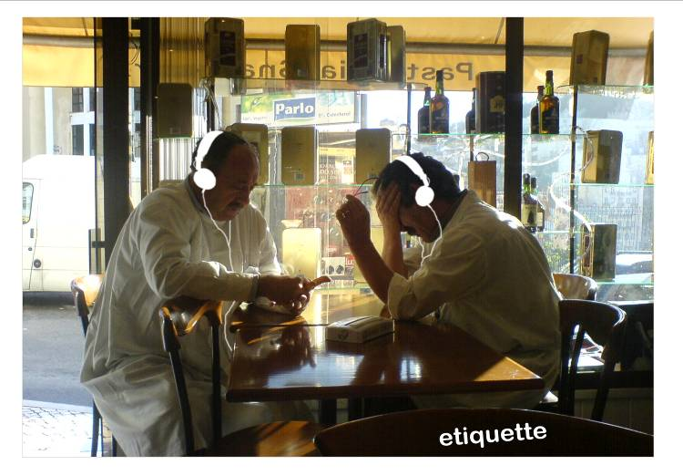

In 2001 Rotozaza conceived of ‘Autoteatro’, a self-generating performance mechanism where the audience's participation is the show, and nothing else. The style of ‘Autoteatro’, where audiences receive instructions and respond accordingly, offers the fantasy of carrying out actions or speaking to someone without having to plan what you do or say, with the resulting thrill of disowning responsibility in a performance situation. The form enables the participants to wholly immerse themselves in the piece, at once actor and audience. Using simple technology, participants are given instructions - usually via headphones - about what to say and do.

The first project in the ‘Autoteatro’ series was Etiquette. Since launching at the Edinburgh Festival in 2007 Etiquette has been to over 20 countries and has been translated into thirteen languages.

Rotozaza have since developed two further shows; Guru Guru by Ant Hampton with Joji Koyama and Isambard Khroustaliov and Wondermart by Silvia Mercuriali in collaboration with Matt Rudkin and Tommaso Perego.

See www.rotozaza.co.uk for further details.

Produced by ArtsAgenda

Contact: Alice Booth, Project Manager
alice@artsagenda.co.uk
ArtsAgenda
18 Margaret Street
Brighton BN2 1TS
+44 (0) 1273 626519
www.artsagenda.co.uk

Main Credits

English
Sound Design / Edit - Anthony Hampton
Speaker A: Anthony Hampton
Speaker B: Silvia Mercuriali
Female 'figure' voice: Gemma Brockis
Nora: Melanie Wilson
Torvald: Greg McLaren
Original version funded by Arts Council England and produced by Paul Bennun (Somethin' Else)
