ARTS HOUSE

January – July 2014

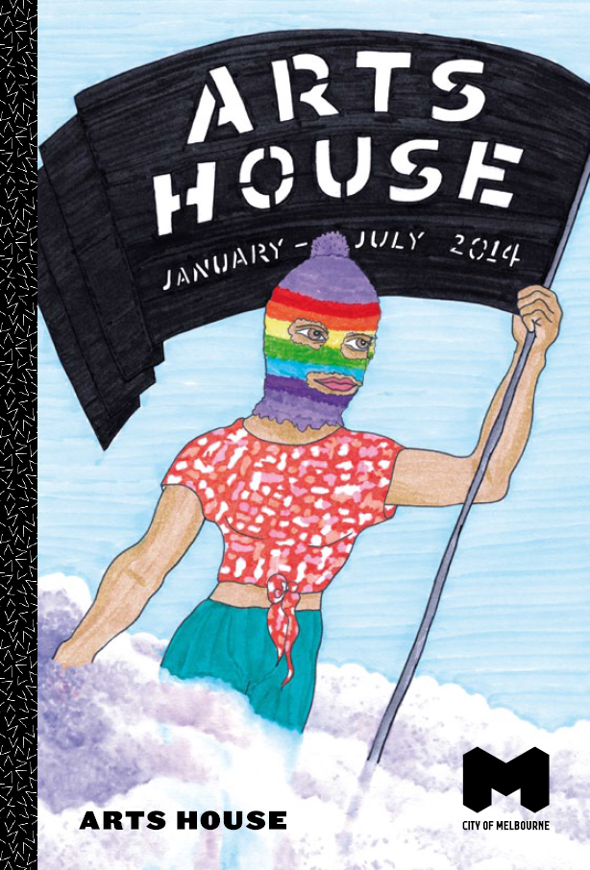
Welcome to Arts House Season 1, 2014

At Arts House artists take creative risks, putting audiences on the frontline of powerful stories, urgent Issues, fascinating international collaborations, new contexts and new ways of making art!

The year begins with a collaboration with Melbourne Indigenous Arts Festival: Little Black Bastard is a compelling story of hardship and achievement told by Aboriginal Elder Noel Tovey, charting his early history in North Melbourne and his journey to fame and fortune. Now 82 years old, Tovey brings his incredible life story up to date.

And then, because we know you love big surprises…
The Festival of Live Art (FOLA) – a collaboration with Footscray Community Arts Centre and Theatre Works – kicks off an extended long weekend at Arts House on
19 March with Tristan Meecham’s Game Show. With a cast of 150, it’s our biggest ever participation event!
Start training now to be match fit for FOLA at Arts House – four days of brilliantly weird, strangely seductive, sometimes confronting live art performances/talks/suppers/sleepovers/dance-offs, culminating in a performance marathon on Sunday
23 March.

In April the sublime Astra, Punkasila and Slave Pianos present one of the year’s most adventurous music and visual experiences – The Lepidopters: A Space Opera. Moving into May, as part of Next Wave, we’re excited to co-present rising stars Natalie Abbott, I’m Trying To Kiss You and Shian Law. Season 1 wraps in July with cross-arts performance experience LIVE WITH IT we all have HIV, created by BalletLab Artistic Director Phillip Adams and visual artist Andrew Hazewinkel in collaboration with HIV+ communities. LIVE WITH IT we all have HIV coincides with the 20th International AIDS Conference.

Bubbling along all the while are our CultureLABs…
This season choreographers Antony Hamilton, Kristina Chan and Rosalind Crisp, and performance makers Tamara Saulwick, Rawcus and Ashley Dyer will test and experiment using all their considerable skills, with a view to making work that will alter your mind!

And because we love doing what we do and want a planet to keep doing it on, we’re doing it green – with Greenie-in-Residence Matt Wicking (thank you Australia Council and City of Melbourne!). Matt is inviting in some truly insightful people to talk about possible futures and how to get there; and will be helping several arts companies to develop their environmental sustainability plans.

What’s not to love? Come and be entranced – we can’t do it without you.

A Message from the City of Melbourne

It is our great pleasure to introduce the 2014 Season 1 program for the City of Melbourne’s wonderful
Arts House.

Arts House is one of Australia’s most exciting developers and presenters of cutting-edge art and since 2005 has been an essential part of Melbourne’s arts and culture landscape.

By developing performance, live art, installation and multidisciplinary work it truly feeds the cultural life of Melbourne and its creative spaces; and its programming pushes boundaries in the presentation of contemporary works.

The iconic North Melbourne Town Hall and the heritage-listed Meat Market provide a worthy home for Arts House. These venues are also community spaces used by local artists whose work, while not part of the curated program of events, is crucial to the cultural life of Melbourne.

The Season 1 program offers a collection of performances that will entertain, entice and surprise you and we encourage you to be part of it.

Robert Doyle, Lord Mayor

Cr Rohan Leppert, Chair, Arts & Culture portfolio

Contents

Show | Artist | Page
Little Black Bastard | ILBIJERRI Theatre Company | 6
Festival of Live Art (FOLA) |  | 9
The Lepidopters: A Space Opera | Slave Pianos, Punkasila and Astra | 20
Next Wave at Arts House |  | 23
LIVE WITH IT we all have HIV | Phillip Adams BalletLab | 28
Greenie-in-Residence Project |  | 31
CultureLAB |  | 33
Bookings & Access |  | 35
Venues |  | 37

Stay Connected

Subscribe to our eNews for updates at artshouse.com.au

Facebook: /artshousemelbourne
Twitter: @artshousemelb
Instagram: @artshouse
- Use hashtag #artshouse
Little Black Bastard

ILBIJERRI Theatre Company

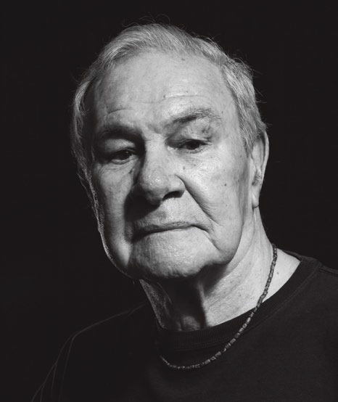

Image: Steven Rhall

Presented by Arts House, City of Melbourne
and ILBIJERRI

Abandoned by his parents at a young age, Noel Tovey struggled through a rough childhood on the streets of Melbourne. At 17 he ran away to London and reinvented himself as a dancer, actor, singer and choreographer on some of the world’s great stages. Little Black Bastard is his story: a gripping and tender monologue told in his own words.

Australia’s first Aboriginal ballet dancer, Uncle Noel describes his life and times with candour, warmth and humour – from post-War Melbourne to swinging sixties London and beyond, where his peers included film and theatre’s artistic elite. His journey from street kid to show-biz star is one of our country’s greatest success stories. Having conquered the ghosts of his early years, Tovey approaches Little Black Bastard with a sense of resolution, healing and completion.

After touring internationally for over a decade,
Little Black Bastard returns to the suburb where it all began – North Melbourne, where Tovey spent some of his harshest childhood years. Performances of
Little Black Bastard are becoming increasingly rare – don’t miss this chance to experience one of our artistic Elders recounting his astonishing story of triumph and transformation.

“Tovey’s performance is gripping and intensely moving…a remarkable story and performance of great cultural and historical importance.” — The Age

Writer/Performer Noel Tovey
Director/Dramaturge Robina Beard
Rehearsal Director Isaac Drandic
Set Designer Richard Roberts
Lighting Designer Rachel Bourke
Sound Designer Sarah De Jong
Arts House, North Melbourne Town Hall
Thu 13 – Sat 15 February

Preview Thu 13, 7.30pm
Fri 14 – Sat 15, 7.30pm

Post-show Q&A: Sat 15

1hr 30min, no interval

Preview: all tickets $15
Full $25 / Conc $20 / Student $15

artshouse.com.au or (03) 9322 3713

Warning: Adult themes. 12 years and older

FOLA at Arts House

Thu 20 – Sun 23 March
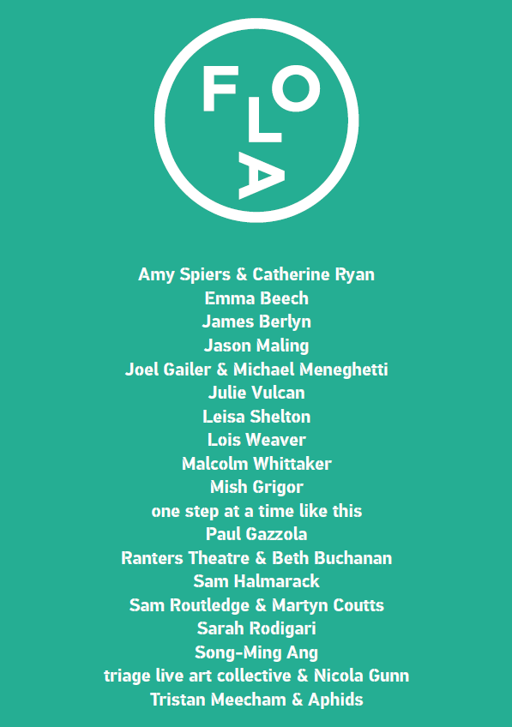
Presented by Arts House
A brand new festival hits Melbourne in March for 17 category-busting days! The Festival of Live Art (FOLA) is performances, experiences and happenings that defy convention, put everything on the line, seduce, cajole and provoke. FOLA brings you all-night speeches and one-on-one encounters, choreographed crowd dispersal, extreme printmaking, cheesy pop anthems and much much more.

Presented by Arts House, Footscray Community Arts Centre and Theatre Works, FOLA unfolds in performance spaces and on the streets, in small tents, public venues and private nooks – and includes a massive extended weekend at Arts House.

From Thursday 20 to Sunday 23 March, join us to sample delights, curiosities and unique experiences made specially for and with you by talented creators from across Australia and beyond. Spend a day or a few with us – there are over 20 events to choose from – then party when the sun goes down at our Meat Market Club Nights. When the stars are high in the sky, gaze up in wonder at the North Melbourne Town Hall clock tower, ablaze with the morphing and transformative light projections of Permanent vs Impermanent 3. And if you just can’t get enough of FOLA, pack your jarmies, sleep over Saturday night and stay for breakfast.

Not sure what live art really is? For the super-shy, there’s the Live Art Escort Service, offering everything you ever wanted to know about live art…but were afraid to ask.
Check out details of all events at artshouse.com.au or fola.com.au.

FOLA takes over Arts House, North Melbourne
Town Hall, Meat Market and Warehouse from
Thursday 20 – Sunday 23 March. Most events are
FREE, with some ticketed performances. Drop by, catch a show and experience FOLA!

The 2014 Festival of Live Art runs across Melbourne from Friday 14 – Sunday 30 March. For full FOLA program information visit fola.com.au.

FOLA at Arts House
Thursday 20 March

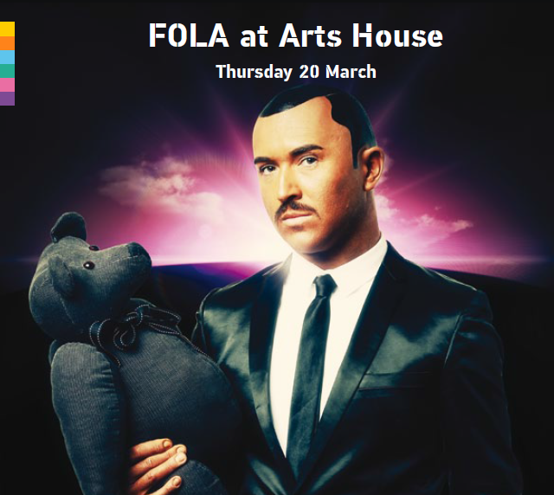
Image: Game Show; Photo Jeff Busby. Design Chris More

FOLA at Arts House kicks off with Game Show – a show-biz spectacular from the creators of Fun Run. Game Show examines one man’s desperate pursuit of fame and his personal sacrifice for a chance at the big time. Join host Tristan Meecham as 50 contestants compete live for a grand showcase of prizes:
Tristan’s very own possessions! Win his fridge! Win his eczema cream! Win his plasma television!

The second work in The Coming Out Trilogy,
Game Show fuses game play, moral dilemmas and live cinema in a critique on celebrity, materialism and competition. What would you do to win? Does what we risk determine what we value? Will the winner really take all?

After Game Show, the Meat Market ramps up a notch with the first of three FOLA Club Nights. From Thursday to Saturday help us celebrate an amazing festival with drinks, grooves and your hottest moves. Til late!

FOLA at Arts House
Friday 21 March

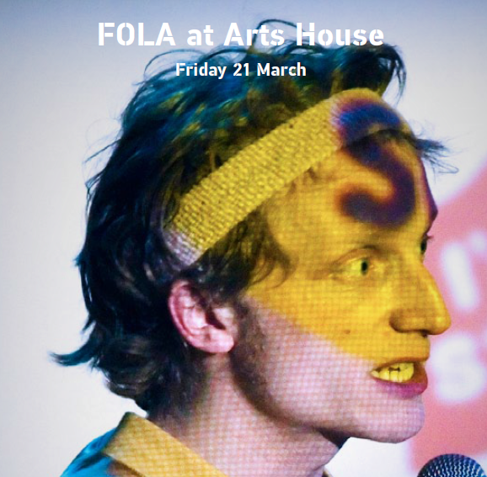

Image: Sam Halmarack & The Miserablites; Photo Paul Blakemore

On Friday night FOLA hits full throttle across Arts House venues from the Meat Market to the Warehouse and everywhere inbetween.

Bare your soul and get your nails done by the towering Tawdry Heartburn, or imagine a new life with
I Think I Can, amid a whimsical model railway and town. Participate in conversational works that explore the GFC (Life is Short and Long), what you don’t know you don’t know (Ignoramus Anonymous), your most memorable live art experience (Mapping), artistic survival skills (GOLD COIN SERIES) and a good night’s sleep (I Know That I Am Not Dead); or rest amid a flotilla of twinkling vessels in Drift’s twilight space.

Don’t miss Sam Halmarack & The Miserablites (UK) – the bombastic pioneers of interactive pop. Located somewhere between a theatre show and a stadium pop concert, get ready for handclapping anthems and electro music to move and inspire. With songs, stories and a little help from you, experience a unique take on what it means to be redeemed by music.

FOLA at Arts House
Saturday 22 March

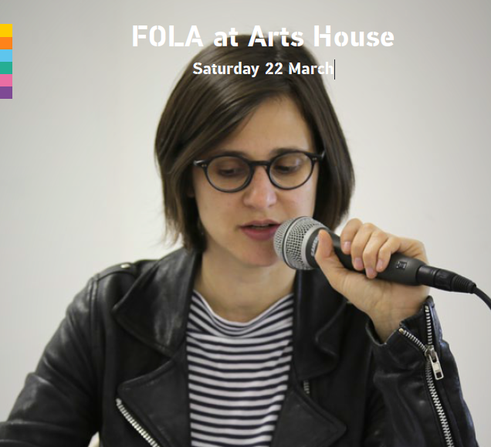

Image: A Filibuster of Dreams; Photo Jessica Olivieri

Sleep in late because you’re in for a big Saturday night! After a leisurely lunch, mosey back to North Melbourne to catch the shows you didn’t squeeze in yesterday, and get set for a string of highlights to take you through till dawn.

At 5pm line up for lamingtons and rousing speeches as Man O Man transports you to the final night of the patriarchy, steeped in the knife-sharp wit of post’s Mish Grigor; then swing into our Saturday Sesh for tasty food, yummy bands and a cheeky drink or two.

Fed and rested, you’ll be ready for the Live Art Dance Party – a one-off mash-up of smokin’ hot DJs, cutting-edge live art performance and guaranteed good times.

Of course, you won’t want to go home after that – and why would you, when you can sleep over? Bring your sleeping bag for all-night durational event A Filibuster of Dreams – and stay for Sunday brekky at the Meat Market followed by all-day extreme printmaking marathon Performprint.

FOLA at Arts House
Sunday 23 March
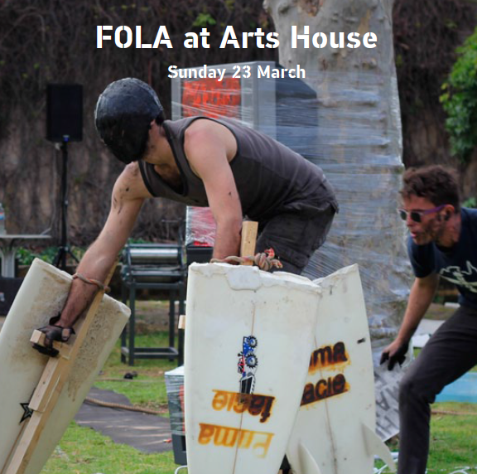

Image: Performprint

On Sunday, explore the music you love despite knowing better with Can’t Help Falling in Love; take part in a workshop (if you dare!) with the man whose live art credentials include getting participants to spank one another at Lords cricket ground (Everybody hates audience participation?); and experience crowd dispersal techniques first hand in Nothing To See Here (Dispersal). Sit down to an afternoon ‘dinner party’ with words and ideas as the food, at Lois Weaver’s (UK) durational performance installation The Long Table, contributing your thoughts on the themes and issues you’ve seen emerging during FOLA: money and power, gender and sex, activism, visibility and more.

Throughout the day, get your fill of extreme printmaking and macho ritual at Performprint – a ten-hour exploration of masculinity, live art and the limits of print production. Come and go as you please, as printmaker Joel Gailer and performance artist Michael Meneghetti join forces along with roaring Harleys and an ear-splitting cacophony of competing bands – a guaranteed wild ride to end FOLA at Arts House!

For full FOLA program information visit fola.com.au from Monday 3 February.

The Lepidopters:
A Space Opera

Slave Pianos, Punkasila and Astra

Image: Slave Pianos, Sedulur Gamelan (Gamelan Sisters); Photo Benjamin Ducroz

Presented by Arts House, Slave Pianos and Astra
World Premiere
Science fiction meets cross-arts mavericks,
Slave Pianos, joining with the 40-member Astra Choir, Yogyakarta mystic punk-art collective Punkasila, Indonesian singer/dancer Rachel Saraswati and virtuoso pianist Michael Kieran Harvey to present
The Lepidopters: A Space Opera.

A kulturnautic expedition defying the sovereign borders of visual arts and music, The Lepidopters responds to a commissioned text by sci-fi writer Mark von Schlegell, in which alien moths invade the Indonesian archipelago with the aim of colonising Earth through inter-species reproduction. Including projected illustrations and film by Yogyakarta artists Erwan ‘Iwank’ Hersi Susanto and Terra Bajraghosa, this multi-art-form concert draws on the work of Robert Smithson to explore sonic landscapes and dystopian visions, Indonesian telepathy, ancient Javanese mysticism, and art practices both traditional and modern.

Slave Pianos are notorious for their novel advances on the prison-house of music. Central to the staging of
The Lepidopters is the Sedulur Gamelan – a self-governing electromechanical ‘slave gamelan’ housed in two large interlocking wooden structures.

A trailblazing choir, a concert pianist, a pop-star mezzo-soprano, a punk band with just-intonation 'gyrostatic' guitars, noise machines, video installation, an automated gamelan and analogue electronics –
don’t miss this renegade cross-cultural and
inter-planetary event.

“Everything is sane. The Moths have gone away.”
— Mark von Schlegell

Slave Pianos Rohan Drape, Neil Kelly,
Antanas Kesminas, Danius Kesminas, David Nelson, Michael Stevenson
Punkasila Uji ‘Hahan’ Handoko Eko Saputro,
Rudy ‘Atjeh’ Dharmawan, Antariksa, Erwan ‘Iwank’ Hersi Susanto, Prihatmoko ‘Moki’ Catur
Astra The Astra Choir, John McCaughey
Piano/Organ Michael Kieran Harvey
Voice/Dance Rachel Saraswati
Video Artist Terra Bajraghosa
Narrator Richard Piper

Arts House, North Melbourne Town Hall
Sat 12 – Sun 13 April

Sat 12, 3pm & 7.30pm
Sun 13, 5pm

2hrs, includes interval

Full $25 / Conc $20 / Student $15

artshouse.com.au or (03) 9322 3713

Next Wave at
Arts House

16 April – 11 May

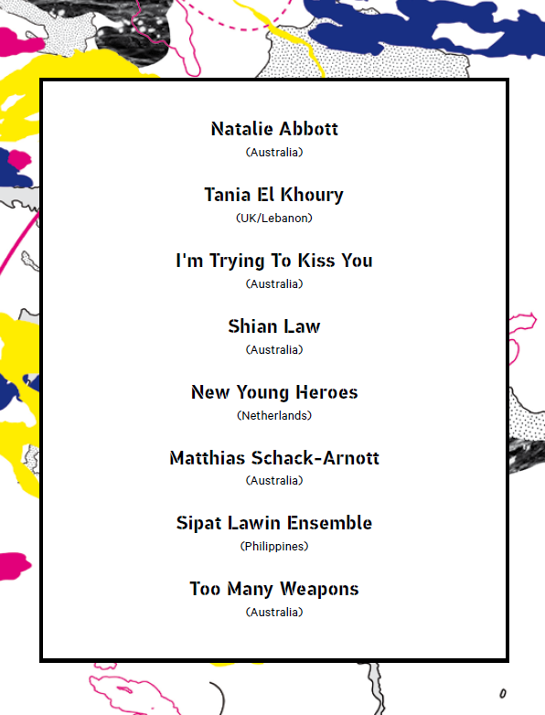

Presented by Next Wave and Arts House

World Premieres
The Next Wave Festival sees emerging artists from Australia and the world converge in Melbourne to challenge our understanding of what art can be. Responding to the theme New Grand Narrative, Next Wave will make the invisible visible, and the things you think you don’t care about shoot bullets at your heart.

Here at Arts House the Next Wave story unfolds from Wednesday 30 April, with an explosion of resolutely ambitious and beautifully bold contemporary performance works.

From the Netherlands to the Philippines, the familiar boroughs of Melbourne to the haunted gardens of Syria, new journeys from radical perspectives will bring into focus the most pressing cultural issues of our time.

To experience new contemporary art at its fullest, hand yourself over on 3–4 and 10–11 May from morning to night – breakfast to dance floor – via curated journeys of the Festival and our city.

Next Wave Festival 2014 tickets go on sale
Friday 28 March. For full program information, visit artshouse.com.au or nextwave.org.au.

Image: Madonna Arms; Photo Theresa Harrison

Madonna Arms
I’m Trying To Kiss You

Welcome to the battlefield. From the treadmill to the taco truck, Madonna Arms follows the internal struggle of chaos, terror and hope as one woman attempts to lose weight. Madonna Arms is a fantastical sci-fi exploration of the ways in which power, strength and fitness live and die in the body and psyche of a young woman. Absurd, hilarious and ultimately heart-wrenching, Madonna Arms is a humorous and dangerous look at a vicious cultural logic we have learned to accept as part of our everyday lives – as futile and devastating as war.

Creators I’m Trying To Kiss You
Writers Zoey Dawson, Anna McCarthy, Allison Wiltshire
Director Allison Wiltshire
Performers Zoey Dawson, Ella Harvey, Anna McCarthy
Producer Bek Berger
Sound/Composition Claudio Tocco
Set/Costume Designer Romanie Harper
Lighting Designer Katie Sfetkidis

Personal Mythologies
Shian Law

Personal Mythologies is an act of self-mythologising. The performance shifts from one spectacle to another:
a human installation, an improvisation championship,
a dance-off between the victor and the creator of the choreographic game. Immersive and self-reflexive, in this work everyone is a performing body, and all bodies are the synthesis of the ultimate spectacle.

The latest offering by award-winning dance provocateur Shian Law and his creative team,
Personal Mythologies queries the power relations of authorship versus spectatorship and interrogates the theatrical and the spectacular.

Concept/Direction/Choreography Shian Law
Dramaturge/Performer Jo Lloyd
Sets/Lighting Matthew Adey, House of Vnholy
Sound Duane Morrison
Performers Lucy Farmer, Chelsea Hooper,
Andrew Treloar
Costumes Nicholas McKinnon

MAXIMUM
Natalie Abbott

A dancer. A bodybuilder. Endurance. Durability. MAXIMUM is a duet between a dancer and a bodybuilder. Two highly trained performers execute demanding acts of intense physical duration, inviting the audience on a sensorial ride of sustained endurance.

As they push their bodies beyond exhaustion, the performers’ actions begin to reveal something more human. Every minuscule action becomes heightened, with a focus on repetition and unison. Under sweltering lights and with a live sound score, awkward images and manoeuvres emerge as they work together to find a physical dialogue.

MAXIMUM takes a sharp look at demanding physical acts, side-by-side, to reveal two seemingly disparate forms united through live performance.

Direction/Choreography Natalie Abbott
Collaborator/Performer Donny Henderson-Smith
Dramaturge Matthew Day
Lighting Designer Matthew Adey

Live With It
we all have HIV

Phillip Adams BalletLab

Image: 3 Deep

Presented by Arts House and Phillip Adams BalletLab

World Premiere
LIVE WITH IT we all have HIV is a striking, cross-arts performance experience, tracking the still present, important issue of HIV/AIDS, and how it impacts those of us who live with HIV/AIDS bodily; and those of us who are profoundly affected by the virus in other ways.

BalletLab Artistic Director Phillip Adams and visual artist Andrew Hazewinkel have developed this powerful,
life-affirming work with project participants of diverse age, sexual orientation and ethnicity; through a series of workshops held in regional and urban centres across Victoria.

LIVE WITH IT is an intimate portrait of how we, as a broad community, have lived through and shaped Australia’s 30-year history with the virus. LIVE WITH IT presents co-authored and individual stories across multiple expressive platforms. Choreography, written and spoken words, video and other visual media are used in interpreting the ideas expressed by the participants, which define their personal relationship
with the virus. LIVE WITH IT explores aspects of the everyday that structure these highly personal and sometimes fugitive spaces and introduces us to the identities inhabiting them.

Created in partnership with the Victorian AIDS Council/Gay Men’s Health Centre, LIVE WITH IT will be presented alongside the 20th International AIDS Conference. LIVE WITH IT attempts to lift the stigma too often associated with HIV/AIDS, foregrounding a distinctly Australian perspective. This message is powerfully entwined with a commitment to the affirmation and wellbeing of its community of creators.

LIVE WITH IT is a unique and timely journey into what HIV/AIDS means to all of us today, and a compelling, uncensored expression of shared human experience.

“We co-create HIV, each of us bringing a whole world to the moment in which those three letters are said.” — LIVE WITH IT Participant

Concept/Co-Direction/Choreography Phillip Adams
Concept/Co-Direction/Design Andrew Hazewinkel
With Community Participants from Melbourne and regional Victoria

Arts House, Meat Market
Thu 17 – Sun 27 July

Preview Thu 17, 8.30pm
Fri 18 – Sat 19, 8.30pm
Tue 22 – Sat 26, 8.30pm
Sun 27, 3pm

1hr 30min, no interval

Preview: all tickets $15
Full $25 / Conc $20 / Student $15

artshouse.com.au or (03) 9322 3713

Warning: Adult content
Image: 3 Deep

Greenie-in-Residence
Project
Future Forums

Join the sustainability conversation with Arts House in 2014.

Melbourne-based theatre artists and organisations will be gathering at Arts House throughout 2014 to develop their environmental sustainability practice as part of our Greenie-in-Residence Project – and you’re invited to join them!

A new initiative by the City of Melbourne and the Australia Council for the Arts, this pilot project will bring together selected small-to-medium companies and artists to work with Greenie-in-Residence and sustainability expert, Matt Wicking (Tipping Point Australia, Monash Sustainability Institute’s Green Steps education program). Program participants will attend a series of workshops during the year: developing sustainability action plans; reviewing sustainable materials, recycling and transport options; measuring and reporting on progress; and learning how to communicate for success.

Alongside the workshops, Arts House will host a series of public forums that open up the conversation to the broader Melbourne community. Meet the participants and join the conversation, build your networks and take home new ideas.

The Greenie-in-Residence Project will launch in February – jump online to find out the details and join us to create a more sustainable future in the arts!

For full details and to book, visit artshouse.com.au/greenieforums.

CultureLAB

CultureLAB is Arts House’s dedicated, venue-based creative development program for independent artists and companies, conducted in partnership with Arts Victoria. Providing time and space for exploration and research, workshopping and rehearsal, CultureLAB supports artists across all art forms to create powerful, exciting, ground-breaking and original works.

Antony Hamilton – Meeting
Meeting explores Antony Hamilton and Alisdair Macindoe’s shared obsession: the relentless interplay between strict rhythmic sound and compulsively detailed movement. Their aim is to develop a formal choreographic study that requires extreme mental and physical agency from the performers. Devised movement, staging and sonic landscapes will test the limits of their unique choreographic discipline.

Tamara Saulwick – Endings
Part chamber concert, part performance work, Endings is a meditation on cycles and the ending of things. Using portable turntables, reel-to-reel tape players and live performance, Endings finds form for experiences both ordinary and extraordinary, that cluster around death, dying and afterlife.

Rawcus – Catalogue
Housed in a vertical playing space, Catalogue is a composition of simultaneously performed self-portraits
– a relentless accumulation of diverse individual expressions, viewed separately and in relation to one another with moments of unison and chorus. Catalogue delves into the complexities of defining identity, and asks whether the celebration of diversity only separates us from each other.

Kristina Chan – A Faint Existence
This landscape is immoral – ever-changing – impermanent. Glaciers melt – species disappear – stars explode – we decompose. A faint existence. In an environment of sound and design, physicality will be
explored as an analogy of the earth’s impermanence.
A Faint Existence draws poetic associations between our microcosmic human sentience and the world’s macrocosmic reality.

Ashley Dyer – Tremor
Tremor is an examination of how vibration might be used as a material in the creation of objects, installations and performance. The project will poetically and technically discover artistic ways to reveal to an audience the most compelling, beautiful and unsettling aural, visual and tangible aspects of this phenomenon.

Rosalind Crisp – Out the back of her head
The first threads of a dance performance installation by Rosalind Crisp in collaboration with Helen Herbertson and photographer Heidrun Löhr. “The innovative potential of the body to create new forms has been exhausted, leaving us in a most extra ordinary un folding, where everything is unfastened, each moment a tear in time.”
Bookings & Access Information

How to Buy Tickets
Tickets can be purchased online at artshouse.com.au or by phone on (03) 9322 3713.
Tickets may be purchased at the venue one hour before the performance, subject to availability.
Please note there will be a $1.50 transaction fee per booking when booking online or by phone.
For all ticketing enquiries, please phone (03) 9322 3713 or visit artshouse.com.au.

Festival of Live Art (FOLA) bookings
The following Festival of Live Art shows are ticketed and bookings are essential: Game Show, Live Art Dance Party, Man O Man (free, but ticketed), Sam Halmarack & the Miserablites and Since I Suppose.
Bookings can be made via artshouse.com.au or fola.com.au from Monday 3 February.
All other FOLA shows are free. Other than the Club Nights and durational works, all free shows require a booking made upon arrival at the venue, so turn up early to put your name down – capacities are limited.
Don’t forget to bring your phone, as we’ll text you when it’s time to start. For more information regarding FOLA bookings, visit fola.com.au.

Discounted Tickets
Concession prices apply to persons aged 14 years and under, full pensioners, Victorian Carer Card holders, Seniors Card holders, welfare benefit recipients and the unemployed.
Full-time and part-time students are able to attend specific shows for a discounted price. You must have a valid student card to access this discount. Proof of concession or student eligibility is required at point of sale and upon entering venues.

Refunds and Exchanges
Arts House regrets it is not possible to refund completed bookings, except as required by the LPA Ticketing Code of Conduct. Exchanges are only permitted to another performance of the same event, and must be arranged via the ticketing team by calling (03) 9322 3713.

Wheelchair Access
Arts House venues are wheelchair accessible, however certain performances may be restricted. Please discuss all access requirements with ticketing staff when booking. For access enquiries contact Arts House on (03) 9322 3713.


How To Get There

Arts House, North Melbourne Town Hall
& Warehouse
521 Queensberry Street
North Melbourne VIC 3051
(03) 9322 3720

Melway ref: 2A J10

Public transport: Tram 57, Stop 12
(corner Queensberry & Errol Streets, North Melbourne)

Arts House, Meat Market
5 Blackwood Street
North Melbourne VIC 3051
(03) 9322 3720

Melway ref: 2B A9

Public transport: Tram 59, Stop 17
(corner Flemington Road & Blackwood Street, North Melbourne)

For more public transport information visit ptv.vic.gov.au.

Arts House

Arts House is one of Australia’s most exciting contemporary arts presenters, with year-round programs of national and international performance, live art, installation and multi-disciplinary work.

Complementing our two annual seasons, Arts House forums and workshops further connect artists and audiences; as well as special biennial events
Going Nowhere (a sustainable international arts exchange program) and two festivals presented in collaboration with venues across Melbourne, the Festival of Live Art (FOLA) and Australia’s only contemporary dance festival, Dance Massive.

Through the CultureLAB program, the City of Melbourne and Arts House in partnership with Arts Victoria provide crucial time and space for creative development. Encouraging risk and innovation, CultureLAB is a prolific incubator for both emerging and established artistic creators.

As part of the City of Melbourne, Arts House enjoys a stability that allows both long-term artistic vision and ongoing investment in new ideas and art forms. Skilled curation of cutting-edge national and international work, combined with a vibrant Expression of Interest process, ensures that new voices are heard and supported within a distinctive and compelling program.

Arts House values an imaginative, just and environmentally sustainable global society. Respectful of all members of our community, we acknowledge the unique and continuing culture of Indigenous Australians, and respectfully acknowledge that our activities take place on the traditional lands of the Kulin Nation.

For more information about Arts House’s programs or Expression of Interest process, please contact us on (03) 9322 3720 or visit artshouse.com.au.

For more information visit:
artshouse.com.au
facebook.com/artshousemelbourne
twitter.com/arthousemelb

